**THREE DIFFERENT COMPANIES NETWORKING DESIGN**



Author/Submitted By

Muhammad Naeem Ur Rehman 17-SE-01

Muzammil Khan 17-SE-40

Syed Muhammad Arfa 17-SE-38

Supervisor

Engr. Sidra Shaffi

DEPARTMENT OF SOFTWARE ENGINEERING

UNIVERSITY OF ENGINEERING AND TECHNOLOGY

TAXILA

August 15th, 2020

# ABSTRACT

A system is a gathering of PCs, servers, centralized computers, arrange gadgets, peripherals, or different gadgets associated with each other to permit the sharing of information. A magnificent case of a system is the Internet, which interfaces many individuals everywhere throughout the world.

Any instructive organization requires a system to share the office of internet, it can be wired and remote. Thus, for this reason we should plan and configure the network for three different companies in such a way that all the PCs in each company must be able to communicate with each other as well as with all the PCs of any other company., for example, desktop PCs and tablets and plan their system.

# UNDERTAKING

We certify that Project work titled “*THREE DIFFERENT COMPANIES NETWORK DESIGN*” is our own work. The work has not, in whole or in part, been presented elsewhere for assessment. Where material has been used from other sources it has been properly acknowledged.

Signature of Student

Muhammad Naeem Ur Rehman 17-SE-01

Muzammil Khan 17-SE-40

Syed Muhammad Arfa 17-SE-38

# ACKNOWLEDGEMENT

We firstly thank Allah Almighty who is humane and tolerant and whose encourage empowered us to finish this employment, which denote an imperative defining moment in our life. Further we thank, our administrator, Engr. Sidra shafi and Our Beloved Professor Engr, Wajahat Abbas for their direction and guidance as both generally been exceptionally responsive in giving fundamental data. We pay our cheerful on account of our folks and companions for their consistent support and assistance all through our reviews and in concluding this venture inside the constrain ed time span.

# 

**TABLE OF CONTENTS**

**ABSTRACT i**

**UNDERTAKING ii**

**ACKNOWLEDGEMENT iii**

**CHAPTER 1: 5**

**1.1 Problem Statement 5**

**1.2 Aims & Objectives 5**

**1.3 Tools used/to be used for implementation 5**

**CHAPTER 2: 6**

**METHODOLOGY 6**

**RIPv2 Protocol 6**

**Working 6**

**Constraints 7**

**CONCLUSION 9**

**REFERENCES 9**

# CHAPTER 1:

**INTRODUCTION**

Without a proper network design between Different Companies in partnership with each other, poor linkage takes place and there comes the communicating barriers and problems between different departments of the companies while sending the data. So a manual procedure is followed to send the data (documents, applications etc).

## 1.1 Problem Statement

Any employee who needed to share web, information or to send any record, due to no or poor linkage between different systems in all departments of companies one must go from one department to another or one company to other for this purpose. Resulting in inaccuracy, time and cost inefficiency.

## 1.2 Aims & Objectives

Our aim is to Network design for Three different Companies to overcome the linkage barrier so that data sharing will be held between departments and between companies via networking.

Our objective is to use the Cisco Packet Tracer tool to design the Companies network.

### 1.3 Tools used/to be used for implementation

* Cisco Packet Tracer 7.0 (Networking software)
* High quality fiber optic cables, Routers, Switches (Hardware Requirements)

# CHAPTER 2:

## METHODOLOGY

### ****RIPv2 Protocol****

RIPv2 is a classless, distance vector routing protocol as defined in RFC 1723. Being a classless routing protocol, means, it includes the subnet mask with the network addresses in its routing updates.

As with other classless routing protocols, RIPv2 supports [CIDR](http://www.orbit-computer-solutions.com/classless-interdomain-routing-cidr-explained/)supernets, VLSM and discontiguous networks.

### Working

The companies are named as **SCP X, SCP Y and SCP Z**.

* **SCP X** has **5 Rooms** with **1 PC** in each room.
* **SCP Y** has **3 Rooms** with **3 PCs** in each room.
* **SCP Z** has **2 Rooms** with **4 PCs** in each room.

We have assigned the following IP network addresses to each of the company:

* **SCP X: 144.186.96.0/19**
* **SCP Y: 50.152.0.0/15**
* **SCP Z: 210.98.169.64/26**

**All the PCs in a single room are on the same sub network and all the rooms of a single company are on a different sub-network which are assigned after sub-netting the assigned network address only for the relevant company** (no outside network or the network of other company is accepted) e.g, each room for SCP X is assigned a different sub-network after sub-netting the address of 144.186.96.0/19 only and not any other network address. The companies can extend the number of their PCs in each room in the future.

We, begun cleverly economical, decide to install old switces (**Generic Switches** in Cisco Packet Tracer) with only **three Ethernet ports working out of four** and routers (**Generic Routers** in Cisco Packet Tracer) to configure the network for three companies in such a way that you use as much less routers and switches as possible.

We have also the IP network address for the serial communication between different routers which connect different Inter-Company and Intra-Company subnets. We formed the subnets of the following address in order to cater the serial communication between all the routers: **Routers Serial Communication: 199.210.121.160/28**

### Constraints

We, being very cautious, decide to **simulate the topology on Cisco Packet Tracer** in order to optimally design the network considering the number of devices (switches, routers etc.) used to maximize the profit margins of our company. However, we have simulated the topology strictly following rules and regulations described below:

**1-** Used Straight Through wires, Cross Over cables or Serial DCE wires where necessary and applicable.

**2-** Used Generic Router and Generic PCs for your design

**3-** Used Generic Switches such that we attach **only 3 of the 4** available **Ethernet Interfaces** for a single switch, however, we could have attached as many switches considering optimal design.

**4-** We assigned IPs to the PCs using **Static IP allocation**.

**5-** Although We have to used GUI of the router to configure its interfaces but we also used CLI of the router to configure the **RIPv2 Protocol** for **Classless Subnet Addressing**.

**TOPOLOGY**

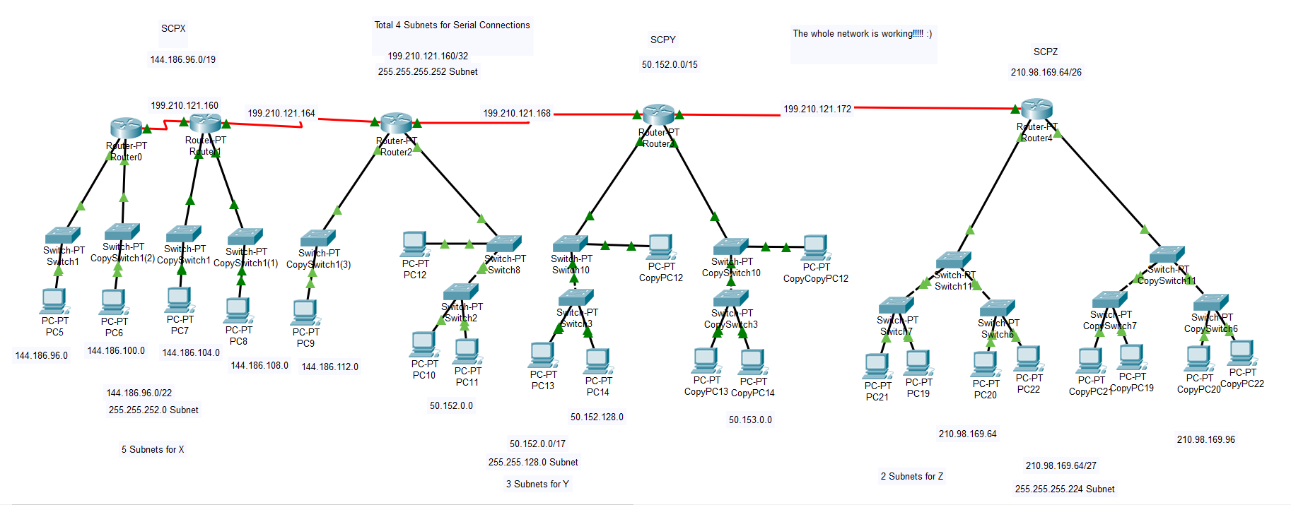

# CONCLUSION

Arrange design and its security are essential for any association. On the off chance that we take after the various leveled arrange configuration, system will be versatile, execution and security will be expanded, and the system will be anything but difficult to keep up. In this work, we proposed a minimal financially savvy secure grounds organize configuration in view of the workplace of different companies with their departments and required adaptability, security and different perspectives.

# REFERENCES

* www.cisco.com
* <https://www.orbit-computer-solutions.com/ripv2/#:~:text=RIPv2%20is%20a%20classless%2C%20distance,supernets%2C%20VLSM%20and%20discontiguous%20networks.>