"""
Grover's Quantum Search Algorithm
Problem : Unstructured search over N = 2^n states with M marked targets.
Algorithm: Grover's algorithm achieves success in O(sqrt(N/M)) oracle calls vs the classical lower bound of O(N/M).
This code: 4-qubit search space (N=16), M=3 marked states, optimal k=1 Grover iteration, simulated on AerSimulator.

Install : pip install "qiskit>=2.1" qiskit-aer matplotlib
"""
import numpy as np
import matplotlib
matplotlib.use("Agg")
import matplotlib.pyplot as plt
import matplotlib.patches as mpatches
from math import pi, floor, asin, sqrt
from qiskit import QuantumCircuit, transpile
from qiskit.circuit.library import grover_operator
from qiskit_aer import AerSimulator

# Experiment parameters
N_QUBITS = 4 # 4 qubits gives N = 2^4 = 16
TARGETS = ["0011", "1010", "1101"] # Marked bitstrings
SHOTS = 8192
OUT_DPI = 300

# 1. Phase Oracle
def build_phase_oracle(n: int, targets: list) -> QuantumCircuit:
"""
Constructs the phase oracle O_f |x⟩ = -|x⟩ for x in targets.
Method: for each target bitstring t
(a) Apply X to qubit j wherever t[j] = '0' (open-control trick)
(b) Apply n-qubit multi-controlled Z (MCZ = H · MCX · H on last qubit)
(c) Undo the X gates from step (a)
This marks exactly the state |t⟩ with a phase flip of −1.
Qiskit bitstring convention: t[0] ↔ q[n-1], t[n-1] ↔ q[0].
"""
oracle = QuantumCircuit(n, name=r"$\mathcal{O}_f$")
for t in targets:
# Qubits where the target bit is '0' get an X-gate (open control)
flip = [j for j in range(n) if t[n - 1 - j] == "0"]
if flip:
oracle.x(flip)

# MCZ via H – MCX – H sandwich on the last qubit
oracle.h(n - 1)
oracle.mcx(list(range(n - 1)), n - 1)
oracle.h(n - 1)

# Undo open controls
if flip:
oracle.x(flip)
oracle.barrier()

return oracle

# 2. Optimal Iteration Count
def optimal_iterations(n: int, m: int) -> int:
"""
Returns k = floor(π/(4·arcsin(√(M/N)))), the number of Grover operator applications that maximises success probability.
"""
return max(1, floor(pi / (4.0 * asin(sqrt(m / 2 ** n)))))

# 3. Full Grover Circuit
def build_grover_circuit(n: int, oracle: QuantumCircuit, k: int) -> QuantumCircuit:
"""
Constructs: H^⊗n → (Q)^k → measure
where Q = grover_operator(oracle) = D · O_f,
D = H^⊗n · (2|0⟩⟨0| − I) · H^⊗n is the diffusion operator. [Ref 2, 4]
"""
qc = QuantumCircuit(n, n, name="Grover Circuit")
# Step 1 – uniform superposition
qc.h(range(n))
qc.barrier()
# Step 2 – k Grover iterations
G = grover_operator(oracle, insert_barriers=True)
G.name = r"$\mathcal{Q}$"
for _ in range(k):
qc.compose(G, inplace=True)
qc.barrier()
# Step 3 – measure all qubits
qc.measure(range(n), range(n))
return qc

# 4. Simulation
def run_simulation(qc: QuantumCircuit) -> dict:
"""
Transpiles and runs on AerSimulator (statevector method). [Ref 4]
Returns measurement counts dict.
"""
sim = AerSimulator(method="statevector")
tqc = transpile(qc, sim, optimization_level=1)
return sim.run(tqc, shots=SHOTS).result().get_counts()

# 5. Theoretical Quantities
def theory(n: int, m: int, k: int) -> dict:
"""Exact analytical quantities for Grover's algorithm. [Ref 3]"""
N = 2 ** n
theta = asin(sqrt(m / N)) # rotation angle in Hilbert space
# Success prob = sin²( (2k+1)·θ ) over all M targets [Ref 3, Eq. 6.14]
p_total = np.sin((2 * k + 1) * theta) ** 2
p_per_tgt = p_total / m
# Classical expected oracle calls for random search (without replacement) [Ref 1]
q_classic = (N + 1) / (m + 1)
# Quantum oracle calls = k
speedup = q_classic / k
return dict(theta=theta, p_total=p_total, p_per_tgt=p_per_tgt,
q_classic=q_classic, speedup=speedup)

# 6. Figure 1 - Circuit Diagram
def save_circuit_figure(qc: QuantumCircuit, n: int, m: int, k: int,
path: str = "grover_circuit.jpg"):
"""
Draws the full Grover circuit decomposed one level so the oracle and
diffusion sub-circuits are visible as labelled boxes.
"""
# Decompose one layer to expose oracle + diffusion labels
qc_d = qc.decompose(gates_to_decompose=[r"$\mathcal{Q}$"])

fig = qc_d.draw(
output="mpl",
fold=60,
style={
"backgroundcolor": "#ffffff",
"fontsize": 9,
"displaytext": {r"$\mathcal{O}_f$": r"$\mathcal{O}_f$"},
},
)

fig.suptitle(
rf"Grover's Algorithm — $n={n}$ qubits, $N=2^{{{n}}}={2**n}$ states,"
rf" $M={m}$ targets, $k={k}$ iteration",
fontsize=12, fontweight="bold", y=1.03,
)
fig.savefig(path, dpi=OUT_DPI, bbox_inches="tight", format="jpeg")
plt.close(fig)
print(f" [saved] {path}")

# 7. Figure 2 – Histogram and Quantum Advantage
def save_results_figure(counts: dict, n: int, targets: list, k: int,
th: dict, path: str = "grover_histogram.jpg"):
"""
Two-panel figure:
Left – probability histogram
Right – classical vs Grover comparison
"""
N = 2 ** n
labels = [format(i, f"0{n}b") for i in range(N)]
probs = np.array([counts.get(s, 0) / SHOTS for s in labels])
colors = ["#c0392b" if s in targets else "#2980b9" for s in labels]

fig, (ax1, ax2) = plt.subplots(
1, 2, figsize=(14, 5.5),
gridspec_kw={"width_ratios": [2.8, 1]},
)
fig.suptitle(
"Grover's Algorithm: Measurement Outcomes & Quantum Advantage",
fontsize=13, fontweight="bold", y=1.01,
)

# Left panel: probability histogram
ax1.bar(range(N), probs, color=colors, edgecolor="black", linewidth=0.5, width=0.75)

uniform = 1.0 / N
ax1.axhline(uniform, color="#7f7f7f", linestyle="--", linewidth=1.4, zorder=3,
label=f"Uniform baseline $1/N = {uniform:.4f}$")
ax1.axhline(th["p_per_tgt"], color="#8e44ad", linestyle=":", linewidth=1.8, zorder=3,
label=rf"Theory per target $\approx {th['p_per_tgt']:.4f}$")

ax1.set_xticks(range(N))
ax1.set_xticklabels(labels, rotation=90, fontsize=8, fontfamily="monospace")
ax1.set_xlabel(r"Measurement Outcome (bitstring $q_{n-1}\cdots q_0$)", fontsize=11)
ax1.set_ylabel("Probability", fontsize=11)
ax1.set_title(rf"Simulation: {SHOTS:,} shots, $k={k}$ Grover iteration", fontsize=11)
ax1.set_xlim(-0.6, N - 0.4)
ax1.set_ylim(0, max(probs) * 1.28)
ax1.yaxis.grid(True, linestyle="--", alpha=0.4, zorder=0)
ax1.set_axisbelow(True)

legend_handles = [
mpatches.Patch(color="#c0392b", label="Target states (marked)"),
mpatches.Patch(color="#2980b9", label="Non-target states"),
plt.Line2D([], [], color="#7f7f7f", linestyle="--",
label=f"Uniform $1/N = {uniform:.4f}$"),
plt.Line2D([], [], color="#8e44ad", linestyle=":",
label=rf"Theory per target $\approx {th['p_per_tgt']:.4f}$"),
]
ax1.legend(handles=legend_handles, fontsize=9, loc="upper left",
framealpha=0.9, edgecolor="grey")

# Annotate each target bar with its probability
for s in targets:
idx = int(s, 2)
ax1.annotate(
f"{probs[idx]:.3f}",
xy=(idx, probs[idx]),
xytext=(0, 4), textcoords="offset points",
ha="center", va="bottom", fontsize=8, color="#c0392b", fontweight="bold",
)

# Right panel: quantum advantage comparison
cat_labels = [f"Classical\nRandom\nO(N/M)", f"Grover\nO(√(N/M))"]
cat_vals = [th["q_classic"], float(k)]
cat_colors = ["#e67e22", "#27ae60"]

bars = ax2.bar(cat_labels, cat_vals, color=cat_colors, edgecolor="black",
linewidth=0.8, width=0.5)
for bar, val in zip(bars, cat_vals):
ax2.text(bar.get_x() + bar.get_width() / 2.0, bar.get_height() + 0.08,
f"{val:.2f}", ha="center", va="bottom",
fontsize=13, fontweight="bold")

ax2.set_ylabel("Expected Oracle Queries\nto Find One Solution", fontsize=10)
ax2.set_title(rf"Quantum Advantage ×{th['speedup']:.1f}", fontsize=12,
fontweight="bold", color="#27ae60")
ax2.set_ylim(0, th["q_classic"] * 1.55)
ax2.yaxis.grid(True, linestyle="--", alpha=0.4)
ax2.set_axisbelow(True)

# Complexity annotation box
ax2.text(
0.5, 0.88,
rf"$N={2**n}$, $M={len(targets)}$" + "\n"
rf"Classical: $(N+1)/(M+1) \approx {th['q_classic']:.2f}$" + "\n"
rf"Grover: $k={k}$ (1 oracle call)",
transform=ax2.transAxes, ha="center", va="top", fontsize=8.5,
bbox=dict(boxstyle="round,pad=0.45", facecolor="#f4f4f4", edgecolor="#aaaaaa"),
)

fig.tight_layout()
fig.savefig(path, dpi=OUT_DPI, bbox_inches="tight", format="jpeg")
plt.close(fig)
print(f" [saved] {path}")

# 8. Console Report
def print_report(n: int, targets: list, k: int, counts: dict, th: dict):
N = 2 ** n
hit = sum(counts.get(t, 0) for t in targets)
p_sim = hit / SHOTS
th_angle = th["theta"]
print("\nResults Summary\n")

print(f" Qubits n : {n}")
print(f" Search space N : {N}")
print(f" Marked states M : {len(targets)} {targets}")
print(f" Grover angle θ : {th_angle:.6f} rad")
print(f" Optimal iter. k : {k} \n")

print(f" Theory P(success) = sin²((2k+1)θ) = {th['p_total']:.5f}")
print(f" Sim. P(success) = {p_sim:.5f} ({SHOTS:,} shots)")
print(f" Theory P(per target) = {th['p_per_tgt']:.5f}")

print("\n Per-target counts:")
for t in targets:
c = counts.get(t, 0)
print(f" |{t}⟩ {c:5d} shots ({c/SHOTS:.4f})")

print(f"\n Classical queries : {th['q_classic']:.2f}")
print(f" Grover oracle calls : {k}")
print(f" Quantum speedup : ×{th['speedup']:.2f}")

# Main
def main():
n, m = N_QUBITS, len(TARGETS)
k = optimal_iterations(n, m)
th = theory(n, m, k)

print(f"\nBuilding oracle for targets {TARGETS} (n={n}, N={2**n}, M={m}, k={k})")
oracle = build_phase_oracle(n, TARGETS)
print("Building full Grover circuit")
qc = build_grover_circuit(n, oracle, k)
print(f" Gate count : {sum(qc.count_ops().values())}")
print(f" Circuit depth: {qc.depth()}")

print("Running simulation on AerSimulator")
counts = run_simulation(qc)
print_report(n, TARGETS, k, counts, th)

print("\nOutput figures have been saved in your current working directory.")
save_circuit_figure(qc, n, m, k, path="grover_circuit.jpg")
save_results_figure(counts, n, TARGETS, k, th, path="grover_histogram.jpg")

if __name__ == "__main__":
main()

# References
# [1] L. K. Grover, "A fast quantum mechanical algorithm for database search,"
# in Proc. 28th Annual ACM Symposium on Theory of Computing (STOC),
# pp. 212–219, 1996. https://arxiv.org/abs/quant-ph/9605043
# [2] IBM Quantum Documentation, "Grover's Algorithm,"
# https://quantum.cloud.ibm.com/docs/en/tutorials/grovers-algorithm
# Accessed May 2026.
# [3] M. A. Nielsen and I. L. Chuang, "Quantum Computation and Quantum
# Information," Cambridge University Press, 10th Anniversary Ed., 2010.
# Chapter 6 (Quantum search algorithms), in particular §6.1 and Eq. 6.14–6.15.
# [4] Qiskit Development Team, "qiskit.circuit.library.grover_operator,"
# https://docs.quantum.ibm.com/api/qiskit/qiskit.circuit.library.grover_operator
# Accessed May 2026.
# [5] G. Brassard, P. Høyer, M. Mosca, and A. Tapp, "Quantum amplitude
# amplification and estimation," AMS Contemporary Mathematics,
# vol. 305, pp. 53–74, 2002. https://arxiv.org/abs/quant-ph/0005055

Output:
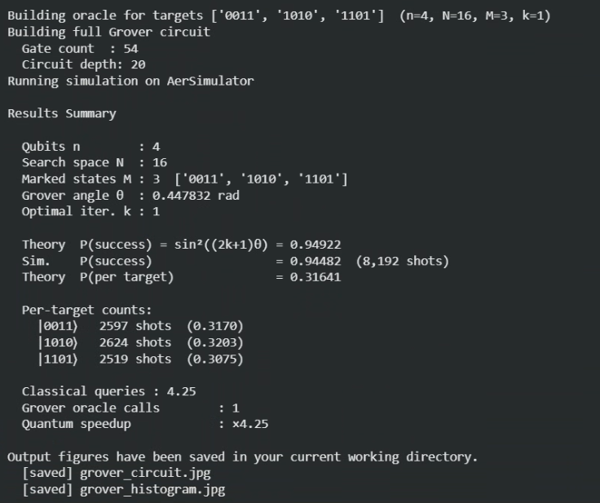

Saved outputs:
Grover circuit:
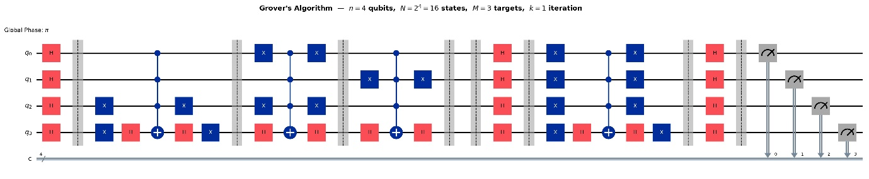
Quantum Advantage:

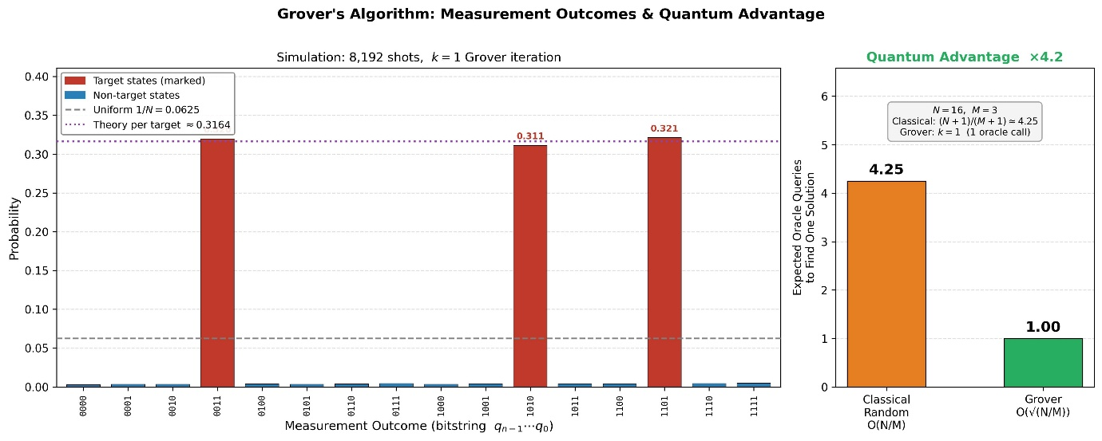

Now performed by me on IBM quantum simulator QASM:
Circuit with results
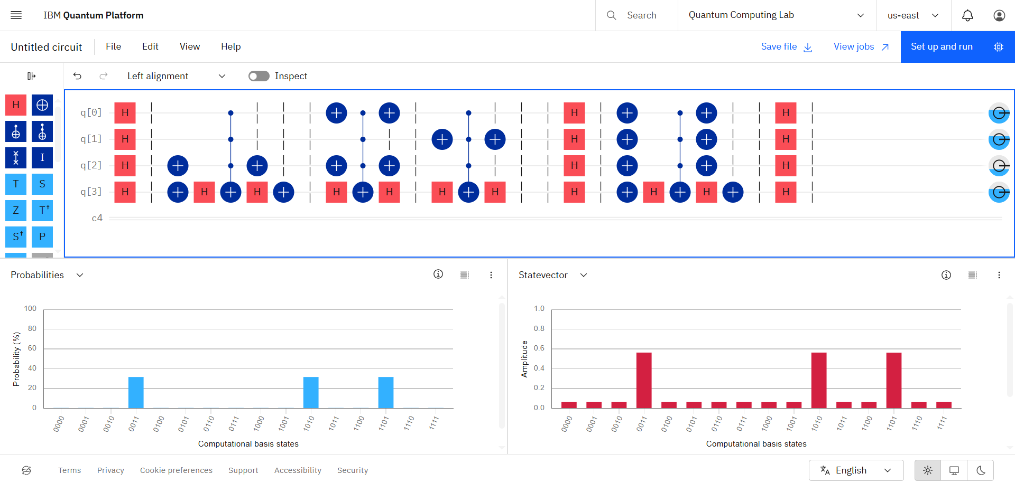

After performing measurement:
