Task 1:  
Write statements that assign random integers to the variable n in the following ranges:

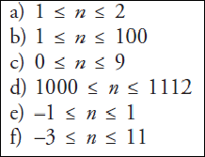

|  |  |
| --- | --- |
| **Range** | **C Statement** |
| a | int n1 = 1 + rand() % 2; |
| b | int n2 = 1 + rand() % 100; |
| c | int n3 = rand() % 10; |
| d | int n4 = 1000 + rand() % 113; |
| e | int n5 = rand() % 3 - 1; |
| f | int n6 = rand() % 15 - 3; |