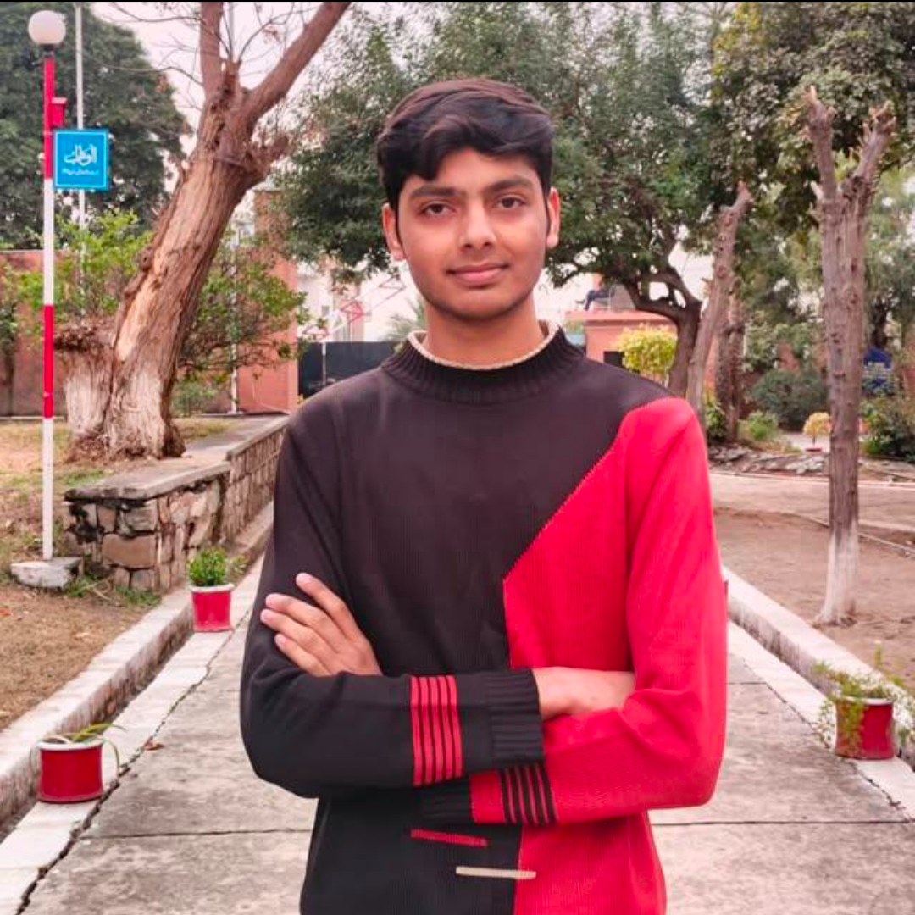 | Zain Ali – Team Leader & Developer  BS Computer Science  Riphah International University, Islamabad  Contact No.: +92 3266295094  Email Address: 57113@students.riphah.edu.pk  Contribution(s)  - Team Lead for the FYP development team, responsible for coordinating task distribution, timelines, and supervisor deliverables.  - Full-Stack Web Application Development: architected and built the core web portal.  - Web Application Integration: integrated the Gen AI engine, database, and semantic search module into a unified web platform.  - Khutba Generation using Gen AI: designed the RAG-grounded generation pipeline for scholar-verified khutba content.  - Semantic Search Integration: implemented and connected the semantic similarity search feature within the web application.
 | Waleed Ahmad – Developer  BS Computer Science.  RIPHAH International University (RIU), Islamabad.  Contact No: +92 312 5494970  Email Address: 56336@students.riphah.edu.pk  Contribution(s)  - Responsible for designing, implementing, and managing the Mudabbir project database.  - Managed Quranic verse data and embeddings to support semantic similarity search and relevance-based ranking.  - Topic Assessment Module & Microcredential Courses Module .  - Responsible for implementing NLP techniques to process and analyze textual research data.
 | Ehtisham Hussain – Developer  BS Computer Science  Riphah International University, Islamabad  Contact No.: +92 316 5366937  Email Address: 56305@students.riphah.edu.pk  Contribution(s)  - Mobile Application Development, responsible for designing, developing, and maintaining the Mudabbir mobile application using React Native and integrating it with backend services.  - AI-Based Summary Generation, responsible for generating concise summaries of relevant Quranic verses and Tafsir using AI techniques.

