**Group Member Names:**

1. Asad Nadeem SP22-BCS-057
2. Huzaifa Malik SP22-BCS-018

**Project name:**

Outlet Store Management System

**General overview:**

Our project is on an outlet store in which different products will be available to purchase by the customer with a” log in and signup form “at the front end. With multiple option to choose from, from filter price to product type and Color’s. Following are the functionalities of the project:

* Select product
* Add product by (Seller)
* Add new Product Category by (Seller)
* Search by name
* Search by category
* Purchase product
* Bill Calculate in the checkout page
* Storing User(consumer) data while purchasing
* Login / Signup page
* Add to cart connected to checkout page

**Objective:**

The main objective behind developing this project is to:

* Grow the target customer from local to national or international level.
* Maintain the purchase and stock at shop.
* Utilizing the resources in a more efficient way to increase the productivity.
* Providing comfort to both end user and the retailer by minimizing the shopping efforts.

**Data Flow Diagram:**

**Outlet Management System**

**New Customer**

**Order**

**Sales**

**Purchase**

Bill Details

Order Details

Class Details

Customer Details

**Languages To be Used:**

* Java
* JavaFX
* Scene builder (application for CSS designing )

**Inputs:**

* Product Details
* Quantities of products
* Customer Details
* Sale Details

**Controller / Classes:**

* Hello Controller (Log in Page Controller)
* Signup Controller (Signup Page Controller)
* Outlet main Controller (Main Page of the Outlet)
* Mens Page Controller
* Womens Page Controller
* Kids Page Controller
* On Sale Page Controller

**FXMLS:**

* Hello fxm (Log in Page Controller)
* Signup fxml (Signup Page Controller)
* Outlet main fxml (Main Page of the Outlet)
* Mens Page fxml
* Womens Page fxml
* Kids Page fxml
* On Sale Page fxml

**Outputs:**

* Customer bill receipt (in the checkout page )
* Rate of clothes with the product name
* Current quantities of products (after each sale)

**Code for the Log in Page Connecting Main page and the Sign Up Page :**

package com.example.demo4;  
  
import javafx.fxml.FXML;  
import javafx.fxml.FXMLLoader;  
import javafx.fxml.Initializable;  
import javafx.scene.Parent;  
import javafx.scene.Scene;  
import javafx.scene.control.*;  
  
  
import javafx.event.ActionEvent;  
import javafx.scene.control.Label;  
import javafx.scene.image.Image;  
import javafx.scene.image.ImageView;  
import javafx.stage.Stage ;  
  
  
import java.io.File;  
import java.io.IOException;  
import java.net.URL;  
import java.util.ResourceBundle;  
  
public class HelloController {  
  
 @FXML  
 private Button CancelButton;  
 @FXML  
 private Button Signupbutton;  
 @FXML  
 private Label LogInLabeltext;  
  
 @FXML  
 private ImageView brandingImageview;  
  
 @FXML  
 private Button LoginButton;  
  
 @FXML  
 private PasswordField passwordTextfield;  
  
  
 @FXML  
 private TextField usernametextfield;  
  
  
  
  
  
  
  
  
  
  
 @FXML  
 void CancelButtonOnAction(ActionEvent event) {  
 Stage stage =(Stage) CancelButton.getScene().getWindow();  
 stage.close();  
  
 }  
  
 @FXML  
 void LoginButtononAction(ActionEvent event) {  
  
 if (usernametextfield.getText().isBlank()==false && passwordTextfield.getText().isBlank()==false){  
 LogInLabeltext.setText("You Logged in Successfully");  
 validatedlogin();  
  
 }  
 else {  
 LogInLabeltext.setText("Please enter username and Password");  
  
 }  
  
 }  
 @FXML  
 void signupbuttonOnAction(ActionEvent event) throws IOException {  
 try{FXMLLoader fxmlLoader = new FXMLLoader(getClass().getResource("Signup.fxml"));  
 Parent root1 = (Parent) fxmlLoader.load();  
 Stage stage = new Stage();  
 //stage.initStyle(StageStyle.TRANSPARENT);  
 stage.setTitle("Signup window");  
 stage.setScene(new Scene(root1));  
 stage.show();  
 }catch(Exception e){  
 System.*out*.println("CANT LOAD NEW WINDOW");  
 }}  
 public void validatedlogin(){  
 try{FXMLLoader fxmlLoader = new FXMLLoader(getClass().getResource("OutletMain.fxml"));  
 Parent root2 = (Parent) fxmlLoader.load();  
 Stage stage = new Stage();  
 //stage.initStyle(StageStyle.TRANSPARENT);  
 stage.setTitle("Outlet Main Window");  
 stage.setScene(new Scene(root2));  
 stage.show();  
  
 }catch(Exception e){  
 System.*out*.println("CANT LOAD NEW WINDOW");  
 }}  
 }  
  
  
  
  
// FXMLLoader fxmlLoader = new FXMLLoader(getClass().getResource("Signup.fxml"));  
// Parent root = fxmlLoader.load();  
// Stage stage = new Stage();  
// stage.initStyle(StageStyle.UNDECORATED);  
// stage.setOpacity(1);  
// stage.setTitle("My New Stage Title");  
// stage.setScene(new Scene(root, 600, 563));  
// stage.showAndWait();  
// FXMLLoader loader = new FXMLLoader(HelloApplication.class.getResource("Signup.fxml")); // create and load() view  
// Stage stage = (Stage) Signupbutton.getScene().getWindow();  
// Scene registerscene = new Scene(loader.getRoot());  
// stage.setScene(registerscene);  
// stage.showAndWait();

**Log in Page :**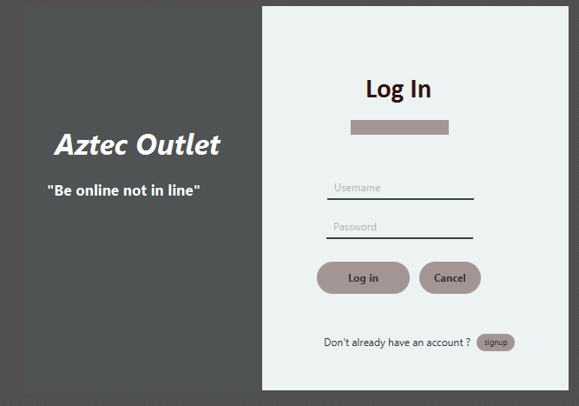

**Code for the Signup Page Connecting :**

package com.example.demo4;  
  
import javafx.event.ActionEvent;  
import javafx.fxml.FXML;  
import javafx.scene.control.Button;  
import javafx.scene.control.Label;  
import javafx.scene.control.PasswordField;  
import javafx.scene.control.RadioButton;  
import javafx.scene.control.TextField;  
import javafx.stage.Stage;  
import javafx.scene.control.ToggleButton;  
  
public class SignupController {  
  
 @FXML  
 private PasswordField confirmpasswordtextfield;  
  
 @FXML  
 private Button exitbutton;  
  
 @FXML  
 private TextField firstnametextfield;  
  
 @FXML  
 private TextField lastnametextfield;  
  
  
 @FXML  
 private PasswordField passwordtextfield;  
  
 @FXML  
 private Button signupbutton;  
  
 @FXML  
 private Label signupbuttonlabel;  
  
 @FXML  
 private RadioButton termsandpolicies;  
  
 @FXML  
 private TextField usernametextfield;  
  
  
  
  
  
  
  
 @FXML  
 void exitbuttonOnAction(ActionEvent event) {  
 Stage stage =(Stage) exitbutton.getScene().getWindow();  
 stage.close();  
  
}  
 @FXML  
 void signupbuttononAction(ActionEvent event) {  
  
  
 if (firstnametextfield.getText().isBlank()==false && lastnametextfield.getText().isBlank()==false&&usernametextfield.getText().isBlank()==false  
 && passwordtextfield.getText().isBlank()==false && confirmpasswordtextfield.getText().isBlank()==false && termsandpolicies.isDisable()==false){  
 signupbuttonlabel.setText("You have successfully registered,Please exit and login to continue");  
 if(termsandpolicies.isDisable()==false){  
 signupbuttonlabel.setText("please accept the privacy policies");  
 }  
  
 }  
  
 }  
}

**Sign up Page :**

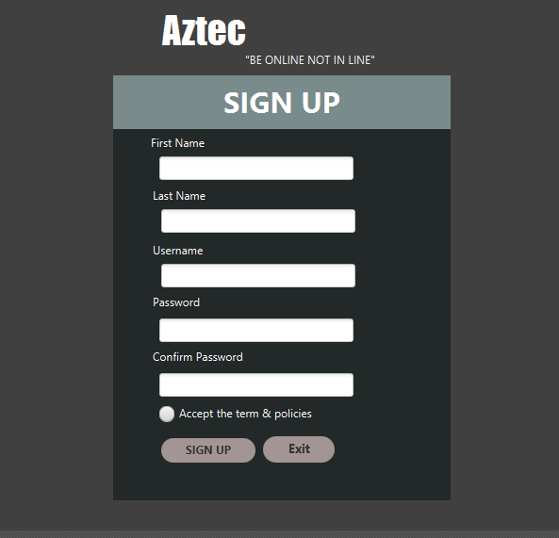

**Code for the Main Page Connecting multiple windows as (Kids , Womens , Sale Page ,Checkout Page , Home Page ) :**

package com.example.demo4;  
  
import javafx.fxml.FXML;  
import javafx.fxml.FXMLLoader;  
import javafx.scene.Parent;  
import javafx.scene.input.MouseEvent;  
import javafx.scene.layout.AnchorPane;  
import javafx.scene.layout.BorderPane;  
  
import java.io.IOException;  
import java.util.logging.Level;  
import java.util.logging.Logger;  
  
public class OutletmainController {  
  
 @FXML  
 private AnchorPane ap;  
  
 @FXML  
 private BorderPane bp;  
  
 @FXML  
 void Kidspage(MouseEvent event) {  
 loadPage("Kidspage");  
 }  
  
 @FXML  
 void Salepage(MouseEvent event) {  
 loadPage("Salepage");  
  
 }  
  
 @FXML  
 void WomensPage(MouseEvent event) {  
  
 loadPage("Womenspage");  
 }  
  
 @FXML  
 void checkoutpage(MouseEvent event) {  
 loadPage("checkoutpage");  
 }  
  
 @FXML  
 void homepage(MouseEvent event) {  
 bp.setCenter(ap);  
  
 }  
 private void loadPage(String page) {  
 Parent root = null;  
 try {  
 root = FXMLLoader.*load*(getClass().getResource(page + ".fxml"));  
 } catch (IOException ex){  
 Logger.*getLogger*(OutletmainController.class.getName()).log(Level.*SEVERE*,null,ex);  
 }  
 bp.setCenter(root);  
 }  
 }

**Main Page:**

