Cancelable Multimodal Biometric Authentication for Critical Infrastructure
Face, Voice, and Dynamic Z-Gesture Verification with Keyed Template Protection
Maanasvee Khetan, Sanya Malik, Reya Oberoi, Dr. Vaishali Kulkarni, Dr. Archana Bhise
maanasveekhetan66@gmail.com · sanyask.malik@gmail.com · reyaoberoi2005@gmail.com · [email to be added] · [email to be added]
[Department], [Institution], [City, Country]
28 September 2026
Full-content research document (single-column review version). Evidence labels used throughout: REAL = public biometric datasets; SYNTHETIC = generated gesture users; DEVELOPMENT OBSERVATION = live captures by one developer; CONFIGURATION = values set in the implementation.

Abstract
Biometric traits cannot be reissued after a database breach, and multimodal systems multiply the sensitive data they retain, a serious concern for access control at critical-infrastructure facilities. This paper presents a multimodal verification system that combines face, voice, and a dynamic Z-shaped hand gesture and stores only keyed, revocable templates. Face and voice embeddings are mapped to 256-bit BioHash templates under HKDF-derived keys, and each enrollment is issued as a pool of four independently keyed template sets that can be revoked and replaced. The hand gesture is captured in the browser as MediaPipe landmark trajectories, matched with dynamic time warping, and protected by a keyed orthonormal transform. Presented modalities are combined under a default all-required fusion policy in which every factor must match individually. In single-reference tests on held-out LFW identities, protected face templates reach an equal error rate (EER) of 8.50%; on a closed-set VoxCeleb1 subset, the deployed two-sentence enrollment, one-sentence verification voice protocol reaches 1.27% EER. Revoked face and voice templates agree with their replacements only at chance level (Hamming similarity about 0.50, no acceptances). The untuned baseline thresholds still yield high false-rejection rates, the hand-gesture threshold has been calibrated only on synthetic data, and real-participant evaluation remains future work.
Keywords: Cancelable biometrics; BioHashing; biometric template protection; multimodal biometrics; face verification; speaker verification; behavioral biometrics; hand-gesture biometrics; dynamic time warping; MediaPipe; critical infrastructure

1. Introduction
Physical and logical access to critical infrastructure—electricity grids, water treatment, industrial control rooms, and government facilities—requires identity assurance that is stronger than passwords or access cards, which can be shared, forgotten, or stolen [1], [2]. Biometric authentication binds a credential to the person, but it introduces a problem that knowledge- and token-based credentials do not have: a biometric trait cannot be changed. If a stored biometric template is leaked, the compromise is permanent, and the same template may be used to link a person across unrelated applications [3], [4].
A single biometric modality also concentrates risk in one sensor. A face capture can fail because of lighting or pose, a voice recording because of background noise or a short utterance, and a behavioral trait because the user performs it differently on a given day. Multimodal biometrics address this dependence by combining several traits, so that the decision does not rest on one capture [5], [6]. Combining modalities, however, multiplies the amount of sensitive biometric data held by the system, and therefore increases the damage that a database breach can cause.
Cancelable biometrics address the permanence problem by storing a keyed, repeatable transformation of the biometric representation instead of the representation itself; a compromised template can be revoked and reissued under a new key without asking the user for a new biometric trait [3], [4], [7]. Bringing cancelable protection and multimodal fusion together is not automatic. Each modality needs a protected representation that still supports its own matching rule; the fusion rule must not allow a strong factor to compensate for a failed one; and revocation must replace the credentials of all modalities consistently.
This paper describes a web-based verification system designed around these requirements. It combines three complementary modalities: face (captured by the camera), voice (captured by the microphone), and a dynamic in-air Z gesture (captured by the same camera). The gesture is a behavioral biometric: the system compares how the palm moves through the three strokes of the Z—its trajectory, direction changes, relative speed, and hand orientation—rather than recognising a static hand shape. All three modalities are stored only as keyed templates organised into revocable template sets, and the final decision is taken by a fail-closed policy that requires every presented modality to match.
The contributions of this work are:
1) An end-to-end implementation in which face and voice embeddings are protected by 256-bit BioHash templates [8] under keys derived with HKDF-SHA256 [9], decisions are expressed through calibrated estimates of the original embedding metrics, and every enrollment is issued as a pool of four revocable template sets.
2) A dynamic Z-gesture modality: browser-side MediaPipe Hands landmarks [10], a normalized palm trajectory enriched with direction, timing, orientation and finger features, a lenient structural validity gate, dynamic time warping (DTW) [11] with a bounded rotation search, three separately stored enrollment samples with median aggregation, and a keyed orthonormal sequence transform that leaves DTW distances unchanged.
3) A fail-closed decision layer: per-modality capture-quality gates that separate capture failures from biometric mismatches, and an all-required fusion policy that prevents a strong modality from overriding a failed one.
4) An evaluation that labels its evidence: public-dataset results for face and voice, including the operating points of the configured thresholds; clearly separated synthetic results for the gesture, including tempo and finger-pose experiments; and development observations from live captures, reported as observations rather than as accuracy.
The remainder of the paper is organised as follows. Section 2 reviews related work. Section 3 describes the architecture and the three modalities, and Section 4 details the processing methodology. Section 5 describes the experimental setup, Section 6 reports results, and Section 7 discusses them. Security and privacy considerations, limitations, and future work are given in Sections 8–10, and Section 11 concludes.

2. Related Work

2.1 Face and Speaker Verification
Modern face verification maps an aligned face crop to an embedding vector and compares embeddings with a cosine or Euclidean distance. FaceNet introduced a triplet-loss embedding trained directly for verification [12], and ArcFace added an additive angular margin to the softmax loss, which produces more compact identity clusters [13]. Face detection and landmark estimation are commonly performed with multitask cascaded convolutional networks (MTCNN) [14], and large pretraining corpora such as VGGFace2 provide pose and age variation [15]. Speaker verification follows the same embedding paradigm: ECAPA-TDNN combines time-delay layers with squeeze-and-excitation channel attention and multi-layer aggregation, and is a strong text-independent architecture [16]; VoxCeleb is a widely used benchmark of speech collected in unconstrained conditions [17].

2.2 Behavioral and Gesture Biometrics
Behavioral biometrics authenticate how a person acts—typing rhythm, gait, signature dynamics, or gestures—rather than what they physically are [18]. Motion gestures have been used for authentication with wearable accelerometers, where uWave compared acceleration sequences with DTW [19], and with depth cameras for in-air handwriting, as in KinWrite [20]. These systems demonstrate that the dynamics of a free-hand movement carry person-specific information, but they rely on dedicated sensors, store the raw or lightly processed trajectories, and are evaluated as single-modality systems. Camera-only hand tracking has since become practical: MediaPipe Hands estimates 21 three-dimensional hand landmarks per frame in real time on commodity devices [10], which makes it possible to capture an in-air gesture with an ordinary web camera.

2.3 Temporal Matching
Two performances of the same gesture rarely have the same duration or the same speed profile. Dynamic time warping aligns two sequences by finding the monotone warping path that minimises the accumulated frame-to-frame cost, and the Sakoe–Chiba band constrains the path to stay near the diagonal so that one short section of a sequence cannot absorb most of the other [11]. DTW remains a standard baseline for comparing trajectories performed at different speeds, and is used in gesture authentication work such as uWave [19].

2.4 Multimodal Fusion
Information from several biometric sources can be fused at the sensor, feature, score, or decision level [5], [6]. Score-level fusion with simple rules such as the sum rule is widely used because it is easy to apply to heterogeneous matchers [5]. For a security-critical application, however, the decision rule matters as much as the fusion score: with a plain average, a very confident match in one modality can compensate for a genuine failure in another. Decision-level policies that require every presented factor to match avoid this effect at the cost of a higher false-rejection rate.

2.5 Cancelable Biometrics and Template Protection
Biometric template protection aims at three properties: revocability (a compromised template can be replaced), unlinkability (templates of the same person in different applications cannot be matched to each other), and non-invertibility (the original biometric cannot be recovered from the template), while preserving recognition accuracy [4], [7]. Ratha et al. introduced cancelable biometrics as intentional, repeatable distortions of the biometric signal [3]. BioHashing combines a user-specific token with a random projection of the feature vector and a thresholding step to produce a binary template [8]; its security, however, degrades substantially when the token is stolen, because an attacker who knows the token can reproduce the projection [21]. Gomez-Barrero et al. proposed a framework and score-based measures to evaluate unlinkability [22], and the connection between random hyperplane projections and the angle between vectors [23] provides a principled way to relate binary template agreement to the original embedding similarity.

2.6 Positioning of This Work
Table 1 summarises representative work. Protected biometric systems in the literature are mostly unimodal, whereas gesture-authentication systems generally store unprotected trajectories and are evaluated in isolation. The gap addressed here is an integrated system in which a camera-based behavioral modality is protected, revoked, and fused together with face and voice under one template lifecycle, accompanied by an evaluation that states explicitly what has and has not been measured. No claim is made that this combination is the first of its kind.
Table 1. Comparison with representative related work
Work | Modality | Method | Template protection | Fusion | Limitation for this setting
Ratha et al. [3] | Generic | Cancelable transforms | Cancelable | — | Concept
Jin et al. [8] | Fingerprint | Random projection + thresholding | BioHash | — | Unimodal; weak if the token is stolen [21]
Ross and Jain [5] | Multimodal | Fusion levels | — | Sensor to decision | No template protection
Liu et al. [19] | Accelerometer gesture | DTW | — | — | Dedicated sensor; unprotected
Tian et al. [20] | In-air handwriting (depth camera) | Trajectory matching | — | — | Depth sensor; unprotected
This work | Face, voice, Z gesture | Embeddings + BioHash; DTW + keyed transform | BioHash; keyed orthonormal | All-required decision | No real-participant evaluation yet

3. Proposed System

3.1 System Overview
The system verifies a claimed identity from one or more biometric factors chosen by the user from the factors they have enrolled. Face and voice are required at registration; the dynamic hand gesture is an optional third factor. Every modality follows the same pattern. A capture is first checked by a modality-specific quality gate; an unusable capture is reported as a capture failure and never reaches matching. A usable capture is converted into a fixed representation, transformed with a key derived for the user, modality, and template set, and compared with the stored protected template of the active template set. Each modality decides against its own threshold, and a fusion policy combines the per-modality decisions into a single accept or deny decision. Table 2 summarises the enrollment and authentication protocol.
Table 2. Final system modalities and protocol
Modality | Enrollment samples | Authentication input | Representation | Matching method | Decision direction
Face | 5 guided poses (front, left, right, up, down); at least 3 valid | 1 fresh capture | 512-D InceptionResnetV1 embedding → 256-bit BioHash | Hamming similarity → calibrated cosine ĉ | ĉ ≥ 0.80 (higher is better)
Voice | 2 sentences (consistency check) | Exactly 1 sentence | 192-D ECAPA-TDNN embedding → 256-bit BioHash | Hamming similarity → calibrated Euclidean d̂ | d̂ ≤ 0.75 (lower is better)
Hand (Z gesture) | 3 independent Z gestures, stored separately | Exactly 1 Z gesture | 64 × 13 feature sequence → keyed orthonormal transform | DTW with rotation search; median over the 3 samples | d ≤ 0.216 (lower is better; development threshold)
The face and voice thresholds are fixed project baselines; the hand threshold was selected on synthetic data (Section 5.7).

3.2 Overall Architecture
Fig. 1 shows the architecture. The client is a React single-page application running in the browser; it guides the user through face capture, records voice as WAV audio, and runs MediaPipe Hands locally for the gesture. For the gesture only the landmark sequence is uploaded—never video. The backend is a FastAPI service that decodes and validates each upload, applies the quality gates, extracts representations with PyTorch models, applies the keyed template transformation, compares templates, applies the fusion policy, and writes an audit record. The relational template store (SQLite in development, PostgreSQL for deployment) contains protected templates, key versions, and non-biometric metadata; raw images, audio, landmark sequences, and embeddings are discarded after processing. Table 3 lists the main components.
Table 3. System components
Layer | Component | Technology | Role
Client | Capture UI | React, TypeScript, Vite | Guided face capture, voice recording, gesture capture and replay of the captured trajectory
Client | Hand tracking | MediaPipe HandLandmarker (tasks-vision 1.0.1), in the browser | 21 landmarks per video frame; uploaded as JSON
Backend | API | FastAPI | Enrollment, verification, fusion, template-set management, audit
Backend | Face model | MTCNN + InceptionResnetV1 (facenet-pytorch, PyTorch) | 512-D face embedding
Backend | Voice model | ECAPA-TDNN (SpeechBrain, PyTorch) | 192-D speaker embedding
Backend | Gesture processing | NumPy (preprocessing/hand_gesture.py) | Gates, normalization, 13-D feature sequence, Z validity
Backend | Template protection | HKDF-SHA256 (cryptography), BioHash, keyed orthonormal transform | Keyed, revocable templates
Backend | Matching and fusion | Hamming similarity, calibrated metric estimation, DTW, fusion policy | Per-modality decision and final decision
Storage | Template store | SQLAlchemy; SQLite (development) / PostgreSQL | Protected templates, 4 template sets per user, audit log

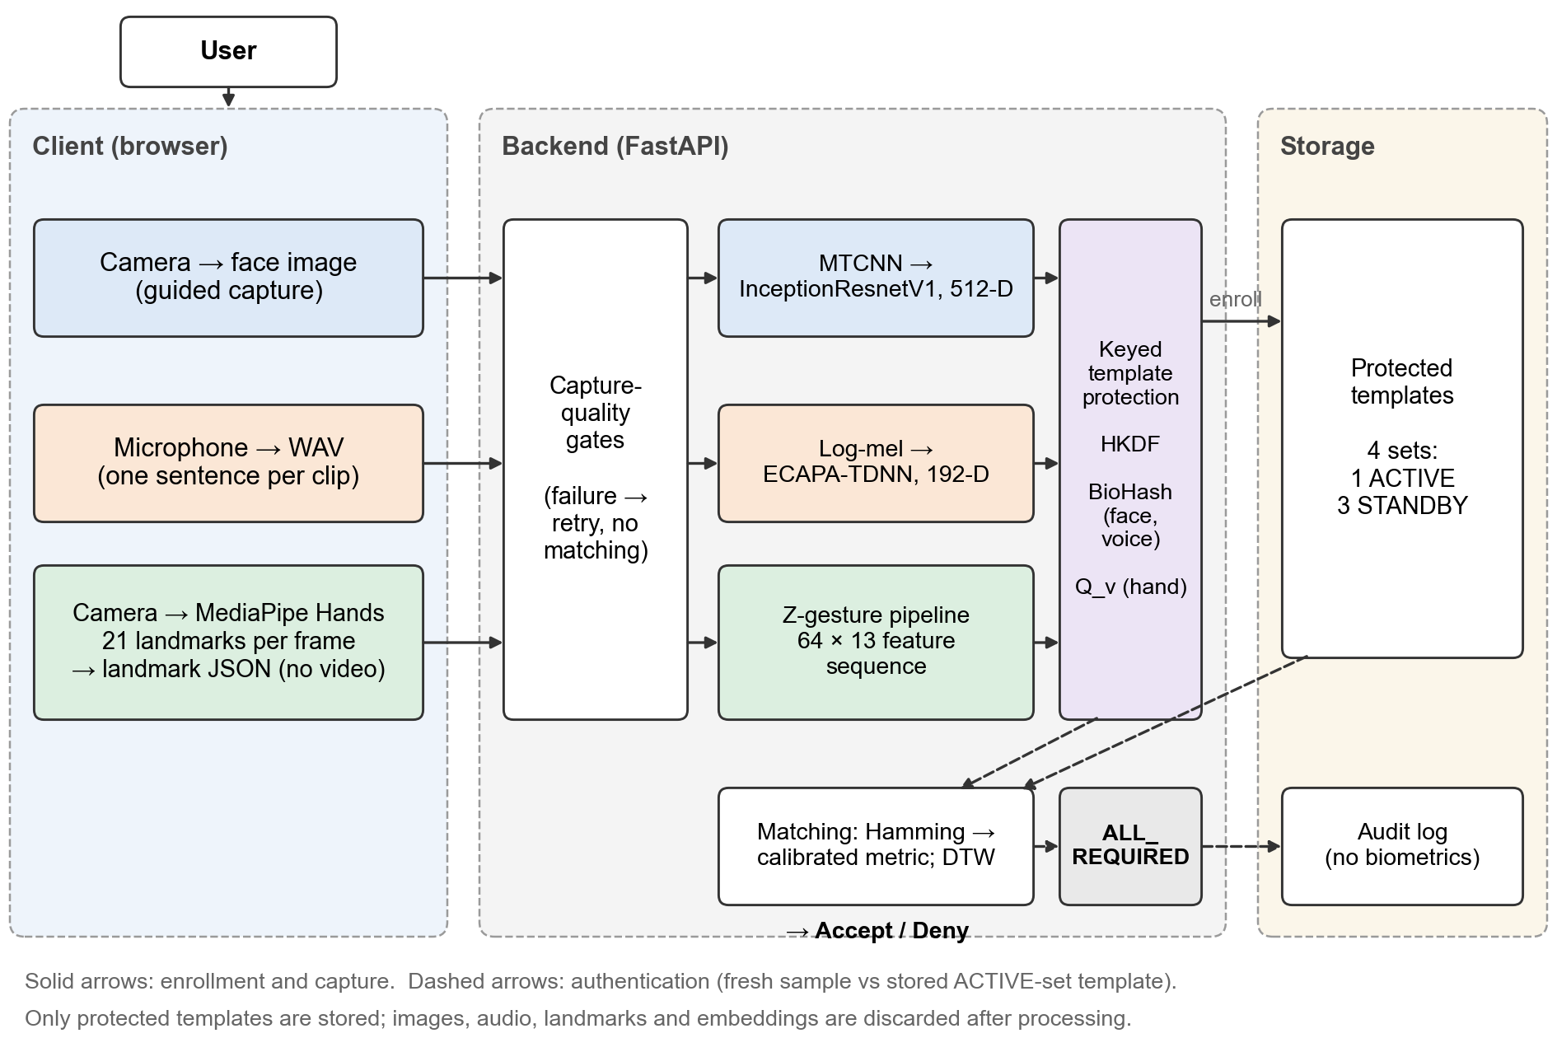
Figure 1. Overall system architecture. The browser captures face images and voice recordings and runs MediaPipe Hands locally; the backend gates, embeds, protects, and matches the samples; only protected templates and a biometric-free audit log are stored.
The figure makes three boundaries explicit. First, hand tracking happens on the client, so only landmark coordinates cross the network. Second, capture-quality gates sit in front of every model, so a bad capture is reported before any comparison takes place. Third, storage receives only the output of the keyed transformation; authentication compares a freshly transformed sample with the stored template of the active set.

3.3 Enrollment Workflow
Enrollment is performed once per modality and never modifies the templates of other modalities. For the face, the interface guides five poses; each capture passes detection and the quality gates, and at least three valid poses are required. For the voice, the user reads two sentences; each recording passes the voice quality gate, and the cosine similarity between the two embeddings is used as a consistency check. For the hand, the user performs three independent Z gestures; each is checked immediately so that a poor sample can be retaken, and on submission the three samples are compared with each other to detect an outlier. The resulting face and voice centroids, and the three hand sequences, are transformed under four consecutive key versions and stored as four template sets: one ACTIVE set and three STANDBY sets (Fig. 2).
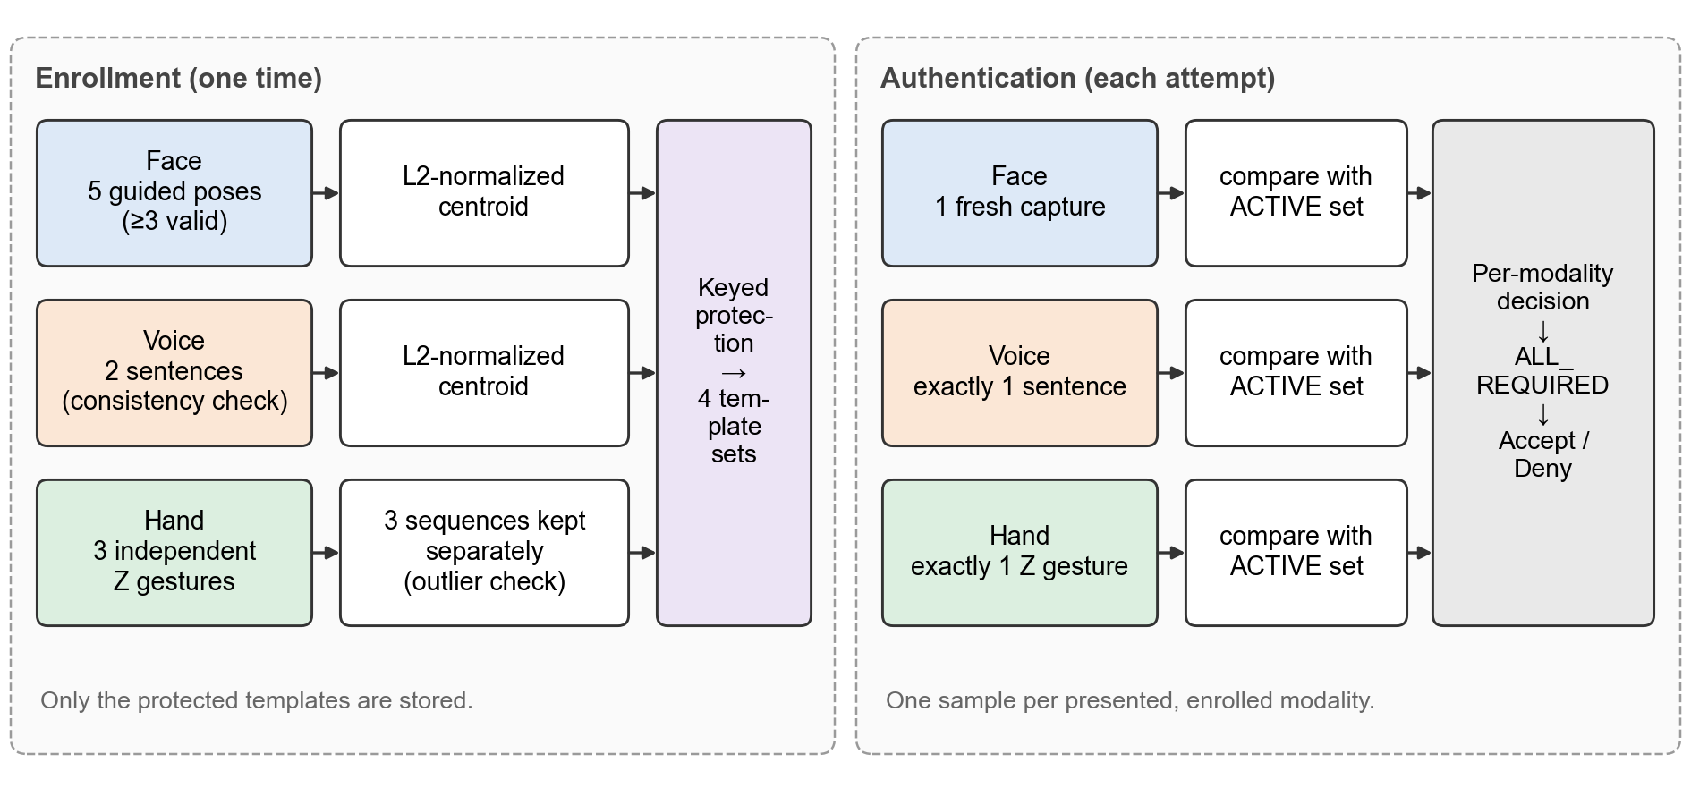
Figure 2. Enrollment versus authentication. Enrollment uses five face poses, two voice sentences, and three Z gestures; authentication uses one sample of each presented modality and compares it with the ACTIVE template set.

3.4 Authentication Workflow
At authentication the user chooses which enrolled factors to present and supplies exactly one sample of each: one face capture, exactly one spoken sentence, and exactly one Z gesture. A factor that is not enrolled is rejected before any processing with an enrollment-required response. Each presented sample is gated, represented, transformed under the key of the user's ACTIVE set, and compared with that set's stored template; templates from different sets are never mixed. The per-modality decisions are then combined by the fusion policy (Section 3.9).

3.5 Face Authentication
The face modality uses an MTCNN detector and an InceptionResnetV1 network pretrained on VGGFace2 and fine-tuned with an ArcFace head on LFW identities, producing a 512-dimensional L2-normalized embedding. The deployed pipeline crops the detected bounding box; a landmark-based similarity alignment was implemented and evaluated but is not deployed (Section 6.1). Enrollment averages the valid pose embeddings into a normalized centroid; authentication embeds a single capture. The decision uses an estimated cosine similarity recovered from the protected templates (Section 3.8), with the rule ĉ ≥ 0.80.

3.6 Voice Authentication
The voice modality uses an ECAPA-TDNN speaker-embedding network trained with an ArcFace loss, producing a 192-dimensional L2-normalized embedding from a 4 s log-mel window. Enrollment records two sentences and uses their normalized centroid as the enrolled representation; authentication uses exactly one sentence. The decision uses an estimated Euclidean distance between unit embeddings recovered from the protected templates, with the rule d̂ ≤ 0.75. A capture-quality gate rejects recordings that are too short, too noisy, or clipped before any embedding is computed.

3.7 Dynamic Z-Hand Gesture Authentication
The hand modality is a dynamic behavioral biometric. The user draws a Z in the air with one hand: left to right, diagonally down to the left, and left to right again. The Z was chosen because it has three distinct strokes and two sharp direction changes, which makes it easy to explain, easy to check for completeness, and rich in timing information at the corners, while its proportions, curvature, and rhythm vary between people. The browser records the 21 MediaPipe landmarks of every frame; the backend validates the capture, reduces it to a normalized 64-point, 13-feature sequence, and compares it by DTW with each of the three enrolled samples. The decision uses the median of the three distances with the development threshold 0.216 (a normalized DTW distance, not a percentage). The full pipeline is described in Sections 4.3–4.9.

3.8 Cancelable Biometric Template Protection
Every stored template is the output of a keyed transformation. Keys are derived per application, user, modality, and key version from a server-side master secret with HKDF-SHA256. Face and voice embeddings are converted into 256-bit BioHash templates; the hand feature sequences are multiplied frame by frame by a keyed orthonormal matrix. A new key version yields an unrelated template from the same biometric, which is what makes a template set revocable and replaceable. The transformation is not encryption and is not claimed to be irreversible: BioHash discards information through quantization, but no formal non-invertibility proof exists, and the hand transform can be inverted by anyone who holds the key (Section 4.10 and Section 8).

3.9 Multimodal Fusion and Decision
Each presented modality first produces its own match decision against its own threshold. For reporting, the modality scores are mapped to a common higher-is-better scale and averaged with equal weights. The authentication decision, however, is taken by a policy; the default and deployed policy, ALL_REQUIRED, accepts only if every presented modality matches, so a strong face score cannot override a failed voice or gesture. A capture failure in any presented modality denies the attempt before fusion and is reported as a retry request rather than a mismatch (Section 4.11).

4. Methodology

4.1 Face Processing Pipeline
MTCNN detects the face and its five landmarks in the uploaded image. A capture is rejected when no face or more than one confident face is found, or when it fails any of the quality gates: detection confidence below 0.90, sharpness (variance of the Laplacian) below 25, face size below 15% of the frame, centre offset above 0.35, roll above 20°, or a yaw ratio above 0.20. The accepted face is cropped to 160 × 160 pixels, normalized as (x − 127.5)/128, and embedded by InceptionResnetV1. The network was fine-tuned with an ArcFace head (scale 30, margin 0.5) on 62 LFW identities with at least 20 images (3,023 images), training only the final Inception block and the embedding layers. The five-pose enrollment forms the centroid
e = (Σ_{k} e_{k}) / ‖Σ_{k} e_{k}‖₂ (1)
where e_{k} are the unit embeddings of the valid poses and ‖·‖₂ is the Euclidean norm; the per-pose embeddings are discarded after the centroid is formed. The comparison metric for face is the cosine similarity between unit vectors, cos(e, e′) = e^{T}e′, which is estimated from the protected templates as described in Section 4.10. Fig. 3 summarises the pipeline.
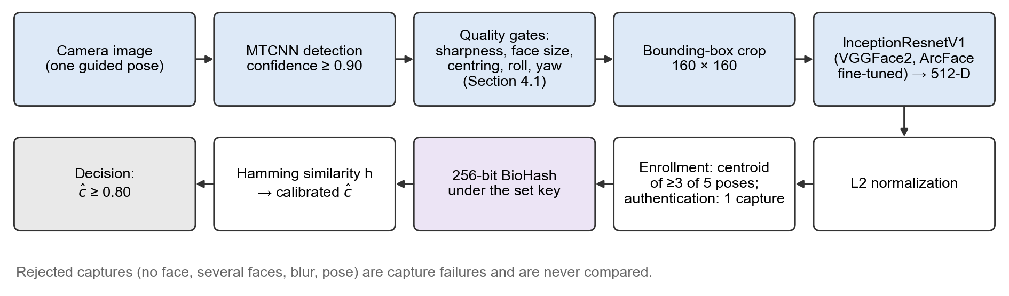
Figure 3. Face authentication pipeline. Captures that fail detection or a quality gate are capture failures and are never compared.

4.2 Voice Processing Pipeline
Each recording is resampled to 16 kHz mono, trimmed of leading and trailing silence by an energy-based voice activity detector (400-sample frames, 160-sample hop), normalized to a fixed RMS level, and converted to 80-bin log-mel features (25 ms window, 10 ms hop). At inference a deterministic 4 s centre window is used. The ECAPA-TDNN was trained on a 24-speaker VoxCeleb1 subset (4,857 utterances) with an ArcFace loss (scale 30, margin 0.5). Before embedding, the capture-quality gate rejects recordings with less than 1.5 s of detected speech, an estimated signal-to-noise ratio below 13 dB, or more than 1% of samples at full scale; such a recording is a capture failure and the user is asked to repeat the sentence. At enrollment the cosine similarity of the two sentence embeddings places the enrollment in a consistency band—at least 0.75 is enrolled, 0.60–0.75 is enrolled only after the user confirms, and below 0.60 is rejected—and the template is formed from the centroid (1) of the two embeddings. For unit embeddings the Euclidean distance used by the voice rule is related to the cosine similarity by
d(e, e′) = ‖e − e′‖₂ = √(2 − 2 cos(e, e′)) (2)
where both vectors have unit length. Fig. 4 summarises the voice pipeline.
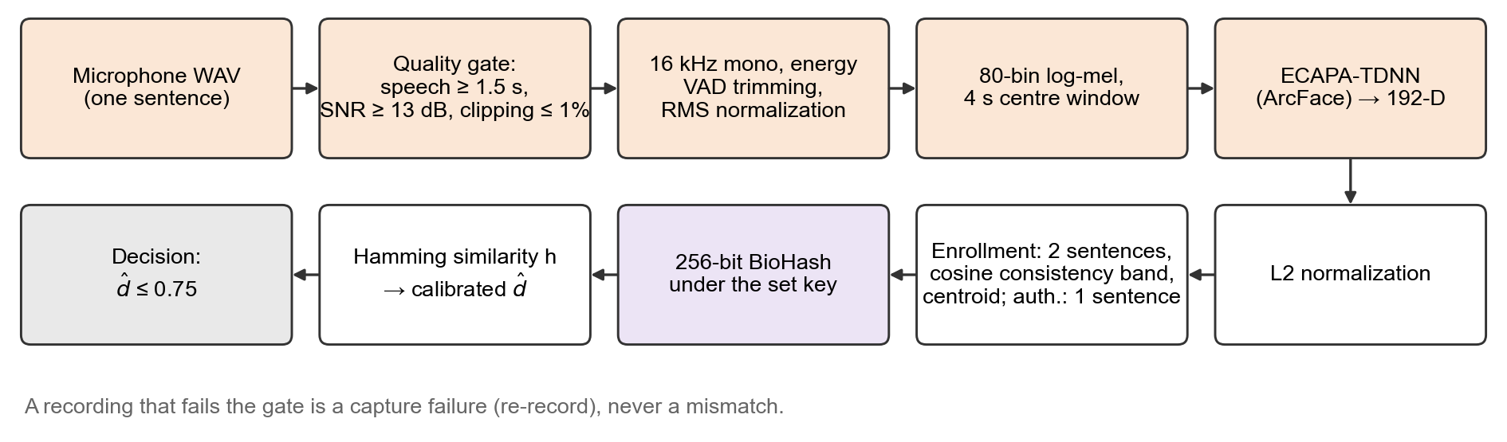
Figure 4. Voice authentication pipeline with two-sentence enrollment and one-sentence verification.

4.3 Hand Landmark Acquisition
MediaPipe HandLandmarker runs in the browser in video mode for one hand. For every processed video frame the client records a timestamp and either the 21 landmarks (x, y, z)—x and y normalized to the image width and height, z a relative depth—or a null entry when no hand is detected. The upload also states that the user watched a mirrored (selfie) preview. The backend rejects a capture structurally (malformed input, unsupported gesture type) or by capture quality: fewer than 15 frames with a hand, a hand present in less than 60% of the span between the first and last detection, a tracking rate below 10 frames per second, or less than 0.5 s or more than 10 s of movement. Coordinates are made isotropic by scaling x with the aspect ratio and are mirrored back so that the user's own left-to-right is the positive x direction. The stable reference point is the palm centre, the mean of the wrist and the four finger-MCP (knuckle) landmarks, which is far less affected by finger posture than any fingertip.
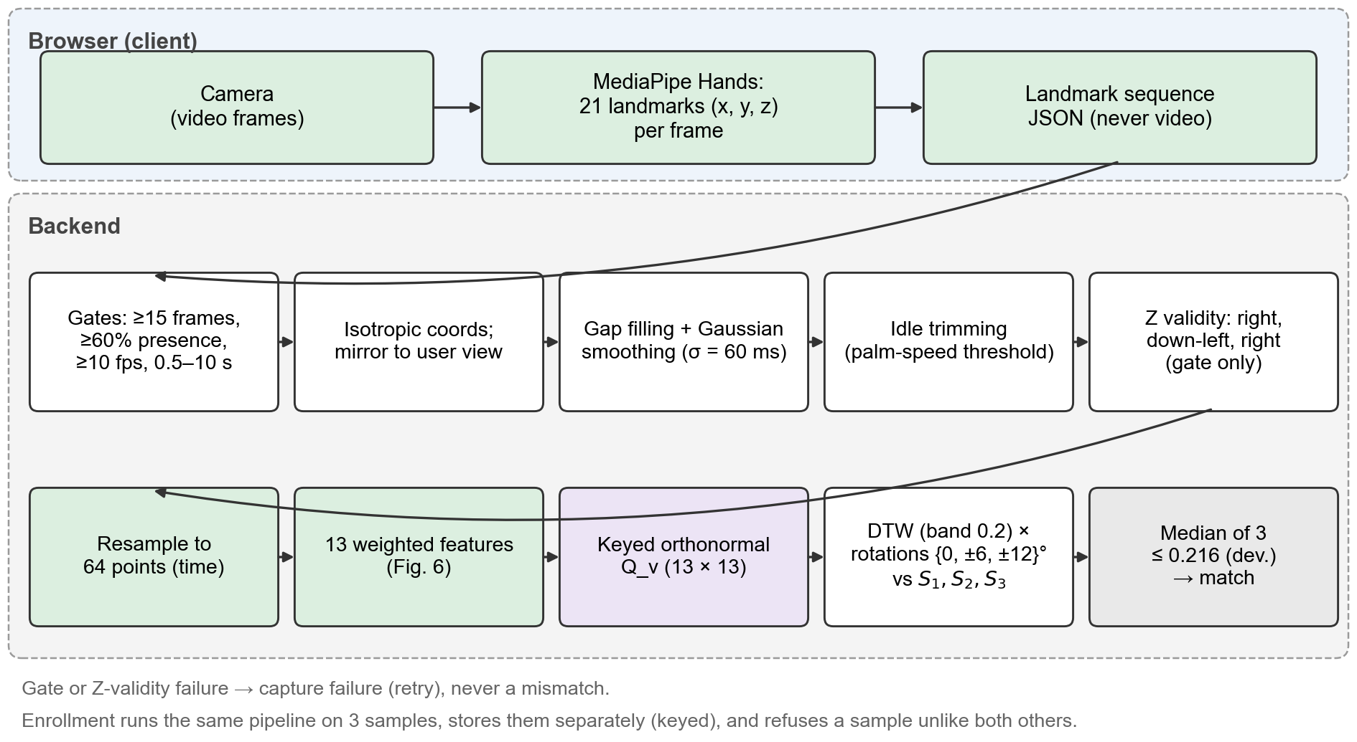
Figure 5. Dynamic Z-gesture pipeline. Landmark extraction runs in the browser; the backend validates, normalizes, represents, protects, and matches the sequence. A gate or Z-validity failure is a capture failure, never a mismatch.

4.4 Z-Gesture Validation
Before a capture is compared, a lenient structural check decides whether it is a complete Z. The palm-centre trajectory is resampled to 48 points equally spaced along its path. An exhaustive search over the two corner positions accepts the capture if it can be split into three strokes whose chords point to the right (within ±55°), down and to the left (90°–180° with the image y axis pointing down), and to the right again, each stroke contributing at least 10% of the total chord length, and the three chords together explaining at least 55% of the path length. The check rejects incomplete, reversed, and mirrored Zs, an N, a circle, and a straight swipe. It is a validity gate only: it decides whether a capture is comparable, and it never contributes to the identity decision.

4.5 Hand Trajectory Normalization
Frames in which the hand was briefly lost are filled by linear interpolation in time. Landmark jitter is removed by a Gaussian kernel defined in time rather than in frames, with standard deviation σ = 60 ms, evaluated on the real frame timestamps; the blur is therefore identical at 12 or 30 frames per second. The idle hand before and after the gesture is trimmed: the gesture spans from the first to the last frame in which the palm speed exceeds max(0.5 palm sizes/s, 0.15 · v₉₀), where v₉₀ is the 90th percentile of the palm speed in the capture, with a 50 ms margin; pauses inside the Z therefore remain part of the gesture. A capture whose palm moves less than one palm size is rejected. With p_{t} the palm centre, the trajectory is centred on its centroid and scaled by its RMS radius:
x_{t} = (p_{t} − p̄) / √((1/T) Σ_{t} ‖p_{t} − p̄‖²) (3)
where p̄ is the mean palm position and T the number of points. Equation (3) removes the position of the Z in the frame and its size, so a small Z and a large Z drawn anywhere in view become comparable.

4.6 Temporal Processing
The trimmed sequence is resampled uniformly in time to T = 64 points. At the 10–30 frames per second that the browser typically tracks, a 1.5–3.5 s Z contains roughly 15–105 frames, so 64 points neither discards detail from a fast capture nor invents much for a slow one. Uniform time resampling removes the overall duration and the frame rate; non-uniform speed differences within the gesture are absorbed by DTW (Section 4.8). Section 6.6 reports an alternative that resamples by arc length instead of time.

4.7 Hand Feature Representation
Each of the 64 points carries 13 features in six groups (Fig. 6): the normalized trajectory x_{t} (2 values, weight 1.0); the unit direction of palm motion (2 values, weight 0.6), which fades to zero while the hand is nearly still so that a pause is not random noise; the relative speed, i.e., the palm speed divided by the sample's own mean speed (1 value, weight 0.3); the change of that relative speed, scaled by 5 and clipped to ±3 (1 value, weight 0.15); the hand orientation, the unit vector from the wrist to the middle-finger MCP (2 values, weight 0.3); and the distance of each fingertip from the wrist in palm sizes (5 values, weight 0.1 each). Because speeds are divided by the sample's own mean, absolute tempo is not a feature; the relative speed profile and the orientation carry behavioral information beyond the shape. The weights are development values stored with every template.
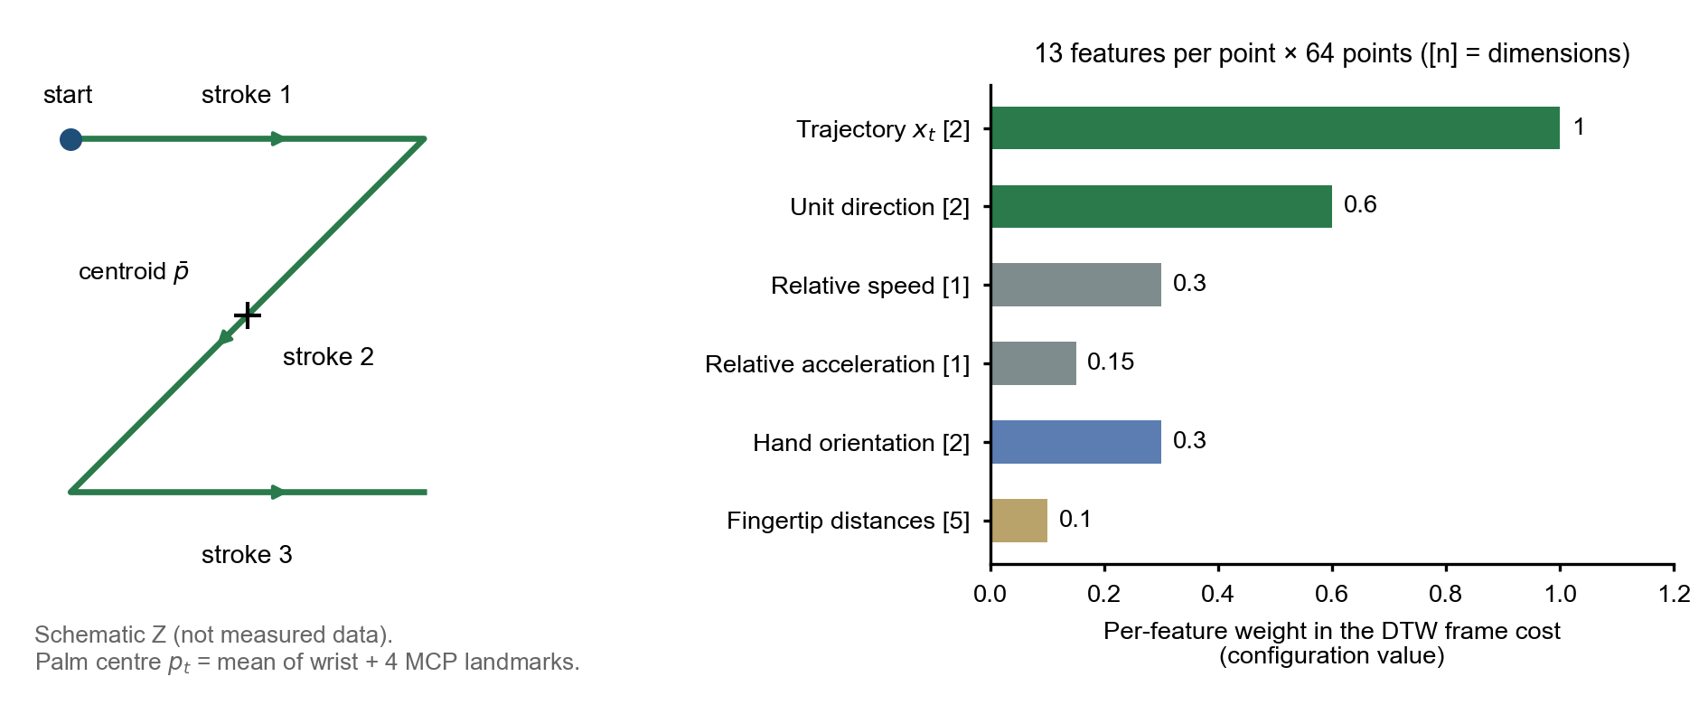
Figure 6. Hand feature representation. Left: schematic Z with its three strokes and the palm-centre reference (not measured data). Right: the six feature groups, their dimensions, and their configured weights in the DTW frame cost.

4.8 Dynamic Time Warping
Let A = (a₁, …, a_{T}) and B = (b₁, …, b_{T}) be two weighted feature sequences and c(i, j) = ‖a_{i} − b_{j}‖₂ the frame cost. DTW accumulates
D(i, j) = c(i, j) + min{D(i−1, j−1), D(i−1, j), D(i, j−1)} (4)
with D(0, 0) = 0, restricted to a Sakoe–Chiba band of width 0.2 · T around the diagonal. The distance is normalized by the number of steps L of the optimal warping path,
d_{DTW}(A, B) = D(T, T) / L (5)
so that it is the mean per-step frame distance along the best alignment and does not grow with the number of frames. Identical sequences have distance 0. Because the frame cost is Euclidean, the distance is unchanged by any orthonormal transformation applied to every frame of both sequences, which is what allows the keyed hand templates of Section 4.10.

4.9 Rotation Handling and Aggregation
Small differences in camera or hand orientation are handled by comparing the live sample also after rotating its two-dimensional features (trajectory, direction, and orientation) by r ∈ R = {0°, ±6°, ±12°}; speeds and distances are rotation invariant. The tolerance is deliberately small: a rotation of 35° is not aligned back, because a fully rotation-invariant matcher would discard how the user orients the Z. With the three enrolled samples S₁, S₂, S₃, the hand distance and decision are
d = median_{k} [ min_{r∈R} d_{DTW}(Rot_{r}(A), S_{k}) ], accept ⇔ d ≤ τ_{h} = 0.216 (6)
where A is the live sequence and τ_{h} the development threshold. The median requires the live gesture to agree with two of the three samples, tolerating one poor sample without being decided by a single lucky alignment. The three samples are stored separately rather than averaged, because they are not time-aligned and an average would blur the corners. At enrollment, pairwise distances between the samples identify a medoid, and a sample whose distance to the nearer of the other two exceeds both τ_{h} and twice the distance between those two is refused as a capture-quality problem, so one abnormal sample cannot enter the template.

4.10 Template Protection
For modality m, user u, application a, and key version v, a salt is computed as SHA-256(a ‖ u ‖ m ‖ v), and HKDF-SHA256 derives three independent 32-byte seeds from the master secret for the projection, the thresholds, and the permutation. For face and voice, a unit embedding e ∈ ℝ^{D} is projected by a keyed matrix W_{v} whose rows are orthonormal (obtained by QR decomposition of a seeded Gaussian matrix; for the 192-D voice embedding two blocks are stacked), quantized against keyed thresholds t_{v}, and permuted:
b = π_{v}( 1[W_{v}e > t_{v}] ) ∈ {0, 1}²⁵⁶ (7)
where 1[·] is the element-wise indicator and π_{v} a keyed permutation. Two templates are compared by the fraction h of equal bits. For a random hyperplane the probability that two vectors fall on different sides is θ/π, where θ is the angle between them [23]; h is therefore a monotone function of θ. The implementation fits
h = (p₁θ + p₂θ² + p₃θ³) / π (8)
on synthetic pairs, where p₁, p₂, p₃ are fitted coefficients, and inverts it to obtain the estimated angle, the estimated cosine ĉ = cos θ̂, and the estimated distance d̂ = √(2 − 2ĉ). The thresholds 0.80 and 0.75 are applied to these estimates; the comparison itself remains a Hamming comparison of protected templates. For the hand, each weighted 13-D frame is multiplied by a keyed orthonormal 13 × 13 matrix Q_{v}; since ‖Q_{v}a − Q_{v}b‖ = ‖a − b‖, every DTW distance is preserved exactly. Rotation variants of a live sample are formed before the key is applied, and each sequence is transformed exactly once with the same key, dimensionality, and feature order as the stored samples. Enrollment produces four template sets under consecutive key versions (one ACTIVE, three STANDBY). Revocation marks the ACTIVE set as REVOKED and promotes a STANDBY set for all modalities at once; when no STANDBY set remains, re-enrollment is required (Fig. 7).
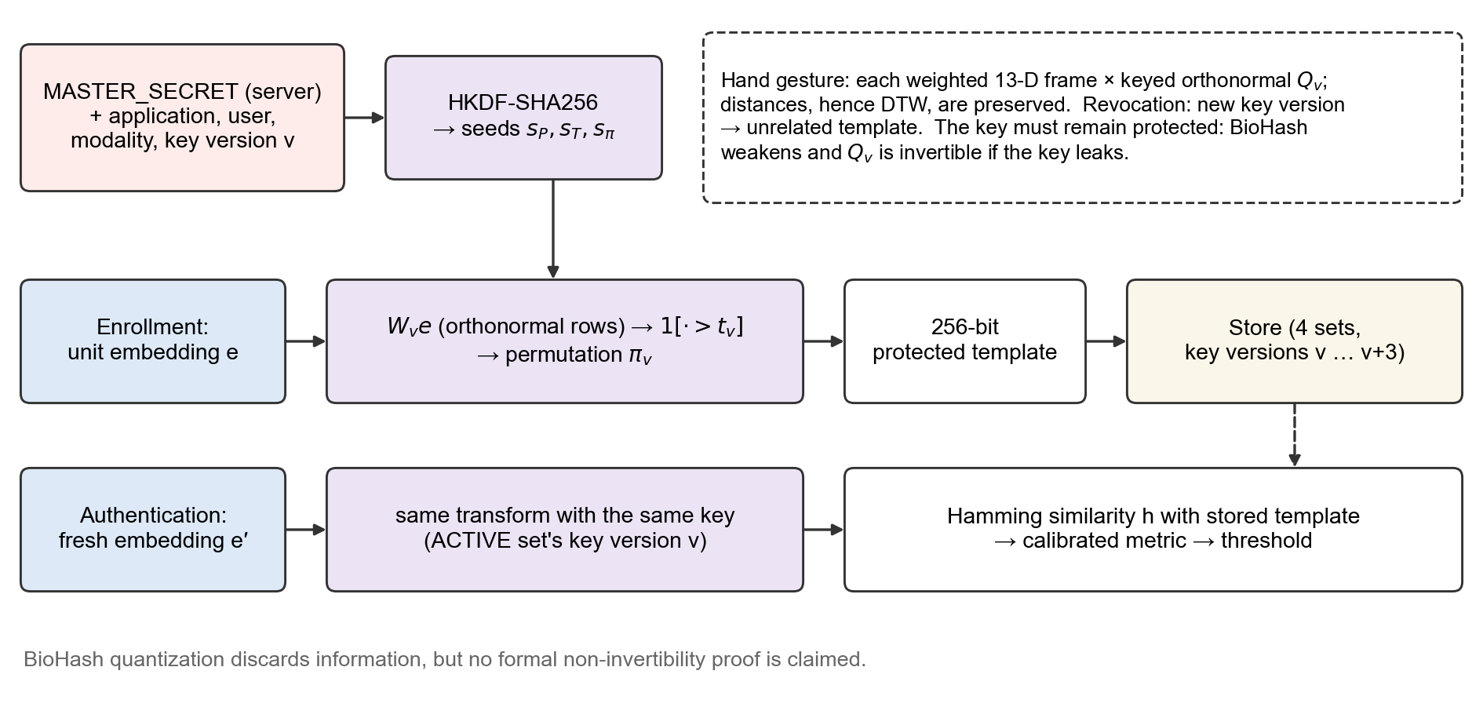
Figure 7. Cancelable template protection. The same key-derived transform is applied at enrollment and authentication; comparison happens between protected templates. The key must remain protected.

4.11 Multimodal Decision Process
For reporting and for the WEIGHTED policy, each modality score is mapped to a common higher-is-better scale: the face score is ĉ; the voice score is 1 − d̂²/2, which equals the estimated cosine for unit vectors; and the hand score is
s_{h} = clip(1 − d / (2τ_{h}), −1, 1) (9)
so that the hand threshold maps to 0.5. The fusion score is the equal-weight mean of the scores of the presented modalities M,
s_{fus} = (1/|M|) Σ_{m∈M} s_{m} (10)
and the fusion threshold is the mean of the per-modality thresholds on the same scale. No other weights are used by the implementation. The decision, however, is taken by the policy. Under ALL_REQUIRED, the default and deployed policy,
accept ⇔ ∀ m ∈ M: match_{m} = true (11)
where match_{m} is the decision of modality m against its own threshold. AT_LEAST_TWO (at least two presented modalities, at least two matching) and WEIGHTED (the fusion score against the fusion threshold, with a per-modality floor that vetoes acceptance) are implemented for comparison. The system fails closed: a capture error or failed quality gate in any presented modality denies the attempt before fusion and is reported as a retry request, not as a mismatch. A failure policy distinguishes isolated failures from suspicious ones: up to two retries are offered for a failed modality, repeated high-quality mismatches within 900 s are treated as a suspicious attempt, and five consecutive capture failures trigger a 60 s cooldown. Automatic rotation of the template set after a suspicious attempt is available but disabled by default. Fig. 8 summarises the decision process.
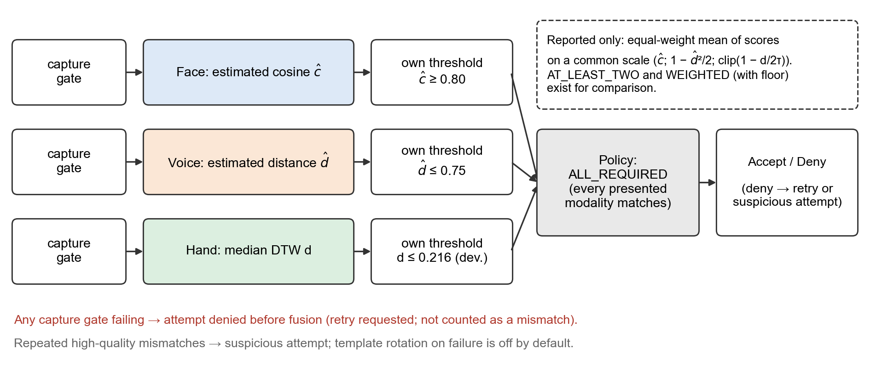
Figure 8. Multimodal fusion and decision. Each modality decides against its own threshold; the ALL_REQUIRED policy accepts only if every presented modality matches. The equal-weight fusion score is reported but does not override the policy.

5. Experimental Setup

5.1 Hardware and Software Environment
Latency measurements were made on an Intel Core i5-1235U laptop CPU with 8.3 GB of RAM under Windows 11, Python 3.13.1, and a CPU-only PyTorch build, without a GPU. The backend uses FastAPI and SQLAlchemy; the frontend uses React, TypeScript, and Vite, with MediaPipe tasks-vision 1.0.1 in the browser. Evaluation scripts in the repository run the shipped code paths (capture gates, representations, keyed transformations, matching, and policies). As software validation, the hand-gesture and failure-handling test suites (178 tests) and the frontend protocol tests passed on 28 September 2026; these are software tests, not authentication trials.

5.2 Datasets and Data Collection
Table 4 lists the data used for each experiment and its evidence type. For the face, the evaluation uses LFW [24] identities with 2–19 images that are disjoint from the 62 fine-tuning identities. For the voice, the evaluation uses the 24-speaker VoxCeleb1 subset on which the model was trained; the evaluation is therefore closed-set. For fusion, chimeric virtual users pair LFW faces with VoxCeleb voices, which assumes that the two modalities are statistically independent. No real multi-person hand-gesture dataset exists yet: the hand is evaluated with a synthetic generator, and live captures were made only during development by one developer. A consented data-collection mode for a real pilot (genuine enrollment, genuine authentication in two sessions, and impostor samples) is implemented in the application's testing interface.
Table 4. Datasets and evaluation data
Data | Modality | Size | Comparisons (genuine / impostor) | Evidence
LFW, fine-tuning identities | Face | 62 identities, 3,023 images | — (training) | REAL
LFW, held-out identities | Face | 1,618 identities, 6,141 images | 4,523 / 80,900 | REAL
VoxCeleb1 subset (closed set) | Voice | 24 speakers, 4,857 utterances (3,389 / 717 / 751 split) | 727 / 17,273 (single utterance); 690 / 15,870 (protocol study) | REAL
Chimeric users (LFW × VoxCeleb) | Face + voice | 20 pairings × 24 users | 72 / 1,656 per pairing | REAL (independence assumed)
Synthetic Z users, design set | Hand | 40 users (development) | — | SYNTHETIC
Synthetic Z users, independent set | Hand | 40 users (disjoint seeds) | 240 / 9,360 | SYNTHETIC
Synthetic Z users, tempo stress | Hand | 30 users, 15 held out | 150 / 2,100 (held out) | SYNTHETIC
Live development captures | Hand | 1 developer, 2 enrollments, 10 attempts | 10 genuine attempts | DEVELOPMENT OBSERVATION

The gesture generator models, for each synthetic person, a characteristic way of drawing the Z (proportions, slant, stroke curvature, per-stroke speed profile and timing, pauses at the corners, hand orientation, and finger geometry) and, for each execution, natural variation (duration of 1.5–3.1 s, Z size, position in the frame, distance to the camera, a few degrees of rotation, and landmark jitter). The tempo-stress set additionally varies each execution's pace between 1.4 and 3.8 s with a non-uniformly changed speed profile, stroke timing, and pauses, tracks at 12–30 frames per second, and adds a second session with rotation and size changes. Synthetic users differ from each other partly by construction, so synthetic separation is optimistic and is never reported as real-world performance.

5.3 Enrollment Protocol
In the face evaluation, the first image of each identity is the enrollment reference; this single-reference protocol differs from the deployed five-pose centroid. In the voice protocol study, one or two utterances form the enrollment centroid, matching the deployed two-sentence enrollment when two are used. In the hand evaluation, each synthetic user enrolls three Z samples through the same service code used by the application, including the capture gates and the outlier check.

5.4 Authentication Protocol
Face probes are single images; voice probes are single utterances in the deployed configuration (the protocol study also reports two-utterance probes for comparison); hand probes are single Z gestures. Every probe is transformed under the target user's key, and comparisons are made in the protected domain, exactly as in the application.

5.5 Genuine and Impostor Evaluation
A genuine comparison pairs a probe with its own identity's enrollment; an impostor comparison pairs it with another identity's enrollment (zero-effort impostors). For the face, 50 random impostor probes are drawn per identity; for the voice, all impostors are used; for the synthetic hand users, every probe is compared with every other user's enrollment. Imitation attacks, in which an impostor watches and copies a user's gesture, were not evaluated.

5.6 Metrics
The false acceptance rate and false rejection rate at a threshold are
FAR = (accepted impostor attempts) / (impostor attempts), FRR = (rejected genuine attempts) / (genuine attempts) (12)
The equal error rate (EER) is the operating point at which FAR equals FRR, and ROC-AUC is the area under the receiver operating characteristic curve. Distance distributions are summarised by their mean, median, and percentiles. Table 5 lists the metrics and where each is used.
Table 5. Evaluation metrics
Metric | Definition | Used for
FAR | Accepted impostor attempts / impostor attempts | Face, voice, fusion, hand (synthetic)
FRR | Rejected genuine attempts / genuine attempts | Face, voice, fusion, hand (synthetic)
EER | Error rate at which FAR = FRR | Face, voice, score-level fusion, hand (synthetic)
ROC-AUC | Area under the ROC curve | Face, voice, score-level fusion, hand (synthetic)
Distance statistics | Mean, median, 5th / 95th percentiles of genuine and impostor distances | Hand (synthetic)
Hamming similarity | Fraction of equal bits between two 256-bit templates | Revocation, unlinkability
D↔^{sys} | System-level linkability measure of Gomez-Barrero et al. [22] | Unlinkability
Latency | Mean, median, 95th percentile of wall-clock time | Pipeline stages, API requests

5.7 Threshold Calibration
The face and voice thresholds (estimated cosine 0.80 and estimated Euclidean distance 0.75) are fixed project baselines that were requested for the project; they were not selected from genuine and impostor data, and they are reported at their operating points. Development-split operating points were computed for comparison but not adopted. The hand threshold was selected on synthetic data following the procedure in Fig. 9: the equal-error threshold of the median rule was determined on the development half of 40 synthetic users (0.216) and then evaluated once on 40 further synthetic users with disjoint seeds. The same development/held-out procedure is implemented for real data and will be applied to the real pilot.
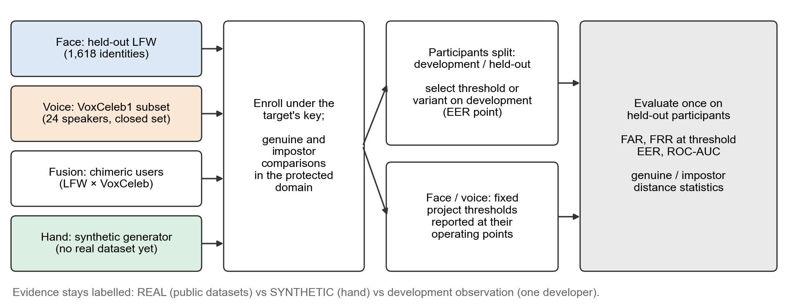
Figure 9. Experimental evaluation pipeline. Thresholds or representation variants are selected on development participants and evaluated once on held-out participants; evidence types are kept separate.

6. Results

6.1 Face Results
Table 6 reports the face results on held-out LFW identities. The keyed BioHash transformation raises the EER from 7.12% on raw embeddings to 8.50% on protected templates (ROC-AUC 0.9682 to 0.9641). The configured threshold is conservative: at ĉ ≥ 0.80 the protected face FAR is 0.0025% but the FRR is 81.5%. Sweeping the threshold from 0.60 to 0.90 moves the FRR from 34.2% to 97.6% while the FAR falls from 0.28% to 0. A development-selected operating point for a FAR of at most 1% (ĉ ≥ 0.533) gave a FAR of 0.83% and an FRR of 22.9% on held-out identities but was not adopted. A landmark-based similarity alignment, evaluated on the same pairs but not deployed, lowered the protected EER from 8.67% to 7.18% (paired bootstrap 95% confidence interval of the difference −1.90 to −0.69 percentage points) and the EER under 30° rotation from 13.0% to 6.75%.
Table 6. Face results on held-out LFW identities (REAL; single-reference protocol)
Configuration | Comparisons | EER | ROC-AUC | FAR / FRR at ĉ ≥ 0.80
Protected templates (deployed pipeline) | 4,523 / 80,900 | 8.50% (95% CI 7.77–8.93) | 0.9641 | 0.0025% / 81.5%
Raw embeddings (reference only) | same | 7.12% | 0.9682 | —
Development-selected ĉ ≥ 0.533 (not adopted), held-out test | identity-disjoint split | — | — | 0.83% / 22.9% (at 0.533)
Alignment study: bounding box (controlled retrain) | same | 8.67% | — | FRR 81.2%
Alignment study: similarity-aligned (not deployed) | same | 7.18% | — | FRR 76.8%
Sources: evaluation/results/protected_vs_raw.csv, raw_vs_protected_metrics.csv, threshold_operating_points.csv, face_alignment_metrics.csv, face_threshold_comparison.csv.

6.2 Voice Results
Table 7 reports the voice results on the closed-set VoxCeleb1 subset. Protection changes the single-utterance EER only slightly (2.21% raw, 2.32% protected). The enrollment and verification protocol, however, has a large effect at the configured threshold d̂ ≤ 0.75: with one enrollment and one probe utterance the FRR is 24.1%, whereas the deployed protocol with a two-sentence enrollment centroid and a one-sentence probe gives an FRR of 12.2%, a FAR of 0.03%, and an EER of 1.27% on the same clips. Two-sentence verification, the earlier protocol, reached an FRR of 2.6% but was replaced by one-sentence verification for usability; its numbers are shown for comparison only. The threshold sweep from 0.50 to 1.00 moves the FRR from 78.4% to 3.0% while the FAR rises from 0 to 2.02%.
Table 7. Voice results on the VoxCeleb1 subset (REAL; closed set)
Protocol (enrollment / probe utterances) | Comparisons | EER | ROC-AUC | FAR / FRR at d̂ ≤ 0.75
Protected, 1 / 1 (published protocol) | 727 / 17,273 | 2.32% (95% CI 1.95–3.03) | 0.9967 | 0.26% / 23.8%
Raw embeddings, 1 / 1 (reference only) | same | 2.21% | 0.9980 | —
Protocol study, 1 / 1 | 690 / 15,870 | 2.31% | — | 0.26% / 24.1%
Protocol study, 1 / 2 | 345 / 7,935 | 1.69% | — | 0.30% / 12.8%
Protocol study, 2 / 1 (deployed) | 690 / 15,870 | 1.27% | — | 0.03% / 12.2%
Protocol study, 2 / 2 (earlier protocol) | 345 / 7,935 | 0.52% | — | 0.013% / 2.6%
Sources: protected_vs_raw.csv, raw_vs_protected_metrics.csv, voice_capture_pipeline.csv (aggregation rows).

6.3 Hand Gesture Results
All hand results in this subsection are SYNTHETIC unless stated otherwise. On the independent set of 40 synthetic users (Table 8), genuine median distances average 0.129 (median 0.127, 95th percentile 0.165, maximum 0.215) and impostor distances average 0.370 (median 0.363, 5th percentile 0.243, minimum 0.150). At the development threshold 0.216 the FAR is 1.35% (126 of 9,360 impostor comparisons) and the FRR is 0% (0 of 240); the pooled EER is 0.42% and the ROC-AUC 0.9999 (Fig. 11). On the design set, the genuine distances remained similar across probe conditions: normal 0.122, slow 3.1 s 0.129, fast 1.5 s 0.134, 2 s of idle padding 0.133, 12 frames per second 0.136, and moved, 20% smaller, 10° rotated with 10% dropped frames 0.128. The enrollment outlier rule flagged none of 40 genuine enrollments and flagged a foreign sample placed among two genuine ones in 37 of 40 cases.
Table 8. Z-gesture results on the independent synthetic set (SYNTHETIC; 40 users)
Quantity | Genuine | Impostor
Comparisons | 240 | 9,360
Mean median-DTW distance | 0.129 | 0.370
Median | 0.127 | 0.363
95th percentile (genuine) / 5th percentile (impostor) | 0.165 | 0.243
Maximum (genuine) / minimum (impostor) | 0.215 | 0.150
Rate at threshold 0.216 | FRR 0% | FAR 1.35%
Pooled EER / ROC-AUC | 0.42% / 0.9999
Source: evaluation/results/hand_gesture_synthetic_metrics.csv and hand_gesture_synthetic_scores.csv. Synthetic separation is optimistic and is not real-world performance.
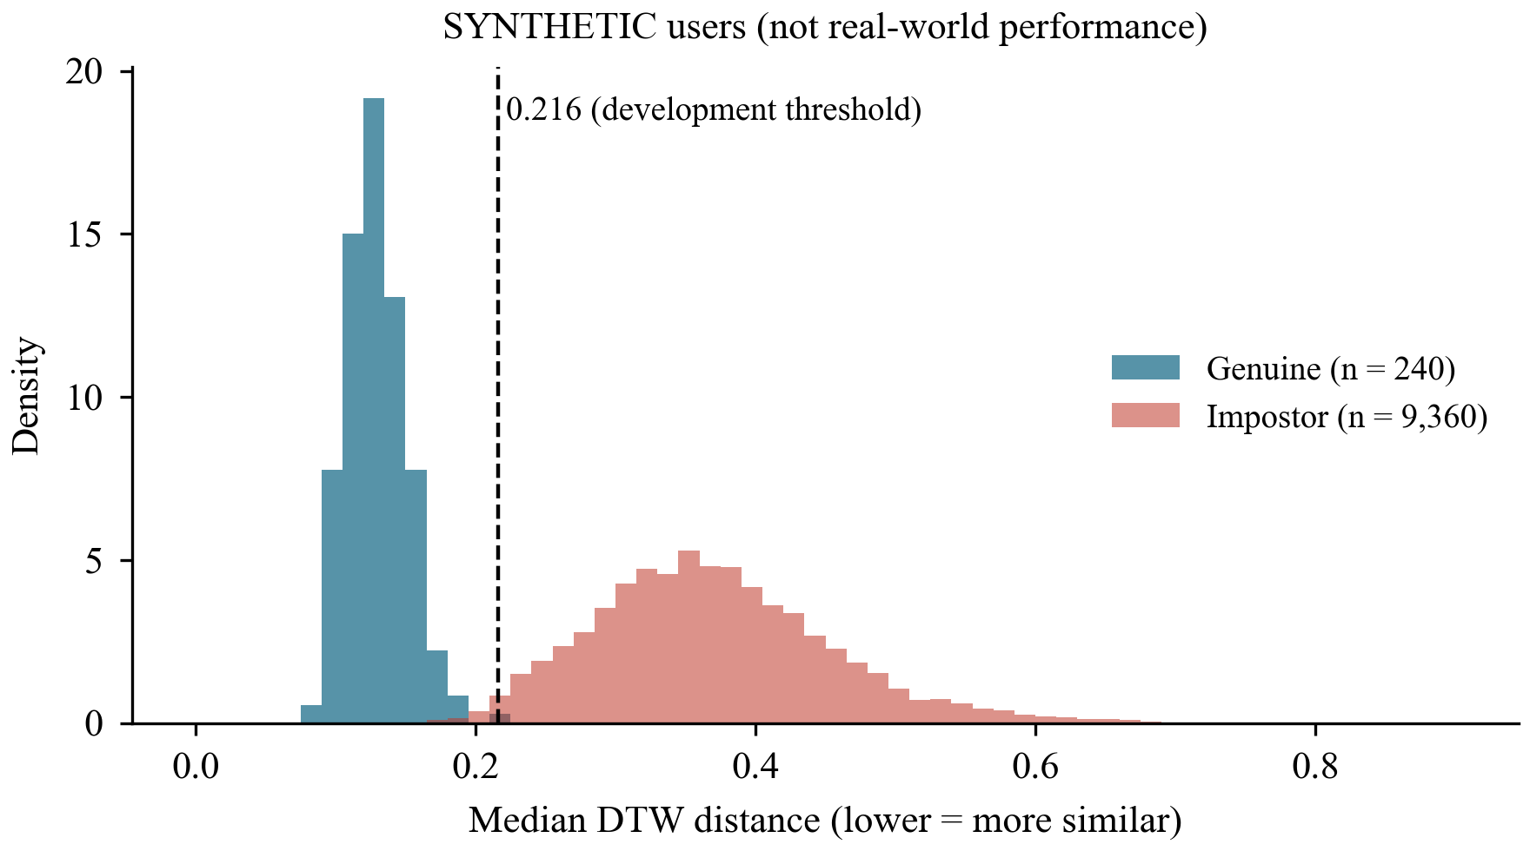
Figure 11. Genuine and impostor median-DTW distances for the independent synthetic gesture users, with the development threshold 0.216. SYNTHETIC data; not real-world performance.
Live development captures by one developer (DEVELOPMENT OBSERVATION, not accuracy) showed larger genuine variation than the synthetic model. With the first enrollment, the pairwise distances between the three enrollment samples were 0.251, 0.250, and 0.154—one sample had been drawn noticeably slower (3.58 s of movement against 2.79 s and 2.76 s)—and one of six authentication attempts matched (median distances 0.181–0.325). After re-enrollment, all four subsequent attempts matched with median distances between 0.165 and 0.195. Diagnostics of the failed attempts showed that the dominant cost components were the trajectory and the timing features when the gesture was drawn markedly faster or slower than at enrollment, and, in one attempt, the fingertip features (20%, 29%, and 37% of the squared cost against the three samples), consistent with the hand being held in a different finger pose. These observations motivated the tempo and finger-pose experiments in Section 6.6; they are not an estimate of error rates.

6.4 Multimodal Results
Table 9 reports fusion results on chimeric users; these experiments use the earlier single-utterance voice protocol. Under ALL_REQUIRED no impostor was accepted (FAR 0), but 85.3% of genuine attempts were rejected, because the conservative face threshold alone rejects 80.3% of genuine attempts. WEIGHTED lowered the FRR to 59.6% with FAR 0. An OR rule, evaluated as a baseline but not implemented in the application, lowered the FRR to 19.4% at a FAR of 0.13%. At the score level, averaging the face and voice scores gave an EER of 1.54% (ROC-AUC 0.9988) against 8.16% and 2.75% for the individual scores on the same users (Fig. 10), which indicates that the errors of the two modalities are complementary. Score-level averaging is not the deployed decision rule.
Table 9. Multimodal fusion on chimeric users (REAL; face + single-utterance voice)
Policy | FAR | FRR (mean ± SD over 20 pairings) | Status
Face only | 0% | 80.3% ± 5.8% | —
Voice only | 0.13% | 24.4% ± 2.0% | —
ALL_REQUIRED (face + voice) | 0% | 85.3% ± 5.2% | Deployed default
WEIGHTED (face + voice) | 0% | 59.6% ± 6.0% | Implemented
OR (face + voice) | 0.13% | 19.4% ± 2.9% | Evaluation baseline only
Score-level mean (EER / ROC-AUC) | EER 1.54% | ROC-AUC 0.9988 | Not a deployed rule
Sources: fusion_policy_metrics.csv, fusion_score_level_eer.csv. No three-modality fusion evaluation exists because there is no real multi-person gesture data to pair with face and voice.
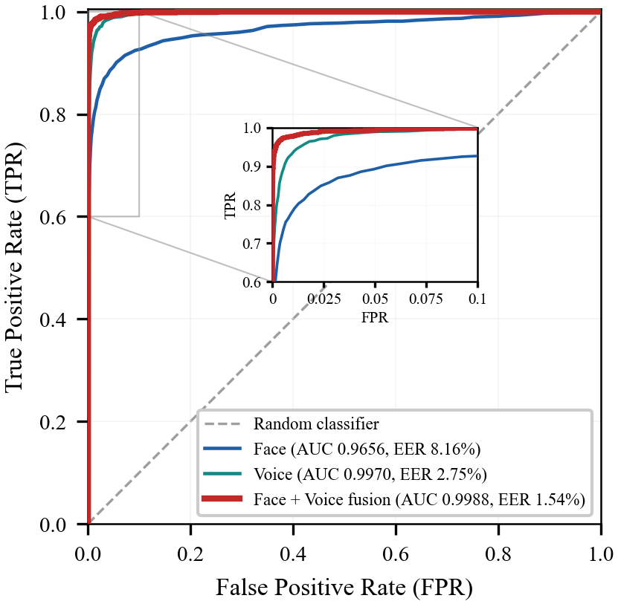
Figure 10. ROC curves of protected face and voice templates and of their score-level mean on chimeric users (REAL data; the fusion curve is not the deployed ALL_REQUIRED policy).

6.5 Failure and Capture Analysis
Table 10 collects the measurements that concern capture quality rather than identity. For voice, noise is the dominant failure: with white noise at 20 dB SNR the FRR at the configured threshold rises to 68.5% (90% at 10 dB), although the EER at 20 dB is only 10%, which shows that noise mainly shifts genuine scores below a fixed threshold. Short speech has a similar effect: probes cut to 4, 3, 2, 1.5, and 1 s give FRRs of 29.5%, 48%, 66.5%, 78.5%, and 90.5%. The SNR gate at 13 dB rejects none of the clean test clips, 3.7% of clips at 10 dB, and 99.3% of clips at 5 dB; it improves capture feedback but does not make accepted noisy recordings verify better. For voice enrollment, 8.1% of genuine pairs of different utterances fall below the 0.60 consistency limit and 29.4% below 0.75, while 0.23% of different-speaker pairs reach 0.60. For the hand, the Z-validity gate accepted all synthetic genuine executions in the automated tests and rejected incomplete, reversed, and mirrored Zs, an N, a circle, and a straight swipe; samples tracked below 10 frames per second are rejected as capture-quality failures.
Table 10. Failure and capture analysis
Condition | Measurement | Result | Evidence
Voice, white noise 20 dB / 10 dB SNR | FRR at d̂ ≤ 0.75 | 68.5% / 90% | REAL
Voice, probe length 4 / 3 / 2 / 1.5 / 1 s | FRR at d̂ ≤ 0.75 | 29.5 / 48 / 66.5 / 78.5 / 90.5% | REAL
Voice SNR gate (13 dB): clean / 10 dB / 5 dB | Recordings rejected | 0% / 3.7% / 99.3% | REAL
Voice enrollment consistency (different utterances) | Genuine pairs below 0.60 / 0.75; impostor pairs ≥ 0.60 | 8.1% / 29.4%; 0.23% | REAL
Hand Z-validity gate | Incomplete, reversed, mirrored Z; N; circle; swipe | All rejected (automated tests) | SOFTWARE TEST
Hand tracking rate below 10 frames/s | Capture outcome | Capture-quality failure, never a mismatch | CONFIGURATION
Sources: robustness.csv, voice_capture_pipeline.csv, docs/VOICE_MODEL.md, tests/test_hand_z_robustness.py.

6.6 Ablation and Comparative Experiments
Template protection. Table 11 reports the protection measurements. The same face embedding under different template-set keys gives a mean Hamming similarity of 0.499 ± 0.032 (n = 900), and a revoked template against its replacement gives 0.500 (face) and 0.504 (voice) with no acceptances, while genuine similarity is essentially unchanged after three revocations. The cross-key linkability measure D↔^{sys} is 0.018 for face, small but above the permutation null floor of 0.013, and 0.020 for voice, which is indistinguishable from the null. The calibration fit of (8) reaches R² = 0.99986 (face) and 0.99990 (voice) on synthetic pairs; on real embedding pairs the estimated cosine has an RMSE of 0.100 (face) and 0.093 (voice) overall and 0.072 and 0.046 on genuine pairs.
Table 11. Template protection, revocation, and calibration measurements
Measurement | Face | Voice | Evidence
Same embedding under different set keys (Hamming similarity) | 0.499 ± 0.032 (n = 900) | — | REAL
Revoked vs. new ACTIVE template (Hamming; acceptances) | 0.500; 0 | 0.504; 0 | REAL
Genuine similarity before → after 3 revocations | 0.761 → 0.766 | 0.811 → 0.804 | REAL
Cross-key linkability D↔^{sys} (null 95th pct.) | 0.018 (0.013) | 0.020 (below null) | REAL
Calibration fit on synthetic pairs, R² / RMSE | 0.99986 / 0.00142 | 0.99990 / 0.00119 | SYNTHETIC
Estimate error on real pairs, RMSE all / genuine | 0.100 / 0.072 | 0.093 / 0.046 | REAL
Template-set lifecycle | 80 / 80 accepted; 3 revocations, then re-enrollment required |  | SYNTHETIC
Sources: revocation_summary.csv, unlinkability.csv, biohash_metric_calibration.json, calibration_real_validation.csv, template_set_*.csv.
Hand representation variants. Motivated by the development observations, a controlled synthetic experiment compared twelve predefined representation variants on the tempo-stress set (Table 12). Every variant uses the same capture gates, rotation search, DTW, and median aggregation; the variants differ only in resampling (by time, as deployed, or by arc length with an additional relative-timing feature) and in feature weights. The threshold of each variant is its equal-error threshold on 15 development users, and FAR and FRR are reported once on 15 held-out users. In a controlled check with an identical spatial path, changing only the rhythm moved the time-resampled trajectory by a mean of 0.45 but the arc-length trajectory by only 0.10, with the rhythm difference appearing in the separate timing feature; a uniform slow-down was absorbed by both resamplings.
Table 12. Hand representation variants on the tempo-stress set (SYNTHETIC; 15 development and 15 held-out users; 150 genuine and 2,100 impostor held-out comparisons)
Variant | Sampling | Feature weights | Genuine mean (p95) | Impostor mean (p5) | Held-out FAR / FRR | EER | ROC-AUC | FAR / FRR at 0.216
A (deployed) | time | traj 1, dir .6, orient .3, speed .3, accel .15, fingers .1 | 0.181 (0.236) | 0.407 (0.265) | 3.5% / 3.3% | 3.3% | 0.9958 | 0.8% / 14.7%
A, no fingers | time | A without fingertip features | 0.181 (0.235) | 0.407 (0.265) | 3.5% / 3.3% | 3.3% | 0.9958 | 0.8% / 14.7%
A, fingers .02 | time | A with fingertip weight .02 | 0.181 (0.235) | 0.407 (0.265) | 3.5% / 3.3% | 3.3% | 0.9958 | 0.8% / 14.7%
B, no speed | time | A without relative speed | 0.156 (0.207) | 0.352 (0.230) | 3.0% / 2.0% | 2.6% | 0.9971 | 2.6% / 2.7%
C | time | trajectory 1, direction .6 | 0.132 (0.177) | 0.297 (0.180) | 6.2% / 1.3% | 4.7% | 0.9910 | 17.5% / 0.0%
D | time | trajectory 1 | 0.096 (0.144) | 0.229 (0.112) | 12.5% / 9.3% | 11.2% | 0.9655 | 47.9% / 0.0%
E1 (tempo) | time | 1 / .6 / orient .2 / speed .1 / accel .05 / fingers .05 | 0.143 (0.191) | 0.326 (0.208) | 4.7% / 1.3% | 2.6% | 0.9960 | 6.5% / 0.0%
E2 (shape) | time | 1 / .5 / orient .1 / speed .05 / accel .02 / fingers .02 | 0.128 (0.174) | 0.291 (0.177) | 6.4% / 2.0% | 4.7% | 0.9918 | 19.2% / 0.0%
F | arc length | A weights + timing .3 | 0.142 (0.197) | 0.319 (0.208) | 4.0% / 3.3% | 3.4% | 0.9945 | 6.9% / 1.3%
G | arc length | traj 1, dir .6, orient .2, timing .3, fingers .05 | 0.111 (0.152) | 0.248 (0.158) | 2.3% / 10.7% | 4.1% | 0.9919 | 33.4% / 0.0%
H | arc length | trajectory 1, direction .6 | 0.108 (0.148) | 0.231 (0.138) | 3.9% / 17.3% | 7.5% | 0.9801 | 44.1% / 0.0%
I | arc length | E1 weights + timing .15 | 0.115 (0.158) | 0.256 (0.165) | 3.1% / 7.3% | 4.0% | 0.9929 | 29.0% / 0.0%
Source: evaluation/results/hand_representation_synthetic_summary.csv (python -m evaluation.hand_representation_experiment --synthetic 30). Held-out FAR / FRR at each variant's own development EER threshold. Variants differ only in resampling and weights; 0.216 belongs to the deployed variant's distance scale.
The tempo-stress data reproduce the behavior observed in the development captures: with the deployed representation, the FRR at the development threshold 0.216 rises to 14.7%, showing that a threshold selected on less variable synthetic data does not transfer to data with more tempo variation. Several variants lower the genuine distances, but mostly by shrinking the whole distance scale, so that impostor distances fall as well; the lowest genuine distance (trajectory only) coincides with the worst separation. Measured by EER and ROC-AUC, no variant clearly outperforms the deployed representation, the differences between the better variants amount to one or two genuine probes out of 150, and removing timing and orientation information reduces separation. A second synthetic set with habitual finger poses and natural pose changes showed no measurable separation benefit from the fingertip features (Fig. 12). Because synthetic users differ from each other partly by their speed profiles and finger geometry, these results favour temporal and finger features by construction and cannot decide the final representation; that decision requires real development data.
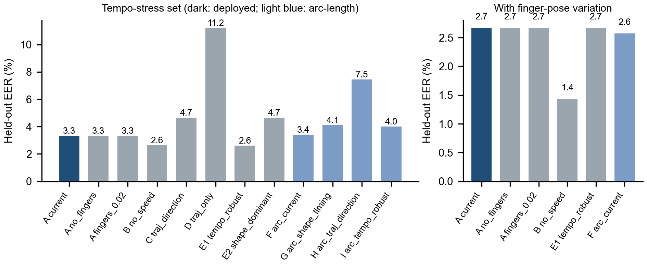
Figure 12. Held-out EER of the hand representation variants on the synthetic tempo-stress set (SYNTHETIC; 15 held-out users, 150 genuine and 2,100 impostor comparisons).
Latency. Table 13 summarises the measured latencies. A complete face-and-voice authentication request takes 778 ms on average; BioHash template generation takes 43.5 ms and a Hamming comparison 0.006 ms. The full one-sentence voice decision takes 193 ms (median of 30 runs). Backend gesture authentication, including feature extraction and 15 DTW comparisons (five rotations for each of three samples), takes 30.6 ms on average on synthetic landmark input; MediaPipe inference runs on the client and is recorded with every capture.
Table 13. Latency on an Intel i5-1235U CPU (no GPU)
Stage | Mean (ms) | Median (ms) | 95th pct. (ms) | Evidence
Face preprocessing (bounding box) | 33.0 | 32.2 | 42.5 | REAL (benchmark)
Face embedding | 38.0 | 39.3 | 44.1 | REAL (benchmark)
Voice preprocessing / embedding | 17.4 / 50.7 | 18.0 / 49.8 | 25.8 / 63.8 | REAL (benchmark)
BioHash generation (face) | 43.5 | 42.4 | 50.5 | REAL (benchmark)
Hamming comparison / decision / fusion | 0.006 / 0.09 / 0.004 | — | — | REAL (benchmark)
Template-set lookup (2,000 users × 4 sets) | 2.8 | 2.5 | 4.5 | REAL (benchmark)
API request, face + voice | 778 | 757 | 845 | REAL (benchmark)
Voice decision, one sentence (gate + embed + protect + compare) | — | 193 | — | SOFTWARE VALIDATION
Gesture authentication, backend (3 samples × 5 rotations) | 30.6 | 30.2 | 34.9 | Synthetic input
Cold start: face / voice model | 6.0 s / 3.4 s | — | — | REAL (benchmark)
Sources: latency_benchmark.csv, docs/VOICE_MODEL.md, docs/HAND_GESTURE_MODALITY.md (gesture benchmark, 30 runs).

7. Discussion

7.1 Face Modality
The protected face templates retain most of the discriminative ability of the raw embeddings (ROC-AUC 0.9641 against 0.9682), and the keyed transformation costs 1.4 EER percentage points. The practical limitation is the operating point: a threshold of 0.80 on the estimated cosine rejects most genuine attempts on LFW, and a development-selected threshold around 0.53 would have traded a FAR below 1% for an FRR of about 23%. The LFW evaluation also uses a single reference image, whereas the deployed enrollment averages five guided poses, which is expected to be more robust; this has not yet been measured. Similarity alignment is a promising, measured improvement that is not yet deployed.

7.2 Voice Modality
The voice results show that the protocol is as important as the model. Averaging two enrollment sentences halves the false-rejection rate of a single-sentence enrollment at the same threshold, which is consistent with the centroid averaging out utterance-level variation. Moving verification from two sentences to one reduced the user's effort but raised the FRR from 2.6% to 12.2% on clean clips; the threshold was not re-tuned for the new protocol. Noise and short utterances are the dominant failure causes, and the quality gate reports them as capture failures rather than mismatches. All voice numbers are closed-set and on clean dataset clips, so live performance with arbitrary microphones remains to be measured.

7.3 Hand Modality
The Z gesture separates genuine and impostor users well in the synthetic evaluation, and the pipeline is robust to the variations it was designed for: position, size, frame rate, idle time, small rotations, and landmark jitter. The development observations and the tempo-stress experiment show, however, that real behavioral variation is larger than the original synthetic model assumed. Drawing the Z markedly faster or slower than at enrollment, or with a different finger pose, raised genuine distances above the development threshold, and one slower enrollment sample was enough to separate itself from the other two. The threshold 0.216 is therefore a development value: it validates the pipeline but is not yet a calibrated operating point, and the representation choice—in particular the weight of timing and finger features—must be made on real development data.

7.4 Multimodal Fusion
The fusion results illustrate the trade-off built into the decision policy. ALL_REQUIRED guarantees that an attacker must defeat every presented modality and that a strong factor cannot compensate for a failed one, but it compounds the false rejections of the individual thresholds. The score-level results show that face and voice errors are complementary, so a calibrated score-level rule could combine them more efficiently; such a rule, however, re-introduces the possibility that a strong factor masks a weak one, which is why the decision policy is kept separate from the reported fusion score. Letting the user choose which enrolled modalities to present keeps the system usable when one factor is temporarily unavailable.

7.5 Template Protection
The measurements confirm the intended revocation behavior: templates of the same biometric under different keys agree only at chance level, revoked templates do not match their replacements, and genuine performance is maintained after revocation. Face templates are slightly linkable across keys (0.018 against a null floor of 0.013), which should be disclosed. The protection rests on the secrecy of the master secret: if the key material is stolen, BioHash loses much of its protection and the hand templates can be inverted.

7.6 Practical Deployment Considerations
The system runs on commodity hardware with a CPU-only backend, and all three modalities use sensors already present on a laptop. Hand tracking in the browser keeps video on the client, and the stored data contain no raw biometric samples. Before deployment at a real facility, however, the thresholds must be calibrated on the target population, presentation-attack detection must be added, key management must move to hardware-backed storage, and the client must be trusted or its landmark output verified. The system is a research prototype, not a production deployment.

8. Security and Privacy Considerations
Implemented protections. Only protected templates, template-set identifiers, key versions, and non-biometric metadata are stored; images, audio, landmark sequences, and embeddings are discarded after processing. Templates are keyed per application, user, modality, and key version, and are grouped into four template sets so that a compromised set can be revoked and replaced without new biometric samples. Authentication reads only the ACTIVE set and never mixes sets; revoking, activating, or generating a set requires a fresh capture of every modality in the ACTIVE set. Decisions are fail-closed, capture failures are distinguished from mismatches, repeated high-quality mismatches are flagged as suspicious, uploads are restricted by content type and size, and every attempt is recorded in an audit log that contains no biometric data.
Template compromise. A leaked template set can be revoked; the replacement set is generated under new key versions and is unrelated to the leaked one, as measured in Section 6.6. Key compromise. All keys derive from a single master secret. An attacker with the secret and a template can reproduce the BioHash projection, which substantially weakens its protection [21], and can invert the hand transform. Protecting the master secret is therefore the central security assumption; hardware-backed key storage is future work.
Presentation attacks and replay. No presentation-attack detection or liveness test is implemented. Face replay with photographs or screens, voice replay or synthesis, and imitation of a user's Z gesture were not tested. Because MediaPipe runs in the browser, the backend accepts client-supplied landmark sequences and cannot distinguish them from fabricated ones; the same applies to any client-supplied sample. These attacks are not claimed to be mitigated.
Privacy. Keeping video on the client and discarding samples after processing limits the data at rest. The hand template, however, is a transformed sequence that can be inverted with the key, and the face templates show a small measurable cross-key linkability; both facts should be considered when assessing privacy risk.

9. Limitations
First, no real-participant evaluation exists for any modality. The face results use a single reference image rather than the deployed five-pose centroid, the voice results are closed-set and on clean clips, the fusion results assume independent chimeric users, and the hand results are synthetic, complemented only by development observations from one person. Second, the face and voice thresholds are fixed project baselines rather than tuned operating points, and the hand threshold was selected on synthetic data that underestimate real tempo and finger-pose variation. Third, cross-session variation, microphone and camera variability, lighting, and demographic effects were not evaluated. Fourth, presentation attacks, replay, gesture imitation, and landmark injection are untested, and the security of the templates depends on the secrecy of the master secret; the hand transform in particular is invertible with the key. Fifth, no three-modality fusion evaluation has been performed.

10. Future Work
The most important next step is a consented real pilot study with at least five and preferably ten or more participants, each providing three enrollment Z gestures, five to ten genuine Z gestures in each of two sessions on different days, and impostor gestures, with natural finger poses. The implemented data-collection mode and evaluation scripts support this protocol. With these data, the hand representation (the deployed variant and the candidates without speed features, with tempo-robust weights, or with arc-length resampling) and the hand threshold will be selected on development participants and evaluated once on held-out participants. Further work includes re-tuning the face and voice operating points on real users, deploying the similarity-aligned face pipeline if it is confirmed on real data, evaluating the deployed five-pose face enrollment and the one-sentence voice protocol with live microphones, adding presentation-attack detection for face and voice [25], verifying landmark provenance on the server side, moving key material to hardware-backed storage, replacing the invertible hand transform with a non-invertible sequence protection, evaluating three-modality fusion, and evaluating demographic effects.

11. Conclusion
This paper presented a cancelable multimodal verification system that combines face, voice, and a dynamic Z-shaped hand gesture, stores only keyed templates grouped into revocable template sets, and decides with a fail-closed all-required policy. The gesture modality captures how the palm moves through the Z, using browser-side MediaPipe landmarks, a normalized trajectory with timing and orientation features, DTW with a bounded rotation search, three separately stored enrollment samples, and median aggregation. On public data, the keyed protection costs 1.4 EER percentage points for face and 0.1 for voice, revoked templates agree with their replacements only at chance level, and the deployed two-sentence voice enrollment halves the single-enrollment false-rejection rate. The results also show that the fixed baseline thresholds reject most genuine face attempts and that the gesture threshold, derived from synthetic users, does not transfer to data with realistic tempo variation. Calibrated thresholds, liveness detection, and a real participant study are required before the system's error rates can be stated for real users.

References
[1] K. Stouffer, M. Pease, C. Tang, T. Zimmerman, V. Pillitteri, S. Lightman, A. Hahn, S. Saravia, A. Sherule, and M. Thompson, “Guide to Operational Technology (OT) Security,” NIST Special Publication 800-82 Rev. 3, Sep. 2023, doi:10.6028/NIST.SP.800-82r3.
[2] A. K. Jain, A. Ross, and S. Prabhakar, “An introduction to biometric recognition,” IEEE Transactions on Circuits and Systems for Video Technology, vol. 14, no. 1, pp. 4–20, 2004.
[3] N. K. Ratha, J. H. Connell, and R. M. Bolle, “Enhancing security and privacy in biometrics-based authentication systems,” IBM Systems Journal, vol. 40, no. 3, pp. 614–634, 2001.
[4] A. K. Jain, K. Nandakumar, and A. Nagar, “Biometric template security,” EURASIP Journal on Advances in Signal Processing, vol. 2008, Art. no. 579416, 2008.
[5] A. Ross and A. K. Jain, “Information fusion in biometrics,” Pattern Recognition Letters, vol. 24, no. 13, pp. 2115–2125, 2003.
[6] A. Ross, K. Nandakumar, and A. K. Jain, Handbook of Multibiometrics. New York, NY, USA: Springer, 2006.
[7] V. M. Patel, N. K. Ratha, and R. Chellappa, “Cancelable biometrics: A review,” IEEE Signal Processing Magazine, vol. 32, no. 5, pp. 54–65, 2015.
[8] A. T. B. Jin, D. N. C. Ling, and A. Goh, “Biohashing: Two factor authentication featuring fingerprint data and tokenised random number,” Pattern Recognition, vol. 37, no. 11, pp. 2245–2255, 2004.
[9] H. Krawczyk and P. Eronen, “HMAC-based Extract-and-Expand Key Derivation Function (HKDF),” IETF RFC 5869, May 2010.
[10] F. Zhang, V. Bazarevsky, A. Vakunov, A. Tkachenka, G. Sung, C.-L. Chang, and M. Grundmann, “MediaPipe Hands: On-device real-time hand tracking,” arXiv:2006.10214, 2020.
[11] H. Sakoe and S. Chiba, “Dynamic programming algorithm optimization for spoken word recognition,” IEEE Transactions on Acoustics, Speech, and Signal Processing, vol. 26, no. 1, pp. 43–49, 1978.
[12] F. Schroff, D. Kalenichenko, and J. Philbin, “FaceNet: A unified embedding for face recognition and clustering,” in Proc. IEEE Conference on Computer Vision and Pattern Recognition (CVPR), 2015, pp. 815–823.
[13] J. Deng, J. Guo, N. Xue, and S. Zafeiriou, “ArcFace: Additive angular margin loss for deep face recognition,” in Proc. IEEE/CVF Conference on Computer Vision and Pattern Recognition (CVPR), 2019, pp. 4690–4699.
[14] K. Zhang, Z. Zhang, Z. Li, and Y. Qiao, “Joint face detection and alignment using multitask cascaded convolutional networks,” IEEE Signal Processing Letters, vol. 23, no. 10, pp. 1499–1503, 2016.
[15] Q. Cao, L. Shen, W. Xie, O. M. Parkhi, and A. Zisserman, “VGGFace2: A dataset for recognising faces across pose and age,” in Proc. IEEE International Conference on Automatic Face and Gesture Recognition (FG), 2018, pp. 67–74.
[16] B. Desplanques, J. Thienpondt, and K. Demuynck, “ECAPA-TDNN: Emphasized channel attention, propagation and aggregation in TDNN based speaker verification,” in Proc. Interspeech, 2020, pp. 3830–3834.
[17] A. Nagrani, J. S. Chung, and A. Zisserman, “VoxCeleb: A large-scale speaker identification dataset,” in Proc. Interspeech, 2017, pp. 2616–2620.
[18] R. V. Yampolskiy and V. Govindaraju, “Behavioural biometrics: A survey and classification,” International Journal of Biometrics, vol. 1, no. 1, pp. 81–113, 2008.
[19] J. Liu, L. Zhong, J. Wickramasuriya, and V. Vasudevan, “uWave: Accelerometer-based personalized gesture recognition and its applications,” Pervasive and Mobile Computing, vol. 5, no. 6, pp. 657–675, 2009.
[20] J. Tian, C. Qu, W. Xu, and S. Wang, “KinWrite: Handwriting-based authentication using Kinect,” in Proc. Network and Distributed System Security Symposium (NDSS), 2013.
[21] A. Kong, K.-H. Cheung, D. Zhang, M. Kamel, and J. You, “An analysis of BioHashing and its variants,” Pattern Recognition, vol. 39, no. 7, pp. 1359–1368, 2006.
[22] M. Gomez-Barrero, J. Galbally, C. Rathgeb, and C. Busch, “General framework to evaluate unlinkability in biometric template protection systems,” IEEE Transactions on Information Forensics and Security, vol. 13, no. 6, pp. 1406–1420, 2018.
[23] M. S. Charikar, “Similarity estimation techniques from rounding algorithms,” in Proc. 34th Annual ACM Symposium on Theory of Computing (STOC), 2002, pp. 380–388.
[24] G. B. Huang, M. Ramesh, T. Berg, and E. Learned-Miller, “Labeled Faces in the Wild: A database for studying face recognition in unconstrained environments,” University of Massachusetts, Amherst, Tech. Rep. 07-49, 2007.
[25] S. Marcel, M. S. Nixon, J. Fierrez, and N. Evans, Eds., Handbook of Biometric Anti-Spoofing, 2nd ed. Cham, Switzerland: Springer, 2019.

