AI EXAM PROCTORING APPLICATION
By
[Student Name 1 (2022-Arid-XXXX)]
[Student Name 2 (2022-Arid-XXXX)]
[Student Name 3 (2022-Arid-XXXX)]

Bachelor of Science in Computer Science
Barani Institute of Information Technology
PMAS Arid Agriculture University Rawalpindi
[Session, e.g. Spring 2026]

AI EXAM PROCTORING APPLICATION
A report submitted in partial fulfillment of the requirements for the degree of
Bachelor of Science in Computer Science
Submitted By
[Student Name 1 (2022-Arid-XXXX)]
[Student Name 2 (2022-Arid-XXXX)]
[Student Name 3 (2022-Arid-XXXX)]

Supervised By
[Supervisor Name]

Barani Institute of Information Technology
PMAS Arid Agriculture University Rawalpindi
[Session, e.g. Spring 2026]

CERTIFICATE
It is certified that the contents and form of the report entitled “AI Exam Proctoring Application” submitted by the above-named students have been found satisfactory for the requirement of the degree of Bachelor of Science in Computer Science.
SUPERVISORY COMMITTEE
PROJECT SUPERVISOR:
[Supervisor Name]
REPORT COORDINATOR:
[Coordinator Name]
WRITE-UP COMMITTEE HEAD:
[Committee Head Name]

ACKNOWLEDGEMENT
In the name of Almighty ALLAH, the most beneficent and merciful, who gave us the strength, patience, and knowledge to complete this project. We are deeply grateful to our project supervisor for continuous guidance, valuable suggestions, and constant encouragement throughout the development of this system. We also extend our sincere thanks to the report coordinator and the write-up committee head for their positive criticism and support. We are thankful to the faculty of the Barani Institute of Information Technology, PMAS Arid Agriculture University Rawalpindi, for providing us with the knowledge and resources that made this work possible. Finally, we are grateful to our parents and friends for their prayers, motivation, and unwavering support. May Allah bless all of them.

ABSTRACT
The “AI Exam Proctoring Application” is an intelligent, multi-modal online examination and remote-invigilation platform developed to preserve academic integrity during online and computer-based examinations. The system is built as a RESTful backend using the Python FastAPI framework, backed by a Microsoft SQL Server database accessed through the SQLAlchemy ORM, and integrates a collection of computer-vision and audio artificial-intelligence models that continuously monitor a candidate through the front camera, the back (secondary) camera, and the microphone during an examination. Traditional online examinations are highly vulnerable to malpractice such as candidate impersonation, the use of mobile phones and printed material, the presence of a second person, looking away from the screen, and verbal dictation of answers; manual invigilation of many candidates over webcams is neither scalable nor reliable. The proposed system addresses these challenges through several integrated modules. A face-based login verifies candidate identity using DeepFace (FaceNet) embeddings compared with cosine similarity. During the examination, a face-count module (RetinaFace) detects the presence of multiple or absent persons, while head-pose and eye-gaze modules built on MediaPipe FaceMesh detect looking-away behaviour. A back-camera object-detection module based on YOLOv8 detects prohibited items such as mobile phones, books, and additional persons. An audio pipeline verifies the candidate’s voice using a SpeechBrain ECAPA-TDNN speaker-recognition model, performs speaker diarization to detect a second speaker, transcribes speech using OpenAI Whisper, and analyses the content of any external speech using a natural-language-inference cross-encoder model to judge whether it is suspicious. Every detection is evaluated against per-examination, teacher-configurable thresholds and is stored as evidence (images, audio clips, and transcripts). The results are aggregated into a per-attempt cheating summary and can automatically trigger warnings or removal of the candidate. Teachers review the flagged evidence through dedicated dashboard endpoints instead of watching every candidate live. The platform provides a scalable, evidence-based, and objective approach to remote examination monitoring for educational institutions.

TABLE OF CONTENTS
Right-click and choose 'Update Field' in Word to build the Table of Contents.

Chapter 1 INTRODUCTION

1.1 Introductory Background
The “AI Exam Proctoring Application” is developed using Python and the FastAPI framework as the core backend, a Microsoft SQL Server relational database as the data store, and a suite of deep-learning models for real-time monitoring. The system is designed to conduct online examinations — consisting of multiple-choice (MCQ) and descriptive questions — while automatically invigilating candidates using artificial intelligence, thereby removing the need for a human proctor to continuously watch every candidate. Education has increasingly moved towards online and computer-based examinations, yet such examinations remain highly susceptible to academic dishonesty. This system integrates biometric identity verification with continuous camera and microphone monitoring to detect and record suspicious behaviour, and presents the collected evidence to teachers through a review dashboard. The client application captures periodic camera frames and short audio segments and transmits them to the backend, where each is analysed by the relevant AI model, compared against configurable thresholds, and logged as evidence for later review.

1.2 Problem Statement
Online examinations are convenient and scalable, but they create significant opportunities for malpractice. A candidate may allow another person to sit the examination on their behalf (impersonation), consult a mobile phone or printed notes, receive help from another person present in the room, repeatedly look away from the screen towards hidden material, or have answers dictated to them verbally. Manually invigilating a large number of candidates over live webcam feeds is labour-intensive, error-prone, and does not scale. There is therefore a clear need for an automated, intelligent, and evidence-based system that can verify candidate identity and continuously detect these forms of cheating in a reliable and objective manner.

1.3 Proposed Solution
The proposed solution is an AI-based examination proctoring platform that combines biometric authentication with continuous multi-modal monitoring. At login, the candidate’s identity is verified from a captured face image using deep face-embedding comparison. During the examination, the front camera is analysed frame-by-frame to count the number of faces (detecting multiple people or an absent candidate), to re-confirm identity, and to estimate head pose and eye-gaze direction so that looking-away behaviour is flagged. A second (back) camera feed is analysed by an object-detection model to detect prohibited items such as mobile phones, books, and laptops, as well as additional people. The microphone audio is processed to verify that the speaking voice belongs to the enrolled candidate, to detect and separate a second speaker through diarization, to transcribe the speech, and to analyse the meaning of any external speech to determine whether it is assisting the candidate. Each modality can be enabled or disabled and tuned per examination through a proctoring configuration. Detections are stored as evidence and aggregated into a cheating summary; when configured thresholds are exceeded the system can automatically warn or remove the candidate. Teachers subsequently review only the flagged evidence, dramatically reducing the manual monitoring effort while producing objective, reproducible results.

1.4 Objectives
Following are the objectives of this project:
- To verify the identity of each candidate at login and during the examination using face-recognition biometrics.
- To detect the presence of multiple persons or the absence of the candidate through real-time face counting.
- To detect looking-away behaviour by estimating head pose and eye-gaze direction.
- To detect prohibited objects (such as mobile phones, books, and laptops) and additional persons using a secondary back camera.
- To verify the candidate’s voice, detect a second speaker, transcribe speech, and analyse whether any external speech is assisting the candidate.
- To store all detections as evidence, aggregate them into a per-attempt cheating summary, and support automatic warning or removal based on teacher-configurable thresholds.
- To provide teachers with review dashboards and administrators with tools for bulk setup of courses, enrollments, and examinations.

1.5 Scope
The “AI Exam Proctoring Application” is designed for educational institutions that conduct online or computer-based examinations. It supports three categories of users: administrators, who perform bulk setup of departments, courses, offerings, enrollments, teacher allocations, and examinations (including through Excel import); teachers, who create examinations, configure per-examination proctoring settings, and review the flagged evidence and cheating summaries; and students, who authenticate biometrically and attempt MCQ and descriptive examinations while being monitored. The scope of this report covers the backend services, the database design, and the artificial-intelligence modules that constitute the proctoring engine. All AI models run locally (offline) on the server for privacy and reliability.

Chapter 2 PROJECT BACKGROUND

2.1 Related Work and Background
This project is titled “AI Exam Proctoring Application”. With the rapid adoption of online learning and remote assessment, automated (AI-based) proctoring has emerged as an active area of application. Existing commercial and research proctoring solutions typically combine one or more of the following techniques: face detection and recognition to confirm candidate identity and presence; head-pose and gaze estimation to detect attention away from the screen; object detection to identify mobile phones and other prohibited materials; and audio analysis to detect additional voices. Many of these techniques build upon well-established open models and libraries, such as convolutional face detectors, the MediaPipe face-mesh landmark model, the YOLO family of object detectors, speaker-embedding models such as ECAPA-TDNN, and automatic speech-recognition models such as OpenAI Whisper.
The distinguishing characteristic of the present system is that it integrates all of these modalities — face identity, face count, head pose, eye gaze, back-camera object detection, speaker verification, speaker diarization, speech transcription, and content analysis of external speech — into a single, threshold-driven proctoring pipeline, and couples it with a complete academic data model (departments, courses, offerings, enrollments, teacher allocations, rooms and seating, examinations with MCQ and descriptive questions, attempts, answers, and evidence logs). The monitoring behaviour of each examination is governed by a configurable proctoring policy, and all suspicious activity is preserved as reviewable evidence rather than acted upon blindly, keeping a human teacher in the loop for the final decision.

Chapter 3 CONCEPTUAL DESIGN
This chapter presents the functional and non-functional requirements of the AI Exam Proctoring Application and describes how these requirements are modelled through system diagrams, data-flow diagrams, and the database design.

3.1 Requirements Elicitation
Requirements for the system were elicited by studying the needs of the three principal stakeholders — examination administrators, teachers/invigilators, and students — and by analysing the forms of malpractice that occur during online examinations. Administrators require efficient bulk setup of academic data and examinations. Teachers require the ability to define examinations, tune how strictly each examination is monitored, and review evidence of suspicious behaviour without watching live feeds. Students require a smooth examination experience with reliable identity verification. From analysis of cheating behaviours, the monitoring requirements (identity, presence, gaze, objects, and voice) were derived.

3.2 Requirements Specification
The following requirements define the scope and behaviour of the software.

3.2.1 Functional Requirements
- The system shall authenticate a candidate at login by comparing a captured face image against a stored face embedding.
- The system shall allow administrators to bulk-create courses, offerings, enrollments, teacher allocations, and examinations, including via Excel import.
- The system shall allow teachers to create examinations containing MCQ and descriptive questions and to configure per-examination proctoring settings.
- The system shall analyse front-camera frames to count faces, re-verify identity, and estimate head pose and eye gaze.
- The system shall analyse back-camera frames to detect prohibited objects and additional persons.
- The system shall analyse microphone audio to verify the candidate’s voice, detect a second speaker, transcribe speech, and analyse the content of external speech.
- The system shall store every detection as evidence and aggregate detections into a per-attempt cheating summary.
- The system shall automatically warn or remove a candidate when configured thresholds are exceeded.
- The system shall allow teachers to review flagged images, audio clips, transcripts, and cheating summaries, and to mark records as not suspicious.
- The system shall record and save descriptive-question answers, including answers captured as transcribed speech.

3.2.2 Non-Functional Requirements
- Performance: The AI models are loaded once at server start-up and executed on background worker pools so that request latency remains acceptable during monitoring.
- Privacy: All artificial-intelligence models run locally/offline on the server, so examination media does not need to be sent to any third-party service.
- Configurability: The monitoring strictness of every examination is configurable through enable/disable flags, suspicious-percentage thresholds, consecutive-detection limits, and warning/removal actions.
- Reliability: Evidence (images, audio, transcripts) is persisted in the database and file store so that decisions are reproducible and auditable.
- Maintainability: The RESTful backend is organised into independent routers and controllers, allowing new monitoring modules to be added.

3.2.3 Domain Requirements
The system must operate within the academic domain of a university examination process. It must represent departments, sections, courses and their semester offerings, student enrollments, teacher allocations, examination rooms and seating, and examinations composed of MCQ and descriptive questions. Monitoring must be tied to a specific examination attempt of a specific student, and the collected evidence must respect this academic structure so that results can be reported per student, per examination, and per course.

3.3 Conceptual Diagram
The conceptual diagram provides a high-level view of how the client application, the FastAPI backend, the AI proctoring engine, and the SQL Server database interact during an examination. As shown in Figure 3.1, the three actors — student, teacher, and administrator — interact through the client application, which uploads camera frames, audio, and answers to the FastAPI backend over HTTP. The backend routes this data to the AI proctoring engine, whose vision and audio modules analyse it; the resulting detections pass to the decision and aggregation layer, where they are evaluated against per-examination thresholds, summarised, and may trigger automatic warning or removal. All evidence and results are persisted to the SQL Server database and media store and are made available to the teacher for review.
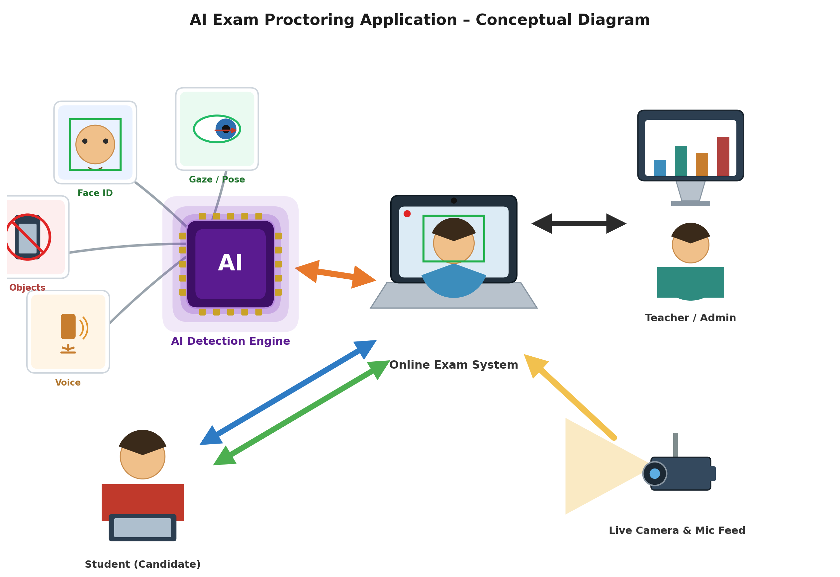
Figure 3.1: Conceptual Diagram

3.4 Data Flow Diagram
A Data Flow Diagram (DFD) is a graphical representation that depicts the flow of information and the transformations applied to data as it moves from input to output.

3.4.1 Context Level Diagram
The context-level diagram, shown in Figure 3.2, represents the entire application as a single process — the AI Exam Proctoring System — inside which all the AI modules run. On the left, the student feeds video frames and voice into the system as inputs, and receives warnings as output. The system processes these inputs through its AI modules and produces results, which are sent to the teacher (as live statistics) and to the database (for storage).
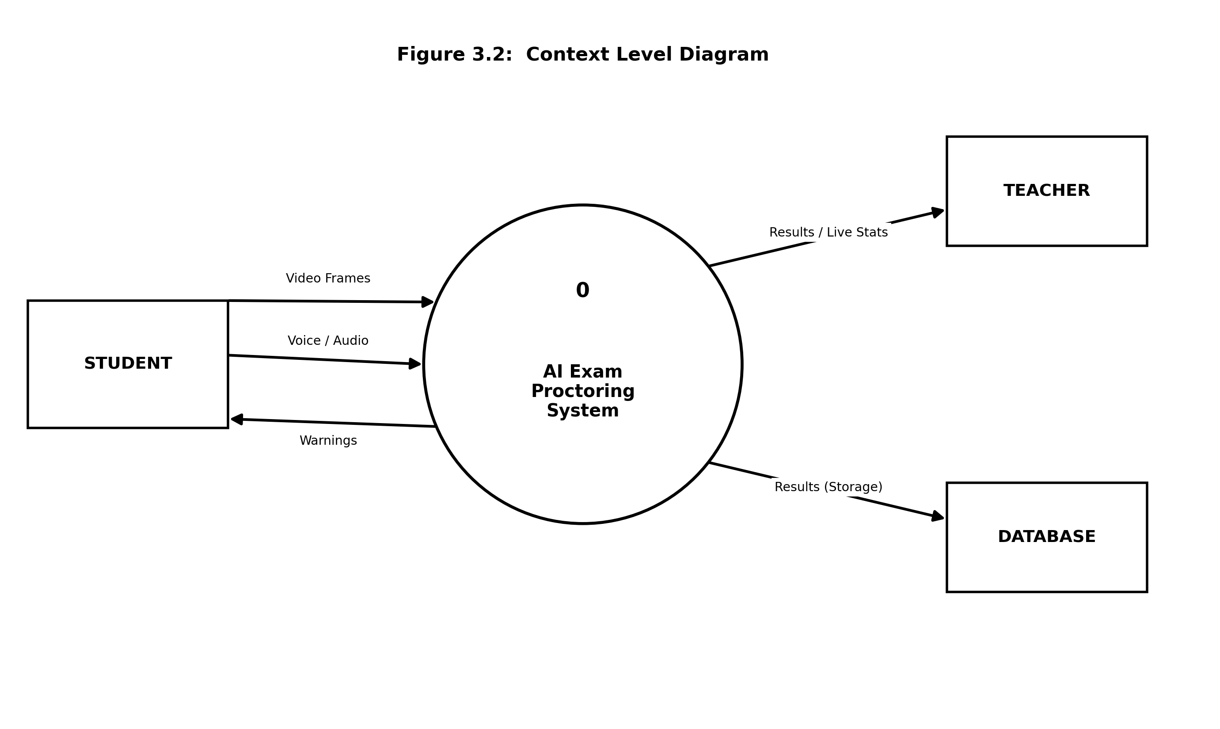
Figure 3.2: Context Level Diagram

3.4.2 Level 1 Diagram
The level-1 diagram decomposes the system into its major processes: Authentication, Academic Setup, Examination Management, Real-Time Proctoring (face, object, and voice monitoring), Evidence Aggregation, and Review/Reporting, together with their interactions with the database.
[Insert Figure 3.3: Level 1 Diagram]
Figure 3.3: Level 1 Diagram

3.5 Database Design
The system uses a Microsoft SQL Server relational database accessed through the SQLAlchemy ORM. The data model is organised into four logical domains: identity and authentication, academic structure, examinations, and proctoring/monitoring. The examination attempt (ExamAttempt) acts as the central hub that links a student to an examination and anchors all submitted answers and monitoring evidence. The principal entities are summarised in Table 3.1.
Domain | Entity | Purpose
Identity / Auth | Users | Central identity record (name, email, role, identity number, profile image, face embedding).
Identity / Auth | Student | Student profile linked one-to-one to Users; section, intake, CGPA, year.
Identity / Auth | Teacher | Teacher profile linked one-to-one to Users; designation, qualification, experience.
Academic | Department / Section | Departments and their sections.
Academic | Course / CourseOffering | Courses and their per-semester/year offerings.
Academic | CourseAllocation | Allocation of a teacher to a course offering and section.
Academic | CourseEnrollment | Enrollment of a student in a course offering.
Examinations | Exam | An examination belonging to a course, with type, date, and duration.
Examinations | ExamMCQ / McqOption | MCQ questions and their answer options.
Examinations | ExamDescQues | Descriptive (free-text) questions.
Examinations | ExamAttempt | A student's sitting of an examination; hub for answers and evidence; holds status, camera flags, warning count.
Examinations | McqAns / DesAns | Submitted MCQ and descriptive answers linked to an attempt.
Examinations | Room / ExamRoom / StudentSeating / TeacherRoomAssignment | Physical rooms, examination scheduling, seat allocation, and invigilator assignment.
Proctoring | StudentExamLog | Per-frame face log: presence, head position, eye gaze, suspicion flag, image path.
Proctoring | DetectedObjects | Objects detected on back-camera frames with image evidence.
Proctoring | StudentMCQ/DESCExamAudioChunk | Per-question audio chunks with transcript, speaker analysis, and suspicion flags.
Proctoring | CheatingSummary | Aggregated per-attempt verdict and suspicious percentages.
Proctoring | ExamProctoringConfig | Per-examination monitoring policy (enable flags, thresholds, actions).
Proctoring | ProctoringEvent / Camera / Screen / VoiceMonitoring | Event-based monitoring records with image and transcript evidence.
Proctoring | StudentBreak | Invigilator-authorised breaks during an examination.

3.5.1 Entity Relationship Diagram (ERD)
The Entity Relationship Diagram illustrates how these entities relate: a Users record is either a Student or a Teacher; departments contain sections and course offerings; teachers are allocated to offerings and students enroll in them; an examination belongs to a course and contains MCQ and descriptive questions; when a student sits an examination an ExamAttempt is created, to which answers and all monitoring evidence (face logs, detected objects, audio chunks, and the cheating summary) are attached, governed by the examination’s proctoring configuration.
[Insert Figure 3.4: Entity Relationship Diagram]
Figure 3.4: Entity Relationship Diagram

Chapter 4 IMPLEMENTATION
This chapter describes the tools and technologies used to build the AI Exam Proctoring Application, the overall system architecture, the artificial-intelligence modules that form the proctoring engine, the application programming interfaces (APIs) exposed by the backend, and the graphical user interface.

4.1 Tools & Technologies
The following tools and technologies were used to develop the system.
Category | Technology
Programming language | Python 3.10
Backend framework | FastAPI (with Starlette and Uvicorn ASGI server)
Data validation | Pydantic v2
Database | Microsoft SQL Server
Database access (ORM/driver) | SQLAlchemy 2.0 with pyodbc and ODBC Driver 17 for SQL Server
Face detection (count) | RetinaFace (also OpenCV DNN Caffe SSD and MediaPipe Face Detection)
Face recognition (identity) | DeepFace (FaceNet embeddings) with cosine similarity
Head-pose & eye-gaze | MediaPipe FaceMesh (with a scikit-learn SVM variant for pose)
Object detection | YOLOv8 (Ultralytics)
Speaker verification | SpeechBrain ECAPA-TDNN (spkrec-ecapa-voxceleb)
Speech-to-text | OpenAI Whisper (base model)
Speech content analysis | SentenceTransformers CrossEncoder NLI (nli-deberta-v3-base); MiniLM for text similarity
Deep-learning runtimes | PyTorch, TorchAudio, TensorFlow/Keras, MediaPipe
Audio processing | librosa, soundfile, pydub, FFmpeg
Data / spreadsheet import | pandas, openpyxl
Concurrency | ThreadPoolExecutor and ProcessPoolExecutor
IDE / Tools | PyCharm, Visual Studio Code, Git

4.2 System Architecture
The application follows a layered client-server architecture. A client application (the candidate’s examination interface and the teacher/administrator dashboards) communicates with the FastAPI backend over HTTP. The backend is organised into routers (which define the API endpoints), controllers (which contain the business logic), ORM models (which map to the SQL Server tables), and schemas (which validate request and response data). The AI proctoring engine loads all models once at start-up and executes inference on background worker pools to keep the asynchronous server responsive. Because the client cannot maintain a persistent streaming socket, real-time monitoring is achieved by the client periodically uploading a single camera frame or a short audio segment to dedicated endpoints; each upload is analysed and logged independently. Captured images and audio are stored on the server and served back to the teacher dashboard as evidence.
[Insert Figure 4.1: System Architecture Diagram]
Figure 4.1: System Architecture Diagram

4.3 AI Modules
The proctoring engine is composed of the following artificial-intelligence modules. For each module the purpose, working, input, output, and integration with the system are described.

4.3.1 Face Identity Verification
Purpose: To confirm that the person logging in and sitting the examination is the enrolled candidate.
How it works: A face image is passed to the DeepFace library using the FaceNet model to produce a numerical face embedding. This embedding is compared with the candidate’s stored embedding using cosine similarity; a similarity above the configured threshold (0.65) is accepted as a match.
Input: A captured face image and the candidate’s identity number.
Output: A match / no-match decision (and the resolved user role and identifier at login).
Integration: Used at login (via the login endpoint) and re-used during front-camera monitoring to confirm the seated candidate’s identity on each analysed frame.

4.3.2 Face Count
Purpose: To detect whether more than one person, or no person, is present in front of the camera.
How it works: Each front-camera frame is processed by the RetinaFace face detector, which returns the detected faces. The number of faces is counted.
Input: A front-camera image frame.
Output: The number of faces detected (zero, one, or more than one).
Integration: Executed first in the face-monitoring pipeline; more than one face or zero faces is recorded as suspicious, and further identity/pose analysis is only performed when exactly one face is present.

4.3.3 Head-Pose Estimation
Purpose: To detect whether the candidate’s head is turned away from the screen.
How it works: The MediaPipe FaceMesh model extracts facial landmarks, from which the head orientation is derived geometrically and classified into directions such as straight, left, right, up, or down. (A scikit-learn SVM classifier trained on yaw/pitch features is also provided as an alternative.)
Input: A front-camera image frame containing a single face.
Output: A head-pose label (e.g. straight, left, right, up, down).
Integration: Combined with eye-gaze in the face-monitoring pipeline; a verified candidate is flagged as suspicious unless the head pose is straight and the gaze is centred.

4.3.4 Eye-Gaze Estimation
Purpose: To detect whether the candidate is looking away from the screen even when facing forward.
How it works: Using MediaPipe FaceMesh iris landmarks, the normalised position of the iris within the eye is computed and thresholded to classify the gaze direction.
Input: A front-camera image frame containing a single face.
Output: A gaze label: centre, left, right, up, or down.
Integration: Runs together with head-pose estimation; non-central gaze contributes to a frame being marked suspicious and is stored in the per-frame log.

4.3.5 Object Detection (Back Camera)
Purpose: To detect prohibited objects and additional persons using a secondary (back) camera.
How it works: Back-camera frames are processed by a YOLOv8 object-detection model. Detected classes are checked against a list of prohibited items (mobile phone, book, laptop, television, remote) and the number of persons is counted. A limited allowance (for example a single laptop or a single phone with one person) is applied to reduce false alarms.
Input: A back-camera image frame.
Output: A list of detected objects and person count; a stored detection record when prohibited items or additional persons are found.
Integration: Invoked through the object-detection endpoint; flagged detections are saved with image evidence and contribute to the object-suspicion component of the cheating summary.

4.3.6 Speaker Verification (Voice)
Purpose: To confirm that the voice heard during the examination belongs to the enrolled candidate.
How it works: The candidate’s voice is enrolled in advance by averaging embeddings extracted from sample recordings using the SpeechBrain ECAPA-TDNN speaker-recognition model. During the examination, silence is removed from each audio chunk, an embedding is extracted from the remaining speech, and cosine similarity with the enrolled embedding is computed; a score of 0.75 or higher is treated as a match.
Input: A short audio chunk and the candidate’s identity number.
Output: A match / no-match decision with a similarity score (silence is treated as non-suspicious).
Integration: Core of the voice-monitoring pipeline; a non-matching voice is recorded as suspicious.

4.3.7 Speaker Diarization
Purpose: To detect the presence of a second speaker and separate speech by speaker.
How it works: A sliding window (approximately three seconds, advanced in one-and-a-half-second steps) is moved across the audio; the ECAPA embedding of each window is compared with the candidate’s enrolled embedding, and each window is labelled as belonging to the candidate or to another person. Consecutive windows of the same label are merged into segments.
Input: An audio chunk and the candidate’s enrolled voice embedding.
Output: A set of time segments labelled candidate or other, indicating whether another speaker is present.
Integration: Runs within the voice-monitoring pipeline to decide whether external-speech content analysis is required.

4.3.8 Speech-to-Text (Transcription)
Purpose: To convert examination audio into text for review and content analysis, and to capture spoken descriptive answers.
How it works: The OpenAI Whisper (base) model transcribes each audio chunk. When a second speaker is detected, word-level timestamps are used together with the diarization segments to attribute each word to the candidate or the other speaker.
Input: An audio chunk (resampled to 16 kHz mono).
Output: A text transcript (optionally with per-speaker attribution).
Integration: Transcripts are stored with each audio record; for descriptive examinations the candidate’s transcribed speech is also saved as the answer to the question.

4.3.9 Speech Content Analysis (NLI)
Purpose: To judge whether speech from a second person is actually assisting the candidate (for example dictating an answer).
How it works: The text spoken by the “other” speaker is evaluated by a SentenceTransformers CrossEncoder natural-language-inference (NLI) model against a set of cheating-related hypotheses (such as telling someone to select a particular option); if enough hypotheses are entailed with sufficient probability, the speech is flagged as suspicious.
Input: The transcribed text attributed to the second speaker.
Output: A suspicious / not-suspicious decision for the external speech content.
Integration: Applied only when diarization detects a second speaker, so that harmless background speech is not treated the same as active assistance.

4.4 Application Programming Interfaces (APIs)
The backend exposes a RESTful API organised into routers for users, students, teachers, administrators, examinations, and proctoring. Representative endpoints are summarised in Table 4.1. Media (camera frames and audio) are uploaded as multipart form data.
Group | Representative Endpoints | Purpose
Users / Auth | GET /users, POST /login | List users; biometric face login.
Students | GET /enrolledCourses/{id}, GET /exam/{id}, POST /AddMcqAnswer, GET /fetchAttemptId/..., GET /isStudentCheating/... | Student courses, exams, answer submission, attempt and cheating status.
Exams | POST /createExam, POST /addMcq, GET /fetchMcqs/{id}, GET /fetchDescQuestions/{id}, POST /addStudentExamAttempt, POST /saveMcqAnswers, GET /submitExam/{id} | Examination and question management, attempts, and answer saving.
Teachers | GET /teacherExams/{id}, GET /studentsAppearedInExam/{id}, POST /getStudentLogsWithImages, GET /fetchStudentAudioLogs/..., POST /examConfig/{id}, GET /get_top_and_worst_students | Review dashboards, evidence retrieval, proctoring configuration, analytics.
Admin | POST /uploadExam (and Excel bulk-setup endpoints) | Bulk import of academic data and examinations.
Proctoring | POST /FaceMonitoring, POST /detectObjects, POST /voiceMonitoringDiarize, POST /AddProctoringEvent, GET /fetchCheatingSummary/..., GET /checkThresholdAction/... | Real-time face, object, and voice monitoring; evidence aggregation and threshold actions.

Table 4.1: Representative API Endpoints

4.5 Pseudo Code
The following pseudo-code summarises the principal flows of the system.
Login (Face Verification):
Capture face image and identity number
embedding = FaceNet(image)
score = cosine_similarity(embedding, stored_embedding[identity])
IF score > 0.65: authenticate and return role/id
ELSE: reject login

Front-Camera Monitoring:
Receive frame, attempt_id, identity, time
IF face monitoring disabled for exam: skip
faces = RetinaFace.count(frame)
IF faces > 1: mark 'multiple faces', suspicious
ELSE IF faces == 0: mark 'no face', absent, suspicious
ELSE: # exactly one face
verify identity, estimate head pose and eye gaze (in parallel)
IF not identity match: mark 'identity mismatch', suspicious
ELSE IF pose != STRAIGHT or gaze != CENTER: suspicious
Save StudentExamLog row + image evidence

Voice Monitoring (with Diarization):
Receive audio chunk, attempt_id, identity, question, exam_type
IF voice monitoring disabled: skip
convert audio to 16kHz mono WAV; save chunk
segments = diarize(audio, enrolled_embedding[identity])
IF single speaker:
result = verify_voice(identity, audio)
transcript = Whisper(audio)
IF descriptive exam: save transcript as answer
IF not match: save suspicious ELSE save normal
ELSE (second speaker present):
labelled = transcribe_with_speakers(audio, segments)
IF no candidate speech: mark absent, suspicious
ELSE: run NLI on other-speaker text; flag if suspicious

Cheating Aggregation & Action:
Gather all face, voice, and object logs for the attempt
face% = suspicious_face_logs / total_face_logs
voice% = suspicious_voice_chunks / total_voice_chunks
compute max consecutive suspicious streaks
Compare with ExamProctoringConfig thresholds
IF thresholds exceeded:
IF action == 'warn': increment warning_count
IF warnings exceed limit and action == 'remove': set attempt = removed
Persist CheatingSummary when attempt is no longer active

4.6 Graphical User Interface
This section presents the graphical user interface of the system through screenshots of the student examination interface and the teacher/administrator dashboards. Each screen is accompanied by a short explanation.
[Insert Figure 4.2: Login / Identity Verification Screen]
Figure 4.2: Login / Identity Verification Screen
[Insert Figure 4.3: Student Examination Screen (MCQ / Descriptive) with Live Monitoring]
Figure 4.3: Student Examination Screen
[Insert Figure 4.4: Teacher Dashboard – Students and Cheating Status]
Figure 4.4: Teacher Dashboard – Cheating Status
[Insert Figure 4.5: Evidence Review – Image Logs, Audio Clips, and Transcripts]
Figure 4.5: Evidence Review Screen
[Insert Figure 4.6: Proctoring Configuration Screen]
Figure 4.6: Proctoring Configuration Screen

Chapter 5 CONCLUSION
The concluding remarks, future directions, and limitations of the project are presented below.

5.1 Conclusion Remarks
The AI Exam Proctoring Application demonstrates how modern computer-vision and audio artificial-intelligence models can be combined into a single, coherent platform to protect the integrity of online examinations. By integrating biometric identity verification with continuous monitoring of face presence, head pose, eye gaze, prohibited objects, and voice, and by analysing the content of any external speech, the system detects a wide range of malpractice and preserves it as reviewable evidence. Its per-examination configurable policy, automatic warning and removal actions, and teacher-facing review dashboards make it a practical and scalable alternative to continuous manual invigilation, providing objective and reproducible results for educational institutions.

5.2 Future Directions
In the future, the system could be extended with a persistent real-time streaming channel to reduce upload overhead, automatic grading of descriptive answers using the semantic-similarity and NLI models already present, deeper analytics and reporting for institutions, expanded prohibited-object classes, token-based authentication and role-based access control for the APIs, and cloud deployment with support for many concurrent examinations.

5.3 Limitations
The system operates on periodically uploaded camera frames and audio segments rather than a continuous stream, so extremely brief events between samples may not be captured. The accuracy of the vision modules depends on adequate lighting and camera quality, and the accuracy of the voice modules depends on microphone quality and background noise. Reliable identity and voice verification requires prior enrollment of each candidate’s face and voice. The proctoring thresholds must be tuned per examination to balance false alarms against missed detections. The scope of this report is the backend services, database, and AI modules; the client user interface is documented through screenshots.

REFERENCES
[1] Deng, J., Guo, J., Ververas, E., Kotsia, I., and Zafeiriou, S. (2020). RetinaFace: Single-Shot Multi-Level Face Localisation in the Wild. Proceedings of the IEEE/CVF Conference on Computer Vision and Pattern Recognition (CVPR).
[2] Schroff, F., Kalenichenko, D., and Philbin, J. (2015). FaceNet: A Unified Embedding for Face Recognition and Clustering. Proceedings of the IEEE Conference on Computer Vision and Pattern Recognition (CVPR).
[3] Serengil, S. I., and Ozpinar, A. (2021). DeepFace: A Lightweight Face Recognition and Facial Attribute Analysis Framework. Proceedings of the International Conference on Engineering and Emerging Technologies.
[4] Lugaresi, C., et al. (2019). MediaPipe: A Framework for Building Perception Pipelines. arXiv preprint arXiv:1906.08172.
[5] Jocher, G., Chaurasia, A., and Qiu, J. (2023). YOLO by Ultralytics (Version 8). Retrieved from https://github.com/ultralytics/ultralytics.
[6] Desplanques, B., Thienpondt, J., and Demuynck, K. (2020). ECAPA-TDNN: Emphasised Channel Attention, Propagation and Aggregation in TDNN-Based Speaker Verification. Proceedings of Interspeech.
[7] Ravanelli, M., et al. (2021). SpeechBrain: A General-Purpose Speech Toolkit. arXiv preprint arXiv:2106.04624.
[8] Radford, A., Kim, J. W., Xu, T., Brockman, G., McLeavey, C., and Sutskever, I. (2023). Robust Speech Recognition via Large-Scale Weak Supervision (Whisper). Proceedings of the International Conference on Machine Learning (ICML).
[9] Reimers, N., and Gurevych, I. (2019). Sentence-BERT: Sentence Embeddings Using Siamese BERT-Networks. Proceedings of EMNLP-IJCNLP.
[10] Ramírez, S. (2018). FastAPI. Retrieved from https://fastapi.tiangolo.com.

ANNEXURE
Annexure A: Candidate Examination Flow
Step 1: The candidate opens the application and captures a face image; the system verifies identity using face-embedding comparison.
Step 2: On success, the candidate views the list of available examinations and selects one; an examination attempt is created.
Step 3: The candidate answers MCQ and descriptive questions. Throughout the attempt, the client periodically uploads front-camera frames, back-camera frames, and audio segments.
Step 4: Each upload is analysed by the AI modules; suspicious detections are stored as evidence and aggregated.
Step 5: If configured thresholds are exceeded, the candidate is warned or removed. The candidate submits the examination when finished.
Annexure B: Teacher Review Flow
Step 1: The teacher configures the proctoring policy for an examination (which modules are enabled and their thresholds).
Step 2: After the examination, the teacher opens the list of students who appeared, each annotated with a cheating status.
Step 3: The teacher reviews the evidence — image logs with head-pose and gaze statistics, detected objects, and suspicious audio clips with transcripts.
Step 4: The teacher may mark records as not suspicious, remove a student, or view top/worst-student analytics.

