(25000, 19, 19, 31) 73m 58.3s

📊 Validation Results for Mon Model — Epoch 100:
- loss : 3.0863
- policy_loss : 2.3095
- value_loss : 0.6842
- policy_categorical_accuracy : 0.4117
- value_mse : 0.1176
- Time: 4437.9698

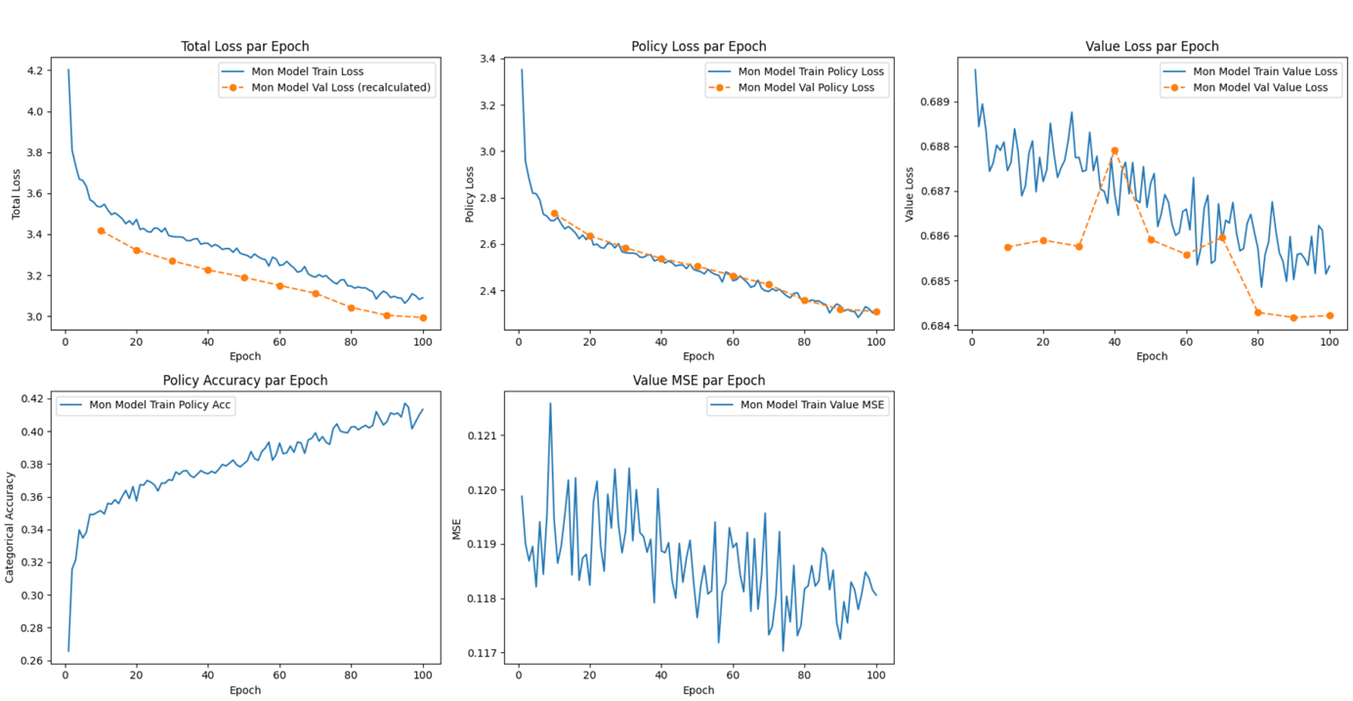

(50000, 19, 19, 31) 153m 34.9s

📊 Validation Results for Mon Model — Epoch 100:
- loss : 3.0059
- policy_loss : 2.2637
- value_loss : 0.6567
- policy_categorical_accuracy : 0.4167
- value_mse : 0.1049
- Time: 9214.5993

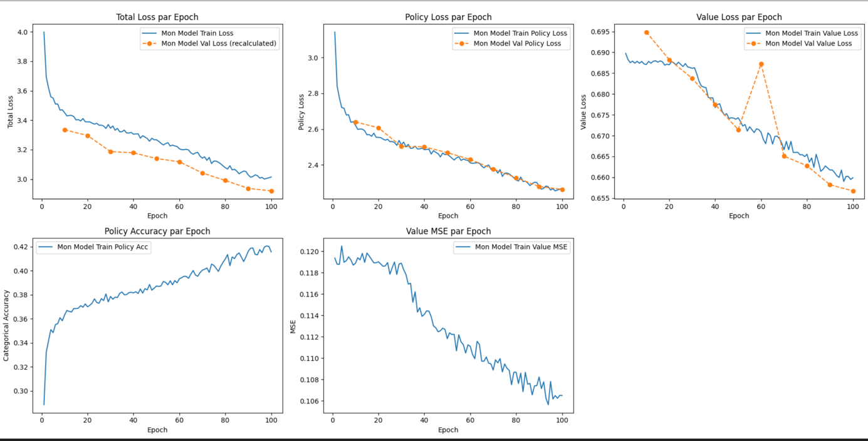

(25000, 19, 19, 31) 403m 21s

📊 Validation Results for Mon Model — Epoch 500:
- loss : 2.9730
- policy_loss : 2.2174
- value_loss : 0.6844
- policy_categorical_accuracy : 0.4229
- value_mse : 0.1176
- Time: 24201.0323

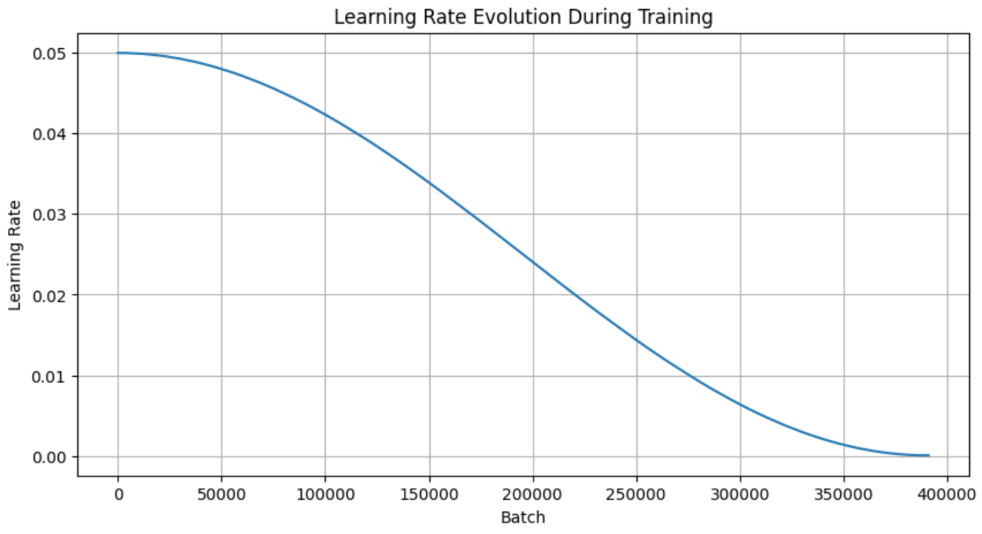
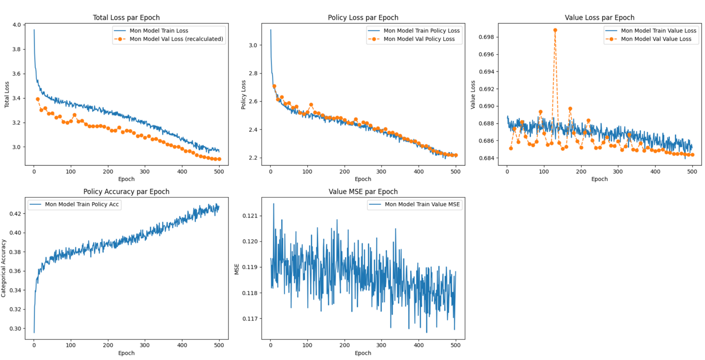

(10000, 19, 19, 31)

📊 Validation Results for Mon Model — Epoch 250:
- loss : 3.0686
- policy_loss : 2.3152
- value_loss : 0.6585
- policy_categorical_accuracy : 0.4081
- value_mse : 0.1059
- Time: 5488.9731