Practices for Secure Software Report
Artemis Financial | CS 305 Project Two
Developer: Malik Clemmons

Document Revision History
Version | Date | Author | Comments
1.0 | October 12, 2026 | Malik Clemmons | HTTPS and SHA-256 implementation
2.0 | October 16, 2026 | Malik Clemmons | Tomcat update, completed scan and execution evidence

Client
Artemis Financial needs a verification step for transferred information and secure communication for its web application. I refactored the starter to calculate and verify a SHA-256 checksum and serve the result over HTTPS. Testing identified a vulnerable Tomcat dependency. After updating it to 11.0.26, the secondary scan reported zero known vulnerabilities, and the application continued to run successfully.

Algorithm Cipher
I recommend AES-256 in Galois/Counter Mode (GCM) for encryption. AES uses the same secret key to encrypt and decrypt data. It operates on 128-bit blocks and supports 128-, 192-, and 256-bit keys. GCM also authenticates the encrypted data so changes can be detected. In this application, AES-GCM is provided by TLS rather than a custom encryption routine (NIST, 2023).
For checksum verification, I selected SHA-256. It is a one-way hash function that produces a 256-bit digest, displayed as 64 hexadecimal characters. It has no encryption key and cannot decrypt data. The number 256 describes the digest size in SHA-256 and the key size in AES-256. A 256-bit hash has about 128-bit generic collision resistance. NIST recommends SHA-256 as a minimum for interoperable secure-hash applications (NIST, 2022).
TLS combines asymmetric authentication and key establishment with symmetric encryption for application traffic. The self-signed certificate uses an RSA-3072 public/private key pair and a SHA256withRSA signature. The private key stays in the PKCS12 keystore, while the CER file contains the public certificate. Java and TLS handle cryptographically secure randomness and session keys. For separate AES-GCM encryption, keys must be securely generated, and a nonce must never repeat with the same key.
Encryption has progressed from older systems such as DES to stronger standards. AES was standardized in 2001, and its 2023 update did not change the algorithm. MD5 and SHA-1 should not be chosen for new collision-resistant verification; SHA-2 and SHA-3 are current alternatives. A checksum also needs an authenticated source. If an attacker replaces both the data and its expected checksum, hashing alone cannot establish authenticity.

Certificate Generation
Java Keytool generated a self-signed certificate for localhost and exported it as certificates/artemis-local.cer. The key settings are RSA-3072, SHA256withRSA, a 365-day validity period, and the alias artemis. The PKCS12 keystore is stored separately from the application classpath. Subject alternative names include localhost and 127.0.0.1, matching the local addresses used for testing (Oracle, n.d.).
The generation and export use Keytool -genkeypair and -exportcert. The project includes generate-certificate.cmd to reproduce those commands from a Windows terminal, including Eclipse Terminal. The exported certificate was inspected in Windows and added to the current user trust store for this local demonstration. The screenshot shows matching issuer and subject names and validity from October 12, 2026, through October 12, 2027.
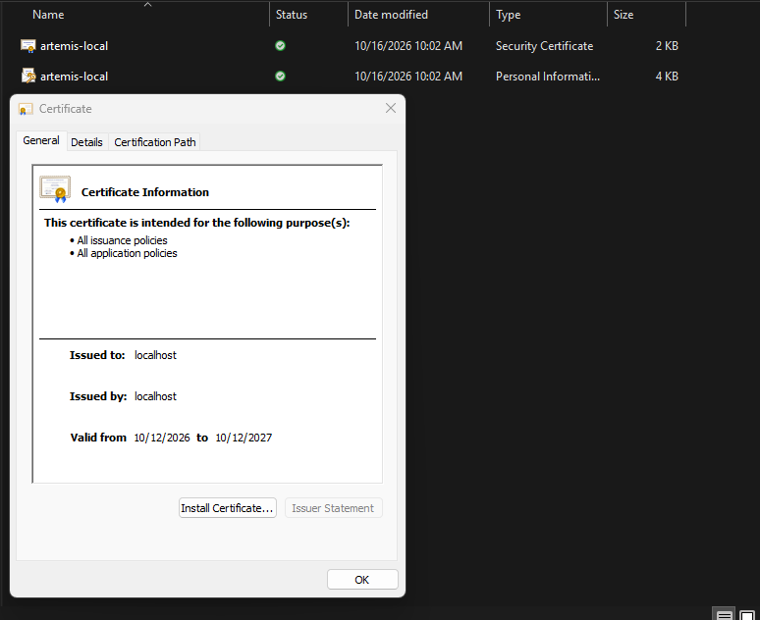
Figure 1. Exported CER file and certificate details in Windows.
The CER contains public certificate information. The P12 contains the private key and is only an expendable classroom keystore. Production deployment requires protected private-key storage and an appropriate trusted CA certificate.

Deploy Cipher
I added ChecksumService.java to calculate SHA-256 using Java MessageDigest. It converts the input string to UTF-8 bytes and returns the digest as hexadecimal. The verification method checks that the expected digest contains exactly 64 hexadecimal characters, converts it to bytes, and compares it with MessageDigest.isEqual. A new MessageDigest instance is created for each calculation, avoiding a shared mutable digest across requests.
HashController.java provides GET /hash. The response contains my name, a unique data string, the algorithm, the calculated checksum, a separately calculated expected checksum, and a verified result. The expected digest was calculated independently with Python hashlib, and the live response matched it.
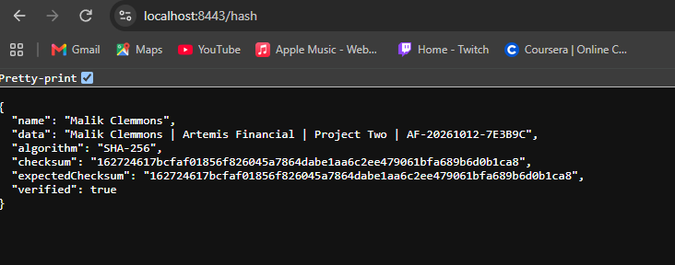
Figure 2. Checksum verification after updating Tomcat to 11.0.26.
The unique data string is “Malik Clemmons | Artemis Financial | Project Two | AF-20261012-7E3B9C”. Both digests match, and verified is true. Automated tests also confirm that altered data is rejected. The endpoint demonstrates a fixed string; a production file-transfer workflow would hash the actual received file bytes and obtain the expected digest through an authenticated channel.
SHA-256 provides the verification value, while HTTPS protects its transmission. An unkeyed checksum does not establish the sender’s identity. TLS certificate validation provides the server authentication needed for this local exchange.

Secure Communications
I replaced the incomplete SSL entries in application.properties with HTTPS on port 8443, the artemis alias, and a PKCS12 keystore path. SSL_KEYSTORE_PASSWORD supplies the password through the run environment. The server binds to loopback and enables TLS 1.2 and TLS 1.3 with AES-GCM cipher suites. The default plain-HTTP connector is not enabled.
After the certificate was trusted locally, Chrome displayed “Connection is secure” for localhost:8443/hash. An independent certificate-validated request also passed hostname verification and negotiated TLSv1.3 with TLS_AES_256_GCM_SHA384. The SHA-384 component belongs to the TLS suite; the application checksum remains SHA-256.
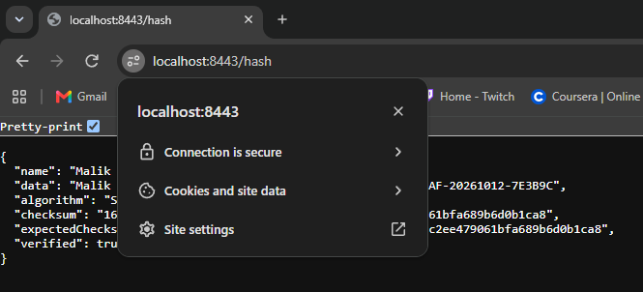
Figure 3. Chrome confirms the locally trusted HTTPS connection.
After the Tomcat dependency update, I restarted the application and confirmed that Tomcat 11.0.26 started on port 8443 with HTTPS. The checksum endpoint still returned verified: true, as shown in Figure 2.
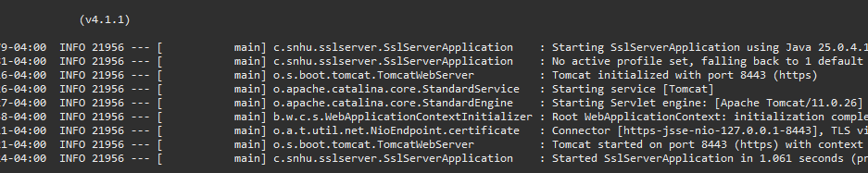
Figure 4. Successful application startup with Tomcat 11.0.26 and HTTPS.
The self-signed certificate is appropriate for this classroom test. Browser trust was configured locally; the certificate is not publicly trusted. The response also sets Cache-Control: no-store and X-Content-Type-Options: nosniff. Detailed error messages and stack traces are disabled in client responses.

Secondary Testing
I used OWASP Dependency-Check 13.0.0 after refactoring. The first completed scan found 11 vulnerabilities in one dependency, tomcat-embed-core 11.0.24. These included CVE-2026-65637, CVE-2026-65182, and CVE-2026-68763. Apache’s advisories identify corrected versions. I added <tomcat.version>11.0.26</tomcat.version> in pom.xml, which updates the managed embedded Tomcat components together (Apache Software Foundation, 2026).
Scan result | Before update | After update
Tomcat version | 11.0.24 | 11.0.26
Vulnerable dependencies | 1 | 0
Vulnerabilities found | 11 | 0
Vulnerabilities suppressed | 0 | 0
After updating Maven’s dependencies, I reran the scan. The October 16, 2026, 4:30 PM report lists 39 scanned dependencies, including 17 unique dependencies, with zero vulnerable dependencies, zero vulnerabilities, and zero suppressions. The HTML confirms that core, EL, and WebSocket components use 11.0.26. The changes fixed the dependency findings without suppression rules.
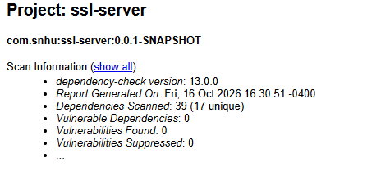
Figure 5. Final Dependency-Check summary with zero reported vulnerabilities.
The Maven scan completed with BUILD SUCCESS and wrote both HTML and JSON reports. The build is configured to fail on scanner errors or findings with CVSS scores of 7 or higher; I reviewed the report rather than relying only on that threshold.
Coverage limitation: the Sonatype OSS Index analyzer was unavailable because its separate credentials were not configured. The NVD analysis and Known Exploited Vulnerability analyzer completed. The scan reused its recently updated NVD cache. Zero findings describes this scan and its available data sources, not a guarantee that the software has no security weaknesses (OWASP Foundation, n.d.).

Secondary Testing Execution Evidence
The following Eclipse Console screenshot records the completed secondary scan, the report paths, and BUILD SUCCESS. It also preserves the OSS Index warning so the analysis coverage is clear.
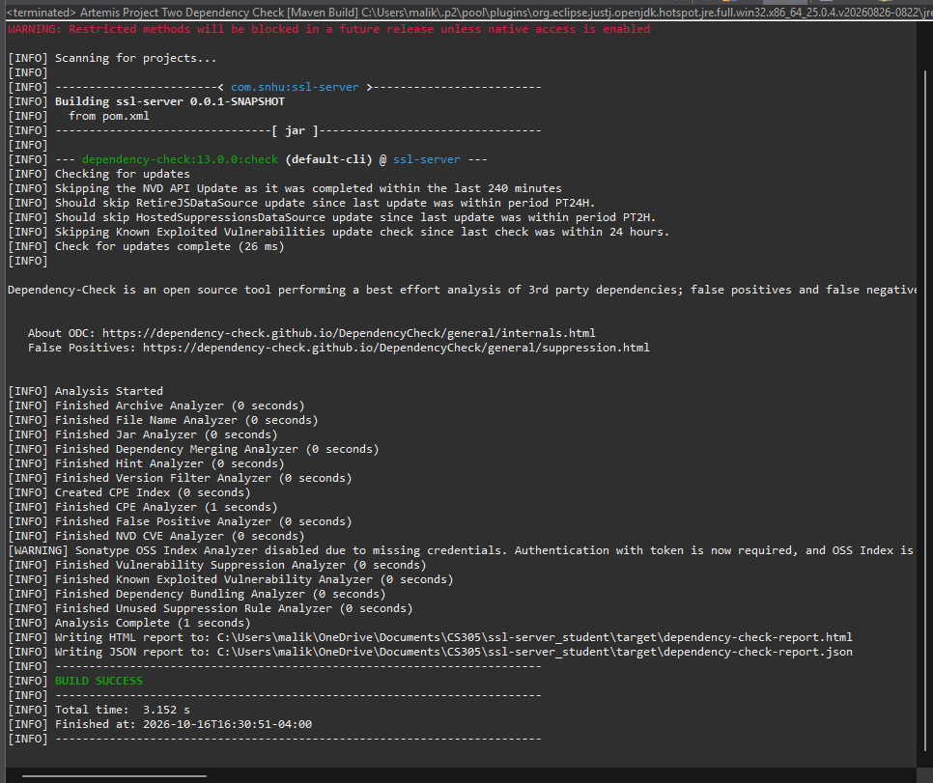
Figure 6. Dependency-Check execution completed successfully in Eclipse.

Functional Testing
I manually reviewed the Java classes, SSL properties, and Maven configuration for syntax, logic, and security issues. I checked imports, route mapping, UTF-8 conversion, hexadecimal formatting, malformed-digest handling, exception behavior, and consistency between the certificate alias and keystore settings. The endpoint returns structured JSON and does not accept user-controlled HTML or file paths.
Test | Result
SHA-256 published abc test vector | Expected digest matched
Original and modified data | Original accepted; changed data rejected
Null or malformed expected digest | Rejected
Controller response | HTTP 200; name and verified checksum present
Live HTTPS after Tomcat update | Application started; /hash returned verified true
The four automated tests completed with no failures, errors, or skipped tests. The test/package build also succeeded. After applying the Tomcat update, the packaged project was rebuilt and the independent HTTPS request was repeated successfully. Figures 2 and 4 document the updated application executing without errors.
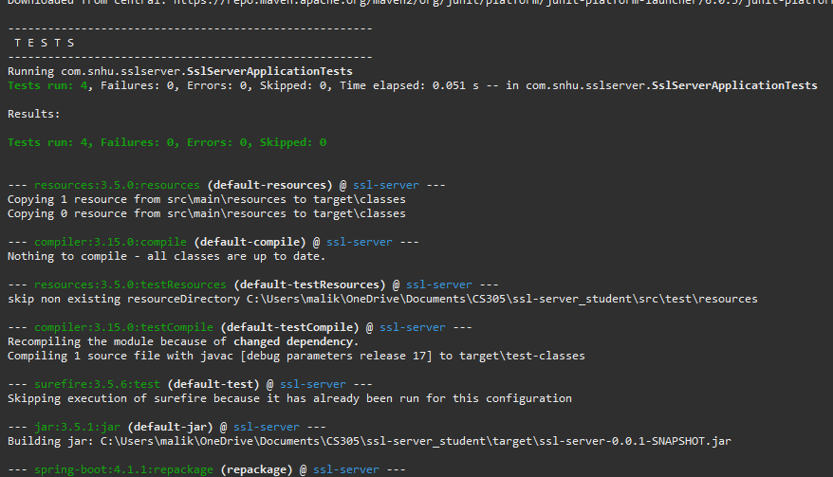
Figure 7. Eclipse Maven output shows all four automated tests passing.
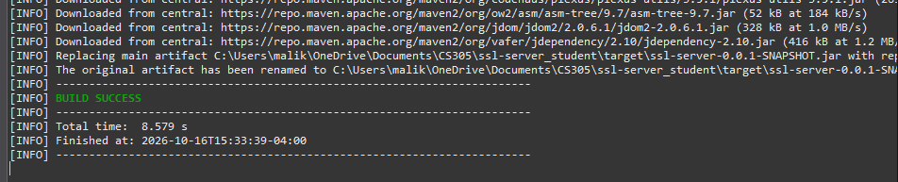
Figure 8. Successful Maven test and package build.

Summary
The refactored application adds a checksum verification route and encrypted transport. TLS protects the connection, the certificate establishes the locally trusted server identity, and SHA-256 checks the demonstration data against an expected digest. These layers address different parts of the communication instead of depending on a single control.
Following the vulnerability assessment process, I identified weaknesses, changed the code and configuration, reviewed the changes, ran tests, and repeated testing after remediation. The security areas addressed are shown below. Dependency testing identified a vulnerable web-server component, which was updated and rescanned until the final report showed no known vulnerabilities.
Security area | Work completed
Cryptography | SHA-256 verification and AES-GCM TLS suites
Client and server communication | HTTPS, certificate identity and hostname validation
Input validation | Expected digest length and hexadecimal checks
Error handling and code quality | Controlled failures, no client stack traces, standard APIs
Dependency review | Tomcat 11.0.24 updated to 11.0.26 and rescanned
Testing and mitigation | Manual review, automated tests, live HTTPS checks and retesting

Industry Standard Best Practices
I used Java’s standard cryptographic APIs rather than implementing a cipher. I selected SHA-256 for verification and TLS 1.2/1.3 with AES-GCM for transport protection. I used a certificate with the correct localhost names, supplied the keystore password through the environment, limited the demonstration to loopback, and prevented detailed server errors from being exposed. The unused Data REST starter was removed to reduce unnecessary dependencies.
I preserved the application’s Spring Boot structure while replacing the old framework and scanner versions. Dependency findings were addressed with an actual Tomcat version update, followed by another scan and runtime check. The NVD API key stays in the local Maven run environment and is not included in the source code or report.
For Artemis Financial, these practices help protect customer information and make future security maintenance easier. Repeatable checks can catch mistakes and known vulnerable components before deployment. A production financial service also needs access controls, protected secret storage, monitoring, trusted certificates, and ongoing patching. These measures reduce exposure to incidents and help maintain customer trust.

Code File Attachments
The accompanying refactored code ZIP contains one complete project folder, including source files, tests, Maven wrapper, the final pom.xml, local certificate files, and evidence. The final HTML scan report and the earlier report are included for comparison. The following files document the implementation.
Project file | Purpose
pom.xml | Java 17, Spring Boot 4.1.1, Tomcat 11.0.26 and Dependency-Check 13.0.0
SslServerApplication.java | Application entry point
ChecksumService.java | UTF-8 SHA-256 calculation and digest verification
HashController.java | GET /hash with name, unique string, checksums and result
application.properties | HTTPS, TLS suites, keystore and error-response configuration
SslServerApplicationTests.java | Four automated tests
certificates/ | Local PKCS12 keystore and exported CER
generate-certificate.cmd | Keytool generation and export commands
LOCAL_SETUP.txt and README.md | Eclipse setup and reproducible build/scan instructions
evidence/ | Screenshots, before/after scan reports and verification logs

References
Apache Software Foundation. (2026). Apache Tomcat 11 vulnerabilities. https://tomcat.apache.org/security-11.html
National Institute of Standards and Technology. (2023). Advanced Encryption Standard, FIPS 197. https://csrc.nist.gov/pubs/fips/197/final
National Institute of Standards and Technology. (2022). NIST policy on hash functions. https://csrc.nist.gov/projects/hash-functions/nist-policy-on-hash-functions
Oracle. (n.d.). The keytool command, Java SE 17. https://docs.oracle.com/en/java/javase/17/docs/specs/man/keytool.html
OWASP Foundation. (n.d.). Dependency-Check. https://owasp.org/projects/dependency-check
Dependency-Check project. (n.d.). Maven plugin configuration. https://dependency-check.github.io/DependencyCheck/dependency-check-maven/configuration.html

