

**The Experiment Report (two) of**

***Deep Learning***

**Name: Fayaz Ahmed Malik (201722800095)**

**College: Software College**

**Subject: Software Engineering**

**E-mail: Fayazmalikscut@gmail.com**

**Tutor: Ming Kui Tan**

**Date submitted: 2017.12. 15**

1. **Topic:** Logistic Regression, Linear Classification and stochastic

gradient descent

**2. Time: Online *Submission 15-12-2017***

**3. Reporter:** Malik Fayaz Ahmed

**4. Purposes:**

1. Further understanding of logistic regression, linear classification and stochastic gradient decent.
2. Compare and understand the relationship and difference between gradient descent and stochastic gradient descent, as well as the logistic regression and linear classification under large scale data-set.
3. Understand the principles of the SVM and practice this process on large scale data.

**5. Data sets and data analysis:**

1. a9a Data (Experiment one)
2. a9a.t Data (Experiment two)

**6. Experimental steps:**

**Experiment: 01 Requirements steps**

*Logistic Regression and Stochastic Gradient Descent*

1. Load the training set and validation set.
2. Initialize logistic regression model parameters, you can consider initializing zeros, random numbers or normal distribution.
3. Select the loss function and calculate its derivation.
4. Calculate gradient toward loss function from partial samples.
5. Update model parameters using different optimized methods(NAG，RMSProp，AdaDelta and Adam).
6. Select the appropriate threshold, mark the sample whose predict scores greater than the threshold as positive, on the contrary as negative. Predict under validation set and get the different optimized method loss.
7. Repeat step 4 to 6 for several times, and drawing graph of different output methods and with the number of iterations.

**Experiment: 02 Requirements steps**

***Linear Classification and Stochastic Gradient Descent***

1. Load the training set and validation set.
2. Initialize SVM model parameters, you can consider initializing zeros, random numbers or normal distribution.
3. Select the loss function and calculate its derivation, find more detail in PPT.
4. Calculate gradient toward loss function from partial samples.
5. Update model parameters using different optimized methods(NAG，RMSProp，AdaDelta and Adam).
6. Select the appropriate threshold, mark the sample whose predict scores greater than the threshold as positive, on the contrary as negative. Predict under validation set and get the different optimized method loss ，， and .
7. Repeat step 4 to 6 for several times, and drawing graph ofdifferent methods and with the number of iterations.

**7. Code for both experiments:**

**Experiment 01 code**

#Code generated by Malik Fayaz Ahmed

#International Student Pakistan

#Student ID 201722800095

#South China University of Technology

import numpy

from collections import defaultdict

class Model(object):

def __init__(self, n_features):

self.params = numpy.random.random(size=(n_features, 1))

self.diffs = numpy.zeros((n_features, 1))

self.recorder = defaultdict(list)

#Code generated by Malik Fayaz Ahmed

#International Student Pakistan

#Student ID 201722800095

#South China University of Technology

def train(self, X, y):

pass

def validate(self, X, y):

self.__loss__(X, y, "validation")

def predict(self, X):

pass

def __calculate_gradient__(self, params=None):

pass

def __loss__(self, X, y, key):

pass

class SVMClassifier(Model):

def __init__(self, n_features, C):

super(SVMClassifier, self).__init__(n_features=n_features)

self.C = C

self.X_train = None

self.y_train = None

def train(self, X, y):

self.X_train = X

self.y_train = y

def predict(self, X):

return numpy.where(numpy.dot(X, self.params) > 0, 1, -1)

#Code generated by Malik Fayaz Ahmed

#International Student Pakistan

#Student ID 201722800095

#South China University of Technology

def __calculate_gradient__(self, params=None):

if params is None:

params = self.params

h = 1 - self.y_train * numpy.dot(self.X_train, params)

y_mask = numpy.where(h > 0, self.y_train, 0)

self.diffs = params - self.C * numpy.dot(self.X_train.transpose(), y_mask)

def __loss__(self, X, y, key):

loss = numpy.sum(self.params * self.params) \

+ self.C * numpy.sum(numpy.maximum(1 - y * numpy.dot(X, self.params), 0))

self.recorder[key].append(loss)

class LogisticRegressionClassifier(Model):

def __init__(self, n_features):

super(LogisticRegressionClassifier, self).__init__(n_features=n_features)

self.X_train = None

self.y_train = None

def train(self, X, y):

self.X_train = X

self.y_train = y

def predict(self, X):

return numpy.where(numpy.dot(X, self.params) > 0, 1, 0)

def __calculate_gradient__(self, params=None):

if params is None:

params = self.params

y_hat = 1 / (1 + numpy.exp(-numpy.dot(self.X_train, params)))

self.diffs = numpy.dot(self.X_train.transpose(), (y_hat - self.y_train))

def __loss__(self, X, y, key):

y_hat = 1 / (1 + numpy.exp(-numpy.dot(X, self.params)))

loss = -numpy.average(y * numpy.log(y_hat) + (1 - y) * numpy.log(1 - y_hat))

self.recorder[key].append(loss)

#Code generated by Malik Fayaz Ahmed

#International Student Pakistan

#Student ID 201722800095

#South China University of Technology

class Optimizer(object):

def __init__(self, model):

self.model = model

self.color = None

def step(self):

pass

class SGD(Optimizer):

def __init__(self, model, learning_rate, momentum=None):

super(SGD, self).__init__(model=model)

self.color = "r"

self.learning_rate = learning_rate

self.momentum = momentum

if momentum is not None:

self.v = numpy.zeros_like(self.model.diffs)

def step(self):

self.model.__calculate_gradient__()

if self.momentum is None:

self.model.params -= self.learning_rate * self.model.diffs

else:

self.v = self.momentum * self.v + self.learning_rate * self.model.diffs

self.model.params -= self.v

#Code generated by Malik Fayaz Ahmed

#International Student Pakistan

#Student ID 201722800095

#South China University of Technology

class NAG(Optimizer):

def __init__(self, model, learning_rate, momentum):

super(NAG, self).__init__(model=model)

self.color = "y"

self.learning_rate = learning_rate

self.momentum = momentum

self.v = numpy.zeros_like(self.model.diffs)

def step(self):

self.model.__calculate_gradient__(params=self.model.params - self.momentum * self.v)

self.v = self.momentum * self.v + self.learning_rate * self.model.diffs

self.model.params -= self.v

class AdaGrad(Optimizer):

def __init__(self, model, learning_rate):

super(AdaGrad, self).__init__(model=model)

self.color = "g"

self.G = numpy.zeros_like(self.model.diffs)

self.learning_rate = learning_rate

self.epsilon = 1e-8

def step(self):

self.model.__calculate_gradient__()

self.G += self.model.diffs * self.model.diffs

self.model.params -= self.learning_rate / numpy.sqrt(self.G + self.epsilon) * self.model.diffs

#Code generated by Malik Fayaz Ahmed

#International Student Pakistan

#Student ID 201722800095

#South China University of Technology

class RMSProP(Optimizer):

def __init__(self, model, leaning_rate, weight_decay):

self.color = "c"

super(RMSProP, self).__init__(model=model)

self.G = numpy.zeros_like(self.model.diffs)

self.learning_rate = leaning_rate

self.weight_decay = weight_decay

self.epsilon = 1e-8

def step(self):

self.model.__calculate_gradient__()

self.G = self.weight_decay * self.G + (1 - self.weight_decay) * self.model.diffs * self.model.diffs

self.model.params -= self.learning_rate / numpy.sqrt(self.G + self.epsilon) * self.model.diffs

class AdaDelta(Optimizer):

def __init__(self, model, gamma):

super(AdaDelta, self).__init__(model=model)

self.color = "b"

self.gamma = gamma

self.G = numpy.zeros_like(self.model.diffs)

self.delta = numpy.zeros_like(self.model.diffs)

self.delta_theta = numpy.zeros_like(self.model.diffs)

self.epsilon = 1e-4

def step(self):

self.model.__calculate_gradient__()

self.G = self.gamma * self.G + (1 - self.gamma) * self.model.diffs * self.model.diffs

self.delta_theta = -(numpy.sqrt(self.delta + self.epsilon)

/ numpy.sqrt(self.G + self.epsilon)) * self.model.diffs

self.model.params += self.delta_theta

self.delta = self.gamma * self.delta + (1 - self.gamma) * self.delta_theta * self.delta_theta

class Adam(Optimizer):

def __init__(self, model, beta, gamma, eta):

super(Adam, self).__init__(model=model)

self.color = "m"

self.beta = beta

self.gamma = gamma

self.eta = eta

self.m = numpy.zeros_like(self.model.diffs)

self.G = numpy.zeros_like(self.model.diffs)

self.epsilon = 1e-8

def step(self):

self.model.__calculate_gradient__()

self.m = self.beta * self.m + (1 - self.beta) * self.model.diffs

self.G = self.gamma * self.G + (1 - self.gamma) * self.model.diffs * self.model.diffs

alpha = self.eta * (numpy.sqrt(1 - self.gamma)) / (1 - self.beta)

self.model.params -= alpha * self.m / numpy.sqrt(self.G + self.epsilon)

import requests

train_set = requests.get("https://www.csie.ntu.edu.tw/~cjlin/libsvmtools/datasets/binary/a9a")

validation_set = requests.get("https://www.csie.ntu.edu.tw/~cjlin/libsvmtools/datasets/binary/a9a.t")

from io import BytesIO

from sklearn.datasets import load_svmlight_file

X_train, y_train = load_svmlight_file(BytesIO(train_set.content), n_features=123)

X_val, y_val = load_svmlight_file(BytesIO(validation_set.content), n_features=123)

X_train = X_train.toarray()

X_val = X_val.toarray()

n_samples_train, n_features_train = X_train.shape

X_train = numpy.concatenate((X_train, numpy.ones(shape=(n_samples_train, 1))), axis=1)

y_train = y_train.reshape((n_samples_train, 1))

n_samples_val, n_features_val = X_val.shape

X_val = numpy.concatenate((X_val, numpy.ones(shape=(n_samples_val, 1))), axis=1)

y_val = y_val.reshape((n_samples_val, 1))

#Code generated by Malik Fayaz Ahmed

#International Student Pakistan

#Student ID 201722800095

#South China University of Technology

optimizers = [

SGD(model=SVMClassifier(n_features=123 + 1, C=1), learning_rate=0.00001, momentum=0.5),

NAG(model=SVMClassifier(n_features=123 + 1, C=1), learning_rate=0.0001, momentum=0.9),

AdaGrad(model=SVMClassifier(n_features=123 + 1,C=1),learning_rate=0.1),

RMSProP(model=SVMClassifier(n_features=123 + 1,C=1),leaning_rate=0.1,weight_decay=0.9),

AdaDelta(model=SVMClassifier(n_features=123 + 1,C=1), gamma=0.95),

Adam(model=SVMClassifier(n_features=123 + 1,C=1),beta=0.9,gamma=0.999,eta=0.1)

]

max_epoch = 100

batch_size = 10000

for epoch in range(max_epoch):

indexes = numpy.random.randint(0, n_samples_train, size=batch_size)

for optimizer in optimizers:

optimizer.model.train(X_train[indexes], y_train[indexes])

optimizer.step()

optimizer.model.validate(X_val, y_val)

from sklearn.metrics import classification_report

print("-" * 20 + optimizers[0].model.__class__.__name__ + "-" * 20)

for optimizer in optimizers:

print("-" * 24 + optimizer.__class__.__name__ + "-" * 24)

print(classification_report(y_val,

optimizer.model.predict(X_val),

target_names=["positive", "negative"],

digits=3))

import matplotlib.pyplot as plt

%matplotlib inline

plt.figure(figsize=(10,10))

plt.xlabel("epoch")

plt.ylabel("loss")

plt.title(optimizers[0].model.__class__.__name__)

for optimizer in optimizers:

plt.plot(optimizer.model.recorder["validation"], color=optimizer.color, label=optimizer.__class__.__name__)

plt.legend()

plt.show()

**Experiment 02 code**

# Fayaz code for logistic regression.

#Code generated by Malik Fayaz Ahmed

#International Student Pakistan

#Student ID 201722800095

#South China University of Technology

y_train = numpy.where(y_train == -1, 0, y_train)

y_val = numpy.where(y_val == -1, 0, y_val)

optimizers = [

SGD(model=LogisticRegressionClassifier(n_features=123 + 1), learning_rate=0.00001, momentum=0.5),

NAG(model=LogisticRegressionClassifier(n_features=123 + 1), learning_rate=0.00001, momentum=0.5),

AdaGrad(model=LogisticRegressionClassifier(n_features=123 + 1), learning_rate=0.1),

RMSProP(model=LogisticRegressionClassifier(n_features=123 + 1), leaning_rate=0.1, weight_decay=0.9),

AdaDelta(model=LogisticRegressionClassifier(n_features=123 + 1), gamma=0.95),

Adam(model=LogisticRegressionClassifier(n_features=123 + 1), beta=0.9, gamma=0.999, eta=0.1)

]

max_epoch = 100

batch_size = 10000

for epoch in range(max_epoch):

indexes = numpy.random.randint(0, n_samples_train, size=batch_size)

for optimizer in optimizers:

optimizer.model.train(X_train[indexes], y_train[indexes])

optimizer.step()

optimizer.model.validate(X_val, y_val)

from sklearn.metrics import classification_report

print("-" * 20 + optimizers[0].model.__class__.__name__ + "-" * 20)

for optimizer in optimizers:

print("-" * 24 + optimizer.__class__.__name__ + "-" * 24)

print(classification_report(y_val,

optimizer.model.predict(X_val),

target_names=["positive", "negative"],

digits=3))

import matplotlib.pyplot as plt

%matplotlib inline

plt.figure(figsize=(10,10))

plt.xlabel("epoch")

plt.ylabel("loss")

plt.title(optimizers[0].model.__class__.__name__)

for optimizer in optimizers:

plt.plot(optimizer.model.recorder["validation"], color=optimizer.color, label=optimizer.__class__.__name__)

plt.legend()

plt.show()

**8. Selection of validation (hold-out, cross-validation, k-folds cross-validation,etc.):**

**9. The initialization method of model parameters:**

* The SVM model is being updated by using different optimizing methods like NAG, RMSProp, AdaDelta and Adam.

**10. The selected loss function and its derivatives:**

**11. Experimental results and curve**

* **Experiment 01 Result**

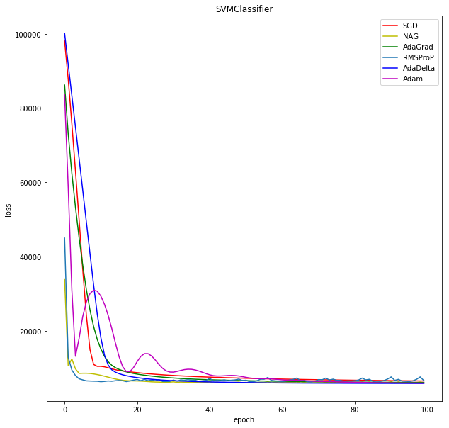

* Experiment result ： 02

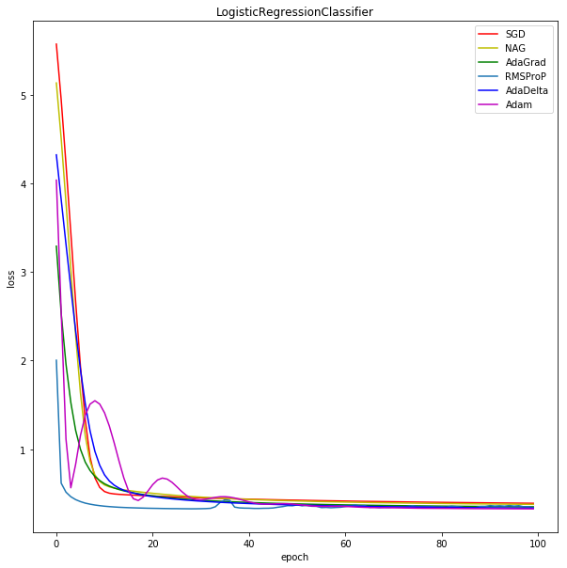

**13. Similarities and differences between logistic regression and linear classification:**

The logistic regression is called as a linear classifier because it produces a decision boundary which is linear in nature. So, the classification makes by logistic regression is linear classification only.

**Regression:** given a set of data, find the best relationship that represents the set of data.

**Classification:** given a known relationship, identify the class that the data belongs to.

We can see that regression and classification start from opposing ends: to find a pattern or to find the pattern that it belongs to.

**14. Summary:**

Logistic regression measures the relationship between the categorical dependent variable and one or more independent variables by estimating probabilities using a logistic function, which is the cumulative logistic distribution. Thus, it treats the same set of problems as prohibit regression using similar techniques, with the latter using a cumulative normal distribution curve instead.

A linear classifier achieves this by making a classification decision based on the value of a linear combination of the characteristics. An object's characteristics are also known as feature values and are typically presented to the machine in a vector called a feature vector.

Classification Problems, Classification is a central topic in machine learning that has to do with teaching machines how to group together data by criteria. Classification is the process where computers group data together based on predetermined characteristics this is called supervised learning.

Stochastic gradient descent (often shortened to SGD), also known as incremental gradient descent, is a stochastic approximation of the gradient descent optimization and iterative method for minimizing an objective function that is written as a sum of differentiable functions. In other words, SGD tries to find minima or maxima by iteration. Stochastic gradient descent is a popular algorithm for training a wide range of models in machine learning, including (linear) support vector machines, logistic regression and graphical models.When combined with the back propagation algorithm; it is the *de facto* standard algorithm for training artificial neural networks.

Classification problems try to determine group membership by deriving probabilities. The first technique ever used was linear discriminate analysis (LDA), proposed by Sir R.A. Fisher in 1936—he used to classify irises. I do not understand it fully, but believe that it used linear regression to derive probabilities for each group, and then used a Mahalanobis distance measure to assign to the closest group.