

COMPUTER ENGENIRING
PHYSICS LABORATORY
TİME CONSTANT - CAPACİTOR CHARGİNG & DİSCHARGİNG EXPERIMENT

GROUP 3

STUDENT’S NAME | : | Malik Fikrat Mohammed Saeed ALHASAN
STUDENT’S NUMBER | : | 123456789

STUDENT’S NAME | : | ------------------------
STUDENT’S NUMBER | : | 123456789

STUDENT’S NAME | : | ---------------------
STUDENT’S NUMBER | : | 123456789

STUDENT’S NAME | : | -----------------------------
STUDENT’S NUMBER | : | 123456789
EXPERIMENT DATE | : | 18 April 2025
DELIVERI DATE | : | 24 April 2025
ASSISTANT’S NAME | : | Berke Can TURAN

Table of Contents
2 PURPOSE OF THE EXPERIMENT: 4
3 THEORETICAL INFORMATION: 4
3.1 Capacitor Charging Equation 4
3.2 Capacitor Discharging Equation 4
3.3 Time Constant ($τ$) 4
4 MATERIALS REQUIRED FOR THE EXPERIMENT: 5
5 PERFORMING THE EXPERIMENT: 5
6 DATA AND CALCULATIONS: 6
6.1 Calculations: 6
7 EVALUATION AND COMMENT: 7
7.1 Comment About Percentage Error in The Experiment: 7
7.2 Questions: 8
7.2.1 First Question: 8
7.2.2 Second Question: 8
7.2.3 Third Question: 8
8 SOURCES: 8

PURPOSE OF THE EXPERIMENT:
The purpose of the Time Constant - Capacitor Charging & Discharging experiment is to investigate and understand the behavior of capacitors during charging and discharging processes in electrical circuits. This experiment focuses on analyzing the exponential nature of voltage changes and deriving the time constant, a key parameter that defines the speed of these transitions. Understanding the time constant is essential for designing and analyzing circuits involving capacitive elements, with practical applications in filters, timing circuits, and transient response analysis in electronic systems.

THEORETICAL INFORMATION:

Capacitor Charging Equation
The voltage across a capacitor during the charging process is described by the exponential equation:
$$V_{c}(t)=V_{max}(1-e^{-t/RC})$$
- $V_{c}(t)$ is the voltage across the capacitor at time $t$.
- $V_{max}$ is the maximum voltage supplied by the source.
- $R$ is the resistance in the circuit.
- $C$ is the capacitance of the capacitor.
- $RC$ is the time constant $τ$, which determines the rate of charging.

Capacitor Discharging Equation
When discharging, the voltage across the capacitor decreases exponentially according to:
$$V_{c}(t)=V_{0}×e^{-t/RC}$$
- $V_{0}$ is the initial voltage across the capacitor before discharge.
- $t$ is the time elapsed after the beginning of the discharge.
- $RC$ is the time constant $τ$.

Time Constant ($τ$)
The time constant is a key parameter that determines how quickly a capacitor charges or discharges. It is calculated as:
$$τ=R⋅C$$
- • A smaller $τ$ means faster charging/discharging.
- • A larger $τ$ indicates slower charging/discharging.

MATERIALS REQUIRED FOR THE EXPERIMENT:
  - Function Generator
  - Capacitors
  - Multimeter (Voltmeter)
  - Resistors
  - Circuit board (with switch)
  - Connection cables

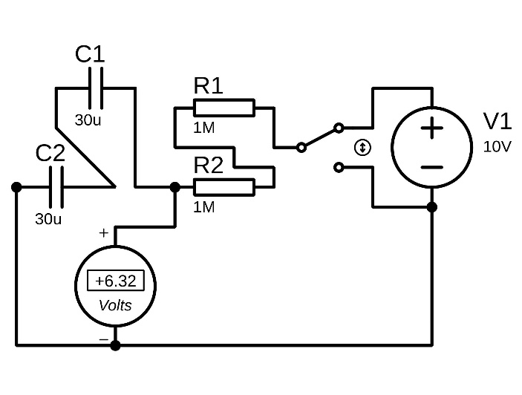
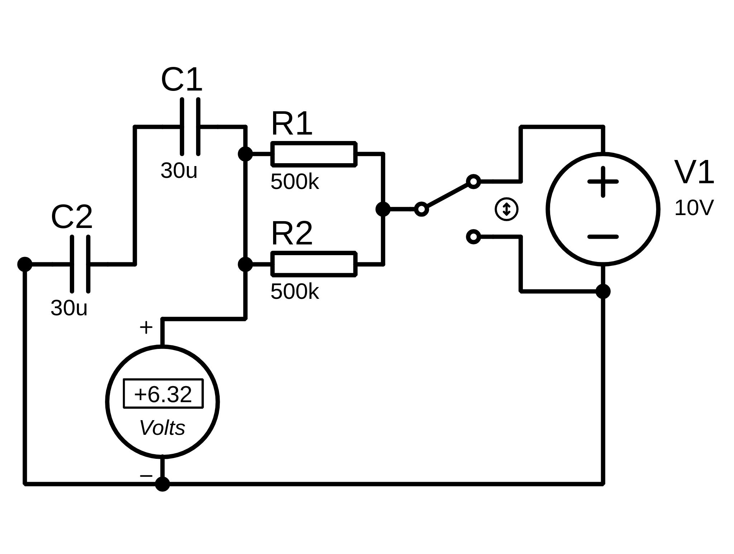
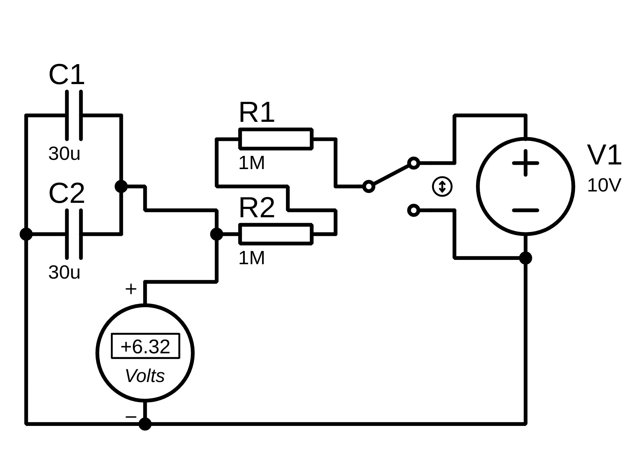
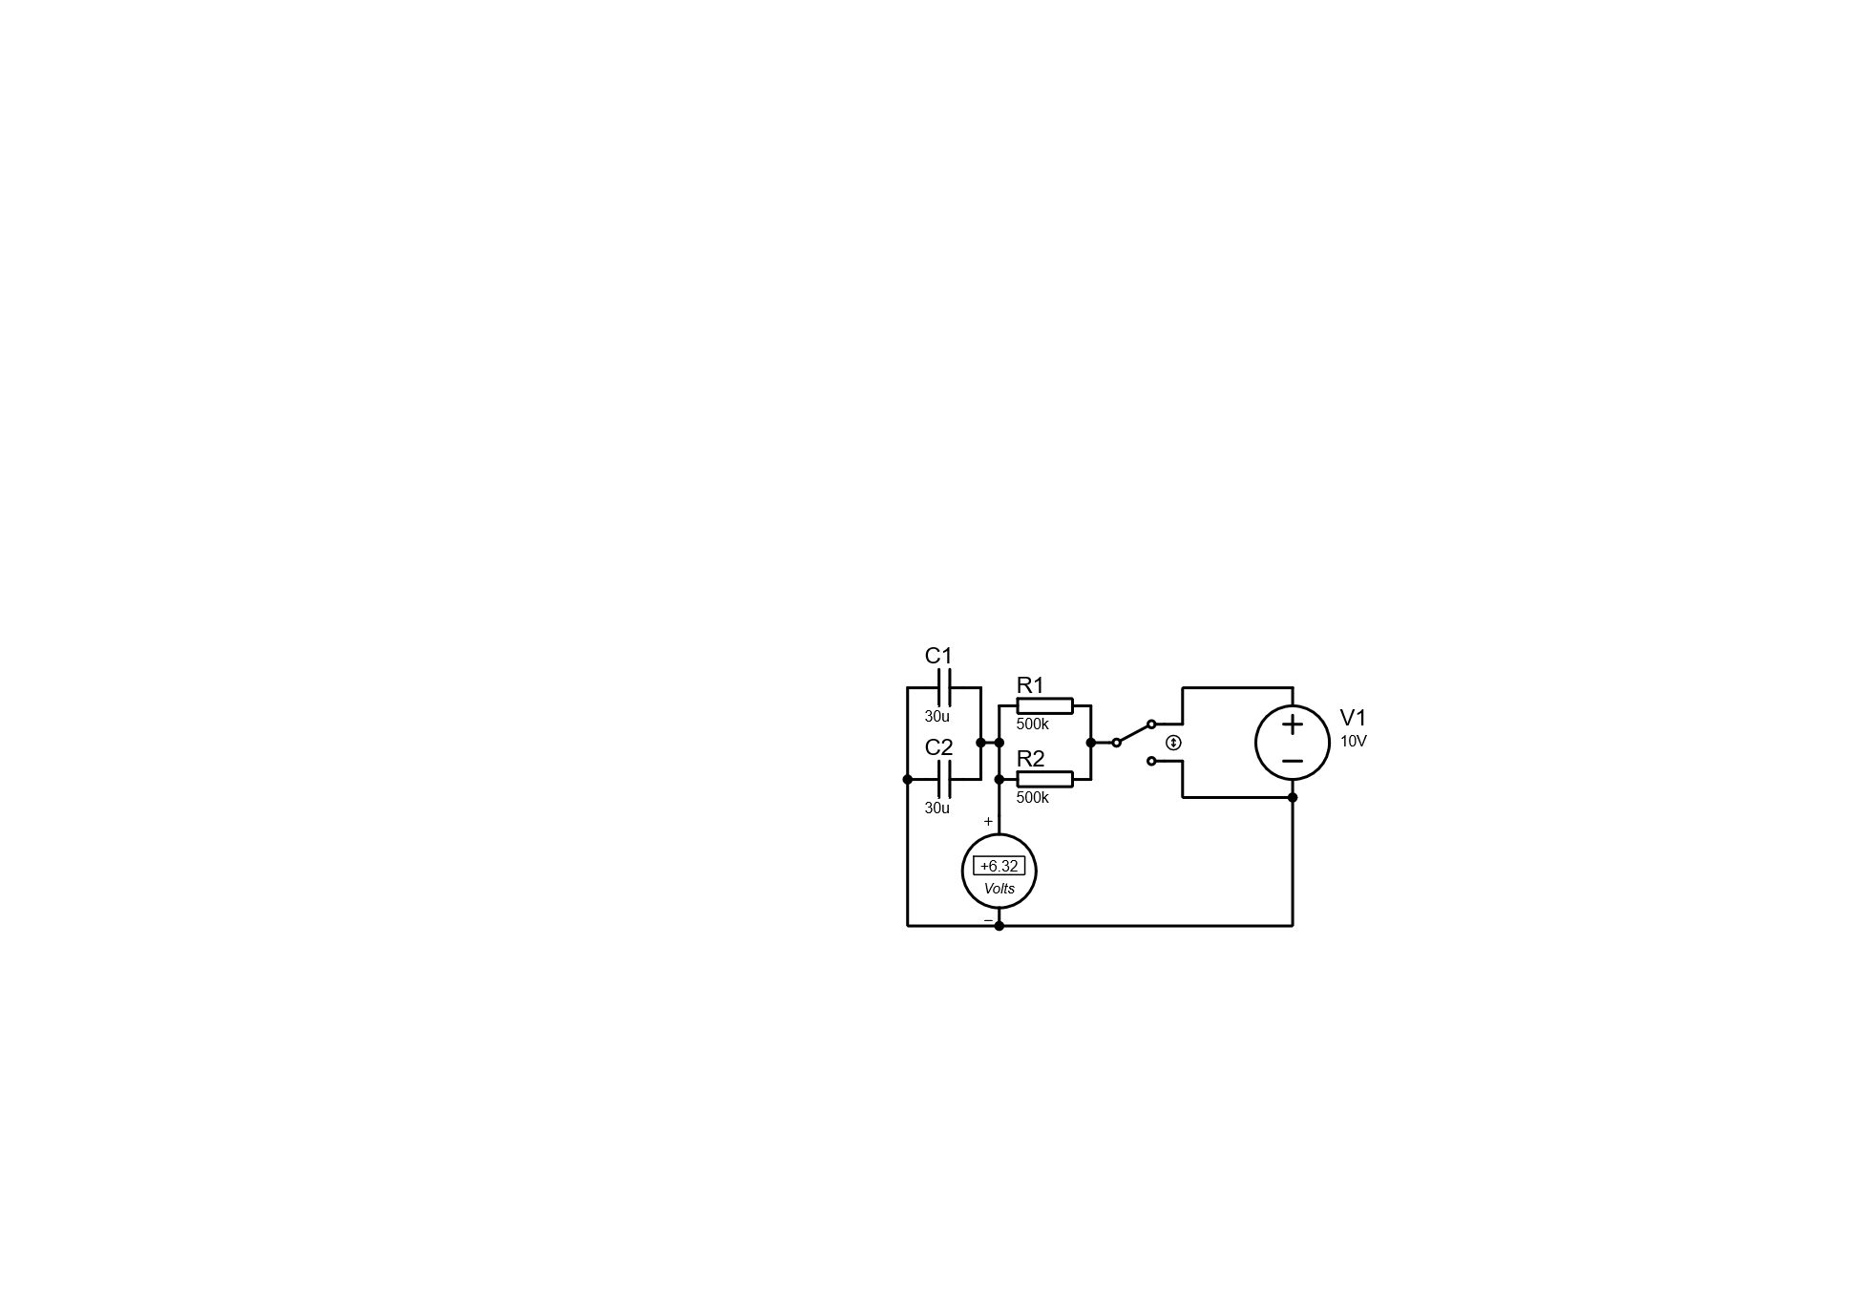
PERFORMING THE EXPERIMENT:
Figure 1: Diagram of the Experiment on Proteus
Parallel Capacitor – Serial Resistor
Serial Capacitor – Parallel Resistor

Parallel Capacitor – Parallel Resistor
Serial Capacitor – Serial Resistor

    - First, the cable was connected to the output of the function generator, and the settings were adjusted.
    - The nagetive cable coming from the function generator was connected to the COM input of the DC voltmeter and at the same time it was connected to switch and connected to outpout of capacitors.
    - The positive cable coming from the function generator was connected to onuther switch’s arm.
    - The output of switch was connected to resetior.
    - The output of resistor was connected to input of capacitors and positive input of DC voltmeter.

DATA AND CALCULATIONS:

Calculations:
To find Time Constant (τ) :
$$τ=RC$$
- $R$ is resistor ($Ω$).
- $C$ is capacitor ($F$).
To find Percentage Error :
$$Percentage Error=\left|\frac{Measured Value-Theoretical Value​}{Theoretical Value​}\right|×100$$
Table 1
Resistance | Capacitance | Time Constant  (Mesured) | Time Constant  (Calculated) | Percetange Error
$$500kΩ$$ | $$15μF$$ | $$7.90s$$ | $$7.5s$$ | $$5.3\%$$
$$500kΩ$$ | $$60μF$$ | $$31.31s$$ | $$30s$$ | $$4.4\%$$
$$1MΩ$$ | $$15μF$$ | $$16.19s$$ | $$15s$$ | $$7.9\%$$
$$1MΩ$$ | $$60μF$$ | $$64.62s$$ | $$60s$$ | $$7.7\%$$
$$2MΩ$$ | $$15μF$$ | $$35.50s$$ | $$30s$$ | $$18.3\%$$
$$2MΩ$$ | $$60μF$$ | $$139.53s$$ | $$120s$$ | $$16.3\%$$

EVALUATION AND COMMENT:

Comment About Percentage Error in The Experiment:
When conducting the Time Constant (Capacitor Charging/Discharging) Experiment, several sources of error could contribute to the percentage error observed in the results. Here are the possible reasons and their impacts:
Possible Sources of Error:
- Measurement Errors:
  - Stopwatch reaction time delays in manual timing.
  - Multimeter inaccuracies or slow sampling rates.
- Component Tolerances:
  - Resistor and capacitor values may deviate from labeled specifications (±5%–10%).
  - Parasitic resistance in breadboards/wires, especially at high resistances (1MΩ–2MΩ).
- Capacitor Imperfections:
  - Leakage current causing premature discharge.
  - Dielectric absorption affecting charging/discharging curves.
- Voltage Source Instability:
  - Power supply fluctuations during charging/discharging phases.
- Environmental Factors:
  - Temperature changes altering resistance/capacitance values.
- Calculation Approximations:
  - Rounding errors in theoretical time constant ($τ=RC$) vs. measured values.
Impact on Results:
- Lower resistances (500kΩ) showed smaller errors (4–5%) due to minimal parasitic effects.
- Higher resistances (1MΩ–2MΩ) had larger errors (7–18%) due to amplified measurement and parasitic influences.

Questions:
There are a few questions that we came up with, and after researching, we found the answers as follows:

First Question:
What is the time constant and why is it important??
Answer:
The time constant (τ) is the product of resistance (R) and capacitance (C) in an RC circuit: $τ=R×C$. It represents the time it takes for the voltage across the capacitor to reach about 63.2% of its final value. It’s important because it determines how fast a capacitor charges or discharges. Time constant is essential in timing, filtering, and signal processing applications.

Second Question:
What happens to the time constant when R1 value increase and decrease?
Answer:
If R1 increases, the time constant (τ = R × C) also increases, meaning the circuit responds more slowly. If R1 decreases, the time constant becomes smaller, so charging/discharging happens faster. So, resistance directly affects how quickly the capacitor reacts to voltage changes. Higher resistance = slower response, lower resistance = faster response.

Third Question:
What happens to the time constant when capacitance value increase and decrease?
Answer:
When the capacitance increases, the time constant increases, resulting in slower charging/discharging. When capacitance decreases, the time constant gets smaller, and the capacitor charges/discharges faster. Just like resistance, capacitance affects how long it takes for the voltage to change. More capacitance means more energy storage and a slower voltage change.

SOURCES:
- J. W. Nilsson & S. Riedel, Electric Circuits, 11th ed., Pearson, 2019.
- K. S. Smith & L. E. Larson, "Effects of Parasitic Elements on RC Circuit Behavior," Journal of Electrical Engineering, vol. 45, pp. 112-125, March 2018.
- MIT OpenCourseWare, "RC Circuits: Time Constants and Transient Response," ocw.mit.edu/courses/electrical-engineering-and-computer-science/6-002-circuits-and-electronics-spring-2007/lecture-notes/, 2007.

