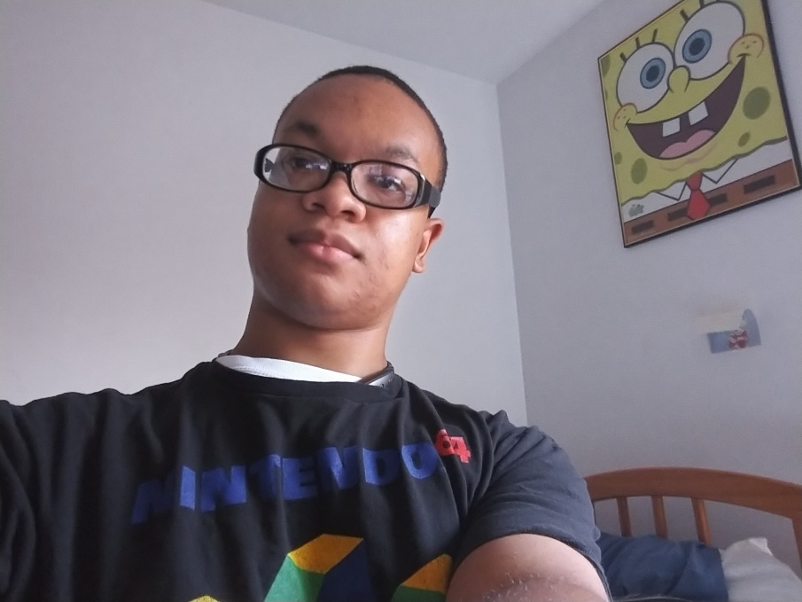**Malik Tifah**

My Values / Beliefs:

I know that it’s rather cliché, but I believe that with enough determination anyone can do anything they set their mind to.

My Interests:

I would say that my most prevalent interest would be playing and building video games. In regards to the games I play, I’m mainly into strategy games and platformers. In regards to building games, I’ve mainly built micro games (ex. maze games, pinball, pachinko, etc.) through engines like Unity and Unreal engine 4, but I’m hoping to at least start building a larger scale project (either a platformer or a short RPG) through either Unity or Unreal before this year ends. I’ve also been spending a lot of time learn more about other programming languages outside of Java. The main one that I’m working on now is C++ and C#. Outside of things involving the computer, I do like spending time with my friends either in real life or through online methods.

Career goals:

My main career goal is to get a job as a game developer/ game programmer. I also do want to develop my own game with a large scale story that I’ve been working out in my mind for years, but that will be something that I work on bit by bit once I get more experience with game engines.

What I hope to learn:

I already do have some cursory experience with Object Oriented programing, so through this class I hope to learn even more about the practical uses for object oriented programing.