CS 305 Project Two
  - Practices for Secure Software Report
Client: Artemis Financial | Application: ssl-server | Developer: Gabdelmalik Ganiev
Prepared: October 2026 | Evidence status: preliminary; unresolved dependency findings

Executive Summary
The Artemis Financial Spring Boot application was refactored to provide an HTTPS-only local endpoint and a SHA-256 checksum of fixed demonstration data. A self-signed PKCS#12 certificate was generated with Java keytool, the /hash endpoint returned the developer identifier and checksum, and four automated tests passed in the captured Maven output. An OWASP Dependency-Check report identified 40 potential vulnerabilities across four libraries; the NVD update subsequently failed. Therefore, the implementation is demonstrated but the dependency-security acceptance criterion remains open.

1. Algorithm Cipher Recommendation
For confidentiality in transit, use TLS 1.3 with an authenticated encryption suite such as AES-128-GCM or AES-256-GCM, negotiated by the TLS implementation. AES is a symmetric block cipher with a 128-bit block size and 128-, 192-, or 256-bit keys. GCM provides encryption plus authentication; it requires a unique nonce for each encryption under the same key. TLS uses asymmetric authentication/key agreement (for example, certificate-backed signatures and ephemeral ECDHE) to establish symmetric traffic keys, which are more efficient for bulk data. Secure random-number generation is essential for ephemeral key material and nonces.
SHA-256 is a cryptographic hash, not an encryption cipher: it outputs a 256-bit (64-character hexadecimal) digest, without a secret key or decryption step. It detects accidental changes when compared to a trusted expected digest; an attacker able to replace both content and digest could defeat this check. TLS authentication or an HMAC/digital signature is needed to authenticate untrusted transferred data. Earlier DES and 3DES designs have been retired or deprecated because of inadequate security margins; AES and modern TLS are preferred. TLS 1.2 remains enabled in this demonstration for compatibility, although TLS 1.3 is preferred.

2. Certificate Generation
A 3,072-bit RSA key pair and a self-signed certificate were generated using Java keytool with SHA256withRSA, a PKCS#12 keystore, alias artemis, and localhost/127.0.0.1 subject alternative names. The screenshot demonstrates successful key generation. The certificate was exported as artemis.cer, visible in the project resources folder. A self-signed certificate supports a local demonstration but is not automatically trusted by browsers; production deployments should use a certificate issued by a trusted CA.

3. Deploy Cryptographic Hash / Checksum
HashController.java defines fixed, non-sensitive demonstration data containing the developer name and a unique identifier. It computes SHA-256 using MessageDigest over UTF-8 bytes and formats the result as hexadecimal. The /hash route returns the developer, input data, algorithm, and checksum. A new MessageDigest is created per invocation to avoid shared mutable digest state. The response disables caching and adds restrictive content headers. The browser evidence demonstrates the endpoint response; the digest should be independently recomputed during final acceptance testing.

4. Secure Communications
application.properties binds the server to 127.0.0.1 on port 8443, enables SSL with a PKCS#12 keystore, and permits TLS 1.3 and TLS 1.2. The keystore password is supplied at runtime through ARTEMIS_KEYSTORE_PASSWORD rather than committed to source control. The endpoint was reached at https://localhost:8443/hash. The browser displayed “Not secure” because the local certificate was self-signed/untrusted; this does not demonstrate public CA trust. A production deployment must validate the certificate chain and host identity.

5. Secondary Static / Dependency Testing
OWASP Dependency-Check Maven plugin 13.0.0 generated an HTML report for the application. The report lists 34 dependencies scanned (16 unique), four vulnerable dependencies, and 40 reported vulnerabilities: Jackson Databind 2.21.4 (1), Log4j API 2.24.3 (3), Spring Core 6.2.19 (17), and Tomcat Embedded Core 10.1.55 (19). Spring Core and Tomcat were classified as critical in the report. The report also shows “Error updating the NVD Data”; later reruns failed because of an unavailable/empty NVD API key and then because no offline database existed. These counts may be stale, and findings must be assessed for applicability. No clean post-remediation scan is available. Do not characterize this as passing security validation.
Recommended remediation: obtain a working NVD feed, update to vendor-supported patched versions compatible with the Spring Boot release, examine the exact CVEs and reachable attack surfaces, rerun tests, and repeat Dependency-Check. Do not suppress findings merely to obtain BUILD SUCCESS. The demonstrated /hash endpoint uses plain-text responses, so a view-rendering CVE may not be exploitable there, but that does not remove the need for a full assessment.

6. Functional Testing and Manual Review
Maven output showed four tests run, zero failures, zero errors, and zero skipped, followed by BUILD SUCCESS. The HTTPS endpoint returned a SHA-256 digest and developer-specific data. Manual review considered correct route mapping, UTF-8 conversion, exception handling, no shared digest state, loopback-only binding, and avoidance of plaintext keystore credentials in application.properties. Remaining checks: confirm certificate export contents, verify SHA-256 independently, verify HTTP is not listening on port 8080, inspect the test source, and retest after dependency upgrades.

7. Security Refactoring Summary
The changes addressed data integrity (SHA-256 checksum), transport confidentiality and integrity (TLS), server identity for a local test (self-signed certificate), secret-handling hygiene (environment-variable password), and automated dependency visibility (OWASP scanner). The process followed identification, remediation, functional validation, secondary analysis, and iteration. Security is layered: TLS protects transport; checksum illustrates change detection; headers limit some browser behaviors; dependency scanning identifies third-party risk. The scan results show that remediation and final validation are still pending.

8. Industry Standard Best Practices
The implementation uses Java standard cryptographic APIs instead of custom cryptography, SHA-256 instead of weak legacy hashes, HTTPS instead of plaintext HTTP, restricted local binding, environment-based secret configuration, explicit TLS protocol configuration, repeatable Maven tests, and a dependency vulnerability scanner. These practices reduce avoidable implementation errors and help preserve customer confidence, regulatory readiness, business continuity, and maintainability. For production, use CA-issued certificates, an approved secrets manager, authenticated file-integrity protection where needed, monitored patching, and a clean reproducible security scan.

Evidence Appendix
The screenshots below were supplied during development. Screenshots are evidence of observed output, not proof that unresolved vulnerabilities were remediated.

A. Certificate creation in Java keytool
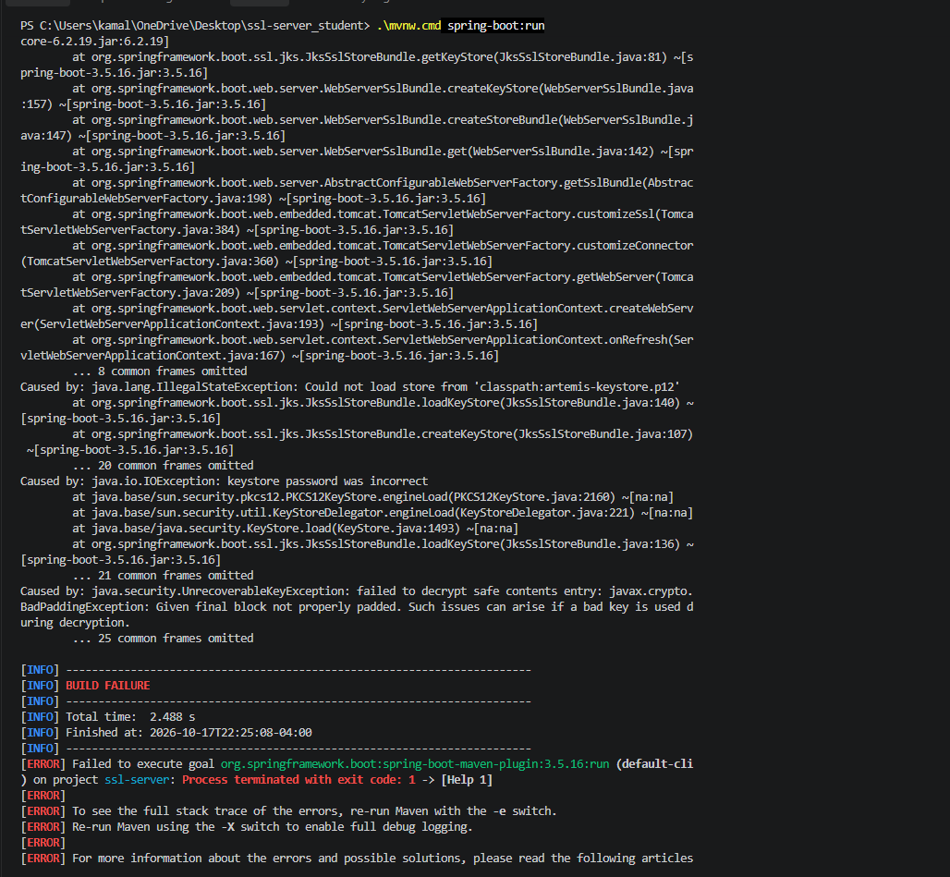

B. HTTPS /hash response and SHA-256 checksum
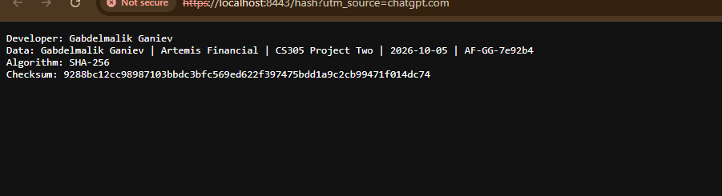

C. OWASP dependency-check summary and NVD exception
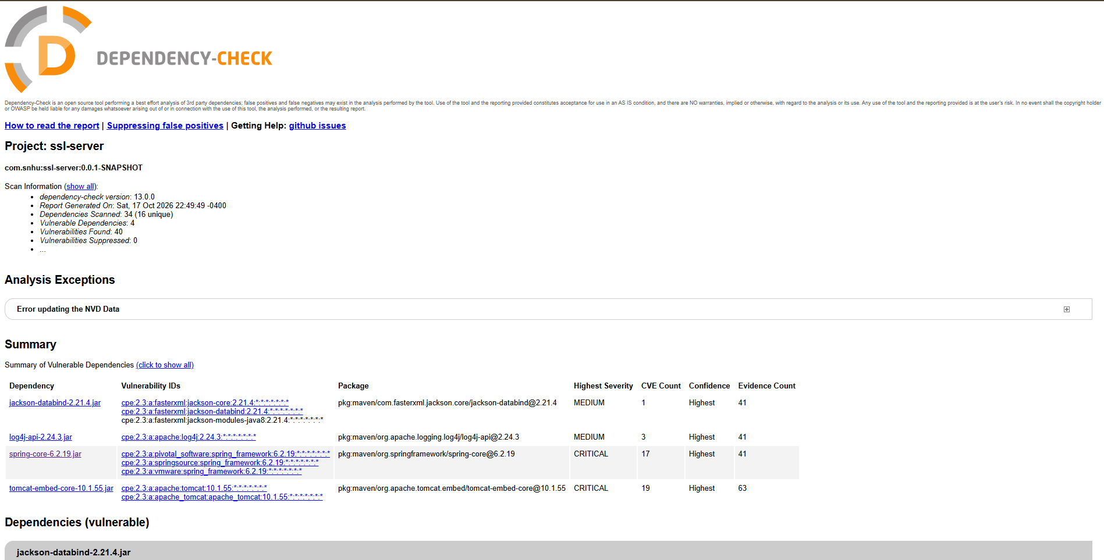

Final Submission Checklist
- Confirm exported artemis.cer and include a close-up screenshot of the certificate file/details.
- Capture a current clean application-run screenshot and, if possible, independently verify the digest.
- Resolve or document remaining OWASP CVEs; repeat the scan after obtaining usable vulnerability data.
- Copy this report into the official SNHU Project Two Template if your instructor requires its exact layout.
- Create a ZIP of the actual project directory, excluding old keystores, passwords, generated target files, and unnecessary effective-pom.xml. Include the source, pom.xml, Maven wrapper, and only the intended demo keystore/certificate.
- Never submit the keystore password or NVD API key in screenshots, reports, or source files.

