# FTP Search Engine

Muhammad Rizwan Babar Kamal

051-09-000000 051-09-000000



# Mr Adeel K. Siddique

A Final Year Project Report is

Submitted in Partial Fulfilment of the

Requirements for the Degree of

Bachelor of Science in Telecommunication & Networks

**Department of Computing & Technology**

**Iqra University, Islamabad Campus**

**June 2016**

**Certificate**

We hereby accept the work contained in this report titled: ***Project Title***, as a confirmation to the required standards for the partial fulfillment of the degree of Bachelors of Science in Computer Science.

*Internal Examiner*  *External Examiner*

*Project Supervisor Head of Department*

# Declaration

I hereby declare that this work, neither whole nor in part, has been copied from any source. It is further declared that I have prepared this report entirely on the basis of my personal efforts made under the sincere guidance of teachers especially my supervisor Mr. Adeel K Siddique. If any part of this thesis is proved to be copied out from any source or found to be reproduction of some other, I will stand by the consequences. No potion of the work presented has been submitted in support of any application for any other degree or qualification of this or any other university or institute of learning.

Waseem Abbas

# Dedication

I dedicate this thesis to my parents, my brother, my supervisor, friends and all those people who helped me in the completion of this project.

# Acknowledgments

First I would like to thank ALLAH Almighty who has enabled me to do this project. Secondly, I would like to express my deepest appreciation and sincerest gratitude to my supervisor Mr. Adeel Khalid Siddique who guided me in this project and finally to my parents who supported mean all up and downs throughout the life.

# Abstract

A very brief description of your project needs to go here. Normally, this would be a very concise summary of your entire report. In addition, this should not be more than two paragraphs.

Contents

FTP Search Engine i

Mr Adeel K. Siddique i

Declaration iii

Dedication iv

Acknowledgments v

Abstract vi

List of Tables xi

Chapter 1 Introduction 1

1.1 Over View of Communication System 2

1.2 Digital Systems 2

1.2.1 Disadvantages of Digital 2

1.2.2 Definition of Analogue 2

1.2.3 Advantages of Analogue Systems 3

1.2.4 Disadvantages of Analogue Systems 3

1.3 Generations of Mobile Systems 3

1.3.1 FIRST GENERATION 3

1.3.2 SECOND GENERATION 3

1.3.3 THIRD GENERTAION 4

1.4 BEYOND 3G 4

Chapter 2 Multiple Accesses in Communication Systems 5

2.1 Frequency Division Multiple Access (FDMA) 6

2.2 Time Division Multiple Access (TDMA) 6

2.3 SDMA 7

2.4 CDMA 7

Chapter 3 Source Coding and Digital Modulation 9

3.1 Introduction 10

3.2 Mechanized sign 10

3.2.1 Non-Return to Zero (NRZ) 10

3.2.2 Multilevel Binary (AMI) 10

3.2.3 Manchester Coding 10

3.2.4 Differential Manchester 11

3.3 Analog Data Conversion 11

3.3.1 Pulse Code Modulation 11

3.3.2Delta Modulation 12

3.4 DIGITAL DATA, SIGNAL 12

3.4.1Amplitude Shift Keying (ASK) 12

3.4.2 *Frequency Shift Keying (FSK)* 12

3.4.3 Phase Shift Keying (PSK) 13

Chapter 4 Channel Coding 15

4.1 Introduction 16

4.2 Channel Coding Schemes: 16

4.3 CONVOLUTIONAL CODES 16

4.4 CONVOLUTIONAL CODE REPRESENTATIONS 17

4.4.1 State Transition Diagram 19

4.4.2 Convolution Coding Explanation: 20

4.4.3 Representation using Trellis Diagram 21

4.5 LOW DENSITY PARITY CHECK 21

Chapter 5 Pulse Shaping Techniques 23

5.1 INTRODUCTION 24

5.2 RAISED COSINE FILTER 24

5.3 ROOT RAISED COSINE FILTER 26

5.4 ROLL OFF FACTOR 28

Chapter 6 Spread Spectrum 29

6.1 INTRODUCTION 30

6.2 Advantages 30

6.3 Disadvantages 30

6.4 Types of Spread Spectrum Techniques 30

6.4.1 Frequency Hopping Spread Spectrum 30

6.4.2 Direct Sequence Spread Spectrum 30

6.5 Spreading effect on Bandwidth 34

6.6 De-spreading effect on Bandwidth 35

Chapter 7 DESIGN OF A WCDMA BASED COMMUNICATION SYSTEM 36

7. 1 THE SYSTEM DIAGRAM 37

7.2 THE TRANSMITTER 38

7.2.1 CRC Attachment and Block Segmentation: 38

7.2.2 Channel Encoding 38

7.2.3 WCDMA Spreading 38

7.2.4 Digital Modulation 38

7.2.5 Pulse Shaping 38

7.3 THE CHANNEL 39

7.3.1 Additive White Gaussian Noise (AWGN) Channel: 39

7.4 THE RECEIVER 40

7.4.1 Synchronization 40

7.4.2 Matched Filtering 40

Chapter 8 Results 41

8.1 RANDOM BIT GENERATION 42

8.2 QPSK TRANSMITTER 43

8.3 QPSK RECEIVER 44

8.4 BER Curve for WCDMA 44

8.5 CONCLUSION 45

8.5.1 Convolutional Encoding 45

List of Figures

Figure 1.1 general overview 3

Figure 2.1: Channel Used by FDMA 7

Figure 2.2: Channel Used by TDMA 8

Figure 3.2.1: Representation of NRZ coding scheme 11

Figure 3.2.2: Representation of AMI coding scheme 11

Figure 3.2.3: Representation of Manchester Coding Scheme 11

Figure 3.2.4: Representation of Differential Manchester Coding Scheme. 12

Figure 3.3.1: Pulse Code Modulation 1 12

Figure3.3.2: Delta Modulation 13

Figure 3.4.1: Digital modulation technique ASK 13

Figure 3.4.2: Digital Modulation technique FSK 14

Figure 3.4.3(a): Digital Modulation Technique PSK 14

Figure 3.4.3(b): Representation of Binary phase in Constellation Diagram 14

Figure 4.4.1: Diagram representing state transition for 1/2 20

Figure 4.4.2(a): Convolution Coding Representation using Block diagram 21

Figure 4.4.2(b): Convolution Coding Representation using Block diagram 21

Figure 4.4.3: Convolution Coding scheme representation using Trellis Diagram. 22

Figure 5.2(a): Impulse Response of Pulse shaping filter 27

Figure 5.2(b): Frequency Response of Pulse Shaping Filter 27

Figure 5.3(a): Impulse Response of RRC Filt 1 29

Figure 5.3(b): Frequency Response of RRC Fi 1 29

Figure 6.4.2(a): Basic model of Direct-sequence spread spectrum communication system 33

Figure 6.4.2(b): Direct Sequence Spread Spect 1 34

Figure 6.4.2(c): Spreading Principle of information signal 35

Figure 6.4.2(d): de-spreading principle of information signal 36

Figure 6.5: Spreading Trend on signal Bandwidth 36

Figure 6.6: De-spreading effect on signal Bandwidth 37

Figure 7.1: The Complete system diagram 38

Figure 7.3.1: Fundamental block diagram of WCDMA transceiver 40

Figure 8.1: Data and chips 1 43

Figure 8.2: Scatter Plot for QPSK Transm 1 44

Figure 8.3:ScattPlot for QPSK Receive 1 45

Figure 8.4: BER Curve for WCDMA 1 46

# List of Tables

Table 4.3: Specifications of WCDMA Scheme 18

Table 4.4.1: Table Representing State Transition 20

Table 8.5.1(a): Convolutional Encoding Summary 46

Table 8.5.1(b): LDPC Encoding Summary 47

# Chapter 1 Introduction

## 1.1 Over View of Communication System



Figure 1.1 general overview

## 1.2 Digital Systems

A technique for generating, saving, process and sending knowledge exploitation specific electronic or optical pulses within the type of 2 digits zero and one.

* **Low cost**
* **Less possibilities of errors**
* **Easy to control**
* **Universal**
* **No noise filter needed**
* **Incorporated networks**

### 1.2.1 Disadvantages of Digital

* Down sampling errors
* Requirement of larger bandwidth
* Synchronization errors

### 1.2.2 Definition of Analogue

The representation of Audio signal into electrical impulses is referred as Analog signal. The mike of a phone converts the voice variations into corresponding electrical impulses to convert the audio into an electrical signal for transmission over a medium.

### 1.2.3 Advantages of Analogue Systems

* Utilizes Less Bandwidth
* Accuracy level is better

### 1.2.4 Disadvantages of Analogue Systems

* Distortion effect
* effects of random noise
* hard to reconstruct

## 1.3 Generations of Mobile Systems

The possibility of cell communication was exhibited in Advanced portable Systems (AMPS). AMPS parceled the mixture reach very little areas referred to as cells and this was from wherever the likelihood of cell communication started. Cell Systems had numerous central focuses, for example, they extended quality, limit, dependableness and availableness of portable framework. a quick presentation of versatile framework eras is given beneath.

### 1.3.1 FIRST GENERATION

• Introduced in 1980's.

• Based on Analog Frequency Modulation strategy.

• Offered just remote voice administrations in light of simple technology.

• Not prepared to adjust to the extending solicitations of customers.

• Less breaking point

• Distortion in voice

• Some cases are

1. Advanced Mobile Telephone System (AMPS)

2. NAMPS (AMPS)

3. Total Access Cellular System (TACS)

4. Nordic Mobile Telephone System (NMT-900)

### 1.3.2 SECOND GENERATION

• Larger limit than original frameworks.

• Based on Digital Modulation technique.

• Used different access techniques like TDMA and FDMA.

• Major disadvantage of this era was its similarity issue with various computerized frameworks.

• Some illustrations are

1. North American Digital Cellular, NADC

2. Global System for Mobile Communication, GSM

3. Pacific Digital Cellular, PDC

4. CDMAONE, IS-95 CDMA

### 1.3.3 THIRD GENERTAION

• Provide high caliber and huge limit in information trade.

• Good voice quality

• High information rate.

• Compatible with parcel exchanged and circuit exchanged information administrations.

• Also perfect with the present systems.

• Some Third Generation Systems are

1. Wideband CDMA, WCDMA

2. Universal Mobile Telephone System, UMTS

3. CDMA 2000

## 1.4 BEYOND 3G

The considerably created variation of 3G compact correspondence area unit the 4G versatile correspondence organizations. it's surveyed that 4G convenient correspondence organizations can offer increase in purpose of confinement, information transmission with fast, broadband, headquarters shading video photos for purchasers, smart action preoccupations in 3D, sound organizations in five channels. For the structure and planning of 4G compact correspondence numerous researches area unit done. Upgrades area unit created within the terminal tradition innovation for fast bundle organizations, bigger farthest purpose, enabling downloading application programs by open programming stage innovation, multimode radio access stage innovation and top notch media committal to writing innovation.

# Chapter 2 Multiple Accesses in Communication Systems



A technique in which a singular transporter is utilized to transmit a couple of unmistakable signals. These few signals are collectively transmitted by solidifying them and molding one banner that will suitably go through the transporter information transmission.

Multiplexing is a champion amongst all the systems used today as a piece of skirting on every correspondence structure. As a consequence of the mechanical improvement multiplexing, we have seen genuine augmentation in capability of a broad assortment of communication organizations.

## 2.1 Frequency Division Multiple Access (FDMA)

One of the most significant and first type for communicating in analog system is Multiple access method. The system is break down in to different channels whenever we use Frequency division multiple access (FDMA) and then the available users can avail it properly. Whenever demand is high, then we can distribute the channels to the subscribers. On the other hand the channel is considered to be wasted when no one is using it. For implication in narrow band systems FDMA channels are used because they have a narrow bandwidth of 30 KHZ. The organization of user data and control data is not a concern reason being the application of FDMA system is difficult algorithmically because every user can be allocated the data at any time. In order to restrict multiple users to share the same data the concept of guard band is introduced. Furthermore, in order to limit the impact of adjacent channel interference it is used as a frequency delay system. Guard bands are those vacant frequency slots that can differentiate neighboring channels on the frequency axis. Resultantly a large amount of data is wasted than can be used some where else effectively and efficiently. However, we must know that this thing happens when a user is shiftless and there has been zero transmission of data from the user side. In doing so the bandwidth is lost.



Figure 2.1: Channel Used by FDMA

## 2.2 Time Division Multiple Access (TDMA)

FDMA is a not an appropriate choice reason being this technique do not exploit the allocated bandwidth all the time. There is a point that FDMA is comparatively unfavorable multiple access method as compared to Time division Multiple Access (TDMA) system. For instance the 2G technologies that are used all over the world uses TDMA as multiple access technique. In TDMA entire bandwidth is allocated

to the user for a limited time span. The benefits of using TDMA differs from that of FDMA. However , one of the main advantage of TDMA over FDMA is that less bandwidth is lost when we use TDMA as compared to FDMA. Hence, we can say that TDMA is a better technique than FDMA if we want to reduce the wasted bandwidth.



Figure 2.2: Channel Used by TDMA

## 2.3 SDMA

The omni- directional communication space is divided in separateable sectors in SDMA. In order to use similar channel the base stations uses smart antennas. The communications that can be employed are characterized by spreading codes or carrier frequency and time slots. Furthermore, in order to gain the maximum benefit of smart antennas in required directions they are also called as directional antennas they serve the dual purpose. These directional antennas helps us in increasing the range which resultantly improves the quality required to cover a specific area. In order to reduce the traffic from different directions, increase the quality of communication and enhance the overall system capacity spot beans are used.

## 2.4 CDMA

CDMA stays for Code division distinctive access. CDMA structures trust upon the unfold reach technique. within which transmissions by all of the purchasers are tired the in the meantime whereas performing at identical repeat and exploitation the whole extent exchange speed.

The same bandwidth is allocated to the users in CDMA. But each user has given a different code that differentiates him/her from other users. The bandwidth of the multiple signal is enhanced because when we employ CDMA technique the orthogonal signal is non related to the signal message. This thing is commonly known as direct sequence spread spectrum and it is widely used in CDMA. The noise like

characters changes the message signal or we can say multiply the message signal. After than each user is assigned different codes so that there are few chances of error between communication. Hence it helps the receiver on the other side to easily recognize the transmission code. One thing that differentiates between TDMA and CDMA is that we don’t have to worry about time synchronization in CDMA.



# Chapter 3 Source Coding and Digital Modulation



## 3.1 Introduction

* in this project, digital modulation is incorporated keeping in mind the top goal to talk to processed information in a company that's good with our correspondence channel.
* Why Digital Modulation? processed adjustment plans have additional outstanding ability to die lots of information than easy tweak plans.
* DIGITAL knowledge, DIGIITAL SIGNAL
* Mechanized sign is combined knowledge encoded into sign segments. specific encryption anticipates encryption propelled knowledge into machine-controlled sign are:

## 3.2 Mechanized sign

### 3.2.1 Non-Return to Zero (NRZ)

NRZ scheme uses two distinctive voltage levels for the representation of binary digits 0 and 1.

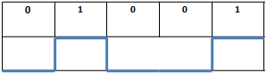

Figure 3.2.1: Representation of NRZ coding scheme

The main advantage of NRZ theme includes that it doesn't add a dc element to the input signal.

### 3.2.2 Multilevel Binary (AMI)

For this scheme multiple levels are introduced for binary bits. No sign addresses 0 and 1 are addressed by both (positive and negative) electrical voltage levels. 1's heartbeats are converse in furthest point.

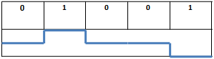

Figure 3.2.2: Representation of AMI coding scheme

Advantage of this coding scheme is similar to NRZ, no dc component is added. Furthermore, in case of successive 1’s this scheme provides full data synchronization.

### 3.2.3 Manchester Coding

There is move in center of every piece, which goes about as a clock and in addition information. The low to high move speaks to 1 and high to low speaks to 0.

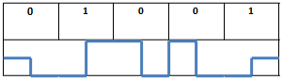

Figure 3.2.3: Representation of Manchester Coding Scheme

### 3.2.4 Differential Manchester

In this plan move at the center of the bit speaks to just timing while move at begin speaks to 0 and no move at begin speaks to 1.

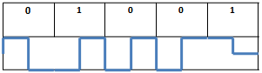

Figure 3.2.4: Representation of Differential Manchester Coding Scheme.

# 

## 3.3 Analog Data Conversion

Simple information is initially changed over into advanced information by utilizing simple to computerized converters. These use distinctive methods to finish their assignment, some of them are

### 3.3.1 Pulse Code Modulation

If an indication is analyzed at traditional intervals at a rate above twofold the foremost raised sign repeat, the cases contain all of the knowledge of the most banner. every illustration is parceled out a propelled price. In spite of the method that its quality is like that of easy transmission nonetheless within the meanwhile during this methodology a number of data is lost and also the main banner will never be recovered.

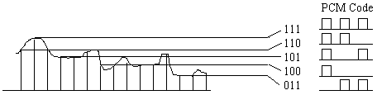

Figure 3.3.1: Pulse Code Modulation 1

### 3.3.2Delta Modulation

Simple data is approximated by a steps capability. capability climbs or downward at each bit by one level (d)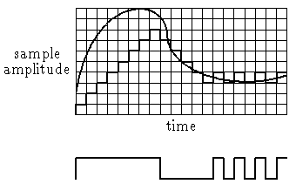

Figure3.3.2: Delta Modulation

Delta adjustment is less complicated than PCM in usage, but it shows additional terrible sign to noise proportion for an equivalent data rate. In any case, it's helpful for data pressure.

## 3.4 DIGITAL DATA, SIGNAL

There are many modulation schemes for digital data. Some of them are presented below:

### 3.4.1Amplitude Shift Keying (ASK)

A parity system within which electronic knowledge is self-addressed as assortments within the adequacy of a radio radiation is named Amplitude-shift scratching (ASK). One parallel digit is self-addressed by proximity of transporter, at steady abundancy and also the different twofold digit self-addressed by group action of conveyor.

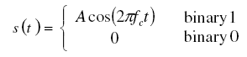

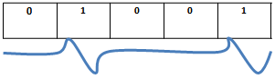

Figure3.4.1: Digital modulation technique ASK

### 3.4.2 *Frequency Shift Keying (FSK)*

In repeat shift keying various frequencies square measure utilised to talk to approaching advanced info. Say if there ought to be a happening of Binary Frequency Shift Keying f1 is used to talk to zero whereas f2 is used to talk to one.

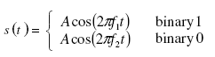

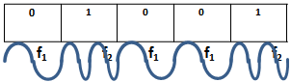

Figure 3.4.2: Digital Modulation technique FSK

In MFSK quite 2 frequencies square measure used and thence information measure is a lot of with efficiency utilized.

### 3.4.3 Phase Shift Keying (PSK)

A propelled amendment methodology within which knowledge has been transmitted by organization and ever-changing the time of the reference sign is named PSK. On the off probability that there need to emerge an incident of PSK, a collection variety of stages are used. associate intriguing case of parallel bits is allotted to every of those stages. All things thought-about, every stage encodes the same variety of bits. the image is enclosed by every case of bits that's addressed by the actual stage.

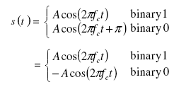

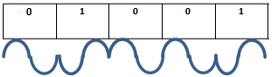

Figure 3.4.3(a): Digital Modulation Technique PSK

[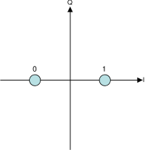](http://en.wikipedia.org/wiki/Image:BPSK_Gray_Coded.svg)

Figure 3.4.3(b): Representation of Binary phase in Constellation Diagram

The relationship for the bandwidth of ASK and PSK can be represented as follows:



And for FSK the bandwidth relation is:



In the above equations ‘R’ represents the bit rate. And Df is the difference between the carrier frequency and input frequency.

# Chapter 4 Channel Coding

## 4.1 Introduction

Why to use Channel Coding, this question arises very often, In injury edge propelled correspondence systems data is self-addressed in bit streams, that ar then conformed to simple waveforms before transmitting them on a medium. At gatherer this basic data is demodulated into binary data bits, but since of the closeness of electrical resistance and disturbance within the correspondence channel this bit stream is also debased. Therefore to attenuate occasion of bits in oversight and protect progressive information from channel confusion and electrical resistance channel secret writing is employed.

How Channel writing is performed? extra monotonous bits area unit extra to the message information stream to perform channel writing, these further bits facilitate with miscue acknowledgment and cure at the authority's finish.

Channel writing to the hurt of? Channel writing is performed to the hurt of transmission limit improvement and rate decreasing.

## 4.2 Channel Coding Schemes:

There are two basic schemes used for channel coding.

1. Block Coding scheme
2. Convolutional Coding scheme.

Convolutional committal to writing is forward botch revision technique that's at this moment most for the foremost half used as a bit of forefront correspondence systems, this explicit methodology is employed for consistent error modification. Not the least bit like piece codes that embrace dreary bits toward the top of remarkable message signal, Convolutional committal to writing define another code word mistreatment one among a sort information sequence. The encoded bits are not alone subject to k current data bits but instead in the meantime on perspective data bits.

## 4.3 CONVOLUTIONAL CODES

Convolutional cryptography is completed using convolutional codes. These codes are of two types:

1. Trellis Coded Modulation (TCM)
2. Turbo Coding schemes

Properties of Trellis Coded Modulation (TCM) are listed below:

* Non algorithmic approach,
* Interleaver is not needed.

Turbo Coding scheme has the following properties:

* Algorithmic approach,
* Efficient and parallel composed
* Interleaver is necessary for this coding scheme.

In broadband CDMA structures the distribution is as follows:

All channels utilize TCM modulation whereas FACH and DCH channels uses Turbo Codes.

|  |  |  |
| --- | --- | --- |
| **Transmission Channels** | **Coding methods** | **Coding Rate** |
| **RACH** | Convolution Codes | 1/2 |
| **BCH** |
| **PCH** |
| **DCH, FACH** | 1/2, 1/3 |
| Turbo Codes | 1/3 |

Table 4.3:Specifications of WCDMA Scheme

## 4.4 CONVOLUTIONAL CODE REPRESENTATIONS

The method which we are going to use in this project is Cyclic Redundancy Check CRC that will be explained in detail in the following few lines.

We will use synthetic division in CRC. In order to fulfill the requirements of convolution code representation synthetic division of the message signal is done by a divisor called divisor polynomial. Now we are going to explain the example of CRC. For message polynomial the project uses “101111” and the key polynomial is denoted “1010”. Furthermore, key polynomials or divisor polynomial are shown by (x^4+x^2) where as corresponding polynomials are denoted or shown by (x^6 + x^4+ x^3+x^2+1). The alphabet ‘K’ is used to measure the length of divisor polynomial. Hence, (k-1) 0’s are attached or added with the message which is then followed by employing synthetic division. Ones and zeroes are coefficients of polynomial’s message.

1010/101111000

101

underline

111

101

underline

100

101

underline

100

101

underline

011

we don’t have to be worry owing to the investigation of quotient as it is can be seen in the above given example. Remainder is 011 in this example. When original message is attached with remainder then CRC reads it as 101111000.

### 4.4.1 State Transition Diagram

Convolutional writing may be spoken to utilizing State Transition Diagram. Both the diagram and table for state transition are represented below: 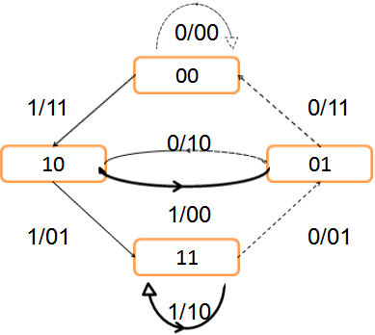

Figure 4.4.1: Diagram representing state transition for 1/2

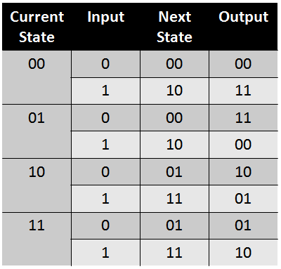

Table 4.4.1: Table Representing State Transition

Again we see that for the same input (10100) bits, the coded word becomes (11 10 00 10 11) .it is to be noted that the last two bits (‘00’) in the input are referred as tail bits.

### 4.4.2 Convolution Coding Explanation:

The bock diagram representing the process of convolution coding is represented below.

In this explanation we use the Code Rate value as ( ½) and total number of stages are 3 in this case.

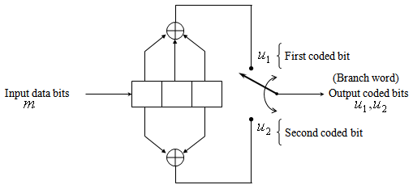

Figure 4.4.2(a): Convolution Coding Representation using Block diagram

The input stream of bits used in this process of convolution is 101.

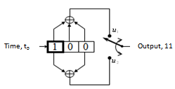 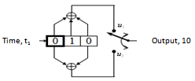

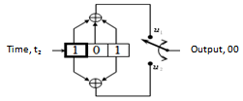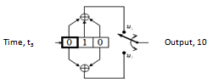

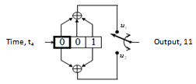

Figure 4.4.2(b): Convolution Coding Representation using Block diagram

The coded signal after the aforesaid process is represented as: (11 10 00 10 11)

### 4.4.3 Representation using Trellis Diagram

Trellis diagram gives in depth of any coding scheme, so in our case we also represent the convolution coding diagram for input signal bits (101).

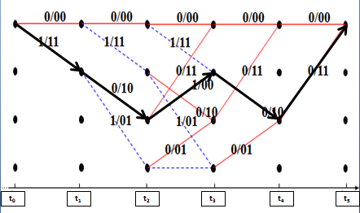

Figure 4.4.3: Convolution Coding scheme representation using Trellis Diagram.

## 4.5 LOW DENSITY PARITY CHECK

In order to encode incoming bit stream Low density parity check codes are used in sparse matrix. It is an m x n matrix with

* + m = no. of encoder input bits or no.of encoder input bits=m
  + n = no. of encoder output bits or no.of encoder output bits=n

For LDPC coding, the condition is that weight of ones in a very row (wr) should be but the no. of encoder input bits and weight of ones in column (wc) should be but no. of encoder output bits. There are two kinds of Low density parity check Codes:

* Regular LDPC Codes

wr  = wc

* Irregular LDPC Codes

wr ≠ wc

Let us assume an example that will elaborate low density parity check coding

The input bits taken in this example is M=(1 1 0)

Three input bits are present in this example, the code rate is ½ hence six no of outputs will be there.

The sparse matrix (H) which is generated for encoding is described below

|  |  |  |  |  |  |
| --- | --- | --- | --- | --- | --- |
| **1** | **0** | **0** | **0** | **1** | **0** |
| **0** | **1** | **0** | **1** | **0** | **0** |
| **0** | **0** | **1** | **0** | **0** | **1** |

Using simple matrix multiplication we get the output of the encoder.

C = M x H

C = [1 1 0 1 1 0]

At the receiver side signal is decoded by multiplying the transpose of sparse matrix with code matrix.

R = C x HT

Where ‘R’ is the received signal.

# Chapter 5 Pulse Shaping Techniques

## 5.1 INTRODUCTION

Why we need Pulse shaping filters? It’s through with a particular finish goal to decrease entomb image Interference commonly referred to as ISI.

How Pulse Shaping is performed? Therefore on accomplish zero-ISI the final framework reaction should be resembling Nyquist return reaction.

## 5.2 RAISED COSINE FILTER

Information pointer ability on a basic level is spoiled by cover image interference that will results in weakening the the ability of information pointer to isolate among adjacent image and a gift image from subtle imperativeness. Hence BER grows and it prompts the reveleation of errors thus memory verity objective to cook ISI, a unremitting acknowledgment of Nyquist direct is associated in gift day correspondence systems. Nuquist channel acknowledges the raised circular function channel.

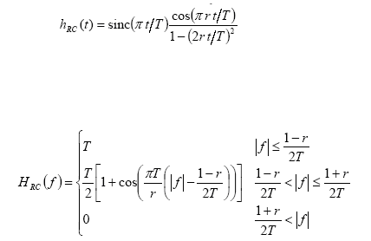

where 1 ≤ r ≤ 0

T = 1/R

‘R’ is the Roll-off factor and ’T’ is the Symbol time period. Move off element decides channel data transmission and speaks to an exchange off between the motivation reaction ringing greatness of the channel and sharpness of the move band of the channel.

Nyquist channel has taking after properties:

• Time reaction in the end goes to zero in a day and age precisely equivalent to the image dispersing.

• By examining the image succession at a given image time point, present image is not influenced by the vitality spreading from the adjoining images.

The Frequency and the impulse response of pulse shaping filter is presented below:

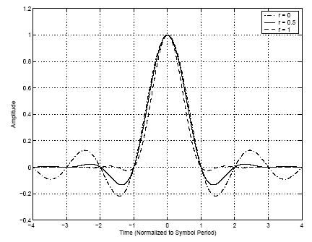

Figure 5.2(a): Impulse Response of Pulse shaping filter

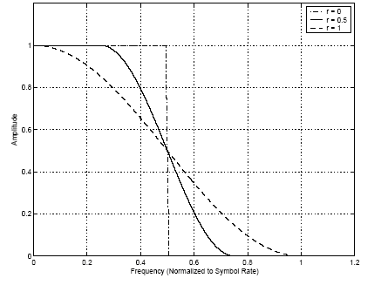

Figure 5.2(b): Frequency Response of Pulse Shaping Filter

Time reaction of RC channel gradually decreases till zero along a period that precisely equivalent to the image divion. As the reaction approaches zero at all image times aside from the sought one none of the nearby images meddle with each other.

## 5.3 ROOT RAISED COSINE FILTER

RC channel is isolated into a root raised circular function (RRC) channel try, with one at the transmitter finish, that plays out the beat shaping memory actuality objective to oblige the modified sign data transmission, and also the alternative at the beneficiary finish, that performs expedited acknowledgment for redesigning the SNR of a known sign up AWGN closeness.

The Root Raised circular function divert is thus named in light-weight of the manner that its trade work properly is that the sq. institution of the trade limit of the Raised circular function channel.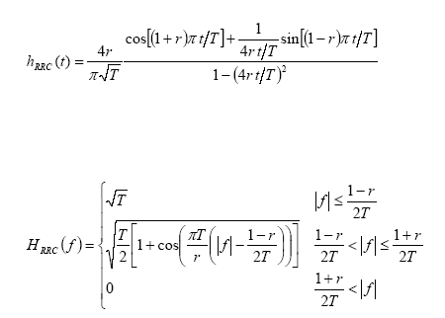

Where r = move off variable and T is image amount. The RRC channel transmission capability is like the basis mean sq. (RMS) abundancy 2R.

The drive reaction and the recurrence reaction of the RRC channel is

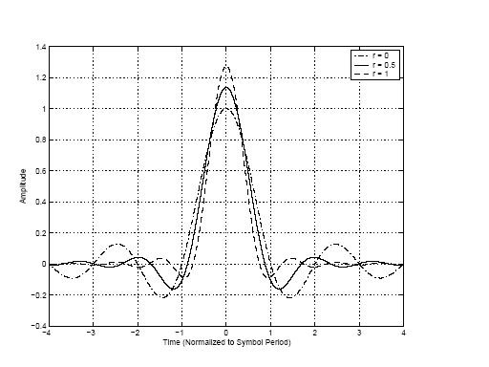

Figure 5.3(a): Impulse Response of RRC Filt 1

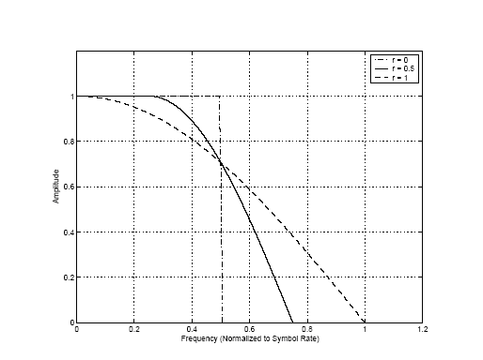

Figure 5.3(b): Frequency Response of RRC Fi 1

Identical pulse shapes have recognized for both RCC and RC, however the difference here is that the when RRC beat it takes snappier to a point, resultantly the scope of RRC pulse shows additional straight once appeared otherwise in relation to pulse of RC. Another major difficulty between each heartbeats is while putting down image interference RRC beat don’t have 0. Reason being at authority and transmitter point RRC channel is employed, the impact of these trade limits can result in increasing circular function, that can understand 0 international agency yield.

## 5.4 ROLL OFF FACTOR

(r) is that the roll-off issue that shows the surplus information measure of filter. the surplus information measure includes the portion that is occupied by the Nyquist information measure of 1/2T.



In the above euation ∆f is refereed as excess bandwidth and Rs is the symbol rate.

# Chapter 6 Spread Spectrum

## 6.1 INTRODUCTION

Spread extent could be a kind of direction wherever the information is adjoin the complete repeat vary. This strategy of spreading the information over the complete reach signals against noise and obstacle. These ways ar usually utilized in cellular telephones besides with remote LAN's. To qualify as an expansion extent signal, 2 tenets should be met .

1. The transmitted sign data transmission should be in wealth of the data exchange speed.

2. Some limit apart from the information being transmitted is employed to line up the data transmission of the resultant transmission.

Why unfold Spectrum? As a results of its choose and specific properties unfold reach is favored over different modification arranges. a number of these properties ar delineate as inclinations and inconveniences of a significant unfold extent system beneath.

## 6.2 Advantages

* It decreases the impacts of multi path impedance.
* Frequency band is mutually shared at the same time to different clients.
* Pseudo arbitrary codes guarantee security of transmission.
* After signal spreading over a whole range, refers to low power phantom thickness.

## 6.3 Disadvantages

**•** Due to spreading operation, it uses more exchange velocity.

• Sometimes hard to execute.

## 6.4 Types of Spread Spectrum Techniques

1. Direct Sequence Spread Spectrum
2. Frequency- Hopping Spread Spectrum

### 6.4.1 Frequency Hopping Spread Spectrum

A repeat skipping spread extent bounced beginning with one tight band then onto the following all within a more broad band. When all is said in done the repeat compartment transmitter sends data groups at one conveyor repeat and after that jumps to another transporter repeat before sending mineral packages and continues with the same schedule all through the season of transmission. The case that creates is from every angle sporadic yet is honestly incidental and easily traceable by pre planned transmitter and beneficiary. These systems can be helpless against clatter at a particular bob however for the most part can send bundles in the midst of the accompanying bounce.

### 6.4.2 Direct Sequence Spread Spectrum

One of the most widely used and most renowned type of spread spectrum is direct sequence spread spectrum. It deals with the simplicity of data. Figure 21 displays the key characteristics of DS-SS communication system and basic model. Pseudo-noise (PN) code is generated in this type of modulation.

This PN sequence is directly modulated and is represented by various bits in transmitted signal, when original data is given as input. In order to recover the input data from the receiver point only the identical PN sequence can be used.

m(t) s(t) s’(t) m’(t)

**Channel**

**Encoder**

**Modulator**

**Channel**

**De-**

**Modulator**

**Channel**

**Decoder**

**Input**

**Output**

**Pseudorandom**

**Noise**

**Generator**

**Pseudorandom**

**Noise**

**Generator**

Figure 6.4.2(a): Basic model of Direct-sequence spread spectrum communication system

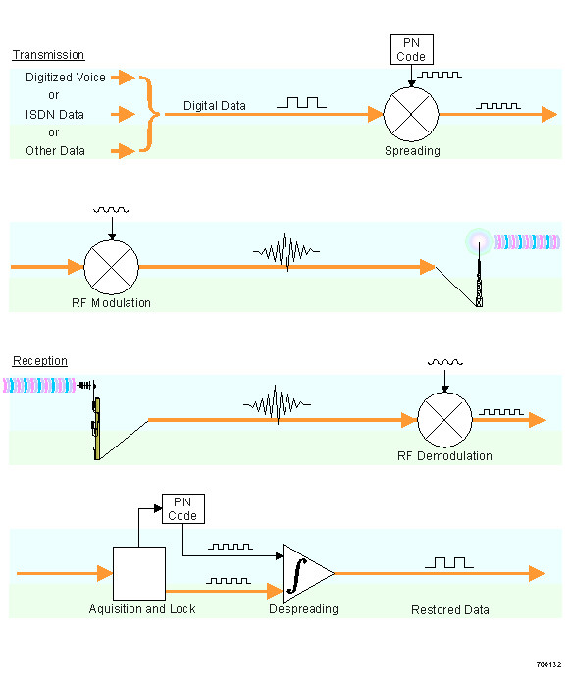

Figure 6.4.2(b): Direct Sequence Spread Spect 1

The above shown figure describes the basic principle of Direct Sequence spread.

**Transmission Side**

1. First of all, every channel is allotted a one of a kind pseudo arbitrary code.
2. The data stream is then duplicated with past Pseudo code to spread the information.
3. The resultant is tweaked on to the transporter.
4. Finally, the tweaked sign is enhanced before transmitting.

**Receiving Side**

1. The received signal is amplified after detection at receiver.
2. This amplified signal is then multiplied with local carrier.
3. Then a pseudo code is generated.
4. Correlation process is then carried out on the basis of produced code and signal which results in original signal.

**Pseudo-Random Noise**, the spread range frameworks are built fundamentally the same to other ordinary frameworks. The difference is categorized by the expansion of pseudo irregular generators that are present at transmitter and the collector which results in creating pseudo code that can increase efficiency required for Direct sequence spread image. For dispreading at the beneficiary end and for spreading the sign at the transmitter point pseudo irregular commotion successions are used. Chips are made up of various images that results in grouping of a pseudo clamor. The framework capacity is influenced by a decent code for its length and sort of straightforwardness.

For each channel a novel code is made then all of the transmission is enclosed. Each shopper at the beneficiary end develops its own specific coordination while recalling the primary objective of recouping the primary flags.

When pseudo random code is copied bitwise it means that signal spreading is done and dusted. The following picture depicts the procedure through which a pseudo code having length of 8 is multiplied by two bits and describes its impact on total range. Left hand figure shows the spreading of signal and its resultant is shown on the right side of image.

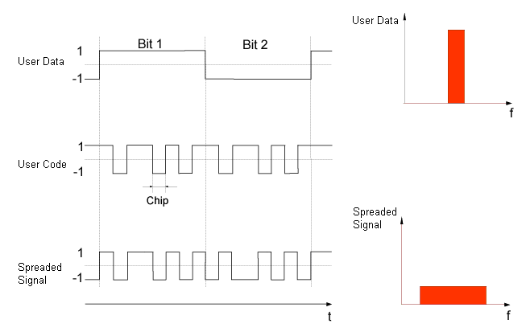

Figure 6.4.2(c): Spreading Principle of information signal

%%%%%%%%%%%%%%%%%%%%%%%%%%%%%%%%%%%%%%%%%

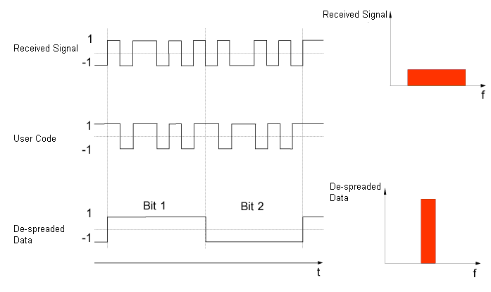

Figure 6.4.2(d): de-spreading principle of information signal

## 6.5 Spreading effect on Bandwidth

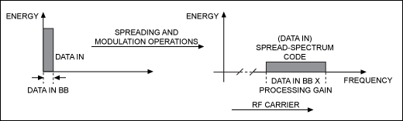

Figure 6.5: Spreading Trend on signal Bandwidth

**After applying the spreading scheme the frequency of the input signal is spread at a wider bandwidth.**

## 6.6 De-spreading effect on Bandwidth

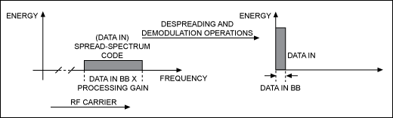

Figure 6.6: De-spreading effect on signal Bandwidth

# Chapter 7 DESIGN OF A WCDMA BASED COMMUNICATION SYSTEM

## 7. 1 THE SYSTEM DIAGRAM

Data Bits generation

CRC Attachment

Block Segmentation

Channel Encoding

Interleave

Modulation

Mapper

WCDMA Spreading

TX Filtering

AWGN Channel

Matched Filtering

De-spreading

Modulation de-mapper

De-interleave

Channel Decoding

CRC Remove

Data Extract

Figure 7.1: The Complete system diagram

## 7.2 THE TRANSMITTER

### 7.2.1 CRC Attachment and Block Segmentation:

Keeping in mind the tip goal to create approaching message sensible with the correspondence framework supply cryptography is used. During this anticipate NRZ encryption set up is used so the approaching message signal gets to be sensible with the walsh codes that square measure likewise in NRZ structure. NRZ encryption offers a superior usage of the info transmission, in addition on the off probability that we tend to distinction it and AMI set up it's simpler in light-weight of the actual fact that in this collector has to acknowledge 3 distinct levels and it needs a lot of flag force. On the other hand differential Manchester plans and the Manchester have regulation rate that is double or more than double as compared to NRZ. Hence as a result they need noteworthy transmission capability in abundance.

### 7.2.2 Channel Encoding

It is done with objective of decreasing bit bungles at authority level furthermore, the input data signal is protected from block and the channel commotion. Convolution codes that is grounded on encoding scheme is used in this project and after that in order to expand the structure of our project we have used LDPC. Reason being, as it manage Shannon limit it upgrades the channel limit. The structure of both the encoding schemes ( LPDC and convolution) uses a codeword consideration while drawing nearer to message signal. In our project the encoder rate used is ½ suggesting to two data bits and the yield will be four bits. In built MATLAB trellis structure near to convenc has been used to implement the conventional encoder scheme. On the other hand the project used LDPC fecldpc.enc summon and a sprase H network for the construction of LDPC object.

### 7.2.3 WCDMA Spreading

For Cross relationship and auto association of message pictures spreading is one of the most vital standards. In case of a WCDMA based correspondence system as there are various customers that in the meantime transmit data so the structure have incredible cross association properties. Orthogonal codes are utilized in this way. Orthogonal codes are a type of Walsh codes that we used in this project. Reason being, they have extraordinary cross association characteristics. As a result of this in order to spread the sign over the whole information exchange limit, envision straight course of action spread reached (DSSS) strategy.

### 7.2.4 Digital Modulation

Regulation is a procedure that encourages the message sign to be transmitted over the channel. If there should arise an occurrence of computerized tweak, advanced sign is balanced utilizing plentifulness shift keying, recurrence shift keying and stage shift keying and so on. In order to balance 0 and 1 our project have used two images that have an inverse stage to each other. As a part of the frame work the project uses an information rate of 2 and sampling recurrence of 44 KHZ. Moreover, in order to tweak the sign regulate charge has been used in this project if there is an occurrence of LDPC.

### 7.2.5 Pulse Shaping

By the use of pulse embellishment process the impacts of bury picture check (ISI) can be removed. Furthermore, in order to limit the information transmission of the adjusted sign root raised cosine filter has been used at the transmitter side. Velocity is confined with the use of this scheme exchange velocity however the sign spreads in there must be an edge while keeping in mind the primary goal to counter this issue, this edge is commonly called as Nyquist cutoff. It is on a very basic level a low pass divert with a get off component 0.5 which has been used as a piece of this suspect.

## 7.3 THE CHANNEL

In order to make a connection between transmitter and receiver we must use a channel. There is interference between sender of data and receiver of the data. The data can be a multimedia data or any information that is demanded by the consumer from the internet. We are going to use AWGN channel to represent noise in our project.

### 7.3.1 Additive White Gaussian Noise (AWGN) Channel:

The addictive white Gaussian Noise channel amplitudes a Gaussian distribution by adding a white noise that is made up of constant spectral density. The primary block figure of WCDMA transceiver is shown above in figure 6.1 which shows WCDMA technique with its mechanism and significance.

TRANSMITTER

AWGN CHANNEL

NOISE

Figure 7.3.1: Fundamental block diagram of WCDMA transceiver

The Additive White Gaussian Noise (AWGN) channel is added as the receiver’s input. The variance of this noise distribution relies upon the Signal to Noise Ratio (SNR) or *E b /N*0 at the front end of the receiver. The noise variance is a function of the spreading factor (SF), the amplitude of the signal and the sampling rate, which is the number of samples/chip.

## 7.4 THE RECEIVER

### 7.4.1 Synchronization

In this structure, it is acknowledged that the authority is on continually. When transmitter sends signal there must be a beneficiary that indicates where leisure activity is. This must be imaginary by linking the readiness game plan vis a vis the got signal. The most significant part where compelling association comes through is at the start and at the end of message signal.

### 7.4.2 Matched Filtering

The got sign is adhered to dig carried cosine procedure up with a particular true objective to perform composed filtering and down assessing at the recipient end. Most of the times RC channel is connected towards a root raised cosine channel pair, with one end at the transmitter that tells us the transmitter limit and the other part at the beneficiary end that executes collected area for redesigning SNR of a already known sign in AWGN vicinity.

# Chapter 8 Results

## 8.1 RANDOM BIT GENERATION

Figure 8.1: Data and chips 1

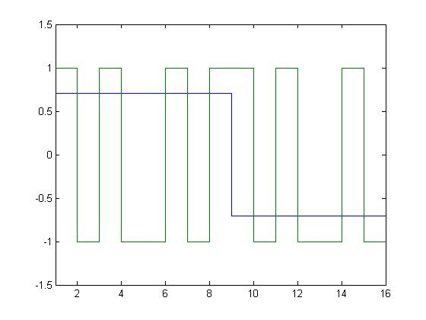

## 8.2 QPSK TRANSMITTER

Figure 8.2: Scatter Plot for QPSK Transm 1

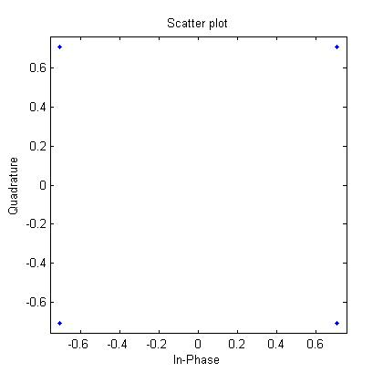

## 8.3 QPSK RECEIVER

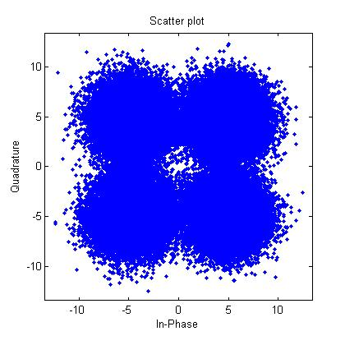

# 

Figure 8.3:ScattPlot for QPSK Receive 1

## 8.4 BER Curve for WCDMA

Despite the fact that QPSK can be seen as a quaternary tweak, it is less demanding to consider it to be two freely adjusted quadrature transporters. With this translation, the even (or odd) bits are utilized to balance the in-stage segment of the bearer, while the odd (or even) bits are utilized to regulate the quadrature-stage segment of the transporter. BPSK is utilized on both bearers and they can be autonomously demodulated.

Accordingly, the likelihood of bit-blunder for QPSK is the same concerning BPSK:

Notwithstanding, keeping in mind the end goal to accomplish the same piece mistake likelihood as BPSK, QPSK utilizes double the force (since two bits are transmitted at the same time). On the off chance that the sign to-commotion proportion is high (as is fundamental for down to earth QPSK frameworks) the likelihood of image mistake might be approximated as figure beneath:

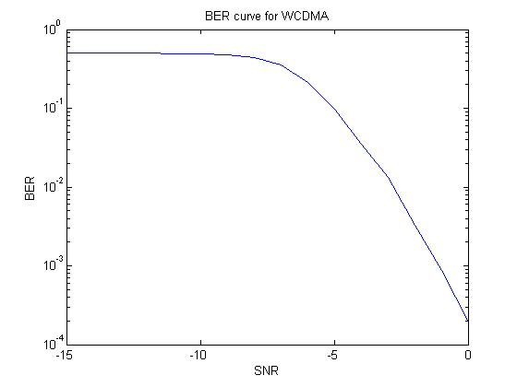

Figure 8.4: BER Curve for WCDMA 1

## 8.5 CONCLUSION

### 8.5.1 Convolutional Encoding

|  |  |
| --- | --- |
| **No. of message bits** | **09** |
| **No. of input bits to Convolutional encoder = message bits + flushing zeros** | **12** |
| **No. of output bits from Viterbi decoder = trail bits + message recovered** | **12** |
| **No. of message bits recovered** | **09** |

Table 8.5.1(a):Convolutional Encoding Summary

|  |  |
| --- | --- |
| **No. of message bits** | **12** |
| **No. of input bits to LDPC encoder** | **12** |
| **No. of output bits from LDPC decoder** | **12** |
| **No. of message bits recovered** | **12** |

Table 8.5.1(b): LDPC Encoding Summary

A single frame for Convolutional Coding system contains 72 bit of 8 user’s messages information whereas a single frame for LDPC Coding system contains 96 bit of 8 user’s messages information.

**Thus there is 25 % improvement in capacity of system using LDPC Coding Technique instead of Convolution Coding Technique with same resources.**

# References

[1] Bernard Sklar, Digital Communications Fundamentals and Applications, 2nd Edition. Prentice Hill, Jan 2001.

[2] B. P. Lathi, Modern Digital and Analog Communication Systems. Prentce Hill, Jan 2009.

[3] Lawrence Harte, Introduction to CDMA.

[4] Kamil Sh. Zigangirov, Theory of Code Division Multiple Access. Aug 2004.

[5] Jae KyunKwon,  Suwon Park and Dan Keun Sung, “Log-likelihood ratio (LLR)conversion schemes in orthogonal code hopping multiplexing”, pp 104 – 106, Mar 2003.

[6] C. Berrou, A. Glavieux, and P. Thitimajshima, "Near Shannon Limit Error-Correcting Code: Turbo Code," Proceedings of the 1993 IEEE International Conference on Communications, 1064–1070 (Geneva, Switzerland, May 1993).

[7] Todd K. Moon, Error Correction Coding: Mathematical Methods and Algorithms. Wiley Publishers

# Appendices

**Appendix B: Glossary**

**List of Acronyms.**

IMTS………………………………………………………Improved Mobile Telephone Service

AMPS…………………………………………………………Advanced Mobile Phone Systems

SDMA……………………………………………………………Space-Division Multiple Access

TDMA…………………………………………………………… Time Division Multiple Access

FDMA………………………………………………………Frequency Division Multiple Access

CDMA…………………………………………………………… Code Division Multiple Access

WCDMA………………………………………………Wideband Code Division Multiple Access

1G…………………………………………………………………………………First Generation

2G ……………………………………………………………………………Second Generation

3G ………………………………………………………………………………Third Generation

4G ………………………………………………………………………………Fourth Generation

TACS …………………………………………………………… Total Access Cellular System

NMT-900………………………………………………………Nordic Mobile Telephone System

NADC……………………………………………………………North American Digital Cellular

GSM…………………………………………………Global System for Mobile Communication

PDC……………………………………………………………………… Pacific Digital Cellular

GPRS…………………………………………………………… General Packet Radio Service

EDGE……………………………………………………Enhanced Data Rate for GSM Evolution

UMTS………………………………………………………Universal Mobile Telephone System

MIMO…………………………………………………………… Multiple-Input Multiple-Output

NRZ ………………………………………………………………………… Non Return to Zero

AMI…………………………………………………………………………… Multilevel Binary

PCM………………………………………………………………………Pulse Code Modulation

ASK………………………………………………………………………Amplitude Shift Keying

FSK………………………………………………………………………. Frequency Shift Keying

PSK…………………………….……………………………………………... Phase Shift Keying

BPSK…………………………………………………………………...Binary Phase Shift Keying

TCM……………………………………………………………………Trellis Coded Modulation

LAN…………………………………………………………………………..Local Area Network

PN……………………………………………………………………………………Pseudo Noise

ISI………………………………………………………………………Inter Symbol Interference

BER…………………………………………………………………………………Bit Error Rate

RC…………………………………………………………………………………...Raised Cosine

RRC……………………………………………………………………………Root Raised Cosine

SNR…………………………………………………………………………Signal To Noise Ratio

AWGN……………………………………………………………Additive White Gaussian Noise

RMS…………………………………………………………………………….Root Mean Square

FHSS………………………………………………………Frequency Hopping Spread Spectrum

DSSS………………………………………………………..…Direct Sequence Spread Spectrum

QAM …………………………………………………………Quadrature Amplitude Modulation

QPSK……………………………………………………………...Quadrature Phase Shift Keying

LDPC…………………………………………………………………...Low Density Parity Check