**MODELLING OF WIDE AREA NETWORK**

**1.2 Background**

**1.2.1 Scheme Nature**

A telecommunications system connecting several LANs and individual devices across many cities, countries, or even continents is called a wide area network. WANs use a wide range of technologies such as leased lines, fiber optics, and wireless connections to offer long-distance communication. They allow companies to link their many locations, including offices, data centers, and off-site locations, improving accessibility to company resources and information flow. Wide area networks are crucial for providing effective communication between the various branches of businesses, educational institutions, and government agencies that are spread out over the globe. Video conferencing, cloud services, and real-time data sharing are just some of the applications that benefit from the dependable and secure data transport provided by WANs, which also encourages teamwork. Their enormous bandwidth capacity and sophisticated routing methods allow them to achieve this.

The scheme was to design a wide-area networking architecture. With the use of several resources, the system was first developed by researching networking terminologies like VWAN, WAN, and many others. The effective layout would be put into action by the routers, switches, servers, and other pieces of gear that have been chosen. The CPT was used to design the network structure and simulate it. To ensure that the system for the project was correctly configured, the wide-area networking scheme design was followed from beginning to end, and the components that were chosen were included. The network system had been efficiently built by the time the finished product was viewed, appraised, and accepted by all parties.

**1.2.2 Scheme Purposes**

The core goal of this research was to create a wide-area networking architecture utilizing a Cisco packet tracer. There were a few other aims that included:

* To optimize the processing of the data transmission and minimize the delay of the desired WAN scheme.
* To raise the efficiency and efficacy of the WAN connectivity and reduce unnecessary traffic on the network connection.

**1.2.3 Scheme Activities Nature**

To execute networking scenarios that entail the availability of numerous publications and reports, I came up with a list of probable concepts. After conducting a study on numerous network factors, I created a list of the basic elements that were utilized in the WAN architecture. With the scheme members, I decided to use a Cisco packet tracer to finish the design and modeling of the WAN. Using the suggested resources, I went on to construct the WAN model in the simulator called CPT. I set up the appropriate WAN networking mechanism by performing and processing the setup of IP, RIP, and DHCP pools. By transmitting 4 packets across the PCs, laptops, and tablets, I and my teammates performed the ping test.

**1.2.5 Duties**

* To learn the most important ideas regarding the wide area networking scheme by reading papers and magazines.
* To pick the all necessary software as well as components for the intended network's modeling.
* To create a suitable architectural model for the network structure with a tool like CPT.
* To assign an IP address to each device independently while configuring laptops, PCs, and routers.
* To carry out the essential tests for the planned network to ascertain its connection and performance.

**1.3 PEAs**

**1.3.1**

I compiled a list of potential concepts to implement networking scenarios that involve the existence of various publications and reports. I became familiar with the functioning and operation of the WAN as well as its characteristics, to be able to do the operation on the network system. With the assistance of a variety of resources, I acquired knowledge about internet protocol. I explored the operation of routers, as well as the many functions and responsibilities that routers fulfill in the framework of a networking system. I researched the numerous applications that routers serve. To ensure that the switching procedure went without a hitch, I did some research into the operation of the switches themselves. I reviewed the many kinds of servers, such as ethernet servers, DHCP servers, and other kinds of servers, which were made possible by the availability of the internet. I explored the features of the Cisco packet tracer and also its application so that I could carry out the simulation.

**1.3.2**

I developed a list of the fundamental components that were used in the WAN design after performing research on various network aspects. To share data and information between the devices, I chose routers that connected the various networking devices. I proposed the switches as devices for switching data packets. I also nominated the IP address to connect devices to the internet. I chose to deploy a DHCP server when it came time to publish network infrastructure information and manage IP numbers. I picked a range of desktop computers and transportable laptops for the work, connecting them all via WAN connections. To complete the design and modeling of the WAN, I selected to employ a Cisco packet tracer.

**1.3.3**

After selecting the materials to design the system, I proceeded to create and built the model of the WAN in the Cisco packet tracer workbench by utilizing these nominated materials. For this, I linked the 3 different routers namely routerWAN1, routerWAN2, and routerWAN3 properly for connecting different networking devices. Then, I linked routers to the respective switches which were joined to the different PCs, laptops, and smartphones in the network design. For the WAN_A, I joined Access point WAP2, PC0 & PC1 to the switch1, PC15 & PC14 to the switch2, and linked switch1 & switch2 to the switch0. For the WAN_B, I also combined PCs & Access points to switches and linked them to switch 3. I attached to switch 3 and switch 0 to the router WAN1. Similarly, I also created the connection of WAN_D with the combination of the switches, PCs, and access points and attached to the router WAN3. For the WAN_C, I attached the access point WAP3, PC4, & PC5 to the switch6 and joined to the router WAN3. For the WAN_E, I coupled the PC2 & PC3 to the switch10, labtop1, and labtop2 to the switch11. I interlinked switch 11 and switch 10 and joined the router WAN2. When a client with DHCP support joins the network, the DHCP server, which I used to manage a pool of IP addresses, leases an address to that client.

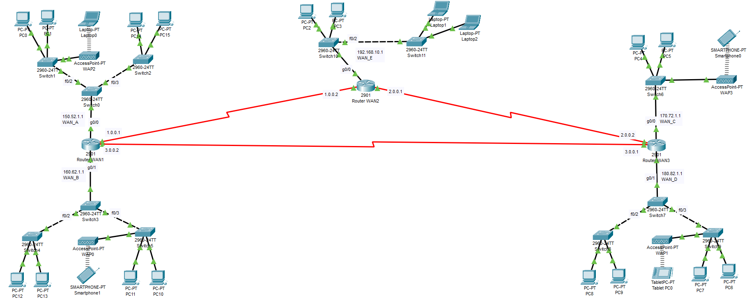

*Figure 2: Main Network Design*

**1.3.4**

After the creation of the WAN network model, I performed and processed the configuration of the desired WAN networking mechanism. I created the system using the CPT before giving each computer structure device an IP address. I set 150.52.1.1 IP for router WAN1, 170.72.1.1 IP for router WAN3, and 192.168.10.1 IP for router WAN2. I also generated the RIP as well as the DHCP pool for all the routers. I gave the 192.168.10.5 IP for the PC2, also 192.168.10.6 IP for the laptop2, 150.52.0.2 IP for the PC0, and 150.52.0.1 IP for the laptop0. I also set 150.52.0.3 IP for PC15, 160.62.0.2 IP for PC12, 160.62.0.1 IP for smartphone1, and 160.62.0.3 IP for PC10. In this way, I provided the IP address for the PC4 as 170.72.0.2 IP, smartphone0 as 170.72.0.1 IP, PC8 as 180.82.0.2 IP, Tablet PC0 as 180.82.0.1 IP and PC6 as 180.82.0.2 IP. I also generated the SSID configuration for the WAP1, WAP3, & WAP2. I used a data rate of 10 Mbps data rate to transfer the data.

**IP configure:**

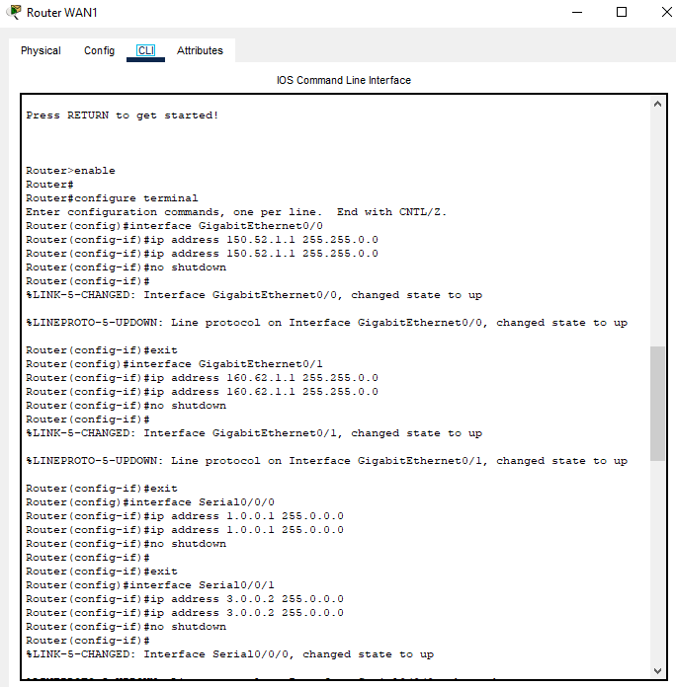

Figure 3: Router WAN1

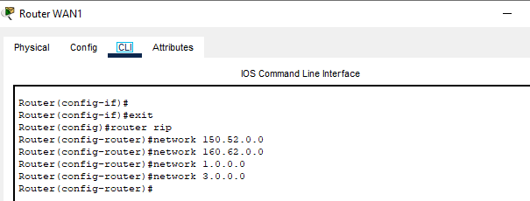

Figure 4: RIP Protocol of Router WAN1

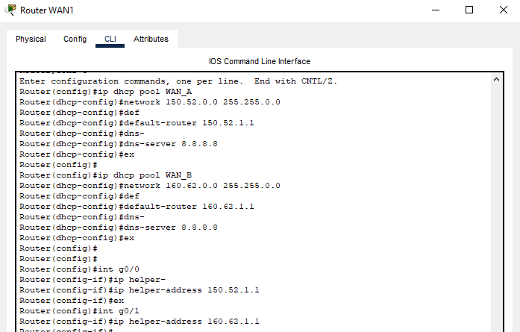

Figure 5: DHCP Pool of Router WAN1

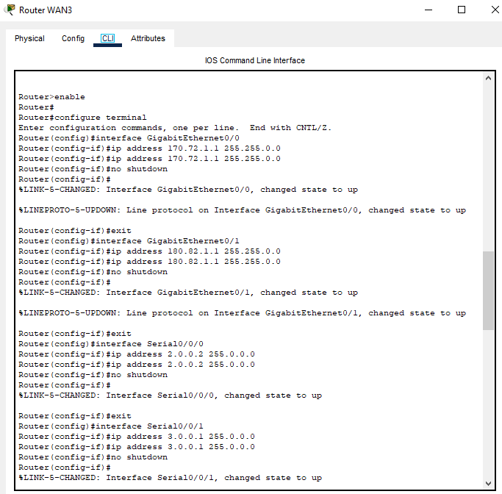

Figure 6: Router WAN3

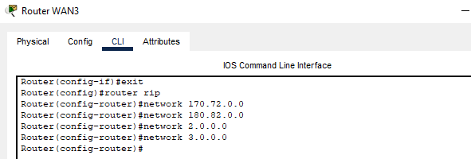

Figure 7: RIP on Router WAN3

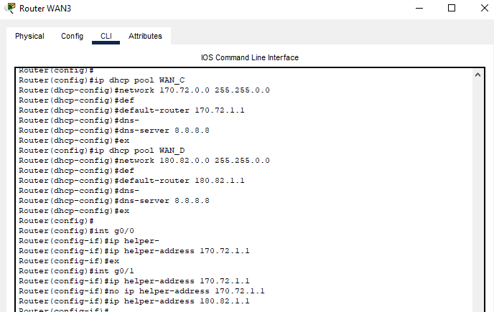

Figure 8: DHCP Pool of Router WAN3

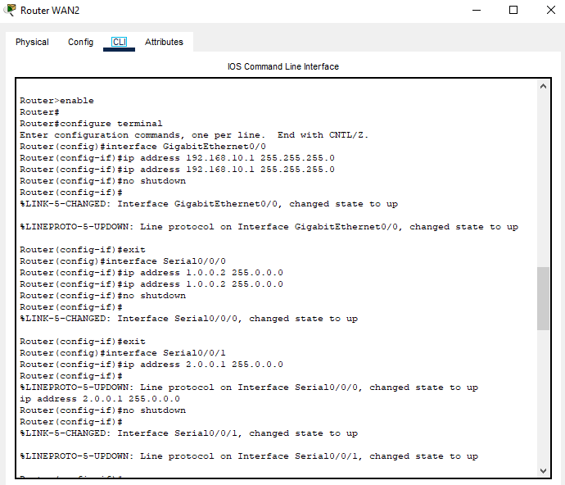

Figure 9: Router WAN2

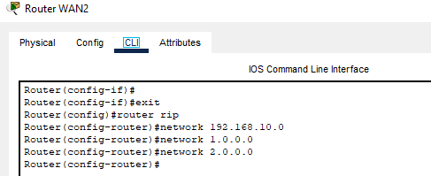

Figure 10: RIP Protocol of Router WAN2

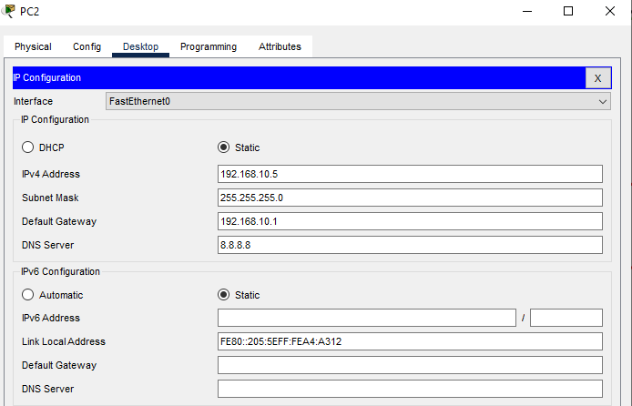

Figure 11: PC2

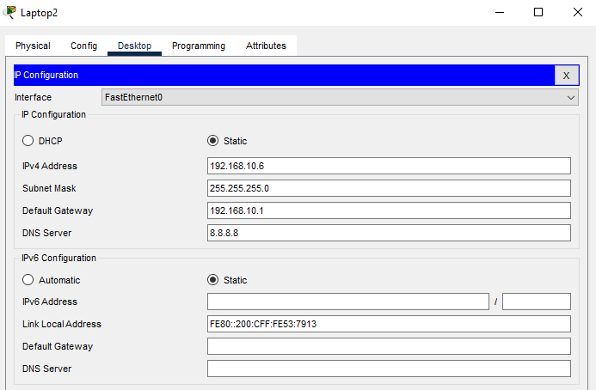

Figure 12: Laptop2

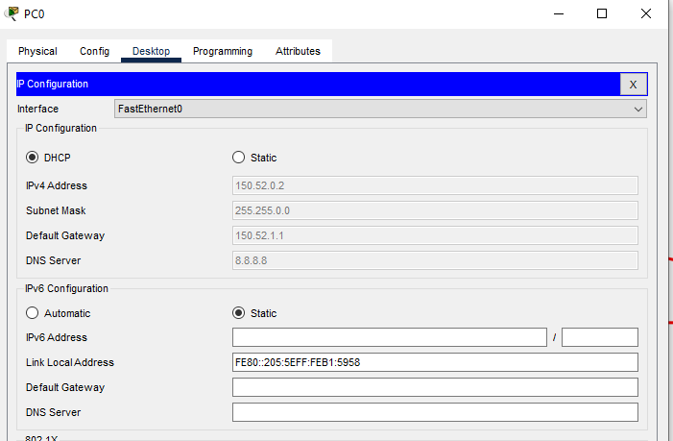

Figure 13: PC0

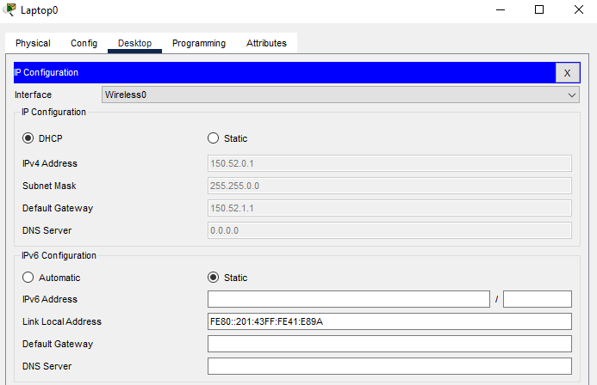

Figure 14: Laptop0

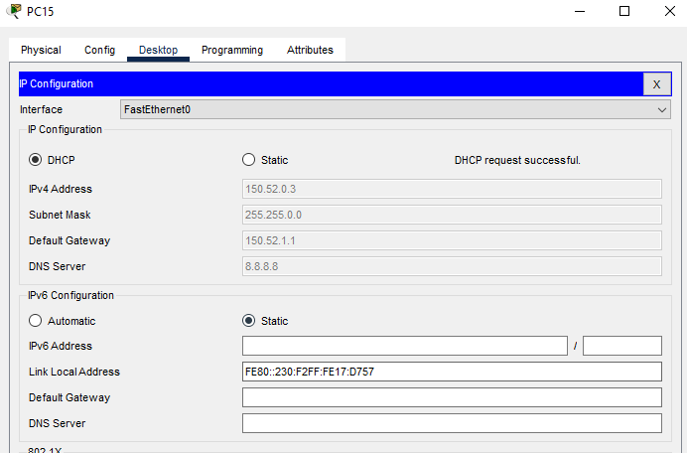

Figure 15: PC15

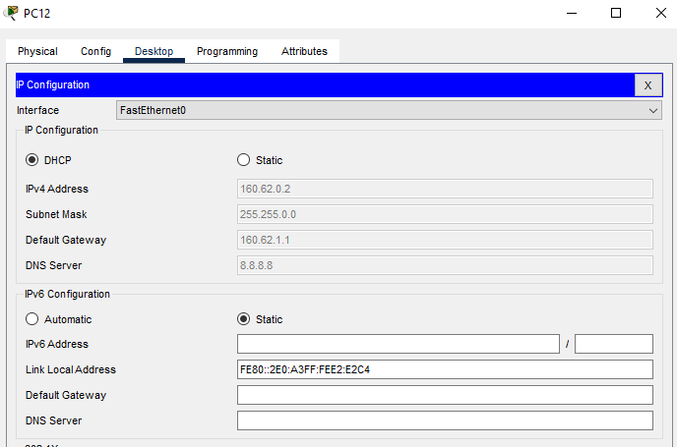

Figure 16: PC12

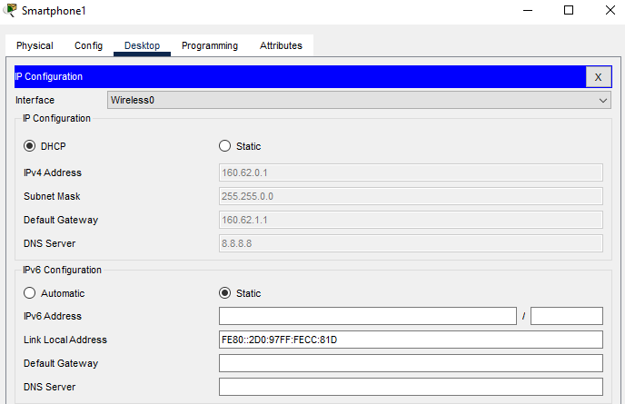

Figure 17: Smartphone1

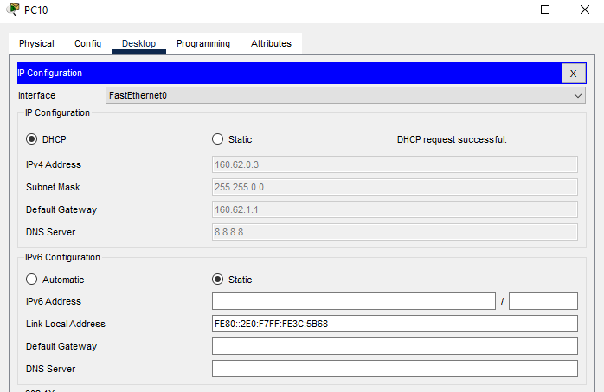

Figure 18: PC10

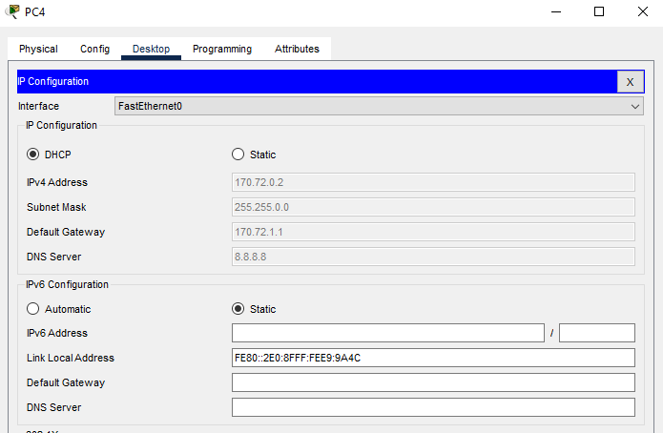

Figure 19: PC4

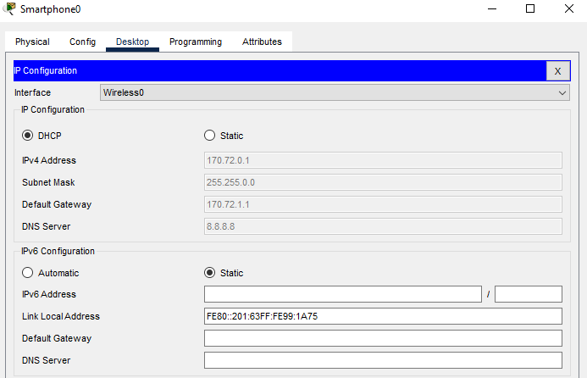

Figure 20: Smartphone0

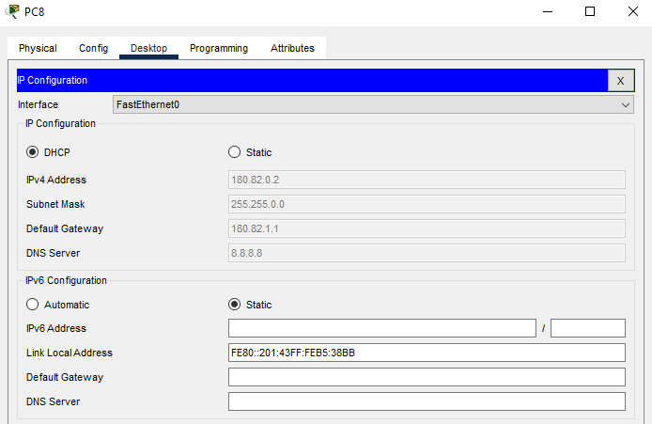

Figure 21: PC8

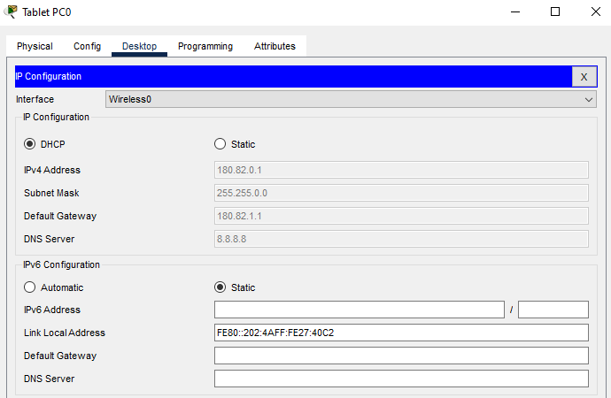

Figure 22: Tablet PC0

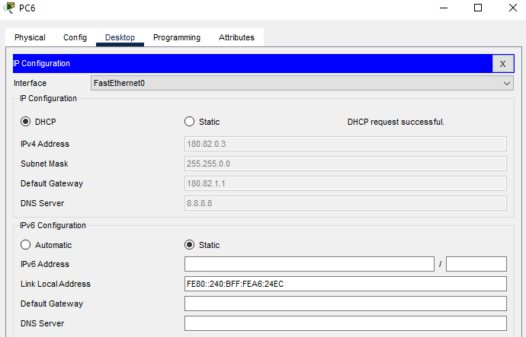

Figure 23: PC6

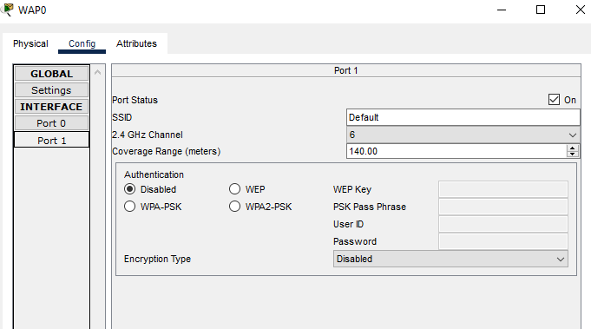

Figure 24: SSID Configuration on WAP0

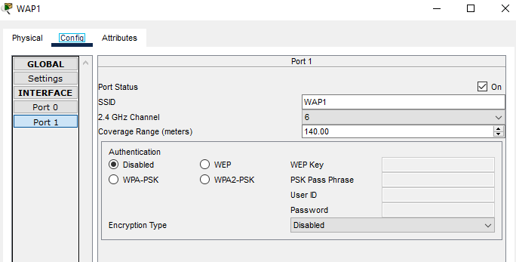

Figure 25: SSID Configuration on WAP1

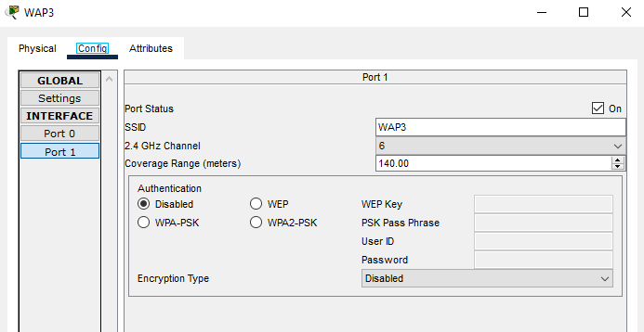

Figure 26: SSID Configuration on WAP3

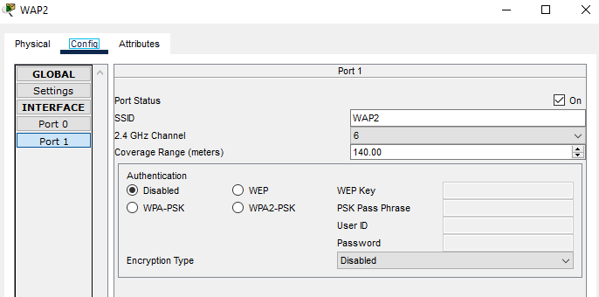

Figure 27: SSID Configuration on WAP2

**1.3.5**

With the use of a Cisco packet tracer, I was successful in obtaining the anticipated results after configuring the WAN networking design. I initially decided on the source from which I got the data and information, after which I transferred the obtained data to the required switch. I then sent four data packets to test the desired system. From PC0 to PC8 (180.82.0.2 IP), I measured round-trip times of around 10 milliseconds (ms), 15 ms (ms) at peak, and 12 ms (ms) on average; there was no packet loss during the transfer. There was no packet loss during transmission from PC8 to PC6 (180.82.0.3 IP), and round-trip timings ranged from 0 milliseconds to 23 milliseconds, with an average of 5 milliseconds. I measured a round-trip duration of 15 milliseconds, with a minimum of 11 milliseconds and a maximum of 28 milliseconds, and zero percent packet loss between PC6 and Smartphone1 (160.62.0.1 IP). There was no packet loss during transmission from PC12 to PC10 (160.62.0.3 IP), and round-trip timings ranged from 2 milliseconds at the fastest to zero milliseconds at the slowest. Between PC10 and PC4 (170.72.0.2 IP), I measured 0 percent packet loss and 2 to 23 milliseconds of round-trip delay, on average. I noticed that packets were delivered from PC4 to Laptop2 (192.168.10.6 IP) with a loss of 0% and that the avg. round-trip times were 1 ms at the very minimum, 14 ms at the maximum, and 8 ms on average. I concluded that the wide area network model forms the basis for secure transactions, e-learning environments, and organisational performance and acts as the framework for all other system exposure.

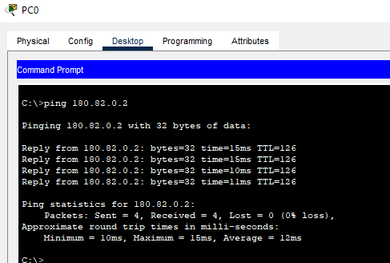

Figure 28: PCP0 to PC8

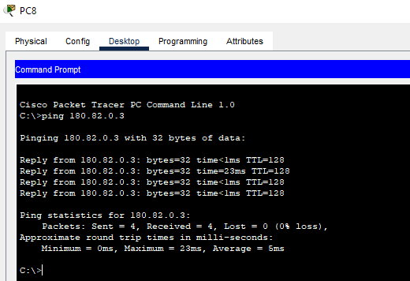

Figure 29: PC8 TO pC6

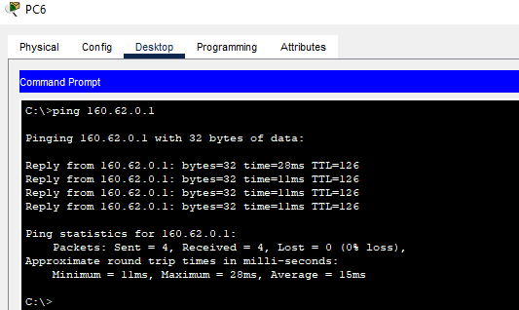

Figure 30: PC6 to Smartphone1

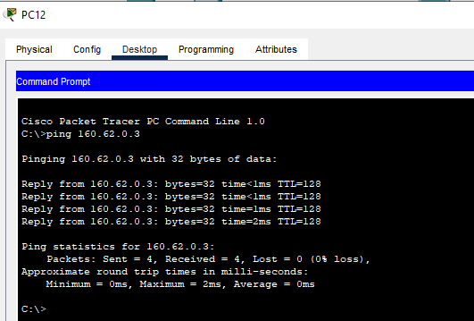

Figure 31: PC12 to PC10

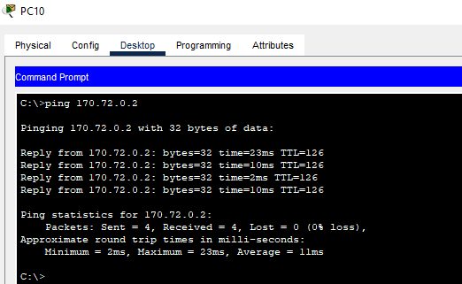

Figure 32: PC10 to PC4

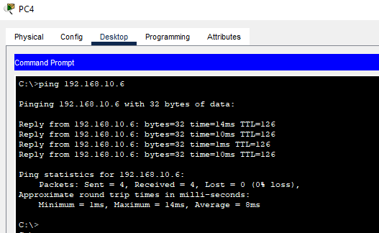

Figure 33: PC4 to Laptop2

**1.4 Difficulties & Mitigations**

**1.4.1**

After I finished establishing the networking structure, I checked out the output. When I studied it, I found out that the delayed process prohibited the correct result from being displayed, and that's when I ran into some problems. I noticed that the system faced a tedious and time-consuming process that was caused by DNS server implementation. After that, I set the meeting and while the supervisor was present, I talked about the problem that had occurred. To effectively solve this matter, I also researched a variety of sires. Following the realization that the utilization of the DNS server was the root reason for the problem, I modified the model after exchanging the DNS server for a DHCP server. I found that the system operated rapidly to process the data, and I also found out that there had been improvements made to the network infrastructure.

**1.4.2**

I also encountered a difficulty when the networking structure was operating. I found that the network system's congestion is brought on by the large system latency. As a consequence, I became aware of the drop-in network performance. After that, I had a meeting before going to the boss to talk about the problem. I researched alternative sires as well to appropriately solve this problem. I realized that the 5 Mbps data transmission rate was to blame for the delay, so I increased it to 10 Mbps and checked the findings again. I learned that the delay was minimized and saw the accomplishment of the network project.

**1.5 Creative Tasks**

I utilized the DHCP server so that the networking system could perform tasks more quickly. In addition, I boosted the data rate from 5 Mbps to 10 Mbps to do two things: increase the data rate and reduce the amount of time that the system wastes waiting for data.

**1.6** **Team Management**

At the beginning of the endeavor, I was given the duty of gathering a variety of information regarding the virtual private network. After gathering these resources, I effectively distributed them among the project team members. As the captain, I took on the essential duties of overseeing time as well as assets to make sure the successful conclusion of the entire endeavor. I provided the faculty with an exhaustive proposal that I had written outlining the venture's planning procedures. The entire time, I closely monitored the project's progress and took care of any issues as they arose. Through the organization of meetings for discussion in advance of possible issues, I promoted genuine interaction among teammates. I significantly contributed to the project's ultimate success and straightforward execution through strategy.

**1.7 Codes**

I completed this assignment per the instructions given by the institution, according to all rules and regulations. In addition, I investigated networking by reading up on the ISO 35.110 standard.

**1.8 Summary**

The strategy, which aimed for building the WAN model in Cisco software, succeeded well. It was advised that the system be constructed utilizing trustworthy hardware like switches, PCS, routers, etc. and trustworthy software like CPT. To build the network structure connection Cisco packet tracer was used. The routers' DHCO pool with RIP was also set up, and the computers' IP addresses were previously configured. By delivering four packets, the ping test was used to assess the network topology between PCs, laptops, and tablets. It was discovered that there was zero packet loss when 4 packets were sent back and forth between the devices. It concluded that the wide area network model is the cornerstone for secure transactions, effective e-learning environments, and efficient business operations. It also provided the framework for all other system vulnerabilities, including network security.

I improved my communication abilities with the support of the scheme's participants. I put extra effort into fully grasping the CPT application so that I could improve my connection design skills. I obtained more understanding of network architecture. My capacity for complex problem solving had increased.