**CAREER EPISODE 3**

**CREATION OF MICROSTRIP ANTENNA WITH HFSS**

**3.2 Background**

**3.2.1 Scheme Nature**

In the microwave area of the electromagnetic spectrum, between 8 and 12 gigahertz (GHz), is where an X-band microstrip patch array antenna will normally operate. When making this form of antenna, many microstrip patch elements are layered in a predetermined geometric pattern on a dielectric substrate. Typically, a ground plane is placed on the opposite side of the substrate. The sizes of the patches and the distances between them are meticulously planned out to get the desired radiation pattern, gain, and beam qualities. X-band microstrip patch array antennas find applications in a variety of fields, including radar systems, satellite communication, and remote sensing. This is because of the antennas' small size, ease of fabrication, and capability to provide directional radiation for effective signal transmission and reception in the X-band frequency range.

The scheme was to prepare the micro-strip antenna. Reading a variety of publications, books, and papers allowed us to begin the project with a solid foundation in knowledge and concepts about radiation patterns, array antennas, and the return loss of a system. Many different components, including feed substrate, ground plane, height of antenna, and so on, were chosen to be employed in the construction of a certain system so that it was designed effectively and efficiently. After then, the idea for a micro-strip antenna that made use of a patch was created and built with the utilization of the selected materials for X-band frequency. After that, the system was effectively simulated by utilizing a wide range of simulation parameters and the values that should have been used. After obtaining the result, it was analyzed for areas in which we made improvements.

**3.2.2 Scheme Purposes**

The focus of the system was to create the micro-strip antenna with the utilization of HFSS. There were a few other types of objectives:

* To reduce the loss of the array antenna mechanism and grow a compact and high-performance
* To optimize the overall efficacy and the radiation pattern of the proposed mechanism.

**3.2.3 Scheme Activities Nature**

I used several articles, books, and papers to execute and explore patch micro-strip antenna operation. I continued by putting together and choosing different parts to carry out the building of the suggested micro-strip antenna system. With the scheme member, I constructed and simulated a hypothetical system using the HFSS program. After deciding on the parts needed to run a patch-fed micro-strip antenna, I started building and designing the model. I used several simulation parameters with the appropriate values to simulate the model. I and my teammates carefully examined each of the created antenna's multiple presentations on the S-parameter, VSWR, overall gain, and return loss.

**3.2.5 Duties**

* To learn the microstrip antennae from various offline as well as online sites.
* To assemble various components to perform the formation of the micro-strip antenna system
* To create a patch-fed micro-strip antenna structure employing a simulator tool called HFSS.
* To simulate the antenna model with a chosen HFSS while setting the antenna's diameters and other characteristics.
* To observe the numerous presentations of the formed antenna on the S-parameter, VSWR, total gain, and return loss.

**3.3 PEAs**

**3.3.1**

At the outset; first; I performed and researched the operation of a patch micro-strip antenna via several articles, studies, books, and papers. By studying the functioning of an array antenna, I gained insight into the inner workings of an array antenna and the X-band kind of frequency. I gathered the data in terms of both the radiation pattern and the VSWR mechanism essential to system operation. I studied the details of the elements of an array and how they function in the context of building a micro-strip antenna patch. I also gathered data on return loss by searching multiple websites. To better understand the dielectric constant and ground plane, I explored up on several different websites. I educated myself on the substrate material and HFSS software to construct a micro-strip antenna with a patch over it.

**3.3.2**

After completing the research in the literature section, I moved on to select various components to perform the creation of the micro-strip antenna system that was proposed. To build a micro-strip antenna, I picked out a dielectric substrate to build transmission lines for radio waves. I chose the height of the substrate in an appropriate dimension to operate the system properly. I nominated the inverted feeding mechanism to enhance the efficacy of the array antenna scheme. Then, I opted to employ the ground plane with suitable dimensions to operate the scheme. I selected the corporate feed structure to design the array type of feed network. For this scheme, I nominated the optimal frequency for its radiation and the size of the patch it used. I picked the HFSS software to create and simulate a potential system. I chose the substrate of feed as 0.77 mm and also chose the height of patch as 2.2 mm in an appropriate manner. I calculated the length of patch, width of patch, and also calculated the length of the substrate as well. I also determined the operating frequency of the microstrip patch antenna by implementing the below mentioned formula. I used the formula to calculate these values which were mentioned below.

$$Lp=Wp=\frac{λp}{2}$$

$$Ls=0.7Lp$$

$$Lstub=\frac{λf}{2}$$

Where, Lp represents length of patch, Wp represents width of patch, Ls represents the length of substrate, and L stub represents the length of stub. $λp$ and $λf$ represents the effective wavelengths of patch and substrate respectively.

$$f=\frac{c}{2*L*\sqrt{Eeff}}$$

Where, f is the resonant frequency of the antenna, c is the speed of light, eff is the effective dielectric constant of the substrate, and L is the length of patch respectively.

**3.3.3**

I began creating and designing the model after settling on the components needed to operate a patch-fed micro-strip antenna. I joined the ground plane to the bottom layer and a suitable dimension for the system for its operation. I also linked the substrate to the bottom layer. Then I added the patch at the top layer and utilized the feeding technique. I employed a micro-strip antenna, which consisted of a dielectric substrate opposite the radiating patch and connected to a ground plate. In addition, I designed an array feed networking scheme with seven mitered T-junctions along with six 1/4th wavelength types of transformers. Then, I linked these four 50 Ohm and two 70.7 Ohm 1/4th wavelength-based transformers in the array antenna scheme. Then, I built the final array antenna system by the linear polarization of 45-degree w.r.to the horizon and then completed the design.

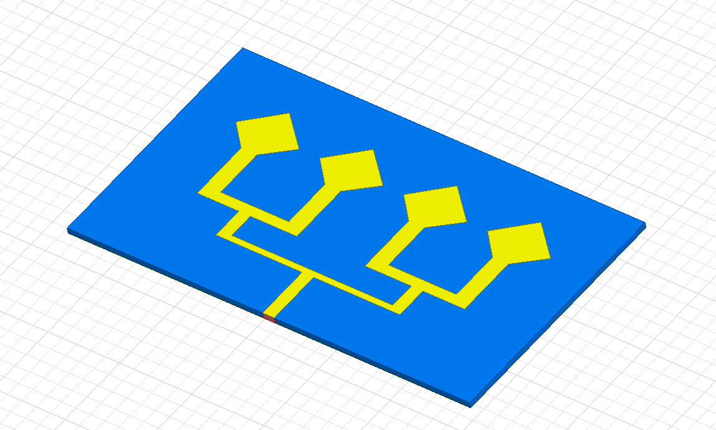

Figure 2: Antenna Structure

**3.3.4**

After developing a model of an antenna utilizing a patch, I simulated the model employing some simulation parameters that were assigned the necessary values. I used the dielectric constant 3 as well as the height of 2 millimeters. I also provided the resonance frequency, which came out to be 6.215 GHz, so that a proposed system would have a better chance of being successfully replicated. To simulate a proposed system, I supplied a ground plate with the necessary dimensions of 30 by 24 millimeters. In addition to the conducting plate with dimensions of 10 by 10 inches for each transformer, I used the 50 Ohm along with 70.7 Ohm quarter wavelength transformers. In addition, I provided the feed substrate material with a suitable size for the patch-based modeling of a micro-strip antenna.

**3.3.5**

I simulated the proposed array antenna, and after doing so, I noticed the result of the provided mechanism. I also looked at the radiation pattern plot in the azimuth plane, and I determined that the antenna's high-point bandwidth was 48. I observed the plotted return loss plot of the system and saw that the maximum return loss was of -27.8656 at 6.2159GHz. I looked for the VSWR of the antenna and noticed that VSWR was 0.7019 at 6.2150 GHz. I also looked for the radiation pattern where I found that the scattering nature of radiation. I observed that the maximum gain total was 2.0115e+001dB. I saw the antenna’s maximum 3D polar of the S parameter was -4.5653e-001dB and the 3D polar of VSWR was 3.1609e+001 dB. After that, I concluded that the antenna's beam width, which was around 60o and 10o in azimuth as well as elevation, was appropriate for finding ground-based broadcasters.

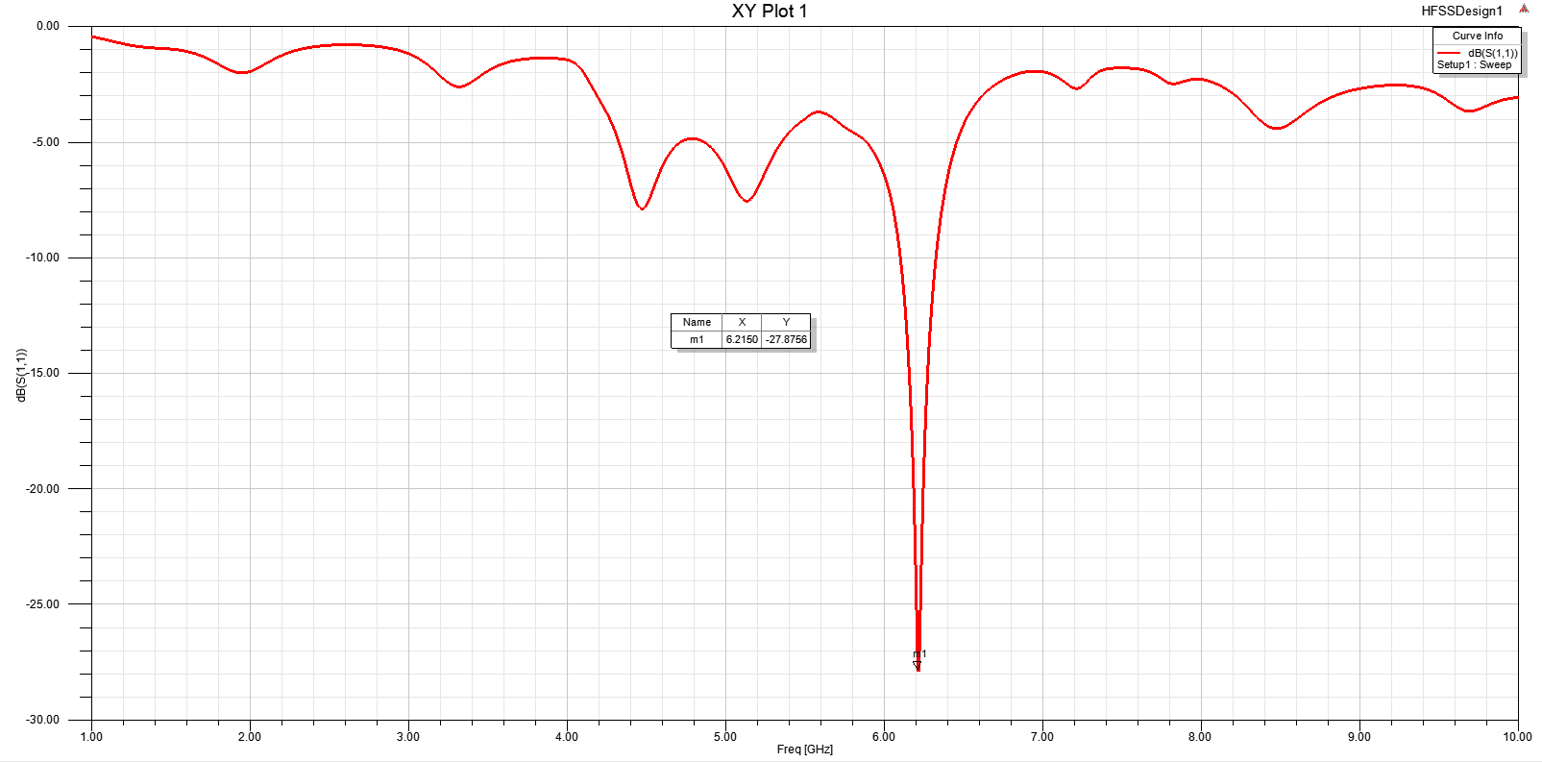

Figure 3:Outcomes of S parameter, Return Loss

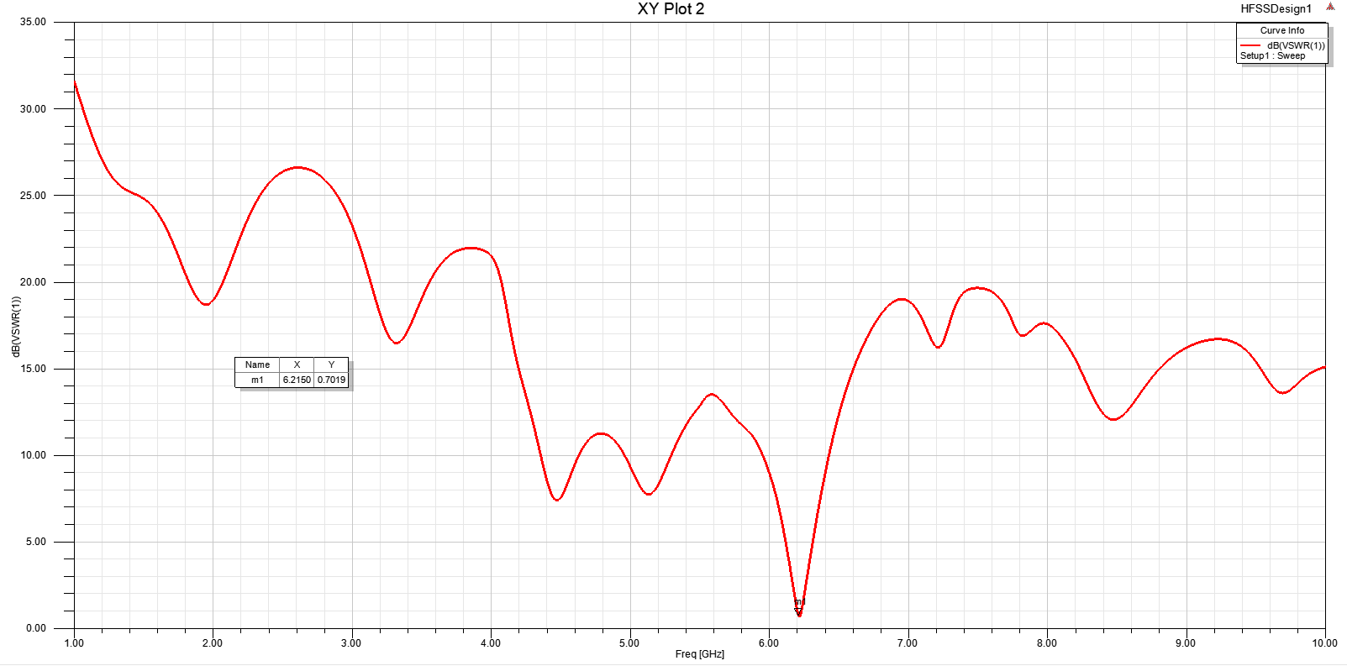

Figure 4: Outcome of VSWR

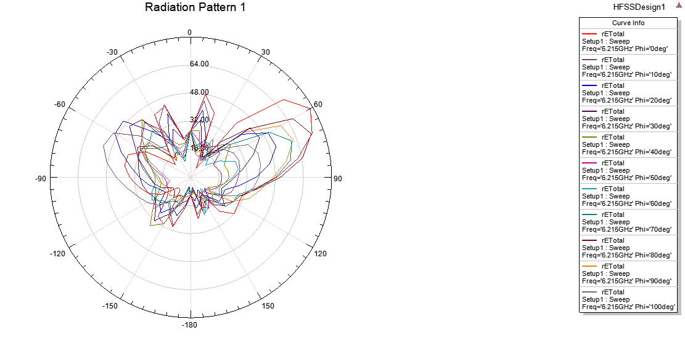

Figure 5:Outcomes of the Radiation pattern

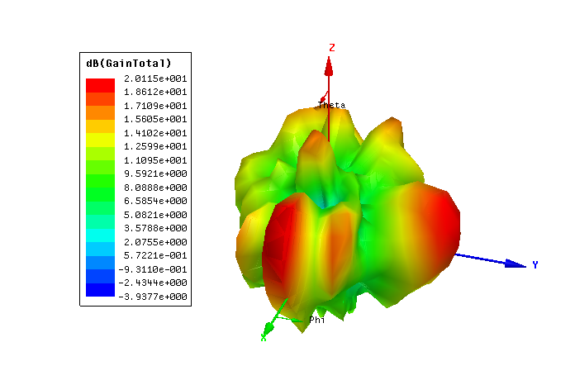

Figure 6: Outcome of gain total’s 3D polar

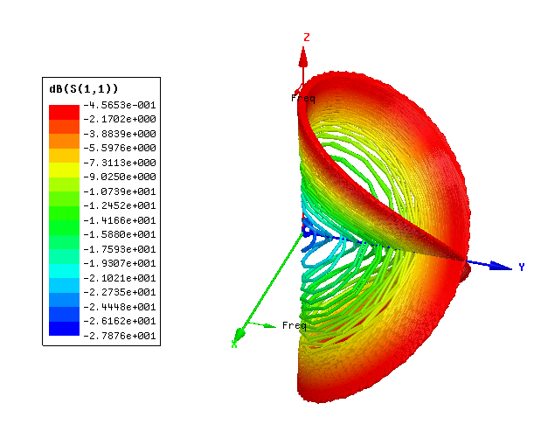

Figure 7: Outcome of 3D polar plot, S parameter

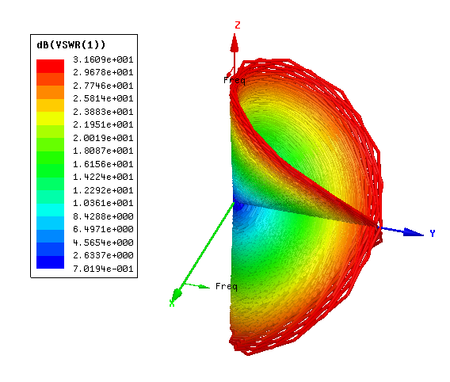

Figure 8: Outcome of 3D polar plot VSWR

**3.4 Difficulties & Mitigations**

After simulating an array antenna and applying numerous simulation settings with the appropriate values, I processed and performed to get the outcome that I was seeking. After doing an investigation into the outcome, I found problems and errors. I realized that neither the radiation pattern nor the high return loss had been cleared. I observed that the graphs did not clarify as well as they normally do because of the lower rate of the substrate height and the greater value of the dielectric constant. After that, I decided to hunt for a solution to the problem online while I also arranged a meeting with the rest of my team and my supervisor to talk about it. To finish the operation of the array scheme one more time, I made the antenna larger by 1.4 mm, increasing the substrate's total height to 2 mm. I found that there was an improvement in the radiation pattern, a decrease in the value of the return loss, and an increase in the gain that had previously been noticed.

**3.5 Creative Tasks**

I optimized the antenna’s height to 1.6 mm from 2 mm to enhance the efficacy and reduce the return loss of the suggested array antenna. I also applied the feed substrate to operate the desired scheme of the array antenna in a precise manner.

**3.6 Team management**

I was selected to serve as the team's captain. I was in charge of gathering all of the data and components essential for the complete production of a micro-strip antenna. In addition to that, I assembled a group and delegated various responsibilities to the team members. I decided to plan a meeting with my team as well as my supervisor, and at that meeting, I discussed the problems and errors that were related to our work. I attempted to find a solution to the problems and errors that I was experiencing. The remaining work on the project was delegated to each individual in this group, and I was responsible for a portion of it myself. I made sure that the project was my first focus while also keeping careful of how the project management system was doing. After then, I was involved in managing the system despite the many obstacles it presented.

**3.7 Codes**

When performing this duty, I adhered completely to the university's policies. I explored IEEE 145-1973 since I was keen on learning more about the antenna.

* 1. **Summary**

The scheme, whose aim was to build a microstrip antenna using HFSS, was successfully developed. The different parts were put together to build the micro-strip antenna system. The HFSS and simulation were used to create the antenna model. The structure for the patch-fed microstrip antenna was developed. A selected HFSS was used to simulate the antenna model while adjusting the antenna's diameters and other features. Observed multiple S-parameter, VSWR, total gain, and return loss presentations of the produced antenna. Observed return loss above -25dB at 6-7 GHz (X 6.2159, Y -27.8656), VSWR fluctuated (30dB to 15dB) 1-10 GHz at X 6.2150 Y 0.7019; max gain 20.115dB; 3D polar S parameter -0.45653dB, VSWR 31.609dB. The beam width of the antenna, which was roughly 60o and 10o in azimuth and elevation, was determined to be appropriate for locating ground-based broadcasters.

I grew my communication skills. About HFSS antenna design, I gained more knowledge. I also get better at fixing problems. I was able to expand my area of competence in antenna design. About the numerous antenna kinds, I gained more knowledge.