Database Lab Manual

Name: Malik Iatazaz Altaf

Reg: 21pwbcs0863

Section: B

Instructor: Sir Sadiq U Rehman

|  |
| --- |
| **Lab Task 1:** |

Lab Task 2:

|  |  |
| --- | --- |
|  | |
|  | |
| * ***Creating table staff*** | |
| CREATE TABLE staff | |
|  | |
| * ***Inserting values into staff*** | |
|  | |
| * ***Creating table privateOwner*** | |
|  | |
| * ***Inserting values into privateOwner*** | |
| * ***Creating table propertyForRent*** | |
|  | |
| * ***Inserting values into propertyForRent*** | |
|  | |
| * ***Creating table client*** | |
| CREATE TABLE client | |
| * ***Inserting values into client*** | |
|  | |
| * ***Creating table viewing*** | |
| * ***Inserting values into viewing*** | |
| * ***Creating table registration*** | |
|  |
|  |
|  |
|  |
|  |
|  |  |
|  | * ***Inserting values into registration*** |
|  |  |

Query 01:

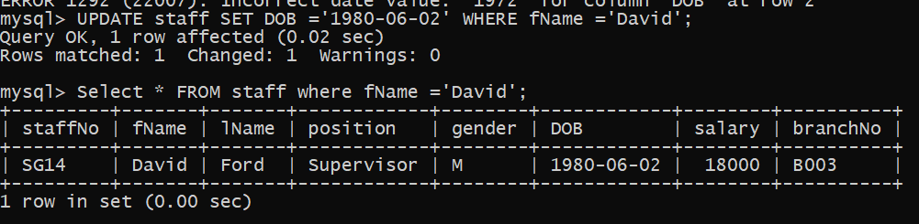

Query 02:

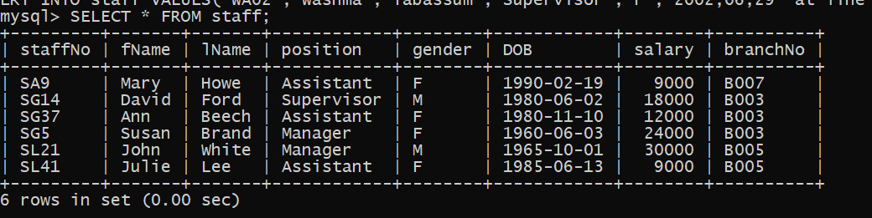

Query 03:

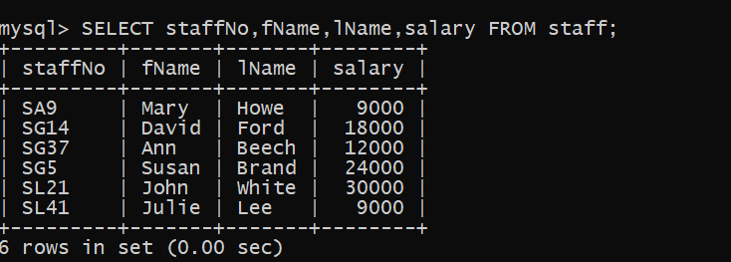

Query 04:

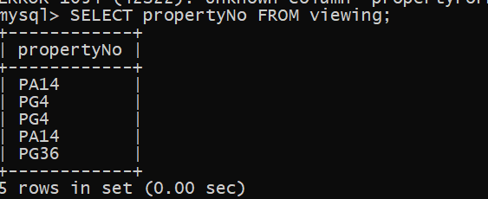

Query 05:

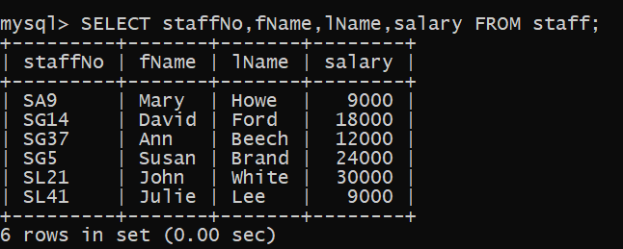

Query 08:

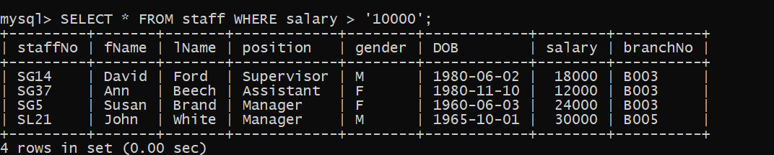

Query 09:

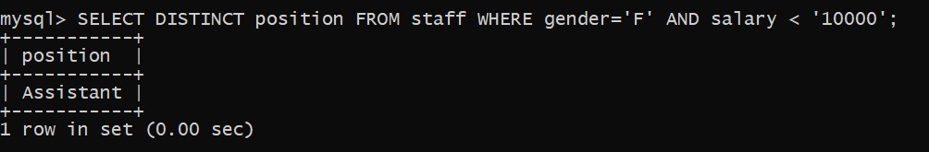

Query 10:

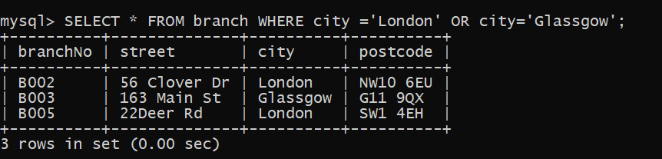

Query 11:

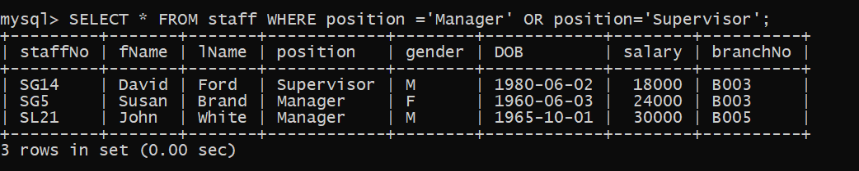

Query 12:

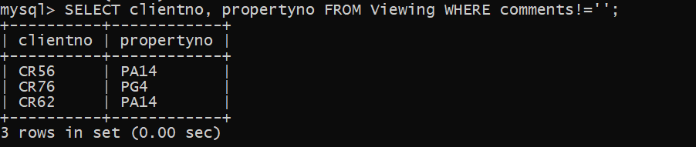

**LAB 04**

**Query: 01**

SELECT roomtype,price FROM rooms WHERE (roomtype = ‘double’ OR roomtype =’family’) AND price < 40.00 ORDER BY price ASC;

**Query: 02**

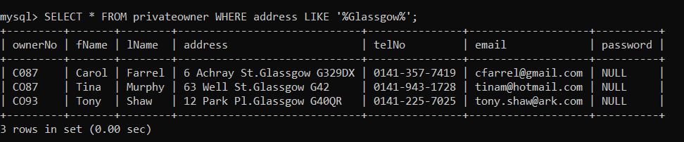

**Query: 03**

SELECT COUNT(*) AS total_customers FROM customers WHERE city = 'Union';

**Query: 04**

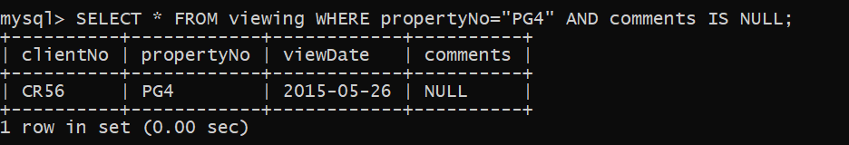

**Query: 05**

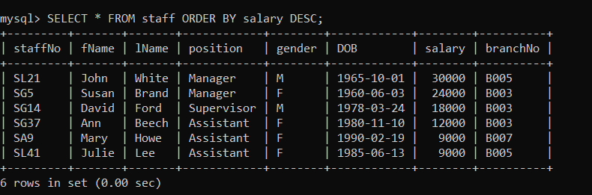

**Query: 06**

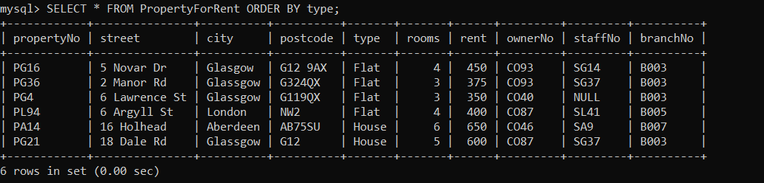

**Query: 07**

SELECT name, address FROM Guest WHERE city =’London’ ORDER BY name ASC;

**Query: 08**

SELECT COUNT (DISTINCT product_ID) FROM A_Reviews table;

**Query: 09**

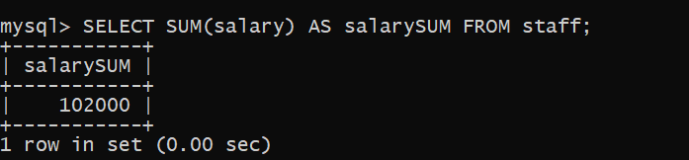

**Query: 10**

SELECT MAX (price) AS max FROM rooms WHERE type =’family’;

**Query: 13**

SELECT sum (sell_price*quantity) as revenue FROM A_Products;

**Query: 14**

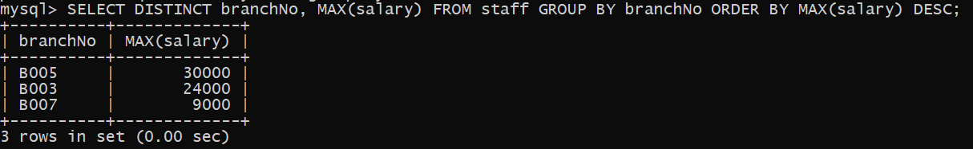

**Query: 15**

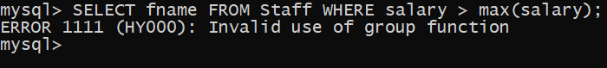

**Query: 16**

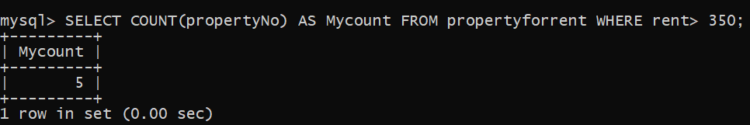

**Query: 17**

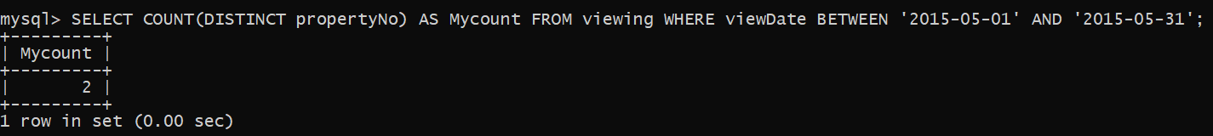

**Query: 18**



**Query: 19**

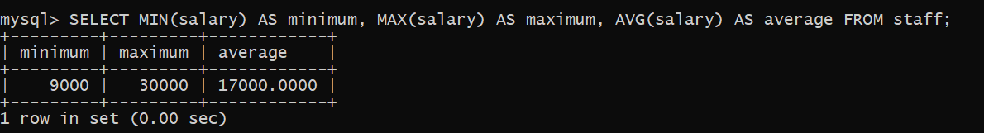

**Query: 20**

**Query: 21**

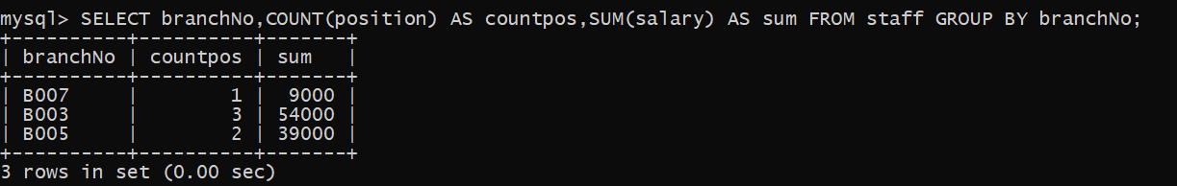

**Query: 22**

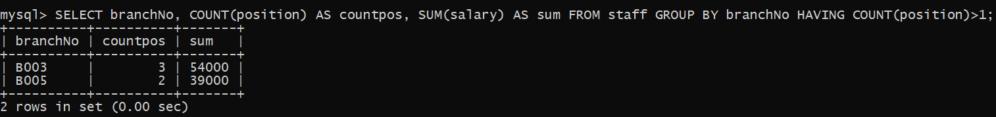

Query 01:

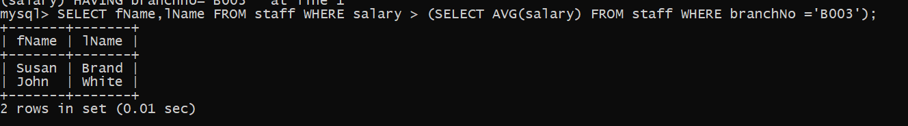

Query 02:



Query 03:

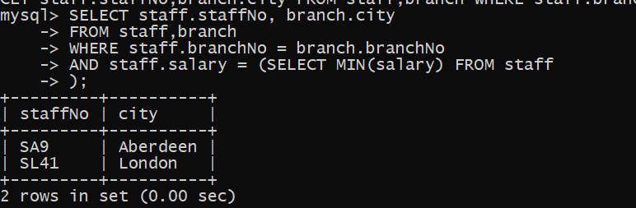

Query 04:

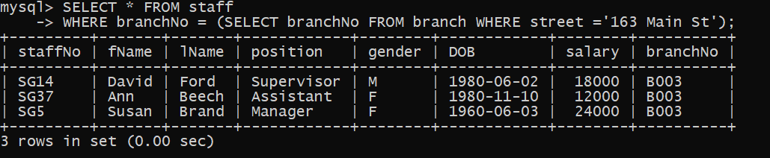

Query 06:

SELECT * FROM guests

WHERE guest_id IN (

SELECT guest_id

FROM reservations

WHERE hotel_name = ‘Grosvenor Hotel’

AND check_in_date >= '2004-04-01'

AND check_out_date <= '2004-08-31');

Query 07:

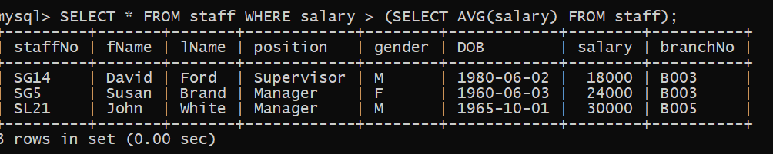

Query 08:

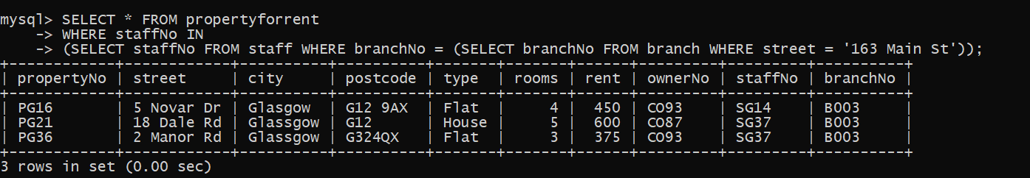

Query 09:

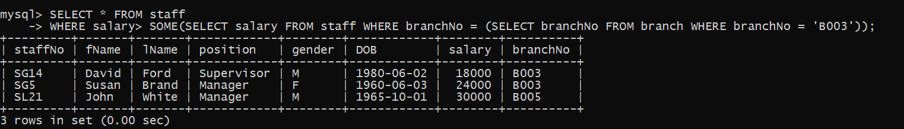

Query 10:

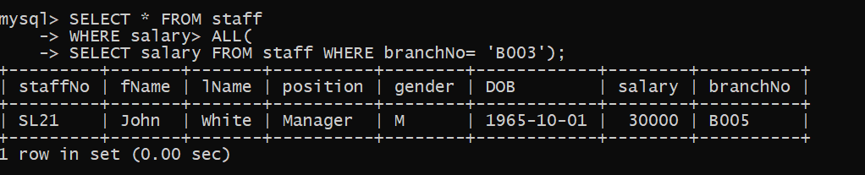

Query 11:

SELECT fName FROM employees

INNERJOIN locations ON employees.locationID = locations.locationID

WHERE locations.city = ‘London’

AND employees.salary> 10000;

Query 12:

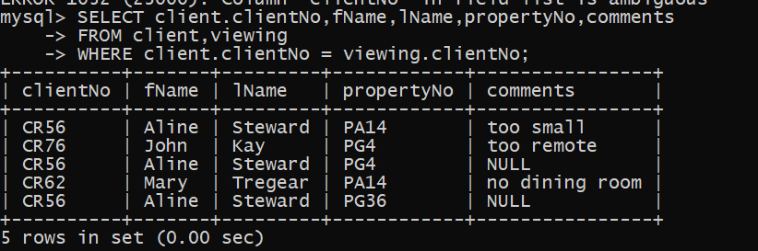

Query 13:

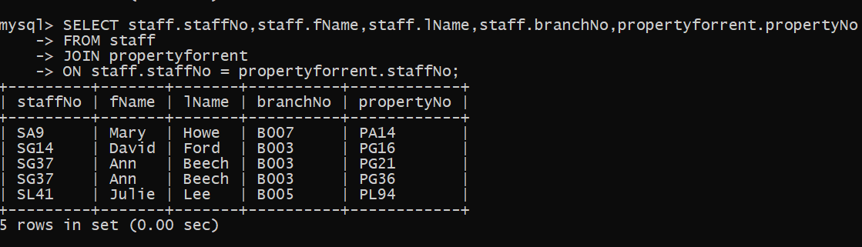

Query 14:

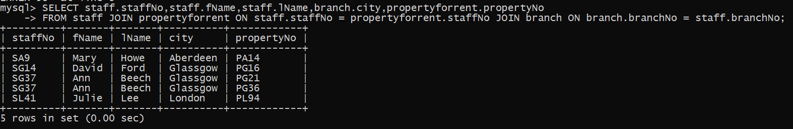

Query 15:

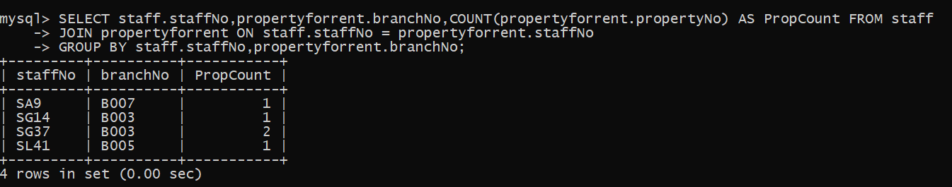

Query 16:

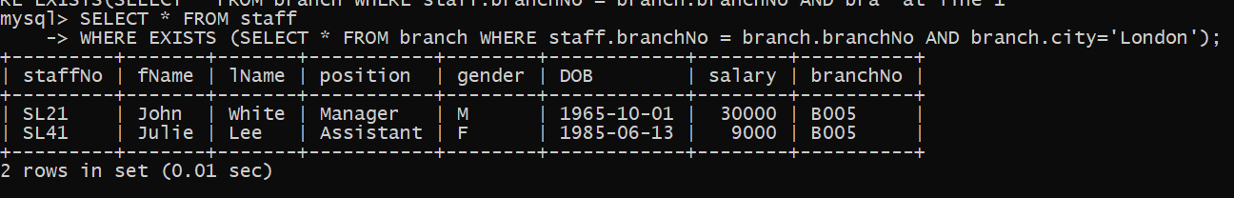

Query 22:

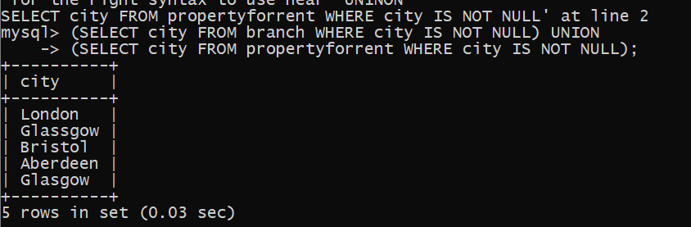

Query 25:

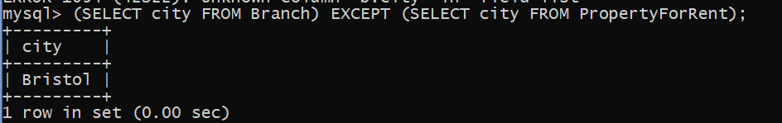

***Lab No.7***

Query 1:



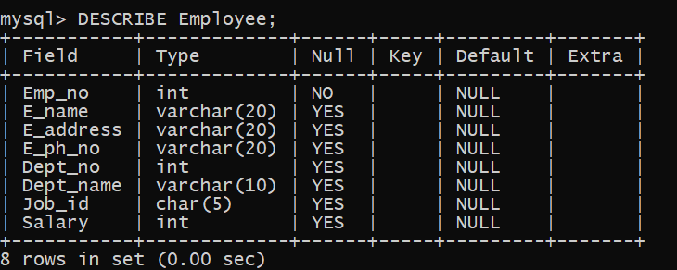

Query 2:

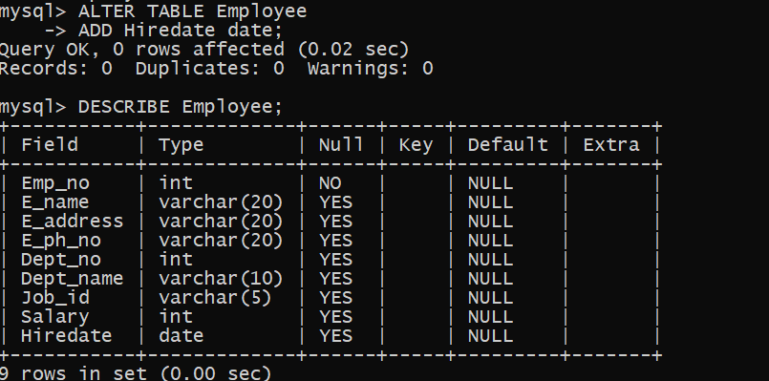

Query 3

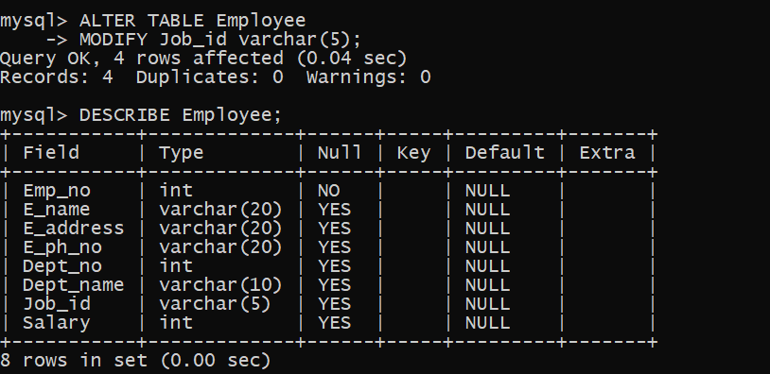

Query 4:

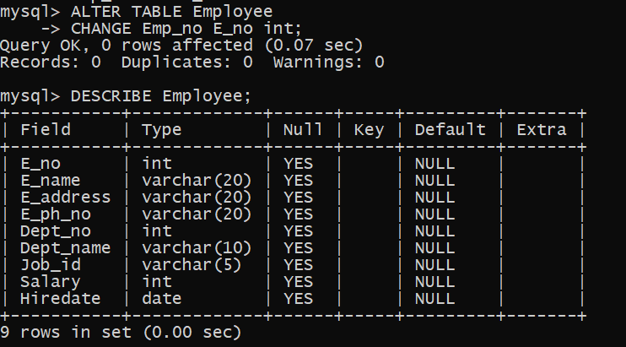

Query 5:

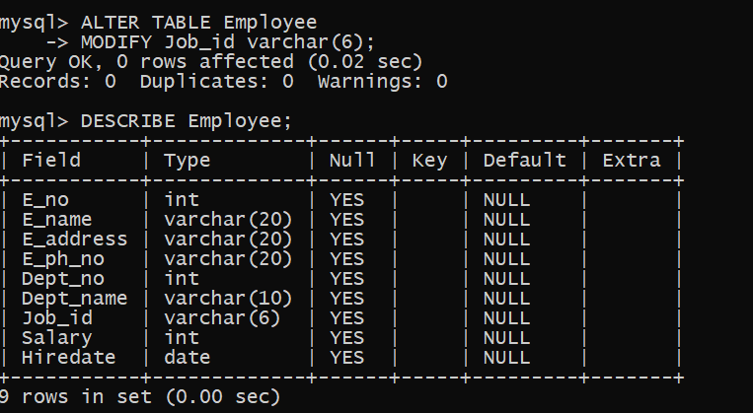

***Lab # 08***

Query 1:

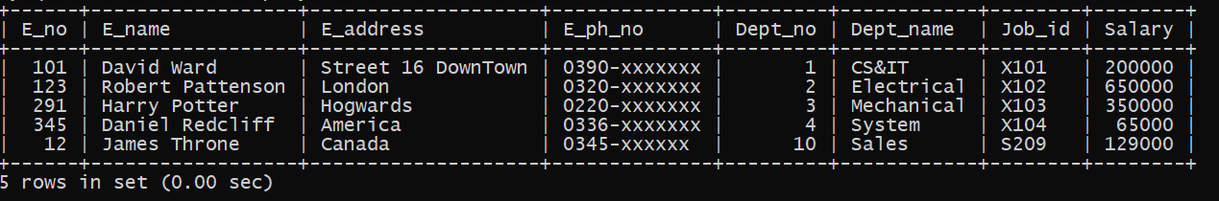

Query 2:

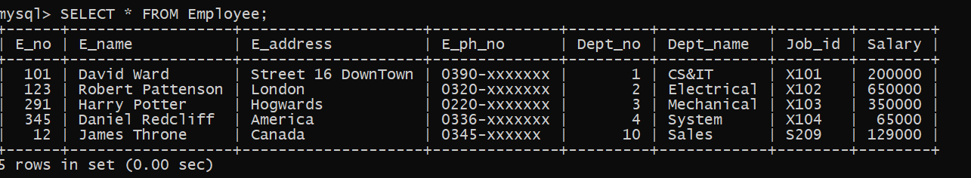

Query 3:

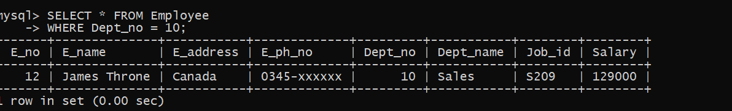

Query 4:

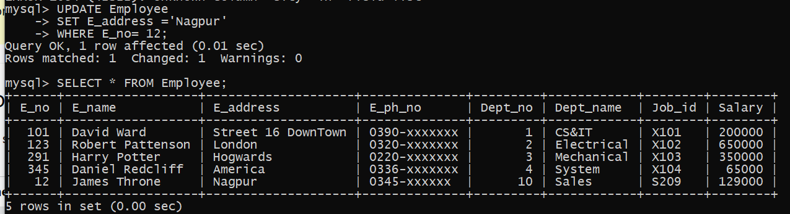

Query 5:

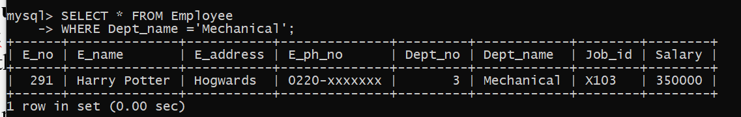

Query 6:

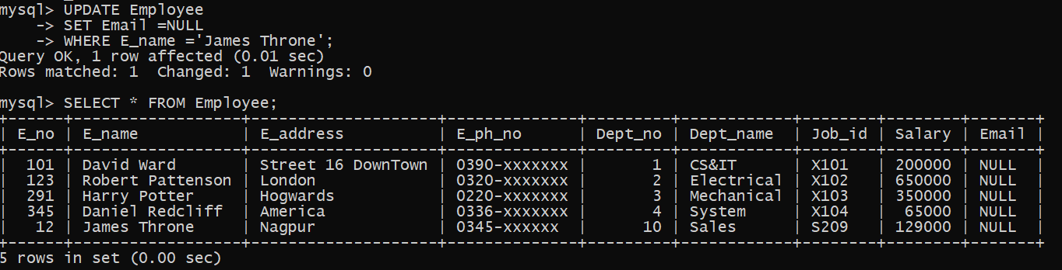

Query 7:

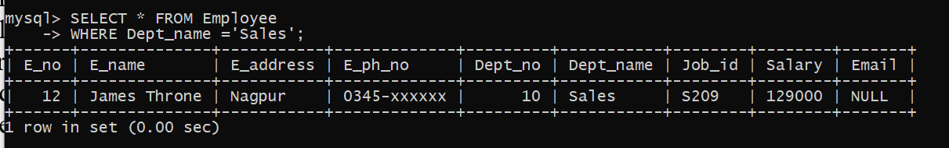

**WEEK 10**

**Creating a View:**

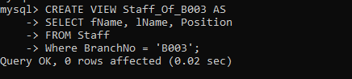

**Displaying a View:**

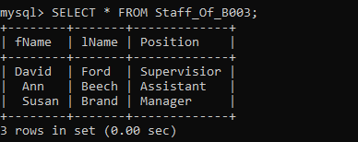

**Updating a View:**

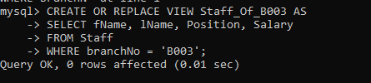

**Dropping a View:**



**Commit:**

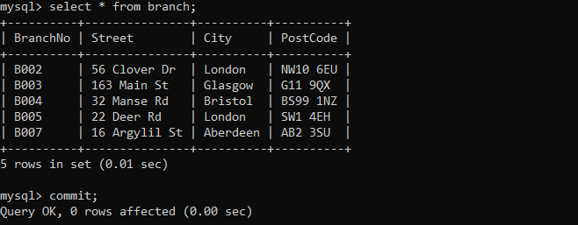

**Save point:**

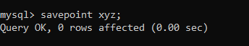

**Rollback:**

