GitHub repo link:

<https://github.com/MalikTalha03/NodeJS-Auth>

Registration:

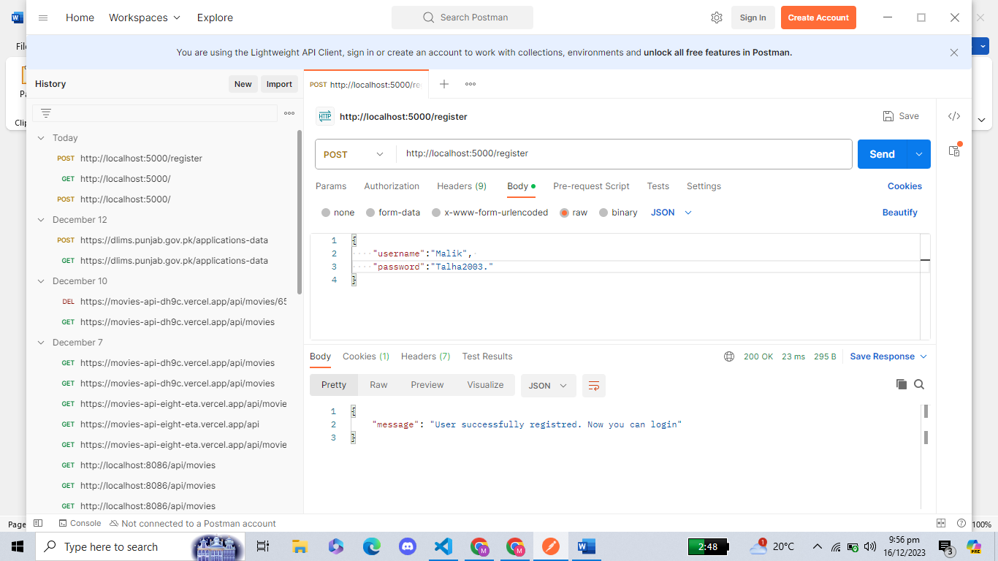

Login:

GET Request:

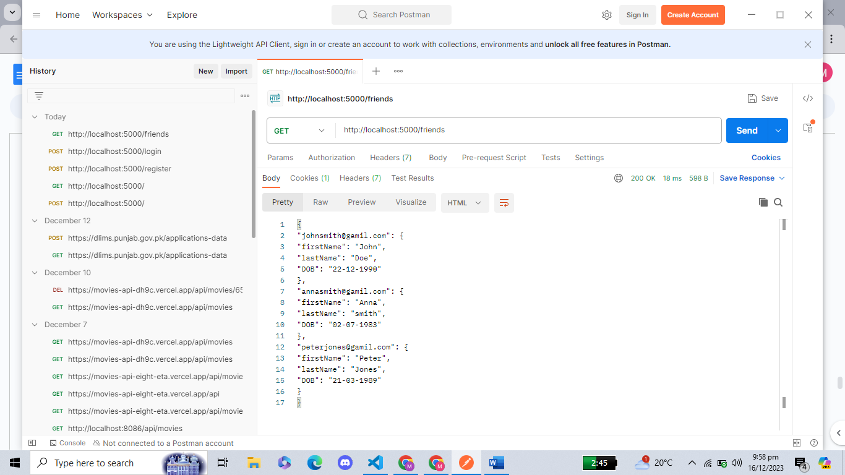

GET by Email:

POST:

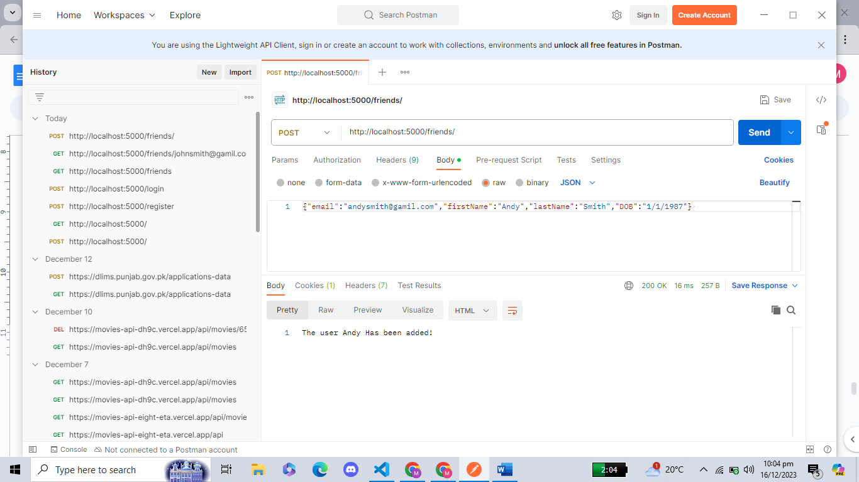

PUT:

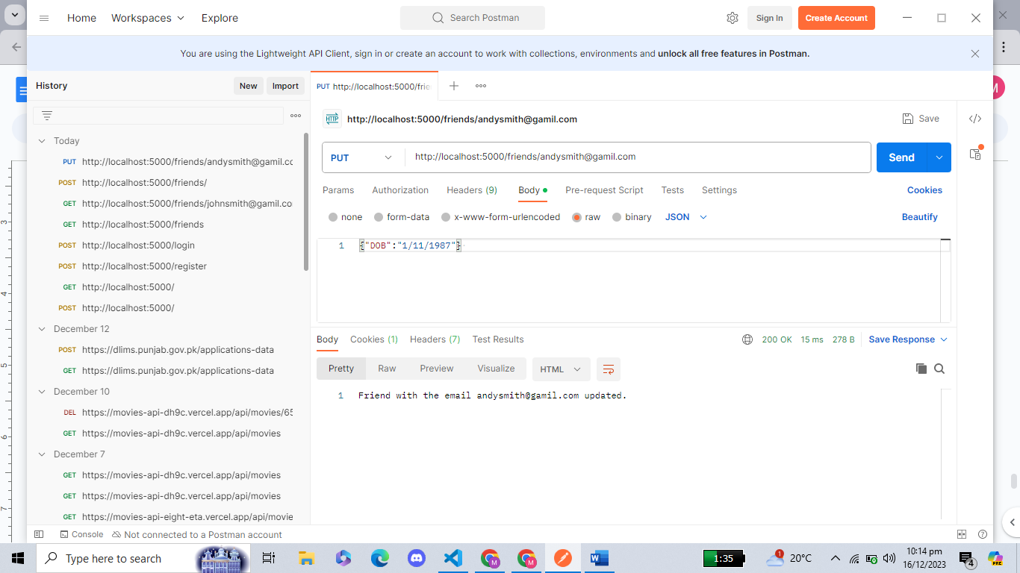

Delete:

GET after Session Time Limit Implementation:

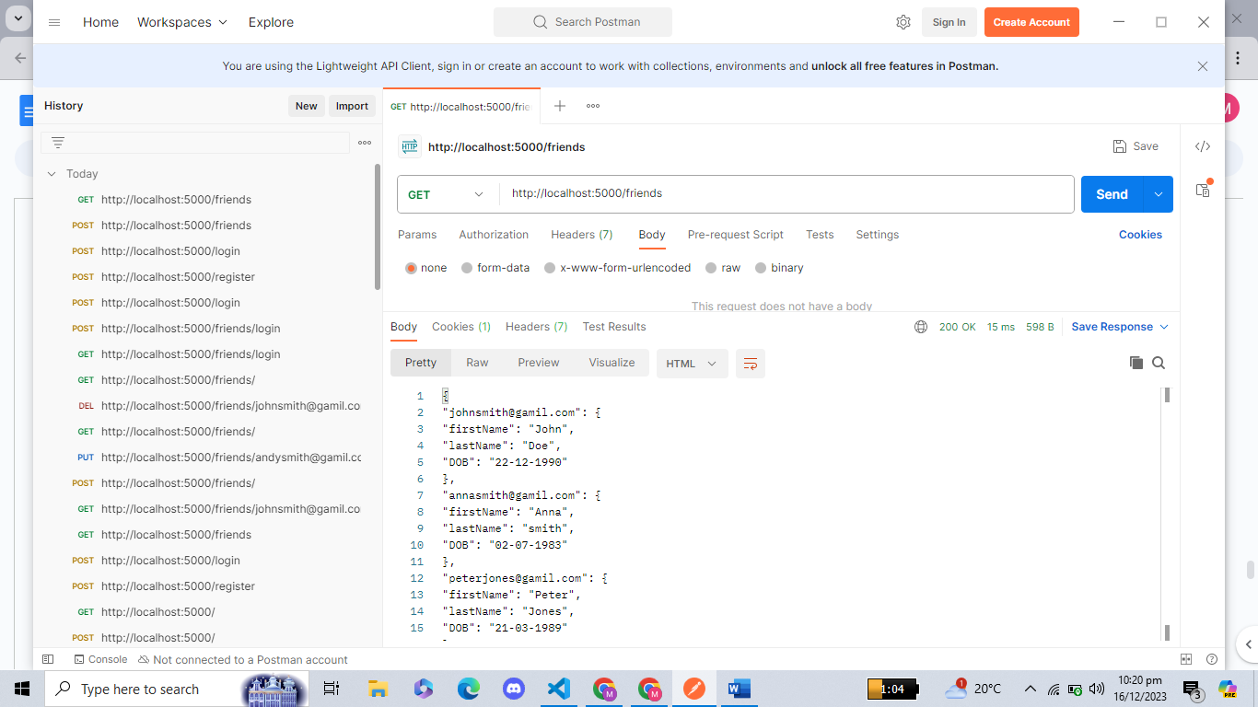

After 60 Seconds Timeout:

