To verify locally

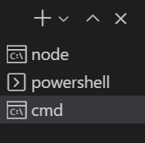

Open command prompt

Npm start

<http://localhost:4200/docs>

Open src\index.html

Uncomment -> <base href="/">

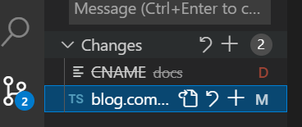

Do not push CNAME change

ng build --configuration production && node scripts/patch-build.js

