**Deep Learning - Lab 03**

IT21277122 – Degaldoruwa D.W.S.S.W.M.R.M.B.B

**Uploaded Images**

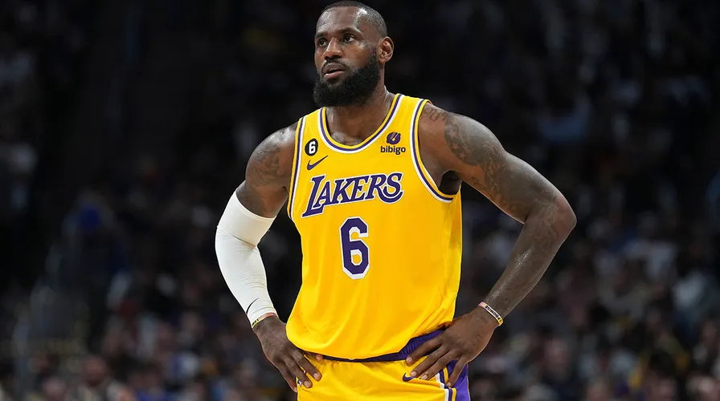

lebronjames01.jpg

lebronjames02.jpg

**Screenshots of outputs**

