ASSIGNMENT 2
Vulnerability Assessment of Metasploitable 2
Network Scanning, Service Enumeration & Vulnerability Documentation

Student Name | Malaika Imran
Course / Lab | Information Security Lab
Target Host | Metasploitable 2 — 10.0.2.4
Attacker Host | Kali Linux — 10.0.2.5
Date of Assessment | 07 November 2026

1. Introduction and Objective
This report presents a vulnerability assessment of a Metasploitable 2 VM from a Kali Linux attacker on an isolated host-only network. The objective is to document three distinct findings in Task A and to complete two options from Task B (B3 and B4).

2. Lab Environment and Methodology
All testing was performed on a private, host-only VirtualBox network with no route to the Internet, so no third-party systems were affected. The environment and tooling are summarised below.
Component | Details
Attacker | Kali Linux
Target | Metasploitable 2 (Linux 2.6.24-16-server)
Attacker IP | 10.0.2.5
Target IP | 10.0.2.4
Primary scanner | Nmap with NSE scripts; curl and the native FTP client for verification

Methodology. A dedicated working directory (~/S6-scanning/evidence) was created to hold all evidence. Reachability to the target was first confirmed with ICMP, after which a service- and version-detection scan (nmap -sC -sV -oA) established the attack surface. Each candidate finding was then verified with a targeted tool — an NSE vulnerability script, an HTTP header request, or an interactive protocol session and the output was captured to disk with timestamps before being documented below.
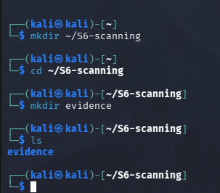
Figure 1 — Evidence workspace created on the Kali attacker.
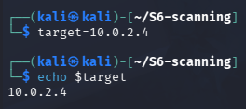
Figure 2 — Target address stored in a shell variable for reuse.
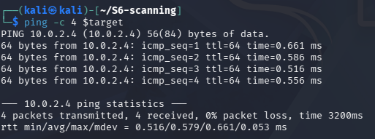
Figure 3 — ICMP reachability confirmed (4/4 replies, 0% loss).

3. Task A — Three Documented Findings
Each finding below follows the section 7.1 template exactly: Title, Severity, Affected asset, Identifiers, Description, Evidence, Proof of concept, Impact, Remediation and References.

3.1 Finding 01 — vsftpd 2.3.4 Backdoor Command Execution (RCE)
Title | The distributed vsftpd 2.3.4 package contains an intentional backdoor that grants an unauthenticated remote attacker a root shell on TCP port 6200.
Severity | CVSS v3.1 Base Score: 9.8 (Critical). Vector: CVSS:3.1/AV:N/AC:L/PR:N/UI:N/S:U/C:H/I:H/A:H.
Affected asset | Host: 10.0.2.4 Port: 21/tcp (FTP) — trigger; the backdoor shell listens on 6200/tcp. Service: vsftpd 2.3.4.
Identifiers | CVE: CVE-2011-2523  CWE: CWE-506 — Embedded Malicious Code (parent: CWE-912, Hidden Functionality)  CPE: cpe:2.3:a:vsftpd:vsftpd:2.3.4:*:*:*:*:*:*:*
Description | The vsftpd 2.3.4 source package downloaded between 30 June and 3 July 2011 contained a backdoor. Sending a username containing :) to the FTP service opens a command shell on TCP port 6200, which gave root access on this target. Since the code was deliberately planted, the fix is to replace the package rather than configure it.
Evidence | The version scan identified vsftpd 2.3.4 on port 21 and flagged anonymous login. A targeted NSE script then confirmed exploitability and executed a command as proof:  sudo nmap -sC -sV -oA evidence/initial-nmap 10.0.2.4  nmap -p 21 --script ftp-vsftpd-backdoor -oN evidence/vsftpd-backdoor-check.txt 10.0.2.4  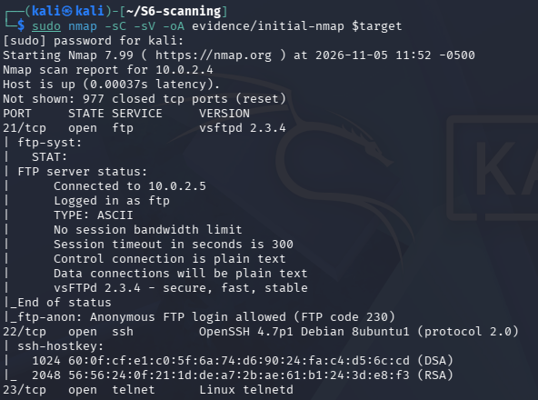  Figure 4 — Initial -sC -sV scan: vsftpd 2.3.4 on port 21.  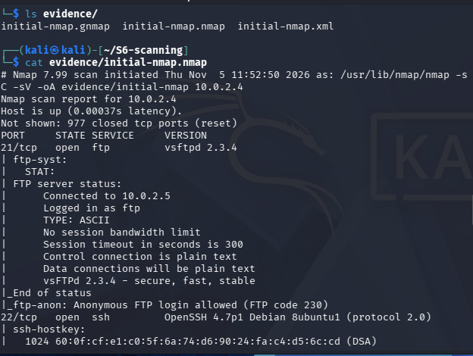  Figure 5 — Saved .nmap evidence of the version scan.  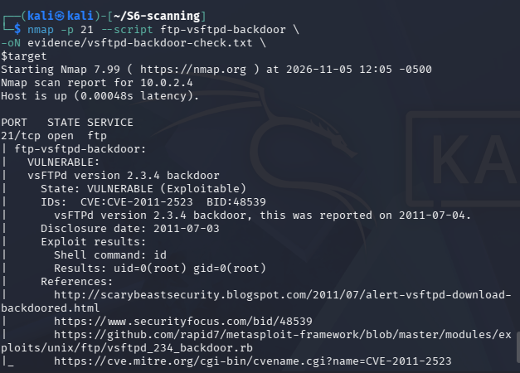  Figure 6 — NSE ftp-vsftpd-backdoor: VULNERABLE, id → uid=0(root).  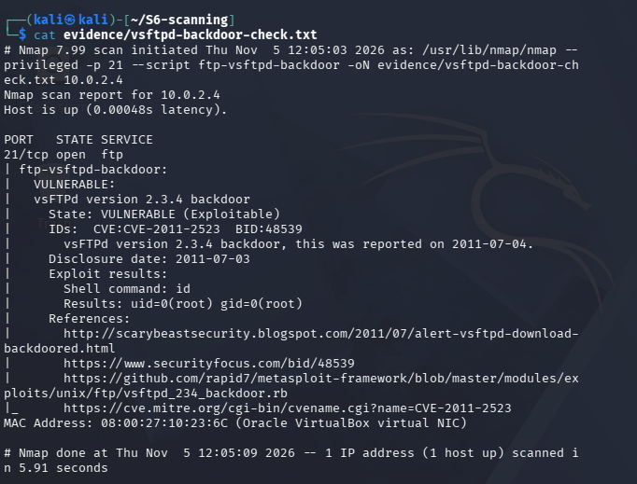  Figure 7 — Saved backdoor-check log with target MAC and scan footer.
Proof of concept | Minimum reproducible steps that demonstrate the flaw:  - Confirm the service is vsftpd 2.3.4 on port 21 (Figure 4).  - Run nmap -p 21 --script ftp-vsftpd-backdoor <target>. The script supplies a username ending in :), opens the shell that appears on port 6200, and issues a test command.  - Observe the returned output uid=0(root) gid=0(root), proving an unauthenticated root command executed on the target (Figure 6).
Impact | Demonstrated rather than assumed: the id command returned root. An unauthenticated attacker therefore obtains a full interactive root shell, which means complete compromise of the host — arbitrary file read and write, credential theft, installation of persistence, and use of the machine as a pivot into the rest of the network. All three security properties (confidentiality, integrity, availability) are fully lost.
Remediation | - Remove the trojan vsftpd 2.3.4 immediately and do not attempt to patch it.  - Reinstall vsftpd from the distribution's signed repository and verify the package hash/GPG signature before installing (the fixed, clean builds — 2.3.5 and later never carried the backdoor).  - Block inbound access to port 6200 and monitor for unexpected listeners.  - Adopt supply-chain controls: install only from trusted mirrors and validate checksums/signatures for all downloaded software.
References | - NVD — CVE-2011-2523  - MITRE CVE — CVE-2011-2523  - CVE Details — CVE-2011-2523  - Exploit-DB 17491 — vsftpd 2.3.4 Backdoor Command Execution (Metasploit)  - Rapid7 Metasploit module (GitHub) — vsftpd_234_backdoor.rb  - MITRE CWE-506 — Embedded Malicious Code

3.2 Finding 02 — PHP Information Disclosure via Exposed phpinfo.php
Title | A publicly reachable phpinfo.php page discloses the complete PHP, web-server and operating-system configuration to any unauthenticated visitor.
Severity | Medium. Self-assessed CVSS v3.1 ≈ 5.3. Vector: AV:N/AC:L/PR:N/UI:N/S:U/C:L/I:N/A:N.  This is an information-exposure issue arising from how the application is deployed, not a flaw in a specific product version, so no CVE is assigned; the severity is derived from the CVSS framework (network-reachable, no privileges, limited confidentiality impact, no integrity or availability impact).
Affected asset | Host: 10.0.2.4 Port: 80/tcp (Apache/2.2.8 (Ubuntu) DAV/2) URL: http://10.0.2.4/phpinfo.php Stack: PHP 5.2.4-2ubuntu5.10.
Identifiers | CVE: Not applicable — configuration/exposure issue, no product CVE.  CWE: CWE-200 — Exposure of Sensitive Information to an Unauthorized Actor  CPE (stack): cpe:2.3:a:apache:http_server:2.2.8 / cpe:2.3:a:php:php:5.2.4
Description | The phpinfo() function prints a full diagnostic page: the exact PHP version, the OS and kernel build, the web-server SAPI, absolute filesystem paths (for example /etc/php5/cgi/php.ini), every loaded module and the server environment. When this page is left in the web root it becomes a reconnaissance goldmine — it hands an attacker precisely the version and path information needed to select working exploits, with no effort and no authentication. It should never be present on a deployed system.
Evidence | An HTTP header request confirmed the page is live and leaked the server and PHP banners; the rendered page confirmed the full configuration dump:  curl -I http://10.0.2.4/phpinfo.php  Response: HTTP/1.1 200 OK, Server: Apache/2.2.8 (Ubuntu) DAV/2, X-Powered-By: PHP/5.2.4-2ubuntu5.10.  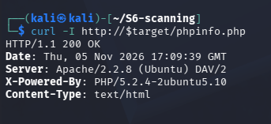  Figure 8 — curl -I reveals Server and X-Powered-By banners (HTTP 200).  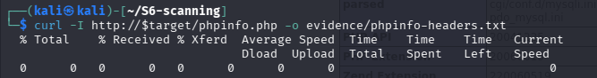  Figure 9 — Response headers saved to evidence/phpinfo-headers.txt.  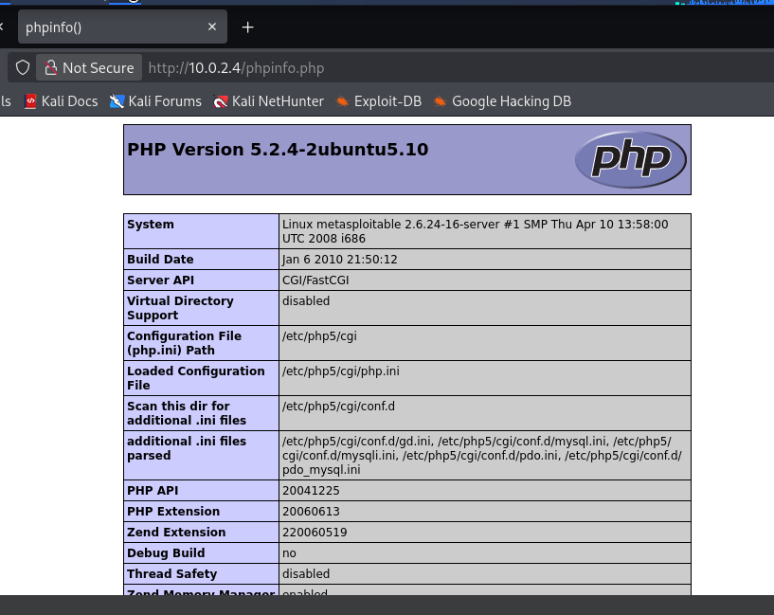  Figure 10 — Rendered phpinfo() page: PHP 5.2.4, kernel, paths and modules exposed.
Proof of concept | - Browse to http://10.0.2.4/phpinfo.php
Impact | The disclosed PHP version (5.2.4, long end-of-life) lets an attacker match known CVEs precisely; the absolute paths assist local-file-inclusion and log-poisoning attacks; and the module list reveals which attack techniques are viable. No data is altered, but the confidentiality of the server's configuration is breached and the effort required for a follow-up attack is sharply reduced.
Remediation | - Delete phpinfo.php (and any similar diagnostic scripts) from the web root.  - Disable the function in production via disable_functions = phpinfo in php.ini.  - If a diagnostic page is genuinely required, restrict it behind authentication and an IP allow-list.  - Upgrade to a supported PHP release so that leaked version data is less immediately exploitable.
References | - MITRE CWE-200 — Exposure of Sensitive Information to an Unauthorized Actor  - https://nvd.nist.gov/vuln/weaknesses

3.3 Finding 03 — Anonymous FTP Access Enabled (Misconfiguration)
Title | The FTP service permits anonymous login, allowing any unauthenticated user to connect and list the server's filesystem.
Severity | Medium. CVSS v3.1 ≈ 6.9. Vector: CVSS:4.0/AV:N/AC:L/AT:N/PR:N/UI:N/VC:L/VI:L/VA:N/SC:N/SI:N/SA:N/AU:Y/RE:M
Affected asset | Host: 10.0.2.4 Port: 21/tcp Service: vsftpd 2.3.4 with anonymous_enable=YES.
Identifiers | CVE: CVE-2025-59980  CWE: CWE-287 — Improper Authentication (related: CWE-1188, Insecure Default Initialization of a Resource)  CPE: cpe:2.3:a:vsftpd:vsftpd:2.3.4:*:*:*:*:*:*:*
Description | The FTP daemon is configured to accept the reserved anonymous / ftp account with any password. The initial scan flagged Anonymous FTP login allowed (FTP code 230), and an interactive session confirmed it. Anonymous FTP removes the authentication boundary entirely: any person who can reach the port can enumerate directories, and where the account is also writable it enables upload of malicious content or defacement. Combined with the fact that FTP is a cleartext protocol, it is a design-level weakness.
Evidence | 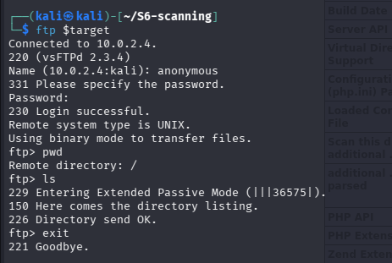  Figure 11 — Anonymous login succeeds (230) and the directory listing is returned.  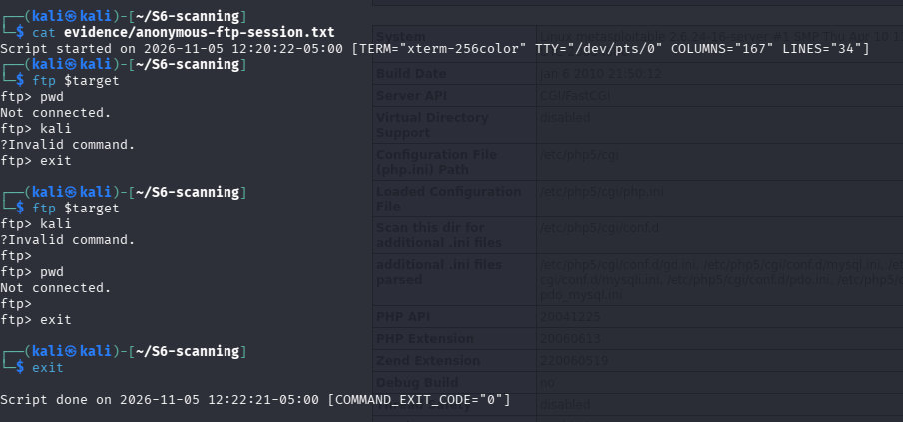  Figure 12 — The session captured to an evidence log with start/stop timestamps.
Proof of concept | - Run ftp 10.0.2.4.  - At the login prompt enter username anonymous and any (or empty) password.  - The server responds 230 Login successful; ls then returns a directory listing — all without a valid account (Figure 11).
Impact | An unauthenticated attacker can browse and enumerate the FTP directory tree, learning about files and structure that aid further attacks. Because FTP transmits in cleartext, any legitimate credentials used elsewhere on the service can also be intercepted. If the anonymous account is writable, the attacker can upload web shells or malware. The immediate, demonstrated impact is a confidentiality breach via unauthenticated filesystem enumeration.
Remediation | - Set anonymous_enable=NO in /etc/vsftpd.conf and restart the service.  - Require named, authenticated accounts and apply chroot jailing so users cannot traverse the wider filesystem.  - Replace cleartext FTP with FTPS or SFTP so that sessions and credentials are encrypted.  - Remove write permissions from any anonymous or upload directories unless strictly required.
References | - MITRE CWE-287 — Improper Authentication  - https://nvd.nist.gov/vuln/detail/cve-2025-59980

4. Task B — Selected Options
Two options were selected: B3 and B4.

4.1 Option B3 — Decoding the CVSS v3.1 Vector for CVE-2011-2523
Each metric of the latest NVD vector, CVSS:3.1/AV:N/AC:L/PR:N/UI:N/S:U/C:H/I:H/A:H, is decoded below in plain English from the behaviour of the vulnerability itself.
Metric | Value | What it means | Decoder Vector
Attack Vector (AV) | N — Network | The version of the scoring system | The backdoor is reached remotely through the FTP port; no physical or local access is needed.
Attack Complexity (AC) | L — Low | Attacker can attack from far away, over the network | One predictable action (a username containing “:)”) triggers it every time; nothing needs to be timed or guessed.
Privileges Required (PR) | N — None | The attack is easy | The attacker needs no account or prior access; the trigger works before any login succeeds.
User Interaction (UI) | N — None | Attacker does not need an account | No victim has to click or open anything; the attacker alone completes the attack.
Scope (S) | U — Unchanged | Nobody else has to click anything | The damage stays inside the vulnerable FTP host; it does not break out into a separate security authority.
Confidentiality (C) | H — High | Damage stays on the same machine | The shell runs as root, so every file on the system can be read.
Integrity (I) | H — High | Attacker can read all the data | As root the attacker can modify or delete any file or configuration.
Availability (A) | H — High | Attacker can change all the data | As root the attacker can stop services, wipe data or shut the host down.

4.2 Option B4 — CWE Classification and How Remediation Differs by Class
Each Task A finding falls into a different CWE class, and the class decides the right fix.
Finding | CWE | Nature of the class | Remediation the class demands
01 — vsftpd backdoor | CWE-506 Embedded Malicious Code (parent CWE-912) | Malicious code was planted in the software package itself. | Cannot be patched: remove the tainted build, reinstall from a signed source and verify checksums.
02 — phpinfo exposure | CWE-200 Exposure of Sensitive Information | Working code reveals data it should not. | Remove the page or restrict it with authentication; no code change needed.
03 — anonymous FTP | CWE-287 Improper Authentication (related CWE-1188) | The access policy is too permissive by default. | Set anonymous_enable=NO and require named accounts; fix the configuration, not the software.

Why remediation differs. A poisoned package must be replaced, an exposed resource must be removed, and a weak policy must be reconfigured, so “just apply updates” would be wrong for two of the three.
CWE references: CWE-506, CWE-200, CWE-287 and CWE-1188 (cwe.mitre.org; links in Section 6).

