**MALIKA REDDY EPPA**

**WEB TECHNOLOGY LAB -4**

**PART-1:**

**Working URL:**

[**https://malikareddyeppa.github.io/ITC505/lab-4/index.html**](https://malikareddyeppa.github.io/ITC505/lab-4/index.html)

[**https://malikareddyeppa.github.io/ITC505/lab-4/styles.css**](https://malikareddyeppa.github.io/ITC505/lab-4/styles.css)

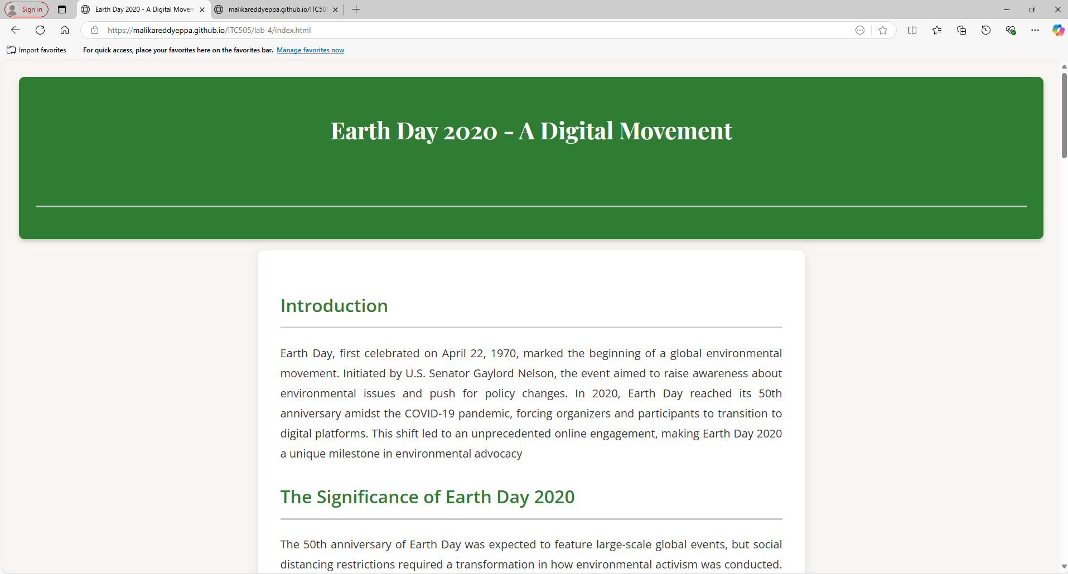

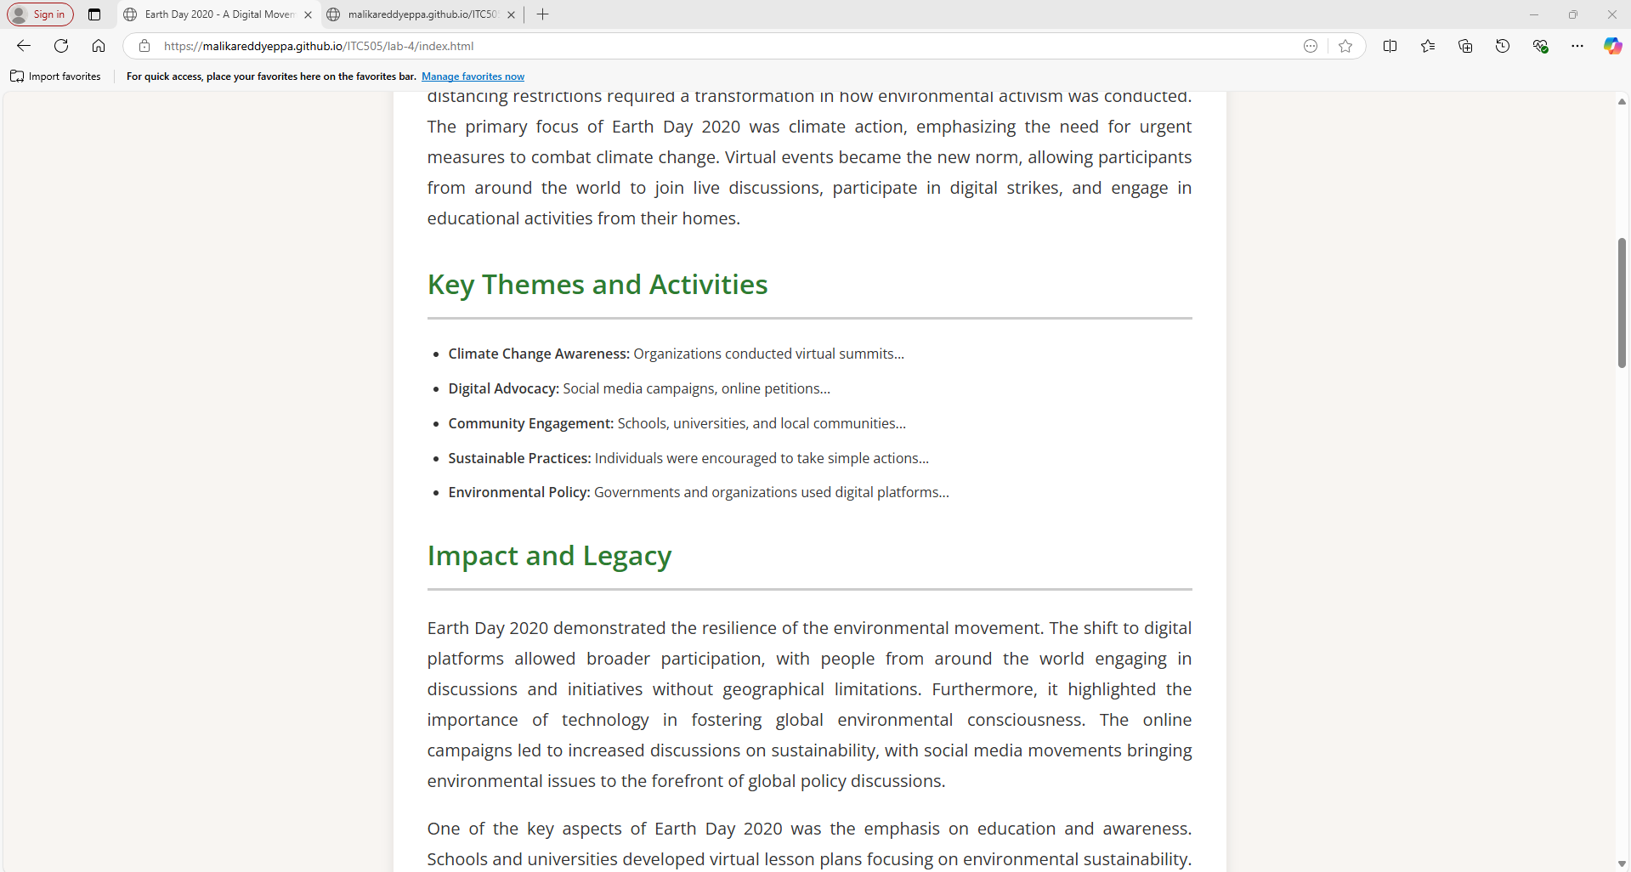

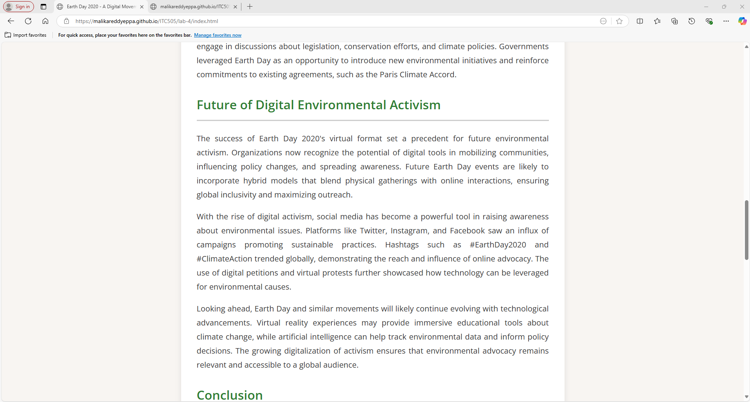

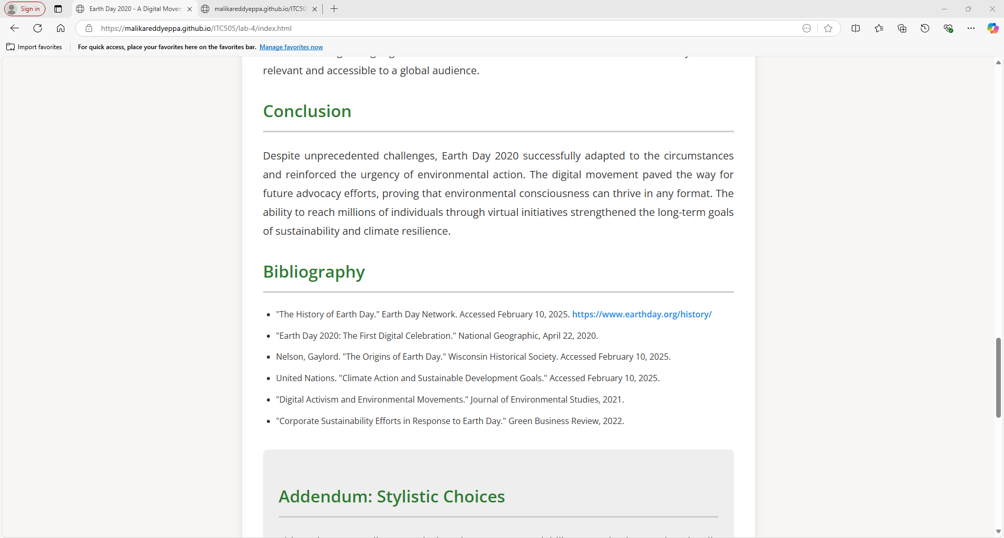

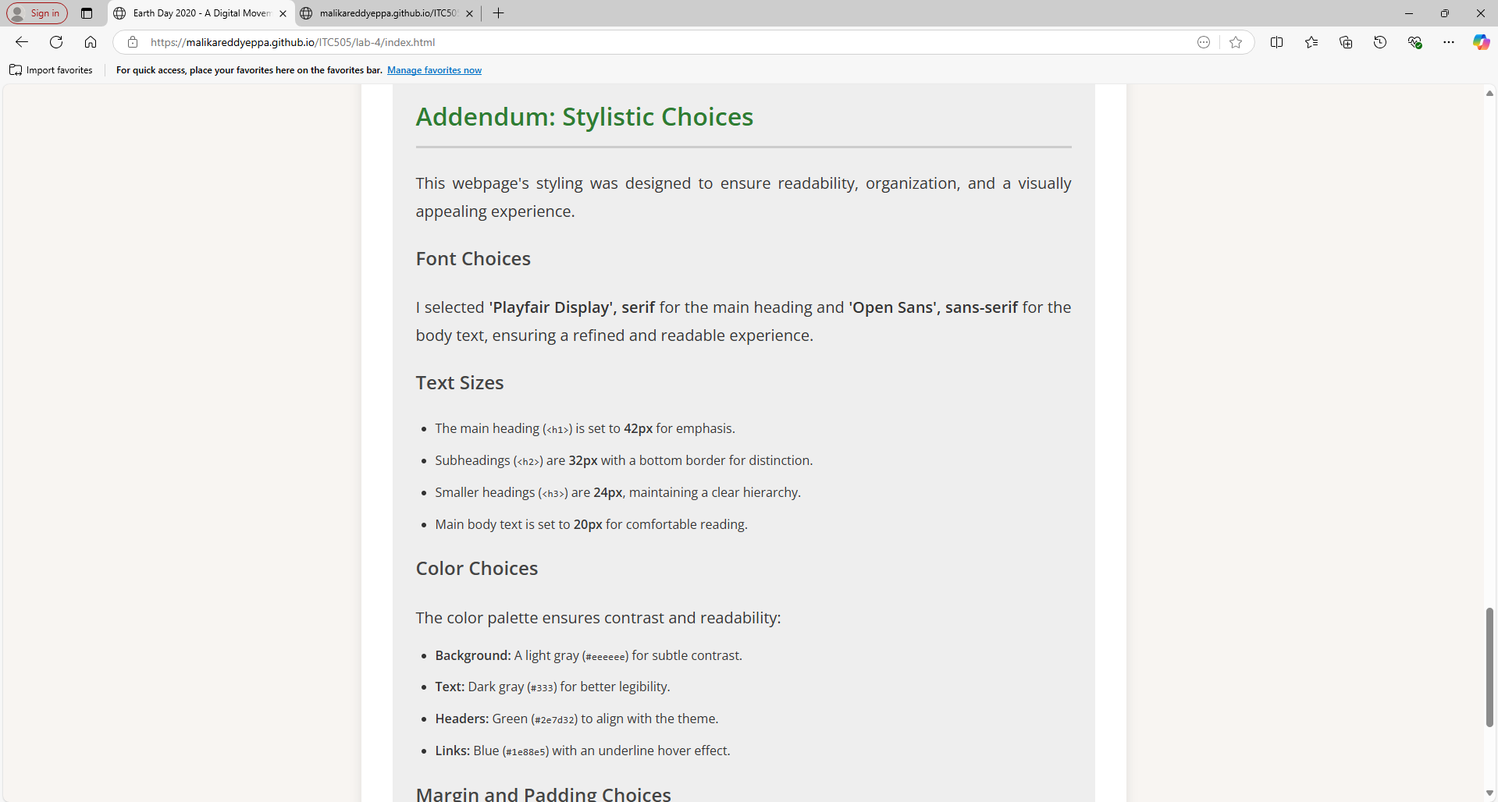

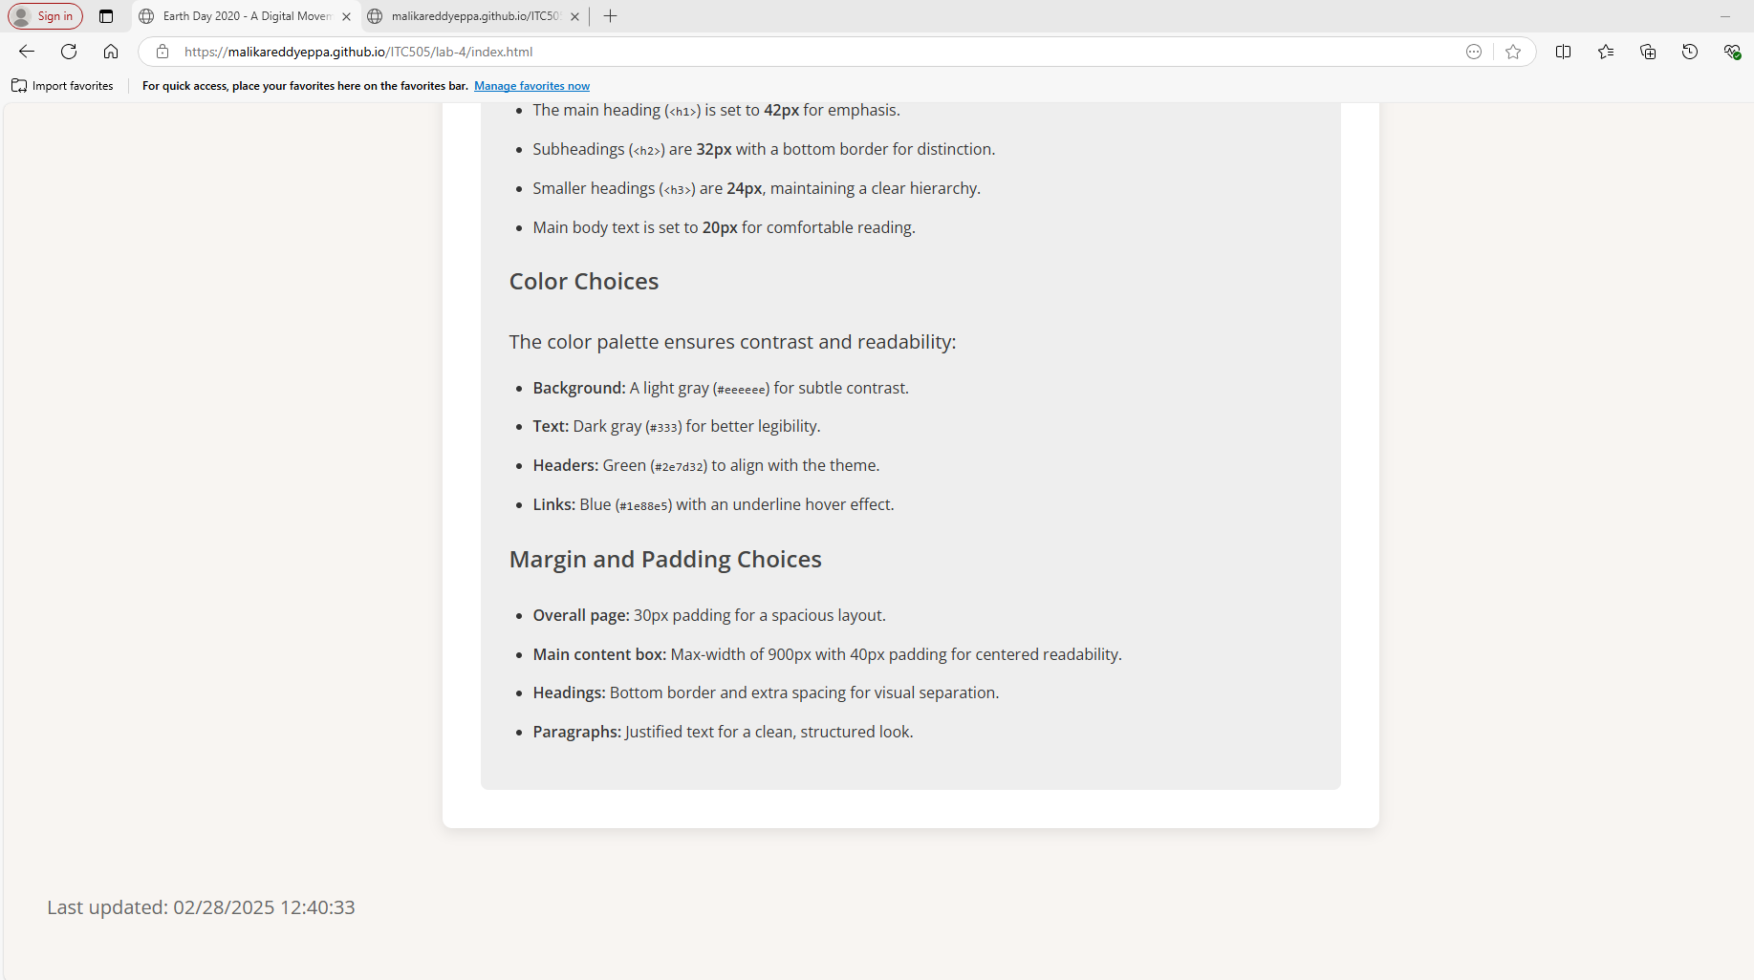

**PART-2:**

**Source Code:  
<!DOCTYPE html>**

**<html lang="en">**

**<head>**

**<meta charset="UTF-8">**

**<meta name="viewport" content="width=device-width, initial-scale=1.0">**

**<title>Earth Day 2020 - A Digital Movement</title>**

**<link rel="stylesheet" href="styles.css">**

**</head>**

**<body>**

**<header>**

**<h1>Earth Day 2020 - A Digital Movement</h1>**

**<h2>Commemorating 50 Years of Environmental Advocacy</h2>**

**</header>**

**<main>**

**<article>**

**<h2>Introduction</h2>**

**<p>Earth Day, first celebrated on April 22, 1970, marked the beginning of a global environmental movement.**

**Initiated by U.S. Senator Gaylord Nelson, the event aimed to raise awareness about environmental issues**

**and push for policy changes. In 2020, Earth Day reached its 50th anniversary amidst the COVID-19**

**pandemic, forcing organizers and participants to transition to digital platforms. This shift led to an**

**unprecedented online engagement, making Earth Day 2020 a unique milestone in environmental advocacy</p>**

**<h2>The Significance of Earth Day 2020</h2>**

**<p>The 50th anniversary of Earth Day was expected to feature large-scale global events, but social**

**distancing restrictions required a transformation in how environmental activism was conducted. The**

**primary focus of Earth Day 2020 was climate action, emphasizing the need for urgent measures to combat**

**climate change. Virtual events became the new norm, allowing participants from around the world to join**

**live discussions, participate in digital strikes, and engage in educational activities from their homes.</p>**

**<h2>Key Themes and Activities</h2>**

**<ul>**

**<li><strong>Climate Change Awareness:</strong> Organizations conducted virtual summits...</li>**

**<li><strong>Digital Advocacy:</strong> Social media campaigns, online petitions...</li>**

**<li><strong>Community Engagement:</strong> Schools, universities, and local communities...</li>**

**<li><strong>Sustainable Practices:</strong> Individuals were encouraged to take simple actions...</li>**

**<li><strong>Environmental Policy:</strong> Governments and organizations used digital platforms...</li>**

**</ul>**

**<h2>Impact and Legacy</h2>**

**<p>Earth Day 2020 demonstrated the resilience of the environmental movement. The shift to digital platforms**

**allowed broader participation, with people from around the world engaging in discussions and initiatives**

**without geographical limitations. Furthermore, it highlighted the importance of technology in fostering**

**global environmental consciousness. The online campaigns led to increased discussions on sustainability,**

**with social media movements bringing environmental issues to the forefront of global policy discussions.**

**</p>**

**<p>One of the key aspects of Earth Day 2020 was the emphasis on education and awareness. Schools and**

**universities developed virtual lesson plans focusing on environmental sustainability. Students**

**participated in online discussions, watched documentaries, and engaged in creative projects promoting**

**green living. Many educators used the opportunity to integrate climate science into their curricula,**

**ensuring that future generations are well-informed about environmental challenges.</p>**

**<p>Corporations and businesses also played a role in the digital Earth Day movement. Many companies launched**

**sustainability initiatives, such as reducing carbon emissions, investing in renewable energy, and**

**promoting sustainable products. Some organizations held virtual sustainability panels with industry**

**leaders discussing strategies to make businesses more eco-friendly. The corporate sector’s involvement**

**demonstrated a growing commitment to environmental responsibility.</p>**

**<p>Another significant aspect of Earth Day 2020 was the collaboration between governments and non-profit**

**organizations. Policymakers and environmental groups used digital platforms to engage in discussions**

**about legislation, conservation efforts, and climate policies. Governments leveraged Earth Day as an**

**opportunity to introduce new environmental initiatives and reinforce commitments to existing agreements,**

**such as the Paris Climate Accord.</p>**

**<h2>Future of Digital Environmental Activism</h2>**

**<p>The success of Earth Day 2020's virtual format set a precedent for future environmental activism.**

**Organizations now recognize the potential of digital tools in mobilizing communities, influencing policy**

**changes, and spreading awareness. Future Earth Day events are likely to incorporate hybrid models that**

**blend physical gatherings with online interactions, ensuring global inclusivity and maximizing outreach.**

**</p>**

**<p>With the rise of digital activism, social media has become a powerful tool in raising awareness about**

**environmental issues. Platforms like Twitter, Instagram, and Facebook saw an influx of campaigns**

**promoting sustainable practices. Hashtags such as #EarthDay2020 and #ClimateAction trended globally,**

**demonstrating the reach and influence of online advocacy. The use of digital petitions and virtual**

**protests further showcased how technology can be leveraged for environmental causes.</p>**

**<p>Looking ahead, Earth Day and similar movements will likely continue evolving with technological**

**advancements. Virtual reality experiences may provide immersive educational tools about climate change,**

**while artificial intelligence can help track environmental data and inform policy decisions. The growing**

**digitalization of activism ensures that environmental advocacy remains relevant and accessible to a**

**global audience.</p>**

**<h2>Conclusion</h2>**

**<p>Despite unprecedented challenges, Earth Day 2020 successfully adapted to the circumstances and reinforced**

**the urgency of environmental action. The digital movement paved the way for future advocacy efforts,**

**proving that environmental consciousness can thrive in any format. The ability to reach millions of**

**individuals through virtual initiatives strengthened the long-term goals of sustainability and climate**

**resilience.**

**</p>**

**<h2>Bibliography</h2>**

**<ul>**

**<li>"The History of Earth Day." Earth Day Network. Accessed February 10, 2025. <a**

**href="https://www.earthday.org/history/">https://www.earthday.org/history/</a></li>**

**<li>"Earth Day 2020: The First Digital Celebration." National Geographic, April 22, 2020.</li>**

**<li>Nelson, Gaylord. "The Origins of Earth Day." Wisconsin Historical Society. Accessed February 10,**

**2025.</li>**

**<li>United Nations. "Climate Action and Sustainable Development Goals." Accessed February 10, 2025.</li>**

**<li>"Digital Activism and Environmental Movements." Journal of Environmental Studies, 2021.</li>**

**<li>"Corporate Sustainability Efforts in Response to Earth Day." Green Business Review, 2022.</li>**

**</ul>**

**</article>**

**<article class="addendum">**

**<h2>Addendum: Stylistic Choices</h2>**

**<p>This webpage's styling was designed to ensure readability, organization, and a visually appealing experience.</p>**

**<h3>Font Choices</h3>**

**<p>I selected <strong>'Playfair Display', serif</strong> for the main heading and <strong>'Open Sans', sans-serif</strong> for the body text, ensuring a refined and readable experience.</p>**

**<h3>Text Sizes</h3>**

**<ul>**

**<li>The main heading (<code>&lt;h1&gt;</code>) is set to <strong>42px</strong> for emphasis.</li>**

**<li>Subheadings (<code>&lt;h2&gt;</code>) are <strong>32px</strong> with a bottom border for distinction.</li>**

**<li>Smaller headings (<code>&lt;h3&gt;</code>) are <strong>24px</strong>, maintaining a clear hierarchy.</li>**

**<li>Main body text is set to <strong>20px</strong> for comfortable reading.</li>**

**</ul>**

**<h3>Color Choices</h3>**

**<p>The color palette ensures contrast and readability:</p>**

**<ul>**

**<li><strong>Background:</strong> A light gray (<code>#eeeeee</code>) for subtle contrast.</li>**

**<li><strong>Text:</strong> Dark gray (<code>#333</code>) for better legibility.</li>**

**<li><strong>Headers:</strong> Green (<code>#2e7d32</code>) to align with the theme.</li>**

**<li><strong>Links:</strong> Blue (<code>#1e88e5</code>) with an underline hover effect.</li>**

**</ul>**

**<h3>Margin and Padding Choices</h3>**

**<ul>**

**<li><strong>Overall page:</strong> 30px padding for a spacious layout.</li>**

**<li><strong>Main content box:</strong> Max-width of 900px with 40px padding for centered readability.</li>**

**<li><strong>Headings:</strong> Bottom border and extra spacing for visual separation.</li>**

**<li><strong>Paragraphs:</strong> Justified text for a clean, structured look.</li>**

**</ul>**

**</article>**

**</main>**

**<footer>**

**<p>Last updated:**

**<span id="lastModified"></span>**

**</p>**

**</footer>**

**<script type="text/javascript">**

**var x = document.lastModified;**

**document.getElementById('lastModified').textContent = x;**

**</script>**

**</body>**

**</html>**

**STYLES.CSS**

**@import url('https://fonts.googleapis.com/css2?family=Playfair+Display:wght@700&family=Open+Sans:wght@400;600&display=swap');**

**body {**

**font-family: 'Open Sans', sans-serif;**

**background-color: #f8f5f2;**

**color: #333;**

**margin: 0;**

**padding: 30px;**

**line-height: 1.8;**

**}**

**header {**

**background-color: #2e7d32;**

**color: white;**

**text-align: center;**

**padding: 30px;**

**border-radius: 10px;**

**box-shadow: 0 4px 8px rgba(0, 0, 0, 0.2);**

**}**

**h1 {**

**font-family: 'Playfair Display', serif;**

**font-size: 42px;**

**margin-bottom: 10px;**

**}**

**h2 {**

**font-size: 32px;**

**border-bottom: 3px solid #ccc;**

**padding-bottom: 10px;**

**margin-top: 30px;**

**color: #2e7d32;**

**}**

**h3 {**

**font-size: 24px;**

**color: #444;**

**margin-top: 20px;**

**}**

**main {**

**max-width: 900px;**

**margin: 20px auto;**

**background-color: white;**

**padding: 40px;**

**box-shadow: 0 4px 15px rgba(0, 0, 0, 0.1);**

**border-radius: 10px;**

**}**

**p {**

**font-size: 20px;**

**text-align: justify;**

**margin-bottom: 15px;**

**}**

**ul {**

**padding-left: 25px;**

**}**

**li {**

**margin-bottom: 12px;**

**}**

**a {**

**color: #1e88e5;**

**text-decoration: none;**

**font-weight: 600;**

**}**

**a:hover {**

**text-decoration: underline;**

**}**

**.bibliography {**

**background: #f4f4f4;**

**padding: 15px;**

**border-radius: 5px;**

**}**

**.addendum {**

**background: #eeeeee;**

**padding: 30px;**

**border-radius: 8px;**

**margin-top: 40px;**

**}**

**footer {**

**text-align: center;**

**font-size: 16px;**

**color: #666;**

**margin-top: 30px;**

**padding: 15px;**

**}**