i. Initialise git repository

ii. Create a file in your repository and check the status and give the explanation of the status

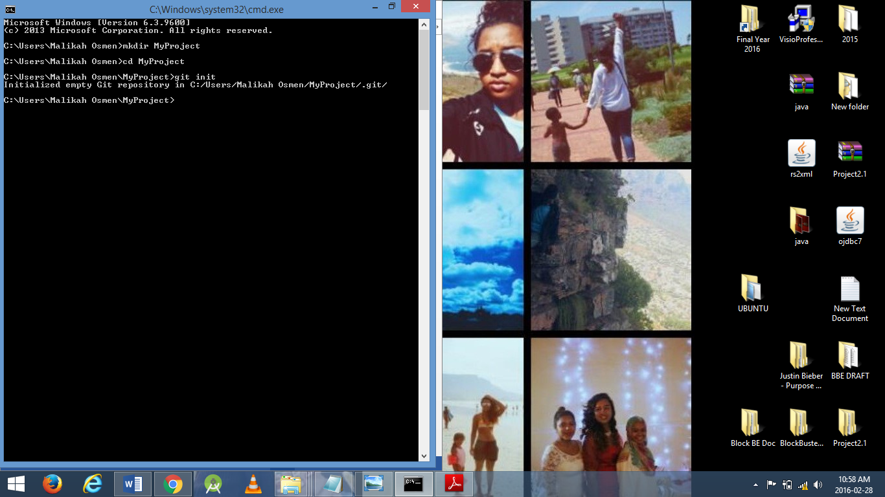

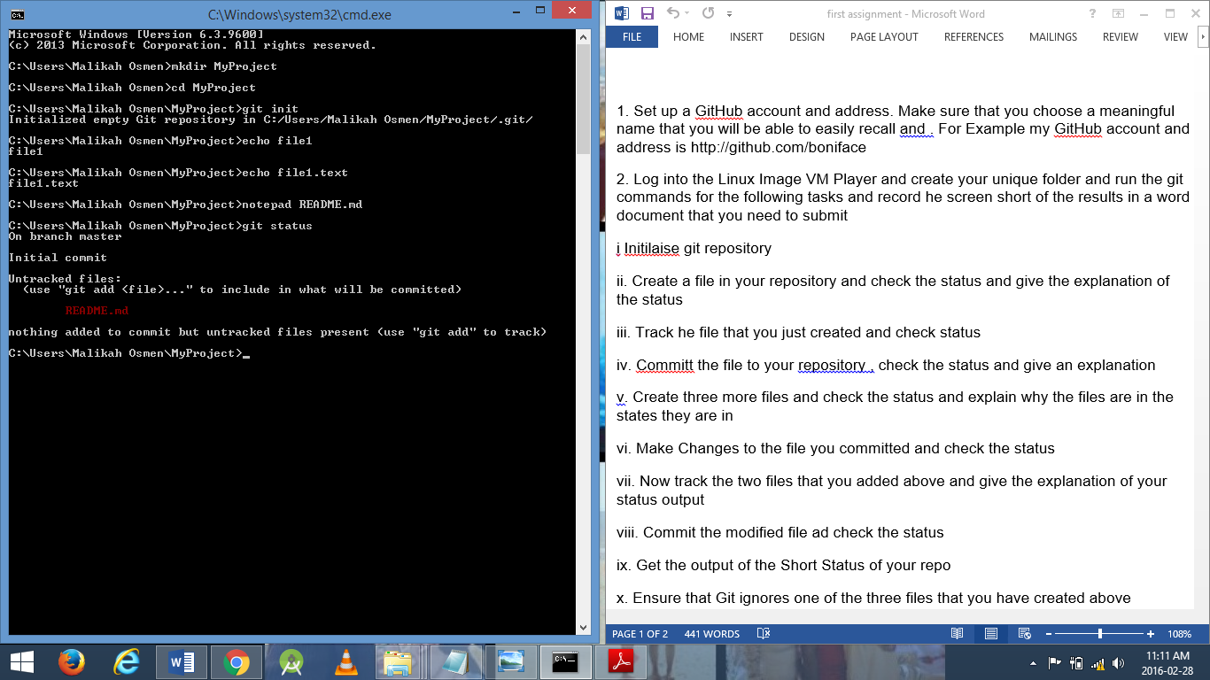

After the text file “README.md” was created, I checked the status and it appears in red text to specify that this text file is not being tracked after being created.

iii. Track the file that you just created and check status.

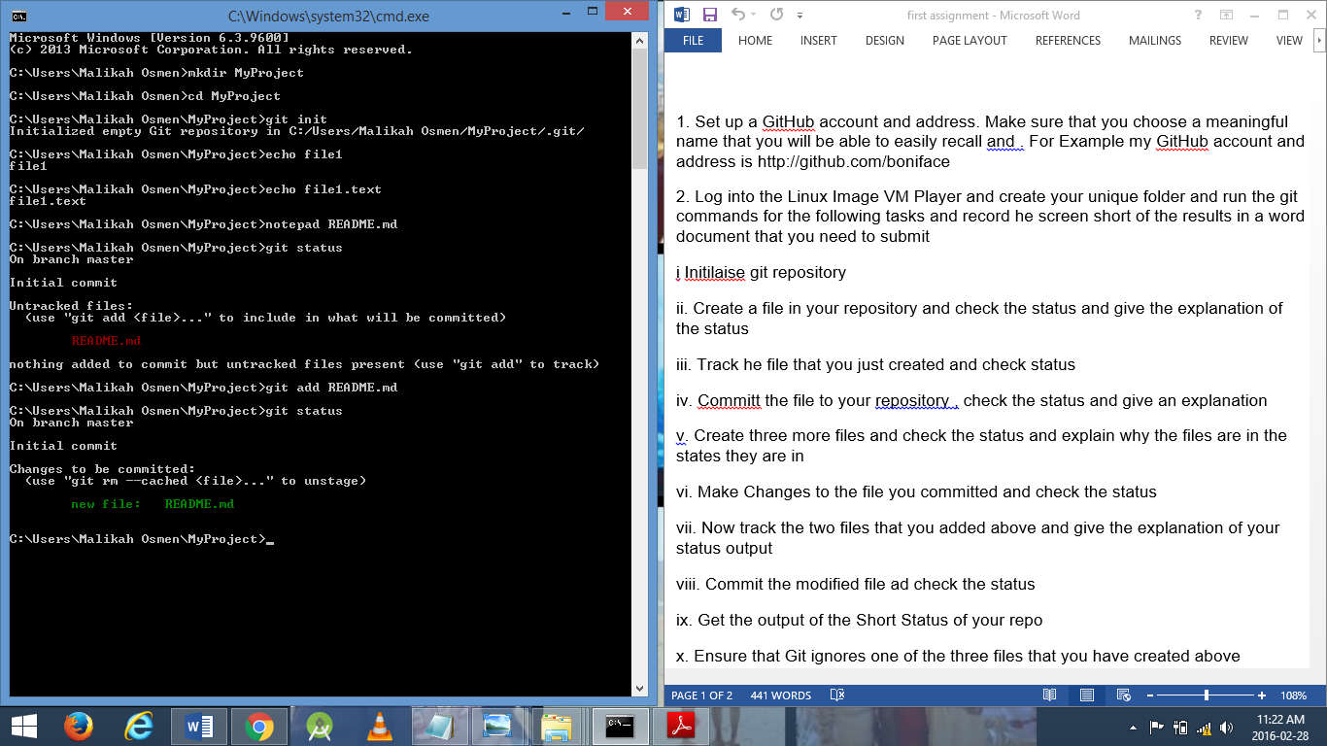

Command – git add README.md tracks the file specified. After checking the status the file will appear in green to signify that it is being tracked.

iv. Commit the file to your repository, check the status and give an explanation

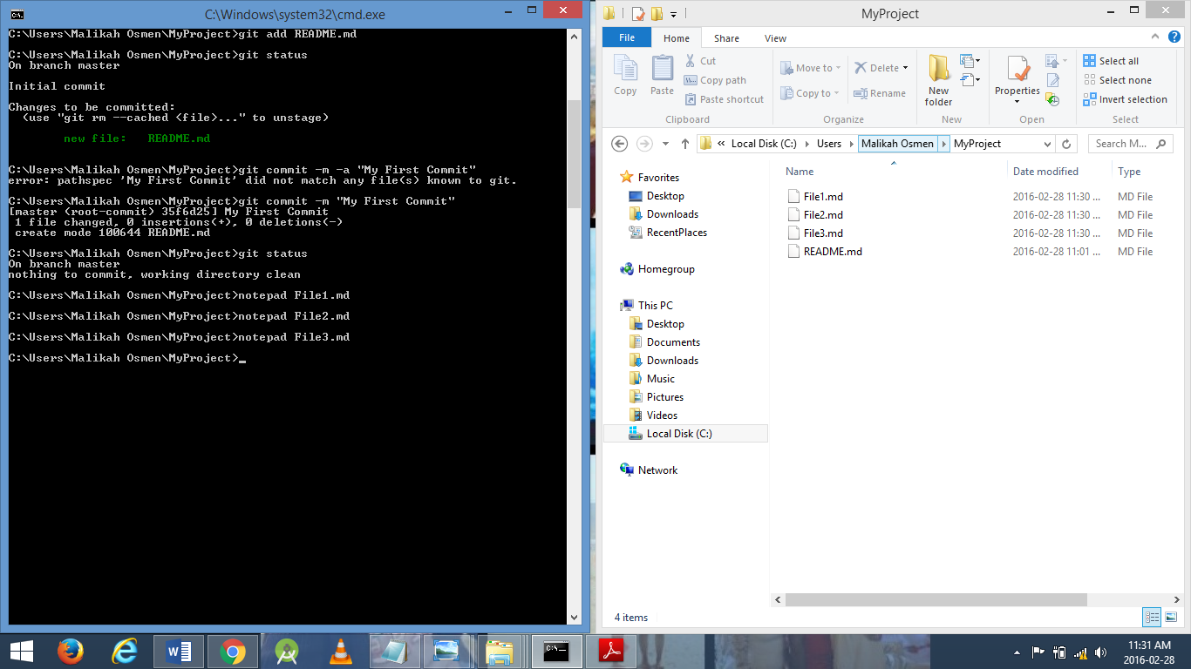

My first commit shows that 1 file has been changed and update my github account with these changes. Git status also shows that in the current state there are no more files to be committed.

v. Create three more files and check the status and explain why the files are in the states they are in.

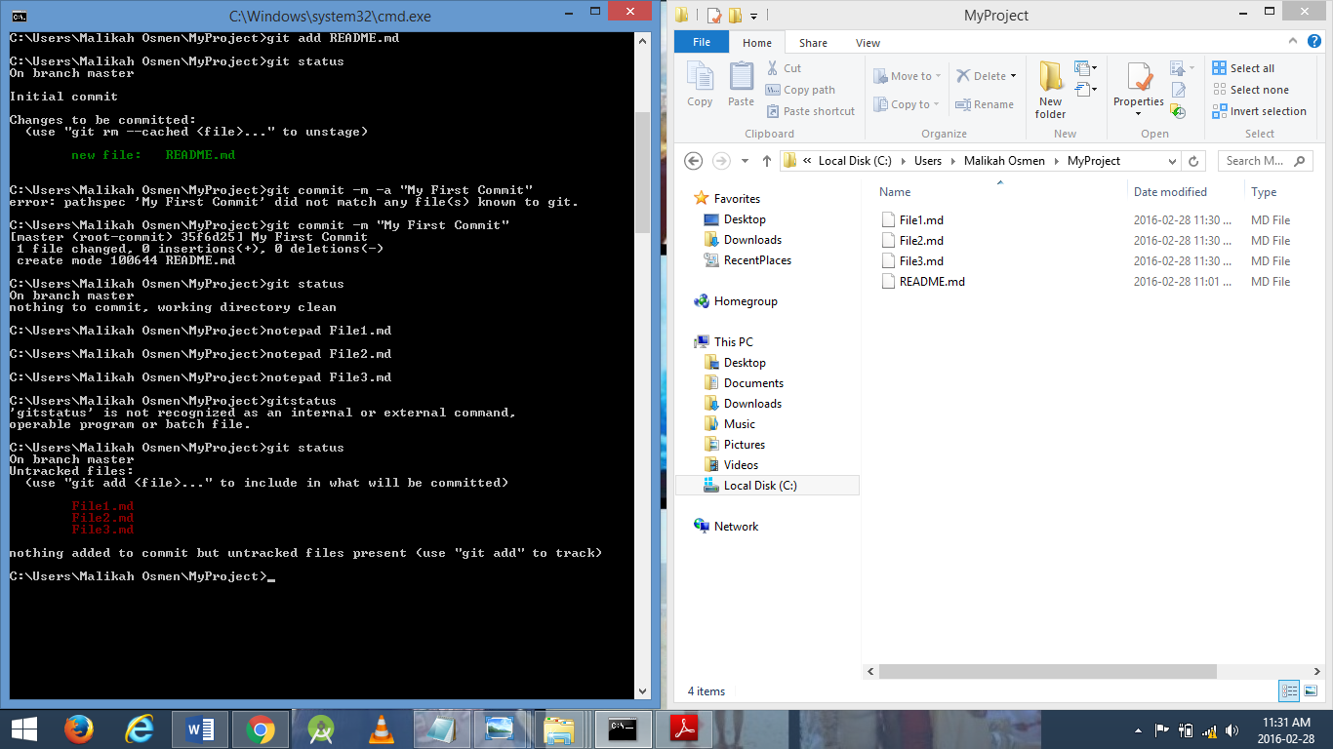

Files were created and not yet tracked so if status is checked they appear in red text. It was not added to the commit yet.

vi. Make Changes to the file you committed and check the status

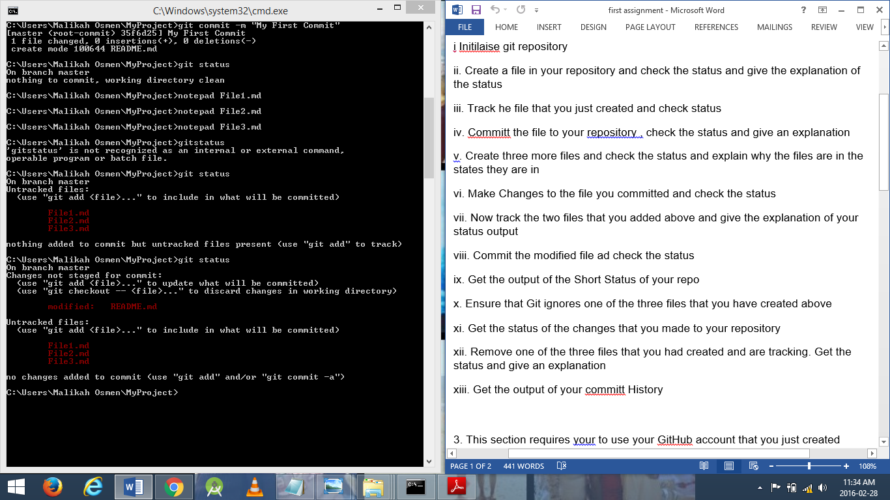

vii. Now track the two files that you added above and give the explanation of your status output

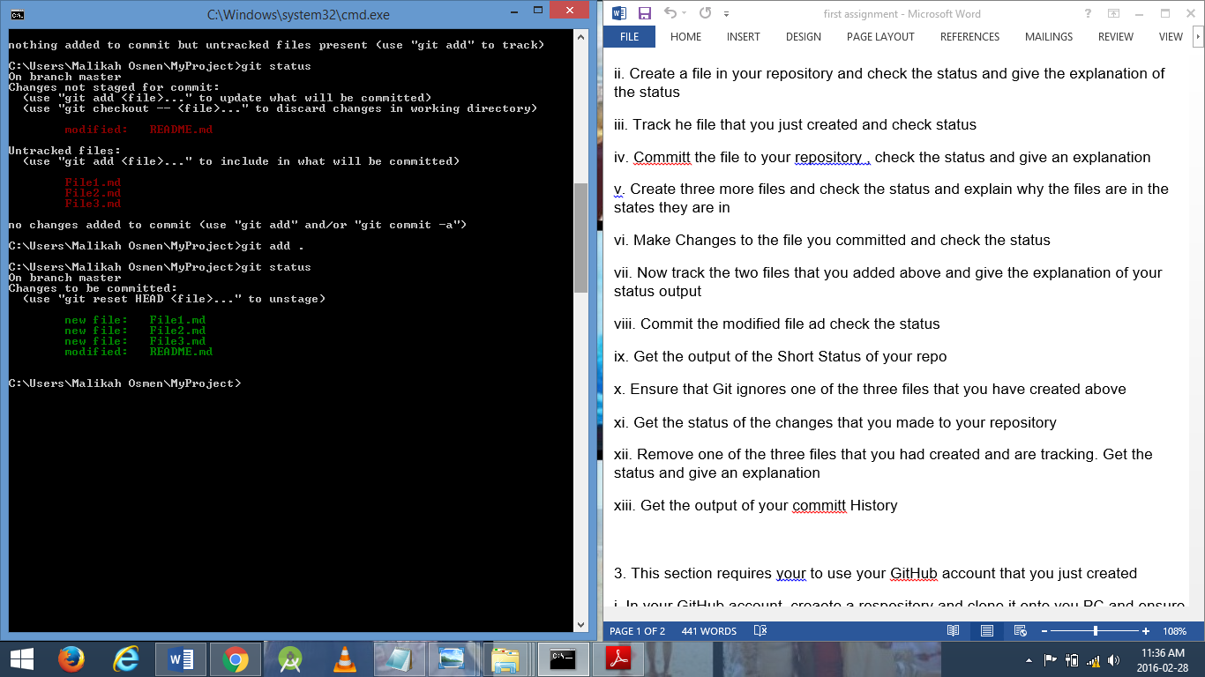

All the files in my repository is now being tracked including the modified file.

viii. Commit the modified file ad check the status

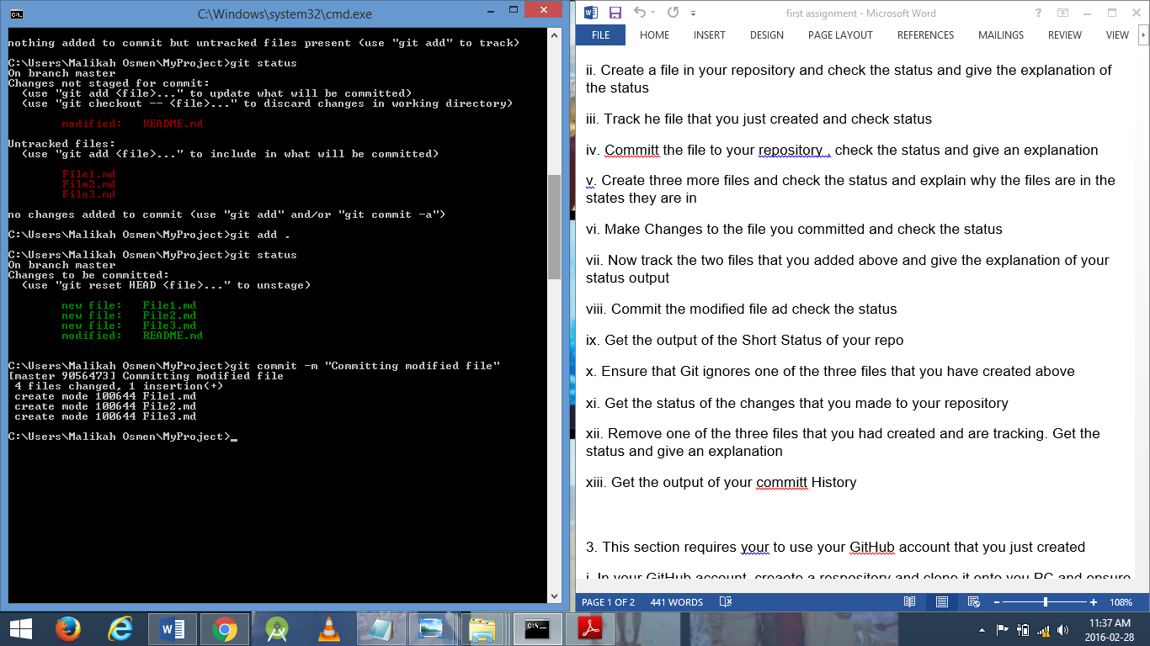

ix. Get the output of the Short Status of your repo

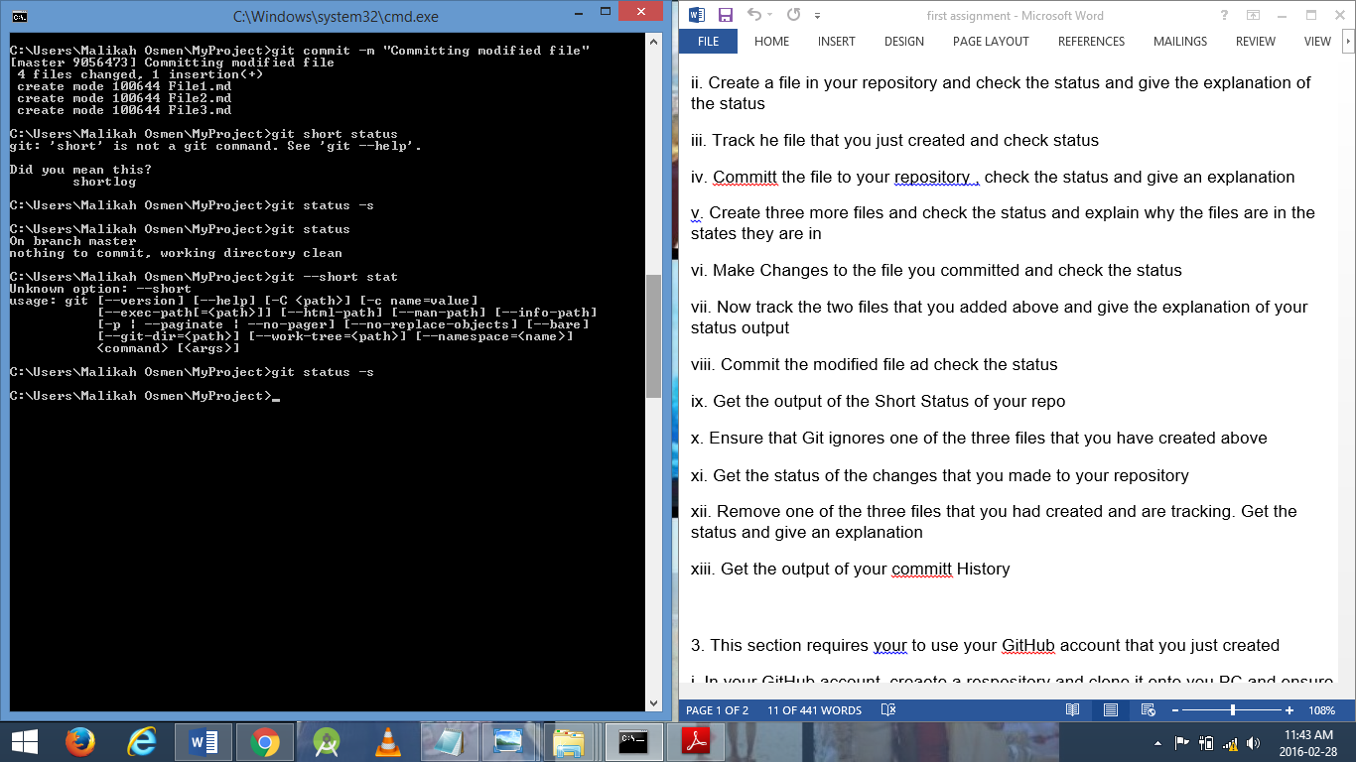

x. Ensure that Git ignores one of the three files that you have created above

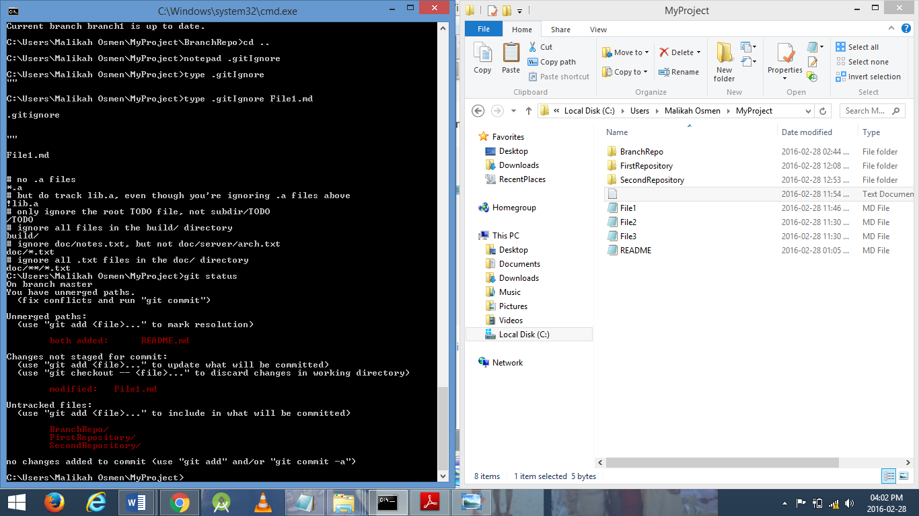

xi. Get the status of the changes that you made to your repository

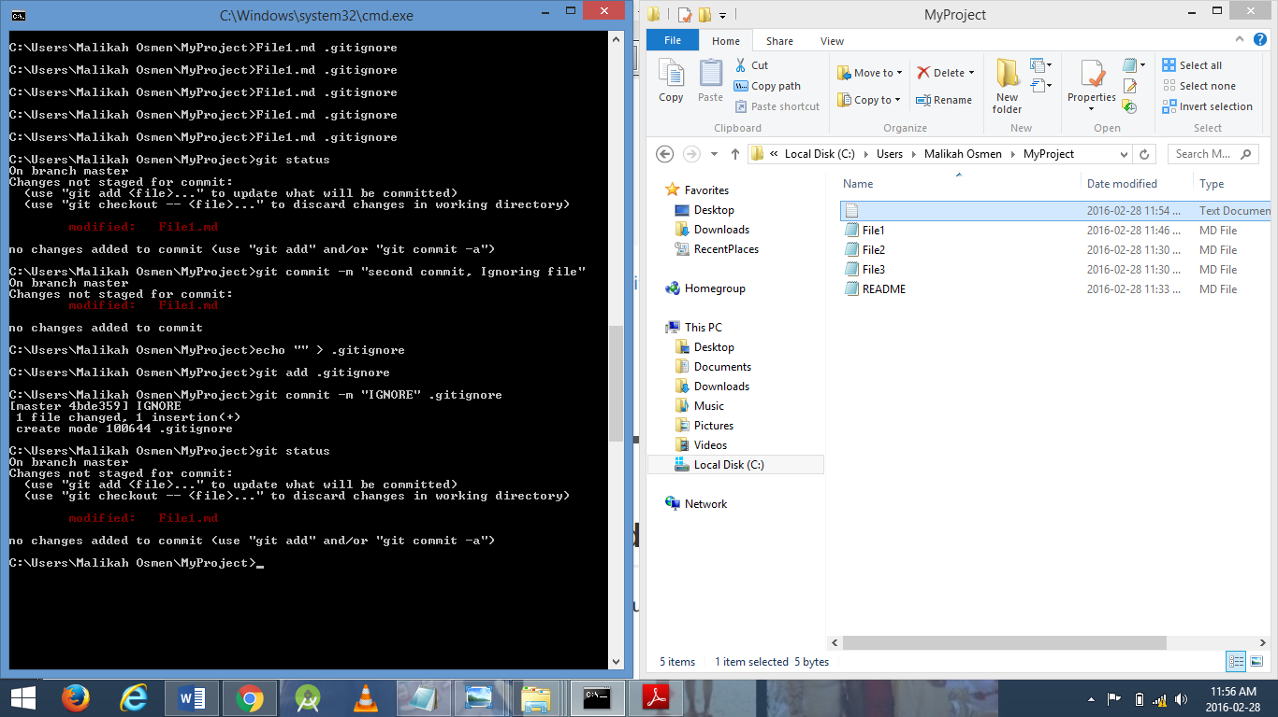

xii. Remove one of the three files that you had created and are tracking. Get the status and give an explanation

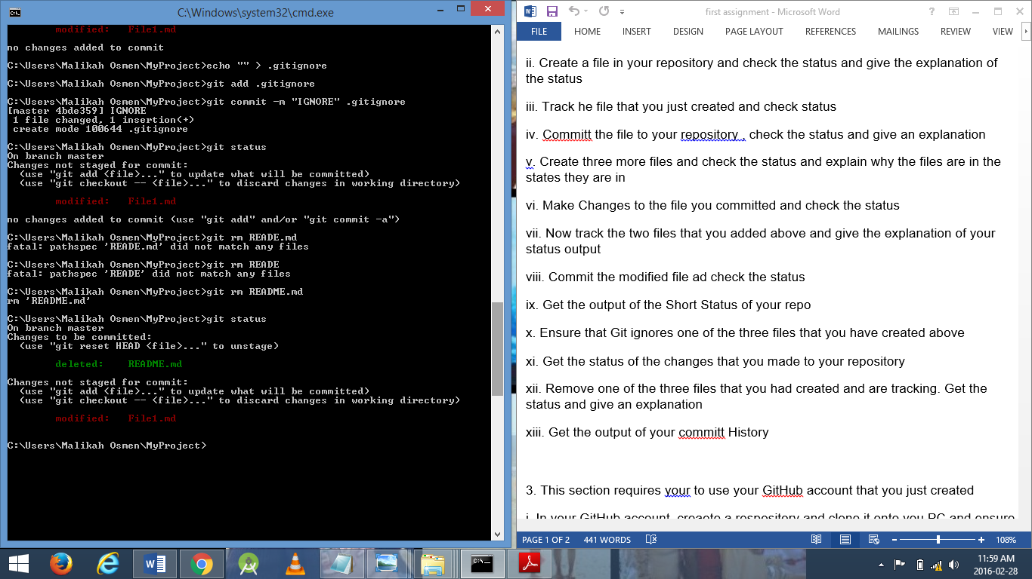

xiii. Get the output of your commit History

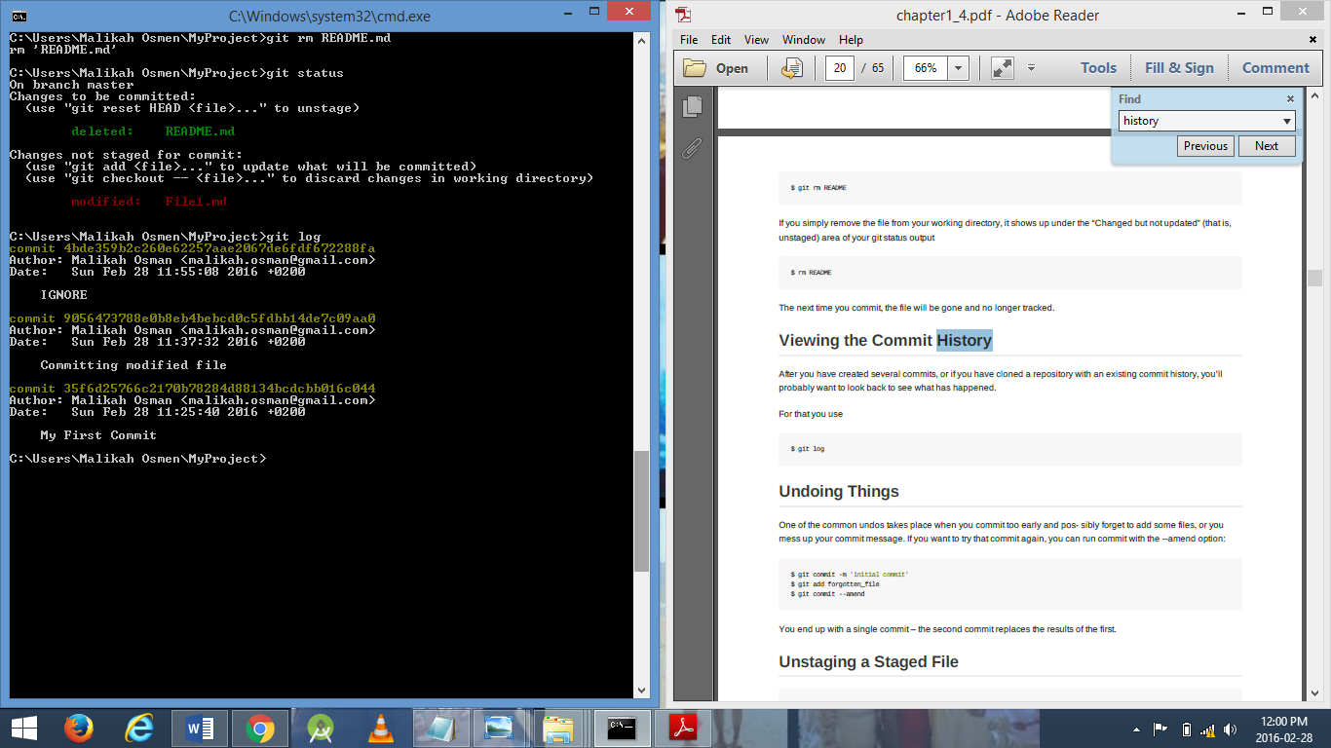

3. This section requires you to use your GitHub account that you just created

i. In your GitHub account, create a repository and clone it onto your PC and ensure that you put it in a different directory

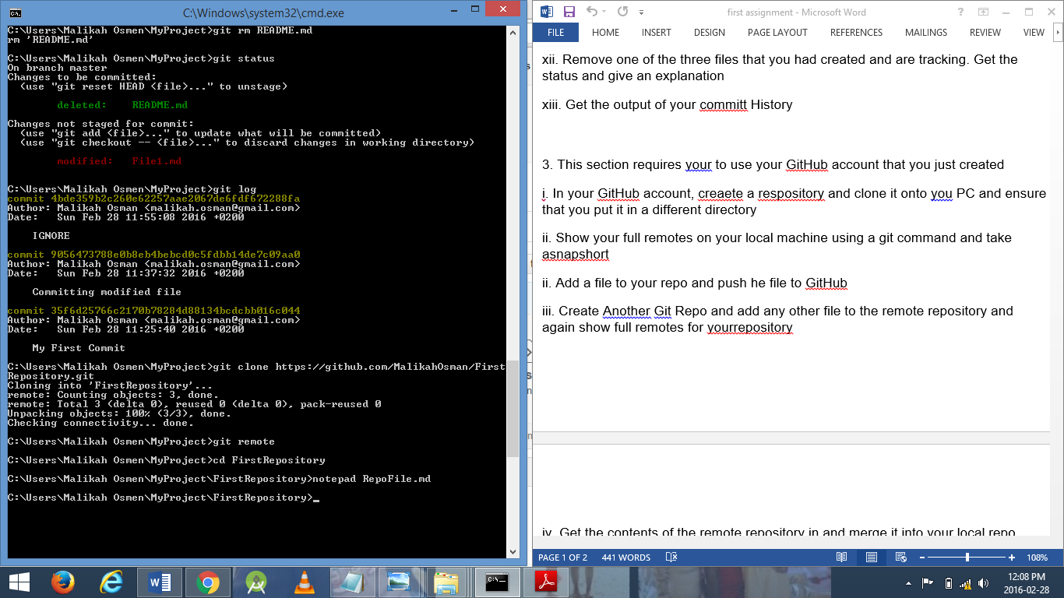

ii. Show your full remotes on your local machine using a git command and take a snapshot



ii. Add a file to your repo and push he file to GitHub

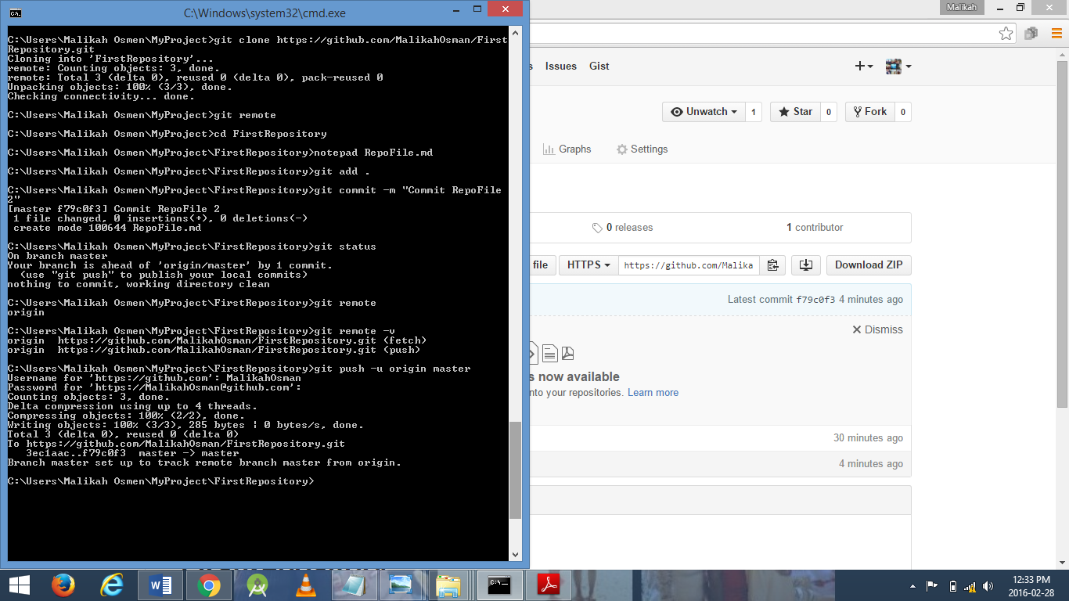

iii. Create Another Git Repo and add any other file to the remote repository and again show full remotes for yourrepository

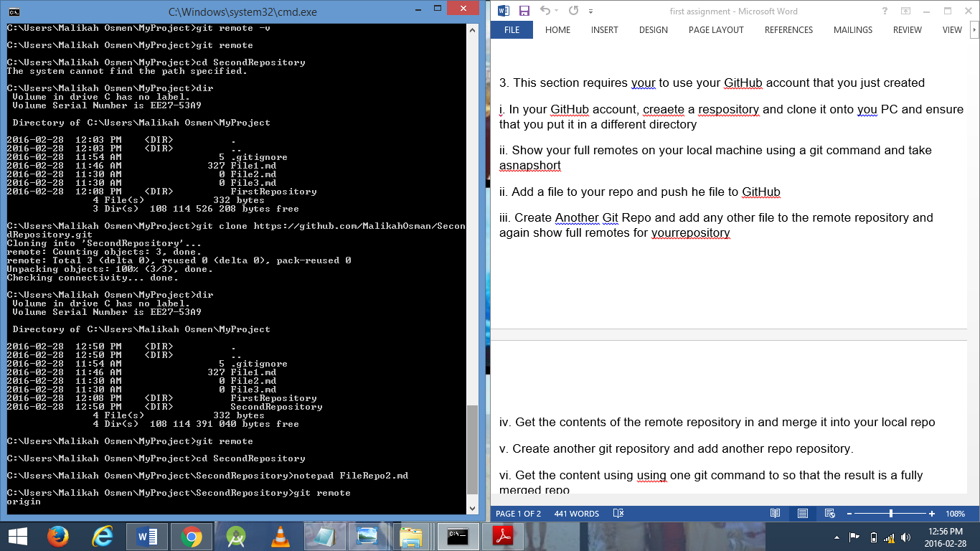

iv. Get the contents of the remote repository in and merge it into your local repo

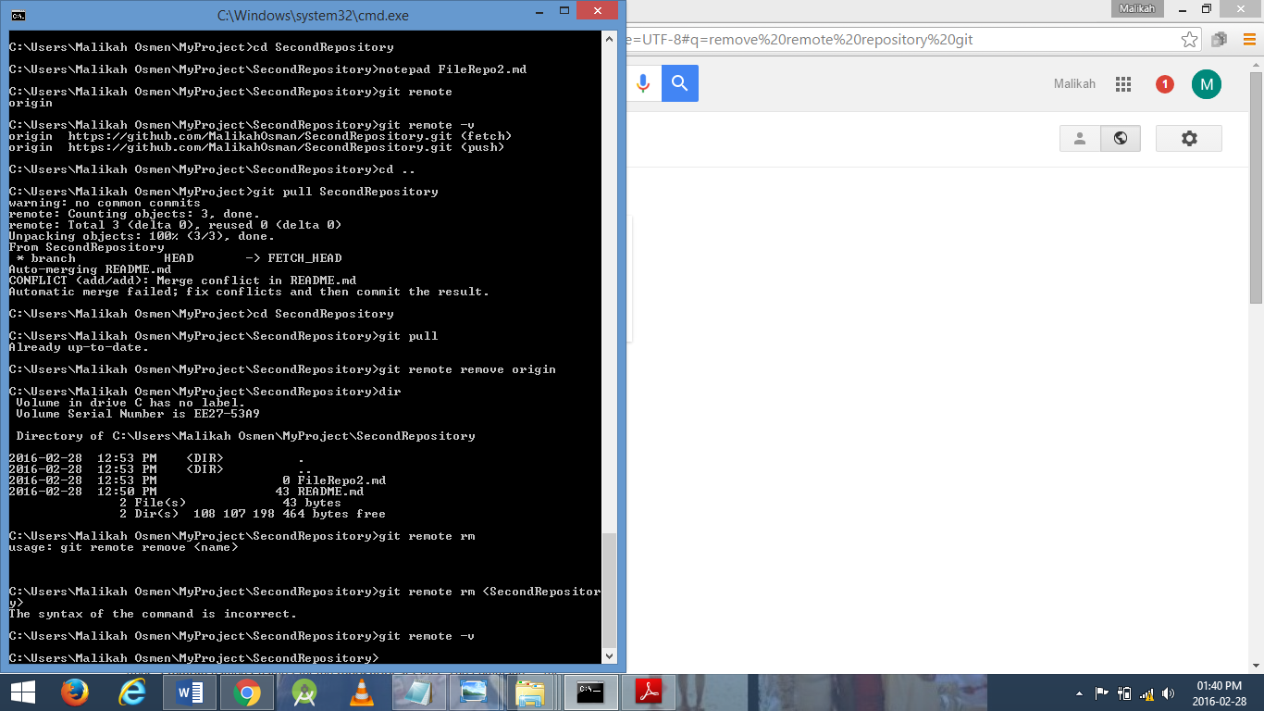

v. Create another git repository and add another repo repository.

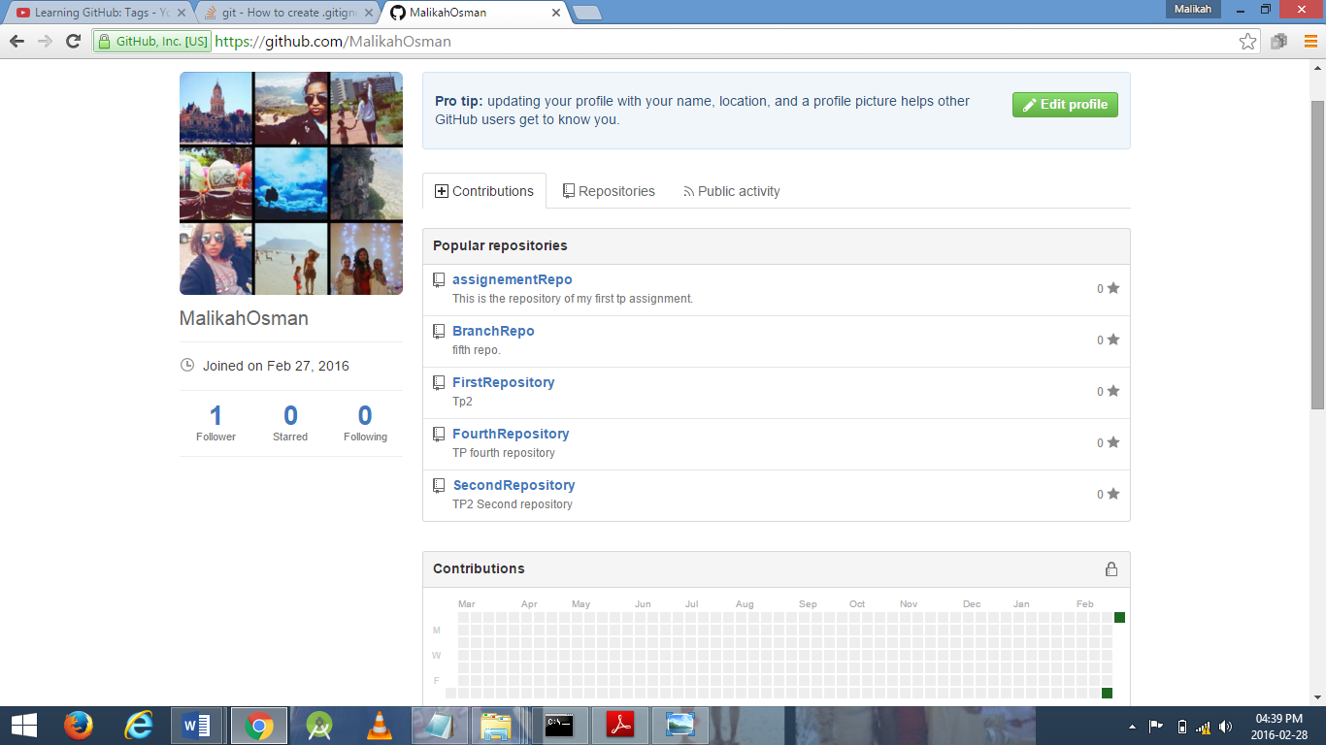

vi. Get the content using one git command to so that the result is a fully merged repo

vii. Remove the remote from your repository



4. Demonstrate the ability to tag your repo with version numbers and commit these them to gitHub

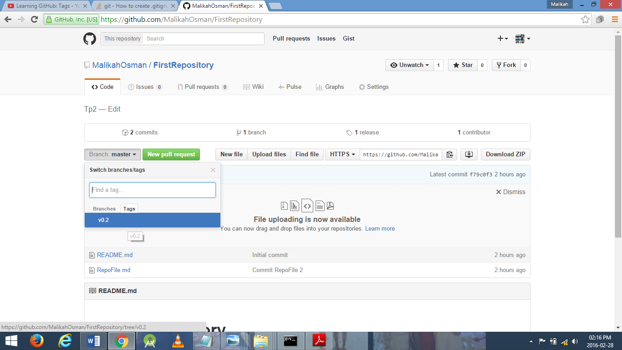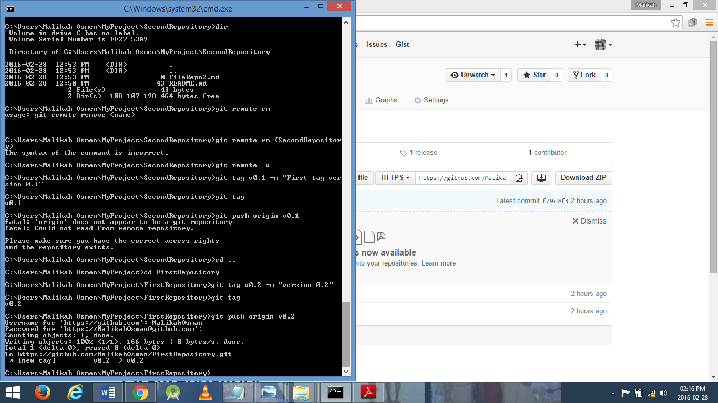5. Read the chapter on branching and demonstrate the ability to create branches and integrating the merge. GitHub will produce graphs for you.

6. Demonstrate Rebasing on another repo that you create on GitHub

