E-commerce Stress Test Report (50 Users)
This report includes the performance results of a stress test executed on a publicly available e-commerce application. The scenario simulated 50 concurrent users performing a product search over a span of approximately 5 minutes. The focus was to monitor how the application handles increasing demand and where performance bottlenecks may appear.

Summary Report
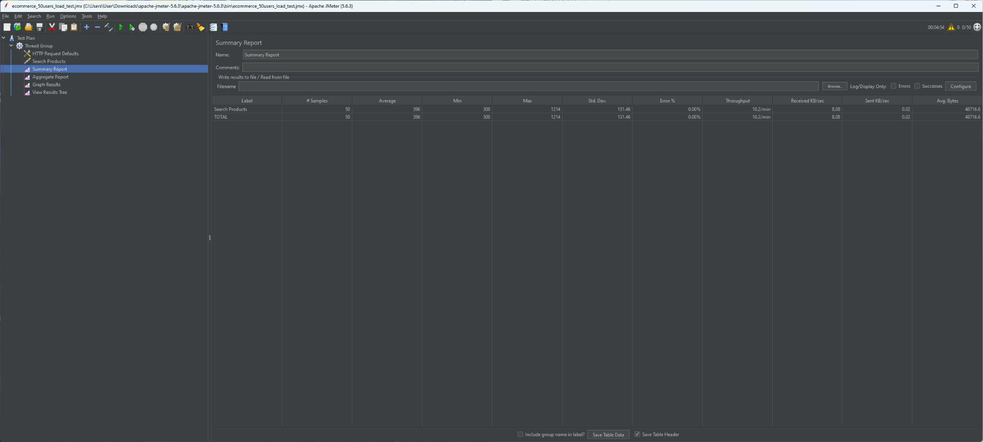

Aggregate Report
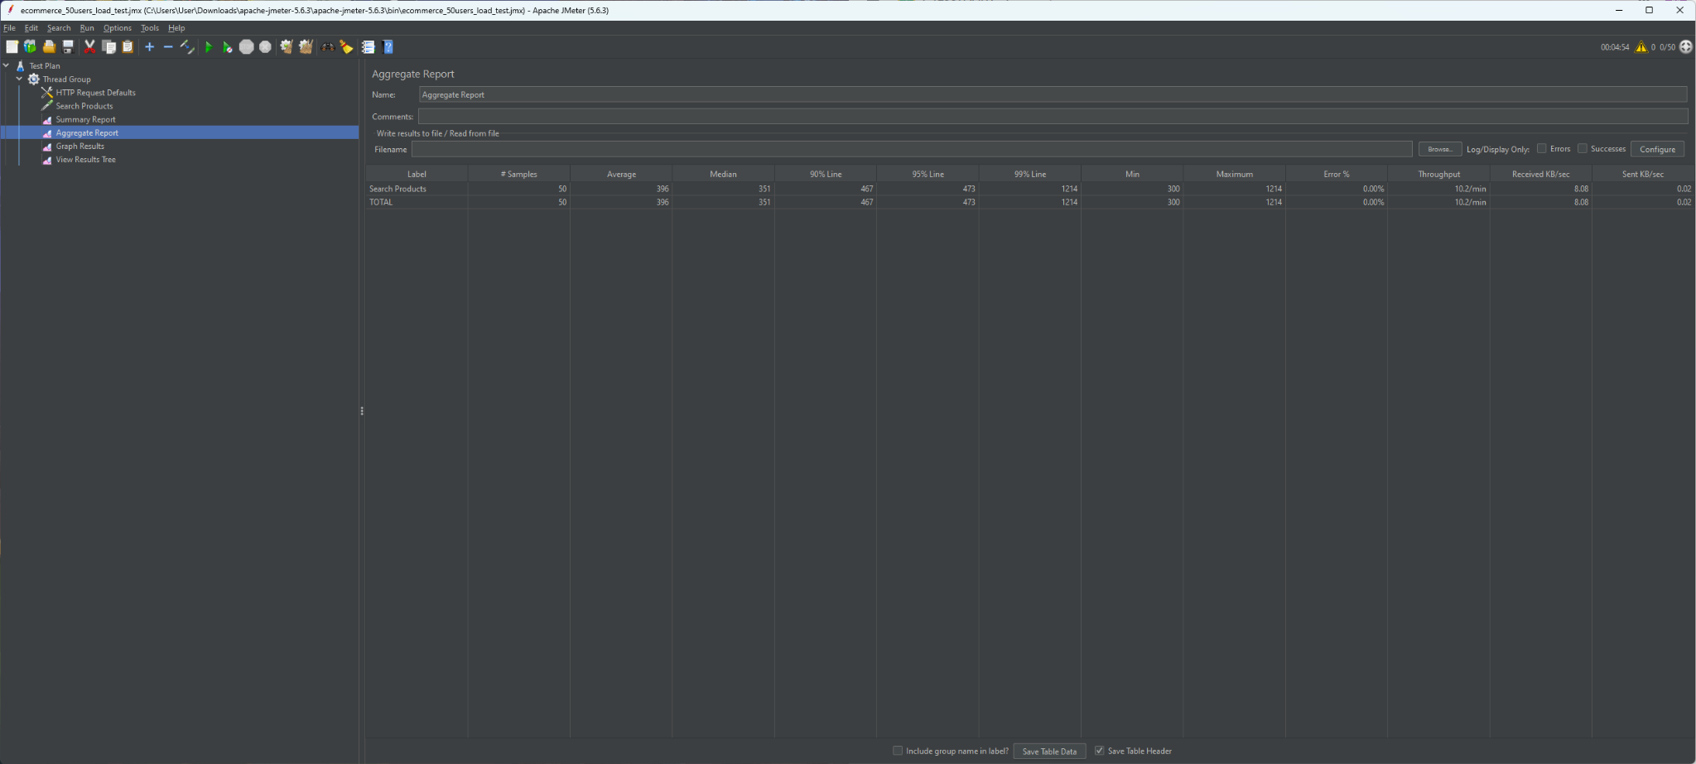

Graph Results
