**Implement simple file server using sockets**

**Output:-**

Server contains two files named file1.txt and file2.txt

* File1.txt content:



* File2.txt content:

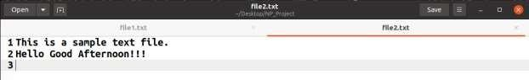

# Communication Between File server and two clients:

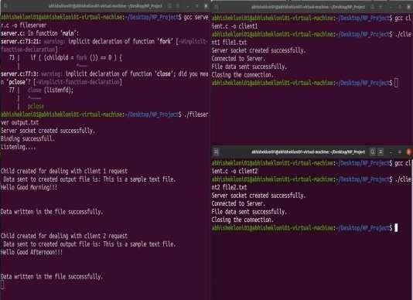

**Client1 appends its message into output.txt file from Server.**



# Client2 appends its message into output.txt file from Server.

