

**SWE205: Introduction to Software Engineering**

**TERM-191**

**Software Design Document (DD)**

**Project:** MyPaintShop (PaintTool)

**TEAM 8**

* MOHAMMAD ALSHEHRI
* ABDULMALIK ALSENANI(Phase Leader)
* ABDULAZIZ ALDAWISH
* MOHAMMED ALOTAIBI

Table of Contents

Introduction 3

Purpose of this document 3

Technical Background: Programming language used to implement your project, and other related technologies used. 3

Overview of the remainder of the document 3

Implementation 4

Code with documentation (attached separately) 4

Screen shots 5

<MAIN PAGE> 5

<DRAG SHAPES> 6

<MOVE SHAPES> 7

<CHANGE FRAME COLOR> 8

<FILL COLOR> 9

<CHANGE SHAPE SCALE WIDTH AND HIGHT> 10

<CHANGE SHAPE ROTATION> 11

<REMOVE SHAPE> 12

<CHANGE BACKGROUND COLOR> 13

<PAINTING BY BRUSH MODE> 14

<SAVED PROJECT> 15

<OPENED PROJECT> 16

<ADD MORE SHAPES> 17

<UNDO> 18

# **Introduction**

## Purpose of this document

The purpose of this document is to show the implementation of the paint tool project, along with the screen shots of user interface (UI) of the final project. This document also will show the technologies used in implementing the project.

## Technical Background

We used Java as the programming language along with JavaFX library as the GUI library. We used eclipse and scene builder as tools.

## Overview of the remainder of the document

The remaining contents of this document will show screenshots of the user interface (UI) and the project will be attached to this document.

# **Implementation**

## Code with documentation

 System functionalities

 FXML launcher

 FXML Graphical User interface design file

(Click to open the file)

## Screen shots

### <MAIN PAGE>

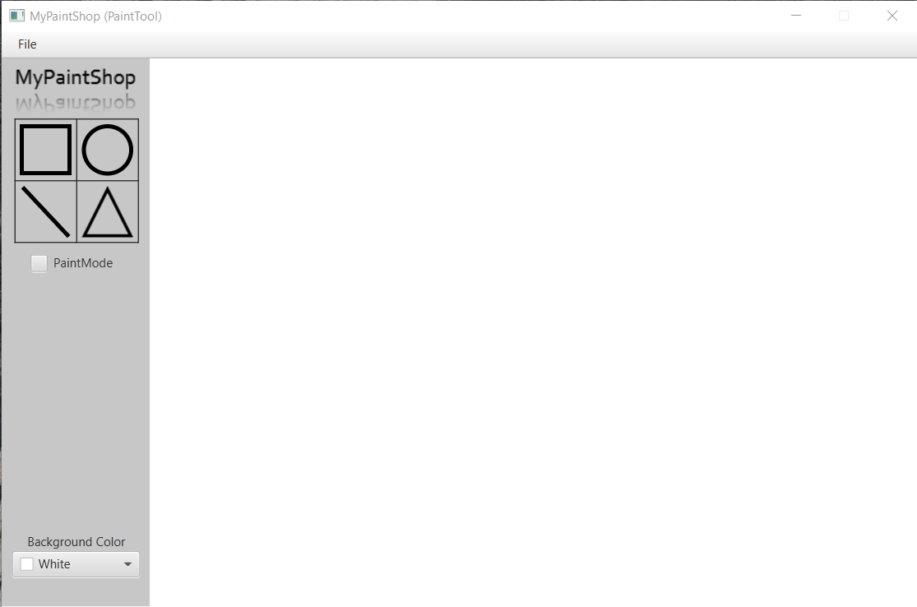

### <DRAG SHAPES>

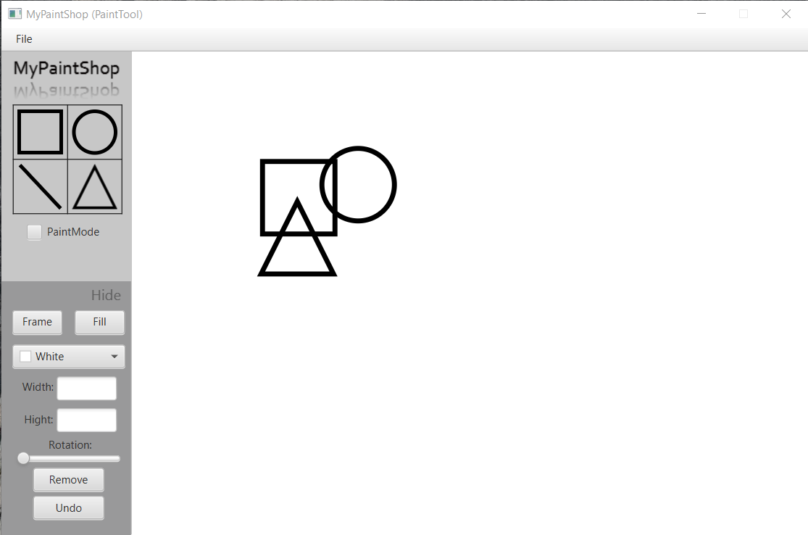

### <MOVE SHAPES>

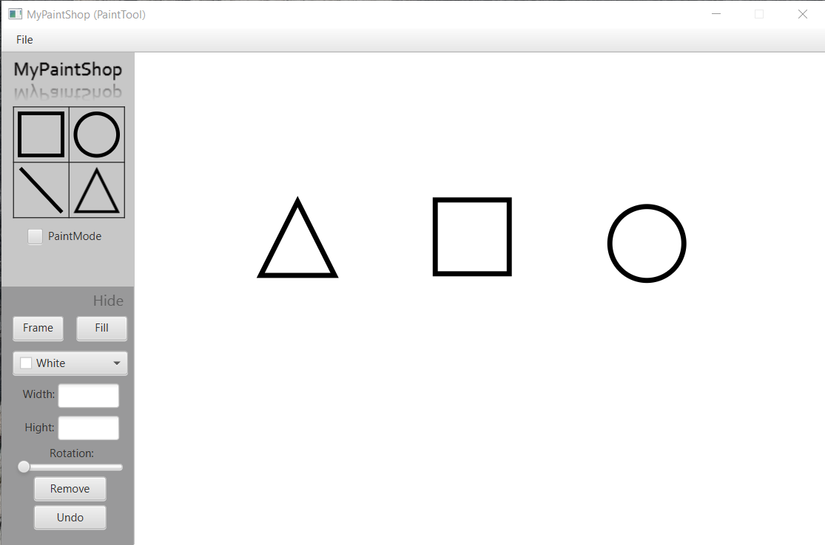

### <CHANGE FRAME COLOR>

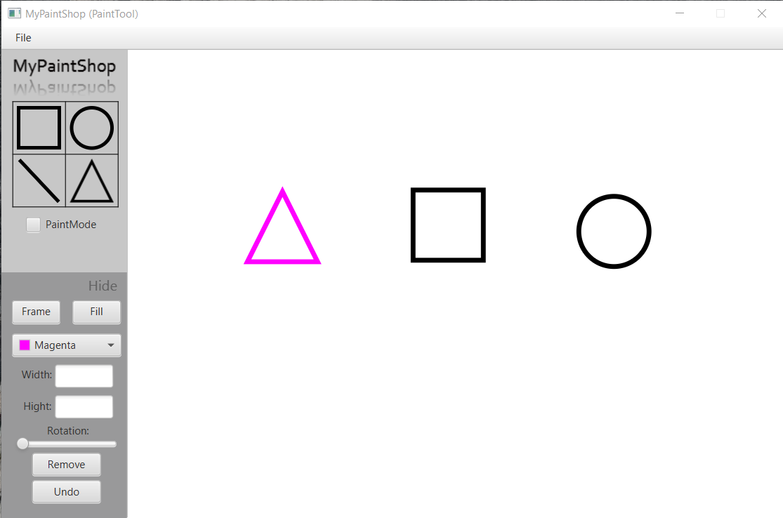

### <FILL COLOR>

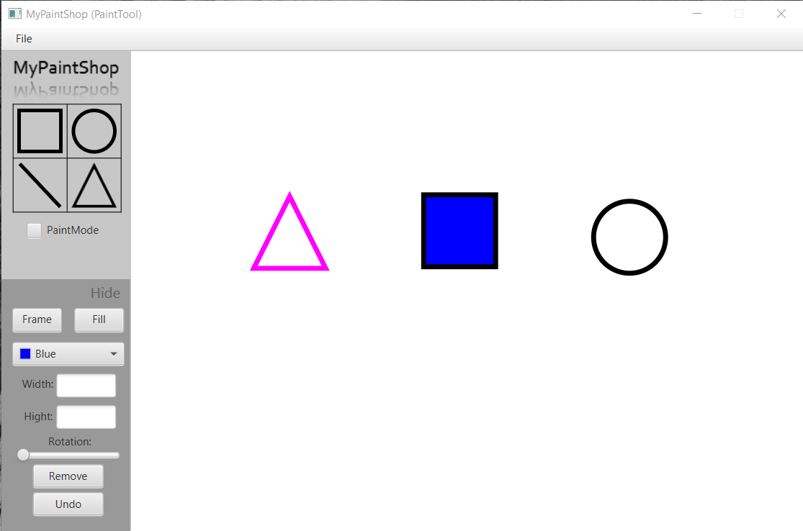

### <CHANGE SHAPE SCALE WIDTH AND HIGHT>

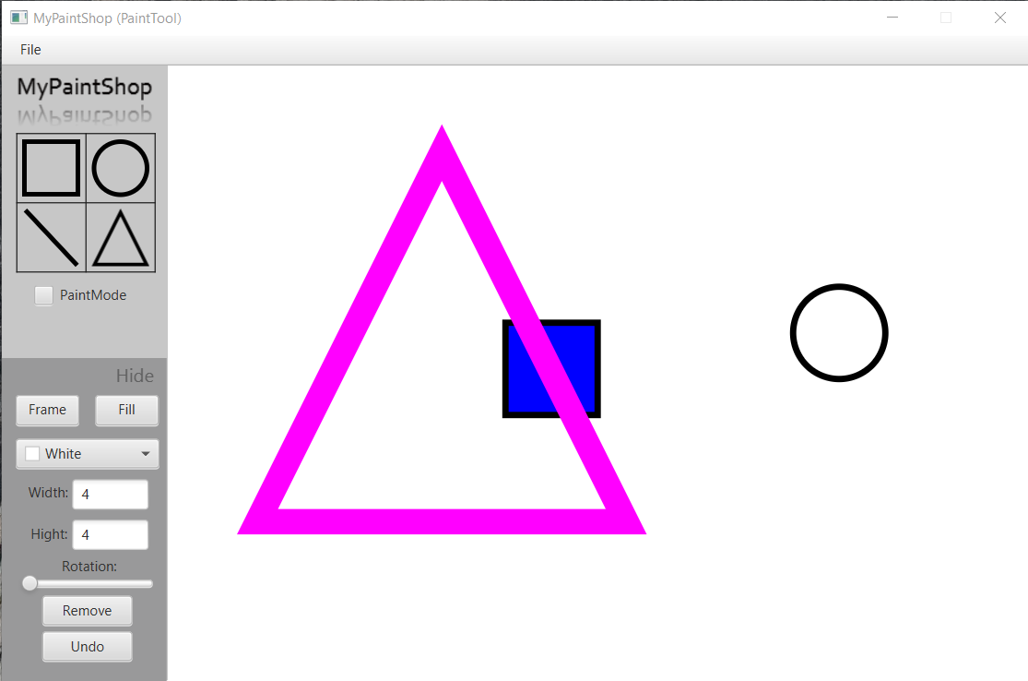

### <CHANGE SHAPE ROTATION>

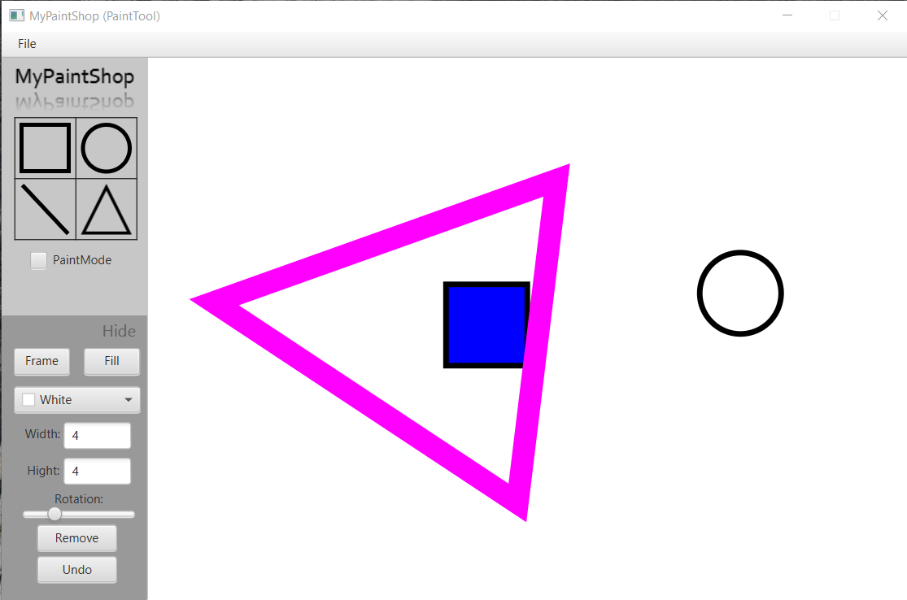

### <REMOVE SHAPE>

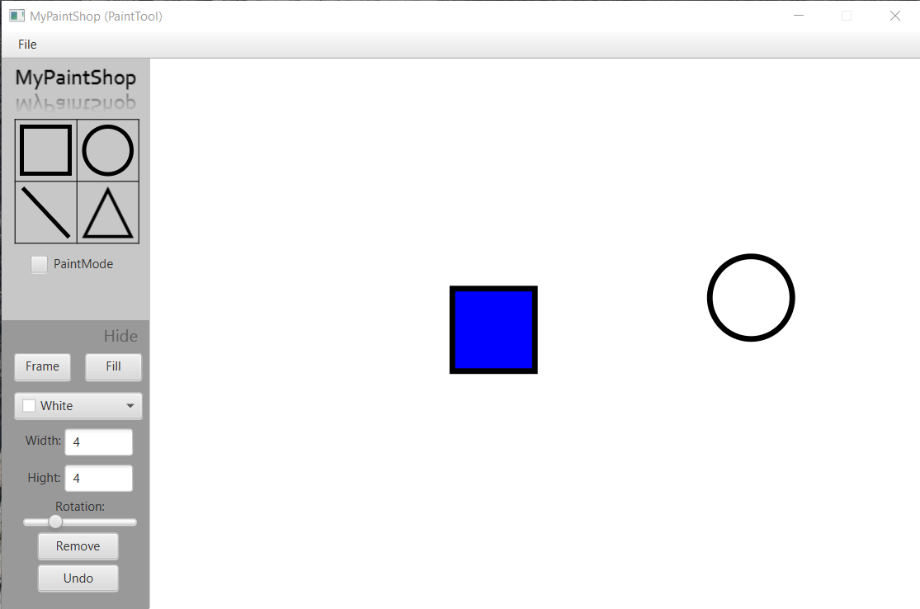

### <CHANGE BACKGROUND COLOR>

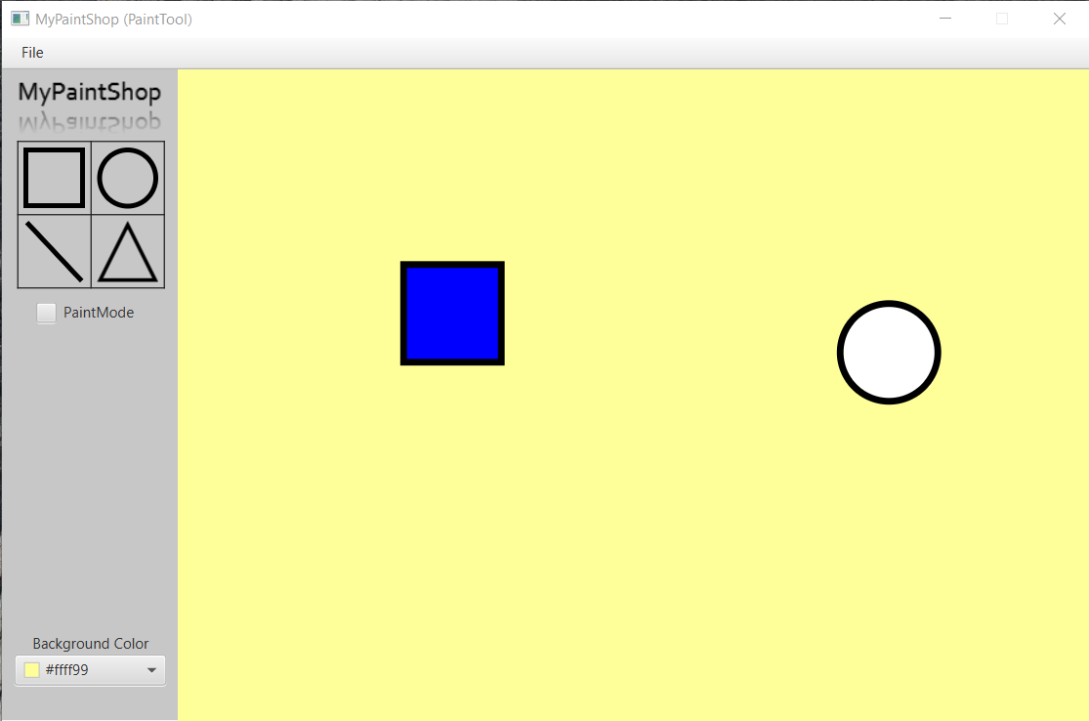

### <PAINTING BY BRUSH MODE>

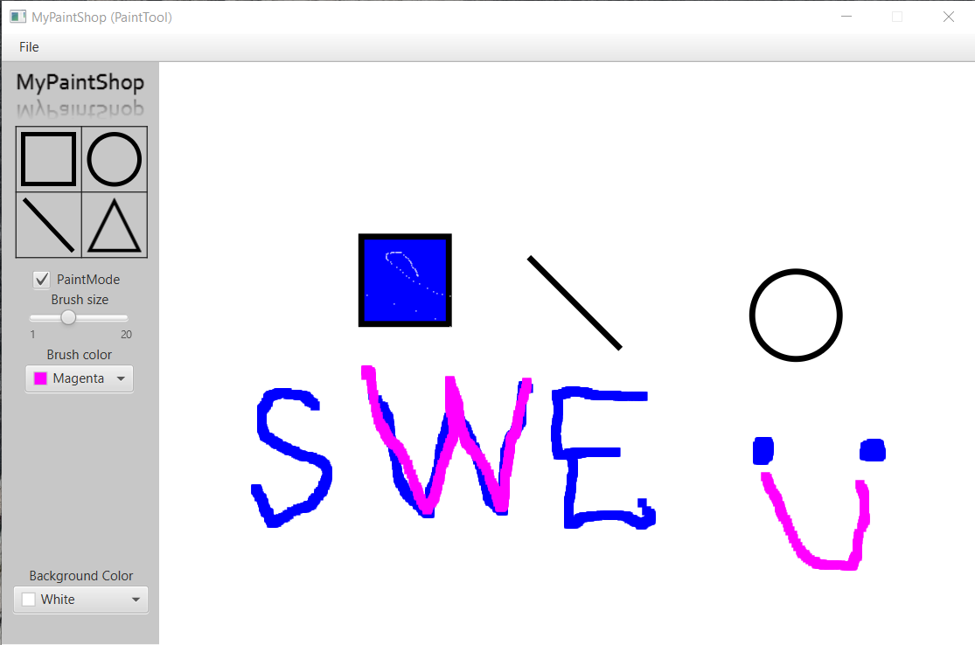

### <SAVED PROJECT>

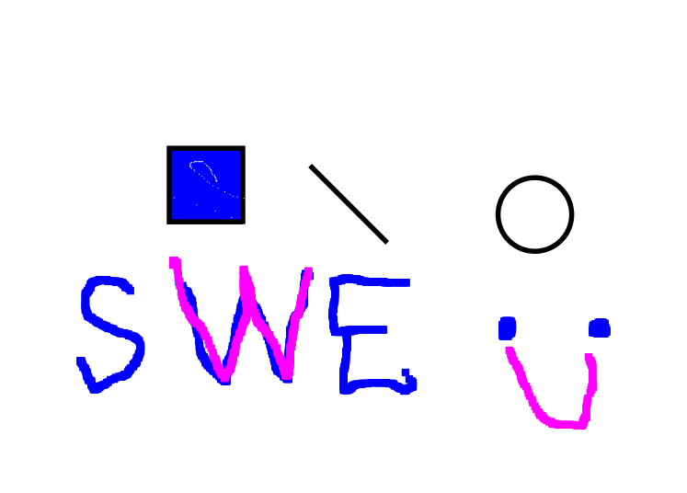

### <OPENED PROJECT>

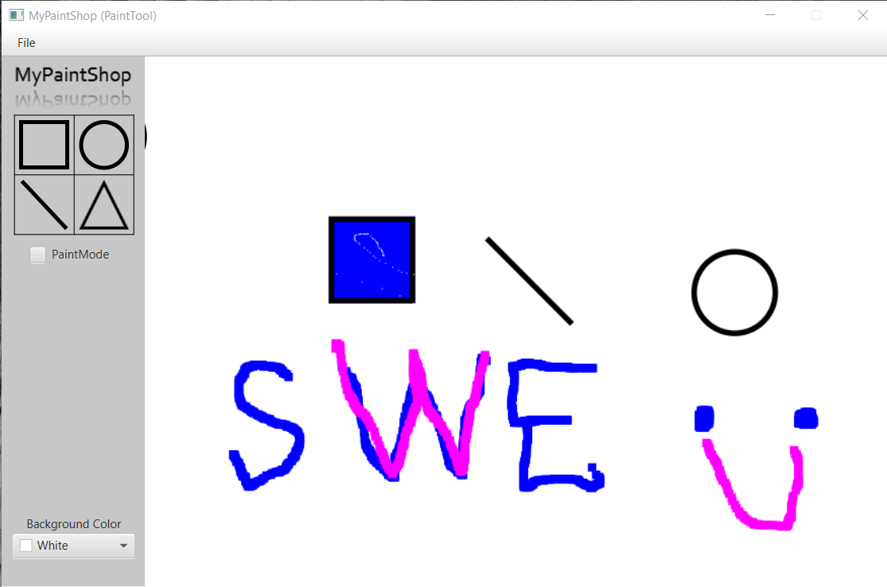

### <ADD MORE SHAPES>

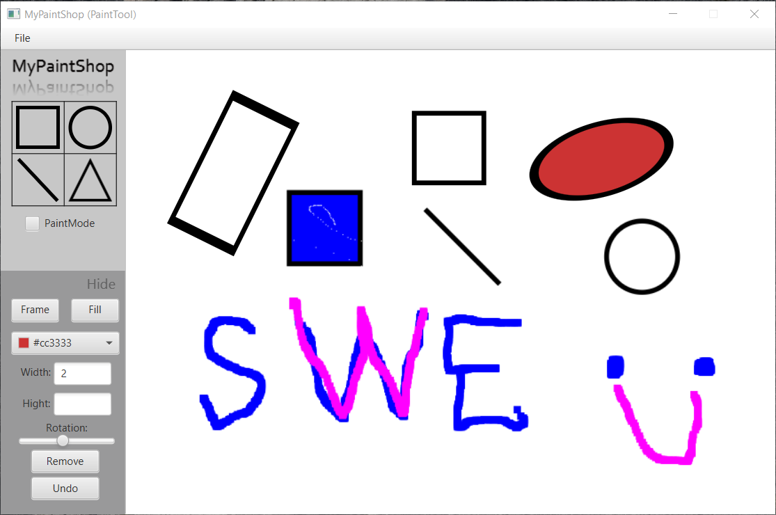

### <UNDO>

