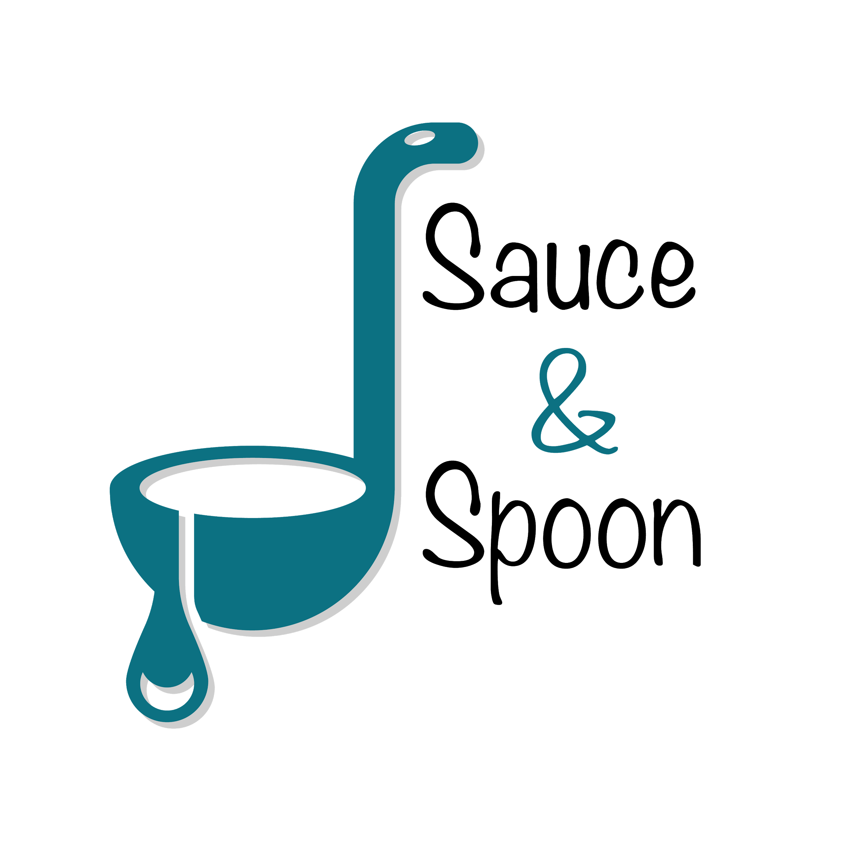

Project Charter: Rollout of tabletop menu tablets

DATE: [25/02/25]

|  |
| --- |
| **Project Summary** |
| launch a pilot rollout of tabletop menu tablets at two of our restaurant locations, Sauce & Spoon North and Sauce & Spoon Downtown. That way, guests can place their orders on the tablets as soon as they arrive at the restaurant, rather than waiting for a server to attend to them. |

|  |
| --- |
| **Project Goals** |
| ● Increase the average check from $65 to $75 by improving product mix and boosting appetizer sales by 15%.  ● Introduce a digital ordering system and train staff thoroughly to ensure a smooth and efficient transition.  ● Make sure both the front of house and kitchen are properly staffed to handle a 10% rise in daily guest volume and to reduce staff burnout and turnover.  ● Cut table turn time by 30 minutes, helping to reduce guest wait times and serve more customers each day.  ● Set clear data points to track key metrics and measure progress effectively.  ● Reduce meal comps by cutting down on food send-backs (exact % TBD) and lowering food waste by 25%.  ● Work on increasing customer satisfaction (target % TBD) through improved service and food quality. |

|  |
| --- |
| **Deliverables** |
| ● Achieve a 15% overall increase in appetizer orders, aiming for a 10% rise at the North location and a 20% increase at the Downtown location.  ● Reduce average table turn time by 30 minutes to improve guest flow and seating efficiency.  ● Raise the average check to $75 by increasing appetizer and beverage sales, leading to higher overall profits.  ● Grow the average number of daily guests by 10%.  ● Roll out a staff training program to enhance service and operational consistency.  ● Improve communication of special guest requests to the kitchen to lower meal comps and cut food waste by 25%.  ● Ensure smooth integration with the current POS system for streamlined operations |

|  |
| --- |
| **Scope and Exclusion** |
| **In-Scope**  ● Reducing food waste and minimizing order return rates  ● Improving employee satisfaction and engagement  ● Increasing average check total  ● Shortening table turn time  ● Boosting the average number of daily guests  ● Implementing effective staff training programs  ● Ensuring seamless integration with the current POS system  **Out-of-Scope:**   * Policy change |

|  |
| --- |
| **Benefits & Costs** |
| **Benefits:**  ● Tablets will offer valuable insights into customer ordering habits and work seamlessly with the POS system to support informed decision-making going forward ● Cutting down on food waste ● Increase profits. ● Increase overall customer experience ● Increasing employee satisfaction  **Costs:**   * Training material fees: $10,000 * Hardware and Software implementation across locations: $30,000 * Maintenance (IT fees through EOY): $5,000   ● Website and menu design updates: $5,000 ● Additional customization costs: $55 |

|  |
| --- |
| **Appendix:** |
| ● **Payroll Reallocation** Peta was hesitant to shift payroll to BOH without data on staffing needs. Deanna and Alex supported planning for BOH resources, while Gilly opposed reducing FOH payroll. **Decision:** Unresolved—will revisit later.  ● **Appetizer Sales Target** Alex felt an increase wouldn’t impact his location much due to existing happy hour traffic. Gilly pushed for a higher target based on her location’s low app sales. **Decision:** Agreed on a 15% average increase—10% for North, 20% for Downtown.  ● **Policy Change** Debated whether to include policy changes in scope. **Decision:** Out of scope—will handle separately.  ● **Employee Satisfaction** Debate on including employee satisfaction measurement. **Decision:** Carter and Deanna to develop a tracking method. |