# **SMART DMV Mobile Application Installation Guide**

1. Open the code in Android Studio given in the Android folder.
2. Attach your Android Mobile wit Developer mode enabled.
3. Click on the following button in Android Studio.

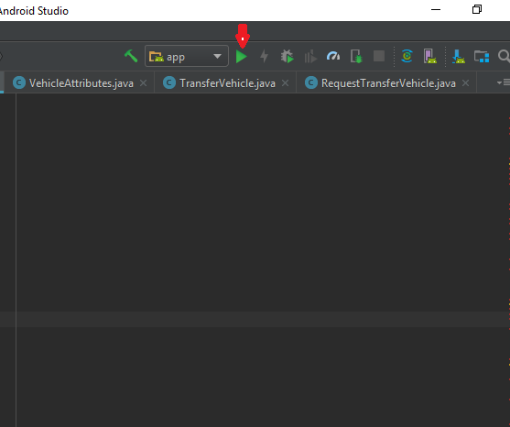

1. Application will be installed.

