# **User manual for Android Application**

**For Citizen**

All the following functionalities can be accessed from the Dashboard (left side bar) of the application.

**Registration**

* For registration, citizen have to get the voucher number physically from the excise officer and after getting that, he/she has to submit the bank fee.
* After submitting the fee, citizen should open the Android app
* In the mobile application, citizen will enter the Voucher No. and Bank Deposit Fee No.
* Press the Request button.
* Request for Registration will be successfully occurred.

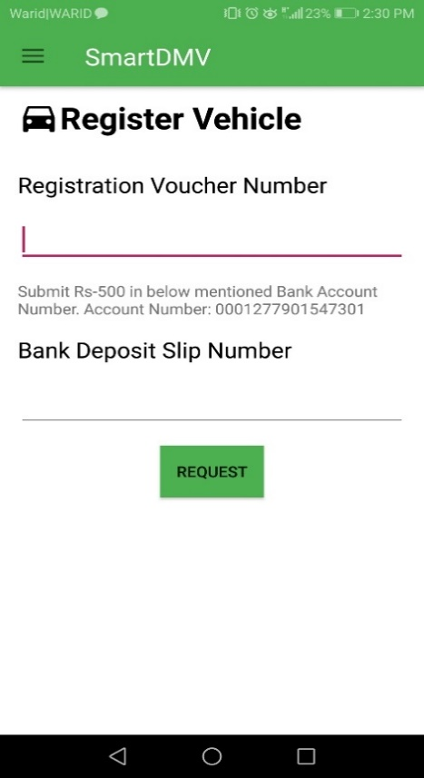

**Transfer**

* For Vehicle Transfer, citizen have to enter the Number Plate of his/her Vehicle, CNIC of new owner and the Bank deposit slip no.
* After the approval of new owner and excise officer, the vehicle will be transferred to the new owner.

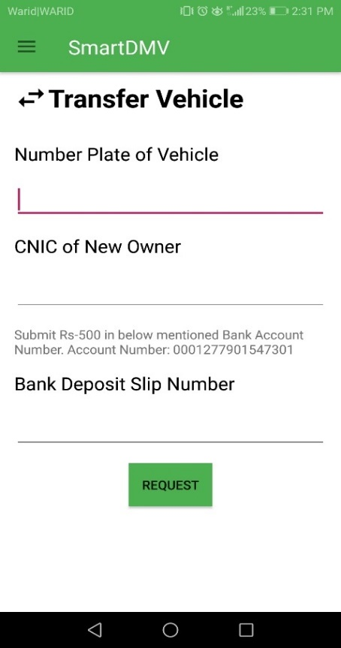

**Block Vehicle**

* To Block the vehicle, citizen have to complain FIR in the Police Station and then enter the Number Plate of his/her Vehicle, FIR Number in the application.
* The vehicle will be blocked.

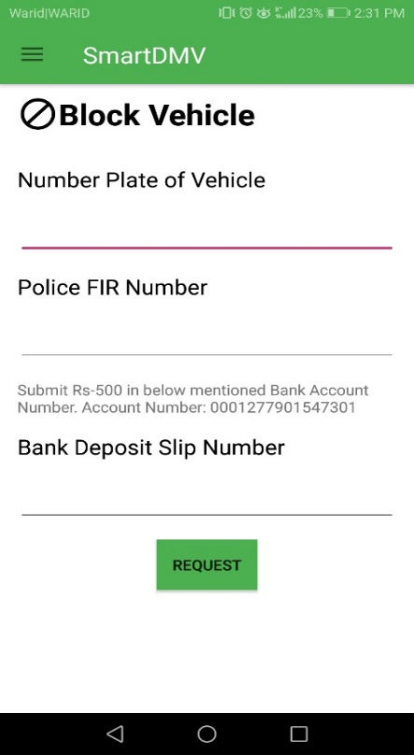

**Submit Token Tax**

* For Submission of token tax, citizen have to enter the Number Plate of his/her Vehicle, and the Bank deposit slip no. in the application
* After the approval of excise officer the token tax will be submitted.

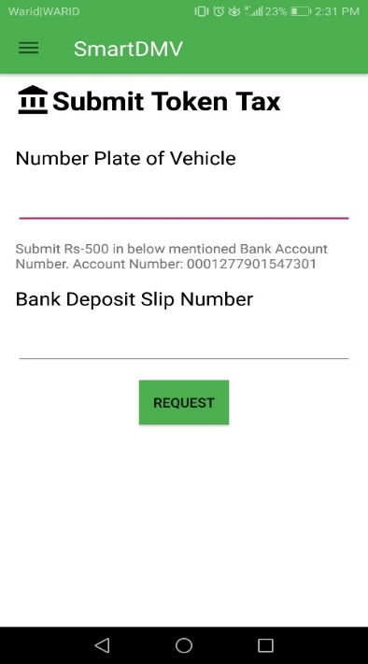

**Change Engine No.**

* For changing the engine no. of vehicle, citizen have to enter the Number Plate of his/her Vehicle, new engine no. of the vehicle and the Bank deposit slip no. in the application.

After the approval and inspection of excise officer, the engine no. of the vehicle will be changed.

