BSCS FINAL PROJECT

SDP Phase IV

Smart DMV (Department of Motor Vehicle)



Project Advisor

**Sir Zaid Munir**

Presented by:

**Group ID: S18BS028**

Student Reg# Student Name

|  |  |
| --- | --- |
| **L1S15BSCS0046** | **MALIK ALI HAIDER AWAN** |
| **L1S15BSCS0047** | **HAFIZ SHAHROZ NAJAM** |
| **L1S15BSCS0060** | **FOZAN AHMAD** |
| **L1F14BSCS0415** | **ZOHAIB KHALID** |

**Faculty of Information Technology**

**University of Central Punjab**

SDP Phase IV

Smart DMV (Department of Motor Vehicle)

Advisor: Zaid Munir

Group S18BS028

|  |  |
| --- | --- |
| Member Name | Primary Responsibility |
| Malik Ali Haider Awan | Blockchain Development + API |
| Hafiz Shahroz Najam | Android Development |
| Fozan Ahmad | Web Development |
| Zohaib Khalid | Blockchain Development + API |

Table of Contents

Table of Contents iii

Revision History v

1. Introduction 1

1.1 Product 1

1.2 Background 1

1.3 Objective(s)/Aim(s)/Target(s) 1

1.4 Scope 1

1.5 Business Goals 1

1.6 Document Conventions 2

1.7 Miscellaneous 2

2. Technical Architecture 3

2.1 Application and Data Architecture 5

2.1.1 Architecture Diagram 5

2.1.2 Component Diagram 5

2.1.3 Entity Relation Diagram 6

2.1.4 Class Diagram 7

2.1.5 Activity Diagram 8

2.1.6 Decision Table 11

2.2 Component Interactions and Collaborations 12

2.2.1 Sequence Diagram 12

2.2.2 Detailed Data Flow Diagram 13

2.2.3 Collaboration Diagram 15

2.3 Design Reuse and Design Patterns 16

2.4 Technology Architecture 16

2.5 Architecture Evaluation 16

3. Detailed/Component Design 17

3.1 Component-Component Interface 17

3.1.1 Deployment Diagram 17

3.1.2 Sequence Diagrams 18

3.2 Component-External Entities Interface 22

3.2.1 Police API Call 22

3.2.2 Bank API call 22

3.3 Component-Human Interface 23

4. Screenshots/Prototype 24

4.1 Workflow 24

*4.1.1* Citizen’s Workflow (Swim Lane Diagram) 24

4.1.2 Excise Workflow (Swim Lane Diagram) 25

4.2 Screens 26

4.2.1 Citizen’s Login Screen 26

*4.2.2* Citizen’s Dashboard Screen 26

4.2.3 Citizen’s Register Vehicle Screen 27

4.2.4 Citizen’s Transfer Vehicle Screen 27

4.2.5 Citizen’s Block Vehicle Screen 28

4.2.6 Citizen’s Change Engine Number Screen 28

4.2.7 Citizen’s Submit Token Tax Screen 29

4.2.8 Excise Officer’s Login Screen 29

4.2.9 Excise Officer’s (Manager) Dashboard Screen 30

4.2.10 Citizen's Android Application Screens 32

5. Test Specification and Results 34

5.1 Test Case Specification 34

5.2 Summary of Test Results 42

6. Project Completion Status 43

7. Deployment/Installation Guide 45

8. User Manual 46

9. References 47

Appendix A: Glossary 48

• Block chain: 48

• Cryptography: 48

Appendix B: IV & V Report 49

(Independent verification & validation) 49

This document has been adapted from the following: 49

1. Previous project templates at UCP 49

2. High-level Technical Design, Centers for Medicare & Medicaid Services. (www.cms.gov) 49

Revision History

|  |  |  |  |
| --- | --- | --- | --- |
| **Name** | **Date** | **Reason For Changes** | **Version** |
|  |  |  |  |
|  |  |  |  |

# Introduction

## Product

The problem that leads us to developing this system are the loop holes in the current system which provides benefit to malicious actors by exploiting them. Like a car can be transferred to someone else even if the car is stolen as well as owner of the car will remain blinded from the situation or a stolen car may be used in a crime which is not blocked from the department. This project will use Block-chain technology to develop smart contracts which will automate the process of motor vehicle registration to reduce fraud around stolen vehicle, to transfer vehicle title or to issue vehicle registration, block the vehicle if it is stolen, request to change of the Engine no. and to submit the token tax of your vehicle to avoid any inconvenience from the police.

## Background

There are many ongoing projects on Blockchain as the Dubai Government is shifting all its government transactions on Blockchain and this technology is spreading vastly after the success of Bitcoin but our project is not related to the cryptocurrency as it is related to the transactions of the department of Motor Vehicle. There are few projects by our fellows on Blockchain working parallel with our project like Secure Land Ownership and others but there is no such work done previously in the history of Project Office

## Objective(s)/Aim(s)/Target(s)

* Develop a user-friendly Web based and Android based Application.
* A user can Register, Transfer, Change Engine no. and Block the Vehicle.
* A user can also submit the Token Tax of its Vehicle in order to avoid any inconvenience from the Taxation department.
* Reduction in fraud.
* Reduce processing time related to Vehicle Registration/Transfer.
* Reduce the cost by reducing man power

## Scope

The scope of this project is to develop a Smart Department of Motor Vehicle (DMV) that will reduce the fraud rate, data tempering, remove few extra steps involved in current system and decreasing the time required in many processing. The system developed would be a Web and Android based application.

## Business Goals

This system can be sold to governments around the world to digitalize their network of department of motor vehicle and achieve their goals of digitalization by replacing the existing system.

## Document Conventions

* The document is written in Times New Roman.
* Normal text size is 12.
* Heading size is 18.
* Sub-Heading size is 14.
* Normal Line spacing is 1.0.

## Miscellaneous

The process of digitalizing the government institution is at its peak around the world where as the digitalization of these institution on the basis of blockchain technologies is in its preliminary phases around the world. Canadian government is exploring the potential of blockchain technology so it can implement it. Government of Dubai has launched an initiative named Smart Dubai to shift all the government transaction onto the blockchain network with a strategic goal “Dubai will be the world’s first blockchain powered government ‘Driving the Future Economy’”

# Technical Architecture

* **Level 0**

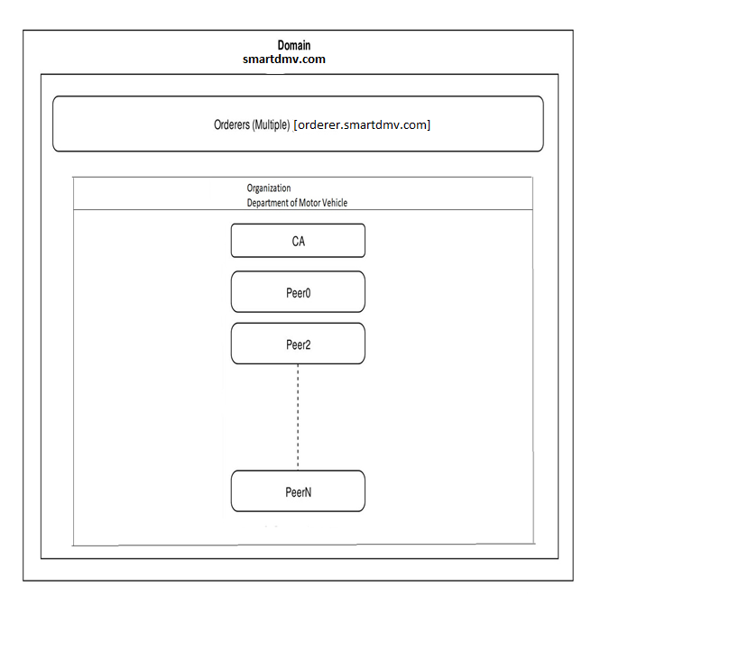

* **Level 1**

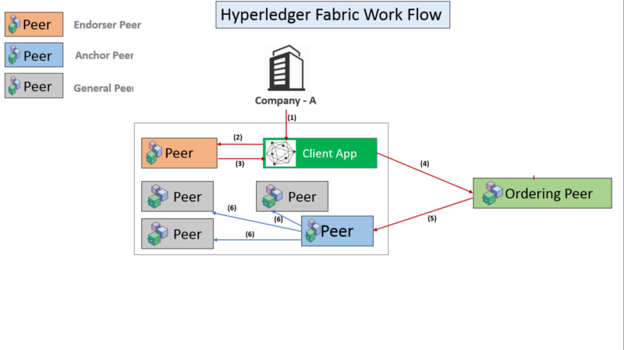

* **Level 2**

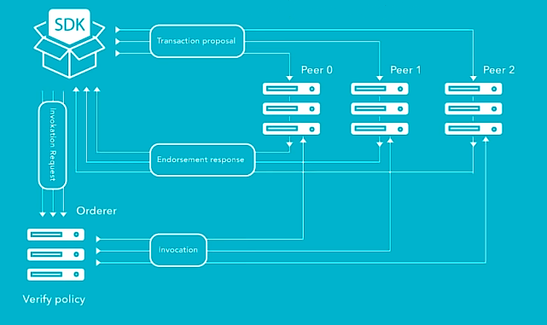

## Application and Data Architecture

### Architecture Diagram

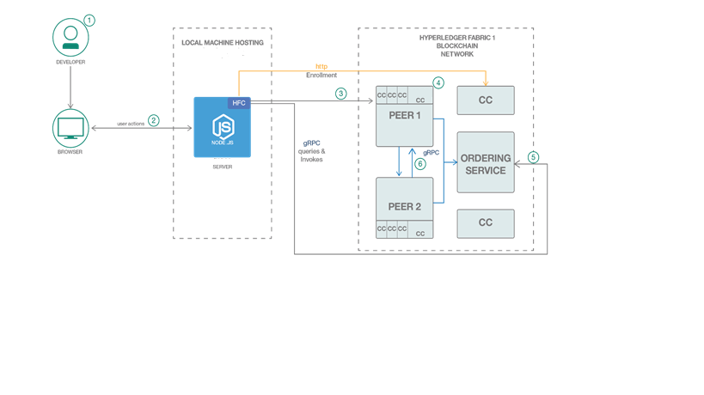

### Component Diagram

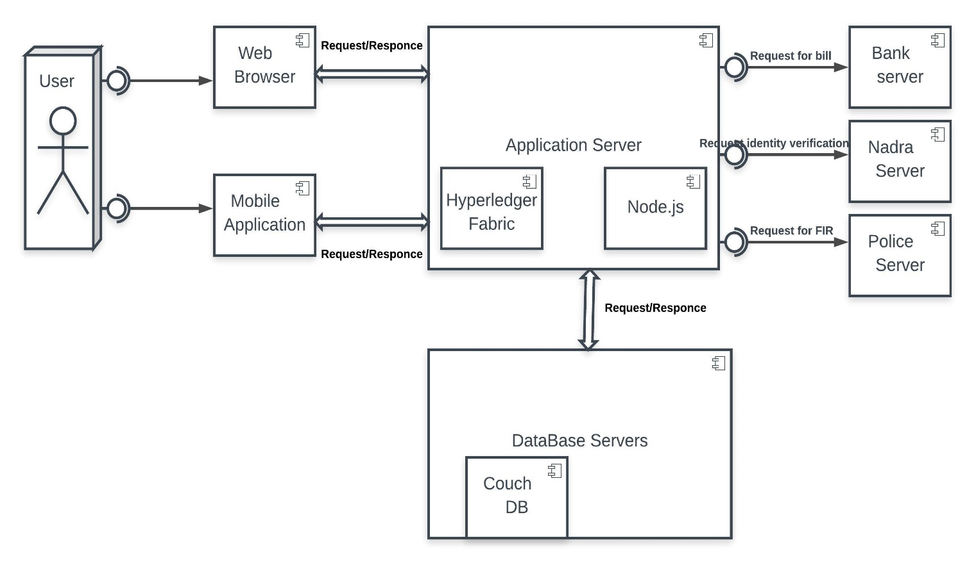

### Entity Relation Diagram

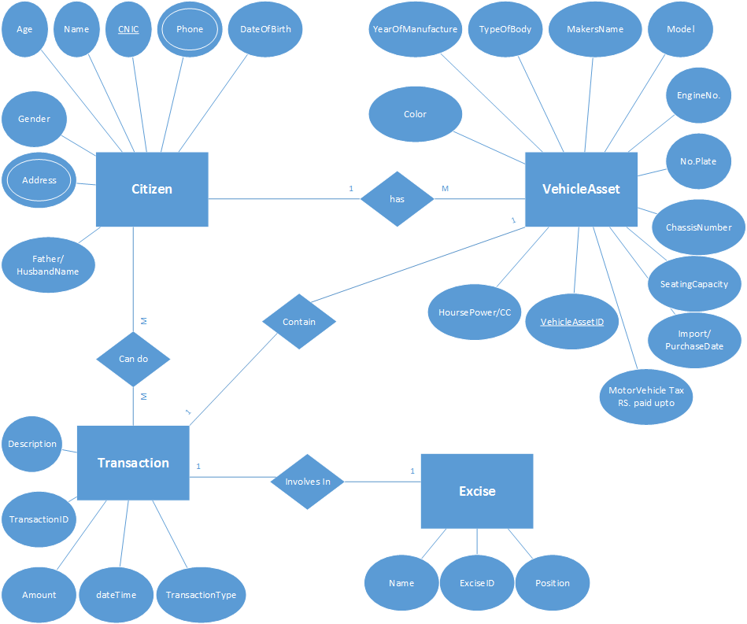

### Class Diagram

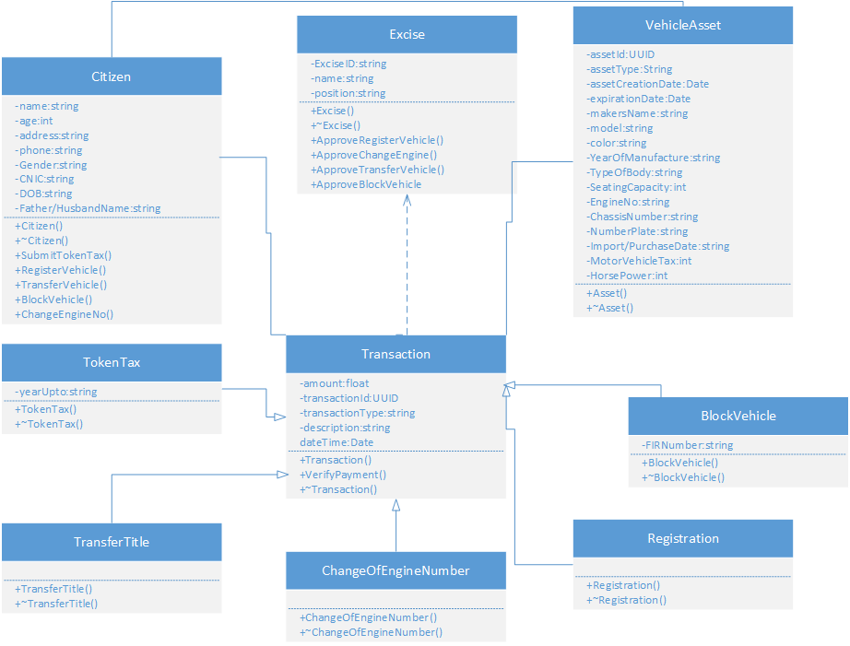

### Activity Diagram

#### User Activity Diagram

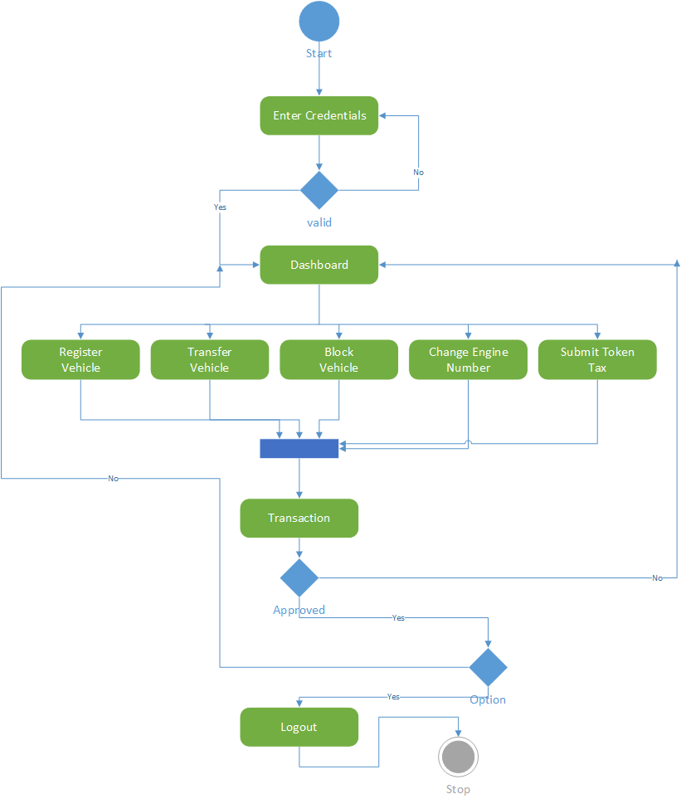

#### User Activity Diagram

|  |  |
| --- | --- |
| ***Excise Registration ID*** | ***Excise Change Engine Number ID*** |
| *C:\Users\l1s15bscs0046\Downloads\Drawing1.png* | *C:\Users\l1s15bscs0046\Downloads\Engine.png* |

|  |  |
| --- | --- |
| ***Excise Block ID*** | ***Excise Transfer ID*** |
| *C:\Users\l1s15bscs0046\Downloads\Block.png* | *C:\Users\l1s15bscs0046\Downloads\Transfer.png* |

### Decision Table

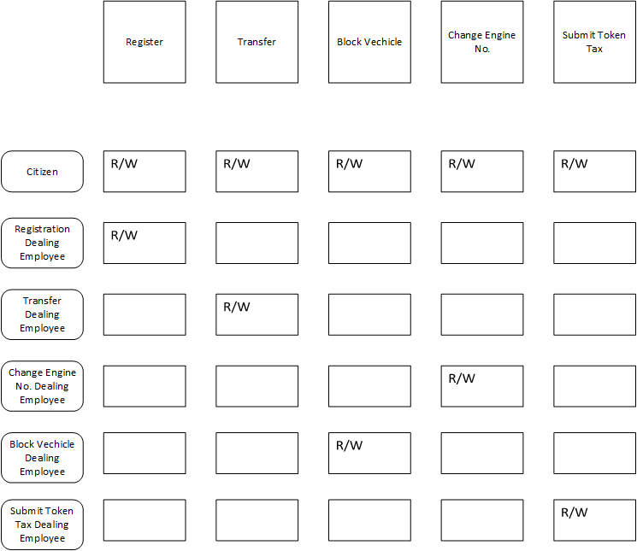

## Component Interactions and Collaborations

### Sequence Diagram

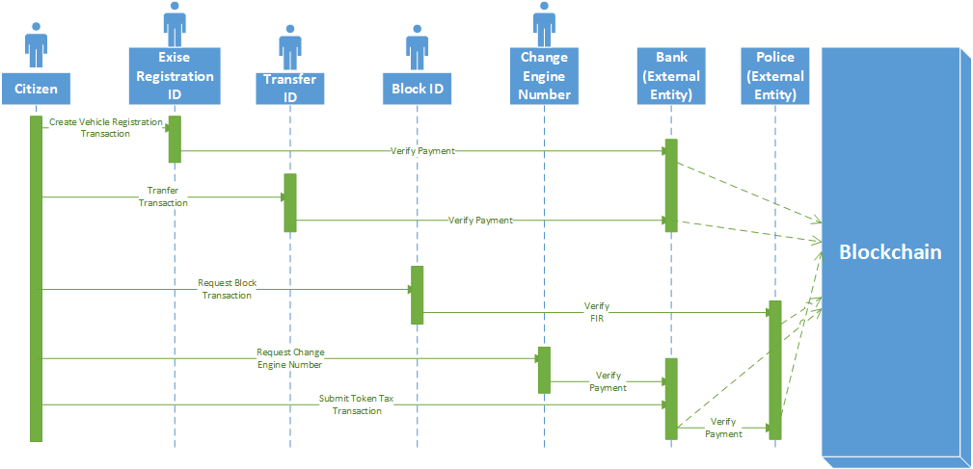

### Detailed Data Flow Diagram

#### Level 0

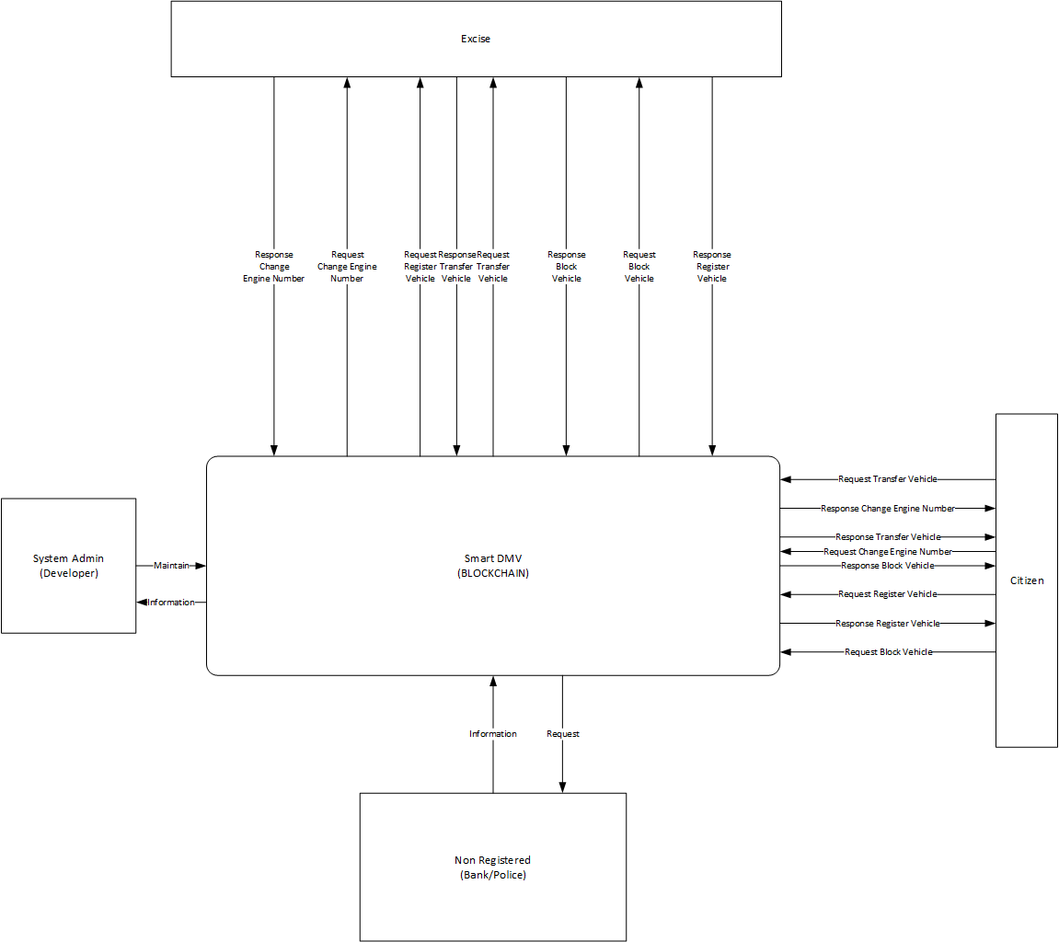

#### Level 1

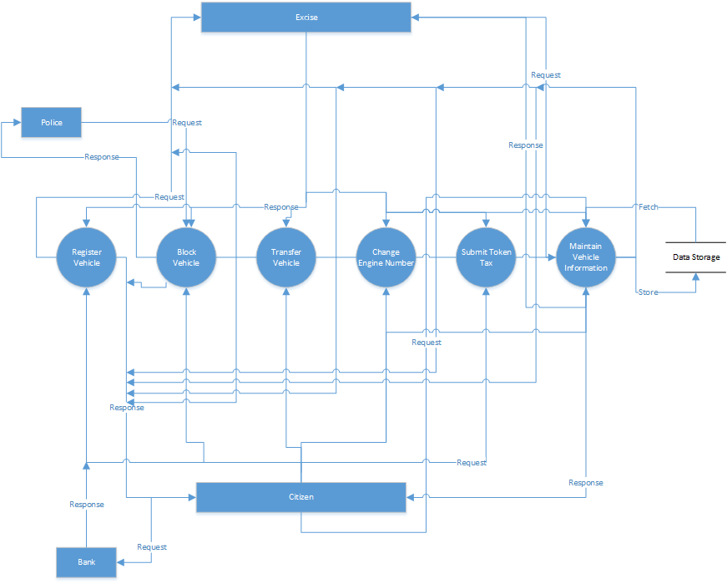

### Collaboration Diagram

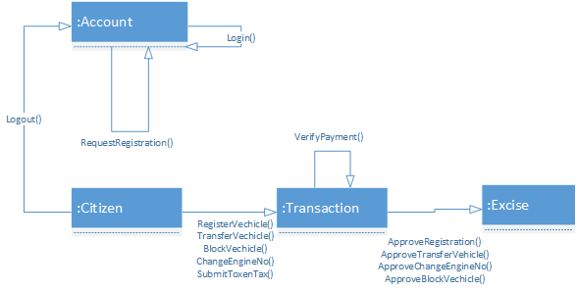

## Design Reuse and Design Patterns

Creational design patterns which includes Prototype will be used as well as Structural design patterns which include Façade will be used for reusability.

## Technology Architecture

* Smart DMV will be hosted on a Linux based server.
* Any device which can run browser can be used to access website of the smart dmv.
* Android Application would require minimum Lollipop version of Android Operating System.
* The most of the system will be developed using MEAN stack.
* Hyperledger Fabric will be using CouchDB for database.
* Hyperledger Composer will be used for deploying the network on blockchain and creating a rest server for getting REST API’s.
* TCP/IP as the IPS for Client-Server Communication.

## Architecture Evaluation

* We have used Linux operating system for development as it is open source and the current stack of technologies we are using are mostly open source and are operating under , The Linux Foundation.
* We have used Hyperledger Fabric for the development of the Blockchain Architecture as it is under development with two IT conglomerate (i.e. IBM and The Linux Foundation) with more than 290 corporate members in their community. So, Hyperledger Fabric have a long term support and being considered a great framework for development.
* Hyperledger Fabric is being used in Smart Dubai initiative of the Government of Dubai and its basic thinking does not only revolve around crypto currencies, which also motivated us to use this technology.
* Hyperledger Composer is a tool used for development of blockchain on the Hyperledger Fabric Framework.
* Angular is used for Web Front End due to its popularity and the robustness.
* Mobile Application for Android Operating System is developed while considering the large user base in the country.

# Detailed/Component Design

## Component-Component Interface

### Deployment Diagram

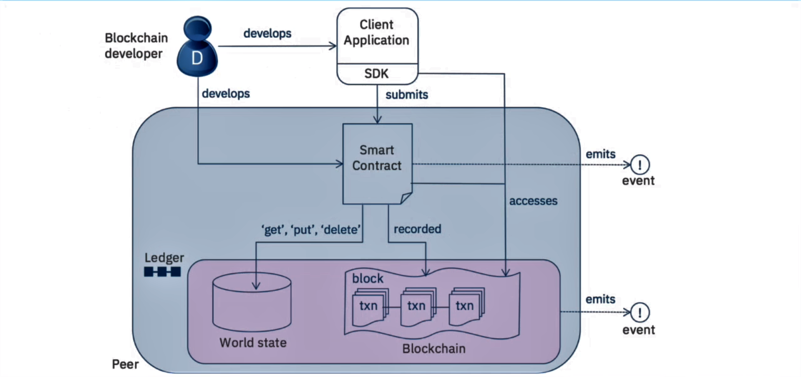

### Sequence Diagrams

#### User Registration

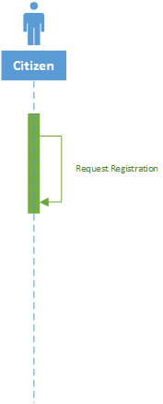

#### User Login

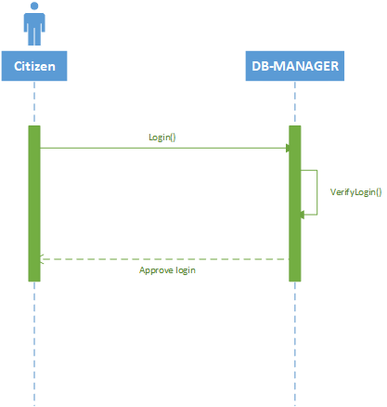

#### User Logout

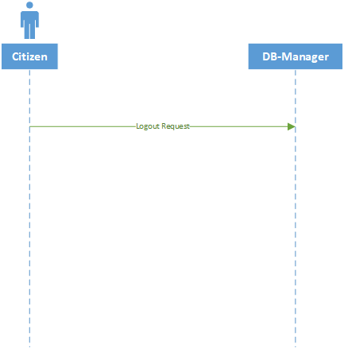

#### Register Vehicle

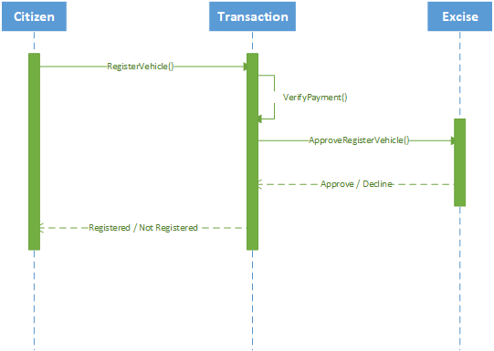

#### Transfer Vehicle

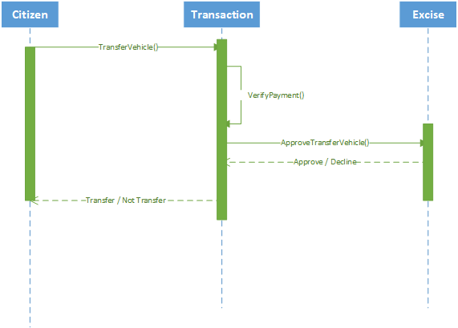

#### Block Vehicle

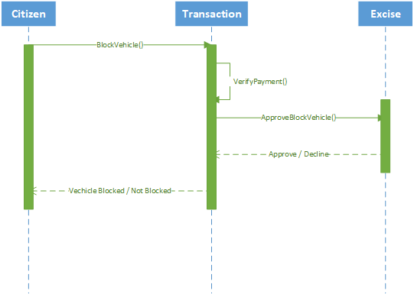

#### Change Engine Number

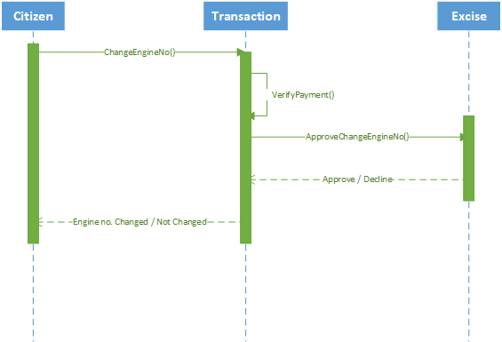

#### Submit Token Tax

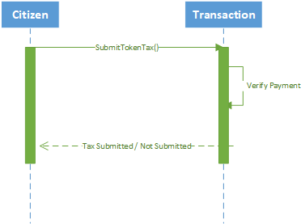

## Component-External Entities Interface

### Police API Call

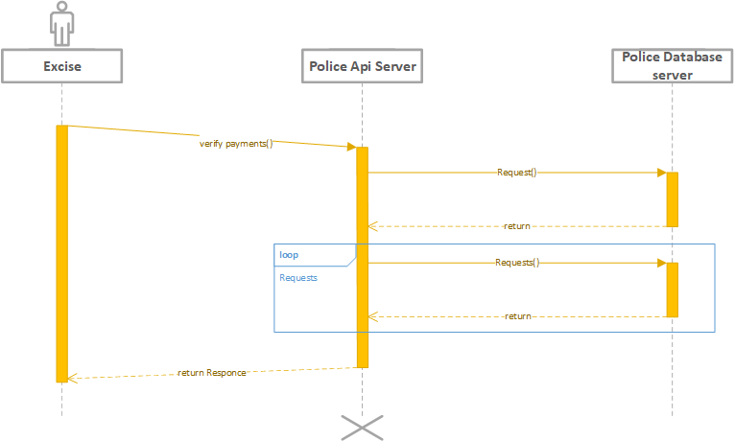

### Bank API call

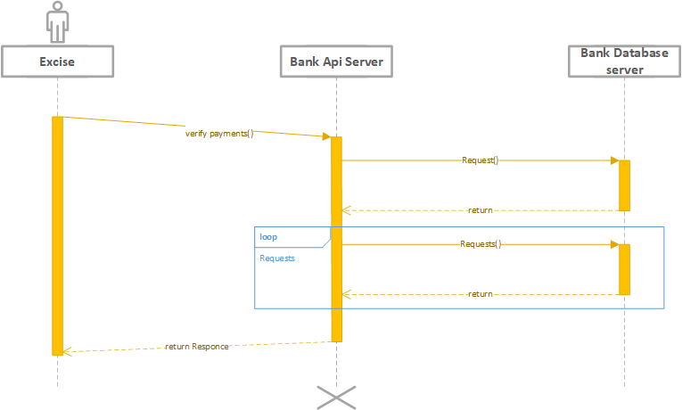

## Component-Human Interface

Basic norms followed in our project are:

* **Learnability:** Easy to use and provide help to those people who are going to use our app for the first time.
* **Efficiency:** The smaller number of steps from the current available system.
* **Satisfaction:** Fulfill the desired requirement of the customer and engage customer for further use.
* **Memorability:** The interface of the app is user friendly so it is quite easy for customers to remember the procedure.
* **Effectiveness:** This app works so effectively without any type of bugs and errors which results in customer’s satisfaction.

# Screenshots/Prototype

## Workflow

### Citizen’s Workflow (Swim Lane Diagram)

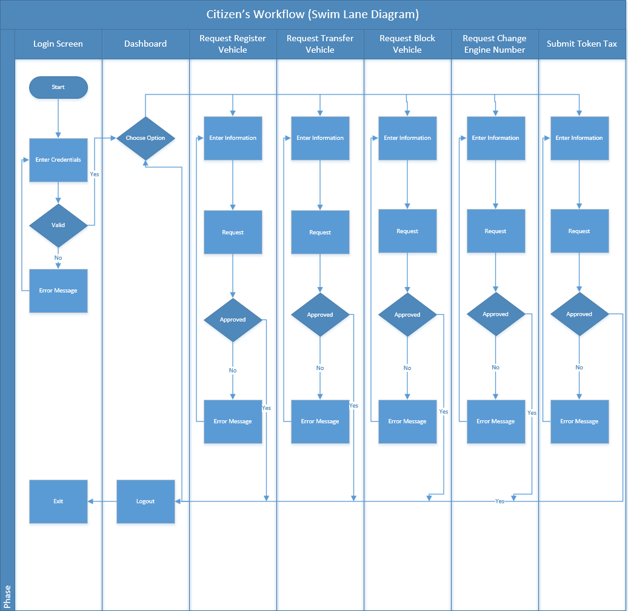

### Excise Workflow (Swim Lane Diagram)

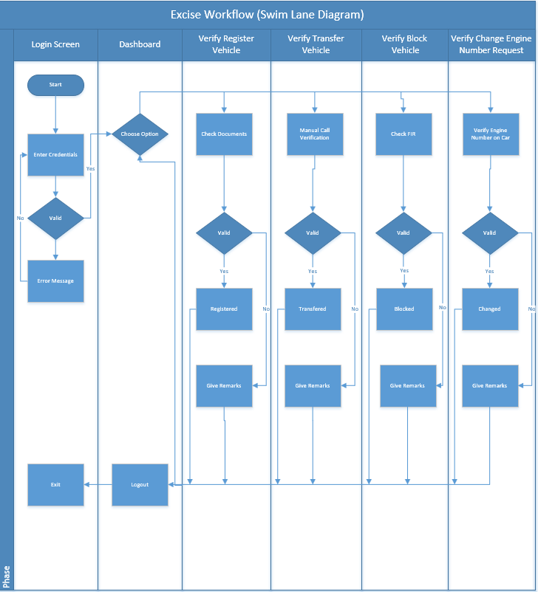

## Screens

### Citizen’s Login Screen

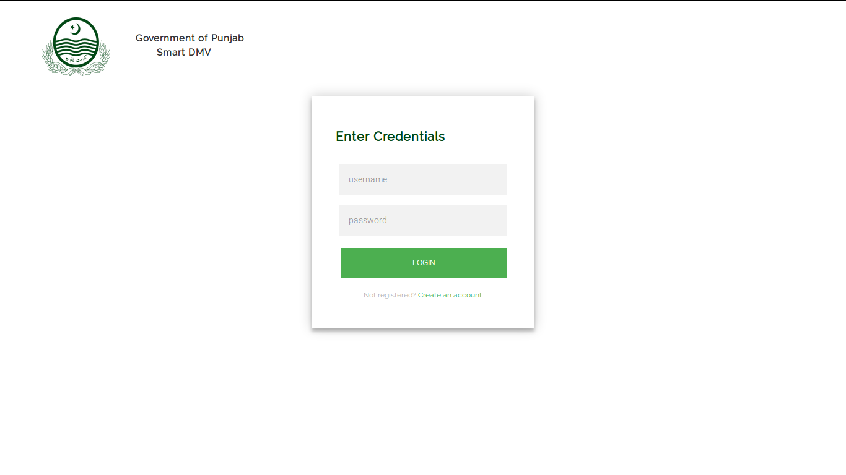

### Citizen’s Dashboard Screen

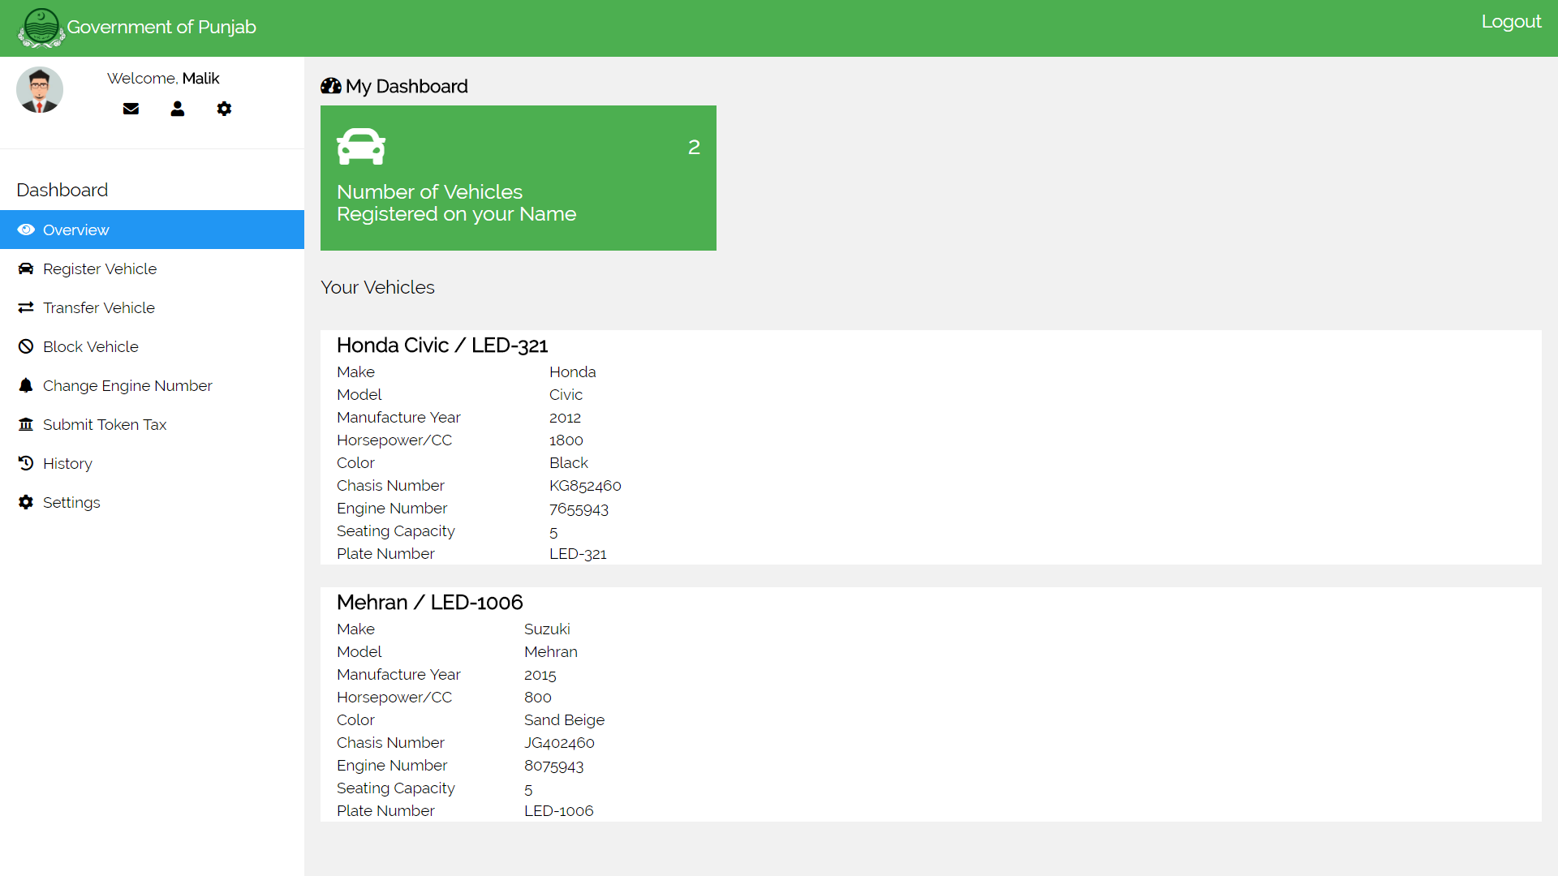

### Citizen’s Register Vehicle Screen

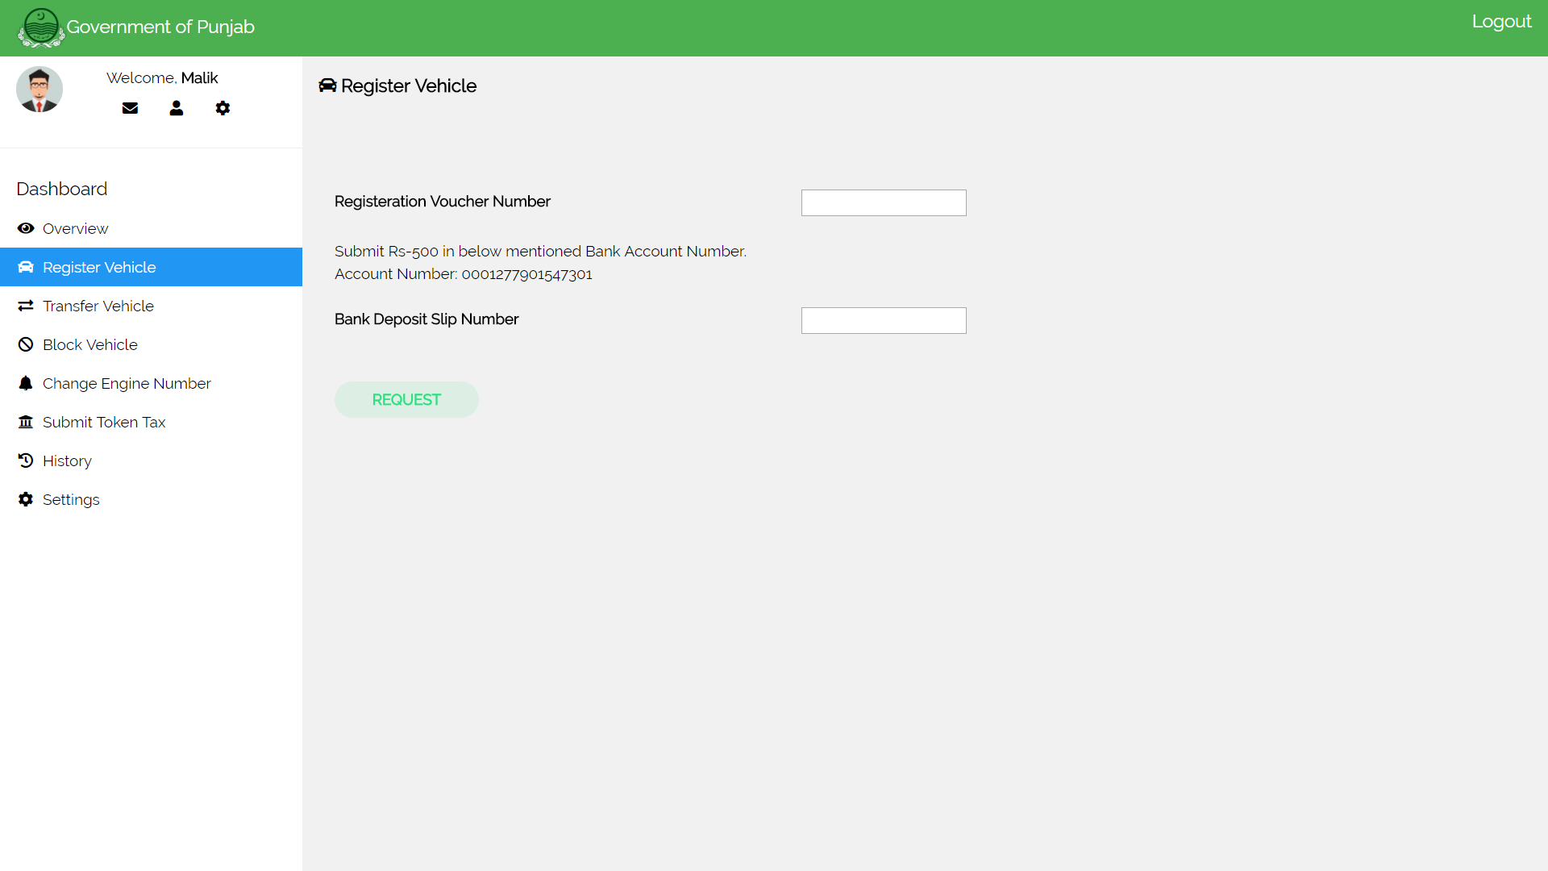

### Citizen’s Transfer Vehicle Screen

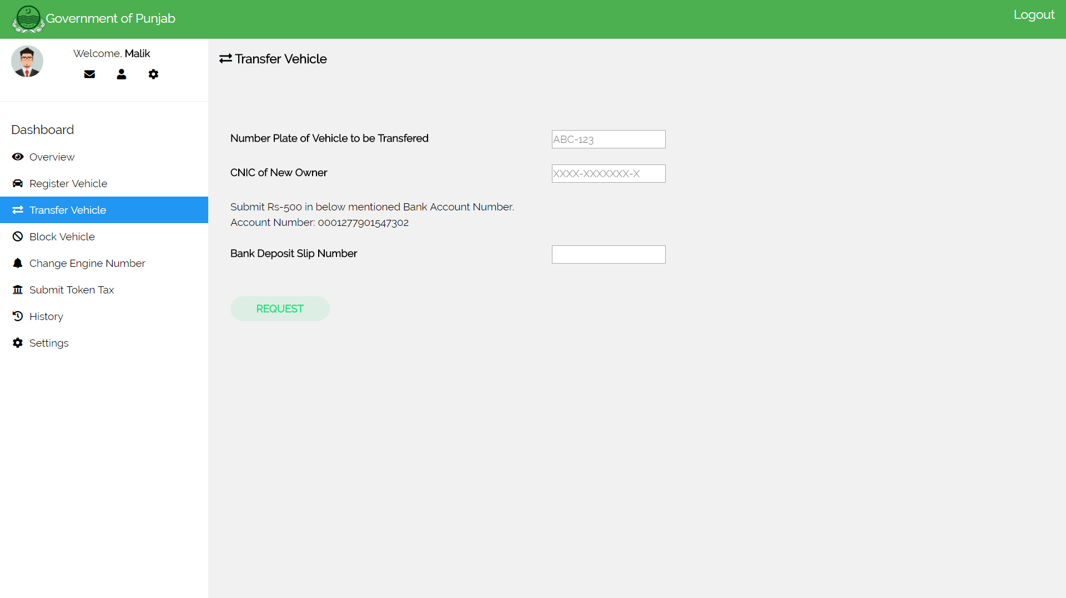

### Citizen’s Block Vehicle Screen

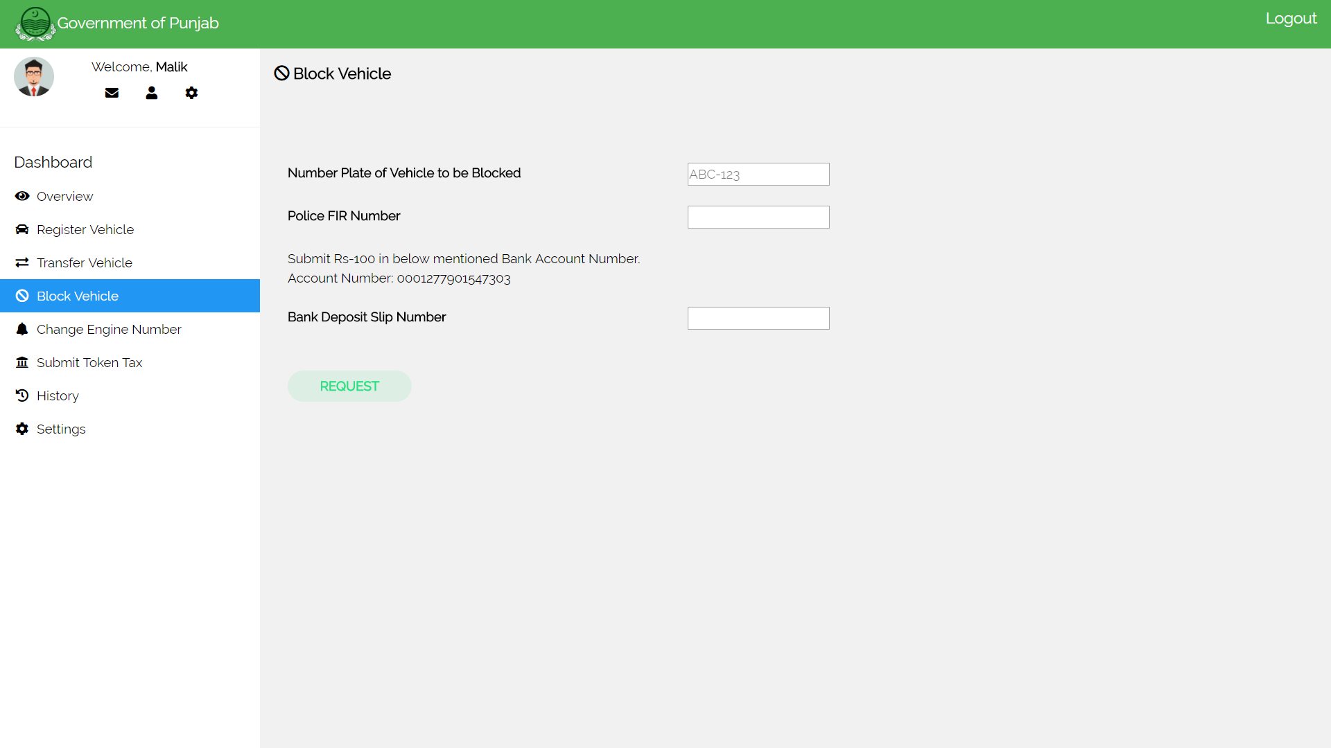

### Citizen’s Change Engine Number Screen

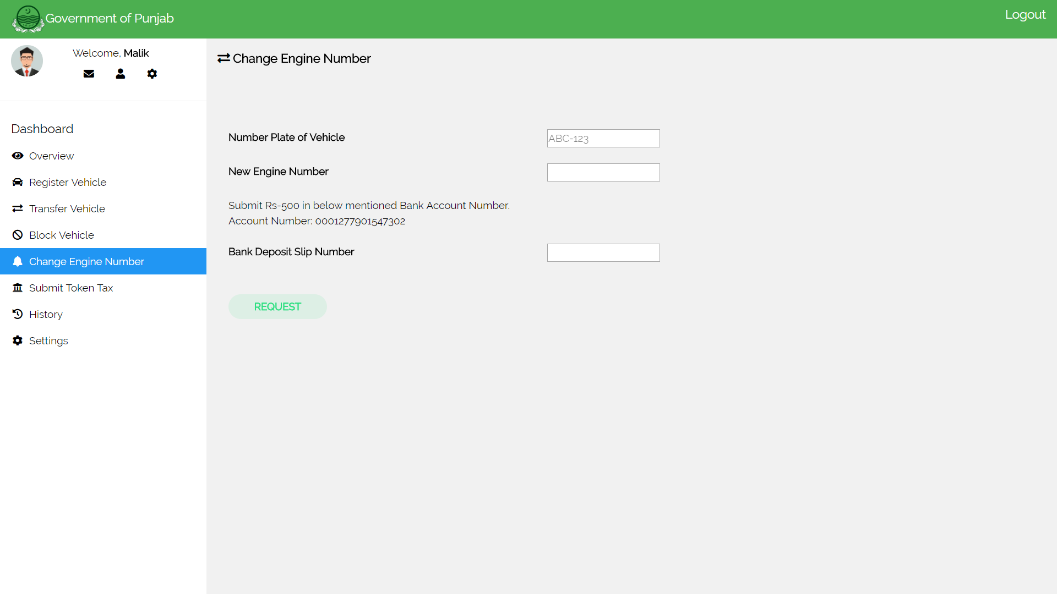

### Citizen’s Submit Token Tax Screen

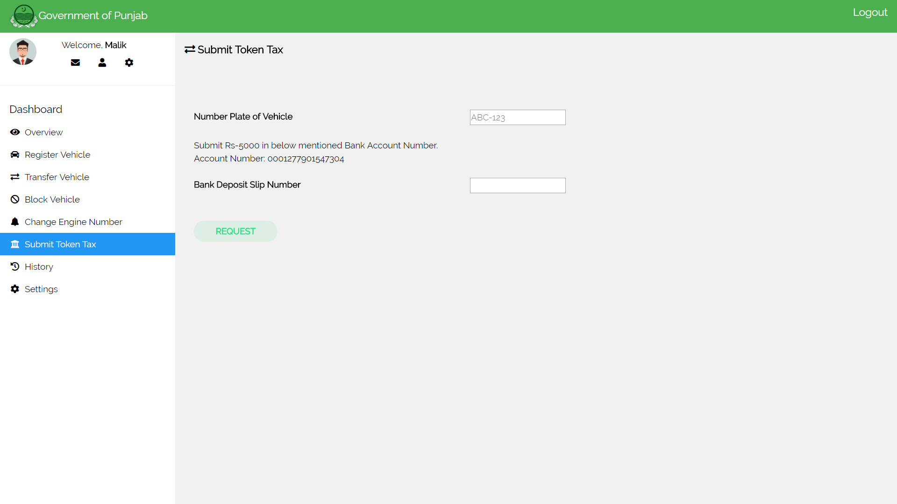

### Excise Officer’s Login Screen

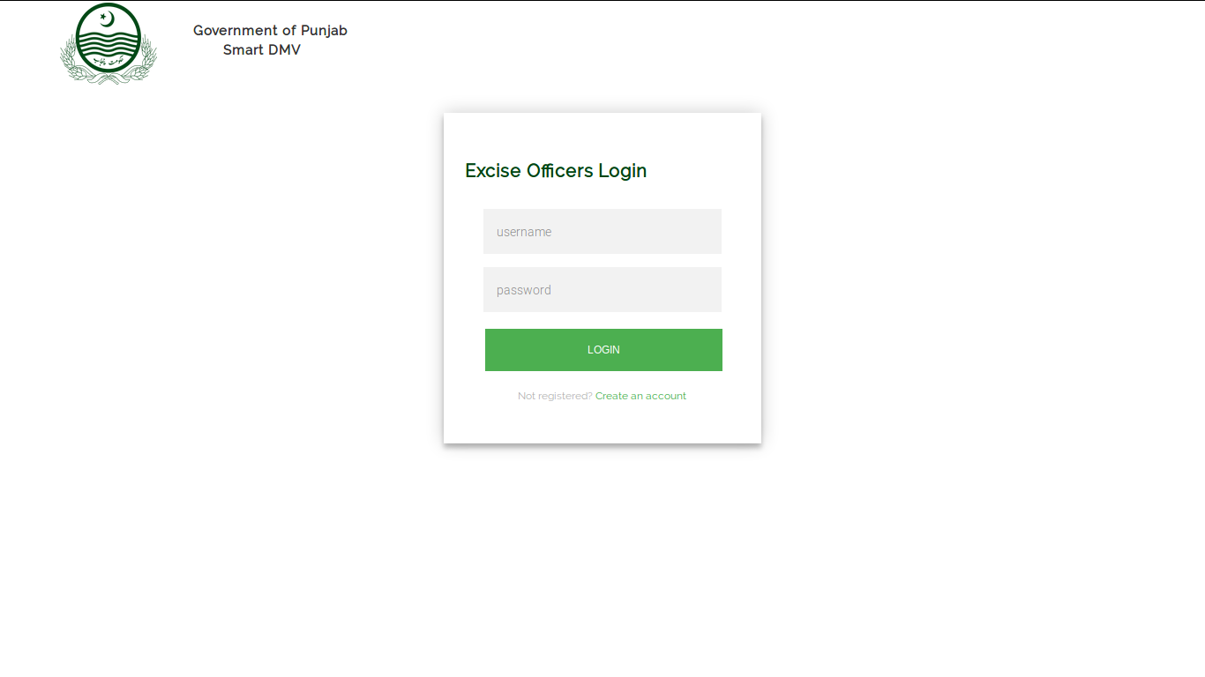

### Excise Officer’s (Manager) Dashboard Screen

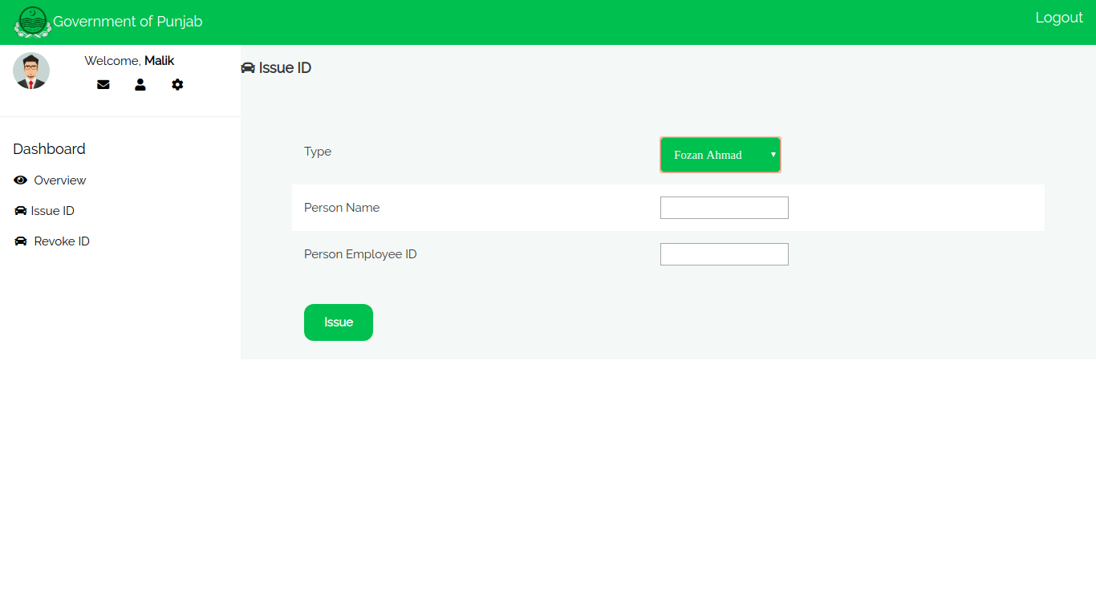

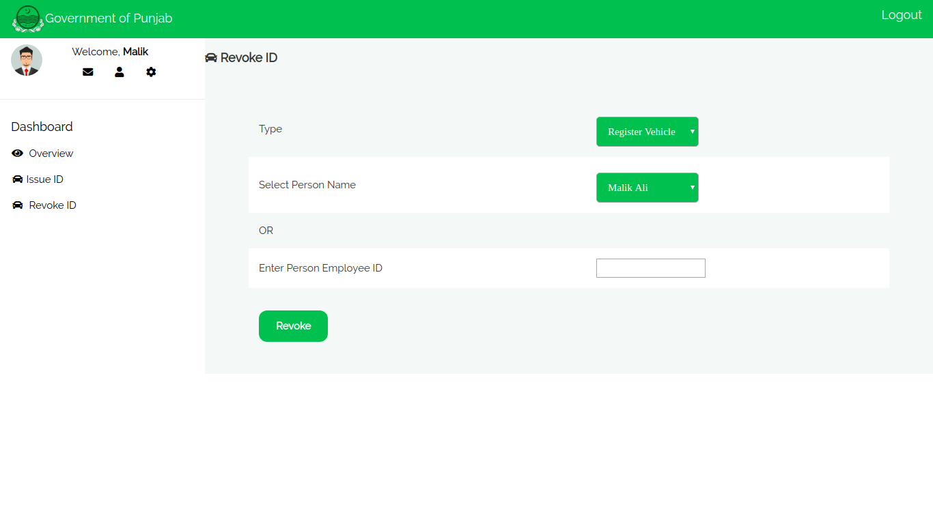

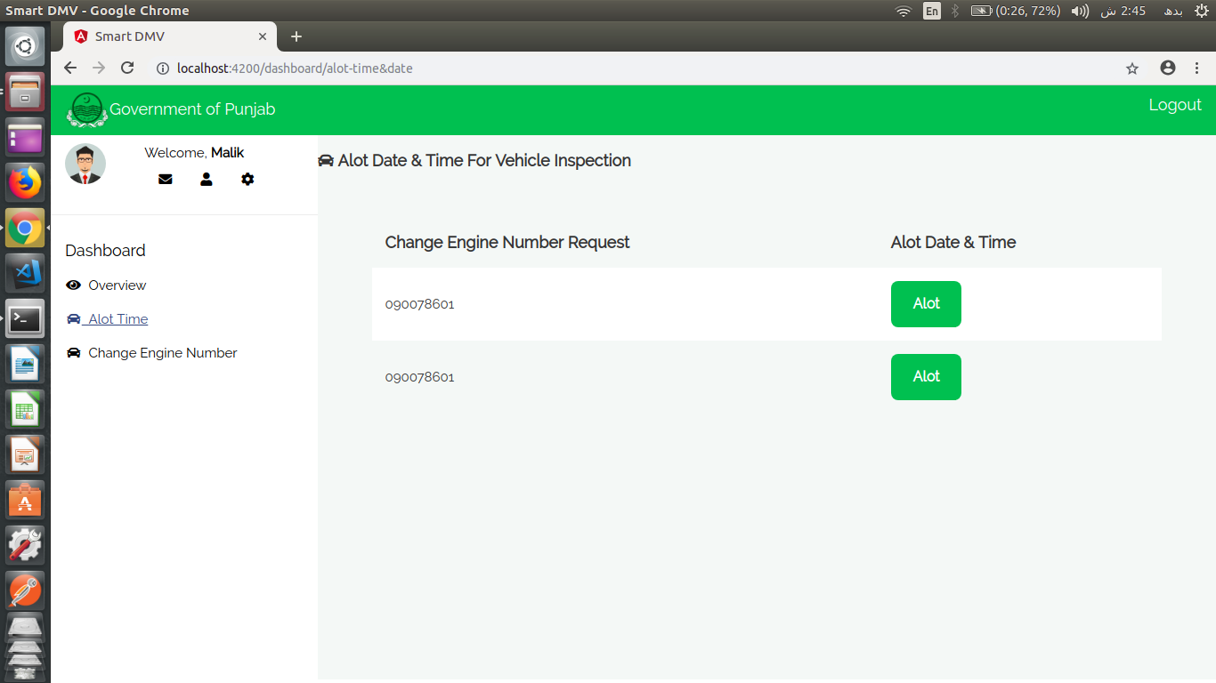

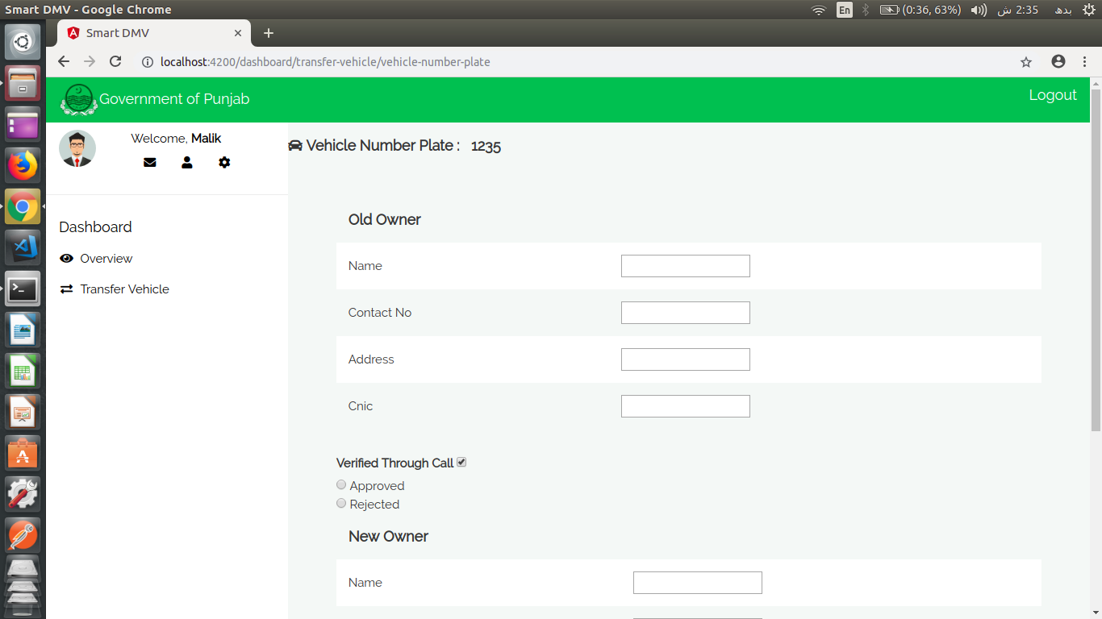

### Citizen's Android Application Screens

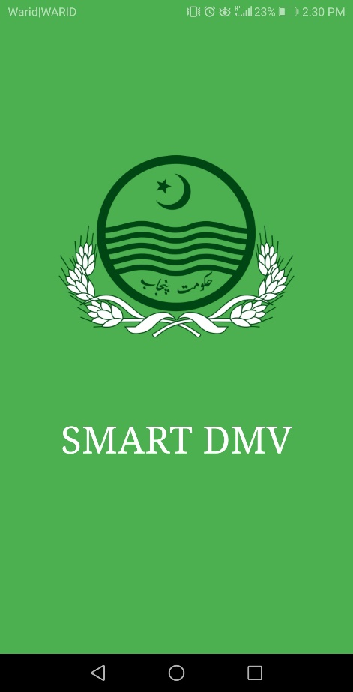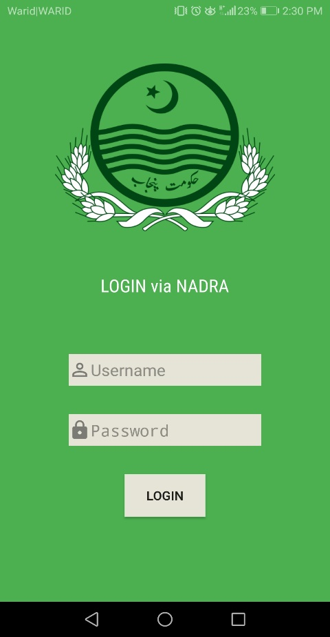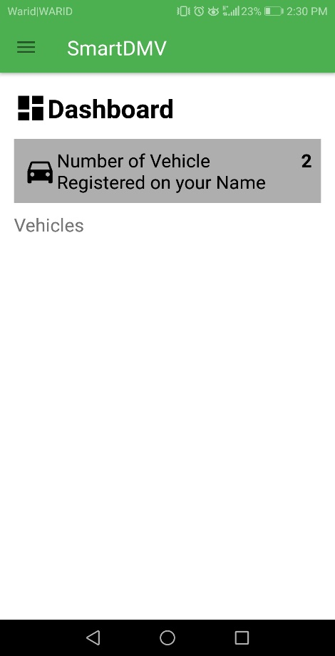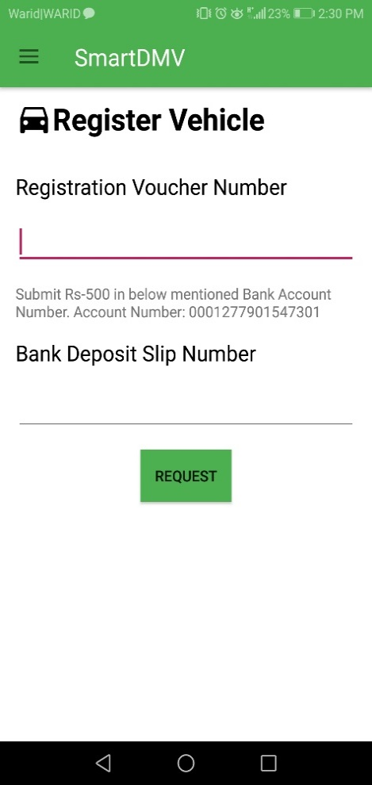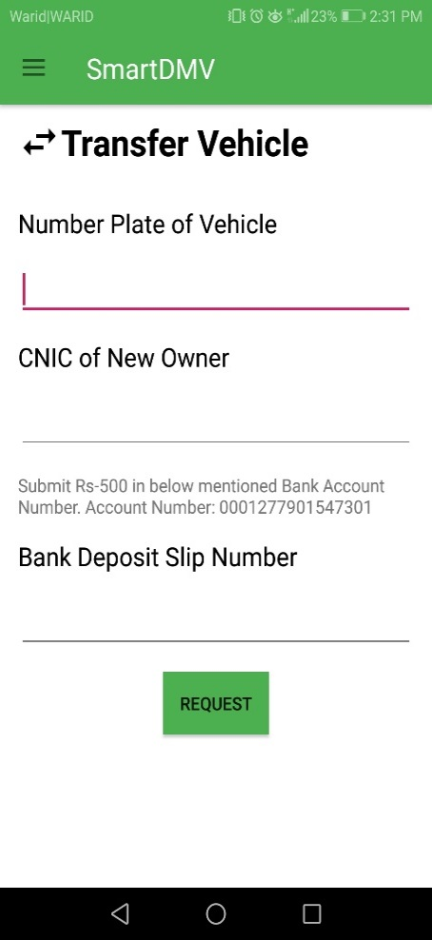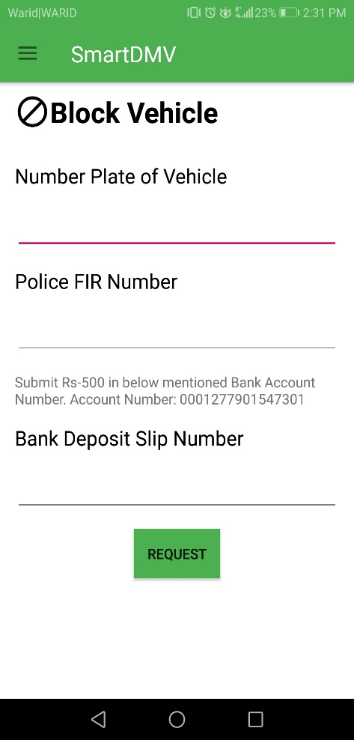

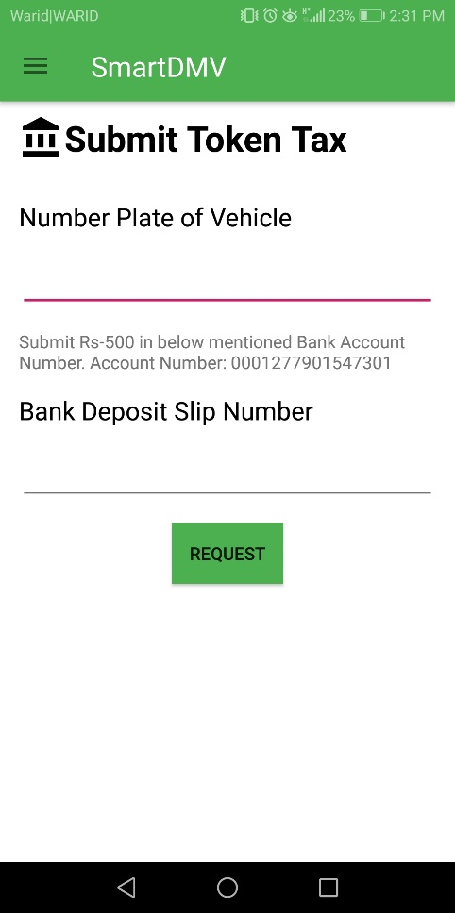 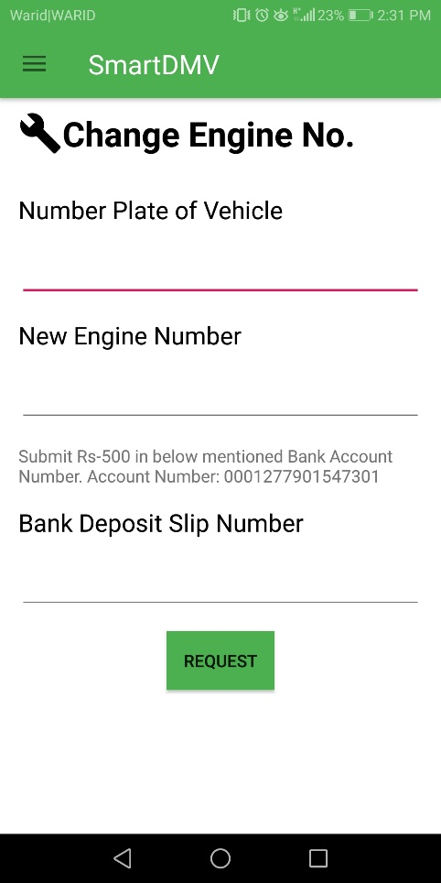 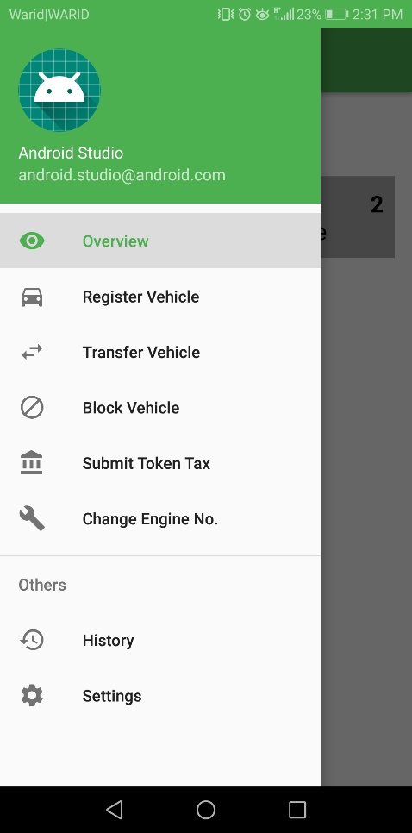

# Test Specification and Results

## Test Case Specification

Table 5.1.1: TC-1

**Manager Excise Login**

|  |  |
| --- | --- |
| **Identifier** | TC-1 |
| **Related requirements(s)** | … |
| **Short description** | Manager Excise wants to login to issue or block accounts |
| **Pre-condition(s)** | Login Screen must open |
| **Input data** | Username: test , password: test |
| **Detailed steps** | * Open login page * Enter password * Enter name * Then click ok to proceed. |
| **Expected result(s)** | Login should be successful |
| **Post-condition(s)** | Details to issue or block account of an excise officer will be shown |
| **Actual result(s)** | Manager Excise logged in. |
| **Test Case Result** |  |

Table 5.1.2: TC-2

**Issuing account to an Excise officer**

|  |  |
| --- | --- |
| **Identifier** | TC-2 |
| **Related requirements(s)** | … |
| **Short description** | Manager Excise wants to issue accounts |
| **Pre-condition(s)** | Manager Excise must be logged in. |
| **Input data** | Select Type from given ones: Registration, Transfer, Block, Change Engine no.  Enter Person Name: test  Enter Person Excise ID: test |
| **Detailed steps** | * Login * Click Issue ID from the menu * Select type from the dropdown menu e.g. Transfer * Enter the Employee name * Enter the Employee ID * Click the button issue |
| **Expected result(s)** | An Account will be issued |
| **Post-condition(s)** | Transactions can be approved from the account added. |
| **Actual result(s)** | Account is added and the person holding an account can now approve or decline the Transactions. |
| **Test Case Result** |  |

Table 5.1.3: TC-3

**Revoke an Account of the Excise Officer**

|  |  |
| --- | --- |
| **Identifier** | TC-3 |
| **Related requirements(s)** | … |
| **Short description** | Manager Excise wants to block account |
| **Pre-condition(s)** | Manager Excise must be logged in. |
| **Input data** | Select Type from given ones: Registration, Transfer, Block, Change Engine no.  Enter Person Name: test  OR  Enter Person Excise ID: test |
| **Detailed steps** | * Login * Click Revoke ID from the menu * Select type from the dropdown menu e.g. Transfer * Enter the Employee name * OR * Enter the Employee ID * Click the button Revoke |
| **Expected result(s)** | An Account will be Revoked |
| **Post-condition(s)** | Transactions can be approved from the revoked Account |
| **Actual result(s)** | Account is Revoked and the person holding that account cannot approve or decline the Transactions. |
| **Test Case Result** |  |

Table 5.1.4: TC-4

**Excise Officer Login**

|  |  |
| --- | --- |
| **Identifier** | TC-4 |
| **Related requirements(s)** | … |
| **Short description** | Excise Officer wants to login |
| **Pre-condition(s)** | Login Screen must be appeared |
| **Input data** | Username: test, Password: test |
| **Detailed steps** | * Open login page * Enter password * Enter name * Then click ok to proceed. |
| **Expected result(s)** | Login will be successful |
| **Post-condition(s)** | Officer can now Approve or Decline the Transactions |
| **Actual result(s)** | Excise Officer is logged in |
| **Test Case Result** |  |

Table 5.1.5: TC-5

**Approve the Registration Request**

|  |  |
| --- | --- |
| **Identifier** | TC-5 |
| **Related requirements(s)** | … |
| **Short description** | Excise Officer wants to approve Registration Request |
| **Pre-condition(s)** | Officer must be logged in |
| **Input data** | Model: 2018  Year: 2018  CC: 1.8  Manufacturing: Toyota |
| **Detailed steps** | * Click Register Vehicle from the menu * Click the View Button in front of the Request No. to approve the Transaction. * Enter the details of the vehicle * Tick the box (Verified through Call) * Then click Approve. |
| **Expected result(s)** | Vehicle will be registered |
| **Post-condition(s)** | Officer can now Approve or Decline other Transactions or Logout from the System |
| **Actual result(s)** | Transaction is approved. |
| **Test Case Result** |  |

Table 5.1.6: TC-6

**Approve the Transfer Request**

|  |  |
| --- | --- |
| **Identifier** | TC-6 |
| **Related requirements(s)** | … |
| **Short description** | Excise Officer wants to approve Transfer Request |
| **Pre-condition(s)** | Officer must be logged in |
| **Input data** | Old Owner:  Name: Zohaib  Contact No: 090078601  Address: 247-A Muslim Town  CNIC: 73516-2046552-8  New Owner:  Name: Ahmad  Contact No: 040098601  Address: 77-A Muslim Town  CNIC: 35762-2046352-0 |
| **Detailed steps** | * Click Transfer Vehicle from the menu * Click the View Button in front of the Request No. to approve the Transaction. * Enter the details of the both owners * Tick the box (Verified through Call) * Then click Approve. |
| **Expected result(s)** | Vehicle will be Transfered |
| **Post-condition(s)** | Officer can now Approve or Decline other Transactions or Logout from the System |
| **Actual result(s)** | Transaction is approved. |
| **Test Case Result** |  |

Table 5.1.7: TC-7

**Approve the Change Engine no. Request**

|  |  |
| --- | --- |
| **Identifier** | TC-7 |
| **Related requirements(s)** | … |
| **Short description** | Excise Officer wants to approve Change Engine No. Request |
| **Pre-condition(s)** | Officer must be logged in |
| **Input data** | Time: 10:00  Date: 28/12/2018  Old Engine no.: 8356765  New Engine no.:7657787 |
| **Detailed steps** | * Click Change Engine no. from the menu * Click the Alot Button in front of the Request No. to approve the Transaction. * Enter Time and Date * Click Submit * After inspection Enter the Number of the old and new engine * Then click Approve. |
| **Expected result(s)** | Engine no. of the Vehicle will be changed |
| **Post-condition(s)** | Officer can now Approve or Decline other Transactions or Logout from the System |
| **Actual result(s)** | Transaction is approved. |
| **Test Case Result** |  |

Table 5.1.8: TC-8

**Approve the Change Engine no. Request**

|  |  |
| --- | --- |
| **Identifier** | TC-8 |
| **Related requirements(s)** | … |
| **Short description** | Excise Officer wants to approve Change Engine No. Request |
| **Pre-condition(s)** | Officer must be logged in |
| **Input data** | Time: 10:00  Date: 28/12/2018  Old Engine no.: 8356765  New Engine no.:7657787 |
| **Detailed steps** | * Click Change Engine no. from the menu * Click the Alot Button in front of the Request No. to approve the Transaction. * Enter Time and Date * Click Submit * After inspection Enter the Number of the old and new engine * Then click Approve. |
| **Expected result(s)** | Engine no. of the Vehicle will be changed |
| **Post-condition(s)** | Officer can now Approve or Decline other Transactions or Logout from the System |
| **Actual result(s)** | Transaction is approved. |
| **Test Case Result** |  |

Table 5.1.9: TC-9

**Citizen Login**

|  |  |
| --- | --- |
| **Identifier** | TC-9 |
| **Related requirements(s)** | … |
| **Short description** | Manager Excise wants to login |
| **Pre-condition(s)** | Login Screen must open |
| **Input data** | Admin name: Abdul Razak , password: bond007 |
| **Detailed steps** | * Open login page * Enter password * Enter name * Then click ok to proceed. |
| **Expected result(s)** | Login should be successful |
| **Post-condition(s)** | Details of named vehicle will be showed |
| **Actual result(s)** | Citizen logged in. |
| **Test Case Result** |  |
|  |  |

Table 5.1.10: TC-10

**Citizen Request for Registration**

|  |  |
| --- | --- |
| **Identifier** | TC-10 |
| **Related requirements(s)** | … |
| **Short description** | Citizen wants to register the vehicle |
| **Pre-condition(s)** | Citizen must be logged in. |
| **Input data** | Registration Voucher number:6487492  Bank deposit slip no.:77792465926 |
| **Detailed steps** | * Click Registration Vehicle in the menu * Enter registration voucher no. * Enter bank deposit slip no. * Click Request button |
| **Expected result(s)** | Registration request will be sent |
| **Post-condition(s)** | Citizen can view the details of registered cars, request another transaction or logout |
| **Actual result(s)** | Request is sent |
| **Test Case Result** |  |
|  |  |

Table 5.1.11: TC-11

**Citizen Request for Transfer**

|  |  |
| --- | --- |
| **Identifier** | TC-11 |
| **Related requirements(s)** | … |
| **Short description** | Citizen wants to Transfer the vehicle |
| **Pre-condition(s)** | Citizen must be logged in. |
| **Input data** | Vehicle number plate : ABC 123  CNIC: 3527873534438  Bank deposit slip no.:77792465123 |
| **Detailed steps** | * Click Transfer Vehicle in the menu * Enter Vehicle number plate. * Enter CNIC. * Enter Bank deposit slip no. * Click Request button |
| **Expected result(s)** | Transfer request will be sent |
| **Post-condition(s)** | Citizen can view the details of registered cars, request another transaction or logout |
| **Actual result(s)** | Request is sent |
| **Test Case Result** |  |
|  |  |

Table 5.1.12: TC-12

**Citizen Request for Change Engine No.**

|  |  |
| --- | --- |
| **Identifier** | TC-12 |
| **Related requirements(s)** | … |
| **Short description** | Citizen wants to Change Engine no. of the vehicle |
| **Pre-condition(s)** | Citizen must be logged in. |
| **Input data** | Vehicle number plate : ABC 123  New Engine No.: 5553563  Bank deposit slip no.:77792465987 |
| **Detailed steps** | * Click Change Engine no. in the menu * Enter Vehicle number plate. * Enter new engine no. * Enter Bank deposit slip no. * Click Request button |
| **Expected result(s)** | Change Engine number request will be sent |
| **Post-condition(s)** | Citizen can view the details of registered cars, request another transaction or logout |
| **Actual result(s)** | Request is sent |
| **Test Case Result** |  |
|  |  |

Table 5.1.13: TC-13

**Citizen Request for Block Vehicle**

|  |  |
| --- | --- |
| **Identifier** | TC-13 |
| **Related requirements(s)** | … |
| **Short description** | Citizen wants to Block the vehicle |
| **Pre-condition(s)** | Citizen must be logged in. |
| **Input data** | Vehicle number plate to be blocked : ABC 123  Police FIR No.: 7376282  Bank deposit slip no.:77792461098 |
| **Detailed steps** | * Click Block Vehicle in the menu * Enter Vehicle number plate to be blocked. * Enter Police FIR no. * Enter Bank deposit slip no. * Click Request button |
| **Expected result(s)** | Block Vehicle request will be sent |
| **Post-condition(s)** | Citizen can view the details of registered cars, request another transaction or logout |
| **Actual result(s)** | Request is sent |
| **Test Case Result** |  |
|  |  |

Table 5.1.14: TC-14

**Submit Token Tax**

|  |  |
| --- | --- |
| **Identifier** | TC-14 |
| **Related requirements(s)** | … |
| **Short description** | Citizen wants to Submit the token tax of the vehicle |
| **Pre-condition(s)** | Citizen must be logged in. |
| **Input data** | Vehicle number plate: ABC 123  Bank deposit slip no.:11192461098 |
| **Detailed steps** | * Click Submit Token Tax in the menu * Enter Vehicle number plate. * Enter Bank deposit slip no. * Click Request button |
| **Expected result(s)** | Token Tax Submission request will be sent |
| **Post-condition(s)** | Citizen can view the details of registered cars, request another transaction or logout |
| **Actual result(s)** | Request is sent |
| **Test Case Result** |  |
|  |  |

## Summary of Test Results

Table 5.2: Summary of Test Results

|  |  |  |  |  |
| --- | --- | --- | --- | --- |
| **Module Name** | Test cases run | Number of defects found | Number of defects corrected so far | Number of defects still need to be corrected |
| **Module 1 (Excise Manager)** | TC1, TC2, TC3 | 0 | 0 | 0 |
| **Module 2 (Excise Officer’s)** | TC4, TC5, TC6, TC7, TC8 | 0 | 0 | 0 |
| **Module 3 (Citizen’s Login)** | TC9, TC10, TC11, TC12, TC13, TC14 | 0 | 0 | 0 |
| **Complete System** | <Sum all of the above> | <Sum all of the above> | <Sum all of the above> | <Sum all of the above> |

# Project Completion Status

**Table 6.1: Project Completion Status**

|  |  |
| --- | --- |
| **Module Name** | **Status**  (Complete, Partially Implemented, Not Implemented) |
| **Module 1 (admin login)** | Partially Implemented |
| **Module 2 (Citizen login/signup)** | Partially Implemented |
| **Module 3 (Register Vehicle)** | Completed |
| **Module 4 (Transfer Vehicle)** | Completed |
| **Module 5 (Submit Token Tax Vehicle)** | Completed |
| **Module 6 (Block Vehicle)** | Completed |
| **Module 7 (Change Engine No.)** | Partially Implemented |
| **Complete System** | Partially completed |

Table 6.2: Objective(s)/Target(s) Status

|  |  |  |
| --- | --- | --- |
| **Target/Objective** | **Status**  (Completed,  Partially Completed,  Not Completed) | **Reason(s)** |
| **Register** | Completed | ------ |
| **Transfer** | Completed | ------ |
| **Submit Token Tax** | Completed | ------ |
| **Block** | Completed | ------ |
| **Change Engine No.** | Partially Completed | ------ |
| **Number of Targets Completed** | 4 | ------ |
| **Number of Targets Partially Completed** | 1 | ------ |
| **Number of Targets Not Completed** | 0 | ------ |

# 

# Deployment/Installation Guide

* **To install our application**
* Citizen will simple have to open play store, as it is an android application
* Type “Smart DMV” on search bar of play store.
* Click install to download our app.
* Our app is 3MB and the android version should be lollipop or more.
* **Secondly, for web browsing**
* Open any web browser and write on search engine “smartdmv.gov.pk”.
* Click enter to proceed.

**\*note: internet connection should be established before downloading application or opening it on web browser. \***

# User Manual

**For Citizen**

All the following functionalities can be accessed from the Dashboard (left side bar) of the application.

**Registration**

* For registration, citizen have to get the voucher number physically from the excise officer and after getting that, he/she has to submit the bank fee.
* After submitting the fee, citizen should open the web application or Android app
* In the web or mobile application, citizen will enter the Voucher No. and Bank Deposit Fee No.
* Click or Press the Request button.
* Request for Registration will be successfully occurred.

**Transfer**

* For Vehicle Transfer, citizen have to enter the Number Plate of his/her Vehicle, CNIC of new owner and the Bank deposit slip no.
* After the approval of new owner and excise officer, the vehicle will be transferred to the new owner.

**Block Vehicle**

* To Block the vehicle, citizen have to complain FIR in the Police Station and then enter the Number Plate of his/her Vehicle, FIR Number in the application.
* The vehicle will be blocked.

**Submit Token Tax**

* For Submission of token tax, citizen have to enter the Number Plate of his/her Vehicle, and the Bank deposit slip no. in the application
* After the approval of excise officer the token tax will be submitted.

**Change Engine No.**

* For changing the engine no. of vehicle, citizen have to enter the Number Plate of his/her Vehicle, new engine no. of the vehicle and the Bank deposit slip no. in the application.
* After the approval and inspection of excise officer, the engine no. of the vehicle will be changed.

**For Excise**

If he/she is not a member of Smart DMV, then the admin will gave the credentials to the excise officer to login into the system but the officer will only have rights to manage his/her department e.g. an officer of Transfer will only be accessing the transfer rights.

* After the excise officer is logged in he/she will be approving the list of transactions that will be accessed from the dashboard
* Select the transaction from list and click the Accept button after verifying it from the user..
* The Excise officer can also View the Transaction by clicking up the View button.
* In Change Engine no. case, the officer should select the transaction by clicking on it and then select Date and Time for the inspection of the Citizen’s car

The officer can logout from the application after successfully approving the transactions.

# References

<http://smartdubai.ae/en/Pages/default.aspx>

<https://excise.punjab.gov.pk/vehicle_registration>

<http://excise.punjab.gov.pk/motorvehicle_tax>

<https://www.hyperledger.org/projects/fabric>

<https://composer-playground.mybluemix.net/>

<https://hyperledger-fabric.readthedocs.io/en/release-1.3/>

<https://hyperledger-fabric.readthedocs.io/en/release-1.3/dev-setup/devenv.html>

<https://hyperledger.github.io/composer/v0.19/tutorials/developer-tutorial.html>

Appendix A: Glossary

### Block chain:

A **block chain**, originally **block chain**, is a continuously growing list of records, called blocks, which are linked and secured using cryptography.[Each block typically contains a cryptographic hash of the previous block, a timestamp and transaction data. By design, a block chain is inherently resistant to modification of the data. It is "an open, distributed ledger that can record transactions between two parties efficiently and in a verifiable and permanent way".

### Cryptography:

**Cryptography** or **cryptology** is the practice and study of techniques for secure communication in the presence of third parties called adversaries. More generally, cryptography is about constructing and analyzing protocols that prevent third parties or the public from reading private messages various aspects in information security such as data confidentiality, data integrity, authentication, and non-repudiationare central to modern cryptography. Modern cryptography exists at the intersection of the disciplines of mathematics, computer science, electrical engineering, communication science, and physics.

* **Smart Contract:**

A **smart contract** is a computer protocol intended to digitally facilitate, verify, or enforce the negotiation or performance of a contract. Smart contracts allow the performance of credible transactions without third parties. These transactions are track able and irreversible. Proponents of smart contracts claim that many kinds of contractual clauses may be made partially or fully self-executing, self-enforcing, or both. The aim of smart contracts is to provide security that is superior to traditional contract law and to reduce other transaction costs associated with contracting.

* **Documents:**

Few documents are attached which are used currently in the department of motor vehicle, i.e. TO Form, F Form, etc.

|  |  |  |
| --- | --- | --- |
| **Sr No.** | **Document Name** | **Description** |
| 1 | Transfer Form | Used for transferring the Vehicle |
| 2 | F Form | Used in registering of new Vehicle |
| 3 | Sales Invoice | Detail of payment of car |
| 4 | Converting Letter | Details of NOC provided by the company on their letter head |
| 5 | Clearance Certificate | Details of Vehicle Violence |

Appendix B: IV & V Report

(Independent verification & validation)

**IV & V Resource**

Name Signature

|  |  |  |  |  |  |
| --- | --- | --- | --- | --- | --- |
| **S#** | **Defect Description** | **Origin Stage** | **Status** | **Fix Time** | |
| **Hours** | **Minutes** |
| 1 |  |  |  |  |  |
| 2 |  |  |  |  |  |
| 3 |  |  |  |  |  |
| … |  |  |  |  |  |

**Table 1: List of non-trivial defects**

This document has been adapted from the following:

1. Previous project templates at UCP
2. High-level Technical Design, Centers for Medicare & Medicaid Services. (www.cms.gov)