BSCS FINAL PROJECT

Software Design Specification

Smart DMV (Department of Motor Vehicle)



Project Advisor

**Sir Zaid Munir**

Presented by:

**Group ID: S18BS028**

Student Reg# Student Name

|  |  |
| --- | --- |
| **L1S15BSCS0046** | **MALIK ALI HAIDER AWAN** |
| **L1S15BSCS0047** | **HAFIZ SHAHROZ NAJAM** |
| **L1S15BSCS0060** | **FOZAN AHMAD** |
| **L1F14BSCS0415** | **ZOHAIB KHALID** |

**Faculty of Information Technology**

**University of Central Punjab**

# Software Design Specification

# SDP Phase II

# Smart DMV (Department of Motor Vehicle)

# Advisor: Zaid Munir

# Group S18BS028

|  |  |
| --- | --- |
| Member Name | Primary Responsibility |
| Malik Ali Haider Awan |  |
| Hafiz Shahroz Najam |  |
| Fozan Ahmad |  |
| Zohaib Khalid |  |

Table of Contents

Table of Contents iii

Revision History iv

1. Introduction 1

1.1. Product 1

1.2. Background 1

1.3. Objective(s)/Aim(s)/Target(s) 1

1.4. Scope 1

1.5. Business Goals 1

1.6. Document Conventions 2

1.7. Miscellaneous 2

2. Overall Description 3

2.1. Product Features 3

2.2. Functional Description 3

2.3. User Classes and Characteristics 4

2.4. Design and Implementation Constraints 4

2.5. Assumptions and Dependencies 4

3. Technical Architecture 5

3.1. Application and Data Architecture 7

3.2. Component Interactions and Collaborations 13

3.2.1. Sequence Diagrams 13

3.2.1.1. User Registration 13

3.2.1.2. User Login 13

3.2.1.3. User Logout 14

3.2.1.4. Register Vehicle 14

3.2.1.5. Transfer Vehicle 15

3.2.1.6. Block Vehicle 15

3.2.1.7. Change Engine Number 16

3.2.1.8. Submit Token Tax 16

3.2.2. Detailed Data Flow Diagram 17

3.2.2.1. Level 0 17

3.2.2.2. Level 1 18

3.3. Design Reuse and Design Patterns 20

3.4. Technology Architecture 20

4. Screenshots/Prototype 21

4.1. Workflow 21

4.2. Screens 23

5. Revised Project Plan 28

6. References 29

Appendix A: Glossary 30

Block chain: 30

Cryptography: 30

Appendix B: IV & V Report 31

Revision History

|  |  |  |  |
| --- | --- | --- | --- |
| **Name** | **Date** | **Reason For Changes** | **Version** |
|  |  |  |  |
|  |  |  |  |

# Introduction

## Product

The problem that leads us to developing this system are the loop holes in the current system which provides benefit to malicious actors by exploiting them. Like a car can be transferred to someone else even if the car is stolen as well as owner of the car will remain blinded from the situation. This project will use Block-chain technology to develop smart contracts which will automate the process of motor vehicle registration to reduce fraud around stolen vehicle as well as to transfer vehicle title or to issue vehicle registration.

## Background

This project will help the government as well as owners of motor vehicles in the sense of saving the time, the cost reduced due to the smart contracts involved in blockchain implementation. This solution will create the openings to minimize the lack of system’s durability in terms of fraud and time required to do this procedure. Now-a-days, the process of motor vehicle registration is semi-digital but its network is centralized and is vulnerable to data tempering. This digitalization is not at its best due to the problem of identity management. If this process will be implemented on blockchain then it will help in reducing the fraud rate as well as reduce time required to do a lot of work. Other than this, it has some environmental benefits due to the reduction of amount of paper used in current system. It will improvise the current system and a step forward to make system’s efficiency in more digitalize way by making decentralized system using blockchain technology. These points leads to the development of this project.

## Objective(s)/Aim(s)/Target(s)

* Develop a user-friendly Web based and Android based Application.
* Reduction in fraud.
* Reduce processing time related to Vehicle Registration/Transfer.
* Reduce the cost by reducing man power.

## Scope

The scope of this project is to develop a Smart Department of Motor Vehicle (DMV) that will reduce the fraud rate, data tempering, remove few extra steps involved in current system and decreasing the time required in many processing. The system developed would be a Web and Android based application.

## Business Goals

This system can be sold to governments around the world to digitalize their network of department of motor vehicle and achieve their goals of digitalization by replacing the existing system.

## Document Conventions

* The document is written in Times New Roman.
* Normal text size is 12.
* Heading size is 14.
* Normal Line spacing is 1.0.

## Miscellaneous

The process of digitalizing the government institution is at its peak around the world where as the digitalization of these institution on the basis of blockchain technologies is in its preliminary phases around the world. Canadian government is exploring the potential of blockchain technology so it can implement it. Government of Dubai has launched an initiative named Smart Dubai to shift all the government transaction onto the blockchain network with a strategic goal “Dubai will be the world’s first blockchain powered government ‘Driving the Future Economy’”.

# Overall Description

## Product Features

* Vehicles Registration
* Transfer of Ownership
* Misplaced/Stolen Registration Certificate
* Change of Engine Number (Alteration)
* Submit Token Tax

## Functional Description

* + 1. **Context Diagram**

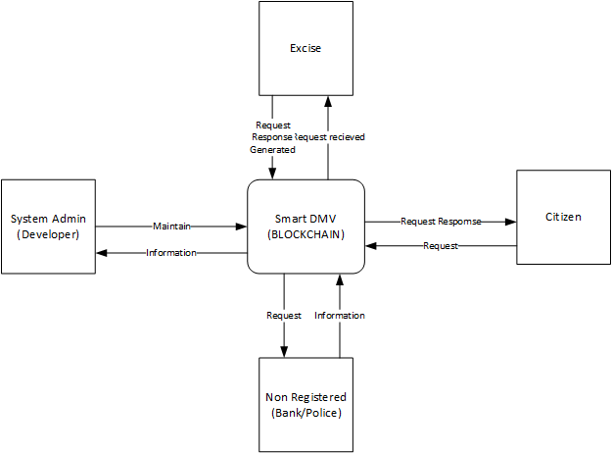

## User Classes and Characteristics

* Primary
  + Vehicle Owners who wants to register, transfer, submit token tax or block (in case of stolen vehicle) their vehicle.
* Secondary
  + Excise officers who will be a limited network administrator.
* Tertiary
  + Administrators are those responsible for the maintenance of the system as a whole. These users are expected to have full comprehension of the system, including but not limited to its web-based interface, mobile interface, and database.

## Design and Implementation Constraints

Constraints and difficulties are always there in implementing something new to the existing system. Along with the advantageous facts, our system also have some boundaries for its development.

* Learning the amateur technology and implementing it.
* Regulatory Policies of the excise department due to which there is a lack of communication and results in less knowledge of current system.
* Many departments which are related to this does not provide interfaces to other applications like Banks.
* We have to use a set of specified technologies, tools and databases because of the limited technologies, tools and databases support the blockchain development for now like CouchDB, Hyperledger Fabric, Hyperledger Composer, etc.

## Assumptions and Dependencies

The scope of this project is vast and because of this vastness we have to take many assumptions due to the presence of many third parties involved in it.

* The allotment of registration number (Vehicle Identification Number) is assumed to be done manually on the current system and then entered in our system.
* The payment method through bank will not be added in it because of the lack of availability of the API of bank for payment verification, instead we will use a demo portal of bank for payment verification.
* Like the above-mentioned scenario of bank, there is also a similar case with the Police in case of theft (blocking vehicle).

# Technical Architecture

* Our system is a custom-built.
* Online and transaction processing.
* Major application components are register vehicle, transfer vehicle, block vehicle, change engine number and submit token tax.
* Current system collects and manage the data about person’s identity as well as the vehicles which he/she own.
* Our basic application architecture is client server but there is also a decentralized system(peer-to-peer) on the backend.
* Our Applications Development would be using MEAN stack while Hyperledger Fabric would be used for Blockchain creation which uses JavaScript.
* Our end-user interfaces are Web and Android based applications.
* Our basic network architecture is based on internet.
* System will be hosted on Enterprise Data Center.

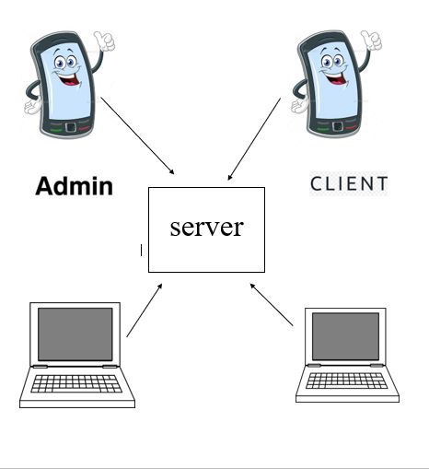

## Application and Data Architecture

* + 1. **Architecture Diagram**

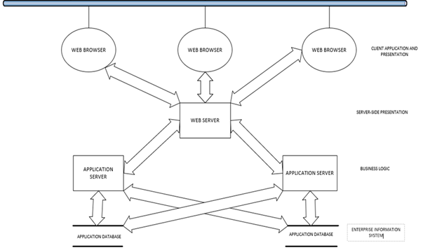

* + 1. **Component Diagram**

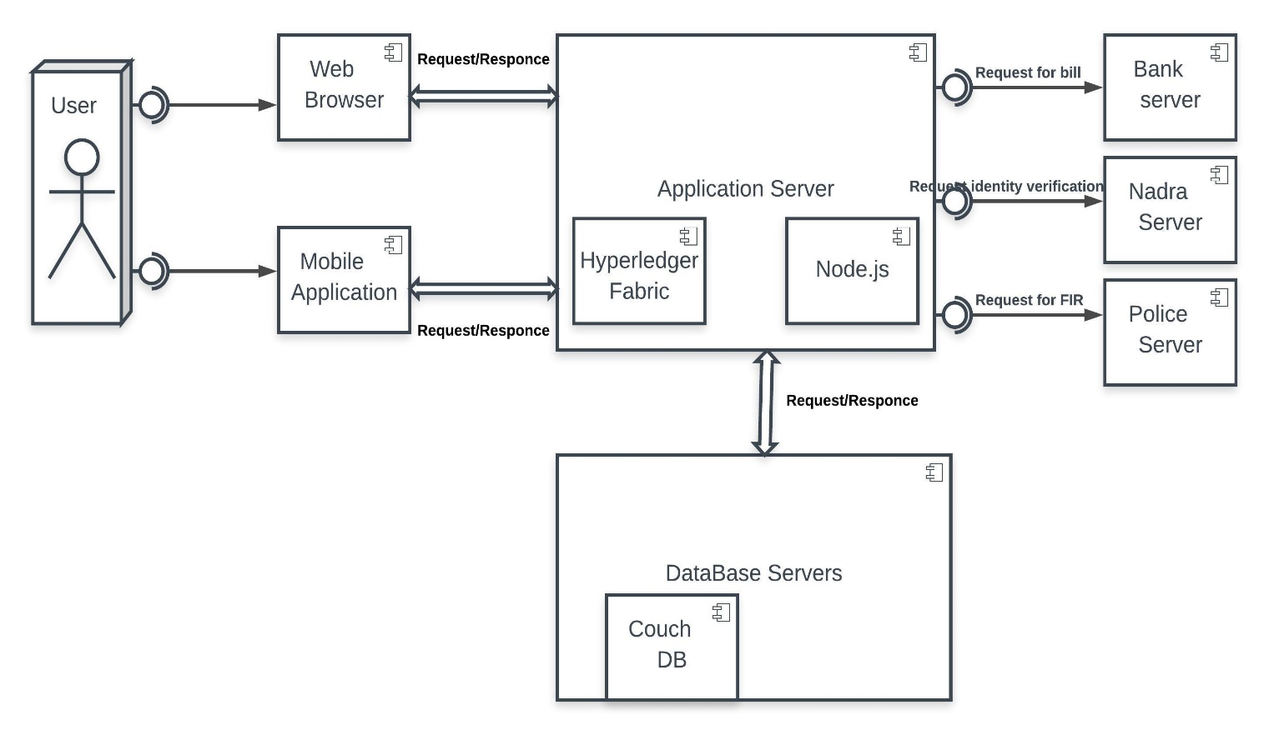

* + 1. **Entity Relation Diagram**

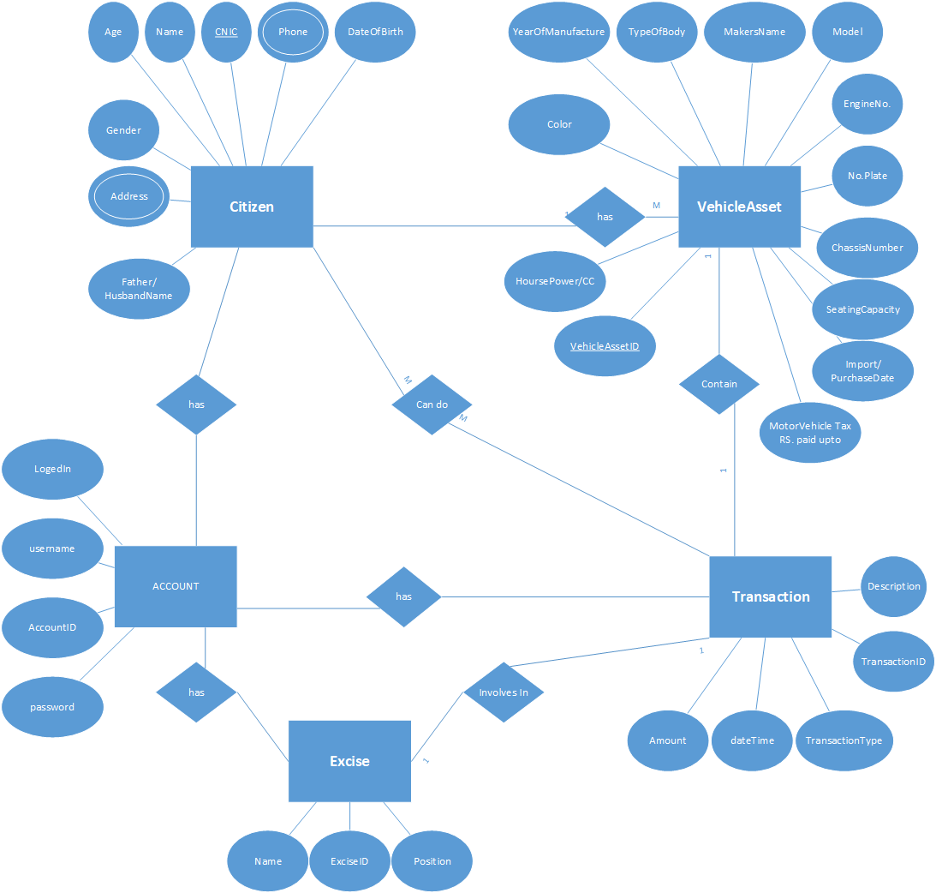

* + 1. **Class Diagram**

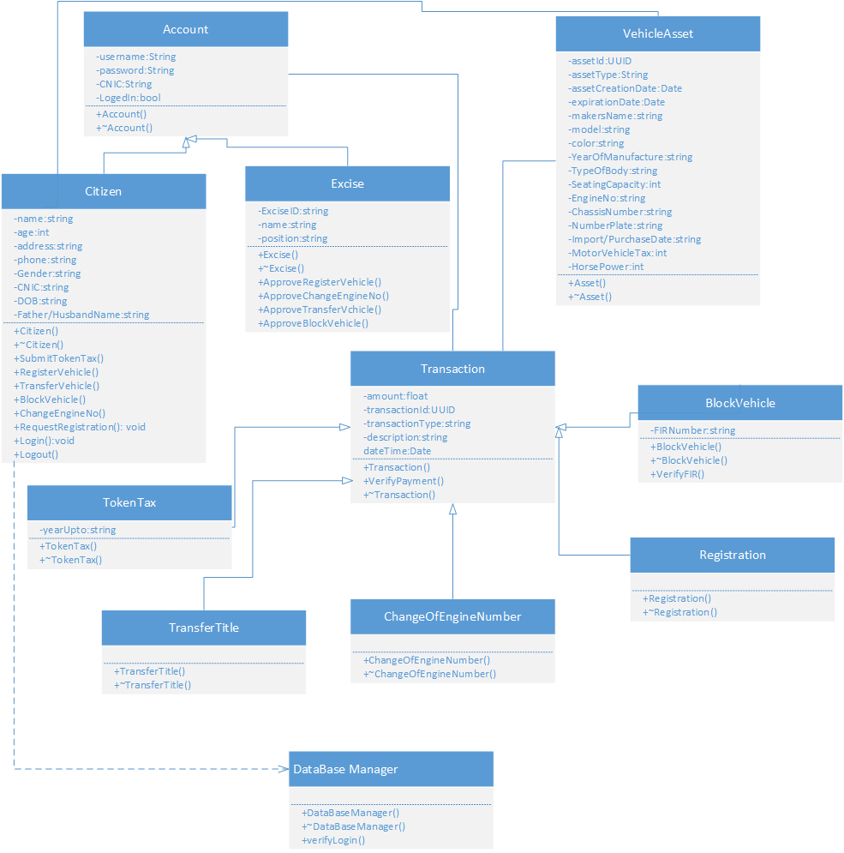

* + 1. **Activity Diagram**
       1. **User Activity Diagram**

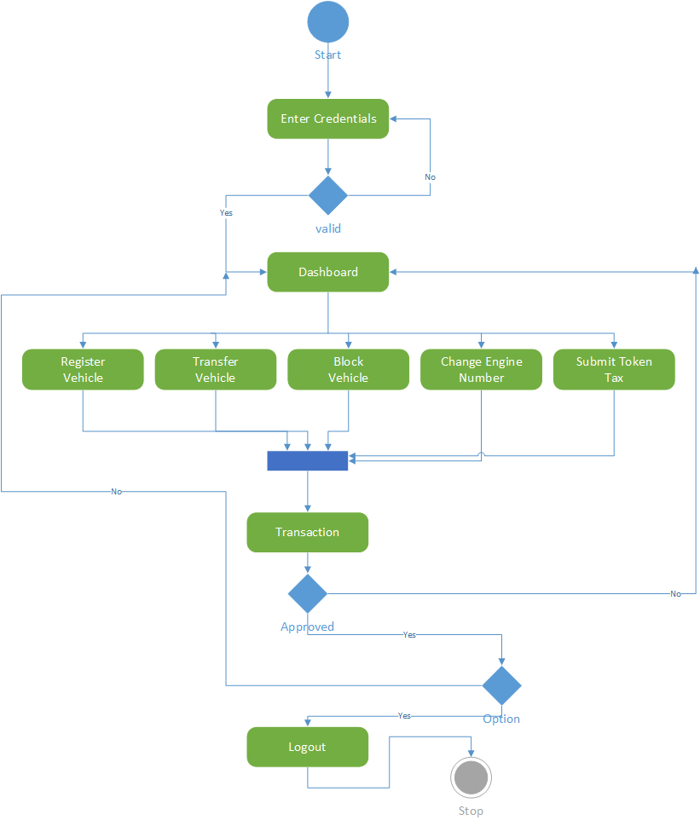

* + - 1. **Excise Activity Diagram**

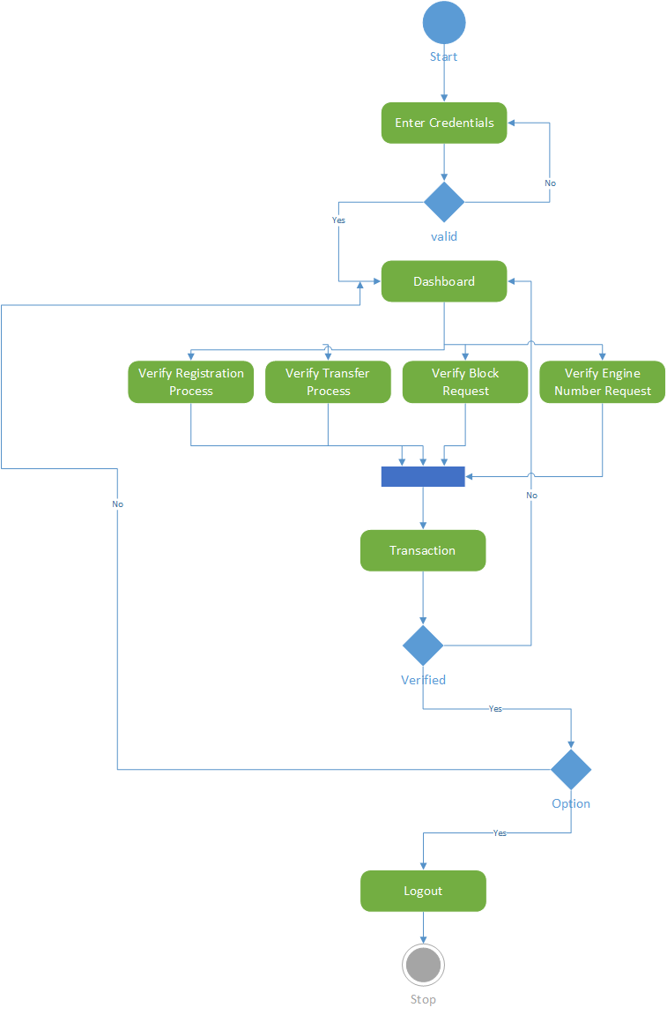

## Component Interactions and Collaborations

## Sequence Diagrams

## User Registration

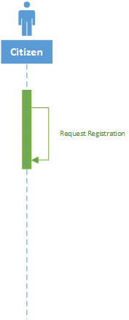

## User Login

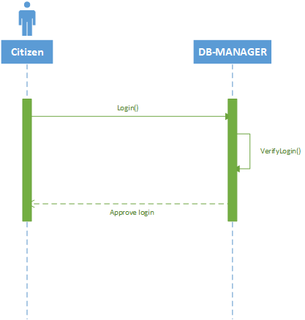

## User Logout

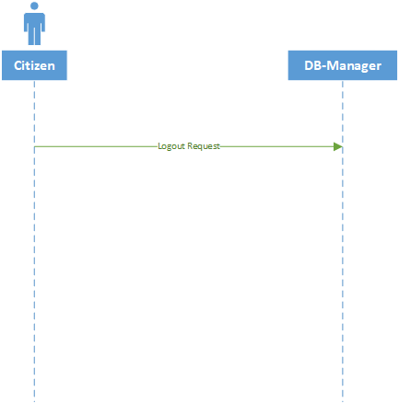

## Register Vehicle

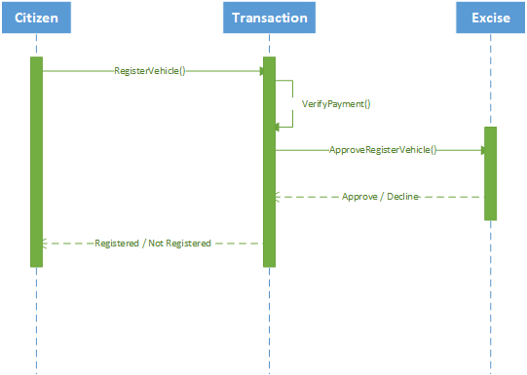

## Transfer Vehicle

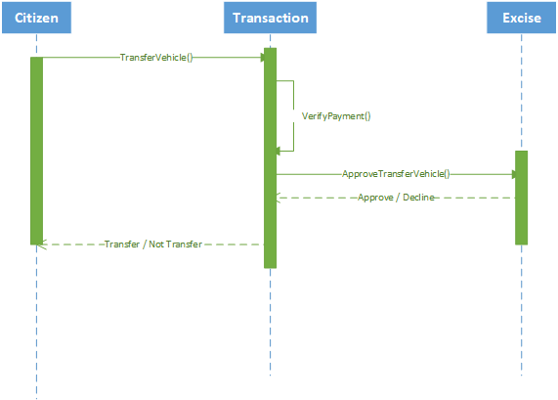

## Block Vehicle

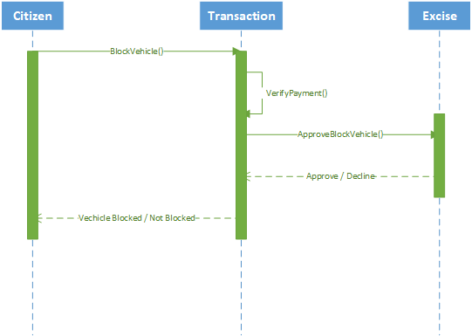

## Change Engine Number

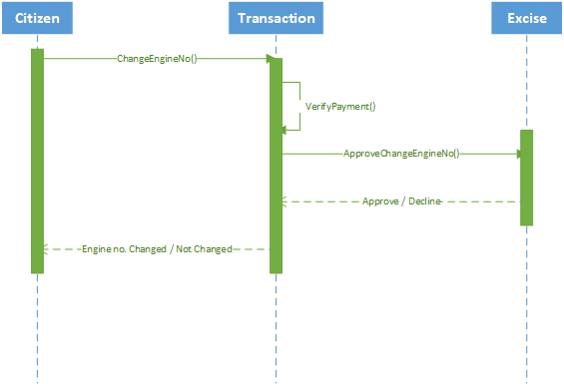

## Submit Token Tax

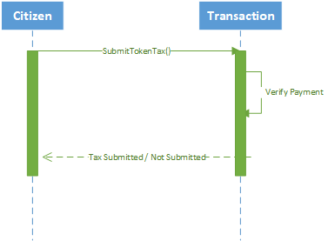

## Detailed Data Flow Diagram

## Level 0

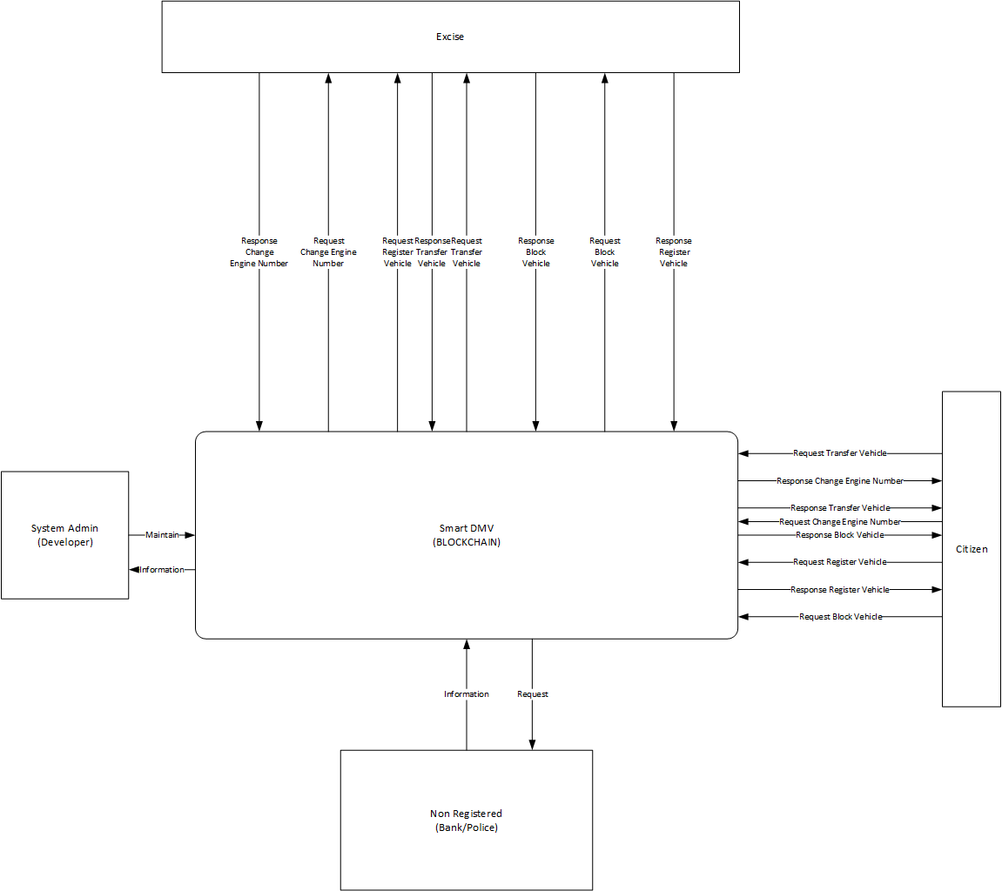

## Level 1

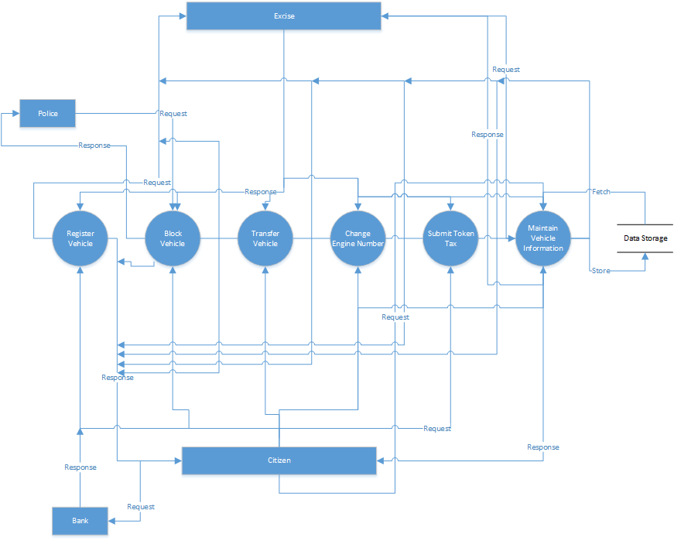

## Collaboration Diagram

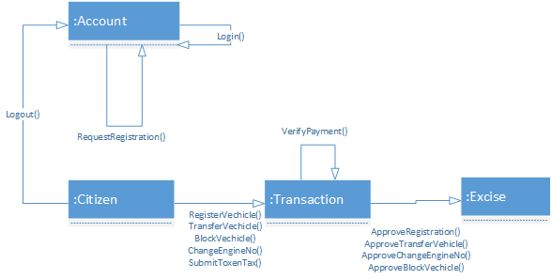

## Design Reuse and Design Patterns

Creational design patterns which includes Prototype will be used as well as Structural design patterns which include Façade will be used for reusability.

## Technology Architecture

* Smart DMV will be hosted on a Linux based server.
* Any device which can run browser can be used to access website of the smart dmv.
* Android Application would require minimum Lollipop version of Android Operating System.
* The most of the system will be developed using MEAN stack.
* The Hyperledger Fabric will be using CouchDB for database.
* TCP/IP as the IPS for Client-Server Communication.

# Screenshots/Prototype

## Workflow

* + 1. **Citizen’s** **Workflow (Swim Lane Diagram)**

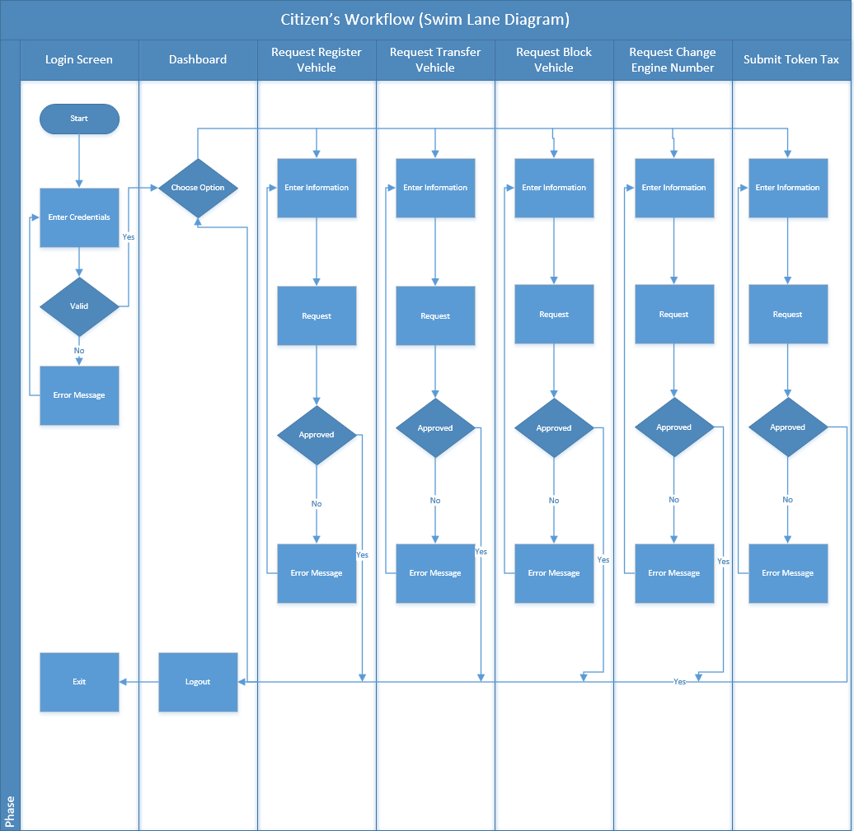

* + 1. **Excise Workflow (Swim Lane Diagram)**

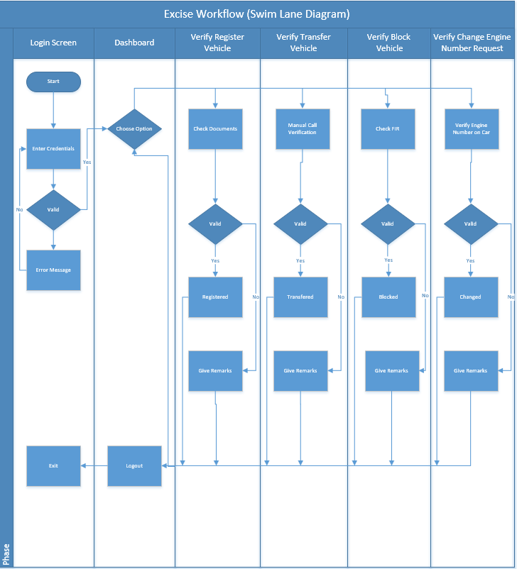

## Screens

* + 1. **Citizen’s Login Screen**

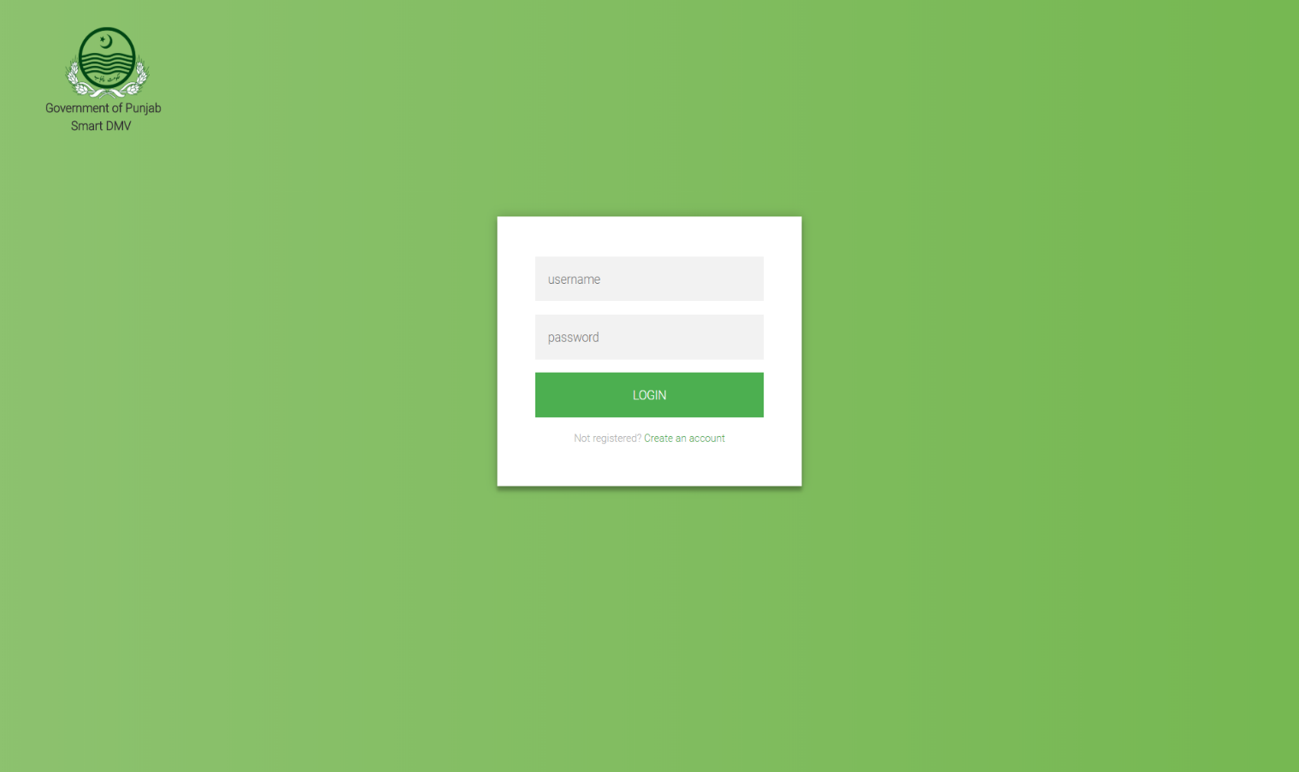

* + 1. **Citizen’s Dashboard Screen**

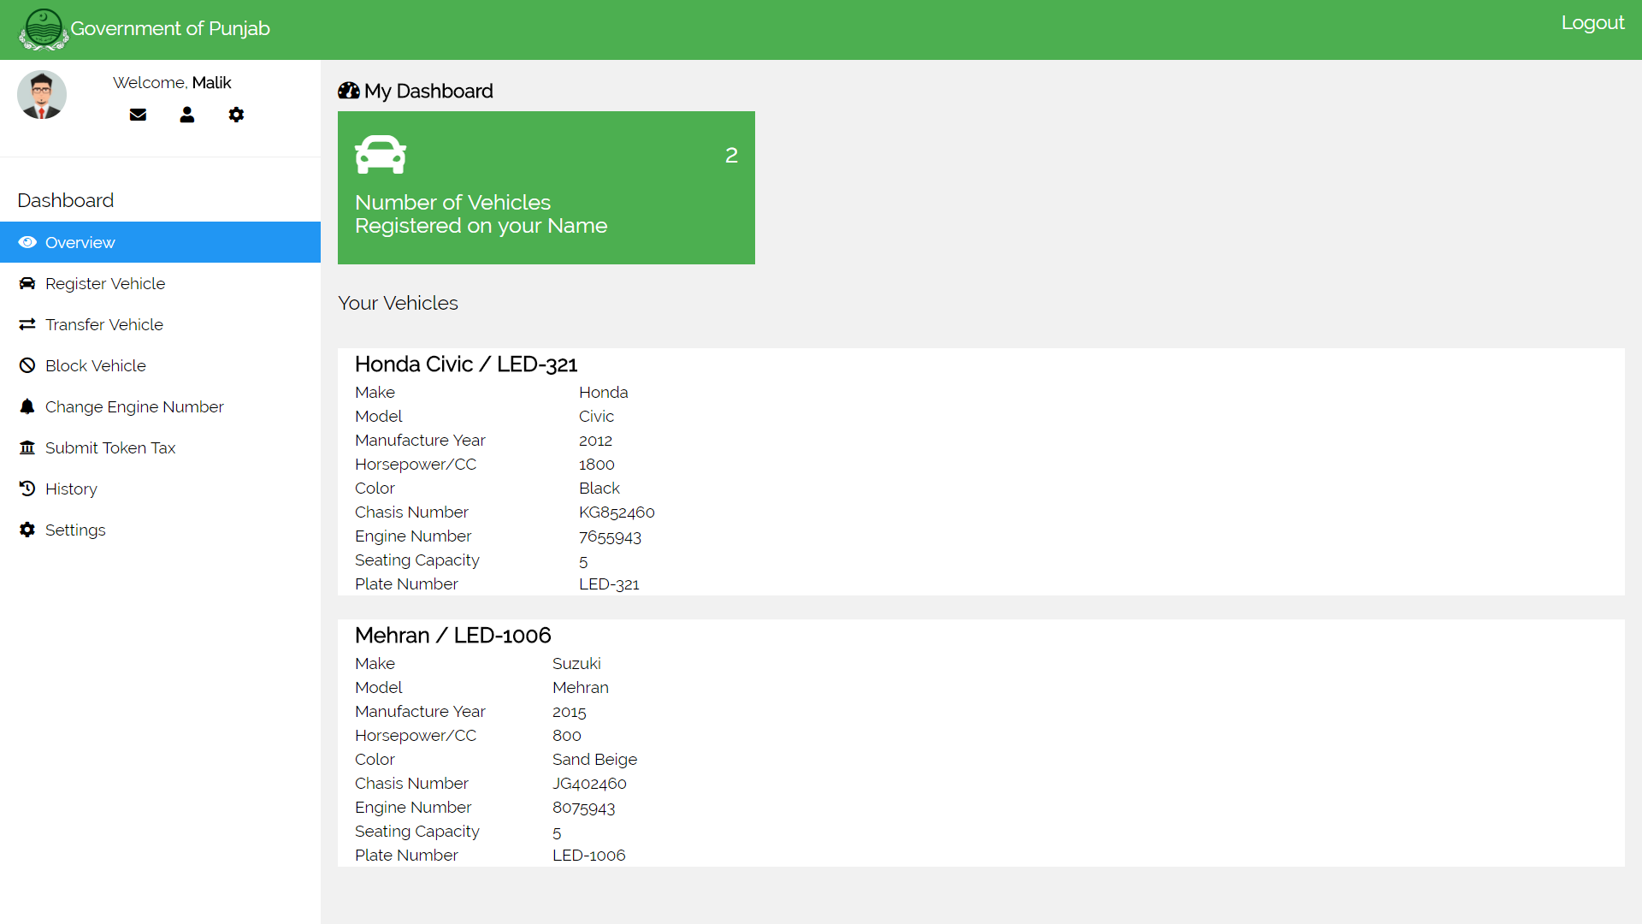

* + 1. **Citizen’s Register Vehicle Screen**

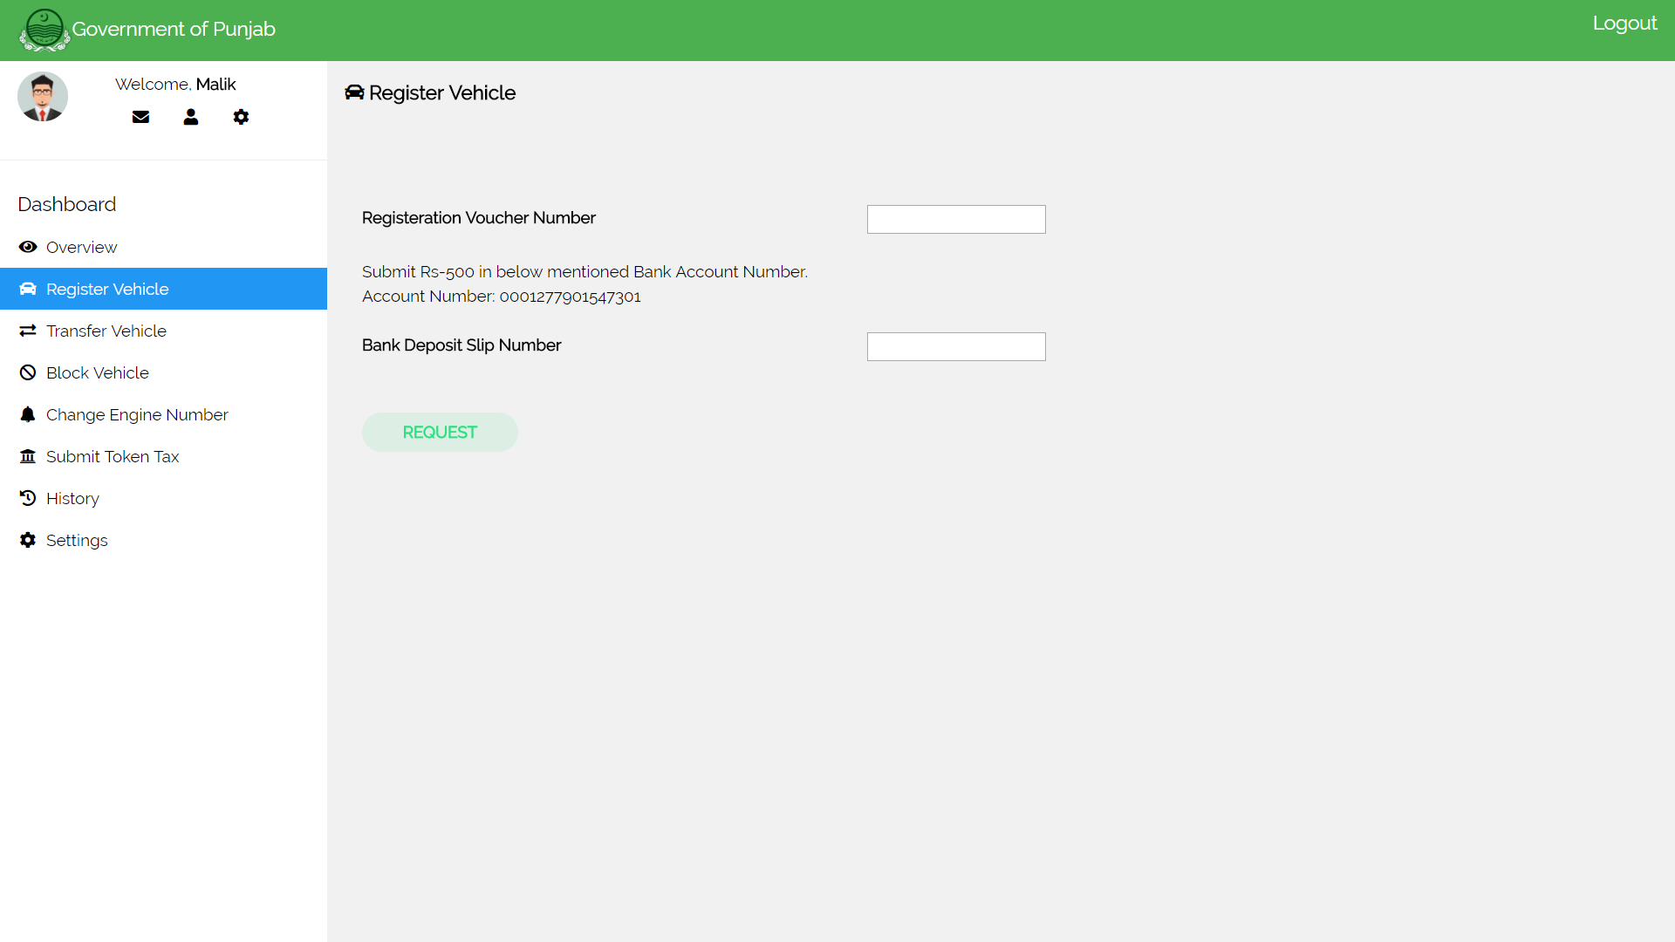

* + 1. **Citizen’s Transfer Vehicle Screen**

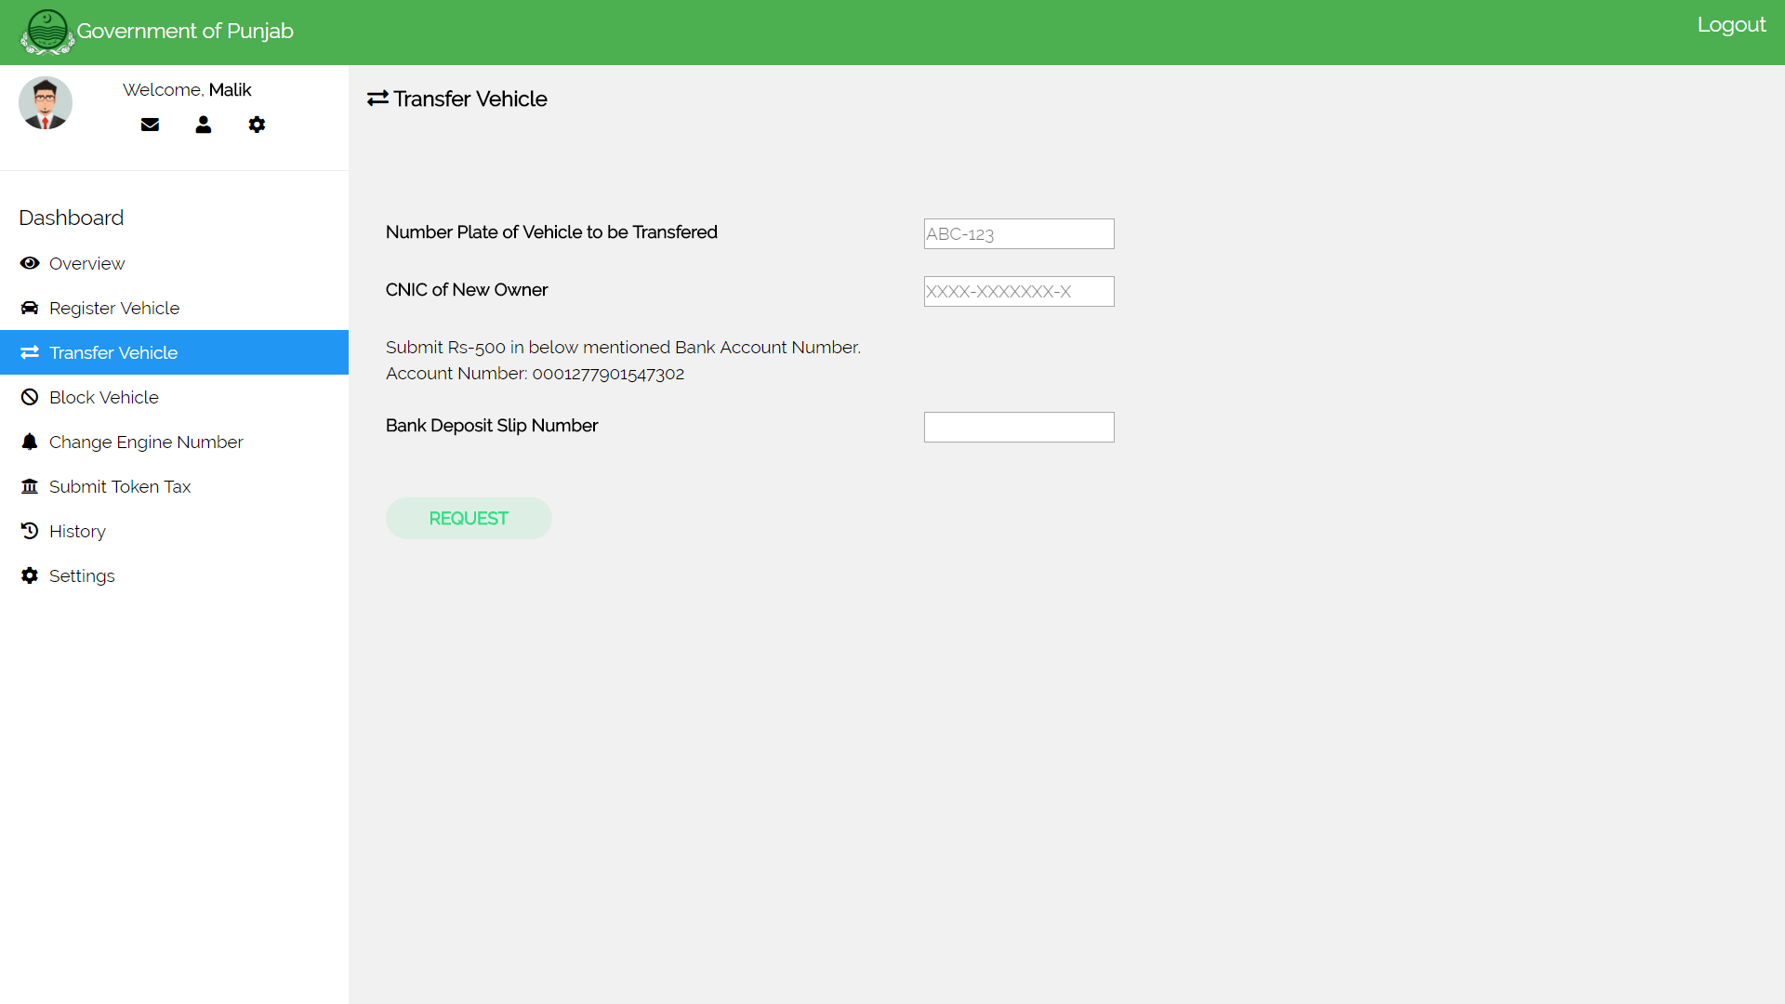

* + 1. **Citizen’s Block Vehicle Screen**

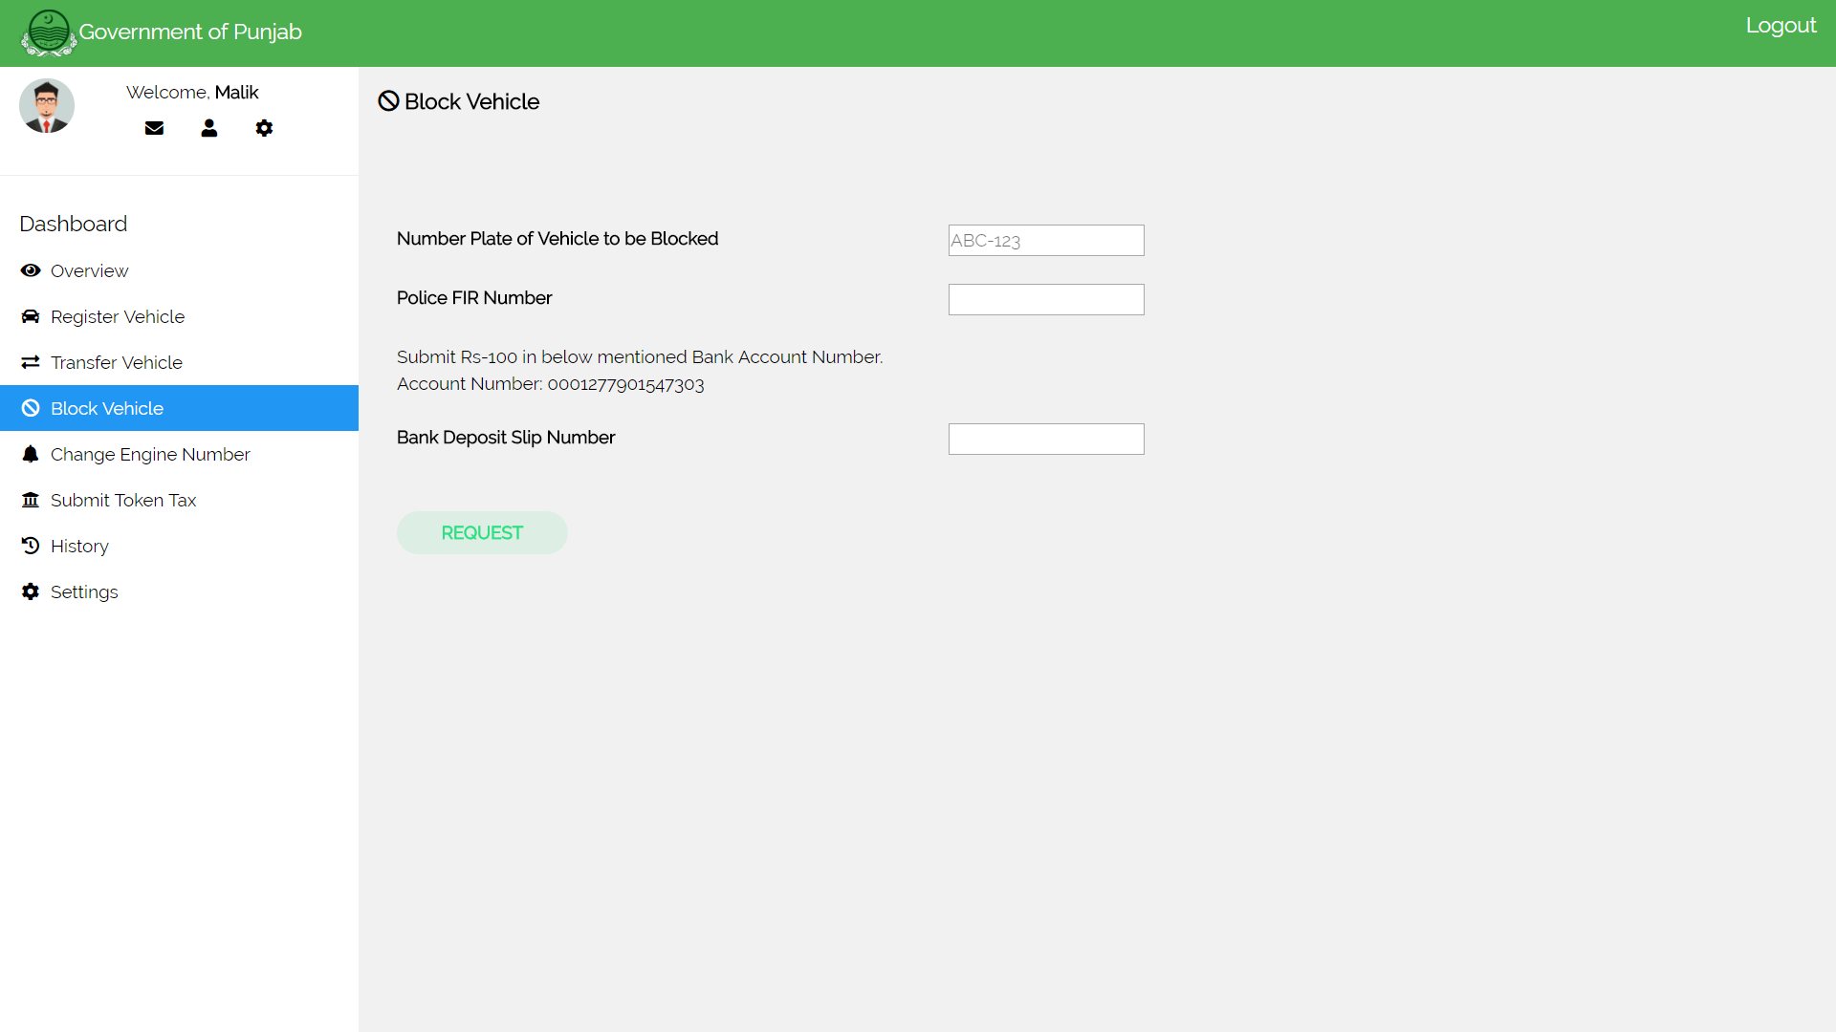

* + 1. **Citizen’s Change Engine Number Screen**

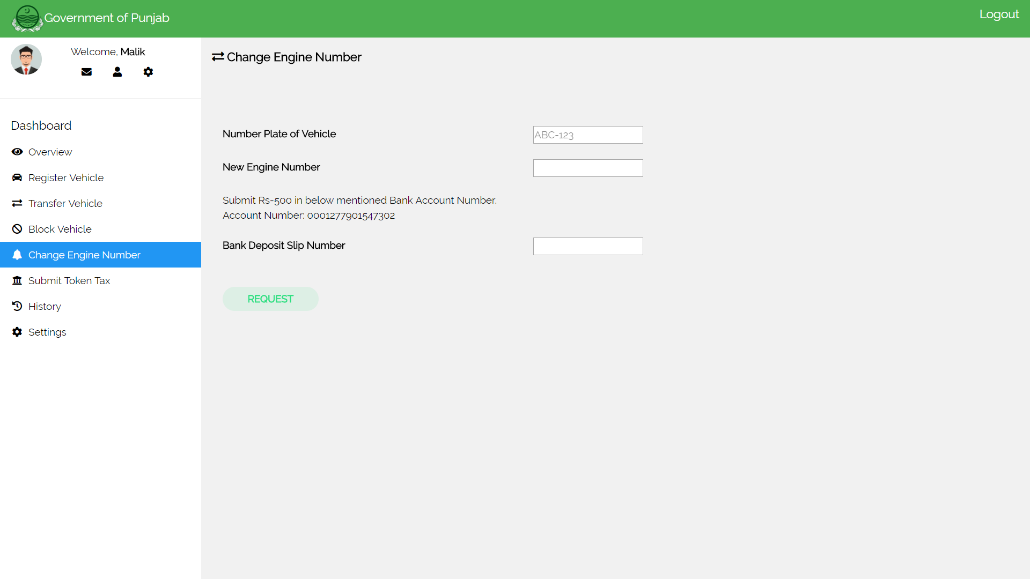

* + 1. **Citizen’s Submit Token Tax Screen**

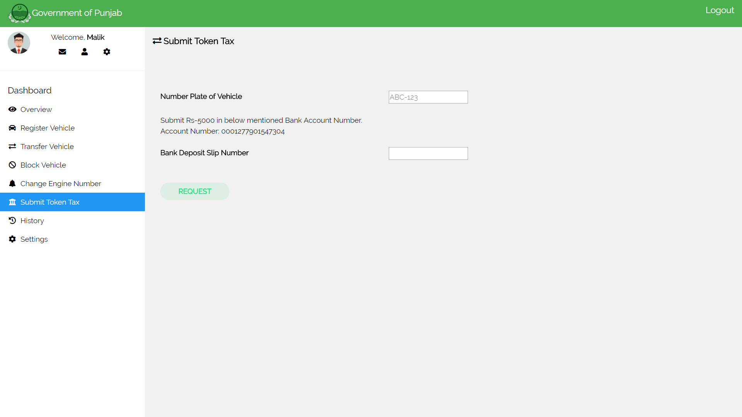

* + 1. **Excise Officer’s Login Screen**

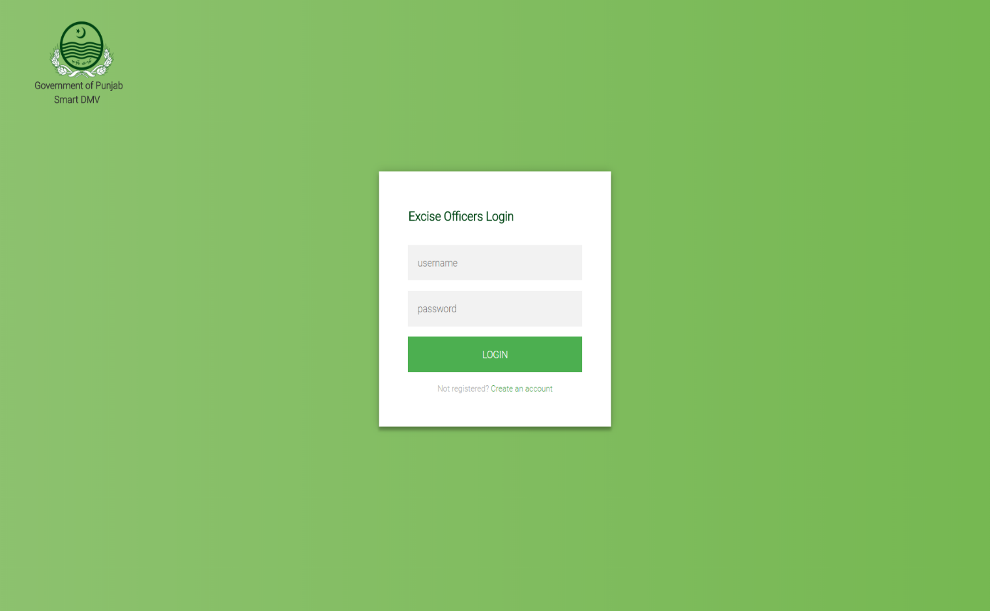

* + 1. **Excise Officer’s Dashboard Screen**

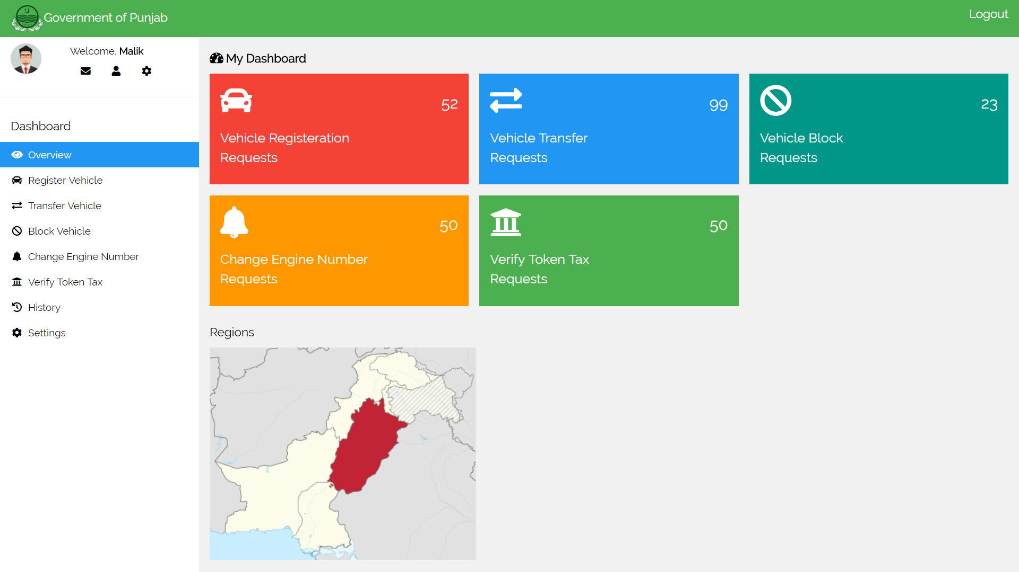

# Revised Project Plan

<Show your progress and provide current status of the project in accordance with the plan provided in project proposal. Gantt chart should be used in this regard. Use Microsoft Office to develop the Gantt chart. Also provide an updated project plan.>

# References

<http://smartdubai.ae/en/Pages/default.aspx>

<https://excise.punjab.gov.pk/vehicle_registration>

<http://excise.punjab.gov.pk/motorvehicle_tax>

<https://www.hyperledger.org/projects/fabric>

<https://composer-playground.mybluemix.net/>

Appendix A: Glossary

### Block chain:

A **block chain**, originally **block chain**, is a continuously growing list of records, called blocks, which are linked and secured using cryptography.[Each block typically contains a cryptographic hash of the previous block, a timestamp and transaction data. By design, a block chain is inherently resistant to modification of the data. It is "an open, distributed ledger that can record transactions between two parties efficiently and in a verifiable and permanent way".

### Cryptography:

**Cryptography** or **cryptology** is the practice and study of techniques for secure communication in the presence of third parties called adversaries. More generally, cryptography is about constructing and analyzing protocols that prevent third parties or the public from reading private messages various aspects in information security such as data confidentiality, data integrity, authentication, and non-repudiationare central to modern cryptography. Modern cryptography exists at the intersection of the disciplines of mathematics, computer science, electrical engineering, communication science, and physics.

**Smart Contract:**

A **smart contract** is a computer protocol intended to digitally facilitate, verify, or enforce the negotiation or performance of a contract. Smart contracts allow the performance of credible transactions without third parties. These transactions are track able and irreversible. Proponents of smart contracts claim that many kinds of contractual clauses may be made partially or fully self-executing, self-enforcing, or both. The aim of smart contracts is to provide security that is superior to traditional contract law and to reduce other transaction costs associated with contracting.

Appendix B: IV & V Report

(Independent verification & validation)

**IV & V Resource**

Name Signature

|  |  |  |  |  |  |
| --- | --- | --- | --- | --- | --- |
| **S#** | **Defect Description** | **Origin Stage** | **Status** | **Fix Time** | |
| **Hours** | **Minutes** |
| 1 |  |  |  |  |  |
| 2 |  |  |  |  |  |
| 3 |  |  |  |  |  |
| … |  |  |  |  |  |

**Table 1: List of non-trivial defects**

This document has been adapted from the following:

1. Previous project templates at UCP
2. High-level Technical Design, Centers for Medicare & Medicaid Services. (www.cms.gov)