BSCS FINAL PROJECT

Smart DMV (Department of Motor Vehicle)



Advisor: **Sir Zaid Munir**

Presented by:

**Group ID: S18BS028**

Student Reg# Student Name

|  |  |
| --- | --- |
| **L1S15BSCS0046** | **MALIK ALI HAIDER AWAN** |
| **L1S15BSCS0047** | **HAFIZ SHAHROZ NAJAM** |
| **L1S15BSCS0060** | **FOZAN AHMAD** |
| **L1F14BSCS0415** | **ZOHAIB KHALID** |

**Faculty of Information Technology**

**University of Central Punjab**

Smart DMV (Department of Motor Vehicle)

By

|  |  |
| --- | --- |
| L1S15BSCS0046 | MALIK ALI HAIDER AWAN |
| L1S15BSCS0047 | HAFIZ SHAHROZ NAJAM |
| L1S15BSCS0060 | FOZAN AHMAD |
| L1F14BSCS0415 | ZOHAIB KHALID |

Project submitted to

Faculty of Information Technology,

University of Central Punjab,

Lahore, Pakistan.

in partial fulfillment of the requirements for the degree of

**BACHELOR OF SCIENCE**

**IN**

**COMPUTER SCIENCE**

|  |  |  |
| --- | --- | --- |
|  |  |  |
| Project Advisor |  | Manager Projects |

Abstract

SmartDMV (Department of Motor Vehicle) is an online portal developed for the citizen of Punjab, which will help the citizens to enjoy the services of Department of Motor Vehicle from anywhere as well as help the government and owners of motor vehicles in the sense of saving the time and the cost reduced. Now-a-days, the process of motor vehicle registration is semi-digital but its network is centralized and is vulnerable to data tempering, current digitalization is not at its best due to the problem of identity management. If this process will be implemented on blockchain then it will help in reducing the fraud rate as well as reduce time required to do a lot of work. Other than this, it has some environmental benefits due to the reduction of amount of paper which is being used in current system. It will improvise the current system and a step forward to make system’s efficiency in more digitalize way by making decentralized system using blockchain technology. These points lead to the development of this project. This project will use Block-chain technology to develop smart contracts which will automate the process of motor vehicle registration to reduce fraud around stolen vehicle as well as to transfer vehicle title or to issue vehicle registration. We did a one to one conversation with the excise officers for requirement gathering, and so we use agile methodology to develop the product.

Dedication

I dedicate this project to ALLAH Almighty our creator, our strong pillar, our source of inspiration, wisdom, knowledge and understanding. He has been the source of our strength throughout this project and on His wings only have I soared. I also dedicate this work to my Parents and Teachers. This project is also specially dedicated to our advisor Sir Zaid Munir, for his kindness and devotion, and for his endless support for the whole time.

Acknowledgements

We would like to express our special thanks of gratitude to our teacher Zaid Munir as well as our parents who gave us the golden opportunity to do this wonderful project on the topic SmartDMV (Department of Motor Vehicle), I am really thankful to them.Secondly, we would also like to thank our friends who helped us a lot in finalizing this project within the limited time frame.

Table of Contents

Abstract i

Dedication i

Acknowledgements ii

Table of Contents iii

Revision History vi

Chapter 1. Introduction 1

1.1 Product (Problem Statement) 1

1.2 Background 1

1.3 Objective(s)/Aim(s)/Target(s) 1

1.4 Scope 1

1.5 Business Goals 2

1.6 Challenges 2

1.7 Learning Outcomes 2

1.8 Nature of End Product 2

1.9 Related Work/ Literature Survey/ Literature Review 2

1.10 Document Conventions 3

1.11 Miscellaneous 3

Chapter 2. Overall Description 4

2.1 Product Features 4

2.2 Functional Description 5

2.2.1 Context Diagram 5

2.3 User Classes and Characteristics 6

2.4 Design and Implementation Constraints 6

2.5 Assumptions and Dependencies 6

Chapter 3. System Requirements 7

3.1 Functional Requirements 7

3.1.1 Use Case Diagram 7

3.1.2 Request Registration 8

3.1.3 Verify Citizen 8

3.1.4 Login 9

3.1.5 Logout 9

3.1.6 Request Register Vehicle 10

3.1.7 Request Transfer Vehicle 11

3.1.8 Request Block Vehicle 11

3.1.9 Request Change of Engine number 12

3.1.10 Verify Payments 13

3.1.11 Token Tax 13

3.2 Functional Requirement 14

3.2.1 Use Case Diagram 14

3.2.2 Entity Relation Diagram 15

3.2.3 Class Diagram 16

3.2.4 Sequence Diagram 17

3.3 Nonfunctional Requirement 18

3.3.1 Performance Requirements 18

3.3.2 Security Requirements 18

3.3.3 Other Requirements 18

Chapter 4. Technical Architecture 19

4.1 Application and Data Architecture 21

4.1.1 Architecture Diagram 21

4.1.2 Component Diagram 21

4.1.3 Entity Relation Diagram 22

4.1.4 Class Diagram 23

4.1.5 Activity Diagram 24

4.1.5.1 User Activity Diagram 24

4.1.5.2 Excise Activity Diagram 25

4.1.6 Decision Table 27

4.2 Design Reuse and Design Patterns 27

4.3 Component Interactions and Collaborations 28

4.3.1 Sequence Diagram 28

4.3.2 Detailed Data Flow Diagram 29

4.3.2.1 Level 0 29

4.3.2.2 Level 1 30

4.3.3 Collaboration Diagram 31

4.4 Technology Architecture 31

4.5 Architecture Evaluation 32

Chapter 5. Detailed Design and Implementation 33

5.1 Component-Component Interface 33

5.1.1 Deployment Diagram 33

5.1.2 Sequence Diagrams 34

5.2 Component-External Entities Interface 38

5.2.1 Police API Call 38

5.2.2 Bank API Call 38

5.3 Component-Human Interface 39

5.4 Screenshots/Prototype 40

5.4.1 Workflow 40

5.4.1.1 Citizen’s Workflow (Swim Lane Diagram) 40

5.4.1.2 Excise Workflow (Swim Lane Diagram) 41

5.4.2 Screens 42

5.4.2.1 Citizen’s Login Screen 42

5.4.2.2 Citizen’s Dashboard Screen 42

5.4.2.3 Excise Officer’s Login Screen 45

5.4.2.4 Excise Officer’s Dashboard Screens 46

5.4.2.5 Citizen's Android Application Screens 47

Chapter 6. Test Specification and Results 49

6.1 Test Case Specification 49

6.2 Summary of Test Results 57

Chapter 7. Project Completion Status 58

References 59

Appendix A Glossary 60

• Block chain: 60

• Cryptography: 60

Appendix B IV & V Report 61

(Independent verification & validation) 61

Appendix C - Deployment/Installation Guide 62

Appendix D - User Manual 63

Revision History

|  |  |  |  |
| --- | --- | --- | --- |
| **Name** | **Date** | **Reason For Changes** | **Version** |
|  |  |  |  |
|  |  |  |  |

# Introduction

# Product (Problem Statement)

The problem that leads us to developing this system are the loop holes in the current system which provides benefit to malicious actors by exploiting them. Like a car can be transferred to someone else even if the car is stolen as well as owner of the car will remain blinded from the situation or a stolen car may be used in a crime which is not blocked from the department. This project will use Block-chain technology to develop smart contracts which will automate the process of motor vehicle registration to reduce fraud around stolen vehicle, to transfer vehicle title or to issue vehicle registration, block the vehicle if it is stolen, request to change of the Engine no. and to submit the token tax of your vehicle to avoid any inconvenience from the police.

# Background

There are many ongoing projects on Blockchain as the Dubai Government is shifting all its government transactions on Blockchain and this technology is spreading vastly after the success of Bitcoin but our project is not related to the cryptocurrency as it is related to the transactions of the department of Motor Vehicle. There are few projects by our fellows on Blockchain working parallel with our project like Secure Land Ownership and others but there is no such work done previously in the history of Project Office

# Objective(s)/Aim(s)/Target(s)

* Develop a user-friendly Web based and Android based Application.
* A user can Register, Transfer, Change Engine no. and Block the Vehicle.
* A user can also submit the Token Tax of its Vehicle in order to avoid any inconvenience from the Taxation department.
* Reduction in fraud.
* Reduce processing time related to Vehicle Registration/Transfer.
* Reduce the cost by reducing man power

# Scope

The scope of this project is to develop a Smart Department of Motor Vehicle (DMV) that will reduce the fraud rate, data tempering, remove few extra steps involved in current system and decreasing the time required in many processing. The system developed would be a Web and Android based application.

# Business Goals

This system can be sold to governments around the world to digitalize their network of department of motor vehicle and achieve their goals of digitalization by replacing the existing system.

# Challenges

* Gathering the information about the current system.
* Finding loop holes in the current system.
* Learn the newly formed technologies like Hyperledger Fabric for the blockchain creation on which the project is based.
* Learn Hyperledger Composer for demo creations.
* Learn NodeJS/.Net for Web Application Development.
* Learn Android for Mobile Application Development.
* Learn Deployment on IBM Bluemix (Cloud Network).

# Learning Outcomes

* Learn to Develop a Project in collaborative environment.
* Learn to Develop as a team.
* Learn to do project in a professional manner by doing proper documentation.
* Learn new tools and technologies related to Blockchain, Web and Android Development.

# Nature of End Product

The end product would be a Web and Android Application developed on the basis of blockchain technology with user friendly interface, to help the government and the owner of vehicles to do things online in efficient way.

# Related Work/ Literature Survey/ Literature Review

The process of digitalizing the government institution is at its peak around the world where as the digitalization of these institution on the basis of blockchain technologies is in its preliminary phases around the world. Canadian government is exploring the potential of blockchain technology so it can implement it. Government of Dubai has launched an initiative named Smart Dubai to shift all the government transaction onto the blockchain network with a strategic goal “Dubai will be the world’s first blockchain powered government ‘Driving the Future Economy’”.

# Document Conventions

* The document is written in Times New Roman.
* Normal text size is 12.
* Heading size is 18.
* Sub-Heading size is 14.
* Normal Line spacing is 1.0.

# Miscellaneous

The process of digitalizing the government institution is at its peak around the world where as the digitalization of these institution on the basis of blockchain technologies is in its preliminary phases around the world. Canadian government is exploring the potential of blockchain technology so it can implement it. Government of Dubai has launched an initiative named Smart Dubai to shift all the government transaction onto the blockchain network with a strategic goal “Dubai will be the world’s first blockchain powered government ‘Driving the Future Economy’”

# Overall Description

# Product Features

* Vehicles Registration
* Submit Token Tax
* Transfer of Ownership
* Misplaced/Stolen Registration Certificate
* Change of Engine Number (Alteration)

# Functional Description

# Context Diagram

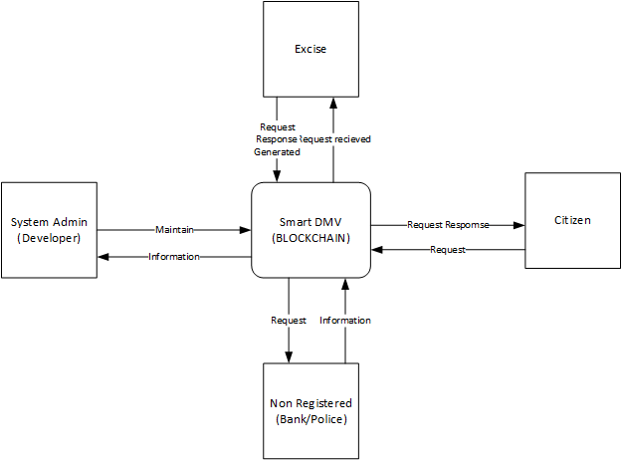

# User Classes and Characteristics

* Primary
  + Vehicle Owners who wants to register, transfer, submit token tax or block (in case of stolen vehicle) their vehicle.
* Secondary
  + Excise officers who will be a limited network administrator.
* Tertiary
  + Administrators are those responsible for the maintenance of the system as a whole. These users are expected to have full comprehension of the system, including but not limited to its web-based interface, mobile interface, and database.

# Design and Implementation Constraints

Constraints and difficulties are always there in implementing something new to the existing system. Along with the advantageous facts, our system also have some boundaries for its development.

* Learning the amateur technology and implementing it.
* Regulatory Policies of the excise department due to which there is a lack of communication and results in less knowledge of current system.
* Many departments which are related to this does not provide interfaces to other applications like Banks.
* We have to use a set of specified technologies, tools and databases because of the limited technologies, tools and databases support the blockchain development for now like CouchDB, Hyperledger Fabric, Hyperledger Composer, etc.

# Assumptions and Dependencies

The scope of this project is vast and because of this vastness we have to take many assumptions due to the presence of many third parties involved in it.

* The allotment of registration number (Vehicle Identification Number) is assumed to be done manually on the current system and then entered in our system.
* The payment method through bank will not be added in it because of the lack of availability of the API of bank for payment verification, instead we will use a demo portal of bank for payment verification.
* Like the above-mentioned scenario of bank, there is also a similar case with the Police in case of theft (blocking vehicle).

# System Requirements

# Functional Requirements

# Use Case Diagram

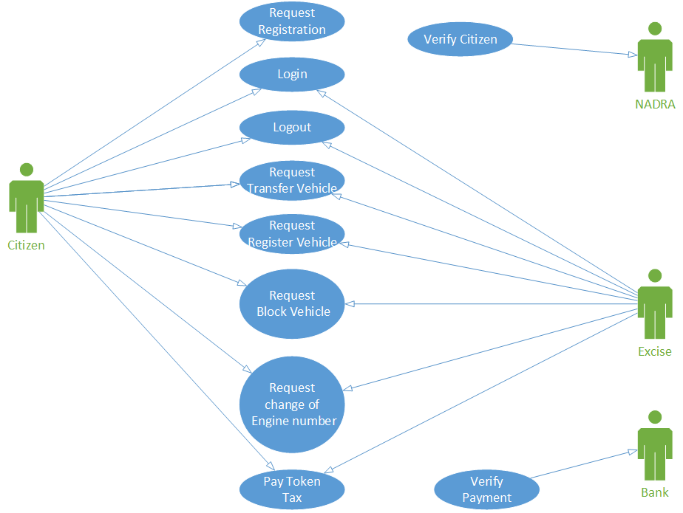

# Request Registration

|  |  |  |  |
| --- | --- | --- | --- |
| **Identifier** | | Citizen, NADRA | |
| **Purpose** | | To Register in the Smart DMV | |
| **Priority** | | High. | |
| **Pre-conditions** | | * Registration screen must be appeared on screen. | |
| **Post-conditions** | | * Registered in the Smart DMV | |
| **Typical Course of Action** | | | |
| **S#** | **Actor Action** | | **System Response** |
| **1** | Citizen accesses the WEB/APP | | System promotes the Citizen to get register in the System |
| **2** | Citizen will verify his/her self through NADRA using Thumb Print/message identification. | | NADRA will verify the Citizen and he/she will be registered in the system. |
| **Alternate Course of Action** | | | |
| **S#** | **Actor Action** | | **System Response** |
| **1** | Invalid information entered. | | Citizen will not be registered in the System and a prompt will be displayed. |

Table 1: UC-1

# Verify Citizen

|  |  |  |  |
| --- | --- | --- | --- |
| **Identifier** | | Citizen, NADRA | |
| **Purpose** | | To verify citizen | |
| **Priority** | | High. | |
| **Pre-conditions** | | * Request verification sent to NADRA | |
| **Post-conditions** | | * NADRA will verify the citizen | |
| **Typical Course of Action** | | | |
| **S#** | **Actor Action** | | **System Response** |
| **1** | Citizen accesses the WEB/APP | | System promotes NADARA to verify citizen |
| **2** | Citizen will verify his/her self through NADRA using Thumb Print/message identification. | | NADRA will verify the Citizen. |
| **Alternate Course of Action** | | | |
| **S#** | **Actor Action** | | **System Response** |
| **1** | Invalid information entered. | | NADRA rejected the citizen registration. |

Table 2: UC-2

# Login

|  |  |  |  |
| --- | --- | --- | --- |
| **Identifier** | | Citizen, Excise | |
| **Purpose** | | Login into smart DMV system. | |
| **Priority** | | High. | |
| **Pre-conditions** | | * Login screen must be appeared on screen. * Actors must be registered. | |
| **Post-conditions** | | * User is logged-in to the system. * User have accessed to functionalities of system. | |
| **Typical Course of Action** | | | |
| **S#** | **Actor Action** | | **System Response** |
| **1** | User enters the login information and click the login button | | System authenticates login information and give access to system. |
| **Alternate Course of Action** | | | |
| **S#** | **Actor Action** | | **System Response** |
| **1** | Invalid credentials entered | | Shows the error |
| **2** | User might not exist | | Error: User not exists |

Table 3: UC-3

# Logout

|  |  |  |  |
| --- | --- | --- | --- |
| **Identifier** | | Citizen, Excise | |
| **Purpose** | | To leave the system. | |
| **Priority** | | Medium | |
| **Pre-conditions** | | * User is logged-in. * User no longer wants to be logged-in. | |
| **Post-conditions** | | * User is logged-out. | |
| **Typical Course of Action** | | | |
| **S#** | **Actor Action** | | **System Response** |
| **1** | User clicks on the logout button. | | * System logged out the user from the system. * System redirects the user to the login page. |
| **Alternate Course of Action** | | | |
| **S#** | **Actor Action** | | **System Response** |
| **1** | Click on another feature button. | | Open the features of the clicked feature button. |

Table 4: UC-4

# Request Register Vehicle

|  |  |  |  |
| --- | --- | --- | --- |
| **Identifier** | | Citizen, Excise | |
| **Purpose** | | To Register Vehicle in Smart DMV system. | |
| **Priority** | | High | |
| **Pre-conditions** | | * Citizen must have account in Smart DMV system. * Excise officer must have account in Smart DMV system. | |
| **Post-conditions** | | * Vehicle Must Registered. | |
| **Typical Course of Action** | | | |
| **S#** | **Actor Action** | | **System Response** |
| **1** | Citizen clicks on the New registration feature button. | | System shows the new registration requirements. |
| **2** | Citizen enters the registration number given to him by excise office and clicks on the Submit button. | | System verifies its payment and alerts the excise officer about the request. |
| **3** | Excise officer verifies the documents and accept or decline the request. | | Citizen will be informed. |
| **Alternate Course of Action** | | | |
| **S#** | **Actor Action** | | **System Response** |
| **1** | Click on Info feature button. | | Can show the procedure how Smart DVM system works. |

Table 5: UC-5

# Request Transfer Vehicle

|  |  |  |  |
| --- | --- | --- | --- |
| **Identifier** | | Citizen, Excise | |
| **Purpose** | | Transfer the vehicle to another citizen. | |
| **Priority** | | High | |
| **Pre-conditions** | | * Citizen must have account in Smart DMV system. * Excise officer must have account in Smart DMV system. | |
| **Post-conditions** | | * Vehicle transferred onto Citizen’s name. | |
| **Typical Course of Action** | | | |
| **S#** | **Actor Action** | | **System Response** |
| **1** | Citizen clicks on the Transfer feature button. | | System shows list of requirements, what system wants. |
| **2** | Citizen enters the transfer details and clicks on the Submit button. | | System verifies its payment and alerts the excise officer about the request. |
| **3** | Excise officer accept or decline the request. | | Citizen will be informed. |
| **Alternate Course of Action** | | | |
| **S#** | **Actor Action** | | **System Response** |
| **1** | Click on Info feature button. | | Can show the procedure how Smart DVM system works. |

Table 6: UC-6

# Request Block Vehicle

|  |  |  |  |
| --- | --- | --- | --- |
| **Identifier** | | Citizen, Excise | |
| **Purpose** | | To Block Vehicle in Smart DMV system. | |
| **Priority** | | High | |
| **Pre-conditions** | | * Citizen must have account in Smart DMV system. * Excise officer must have account in Smart DMV system. | |
| **Post-conditions** | | * Vehicle Must Blocked. | |
| **Typical Course of Action** | | | |
| **S#** | **Actor Action** | | **System Response** |
| **1** | Clicks on the New block registration feature button. | | System Block vehicle requirements. |
| **2** | Clicks on the Upload button. | | Actor Uploads the Digital documents. |
| **3** | Clicks on the Go Smart button. | | Smart contract executed |
| **Alternate Course of Action** | | | |
| **S#** | **Actor Action** | | **System Response** |
| **1** | Click on Info feature button. | | Can show the procedure how Smart DVM system works. |

Table 7: UC-7

# Request Change of Engine number

|  |  |  |  |
| --- | --- | --- | --- |
| **Identifier** | | Citizen | |
| **Purpose** | | To Update the Engine number in smart DMV system. | |
| **Priority** | | Medium | |
| **Pre-conditions** | | * Citizen must have account in Smart DMV system. | |
| **Post-conditions** | | * Engine number must be changed | |
| **Typical Course of Action** | | | |
| **S#** | **Actor Action** | | **System Response** |
| **1** | Clicks on the Login Button. | | Citizen must be logged in the system |
| **2** | Clicks on Change Engine Number button. | | Engine number must be change after verification. |
| **3** | Clicks on Ok button. | | Updated the New info in System |
| **Alternate Course of Action** | | | |
| **S#** | **Actor Action** | | **System Response** |
| **1** | Click on Info feature button. | | Can show the procedure how Smart DVM system works. |

Table 8: UC-8

# Verify Payments

|  |  |  |  |
| --- | --- | --- | --- |
| **Identifier** | | Bank | |
| **Purpose** | | To verify the payments. | |
| **Priority** | | Medium. | |
| **Pre-conditions** | | Bank must be linked to excise. | |
| **Post-conditions** | | Payments must be verified | |
| **Typical Course of Action** | | | |
| **S#** | **Actor Action** | | **System Response** |
| **1** | Excise send request to bank. | | Bank must receive the notification from excise. |
| **3** | Bank verify the payments details. | | Excise complete transection after verification. |
| **Alternate Course of Action** | | | |
| **S#** | **Actor Action** | | **System Response** |
| **1** | Click on Info feature button. | | Can show the procedure how Smart DVM system works. |

Table 9: UC-9

# Token Tax

|  |  |  |  |
| --- | --- | --- | --- |
| **Identifier** | | Citizen, Excise | |
| **Purpose** | | To receive token tax of every car registered in our Smart DMV system. | |
| **Priority** | | Medium. | |
| **Pre-conditions** | | Car must be car registered in our Smart DMV system. | |
| **Post-conditions** | | Payment received | |
| **Typical Course of Action** | | | |
| **S#** | **Actor Action** | | **System Response** |
| **1** | Give Fee challan to vehicle owner. | | Generate fee challan according to car |
| **3** | Verify payment | | Bank will verify the payment |
| **Alternate Course of Action** | | | |
| **S#** | **Actor Action** | | **System Response** |
| **1** | Click on Info feature button. | | Can show the procedure how Smart DVM system works. |

Table 10: UC-10

# Functional Requirement

# Use Case Diagram



# Entity Relation Diagram

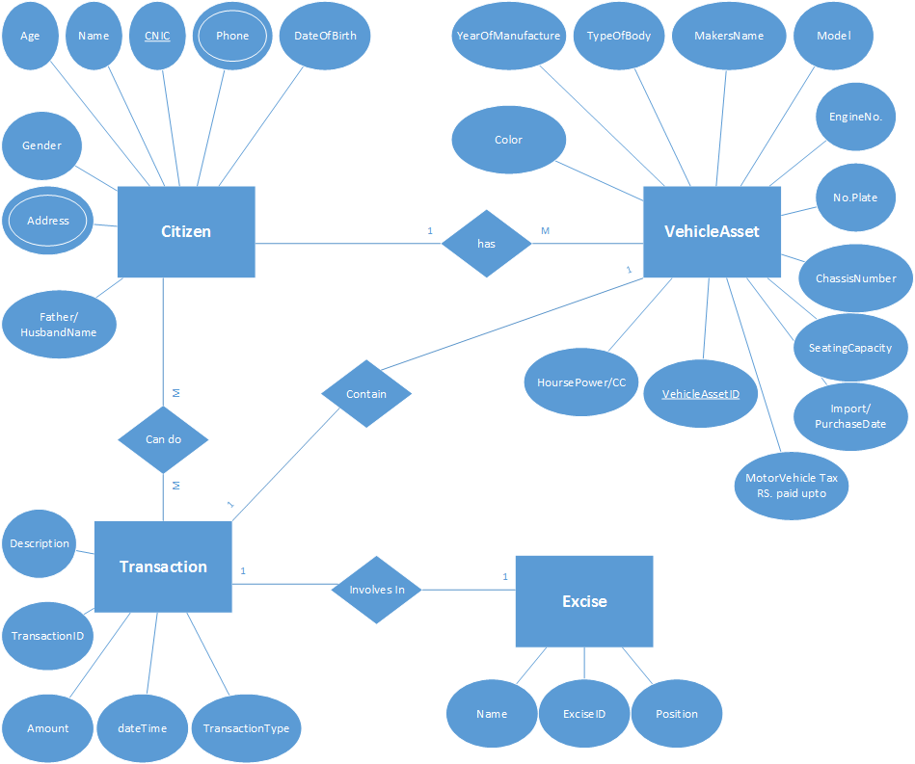

# Class Diagram

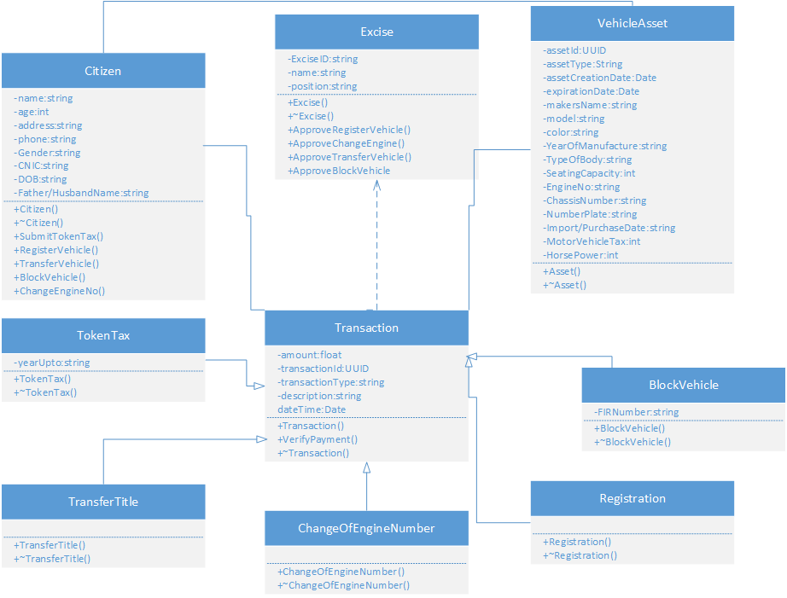

# Sequence Diagram

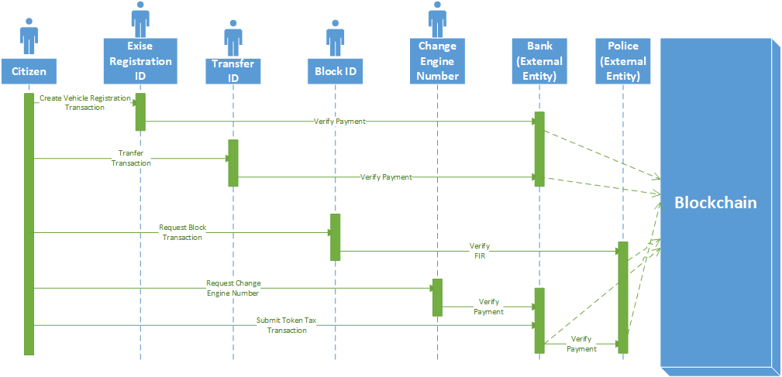

# Nonfunctional Requirement

# Performance Requirements

* The system will be scalable so that under high workload response time will not be saturated.
* It should be accessible through WEB and Android Application.

# Security Requirements

* For the authentication of the user we have use OAuth using OpenLDAP and supposed it as a NADRA system for user authentication.

# Other Requirements

* Android Smartphone with at least Android 5.1.
* Any bowser-based device, with good internet connection.

# Technical Architecture

* **Level 0**

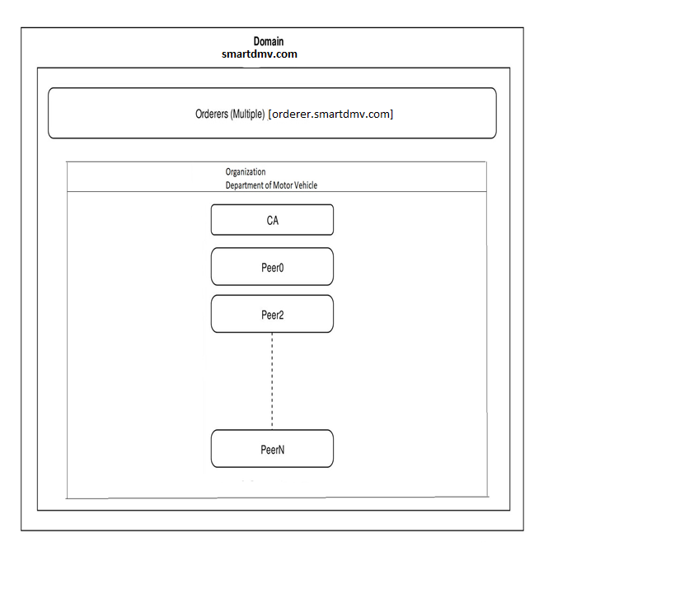

* **Level 1**

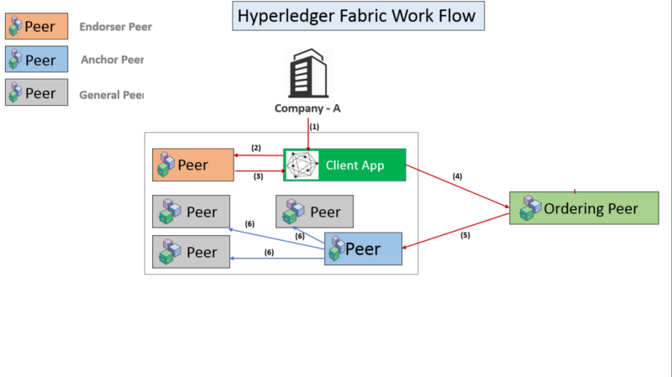

* **Level 2**

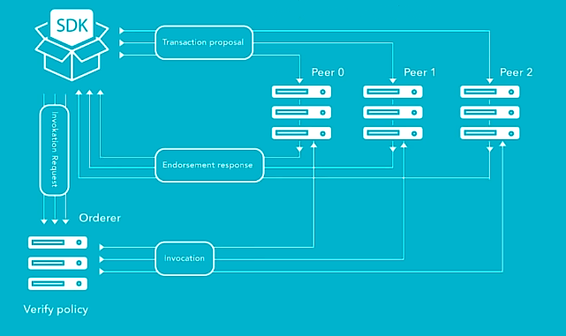

# Application and Data Architecture

# Architecture Diagram

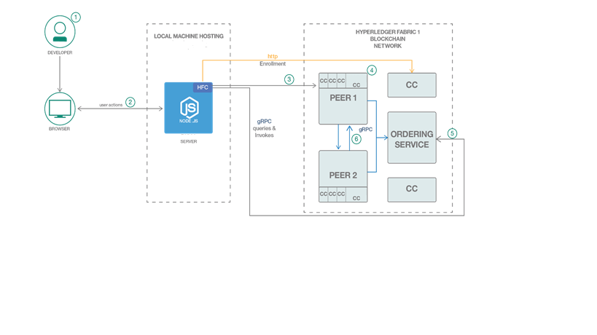

# Component Diagram

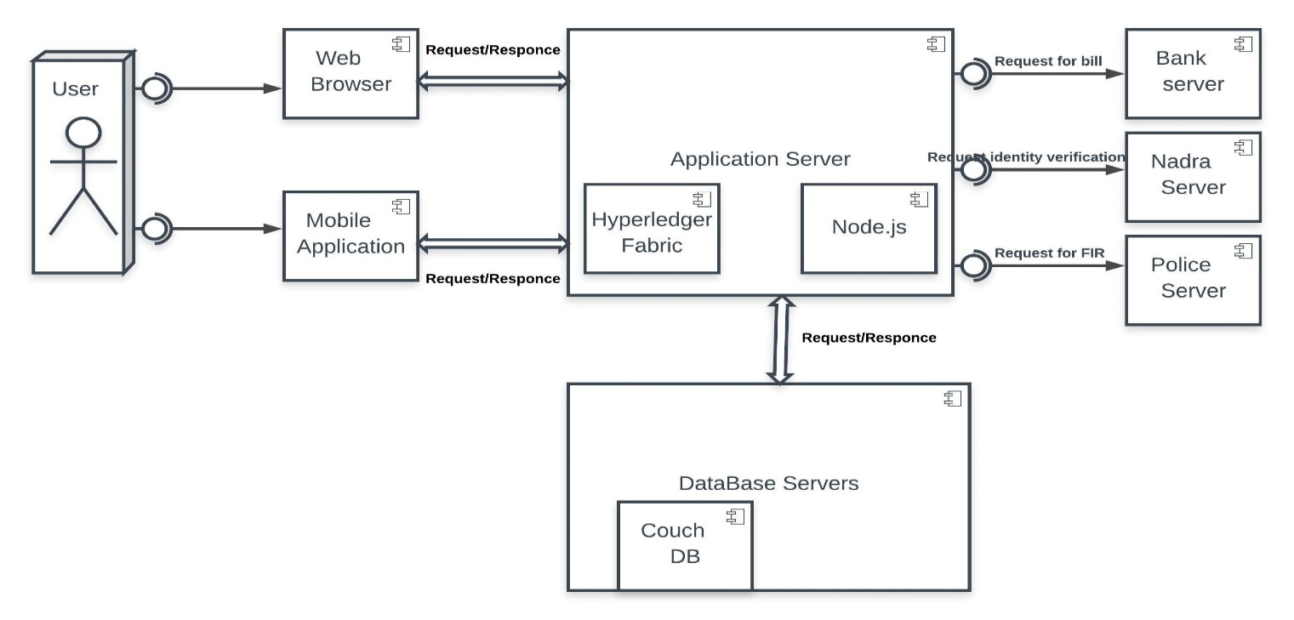

# Entity Relation Diagram

**

# Class Diagram

**

# Activity Diagram

# User Activity Diagram

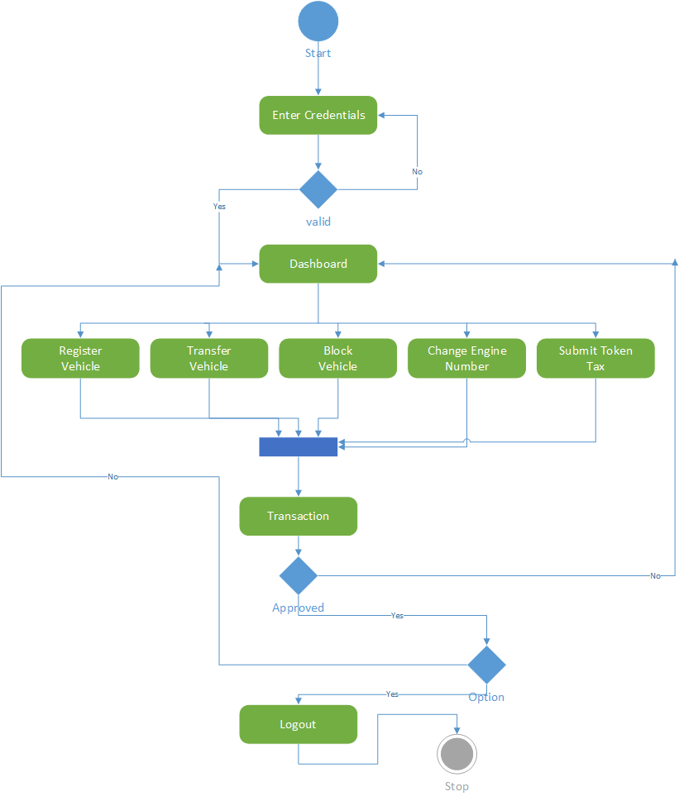

# Excise Activity Diagram

|  |  |
| --- | --- |
| ***Excise Registration ID*** | ***Excise Change Engine Number ID*** |
| *C:\Users\l1s15bscs0046\Downloads\Drawing1.png* | *C:\Users\l1s15bscs0046\Downloads\Engine.png* |

|  |  |
| --- | --- |
| ***Excise Block ID*** | ***Excise Transfer ID*** |
| *C:\Users\l1s15bscs0046\Downloads\Block.png* | *C:\Users\l1s15bscs0046\Downloads\Transfer.png* |

# Decision Table

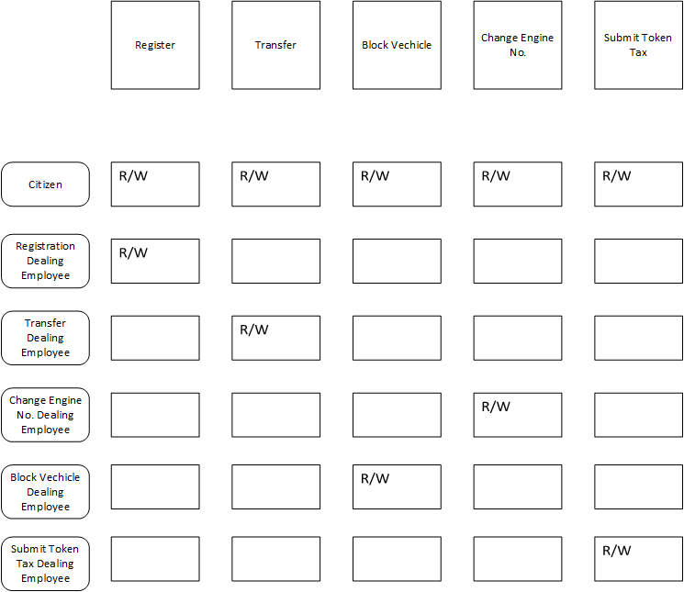

# Design Reuse and Design Patterns

Creational design patterns which includes Prototype will be used as well as Structural design patterns which include Façade will be used for reusability.

# Component Interactions and Collaborations

# Sequence Diagram



# Detailed Data Flow Diagram

# Level 0

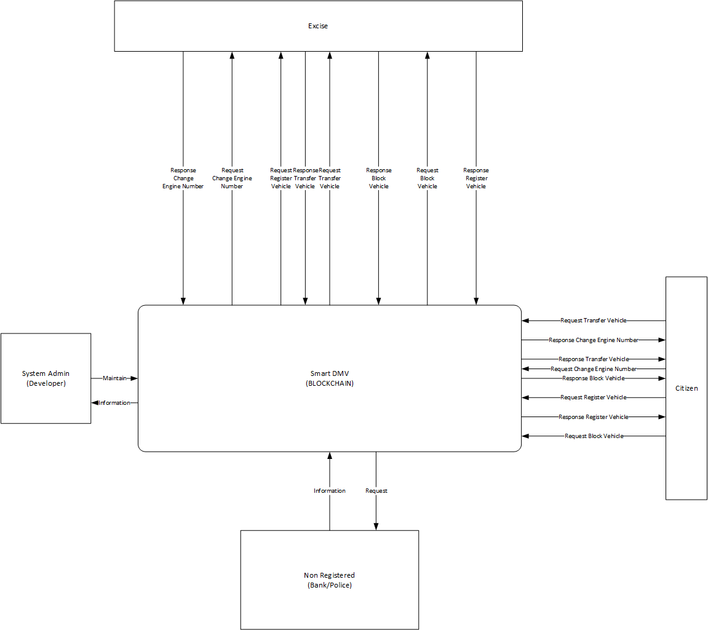

# Level 1

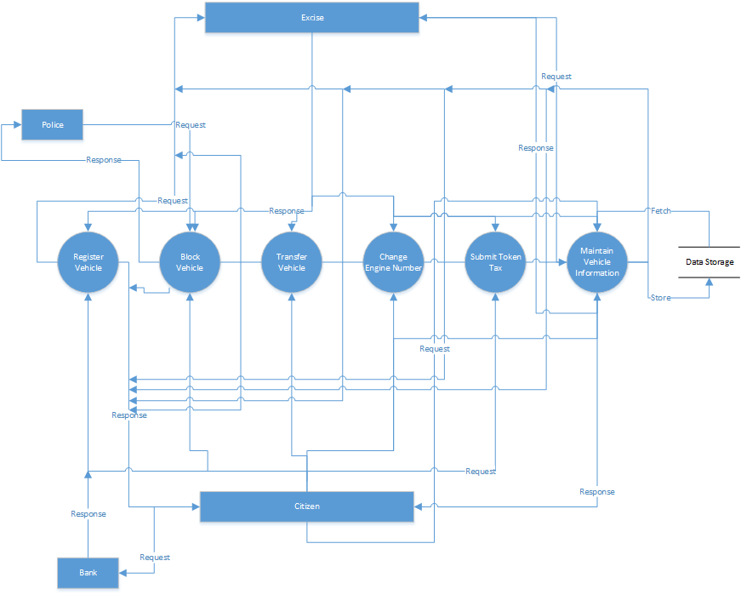

# Collaboration Diagram

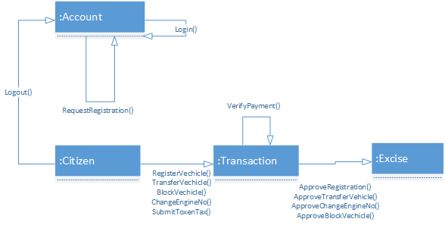

# Technology Architecture

* Smart DMV will be hosted on a Linux based server.
* Any device which can run browser can be used to access website of the smart dmv.
* Android Application would require minimum Lollipop version of Android Operating System.
* The most of the system will be developed using MEAN stack.
* Hyperledger Fabric will be using CouchDB for database.
* Hyperledger Composer will be used for deploying the network on blockchain and creating a rest server for getting REST API’s.
* TCP/IP as the IPS for Client-Server Communication.

# Architecture Evaluation

* We have used Linux operating system for development as it is open source and the current stack of technologies we are using are mostly open source and are operating under , The Linux Foundation.
* We have used Hyperledger Fabric for the development of the Blockchain Architecture as it is under development with two IT conglomerate (i.e. IBM and The Linux Foundation) with more than 290 corporate members in their community. So, Hyperledger Fabric have a long term support and being considered a great framework for development.
* Hyperledger Fabric is being used in Smart Dubai initiative of the Government of Dubai and its basic thinking does not only revolve around crypto currencies, which also motivated us to use this technology.
* Hyperledger Composer is a tool used for development of blockchain on the Hyperledger Fabric Framework.
* Angular is used for Web Front End due to its popularity and the robustness.
* Mobile Application for Android Operating System is developed while considering the large user base in the country.

# Detailed Design and Implementation

# Component-Component Interface

# Deployment Diagram

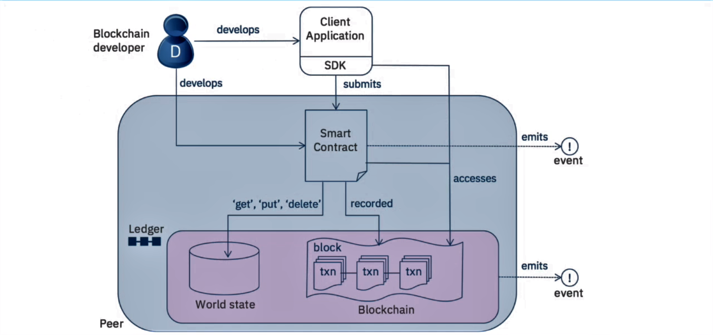

# Sequence Diagrams

#### User Registration

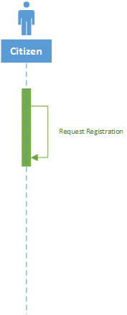

#### User Login

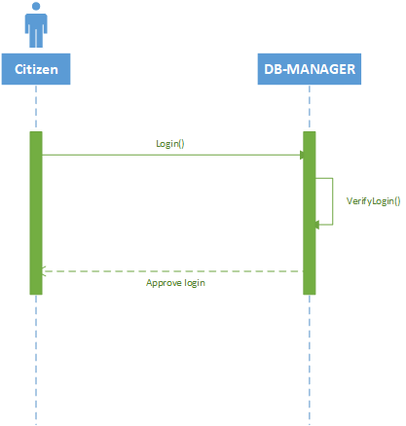

#### User Logout

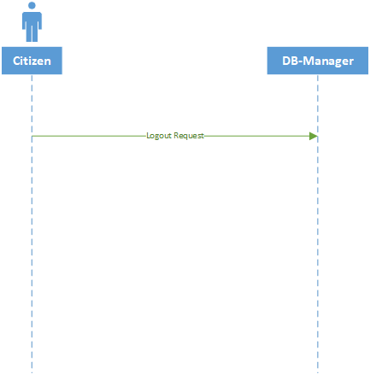

#### Register Vehicle

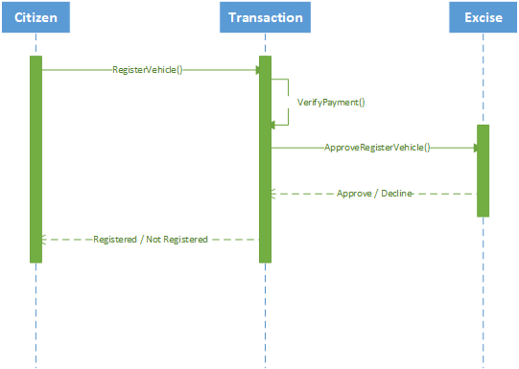

#### Transfer Vehicle

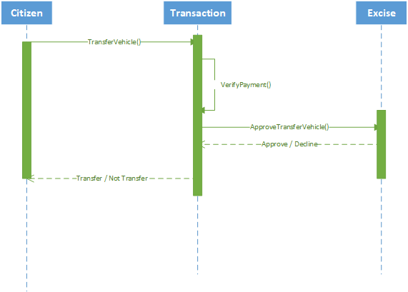

#### Block Vehicle

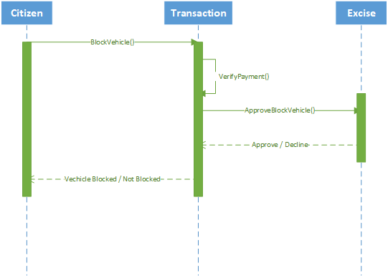

#### Change Engine Number

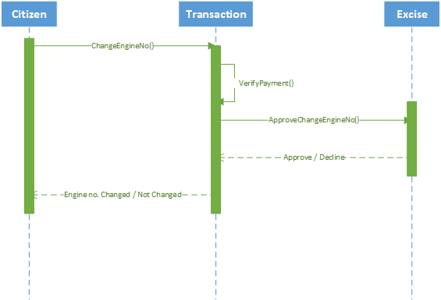

#### Submit Token Tax

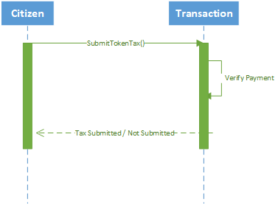

# Component-External Entities Interface

# Police API Call

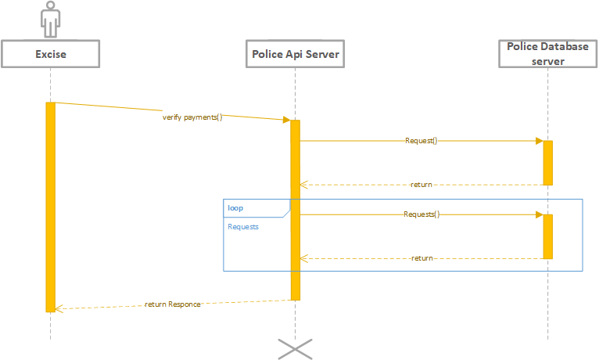

# Bank API Call

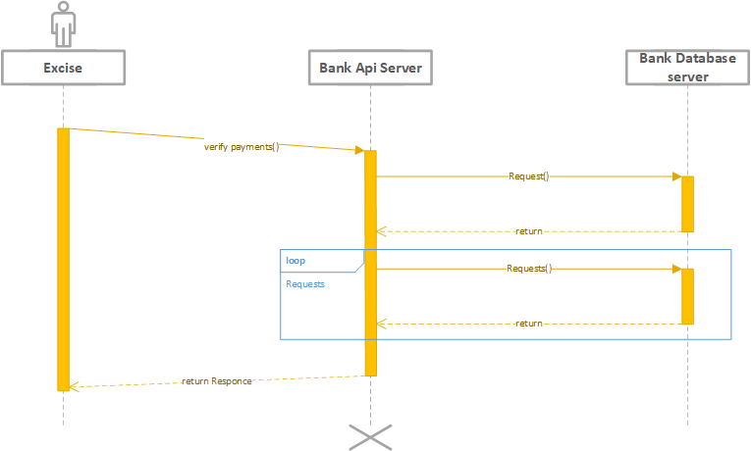

# Component-Human Interface

Basic norms followed in our project are:

* **Learnability:** Easy to use and provide help to those people who are going to use our app for the first time.
* **Efficiency:** The smaller number of steps from the current available system.
* **Satisfaction:** Fulfill the desired requirement of the customer and engage customer for further use.
* **Memorability:** The interface of the app is user friendly so it is quite easy for customers to remember the procedure.
* **Effectiveness:** This app works so effectively without any type of bugs and errors which results in customer’s satisfaction.

# Screenshots/Prototype

# Workflow

# Citizen’s Workflow (Swim Lane Diagram)

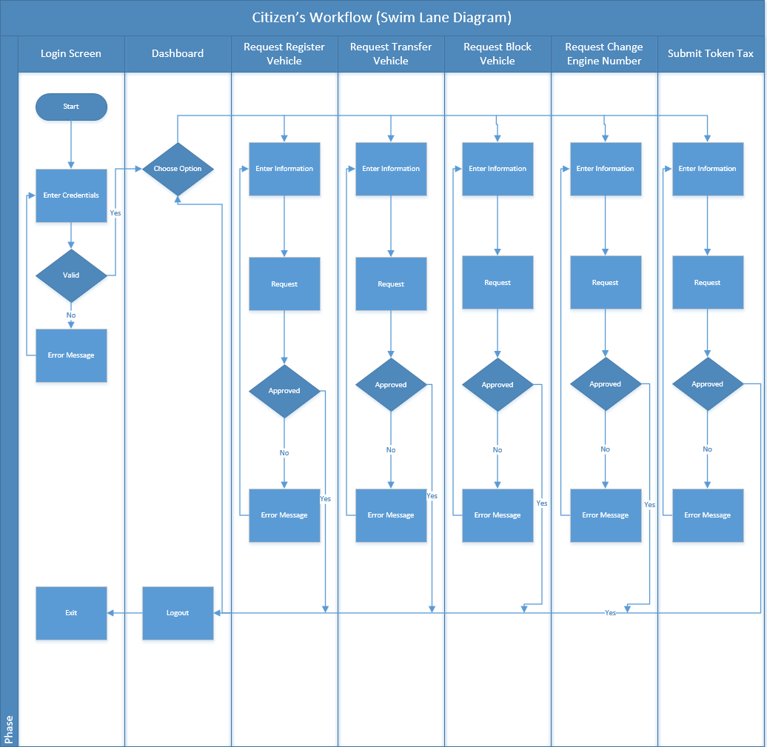

# Excise Workflow (Swim Lane Diagram)

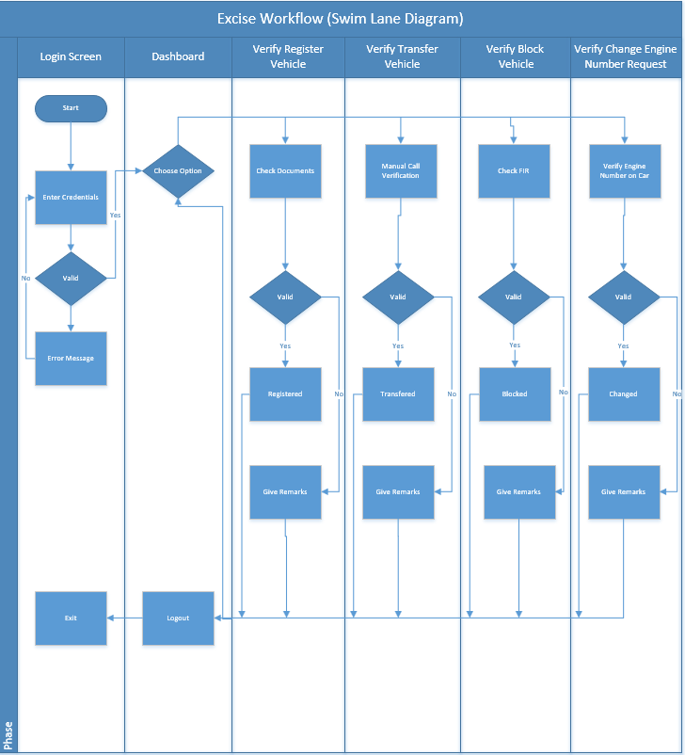

# Screens

# Citizen’s Login Screen

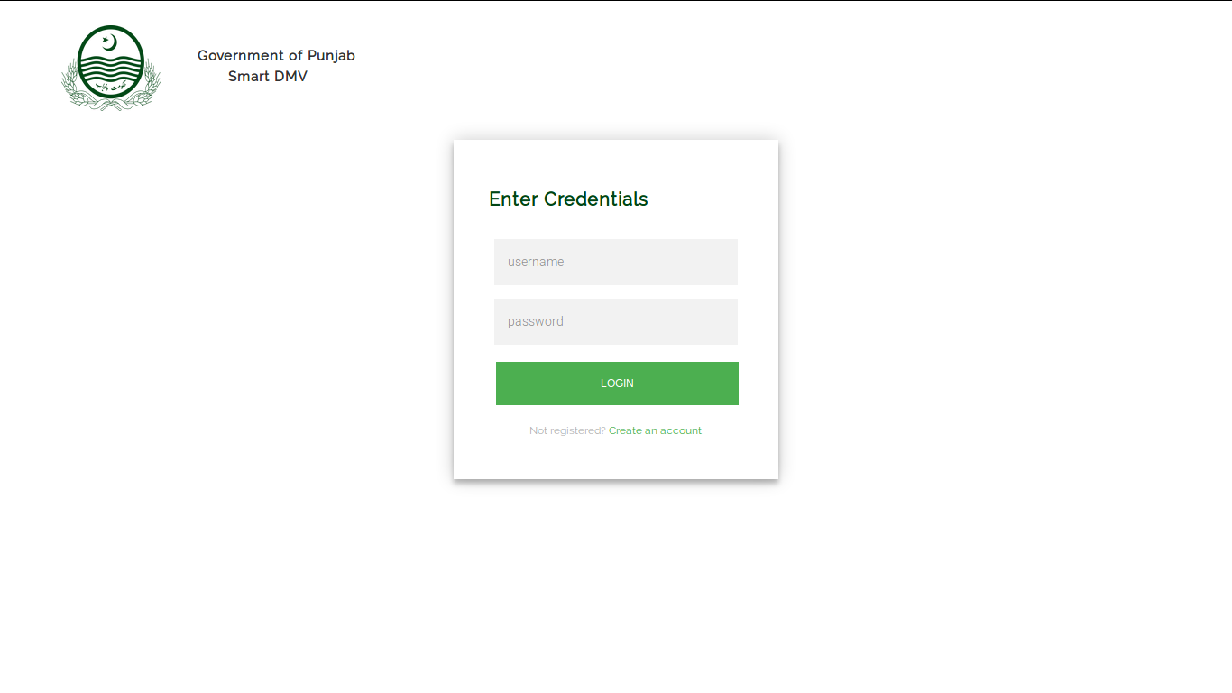

# Citizen’s Dashboard Screen

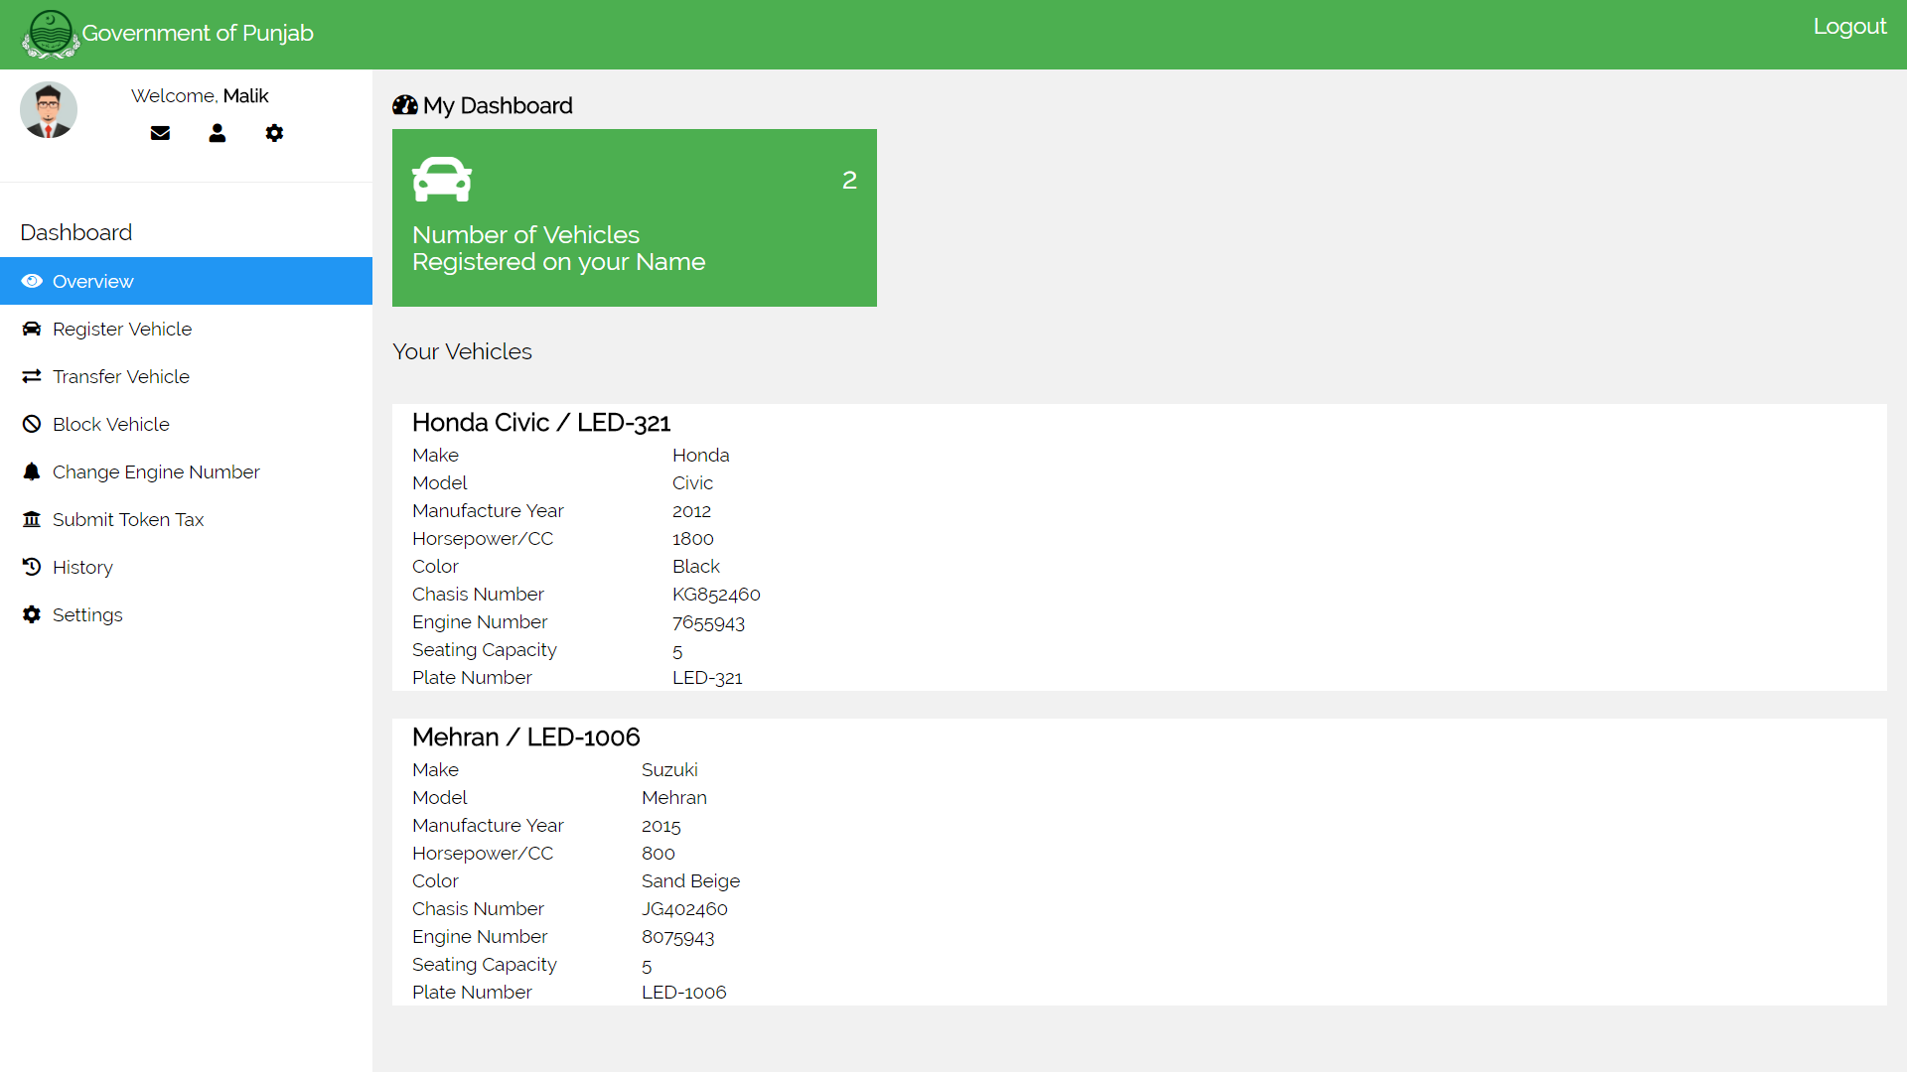

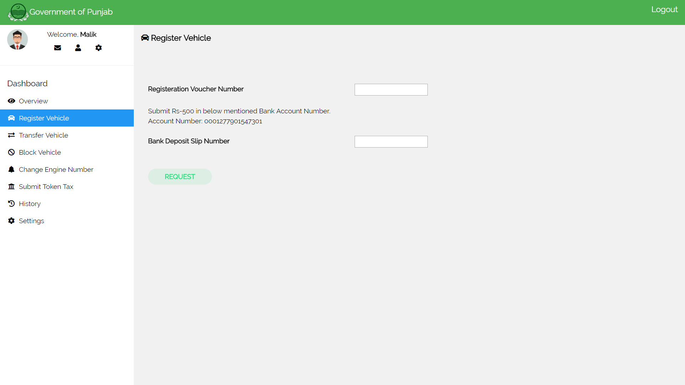

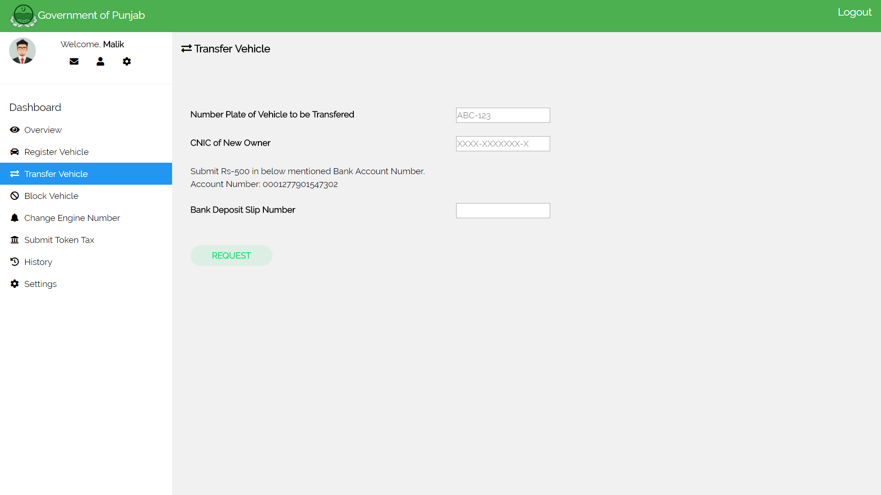

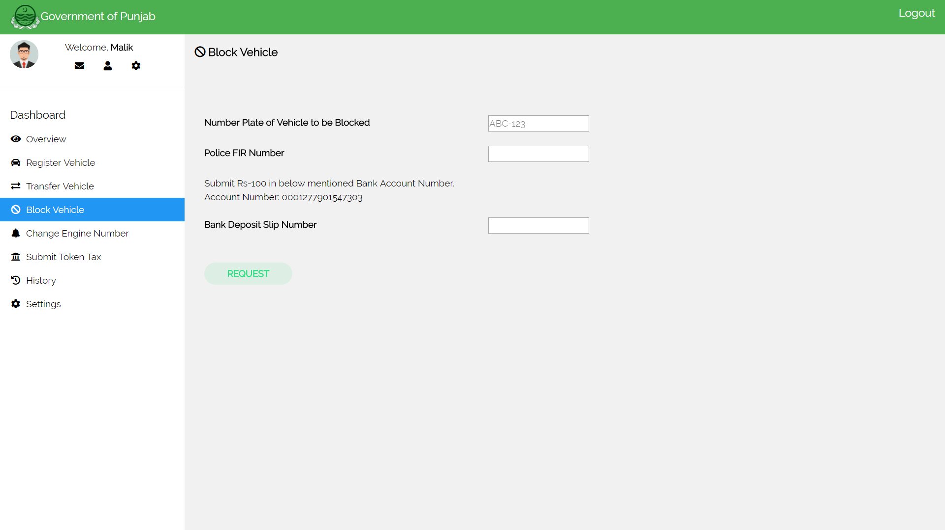

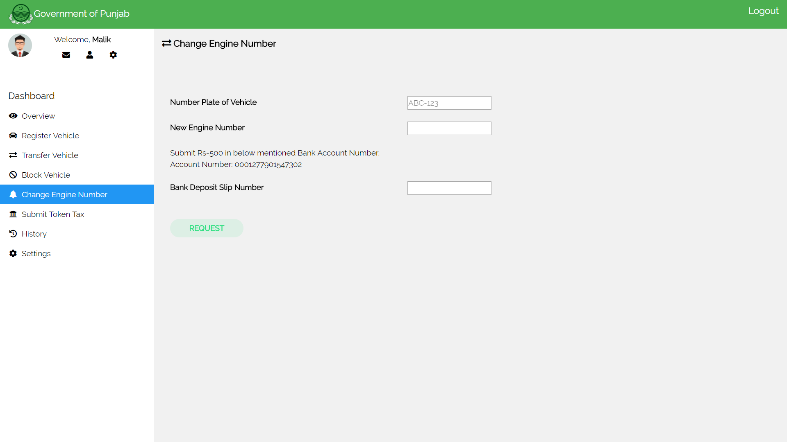

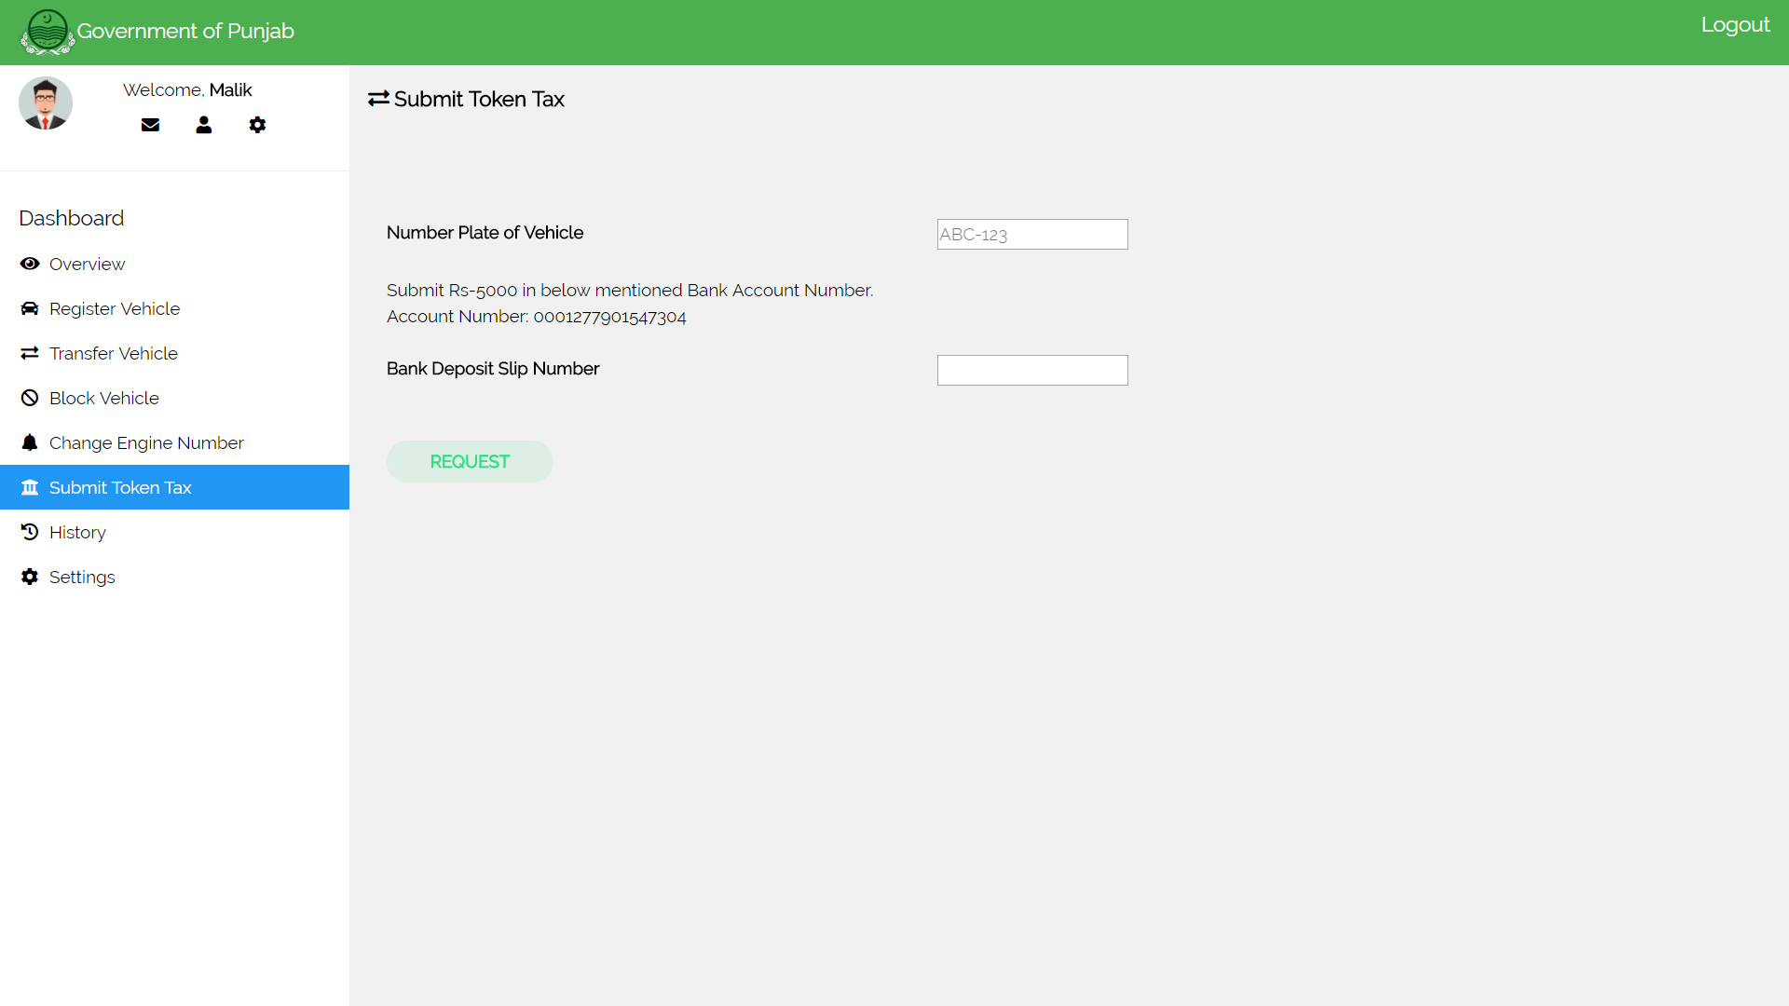

# Excise Officer’s Login Screen

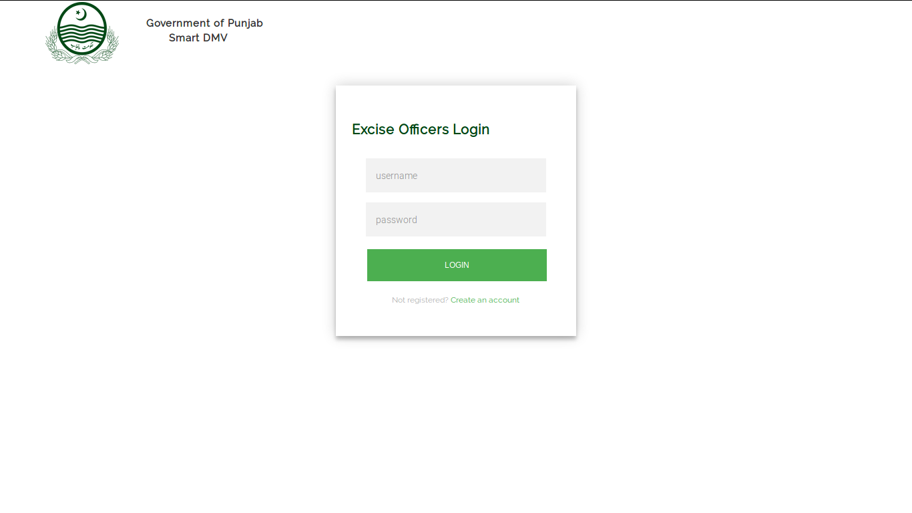

# Excise Officer’s Dashboard Screens

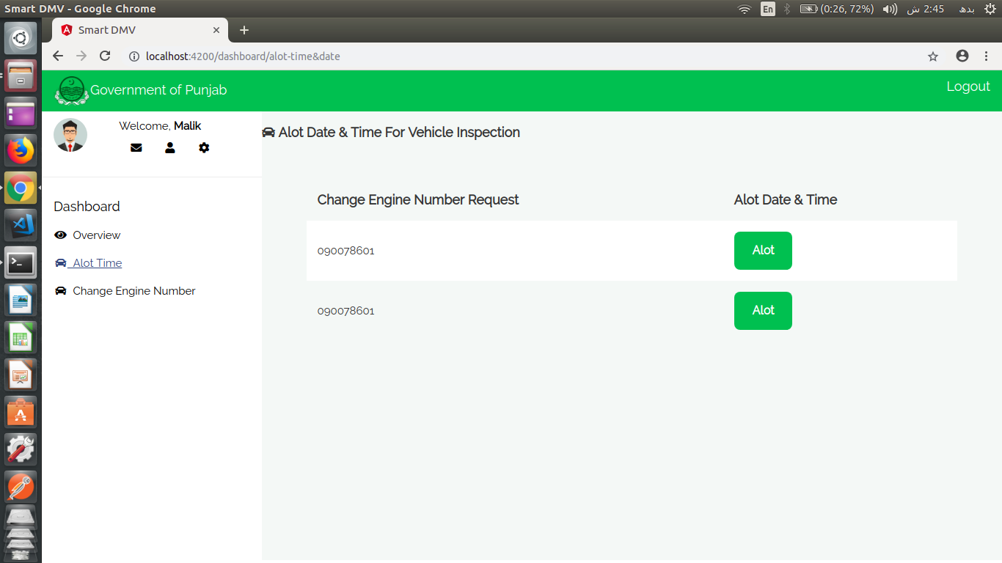

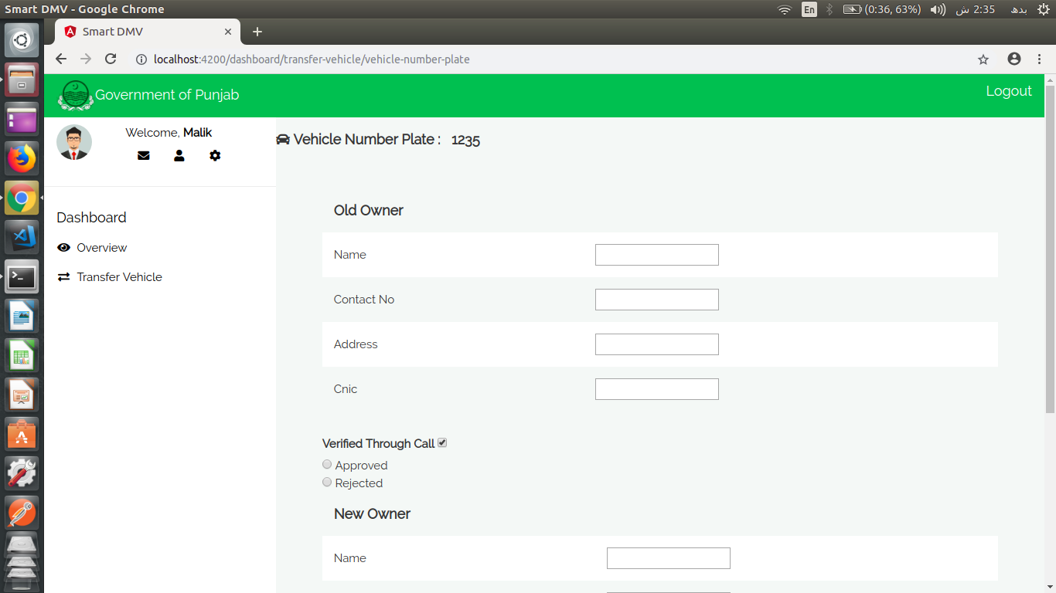

# Citizen's Android Application Screens

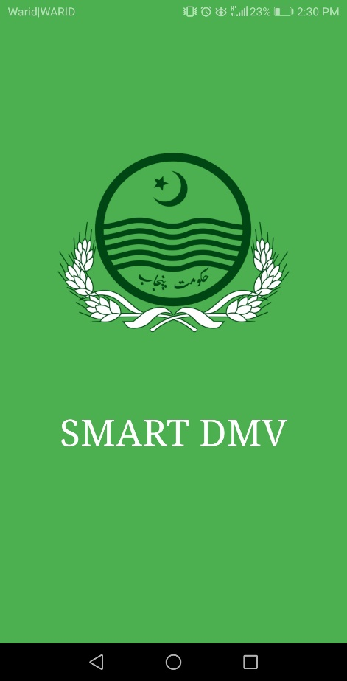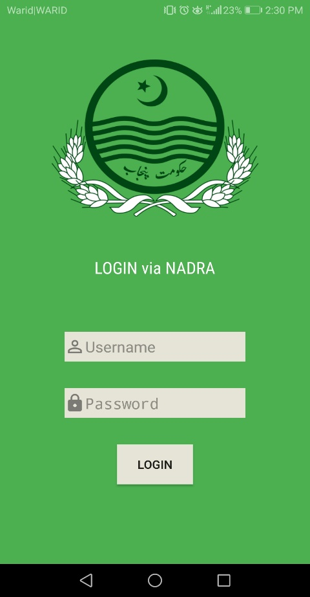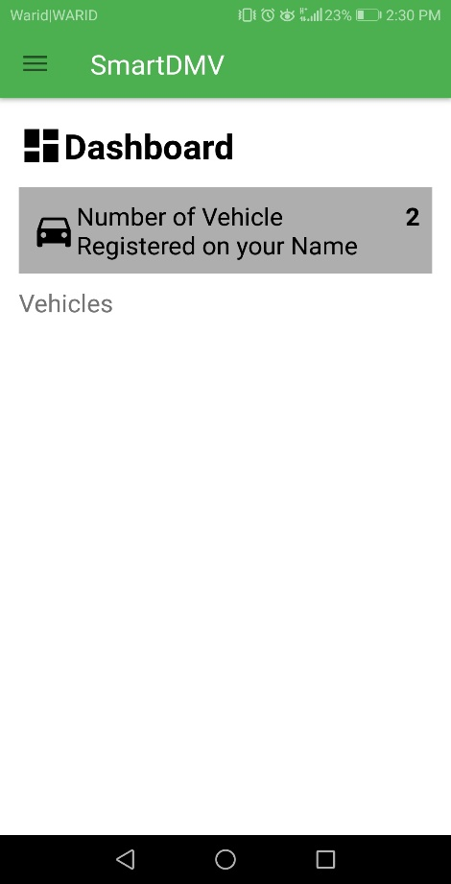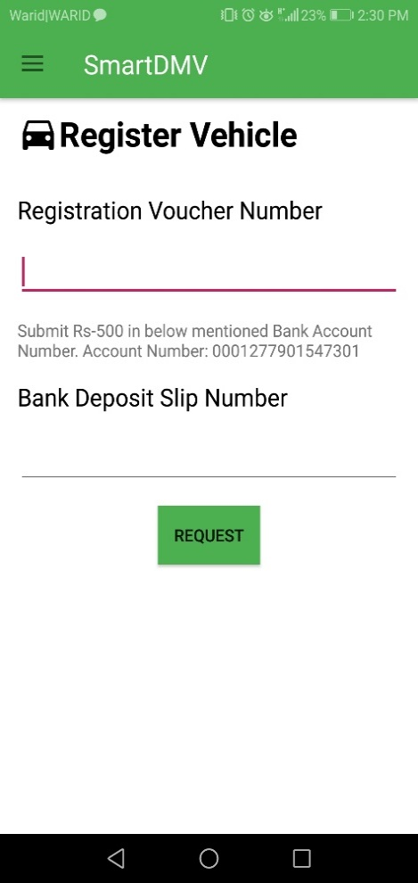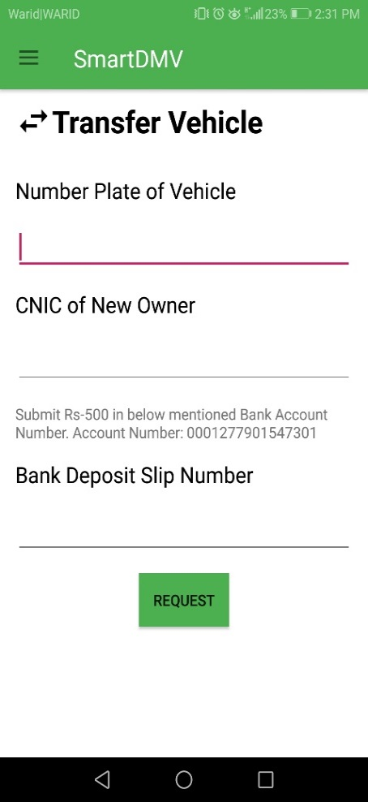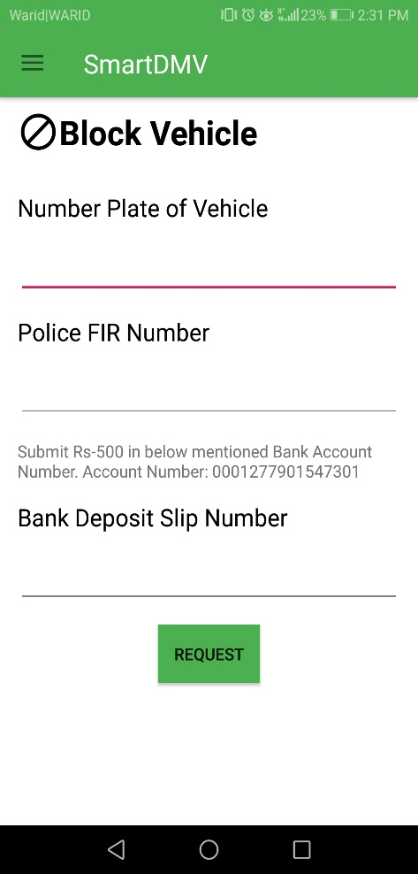

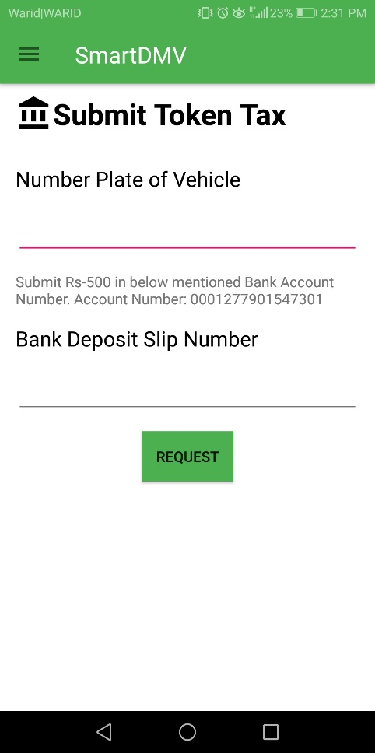 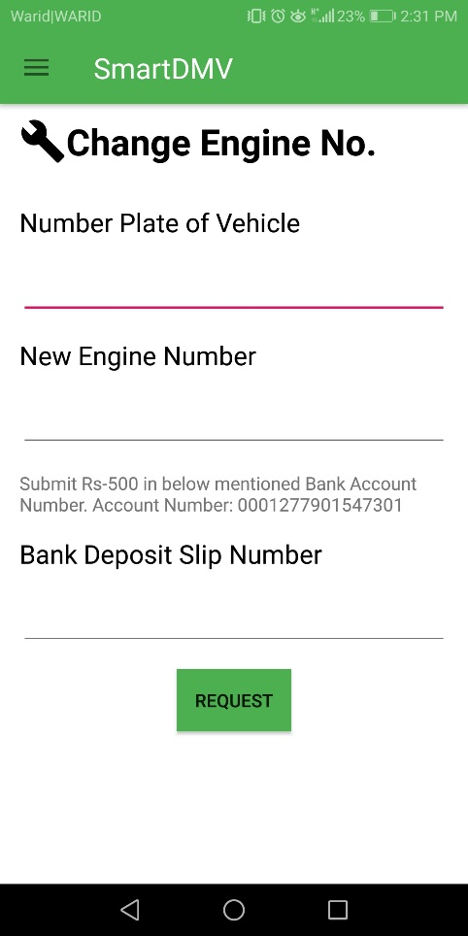 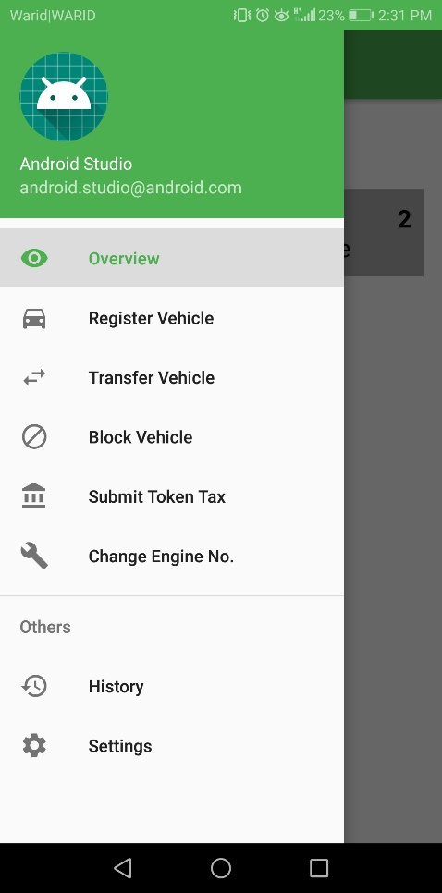

# Test Specification and Results

# Test Case Specification

Table 5.1.1: TC-1

**Manager Excise Login**

|  |  |
| --- | --- |
| **Identifier** | TC-1 |
| **Related requirements(s)** | … |
| **Short description** | Manager Excise wants to login to issue or block accounts |
| **Pre-condition(s)** | Login Screen must open |
| **Input data** | Username: test , password: test |
| **Detailed steps** | * Open login page * Enter password * Enter name * Then click ok to proceed. |
| **Expected result(s)** | Login should be successful |
| **Post-condition(s)** | Details to issue or block account of an excise officer will be shown |
| **Actual result(s)** | Manager Excise logged in. |
| **Test Case Result** | Login successfully |

Table 5.1.2: TC-2

**Issuing account to an Excise officer**

|  |  |
| --- | --- |
| **Identifier** | TC-2 |
| **Related requirements(s)** | … |
| **Short description** | Manager Excise wants to issue accounts |
| **Pre-condition(s)** | Manager Excise must be logged in. |
| **Input data** | Select Type from given ones: Registration, Transfer, Block, Change Engine no.  Enter Person Name: test  Enter Person Excise ID: test |
| **Detailed steps** | * Login * Click Issue ID from the menu * Select type from the dropdown menu e.g. Transfer * Enter the Employee name * Enter the Employee ID * Click the button issue |
| **Expected result(s)** | An Account will be issued |
| **Post-condition(s)** | Transactions can be approved from the account added. |
| **Actual result(s)** | Account is added and the person holding an account can now approve or decline the Transactions. |
| **Test Case Result** | Issued successfully |

Table 5.1.3: TC-3

**Revoke an Account of the Excise Officer**

|  |  |
| --- | --- |
| **Identifier** | TC-3 |
| **Related requirements(s)** | … |
| **Short description** | Manager Excise wants to block account |
| **Pre-condition(s)** | Manager Excise must be logged in. |
| **Input data** | Select Type from given ones: Registration, Transfer, Block, Change Engine no.  Enter Person Name: test  OR  Enter Person Excise ID: test |
| **Detailed steps** | * Login * Click Revoke ID from the menu * Select type from the dropdown menu e.g. Transfer * Enter the Employee name * OR * Enter the Employee ID * Click the button Revoke |
| **Expected result(s)** | An Account will be Revoked |
| **Post-condition(s)** | Transactions can be approved from the revoked Account |
| **Actual result(s)** | Account is Revoked and the person holding that account cannot approve or decline the Transactions. |
| **Test Case Result** | Revoked successfully |

Table 5.1.4: TC-4

**Excise Officer Login**

|  |  |
| --- | --- |
| **Identifier** | TC-4 |
| **Related requirements(s)** | … |
| **Short description** | Excise Officer wants to login |
| **Pre-condition(s)** | Login Screen must be appeared |
| **Input data** | Username: test, Password: test |
| **Detailed steps** | * Open login page * Enter password * Enter name * Then click ok to proceed. |
| **Expected result(s)** | Login will be successful |
| **Post-condition(s)** | Officer can now Approve or Decline the Transactions |
| **Actual result(s)** | Excise Officer is logged in |
| **Test Case Result** | Login successfully |

Table 5.1.5: TC-5

**Approve the Registration Request**

|  |  |
| --- | --- |
| **Identifier** | TC-5 |
| **Related requirements(s)** | … |
| **Short description** | Excise Officer wants to approve Registration Request |
| **Pre-condition(s)** | Officer must be logged in |
| **Input data** | Model: 2018  Year: 2018  CC: 1.8  Manufacturing: Toyota |
| **Detailed steps** | * Click Register Vehicle from the menu * Click the View Button in front of the Request No. to approve the Transaction. * Enter the details of the vehicle * Tick the box (Verified through Call) * Then click Approve. |
| **Expected result(s)** | Vehicle will be registered |
| **Post-condition(s)** | Officer can now Approve or Decline other Transactions or Logout from the System |
| **Actual result(s)** | Transaction is approved. |
| **Test Case Result** | Approved successfully |

Table 5.1.6: TC-6

**Approve the Transfer Request**

|  |  |
| --- | --- |
| **Identifier** | TC-6 |
| **Related requirements(s)** | … |
| **Short description** | Excise Officer wants to approve Transfer Request |
| **Pre-condition(s)** | Officer must be logged in |
| **Input data** | Old Owner:  Name: Zohaib  Contact No: 090078601  Address: 247-A Muslim Town  CNIC: 73516-2046552-8  New Owner:  Name: Ahmad  Contact No: 040098601  Address: 77-A Muslim Town  CNIC: 35762-2046352-0 |
| **Detailed steps** | * Click Transfer Vehicle from the menu * Click the View Button in front of the Request No. to approve the Transaction. * Enter the details of the both owners * Tick the box (Verified through Call) * Then click Approve. |
| **Expected result(s)** | Vehicle will be Transferred |
| **Post-condition(s)** | Officer can now Approve or Decline other Transactions or Logout from the System |
| **Actual result(s)** | Transaction is approved. |
| **Test Case Result** | Approved successfully |

Table 5.1.7: TC-7

**Approve the Change Engine no. Request**

|  |  |
| --- | --- |
| **Identifier** | TC-7 |
| **Related requirements(s)** | … |
| **Short description** | Excise Officer wants to approve Change Engine No. Request |
| **Pre-condition(s)** | Officer must be logged in |
| **Input data** | Time: 10:00  Date: 28/12/2018  Old Engine no.: 8356765  New Engine no.:7657787 |
| **Detailed steps** | * Click Change Engine no. from the menu * Click the Alot Button in front of the Request No. to approve the Transaction. * Enter Time and Date * Click Submit * After inspection Enter the Number of the old and new engine * Then click Approve. |
| **Expected result(s)** | Engine no. of the Vehicle will be changed |
| **Post-condition(s)** | Officer can now Approve or Decline other Transactions or Logout from the System |
| **Actual result(s)** | Transaction is approved. |
| **Test Case Result** | Approved successfully |

Table 5.1.8: TC-8

**Approve the Change Engine no. Request**

|  |  |
| --- | --- |
| **Identifier** | TC-8 |
| **Related requirements(s)** | … |
| **Short description** | Excise Officer wants to approve Change Engine No. Request |
| **Pre-condition(s)** | Officer must be logged in |
| **Input data** | Time: 10:00  Date: 28/12/2018  Old Engine no.: 8356765  New Engine no.:7657787 |
| **Detailed steps** | * Click Change Engine no. from the menu * Click the Alot Button in front of the Request No. to approve the Transaction. * Enter Time and Date * Click Submit * After inspection Enter the Number of the old and new engine * Then click Approve. |
| **Expected result(s)** | Engine no. of the Vehicle will be changed |
| **Post-condition(s)** | Officer can now Approve or Decline other Transactions or Logout from the System |
| **Actual result(s)** | Transaction is approved. |
| **Test Case Result** | Approved successfully |

Table 5.1.9: TC-9

**Citizen Login**

|  |  |
| --- | --- |
| **Identifier** | TC-9 |
| **Related requirements(s)** | … |
| **Short description** | Manager Excise wants to login |
| **Pre-condition(s)** | Login Screen must open |
| **Input data** | Admin name: Abdul Razak , password: bond007 |
| **Detailed steps** | * Open login page * Enter password * Enter name * Then click ok to proceed. |
| **Expected result(s)** | Login should be successful |
| **Post-condition(s)** | Details of named vehicle will be showed |
| **Actual result(s)** | Citizen logged in. |
| **Test Case Result** | Login successfully |
|  |  |

Table 5.1.10: TC-10

**Citizen Request for Registration**

|  |  |
| --- | --- |
| **Identifier** | TC-10 |
| **Related requirements(s)** | … |
| **Short description** | Citizen wants to register the vehicle |
| **Pre-condition(s)** | Citizen must be logged in. |
| **Input data** | Registration Voucher number:6487492  Bank deposit slip no.:77792465926 |
| **Detailed steps** | * Click Registration Vehicle in the menu * Enter registration voucher no. * Enter bank deposit slip no. * Click Request button |
| **Expected result(s)** | Registration request will be sent |
| **Post-condition(s)** | Citizen can view the details of registered cars, request another transaction or logout |
| **Actual result(s)** | Request is sent |
| **Test Case Result** | Request sent successfully |
|  |  |

Table 5.1.11: TC-11

**Citizen Request for Transfer**

|  |  |
| --- | --- |
| **Identifier** | TC-11 |
| **Related requirements(s)** | … |
| **Short description** | Citizen wants to Transfer the vehicle |
| **Pre-condition(s)** | Citizen must be logged in. |
| **Input data** | Vehicle number plate : ABC 123  CNIC: 3527873534438  Bank deposit slip no.:77792465123 |
| **Detailed steps** | * Click Transfer Vehicle in the menu * Enter Vehicle number plate. * Enter CNIC. * Enter Bank deposit slip no. * Click Request button |
| **Expected result(s)** | Transfer request will be sent |
| **Post-condition(s)** | Citizen can view the details of registered cars, request another transaction or logout |
| **Actual result(s)** | Request is sent |
| **Test Case Result** | Request sent successfully |
|  |  |

Table 5.1.12: TC-12

**Citizen Request for Change Engine No.**

|  |  |
| --- | --- |
| **Identifier** | TC-12 |
| **Related requirements(s)** | … |
| **Short description** | Citizen wants to Change Engine no. of the vehicle |
| **Pre-condition(s)** | Citizen must be logged in. |
| **Input data** | Vehicle number plate : ABC 123  New Engine No.: 5553563  Bank deposit slip no.:77792465987 |
| **Detailed steps** | * Click Change Engine no. in the menu * Enter Vehicle number plate. * Enter new engine no. * Enter Bank deposit slip no. * Click Request button |
| **Expected result(s)** | Change Engine number request will be sent |
| **Post-condition(s)** | Citizen can view the details of registered cars, request another transaction or logout |
| **Actual result(s)** | Request is sent |
| **Test Case Result** | Request sent successfully |
|  |  |

Table 5.1.13: TC-13

**Citizen Request for Block Vehicle**

|  |  |
| --- | --- |
| **Identifier** | TC-13 |
| **Related requirements(s)** | … |
| **Short description** | Citizen wants to Block the vehicle |
| **Pre-condition(s)** | Citizen must be logged in. |
| **Input data** | Vehicle number plate to be blocked : ABC 123  Police FIR No.: 7376282  Bank deposit slip no.:77792461098 |
| **Detailed steps** | * Click Block Vehicle in the menu * Enter Vehicle number plate to be blocked. * Enter Police FIR no. * Enter Bank deposit slip no. * Click Request button |
| **Expected result(s)** | Block Vehicle request will be sent |
| **Post-condition(s)** | Citizen can view the details of registered cars, request another transaction or logout |
| **Actual result(s)** | Request is sent |
| **Test Case Result** | Request sent successfully |
|  |  |

Table 5.1.14: TC-14

**Submit Token Tax**

|  |  |
| --- | --- |
| **Identifier** | TC-14 |
| **Related requirements(s)** | … |
| **Short description** | Citizen wants to Submit the token tax of the vehicle |
| **Pre-condition(s)** | Citizen must be logged in. |
| **Input data** | Vehicle number plate: ABC 123  Bank deposit slip no.:11192461098 |
| **Detailed steps** | * Click Submit Token Tax in the menu * Enter Vehicle number plate. * Enter Bank deposit slip no. * Click Request button |
| **Expected result(s)** | Token Tax Submission request will be sent |
| **Post-condition(s)** | Citizen can view the details of registered cars, request another transaction or logout |
| **Actual result(s)** | Request is sent |
| **Test Case Result** | Request sent successfully |
|  |  |

# Summary of Test Results

Table 5.2: Summary of Test Results

|  |  |  |  |  |
| --- | --- | --- | --- | --- |
| **Module Name** | Test cases run | Number of defects found | Number of defects corrected so far | Number of defects still need to be corrected |
| **Module 1 (Excise Manager)** | TC1, TC2, TC3 | 0 | 0 | 0 |
| **Module 2 (Excise Officer’s)** | TC4, TC5, TC6, TC7, TC8 | 0 | 0 | 0 |
| **Module 3 (Citizen’s Login)** | TC9, TC10, TC11, TC12, TC13, TC14 | 0 | 0 | 0 |
| **Complete System** | 14 | 0 | 0 | 0 |

# Project Completion Status

**Table 6.1: Project Completion Status**

|  |  |
| --- | --- |
| **Module Name** | **Status**  (Complete, Partially Implemented, Not Implemented) |
| **Module 1 (admin login)** | Complete |
| **Module 2 (Citizen login/signup)** | Complete |
| **Module 3 (Register Vehicle)** | Complete |
| **Module 4 (Transfer Vehicle)** | Complete |
| **Module 5 (Submit Token Tax Vehicle)** | Complete |
| **Module 6 (Block Vehicle)** | Complete |
| **Module 7 (Change Engine No.)** | Complete |
| **Complete System** | Complete |

Table 6.2: Objective(s)/Target(s) Status

|  |  |  |
| --- | --- | --- |
| **Target/Objective** | **Status**  (Completed,  Partially Completed,  Not Completed) | **Reason(s)** |
| **Register** | Completed | ------ |
| **Transfer** | Completed | ------ |
| **Submit Token Tax** | Completed | ------ |
| **Block** | Completed | ------ |
| **Change Engine No.** | Completed | ------ |
| **Number of Targets Completed** | 5 | ------ |
| **Number of Targets Partially Completed** | 0 | ------ |
| **Number of Targets Not Completed** | 0 | ------ |

# References

<http://smartdubai.ae/en/Pages/default.aspx>

<https://excise.punjab.gov.pk/vehicle_registration>

<http://excise.punjab.gov.pk/motorvehicle_tax>

<https://www.hyperledger.org/projects/fabric>

<https://composer-playground.mybluemix.net/>

<https://hyperledger-fabric.readthedocs.io/en/release-1.3/>

<https://hyperledger-fabric.readthedocs.io/en/release-1.3/dev-setup/devenv.html>

<https://hyperledger.github.io/composer/v0.19/tutorials/developer-tutorial.html>

Appendix A Glossary

### Block chain:

A **block chain**, originally **block chain**, is a continuously growing list of records, called blocks, which are linked and secured using cryptography.[Each block typically contains a cryptographic hash of the previous block, a timestamp and transaction data. By design, a block chain is inherently resistant to modification of the data. It is "an open, distributed ledger that can record transactions between two parties efficiently and in a verifiable and permanent way".

### Cryptography:

**Cryptography** or **cryptology** is the practice and study of techniques for secure communication in the presence of third parties called adversaries. More generally, cryptography is about constructing and analyzing protocols that prevent third parties or the public from reading private messages various aspects in information security such as data confidentiality, data integrity, authentication, and non-repudiationare central to modern cryptography. Modern cryptography exists at the intersection of the disciplines of mathematics, computer science, electrical engineering, communication science, and physics.

* **Smart Contract:**

A **smart contract** is a computer protocol intended to digitally facilitate, verify, or enforce the negotiation or performance of a contract. Smart contracts allow the performance of credible transactions without third parties. These transactions are track able and irreversible. Proponents of smart contracts claim that many kinds of contractual clauses may be made partially or fully self-executing, self-enforcing, or both. The aim of smart contracts is to provide security that is superior to traditional contract law and to reduce other transaction costs associated with contracting.

Appendix B IV & V Report

(Independent verification & validation)

**IV & V Resource**

Name Signature

|  |  |  |  |  |  |
| --- | --- | --- | --- | --- | --- |
| **S#** | **Defect Description** | **Origin Stage** | **Status** | **Fix Time** | |
| **Hours** | **Minutes** |
| 1 |  |  |  |  |  |
| 2 |  |  |  |  |  |
| 3 |  |  |  |  |  |
| … |  |  |  |  |  |

**Table B.1: List of non-trivial defects**

# Appendix C - Deployment/Installation Guide

* **To install our application**
* Citizen will simple have to open play store, as it is an android application
* Type “Smart DMV” on search bar of play store.
* Click install to download our app.
* Our app is 3MB and the android version should be lollipop or more.
* **Secondly, for web browsing**
* Open any web browser and write on search engine “smartdmv.gov.pk”.
* Click enter to proceed.

**\*note: internet connection should be established before downloading application or opening it on web browser. \***

# Appendix D - User Manual

**For Citizen**

All the following functionalities can be accessed from the Dashboard (left side bar) of the application.

**Registration**

* For registration, citizen have to get the voucher number physically from the excise officer and after getting that, he/she has to submit the bank fee.
* After submitting the fee, citizen should open the web application or Android app
* In the web or mobile application, citizen will enter the Voucher No. and Bank Deposit Fee No.
* Click or Press the Request button.
* Request for Registration will be successfully occurred.

**Transfer**

* For Vehicle Transfer, citizen have to enter the Number Plate of his/her Vehicle, CNIC of new owner and the Bank deposit slip no.
* After the approval of new owner and excise officer, the vehicle will be transferred to the new owner.

**Block Vehicle**

* To Block the vehicle, citizen have to complain FIR in the Police Station and then enter the Number Plate of his/her Vehicle, FIR Number in the application.
* The vehicle will be blocked.

**Submit Token Tax**

* For Submission of token tax, citizen have to enter the Number Plate of his/her Vehicle, and the Bank deposit slip no. in the application
* After the approval of excise officer the token tax will be submitted.

**Change Engine No.**

* For changing the engine no. of vehicle, citizen have to enter the Number Plate of his/her Vehicle, new engine no. of the vehicle and the Bank deposit slip no. in the application.
* After the approval and inspection of excise officer, the engine no. of the vehicle will be changed.

**For Excise**

If he/she is not a member of Smart DMV, then the admin will gave the credentials to the excise officer to login into the system but the officer will only have rights to manage his/her department e.g. an officer of Transfer will only be accessing the transfer rights.

* After the excise officer is logged in he/she will be approving the list of transactions that will be accessed from the dashboard
* Select the transaction from list and click the Accept button after verifying it from the user..
* The Excise officer can also View the Transaction by clicking up the View button.
* In Change Engine no. case, the officer should select the transaction by clicking on it and then select Date and Time for the inspection of the Citizen’s car

The officer can logout from the application after successfully approving the transactions.