1. Create a simple thread class

public class SimpleThread extends Thread {

@Override

public void run() {

System.out.println(Thread.currentThread().getId() + " is executing the thread.");

}

public static void main(String[] args) {

SimpleThread thread1 = new SimpleThread();

SimpleThread thread2 = new SimpleThread();

thread1.start();

thread2.start();

}

}

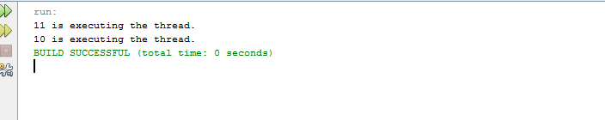

1. Create a runnable class

public class RunnableTask implements Runnable {

public void run(){

System.out.println(Thread.currentThread().getId() + "is executing the runnable task.");

}

public static void main(String[] args){

RunnableTask task1 = new RunnableTask();

RunnableTask task2 = new RunnableTask();

Thread thread1 = new Thread(task1);

Thread thread2 = new Thread(task2);

thread1.start();

thread2.start();

}

}

