**CS5573 – Information Security and Assurance – Assignment #5**

**Student Name: Anusha Malineni Page 1 of 10**

**Student ID: 16233382**



**Information Security and Assurance**

**Assignment - 5**

**Submitted by:**

**Anusha Malineni**

**16233382**

**CS5573 – Information Security and Assurance – Assignment #5**

**Student Name: Anusha Malineni Page 2 of 10**

**Student ID: 16233382**

**To find vulnerabilities in system using Nessus Tool**

Below is the screenshot of the home page of Nessus Tool

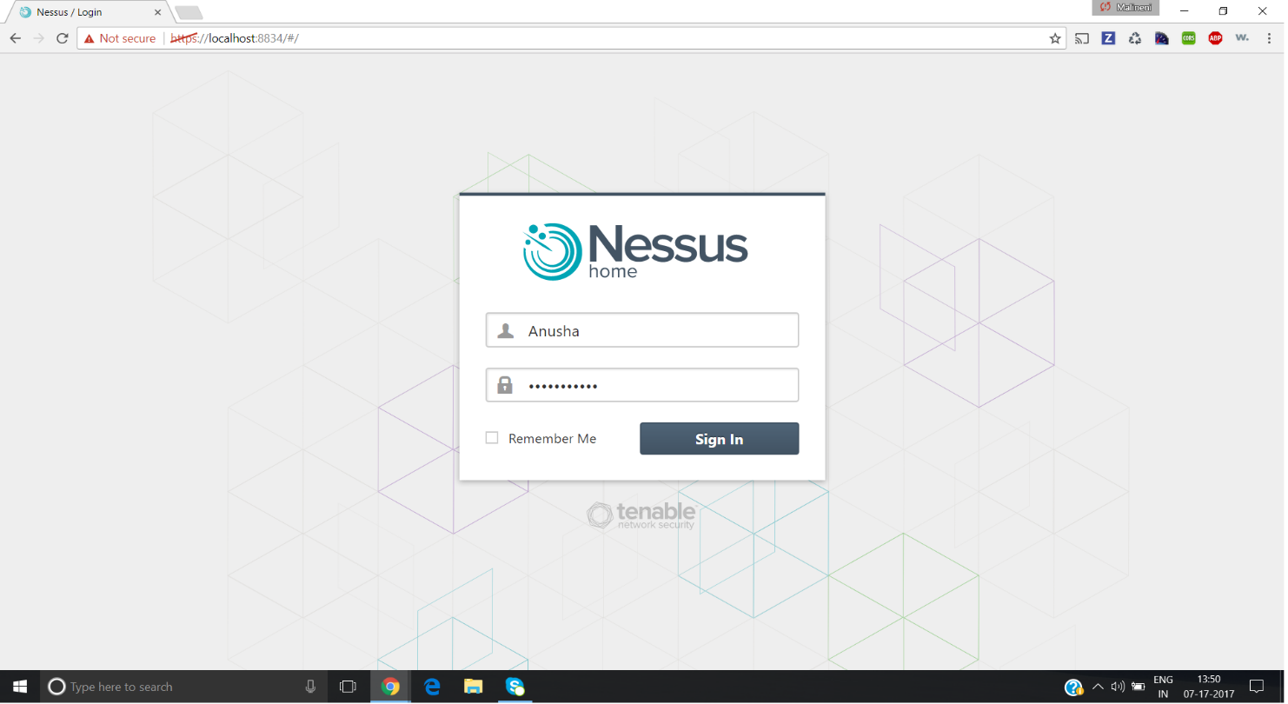

Below is the screenshot after performing three different scans on the system

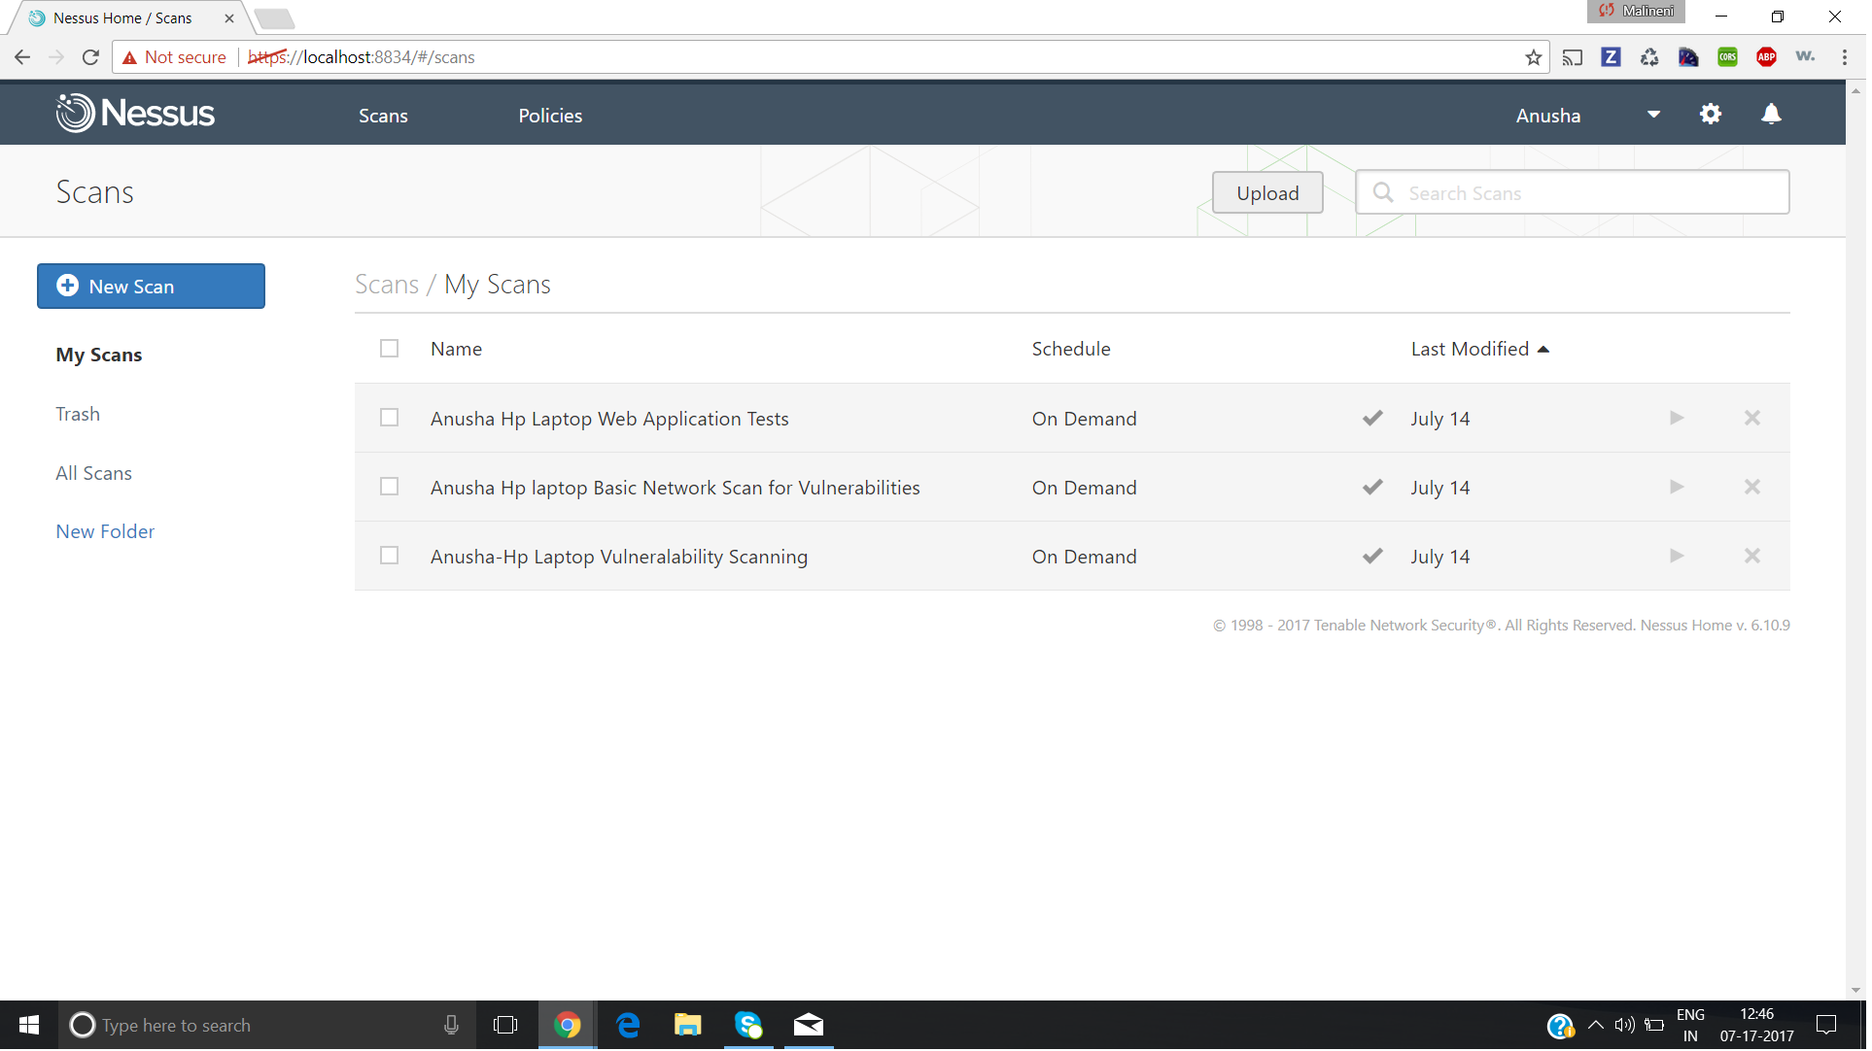

**CS5573 – Information Security and Assurance – Assignment #5**

**Student Name: Anusha Malineni Page 3 of 10**

**Student ID: 16233382**

Below two screenshots depicts different types of scans available in Nessus Tool.

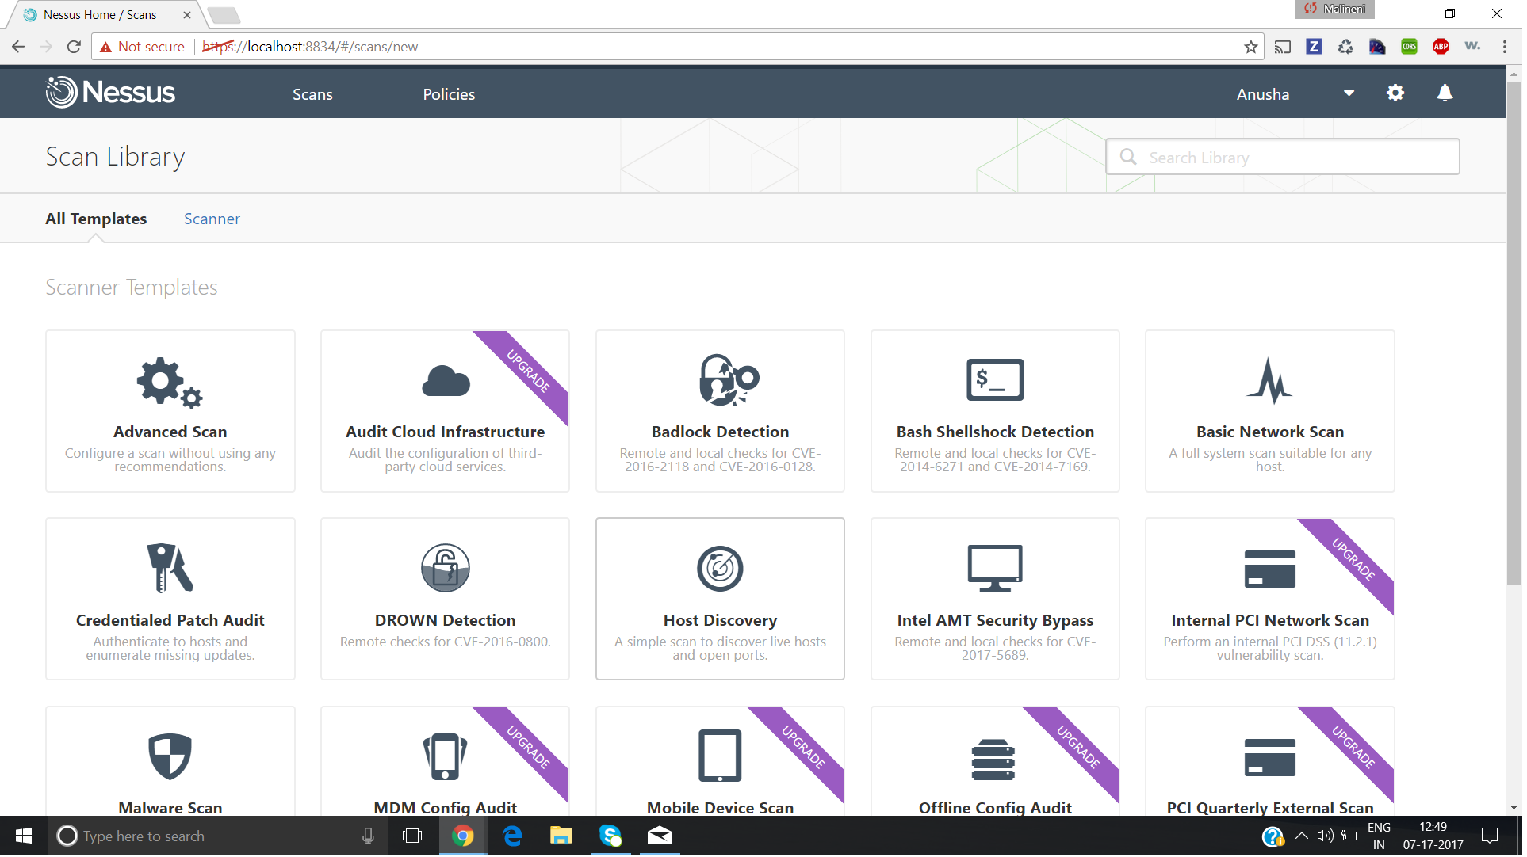

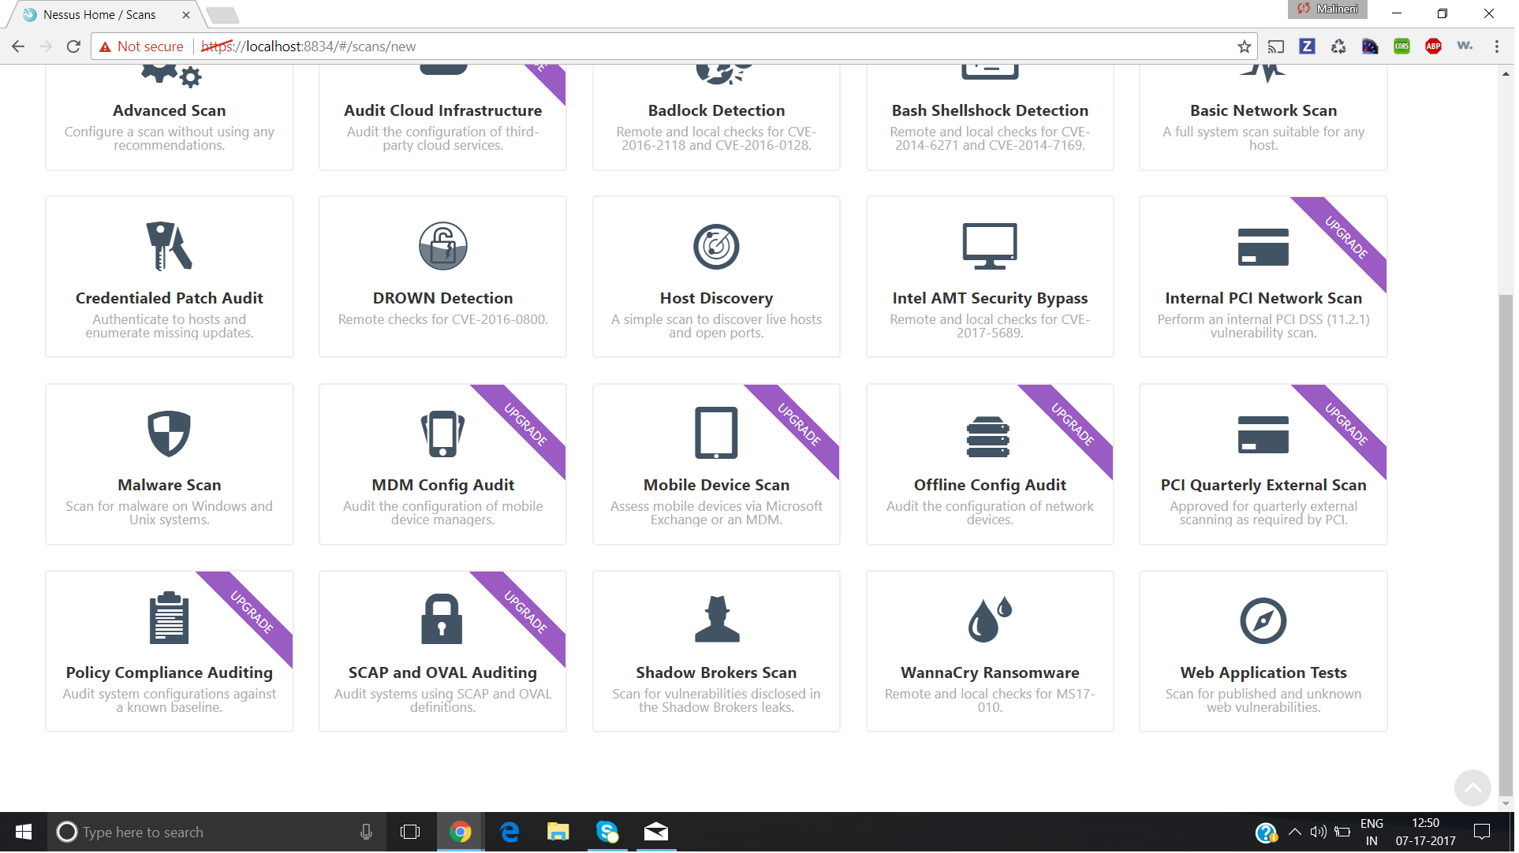

**CS5573 – Information Security and Assurance – Assignment #5**

**Student Name: Anusha Malineni Page 4 of 10**

**Student ID: 16233382**

Below is the screenshot for the IP Address of target machine.

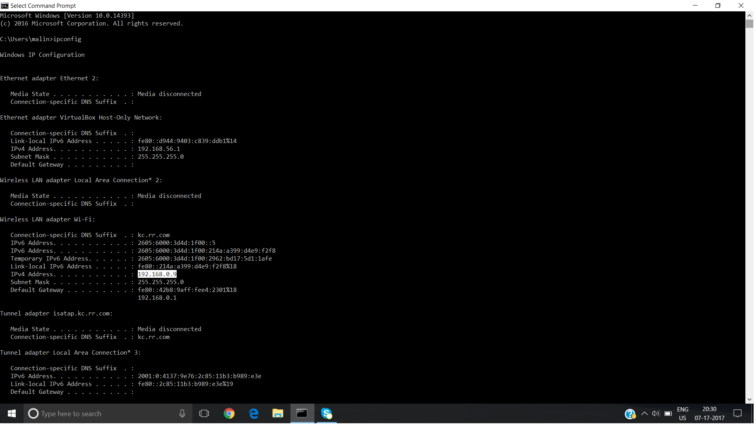

Below screenshot tell us how to start a new scan. Giving the required information and target IP Address and launching the scan, this tool starts the scan on the target machine.

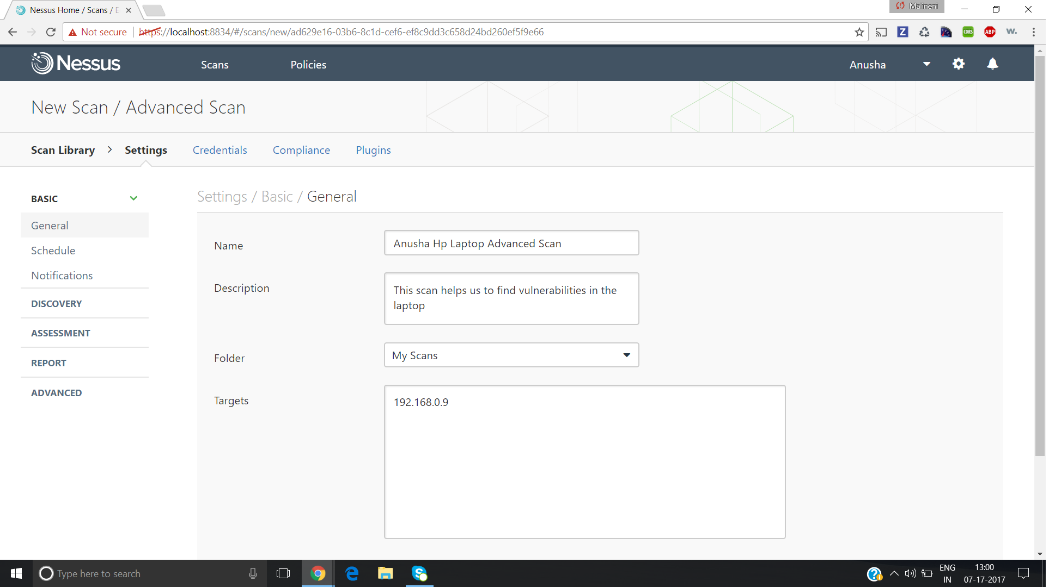

**CS5573 – Information Security and Assurance – Assignment #5**

**Student Name: Anusha Malineni Page 5 of 10**

**Student ID: 16233382**

After the scan is successful, it displays a graphical representation of the vulnerabilities found, other information like time elapsed for scanning, target machine address etc.,

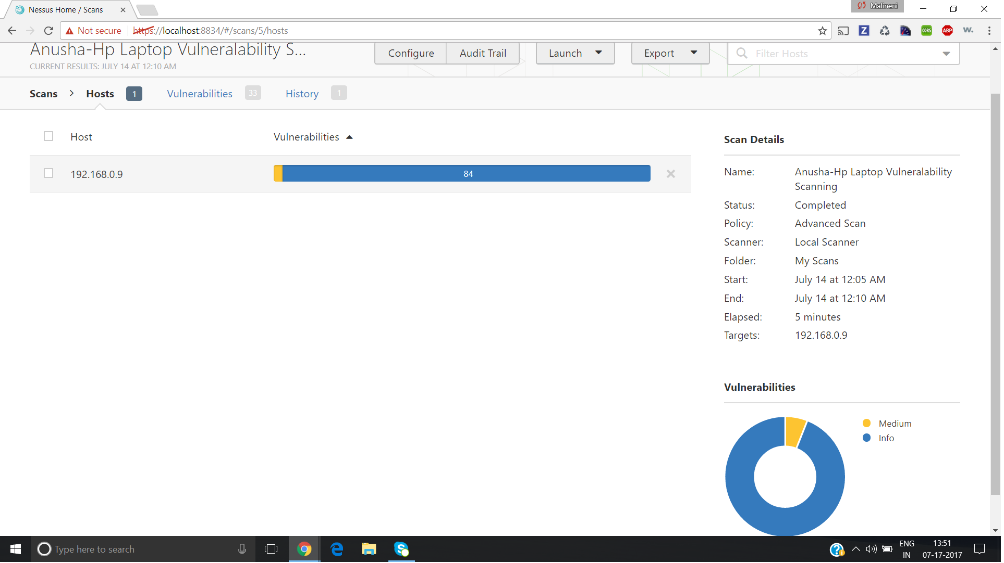

**CS5573 – Information Security and Assurance – Assignment #5**

**Student Name: Anusha Malineni Page 6 of 10**

**Student ID: 16233382**

Double clicking on the count of vulnerabilities, gives us list of all vulnerabilities found in scanning the target machine. The below three screenshots gives us the list of all vulnerabilities.

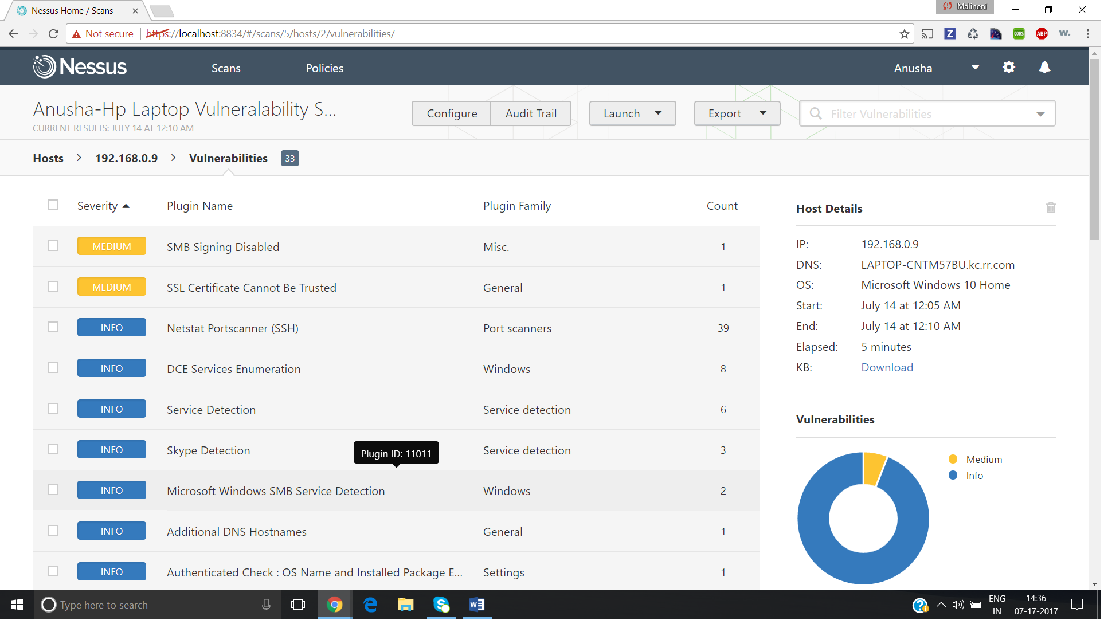

**CS5573 – Information Security and Assurance – Assignment #5**

**Student Name: Anusha Malineni Page 7 of 10**

**Student ID: 16233382**

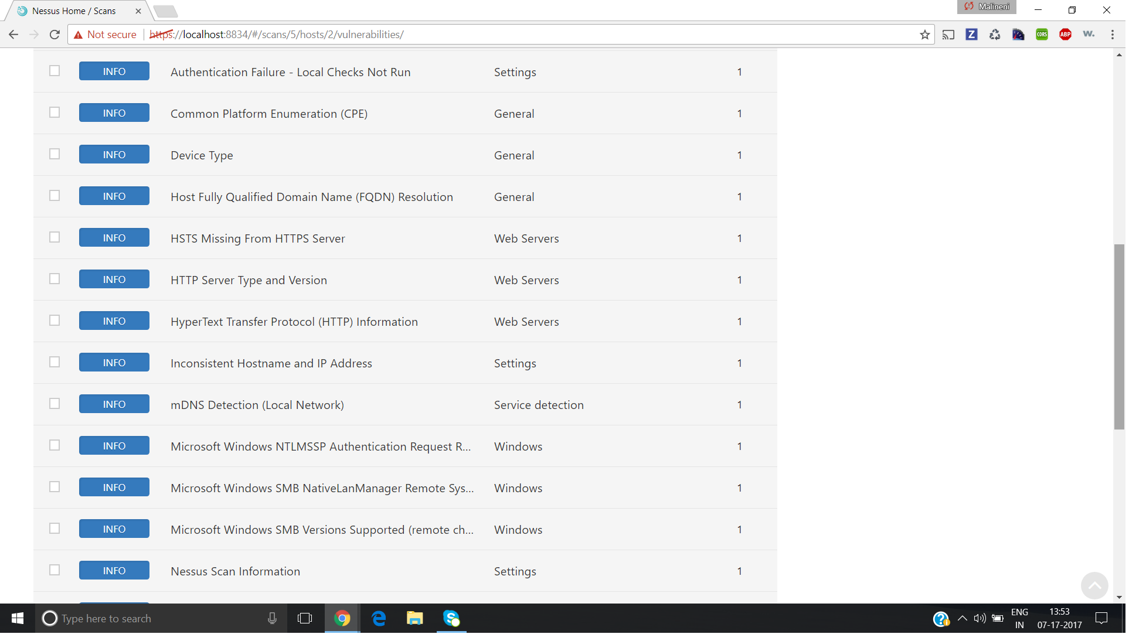

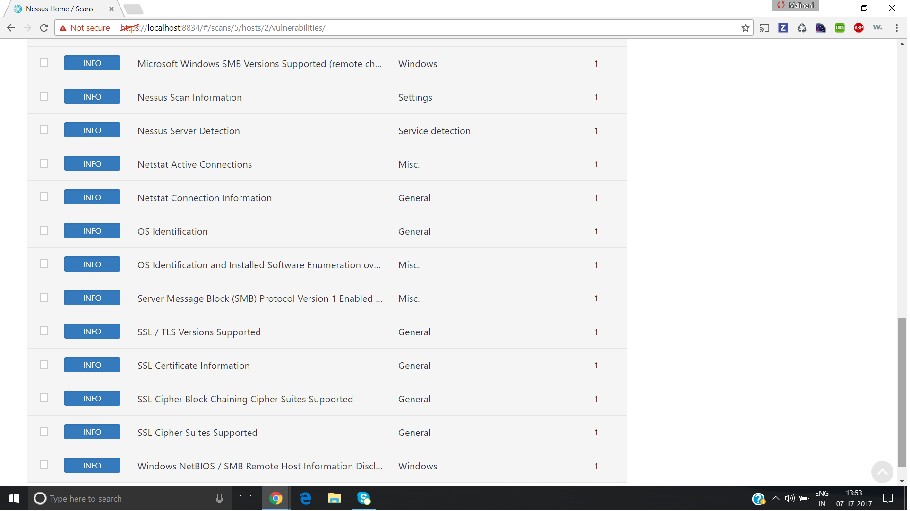

**CS5573 – Information Security and Assurance – Assignment #5**

**Student Name: Anusha Malineni Page 8 of 10**

**Student ID: 16233382**

Each vulnerability can be inspected in detail, which has the description, solution, other reference links etc.,

Name of Vulnerability: **SMB Signing Disabled**

Target IP Address: **192.168.0.9**

CVSS Base Score of the vulnerability: **5.0**

Severity of the vulnerability: **Medium**

CPE information: **cpe:/o:microsoft:windows cpe:/a:samba:samba**

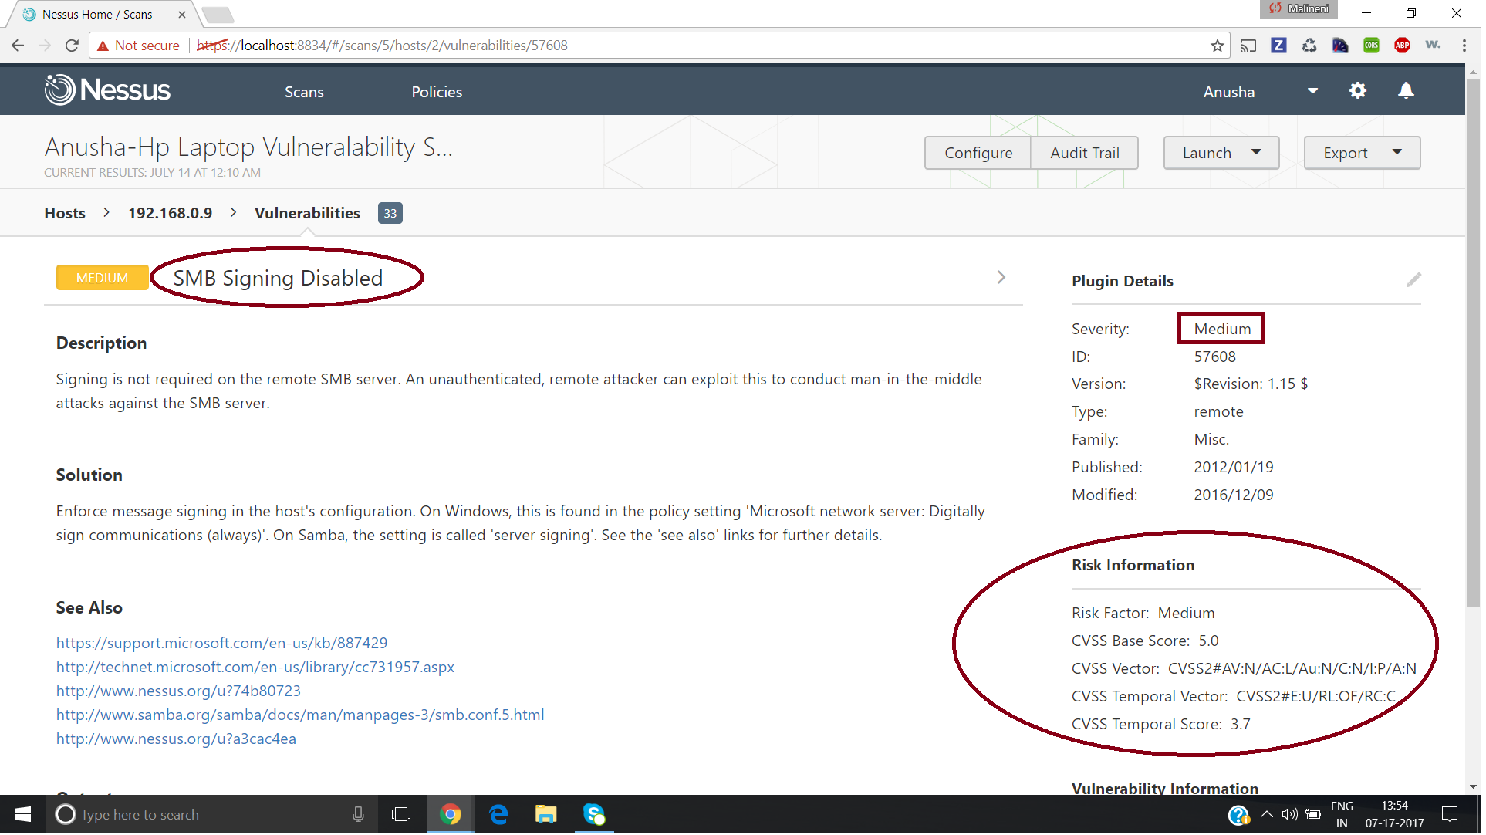

**CS5573 – Information Security and Assurance – Assignment #5**

**Student Name: Anusha Malineni Page 9 of 10**

**Student ID: 16233382**

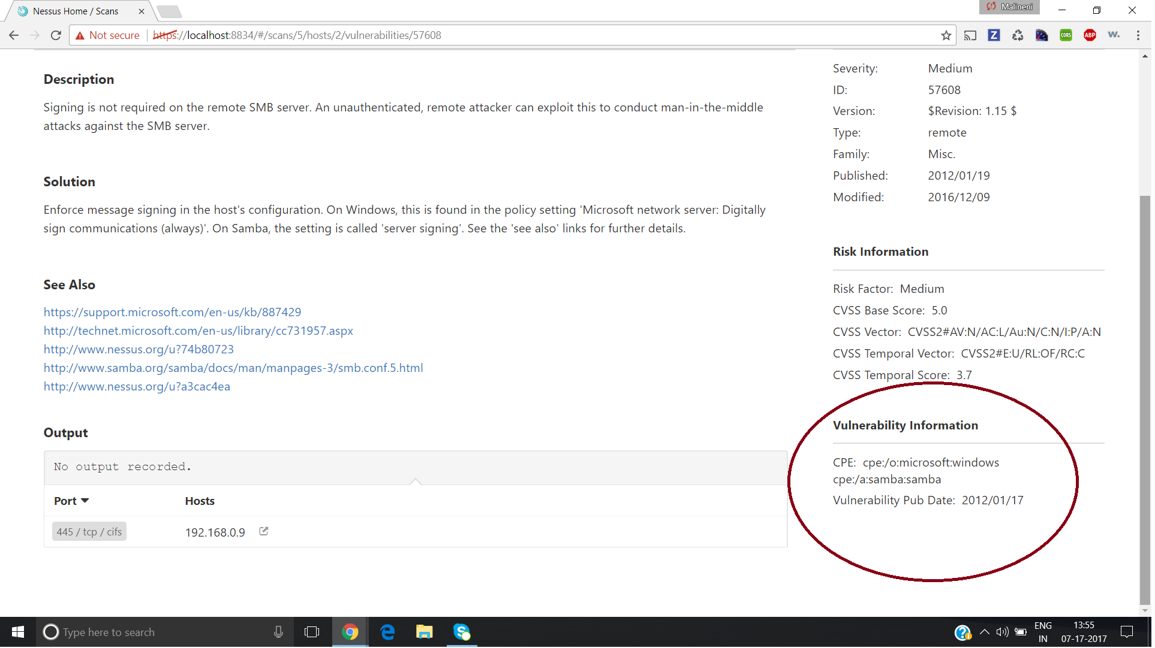

**CS5573 – Information Security and Assurance – Assignment #5**

**Student Name: Anusha Malineni Page 10 of 10**

**Student ID: 16233382**

Name of Vulnerability: **Skype Detection**

Target IP Address: **192.168.0.9**

Severity of the vulnerability: **Info**

CPE information: **cpe:/a:skype:skype**

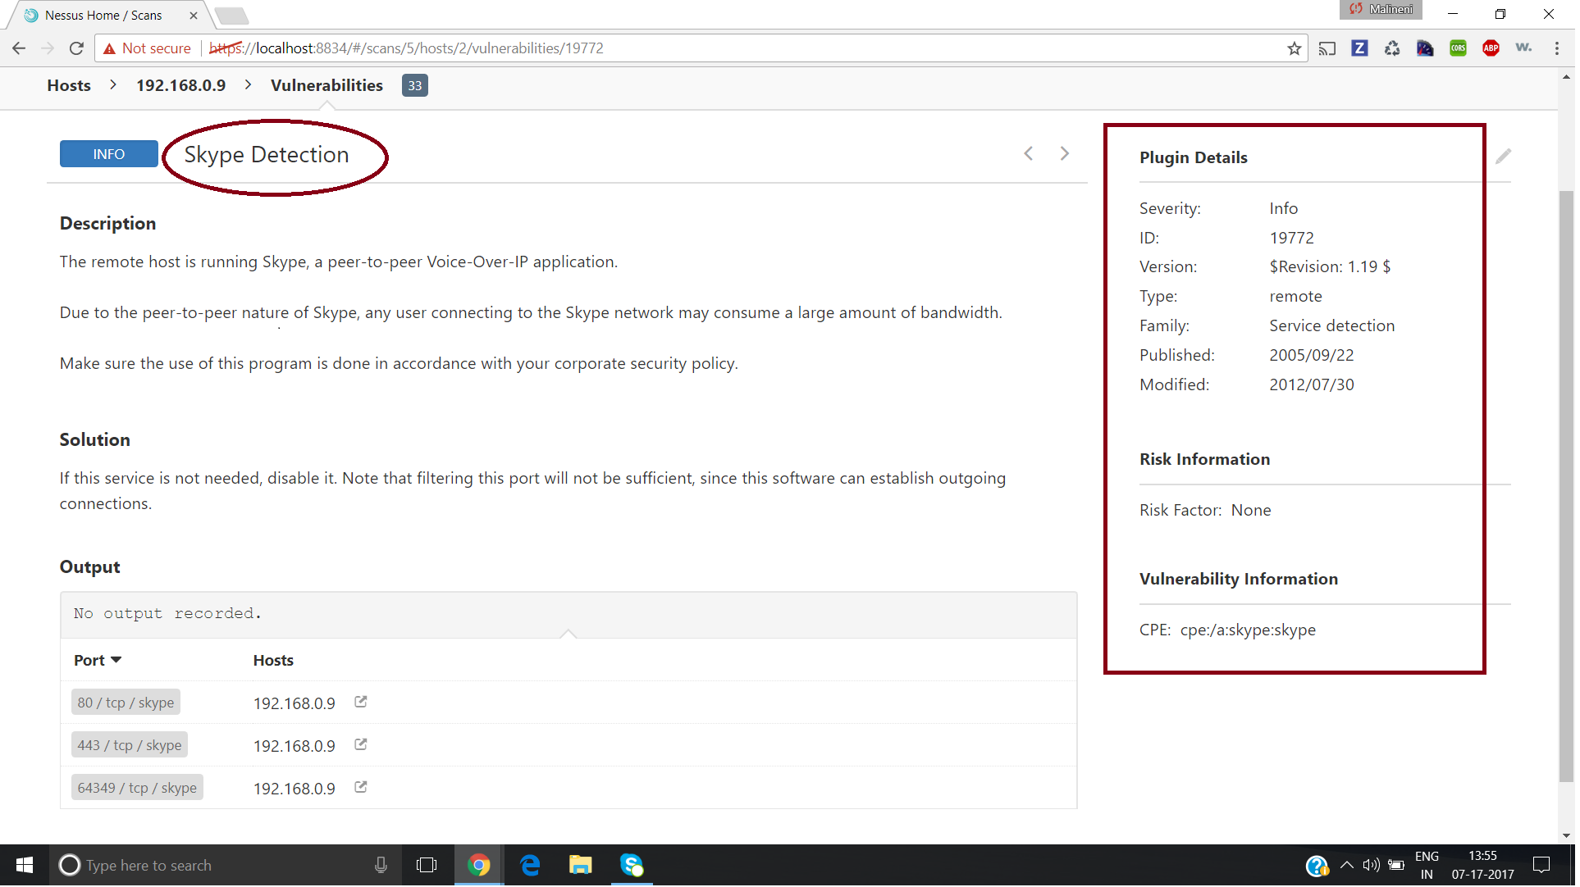

**Please find the attached PDF for the report of the scan for advanced scan.**

