**Lab Assignment – 1**

1. Class diagram for chat application:

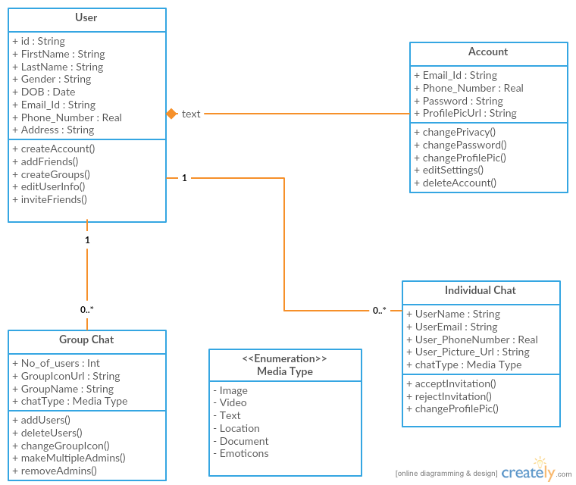

1. Iteration – 1 for Lab assignment - 1

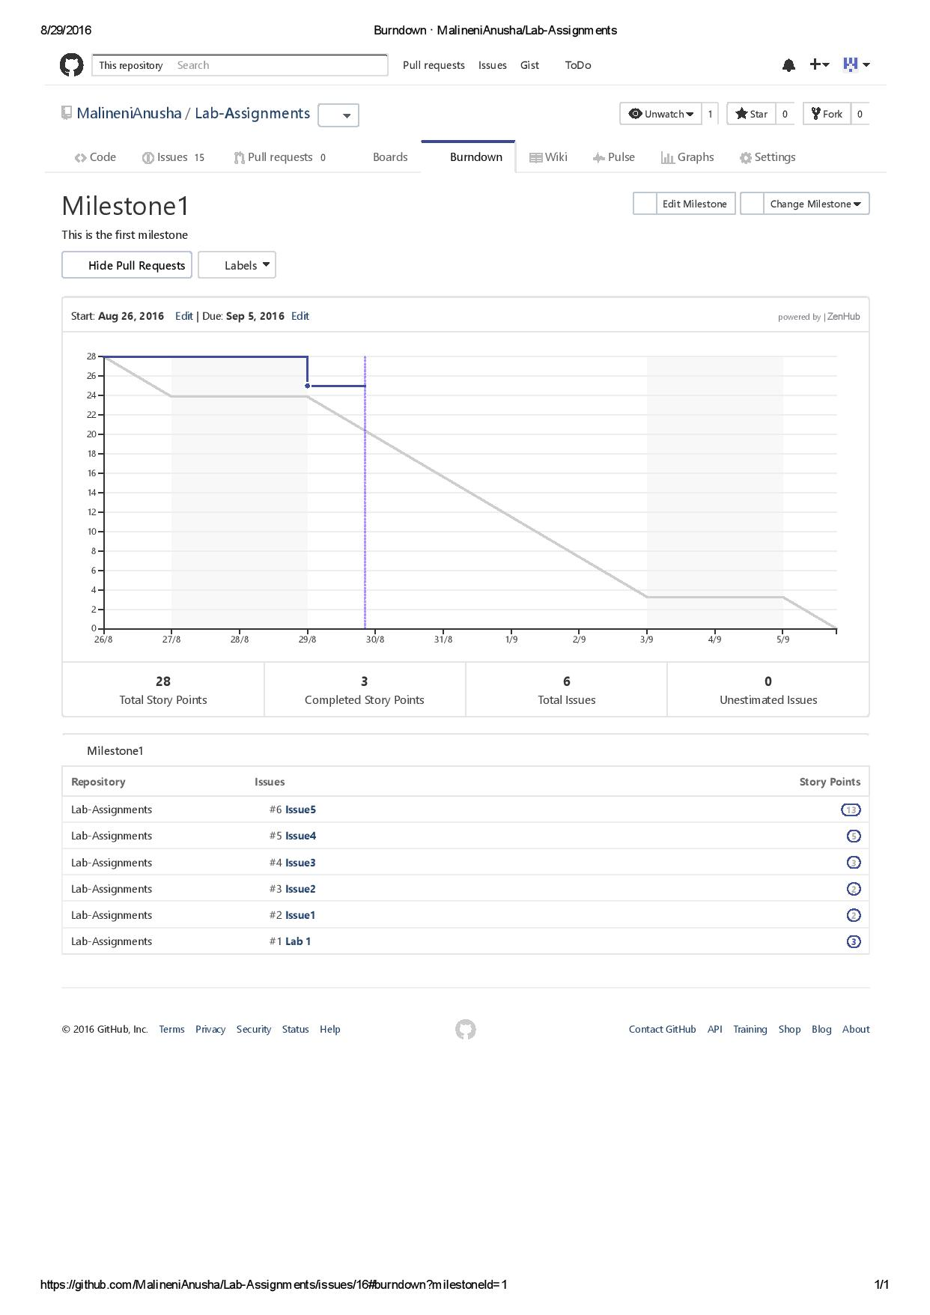

1. Iteration – 2 for Lab assignment – 1

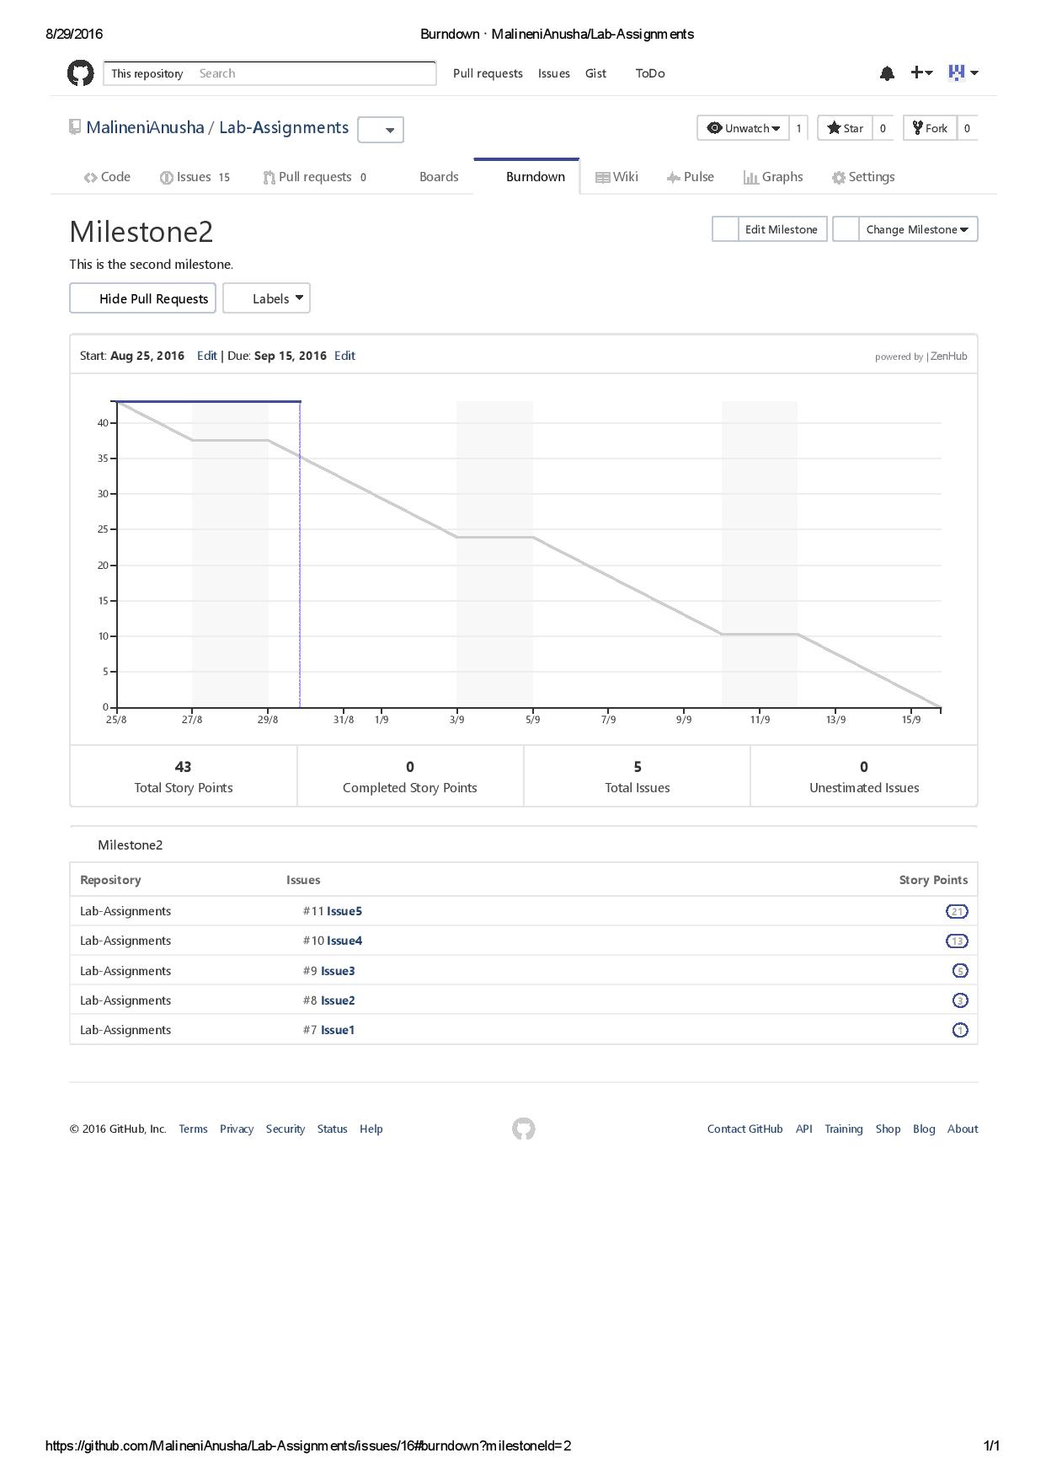

1. Iteration – 3 for Lab assignment – 1

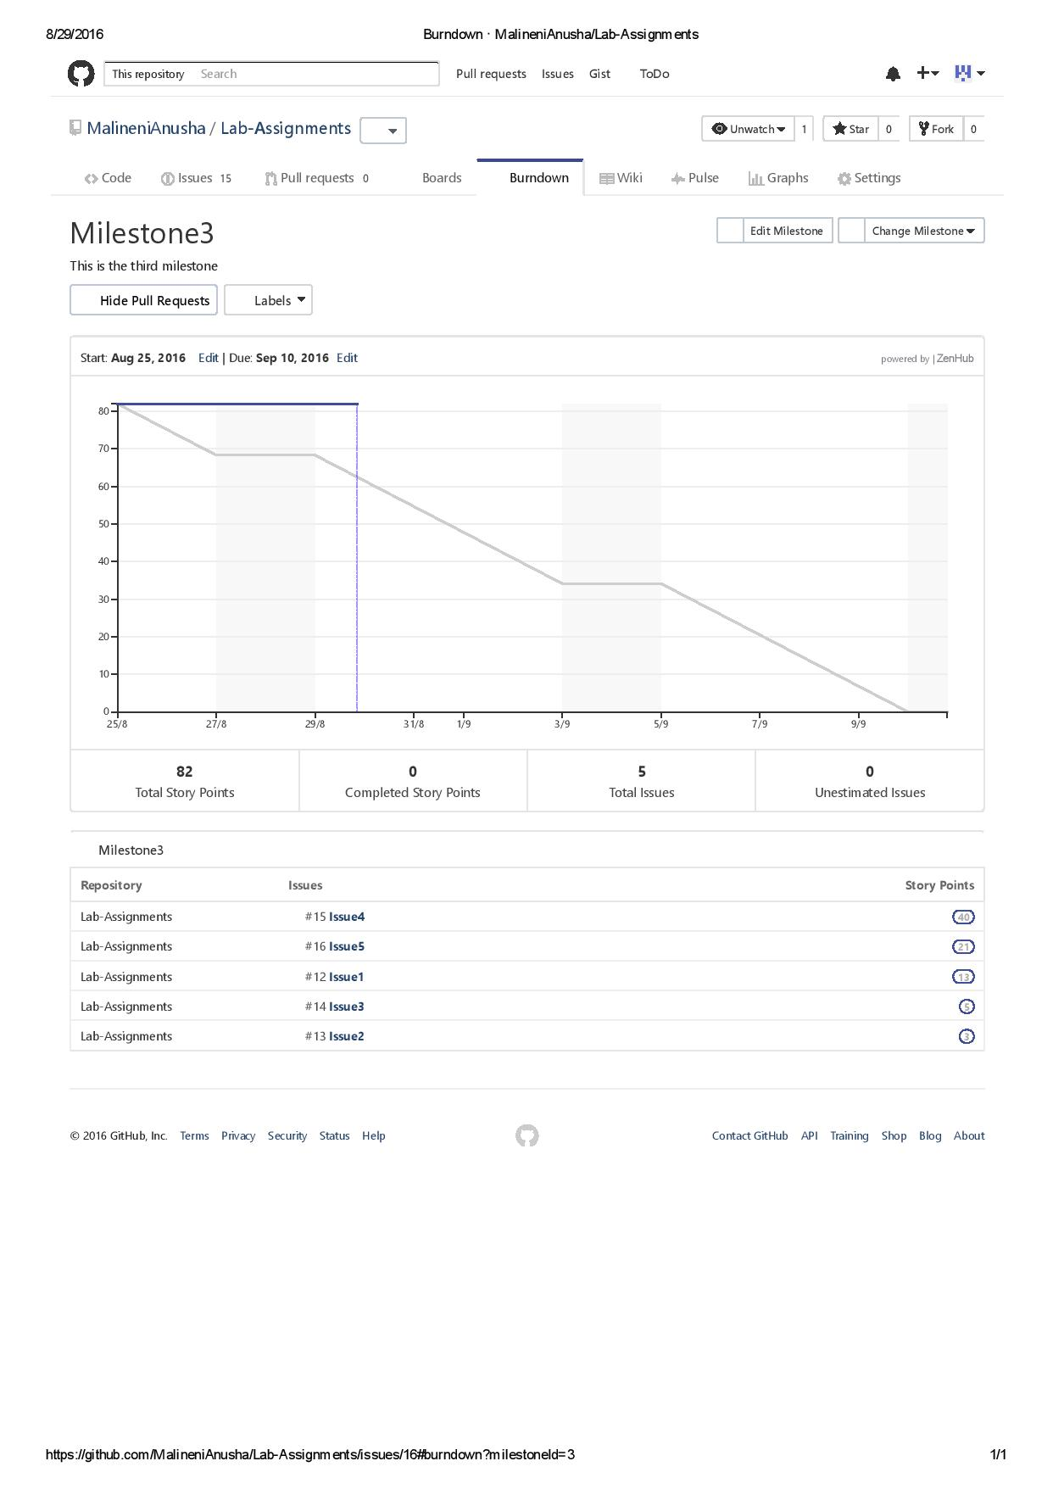

1. Wiki Page for Lab assignment – 1

