**NETWORK ARCHITECTURE - 1**

**HOME WORK - 2**

**FALL 2016**

**SUBMITTED BY:**

**ANUSHA MALINENI**

**STUDENT ID: 16233382**

**1) In CSMA/CD, after the fifth collision, what is the probability that a node chooses K=10? The result K=10 corresponds to a delay of how many seconds on a 10 Mbps Ethernet?**

**Solution:**

**Given:**

K = 10

10 Mbps Ethernet

M = 5

In case of Ethernet CSMA/CD algorithm after aborting, NIC enters binary exponential back off. After mth collisions, NIC chooses K at random from {0,1,2…, (2^(m))-1}. NIC waits K.512 bit times.

Here 2^(m)-1 = 2^(5)-1 = 32-1 = 31

Hence, after the fifth collision the adapter will choose a value of K from {0,1,2,…31}

Probability that the node chooses the value of K=10 from among 32 values is 1/32.

Taking K=10, waiting time is 10*512 bit times.

On a 10 Mbps Ethernet, it will correspond to a delay of

= (10*512) / (10 * 1000 *1000)

= 512 micro seconds.

**2) Consider three LANs interconnected by two routers, as shown in the diagram below**

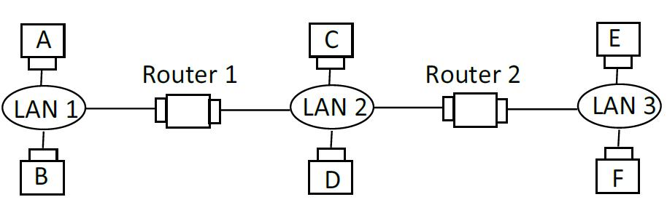

**(a) Assign IP addresses to all the interfaces. For subnet 1 use address of the form 111.111.111.XXX; for subnet 2 use address of the form 122.222.222.XXX; and for subnet 3 use address of the form 133.133.133.XXX.**

**Solution:**

For subnet 1 IP addresses to all the interfaces are 111.111.111.001, 111.111.111.002, 111.111.111.003.

For subnet 2 IP addresses to all the interfaces are 122.222.222.001, 122.222.222.002, 122.222.222.003.

For subnet 3 IP addresses to all the interfaces are 133.133.133.001, 133.133.133.002, 133.133.133.003.

**(b) (randomly) Assign MAC addresses to all the adapters.**

**Solution:**

MAC address of the adapter connecting host A to LAN is 00-00-00-00-00-00.

MAC address of the adapter connecting host B to LAN is 11-11-11-11-11-11.

MAC address of the adapter connecting LAN to 1st router is 22-22-22-22-22-22

MAC address of the adapter connecting 1st router to LAN is 33-33-33-33-33-33.

MAC address of the adapter connecting host C to LAN is 44-44-44-44-44-44.

MAC address of the adapter connecting LAN to 2nd router is 55-55-55-55-55-55.

MAC address of the adapter connecting host D to LAN is 66-66-66-66-66-66.

MAC address of the adapter connecting host E to LAN is 77-77-77-77-77-77.

MAC address of the adapter connecting 2nd router to LAN is 88-88-88-88-88-88.

MAC address of the adapter connecting host F to LAN is 99-99-99-99-99-99.

**(c) Consider sending and IP datagram from Host A to Host F. Suppose all of the ARP tables are up to date. Enumerate all the steps as done for the single-router example.**

**Solution:**

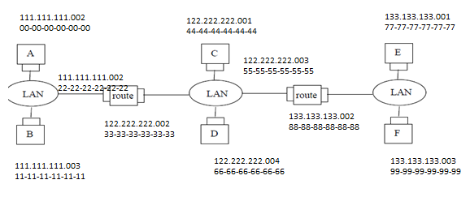

**Steps:**

1) Address resolution protocol ARP table in A determines that the datagram should be sent to the interface 111.111.111.002.

2) Host A uses ARP to determine the LAN address for 111.111.111.002, which is 22-22-22-22-22-22.

3) The adapter in A sends an Ethernet packet with Ethernet destination address 22-22-22-22-22-22.

4) The first router receives the packet and extracts the datagram. The forwarding table in this router indicates that the datagram is to be routed to 122.222.222.003.

5) The first router then uses ARP to obtain the associated Ethernet address, namely 55-55-55-55-55-55.

6) Now, the packet is forwarded to the second router having destination Ethernet address 55-55-55-55-55-55.

7) The second router receives the packet and extracts the datagram. The forwarding table in this router indicates that the datagram is to be routed to 133.133.133.003.

8) The second router then uses ARP to obtain the associated Ethernet address, namely 99-99-99-99-99-99.

9) Now, the packet is sent to the final destination having Ethernet address 99-99-99-99-99-99 from second router.

**(d) Repeat (c), now assuming that the ARP table in the sending host is empty (and all other tables are up to date).**

**Solution:**

If the ARP table in the sending host is empty then ARP in A has to determine the MAC address of first router interface.

**Steps to find the LAN address:**

1. Host A sends out an ARP query packet within a broadcast ethernet frame.
2. The first router receives the query packet and sends back an ARP response to packet A. This ARP response packet is carried by an ethernet frame with destination address 00-00-00-00-00-00.

Now, the ARP table of host A is updated with an entry of MAC address of the router. Then IP datagram is sent in the same sequence of steps as mentioned below.

**Steps:**

1) Address resolution protocol ARP table in A determines that the datagram should be sent to the interface 111.111.111.002.

2) Host A uses ARP to determine the LAN address for 111.111.111.002, which is 22-22-22-22-22-22.

3) The adapter in A sends an Ethernet packet with Ethernet destination address 22-22-22-22-22-22.

4) The first router receives the packet and extracts the datagram. The forwarding table in this router indicates that the datagram is to be routed to 122.222.222.003.

5) The first router then uses ARP to obtain the associated Ethernet ad dress, namely 55-55-55-55-55-55.

6) Now, the packet is forwarded to the second router having destination Ethernet address 55-55-55-55-55-55.

7) The second router receives the packet and extracts the datagram. The forwarding table in this router indicates that the datagram is to be routed to 133.133.133.003.

8) The second router then uses ARP to obtain the associated Ethernet address, namely 99-99-99-99-99-99.

9) Now, the packet is sent to the final destination having Ethernet address 99-99-99-99-99-99 from second router.

1. **Suppose a CSMA/CD network is running 100 Mbps over a 1-km cable with no repeaters. The signal speed in the cable is 400,000km/sec.**
2. **Compute the following:**

**Given:**

Cable length is 1km

Signal speed is 400,000km/sec

Bandwidth is 100Mbps

**(i) End to end propagation delay**

= cable length/signal speed

= 1km/200,000 km/sec

= (1 / 200,000)

= 0.000005 seconds

**(ii) Worst-case collision detection time**

= Round trip propagation time

= 0.000005 * 2

= 0.00001 seconds

**(iii) Minimum frame size**

= 2*t*bandwidth

= 0.00001 * 100 * 1000 * 1000 bits

= 1000 bits

1. **Suppose we increase the bandwidth from 100 Mbps to 1 Gbps, how does it affect the above three values?**

**Solution:**

**Given:**

bandwidth increased from 100 Mbps to 1 Gbps.

End to end propagation delay and collision detection time does not change with the increase in bandwidth since they are independent of the change in bandwidth.

Minimum frame size changes which is as follows:

Minimum frame size = worst case collision * Bandwidth

= 0.00001 * 109 bits

= 10,000 bits

**Laboratory Homework**

**1. What are the Physical and IP addresses of the host?**

**Solution:**

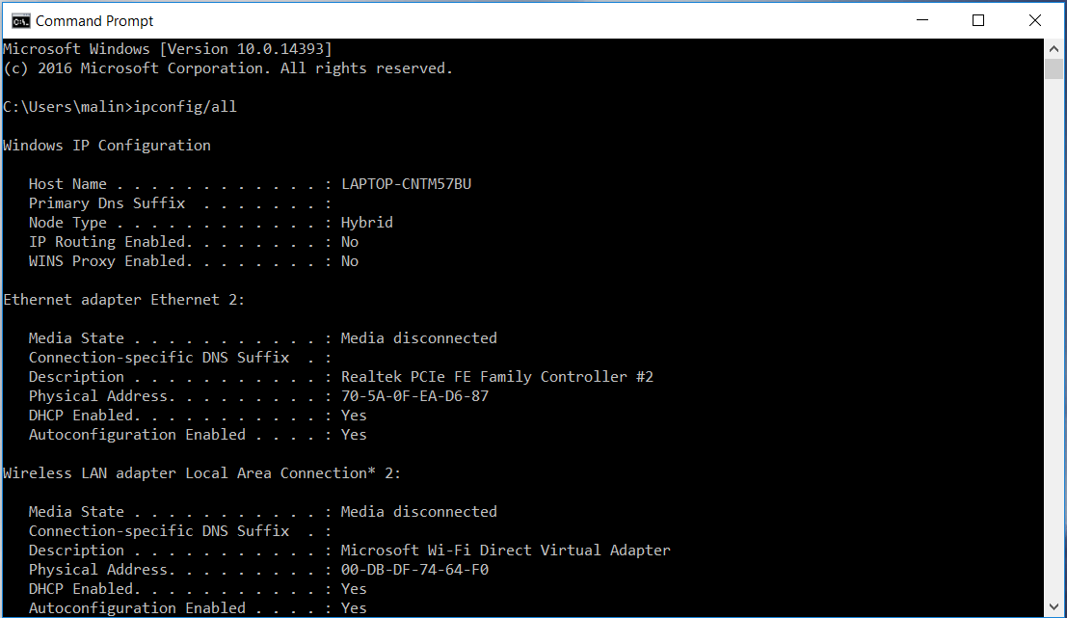

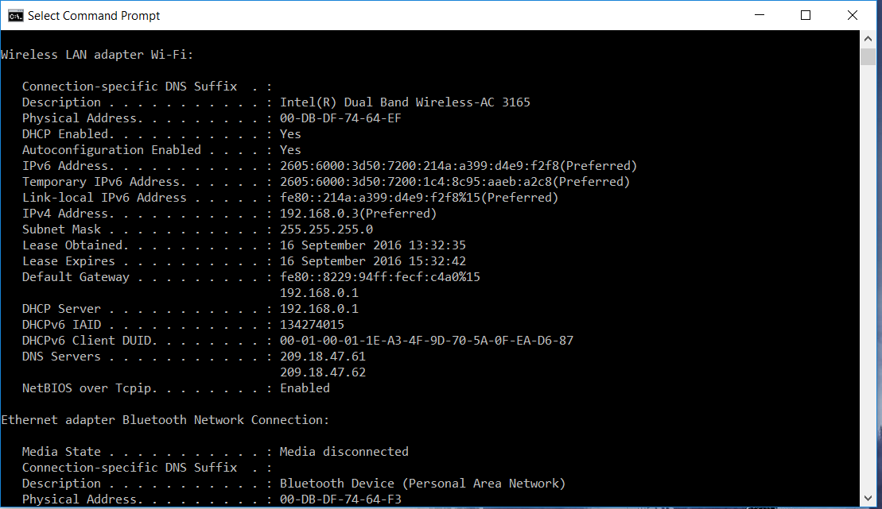

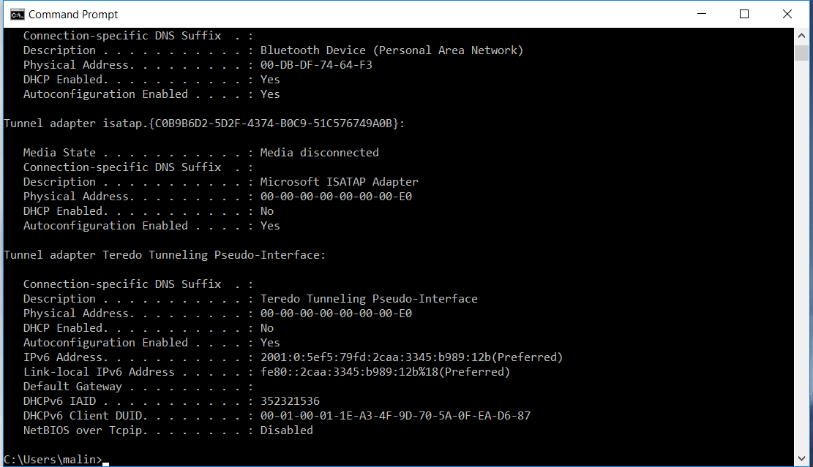

From above **Physical** address,

For Wireless LAN adapter Local Area Connection = **00-DB-DF-74-64-EF**

And **IP** Address = **192.168.0.3**

**2. How many bits are for the subnet mask? What is the subnet (not subnet mask) of the host?**

**Solution:**

Generally, for subnet mask = 32 bits,

Here subnet mask is 255. 255. 255. 0 or **24 bits**.

Number of bits for subnet mask here is 24 bits

We have IP address = 192.168.0.3 and

Subnet mask = 255. 255. 255. 0

To get **subnet** of the host we use **AND** operation between IP and subnet mask:

Converting IP address and subnet mask to binary form,

IP address = 11000000. 10101000. 00000000. 00000011

Subnet mask = 11111111. 11111111. 11111111. 00000000

**Subnet** = **11000000. 10101000. 00000000. 00000000**

Therefore, subnet = **192. 168. 0. 0**

**Laboratory Homework Part 2: arp**

**3. Try ‘arp’ command in order to**

**(a) Show the current ARP table of an interface of your host**

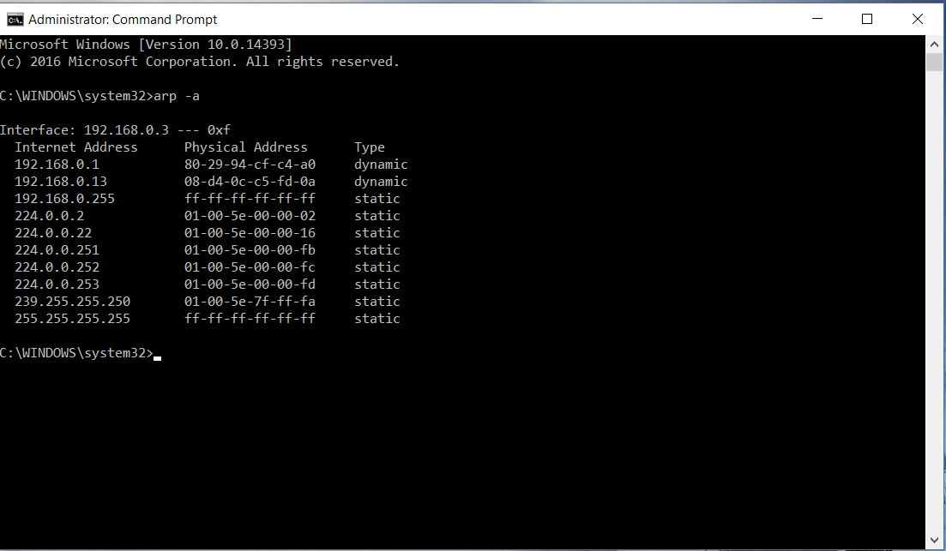

**(b) Delete all current entries of the ARP table of an interface of your host**

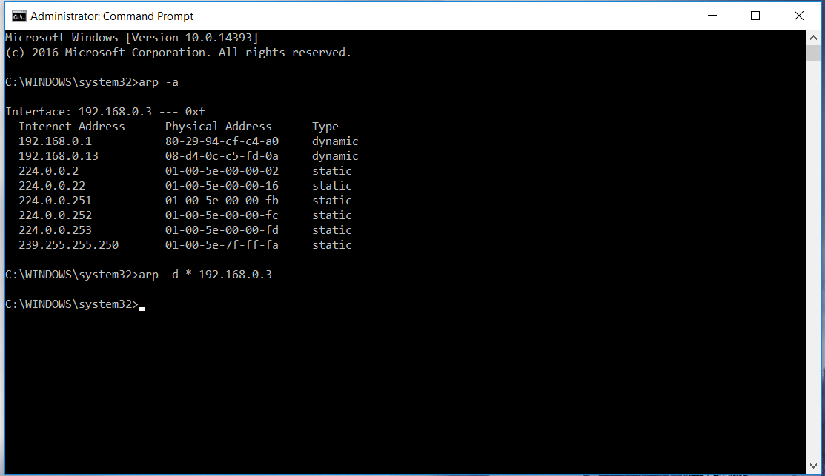

1. **Show the ARP table again after a web browsing**

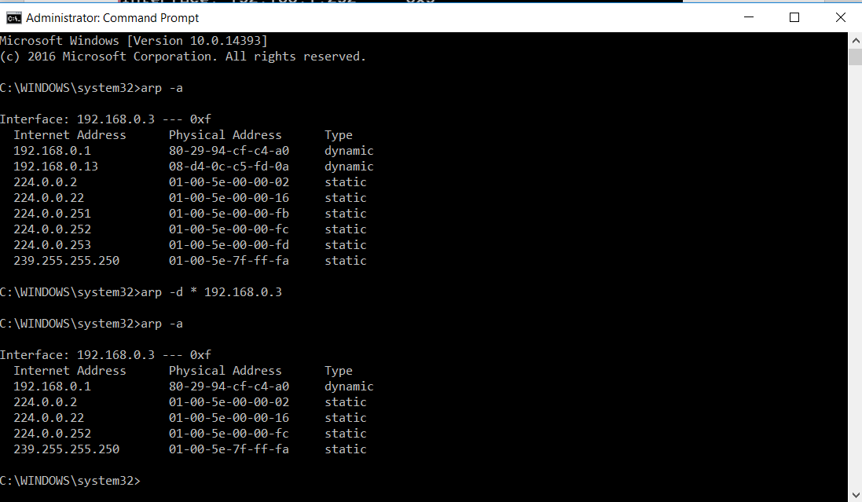

1. **Show the ARP table again after a few minutes of no network activity**

