Network Architecture-1

Project-2

Fall 2016



Submitted by:

Anusha Malineni (16233382)

Sri Sai Narayana Ram Gopal Mangena (16230843)

Sudhireddy Sainath Reddy (16232714)

**Table of Contents**

1. **Introduction............................................................................................................................ 3**
2. **About GENI and Putty........................................................................................................... 3**
3. **Project Description............................................................................................................... 8**

**3.1 Question-a......................................................................................................................... 8 3.2 Question-b........................................................................................................................12 3.3 Question-c ........................................................................................................................15**

**3.4 Question-d ........................................................................................................................18**

**4. References .............................................................................................................................. 21**

**1. Introduction**

In this project, we are developing a simple Chat application by using TCP Client and Server. By using resources in GENI, we have connected several clients to single server. In Question a, we created a chat server that accepts a single client connection and displays messages from the client and the connection get terminated from both sides when the client types ‘exit’. In Question b, when one client terminates, the server remains open for the other client’s that wish to communicate. In Question c, the server will be able to handle multiple clients at a time and the server window displays the messages from the clients. In Question d, the server even echoes the messages from a client to all the remaining clients in the network.

**2. About GENI and Putty**

We need to first create a GENI account and a slice where we can reserve our resources on which we can work.

**GENI Account Creation:**

GENI provides a virtual laboratory for networking and distributed systems research and education.

1. Login to portal.geni.net

2. Activate the GENI account with the required credentials.

3. Download the SSH keys (Putty) for authentication process.

4. Using the Putty key generator, generate a private key which will be used to open the Client and Server windows.

**Steps involved:**

**Step 1:**

After logging in to GENI Portal, we have downloaded the SSH keypairs for authentication purposes.

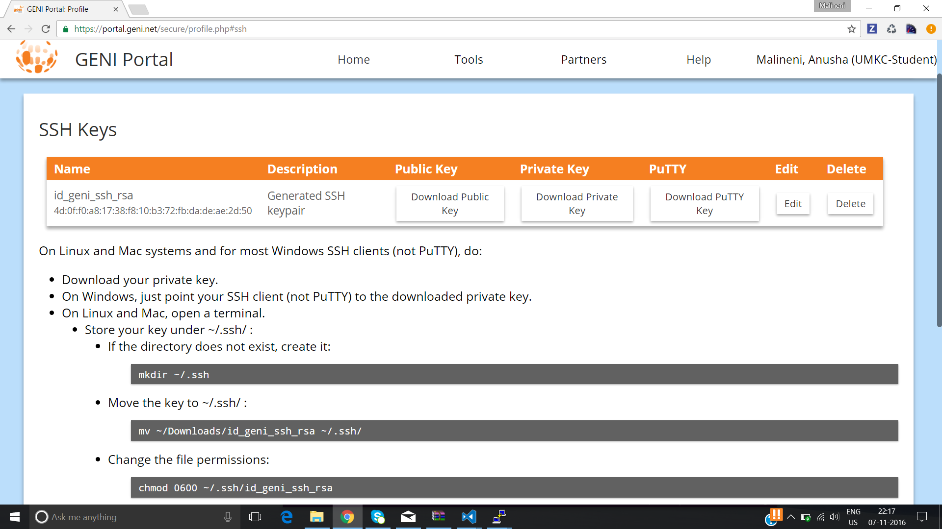

**Step 2**:

Created a slice “Project-2” and added four resources i,'e four VM’s. One of the VMs acts as server and the remaining three will act as clients. In the next step, I’ve established connection between these four resources.

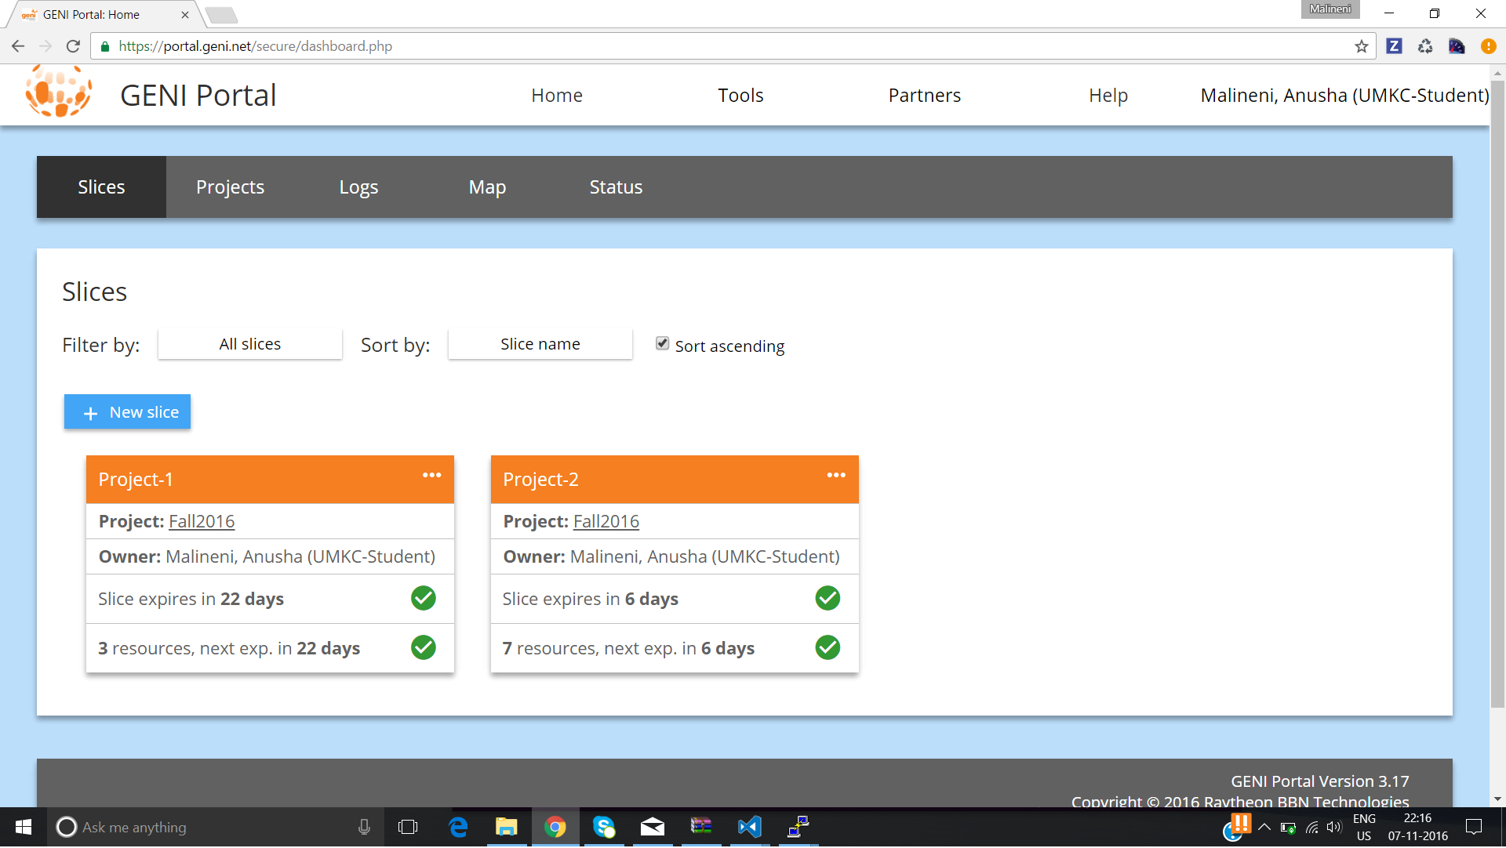

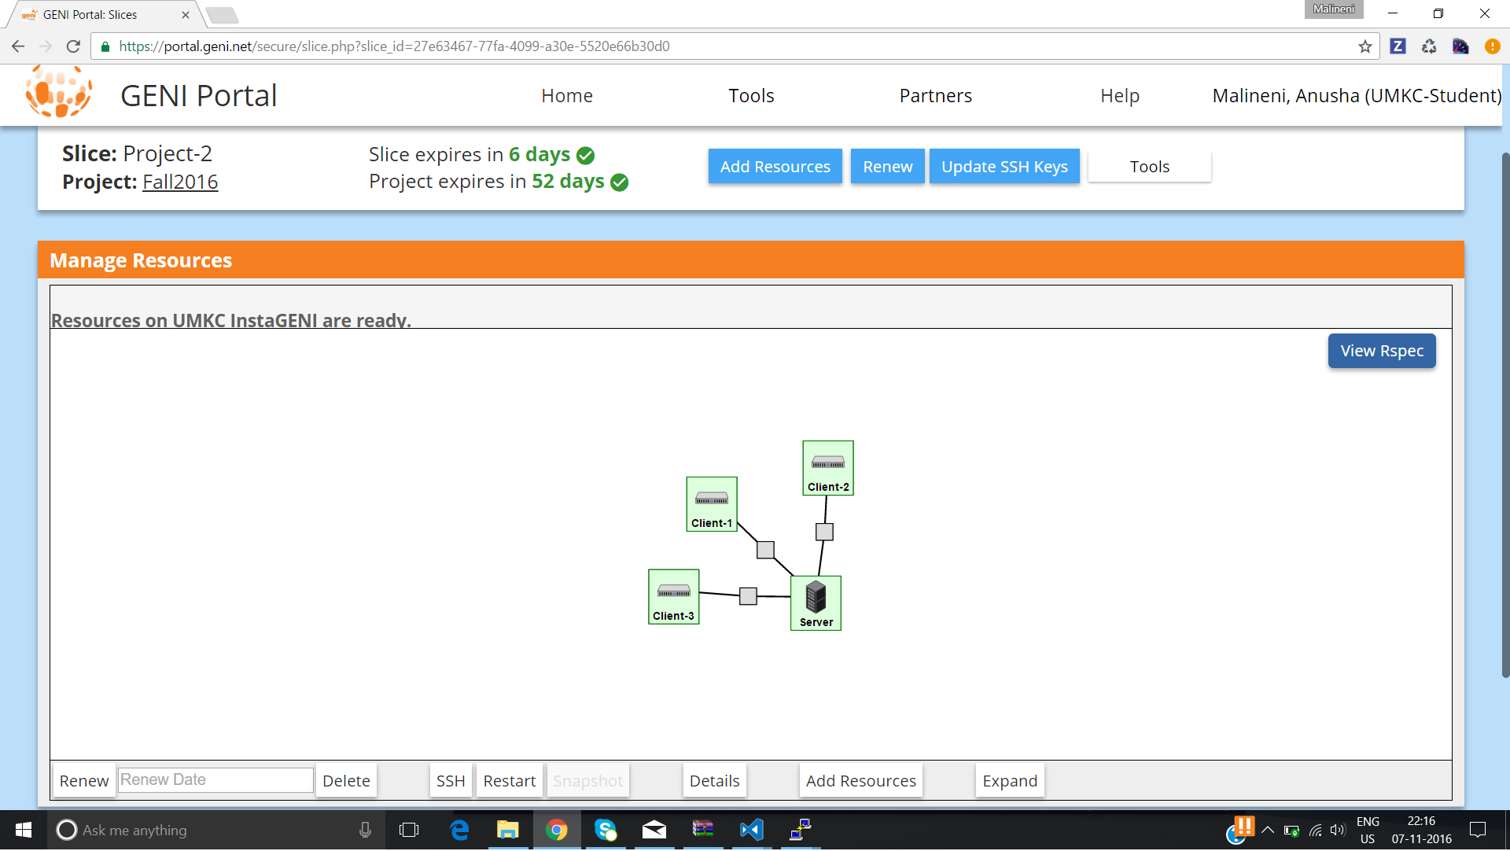

**Step 3**:

After selecting the resources and establishing connection between them, resources will be allocated to the slice and status of these resources will change to ‘Ready’.

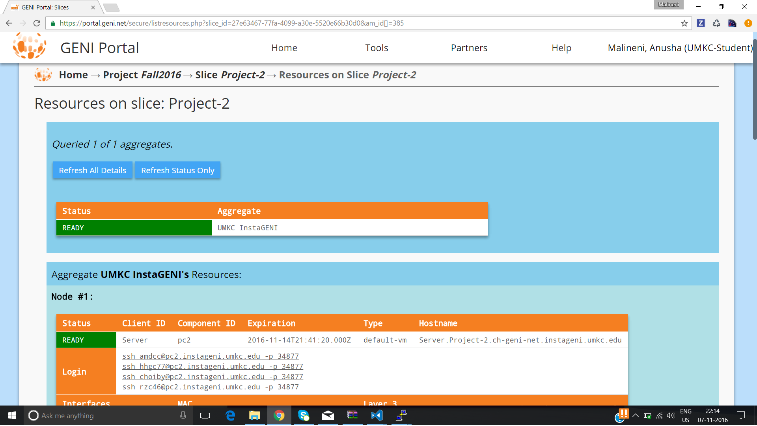

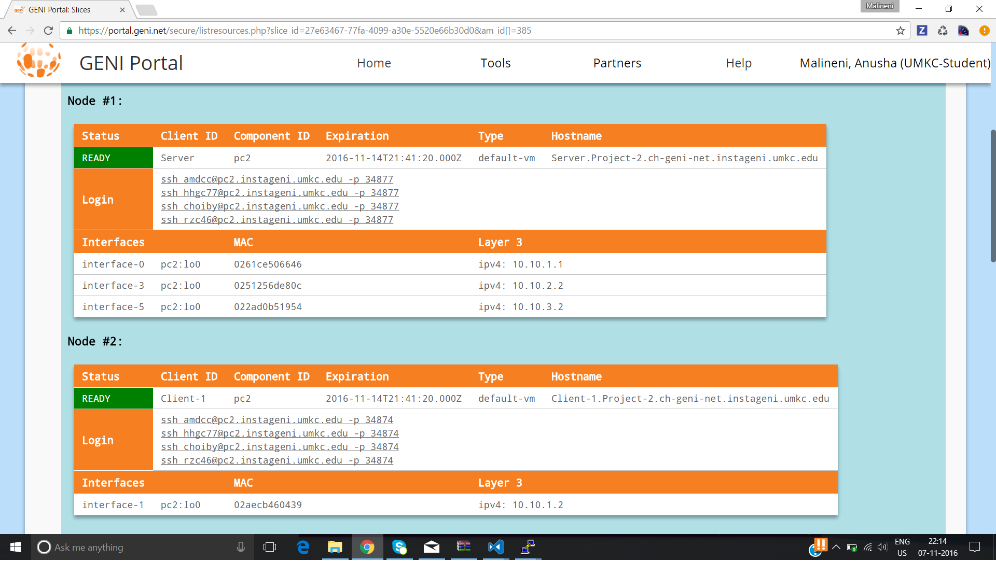

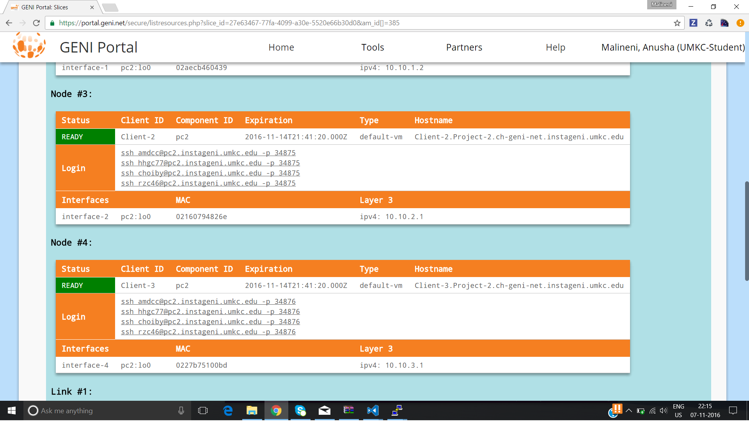

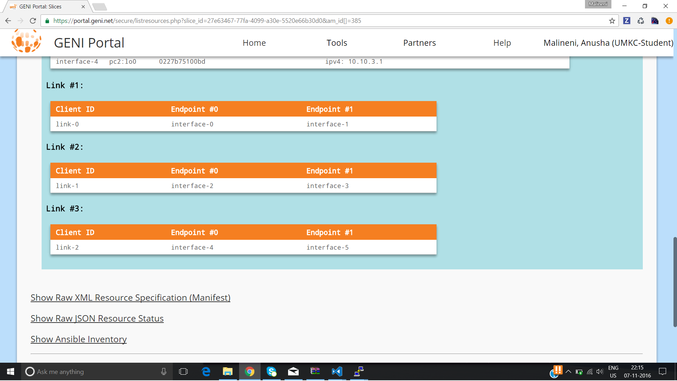

**Step 4**:

By using putty, we need to load all the clients and servers.

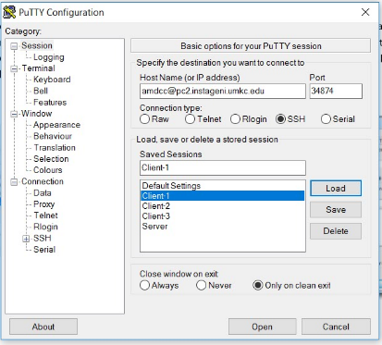

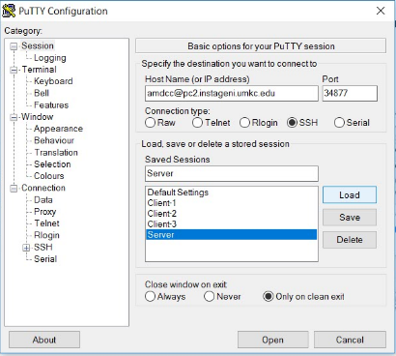

**3. Project Description**

Need to develop a simple chat program (like google hangout and skype chat).

**3.1 Question a**:

**A chat server will accept a single client connection and display everything the client types. If the client user types ‘exit’, both client and server will end the program.**

**Solution:**

Client and server java programs were loaded to client and server respectively. After compiling and running those programs both client and server will run.

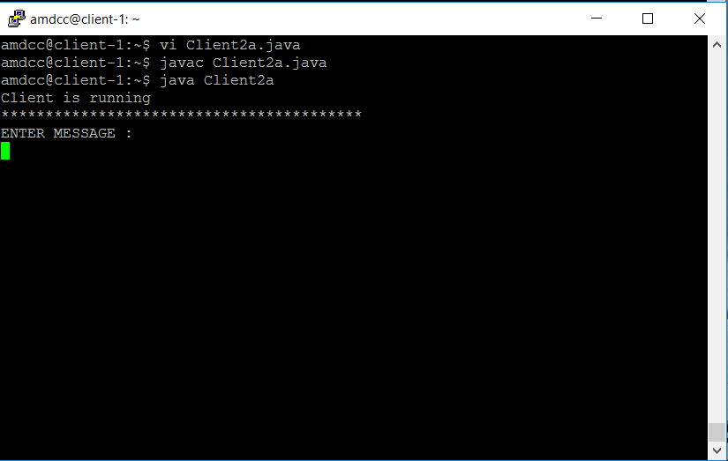

Both client and server can communicate with each other through messages. This connection will stay till client sends ‘exit’. Once client sends ‘exit’ connection between client and server will get terminated. Both client and server connections will get terminated.

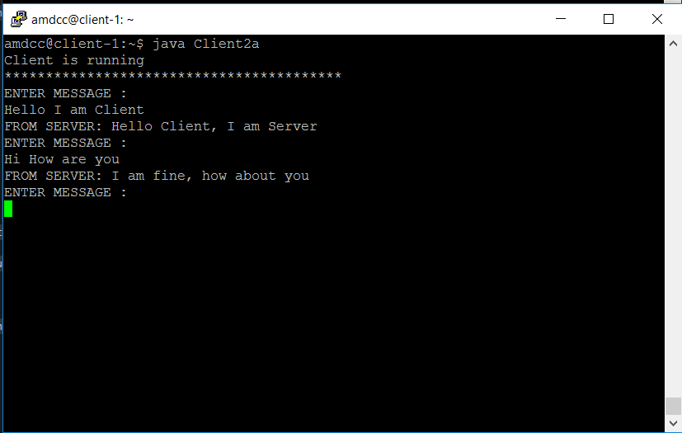

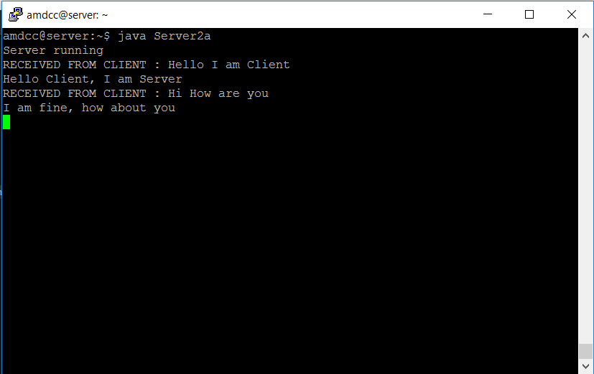

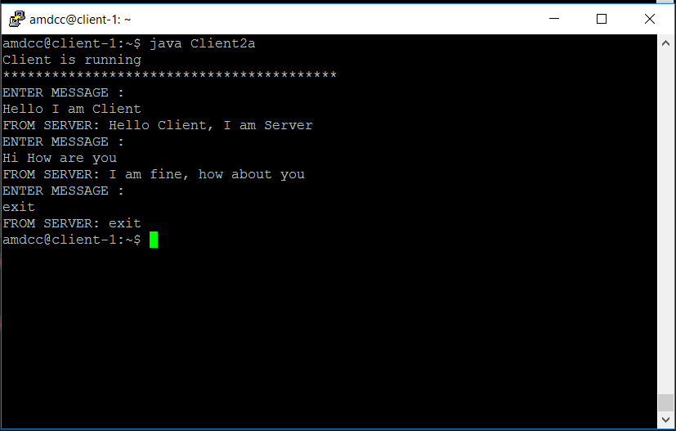

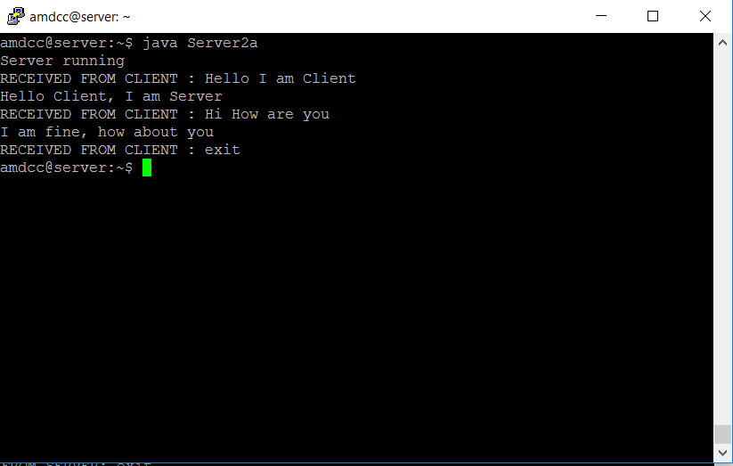

**3.2 Question-b:**

**A server now remains ‘open’ for additional connection once a client quits. The server can handle at most one connection at a time.**

**Solution:**

For the question b, client and server java programs were loaded to client and server. Both client and server can communicate with each other through messages. Once client sends ‘exit’, connection of the client will be terminated and server connection will wait for next client to connect.

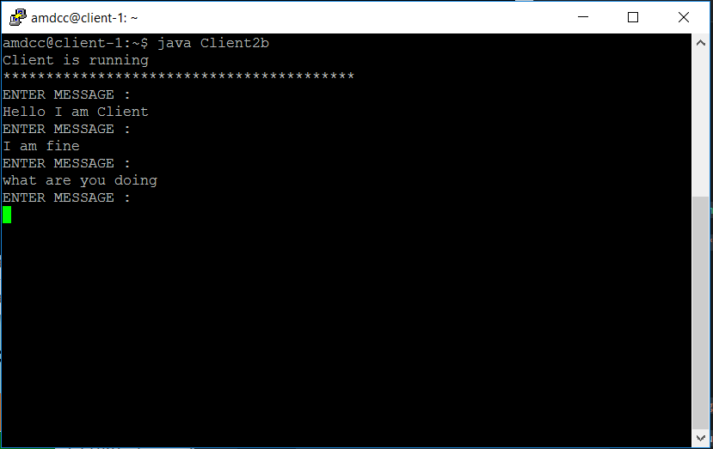

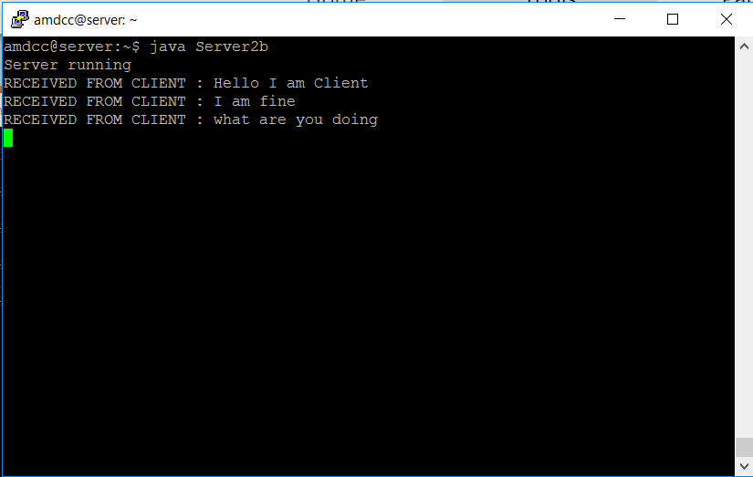

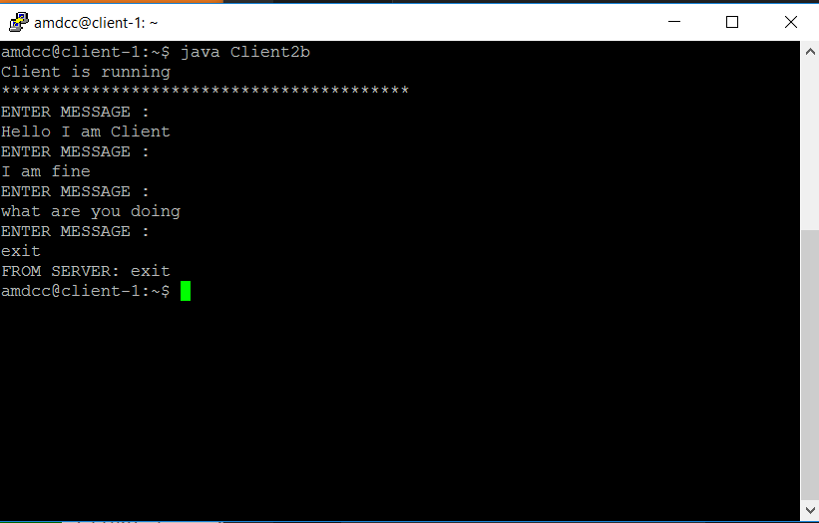

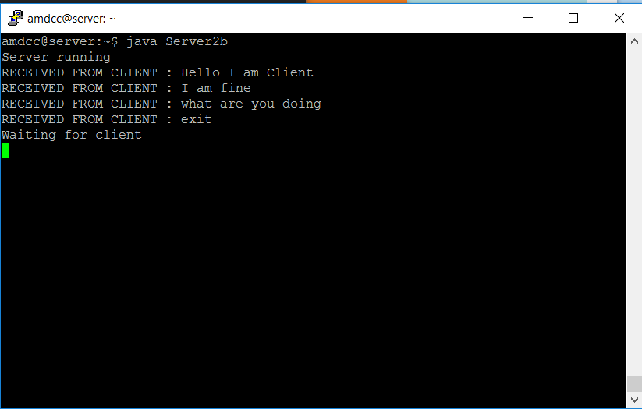

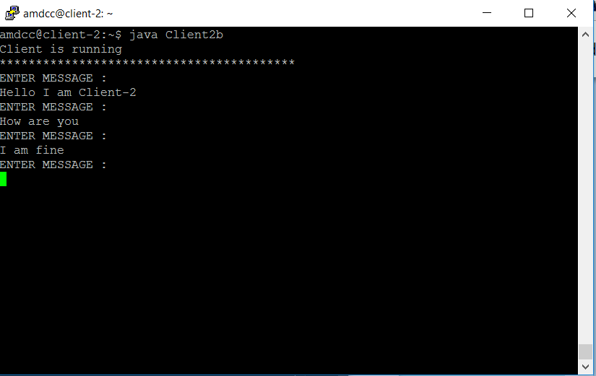

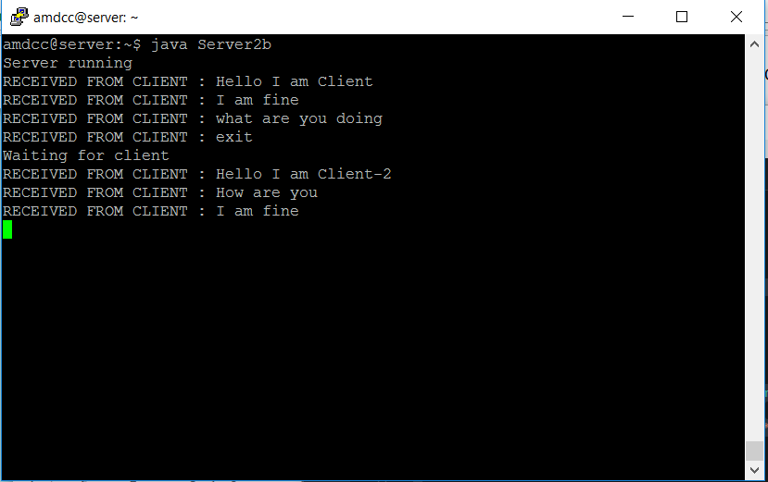

**3.3 Question-c:**

**A server now can handle multiple clients at the same time. The output from all the connected clients will appear on the server’s screen.**

**Solution:**

For the question c, required client and server java programs were loaded to both client and server. Here server handles multiple clients at the same time and it accepts messages from all connected clients and all the messages from the clients were displayed on server.

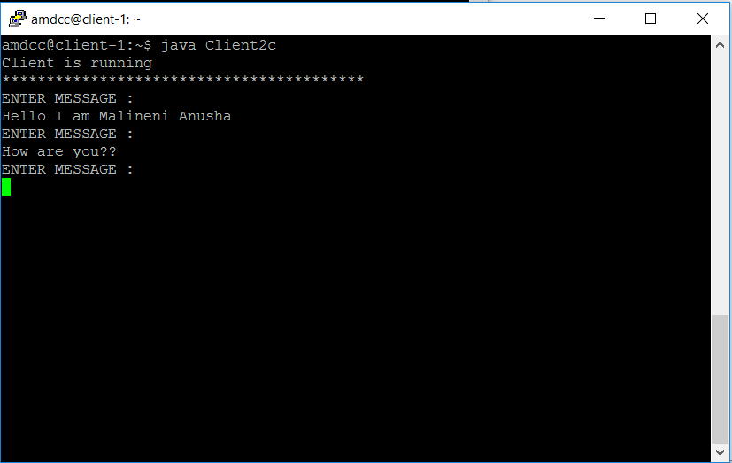

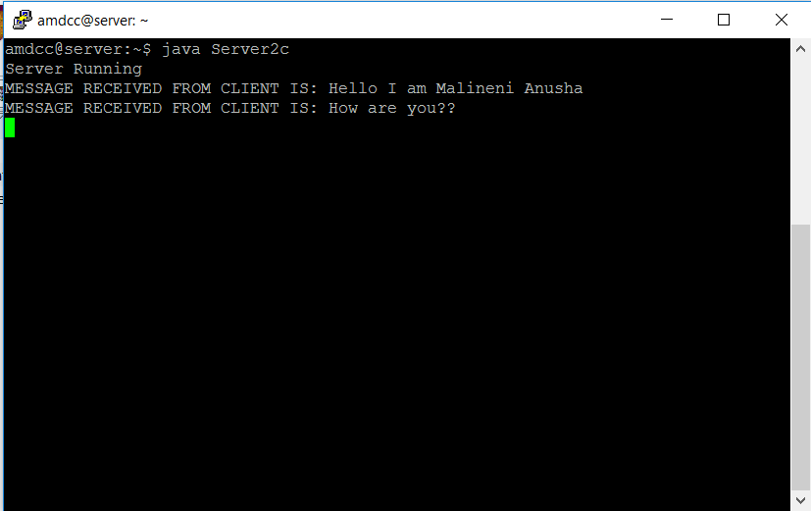

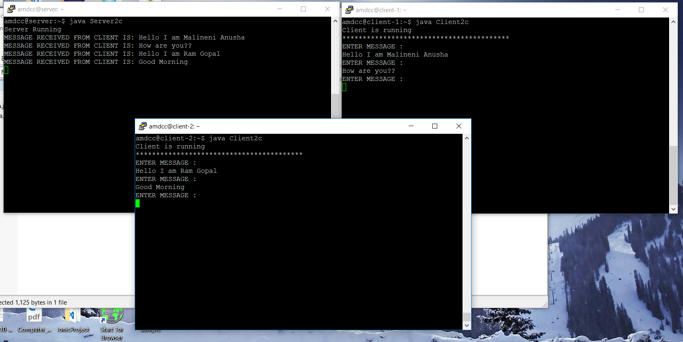

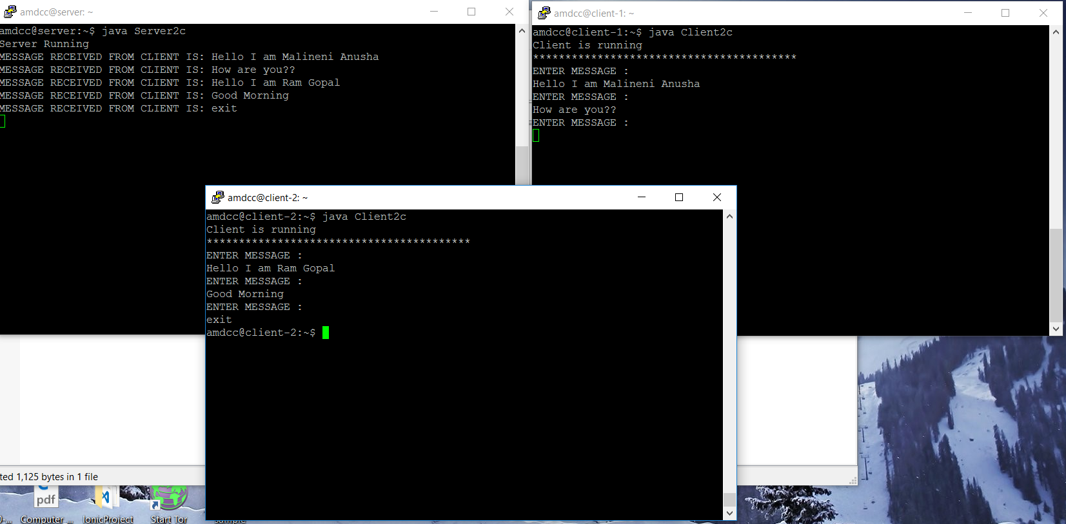

**3.4 Question-d:**

**A server now echoes all the text received from any of the connected clients to all.**

**Solution:**

Java files are created for each of the Clients and Server through which messages are received and sent back. In this query, we show that when any of the Clients sends its message to the Server, it broadcasts the message to the remaining Clients with the name of the Client specified.

Here we are connecting to 3 Clients, whenever new Client is started to Chat Application the intimation is given to all other Clients. Also, when Client is left from Chat the exit message is sent to Server. The communication between client and server is echoed to all other servers. For example, Client-2 sends message ‘hello’, this message will be displayed on Clien-1, Client-3 along with Server.

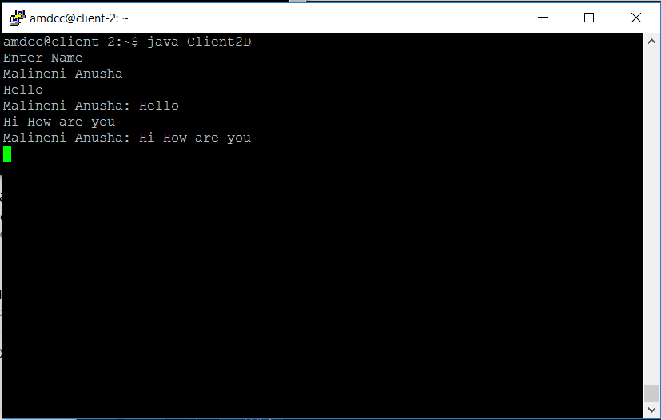

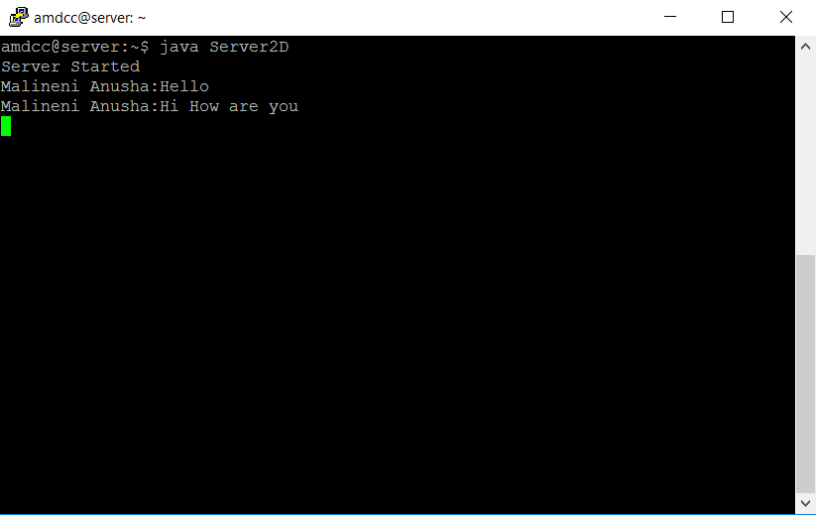

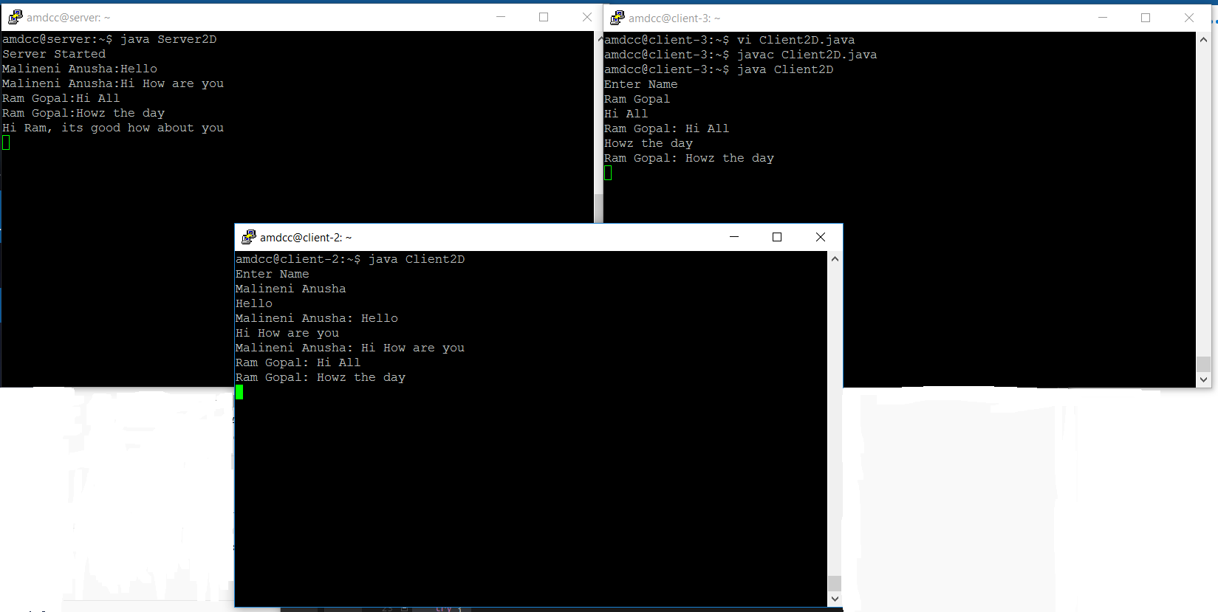

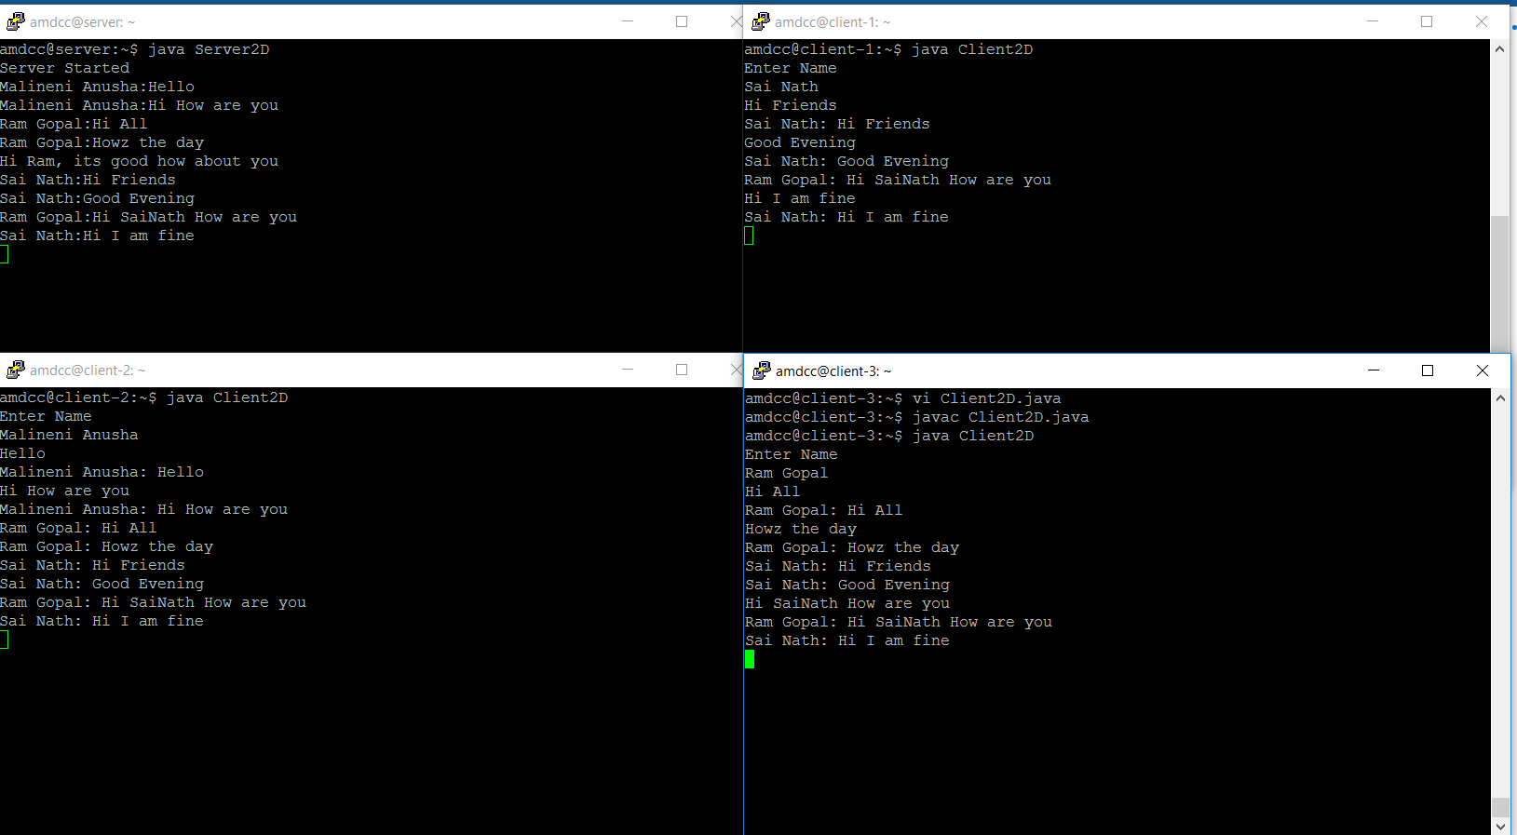

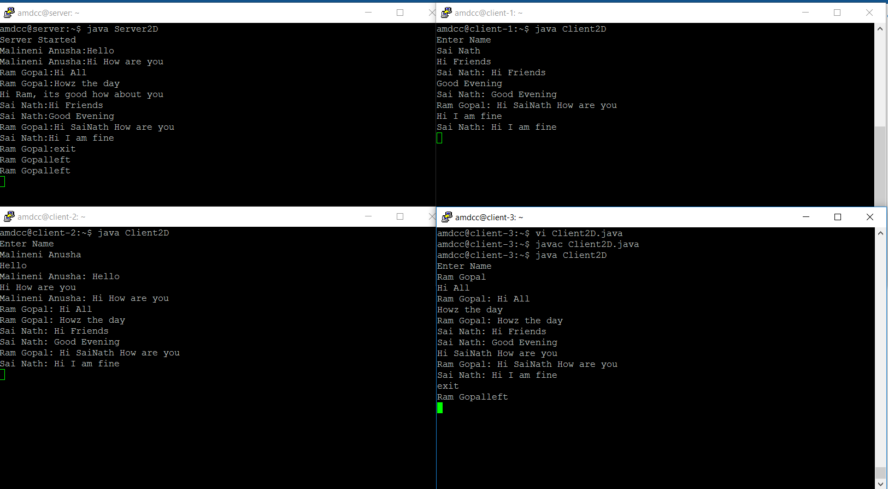

**4. References**

1. <http://portal.geni.net/secure/dashboard.php>
2. <http://stackoverflow.com/>
3. <http://www.putty.org/>