DDoS Detection Powered by Machine Learning: A Comparative Analysis Using the CIC-DDoS2019 Dataset

Victor Ioan MĂLINESCU, Assoc. Professor Daniel ZINCA
Communication Department, Technical University of Cluj-Napoca, Romania

Corresponding author: malinescuionut@yahoo.com

Abstract: This study uses the CICDDoS2019 dataset to assess how well three machine learning models, namely: Random Forest, XGBoost, and LightGBM perform in identifying Distributed Denial of Service (DDoS) assaults. The models' robustness in identifying malicious network traffic was demonstrated by their high accuracy, precision, recall, and F1 scores. A feature importance analysis revealed significant traffic patterns that facilitated detection. Real-time DDoS detection, attack type classification, and Flask-based automated solution deployment are potential avenues for further research. The results demonstrate how machine learning may improve network security and detour DDoS attacks in an ever evolving cyber environments.

Keywords: DDoS, Machine Learning, Random Forrest, XGB Classifier (Extreme Gradient Boosting), LGBM Classifier (Light Gradient-Boosting Machine), Supervised Learning, CIC-DDoS2019 Dataset

I. Introduction

The Internet has undergone some great advancements in the last decades providing users with a reliable, easy to use and fast way of communicating with one another. Because of these key-benefits and many more, people have migrated to using this powerful tool more and more over the years. The Internet was designed to interconnect networks and to ease the sharing of data between them.

Because of its exponential growth over the years, and now the reliance of an ever-increasing number of users and systems to it, defense mechanisms had to also be developed alongside it. The constantly expanding Internet requires a an even more up-to-date way of protecting it, which is done with the help of a firewall, as the first line of defense, as well as through cryptography.

Attacks performed on networks are known as “Anomalies” because when they transpire, abnormal events occur which stray from the usual conduct of a system; this matter will be important later when designing a system able to detect such intrusions.

Some of the most often utilized types of digital assaults are Denial of Service attacks. Such attacks are meant to disrupt the normal activity of a targeted server, service or even a network by overloading it with requests over the system’s capacity to process them [1].

Distributed Denial of Service attacks (DDoS) are more advanced DoS attacks, as instead of only utilizing one infected host, also known as a “Zombie”, they utilize a plethora of such machines, making such attacks hard to detour. Usually, these attacks are done by compromised machines, unknowingly to them, the machines being part of a so-called botnet and depending on the size of this botnet the damage caused by them can be substantial and almost immediate.
Some usual types of attacks will be described in the next sequence of this paper [2]. Attacks can be of three broad kinds:
- Connection – Oriented Attacks – an already existing connection must exist between the attacker and the victim before the DDoS attack can be launched.
- Connectionless Attacks – do not require an already opened connection between the attacker and the victim as protocols which do not establish a handshake can be sent in massive numbers to flood network resources.
- Reflective Attacks – in these types of attacks, an unsuspicious legitimate entity can be utilized to deliver these attacks, thus the true identity of the actual attacker being safeguarded.

From the point of view of the type of resources DDoS attacks can affect, there are two main types to be identified:

- Attacks Targeting Network Resources: these types of
attack attempt to occupy the entire bandwidth of the user with illegitimate traffic, thus disabling the access of the user to the network resources. They are also known as “Flood Attacks”. Some types of network floods are the following:

- UDP Flood: User Datagram Protocol is a connectionless protocol, this is why trough the abuse of this protocol by sending a multitude of such UDP datagrams, which cannot be processed by the server in time, as it tries to respond with ICMP (Internet Control Message Protocol) “destination unreachable” packets.

- ICMP Flood (Ping Flood): ICMP is yet a again a connectionless protocol, that can be maliciously utilized to deny user traffic; this is done by sending a big number of ICMP messages, which cannot be resolved by the server.

- Amplification Attacks: these types of attacks refer to the capability of an attacker to send a relatively small request which could turn in a disproportionate response sent to the victim (target); one common approach to this type of attack is to first forge/ spoof the IP address of the victim in some request packets, which will be sent to servers configured to respond to such packets (ex. Domain Name Systems - DNS), which will respond to these seemingly legitimate requests, thus the victim will be overwhelmed with traffic generating downtime and disruption.

- Attacks Targeting Server Resources: such attacks take
advantage of vulnerabilities presented by the servers, such as web applications, and attempt to drain their resources:

- TCP/IP Weakness: the Transmission Control Protocol can be exploited by attackers by sending packets in an abnormal way, thus making the server utilize excessive resources in the attempt of understanding these packets, potentially making the service inaccessible

- TCP SYN Flood: in this type of attack, the TCP handshake mechanism is initialized multiple times, but it is never completed ; these half-open connections consume memory until they time out – thus targeting directly server resources.

- Attacks Targeting Application Resources:such attacks
operate at the application layer – layer 7 of the Open System Interconnection (OSI) reference model. Unlike lower - level attacks that exhaust lower - level resources or that flood the bandwidth these exploit higher level protocols in an asymmetric way (a low bandwidth leading to a disproportionate impact):

- HTTP Flood: in such an attack a botnet may be utilized to send numerous HTTP POST requests to a login page, forcing a server to validate credentials continuously.

- “Low and Slow Attacks”: do not require a high amount of traffic to be executed, for example an attacker can open multiple Hyper Text Transfer Protocol connections (HTTP) and deliberately send the headers at a very slow rate, to utilize as many connections for as long as possible, thus preventing legitimate users for opening new connections; by their nature, “Low and Slow Attacks” are really hard to determine.

- Secure Socket Layer (SSL) Attacks: these types of attacks are used to exploit the resource – expensive encryption authentication mechanisms by initializing SSL Handshakes without completing them, or by sending erroneous data to the SSL server; these attacks are characterized by being asymmetric because they require a minimal amount of traffic from the malicious party while consuming exponential resources from the server.

Having categorized the types of DDoS attacks based on their targets and mechanisms, it is evident that these threats exploit vulnerabilities across various network and application layers, often in increasingly sophisticated and diverse ways [2].
Because of this, significant research and technological advancements have been made to detect, mitigate, and prevent these attacks. The following section delves into the state-of-the-art solutions and approaches in combating DDoS attacks, highlighting advancements in machine learning, AI-driven defense systems, and robust network security architectures.

II. State of the Art

The paper titled “Detection of DDoS Attacks using Enhanced Support Vector Machines with Real-Time Generated Dataset.” [3] is a notable contribution in the field of machine – learning DDoS detection. This study introduces a novel approach by generating a real-time DDoS dataset in a controlled testbed environment, capturing both network-layer and application-layer attack scenarios. The dataset offers a thorough basis for training detection models since it contains 10 different attack types, including ICMP, TCP, UDP, and HTTP floods, in addition to 14 derived features. The researchers created an Enhanced Multi-Class Support Vector Machine (EMCSVM) to categorize these attacks.

This machine builds upon the classic SVM by adding multi-class categorization and optimized weights to increase detection accuracy. Three kernel functions—linear, polynomial, and radial basis—were used to evaluate the EMCSVM; the radial basis kernel produced the best classification rate. The usage of a current, real-time dataset greatly enhanced the system's performance when compared to earlier datasets like KDD Cup '99, highlighting the significance of updated data in identifying recent DDoS attacks. This study demonstrates how adaptive, machine learning-based techniques can be used to handle the growing complexity of DDoS attacks [3].

The study "Role of Machine Learning Ensemble in DDoS Intrusion Detection" [4] presents another important advancement in the realm of intrusion detection systems. In order to improve detection accuracy and lower false positive rates, this study suggests a machine learning – powered Network Intrusion Detection System (NIDS) that employs ensemble learning (method of machine learning where multiple models are utilized and combined to serve the same purpose) to integrate different classifiers. Using a majority voting approach, the ensemble model combines the outputs of classifiers from several families, including Multi-Layer Perceptron (MLP), Support Vector Machine (SVM), K-Nearest Neighbors (KNN) and Decision Tree. The authors concentrated on the characteristics presenting the best results for DDoS detection by using the NSL-KDD dataset and lowering dimensionality using feature selection methods like chi-square and information gain. The suggested ensemble model outperformed individual classifiers with a detection accuracy of up to 99.2%, an outstanding result for DDoS detection [4].

The paper “Survey and Analysis of DDoS Attack Detection by Hybrid Deep Learning Methodologies” [6] explores the integration of traditional machine learning techniques with advanced deep learning models to create hybrid frameworks for detecting DDoS attacks. The study evaluates various models, such as HTM-LSTM, LSTM, and RNN, using performance metrics including accuracy, ROC, recall, precision, and F-score. By employing real-world datasets and simulating diverse attack scenarios, the hybrid models demonstrated improved detection accuracy and flexibility in identifying new and evolving DDoS patterns. The paper highlights the limitations of conventional approaches, such as signature-based or anomaly detection systems, and shows how hybrid methods effectively address these challenges by combining the strengths of multiple learning models. This research alongside the afore – presented ones underline the importance of adopting adaptive and novel methodologies to enhance network security and combat the increasingly sophisticated nature of DDoS attacks [6].

The paper “DDoS Attack Detection Using Supervised Machine Learning Algorithms Over the CICDDoS2019 Dataset” [6] presents the use of supervised learning techniques for the detection of DDoS attacks occurring at different layers of the OSI network stack. The authors evaluate three machine learning algorithms: Gaussian Naïve Bayes, Logistic Regression, and Random Forest. These models were tested on the CICDDoS2019 dataset, which includes a variety of attacks targeting Layer 4 protocols (such as TCP SYN and UDP floods) and Layer 7 protocols (like MSSQL, NetBIOS, and LDAP). The results show that Random Forest achieved the best performance, with precision and F1 scores ranging from 93.7% to 99.4%, depending on the dataset. This study highlights the limitations of traditional signature-based Intrusion Detection Systems (IDS) and demonstrates the potential of machine learning algorithms in addressing complex scenarios, such as zero-day attack detection (attacks which exploit previously unknown vulnerabilities).

Having presented multiple papers which successfully implemented different methodologies for DDoS detection, the current paper will present some novel alternatives for detecting Distributed Denial of Service Attacks, which will be talked about in the following section

III. The Proposed Method
The proposed method for DDoS attack detection is based on the CICDDoS2019 dataset, which provides a rich and realistic representation of network traffic. The dataset has been split into two distinct parts to properly test the effectiveness of the final model after its training.

The dataset was created by the Canadian Institute for Cybersecurity to simulate real life scenarios, it targets both network-layer (Layer 4) and application-layer (Layer 7) protocols containing a range of attack types, including TCP SYN Flood, UDP Flood, DNS Amplification, HTTP Flood, and attacks utilizing LDAP, MSSQL, and NetBIOS. The dataset provides a comprehensive basis for training machine learning models, with 78 features taken from network flows, including flow duration, packet lengths, flag counts, and idle durations. It is also appropriate for differentiating between attack and regular traffic, thus serving as an important tool for developing DDoS detection algorithms.

This paper serves as a proof – of – concept for the effectiveness of three types of Machine Learning models in the classification of DDoS attacks, namely: Random Forest, XGBoost and, LightGBM. Training using the split dataset will be performed using every model and their effectiveness will be analyzed in a comparative way.

The Random Forest algorithm is a supervised learning model that combines several uncorrelated decision trees into an ensemble to overcome the drawbacks of individual decision trees, for example bias and overfitting. Using the bootstrap sampling technique, a random subset of the dataset—some data points may be repeated, while others may be omitted—is used to train each tree in the forest.

To further reduce correlations between trees, only a random subset of features is taken into consideration for splitting at each split inside a tree. By ensuring variation among the trees, these two “layers of randomness”, data sampling and feature selection, produce a model that more effectively generalizes to unknown data. During classification, each tree independently predicts the class of an input, and the final output is determined by majority voting across all trees [8].

Understanding gradient boosting is a must before understanding XGBoost (Extreme Gradient Boosting). A machine learning method called gradient boosting is applied to supervised learning problems like classification and regression. It develops models one after the other, fixing the mistakes of the previous models. This is accomplished by the use of gradient descent to optimize a loss. Decision trees are often used as the basic models (weak learners) for gradient boosting, which iteratively enhances predictions by concentrating on residual errors and aggregating the outputs of all trees to produce the final prediction, as such increasing the final accuracy of all of the models by pooling the forecasts.

While gradient boosting includes certain parameters like learning rate and loss function that are similar to those in artificial neural networks, it also shares several hyperparameters with other ensemble techniques, such random forests. By prioritizing difficult cases during training, this iterative process progressively enhances model performance [9].

XGBoost brings some further advancements to the regular gradient boosting model. By adding L1 and L2 regularization to gradient boosting, XGBoost improves model generalization and lowers overfitting. In contrast to conventional gradient boosting, which computes gradients using the loss function's first derivative, XGBoost uses the second derivative, yielding more accurate gradient direction information. Furthermore, XGBoost can handle missing values effectively and is faster because of its parallelized tree construction [9].

Finally, LightGBM is an open-source, and highly effective gradient boosting framework. It is made to be accurate, scalable, and efficient. Its foundation is based on decision trees, which are intended to increase model effectiveness and lower memory consumption. In order to maximize memory usage and training time, it uses a number of innovative strategies, such as Gradient-based One-Side Sampling (GOSS), which preserves instances with large gradients throughout training. For effective tree formation, LightGBM also uses histogram-based techniques which are also combined with optimization including leaf-wise tree development and effective data storage formats.

Having presented the algorithms, the paper will present; the next step will be to present the actual implementation of the DDoS detection function.

IV. The Implementation

For the implementation part of this paper the dataset was split into 2 parts, as mentioned before, one for training models and one for testing their accuracy against unknown data, to see how well the models generalize. The files are called “Syn-training.parquet”, respectively: “Syn-testing.parquet”. First, the dataset was analyzed which presents a training set shape of (70336, 78), meaning 70336 samples each having 78 features some of which being: 'Protocol', 'Flow Duration', 'Total Fwd Packets', 'Total Backward Packets' and so on.

Now having the data analyzed an application can be developed to train ML models to detect DDoS attacks following this guideline:

- Import libraries and setup – libraries such as pandas & numpy (utilized for data manipulation) or scikit – learn (utilized for model training and evaluation).
- Configure logging – model logging must be configured to determine the performance metrics for each training such as: accuracy, precision, recall and F1 scores for each of the three models.
- Define preprocessing functions – the pre-processing of data before feeding it into the ML workflow is a key step in obtaining substantial results during training; in this case highly correlated features (above an arbitrarily chosen threshold of 0.9) have been removed to reduce redundancy and to improve model performance.
- Define main training/evaluation function – an evaluation and training function has been created which calls specific functions depending on the model: Random Forest, XGBoost, LightGBM
- Define individual model training functions – because of the individual particularities of each Machine Learning model, different parameters were utilized for the training and evaluation of their specific functions

- Random Forest Training
Random Forest Model Parameters
Nr. of Estimators | 300
Max Depth of Each Tree | 30
Class Weight | “Balanced” (class imbalances are handled by assigning higher weights to minority classes)
Random State (Seed) | 42 – arbitrarily chosen
Table 1. Random Forest Model Parameters

- XGBoost Training – includes early stopping to prevent overfitting
XGBoost Model Parameters
Nr. of Estimators | 1000 (nr of iterations)
Early Stopping Rounds | 10
Evaluation Metrics | “error” & “logloss” – present a metric for determining the performance of the model
Random State (Seed) | 42 – arbitrarily chosen
Table 2. XGBoost Model Parameters

- LightGBM Training – early stopping utilized to prevent overfitting
LightGBM Model Parameters
Nr. of Estimators | 1000 (nr of iterations)
Early Stopping Rounds | “Callbacks” – LightGBM’s built-in early stopping mechanism
Evaluation Metrics | “error” & “logloss” – present a metric for determining the performance of the model
Random State (Seed) | 42 – arbitrarily chosen
Table 3. LightGBM Model Parameters

- The evaluation function – for the evaluation of the models, four metrics have been analyzed:
- Accuracy – by definition, this refers to the ratio of correctly predicted instances to the total number of instances.
- Precision - measures the proportion of positive predictions that are correct.
- Recall - measures the proportion of actual positives that were correctly identified by the model.
- F1 - The harmonic mean of precision and recall, providing a balance between the two metrics.

F1 Score = 2*(Precision * Recall)/ Precision + Recall

- The confusion matrix visualization – to further represent the performance of the classifier, a confusion matrix can be utilized. By contrasting the model's predictions with the dataset's actual labels, it offers a visual analysis of the predictions.

 | Predicted Positive | Predicted Negative
Actual Positive | True Positive (TP) | False Negative (FN)
Actual Negative | False Positive (FP) | True Negative (TN)
Table 4. The Structure of a Confusion Matrix

- The Receiver Operating Characteristic (ROC) curve visualization – is a performance metric used to evaluate the performance of binary classification models; it displays the tradeoff between the True Positive Rate (TPR) and the False Positive Rate (FPR) on the same graph; ideally, the TPR would have the value of “1” while the FPR would have the value of “0”
- The ROC curve helps determine the optimal threshold for which the TPR is at a maximum while the FPR is minimized

TPR = TP / TP + FN

FPR = FP / TN + FP

- The main execution block containing the Machine Learning Workflow can be defined in the following way:
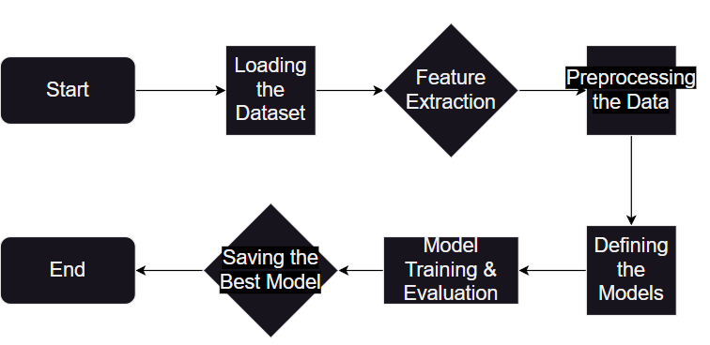
Figure 1. The Machine Learning Process

Figure 1. describes the mechanism of the ML training algorithm. The first step in the machine learning process is importing the dataset. Next, pertinent features are extracted, and target labels are separated. After that, the data is preprocessed to make sure it is balanced and modeling ready. Metrics and visualizations are then used to define, train, and assess machine learning models with the proper hyperparameters. Finally, the model presenting the best outputs is saved.

In the next section of this paper, namely “The Experimental Results part of it” the effectiveness of the models will be presented and compared.

V. Experimental Results

In the next paragraphs, the results of the experiments carried out to assess the effectiveness of the suggested machine learning models for DDoS attack will be presented. The CICDDoS2019 dataset was used for the testing, which concentrated on both typical and abnormal traffic. The models' successfulness is evaluated using key metrics like accuracy, precision, recall and the F1-score. Detailed analysis and visualizations, including confusion matrices and ROC curves, are presented together with comparative results for Random Forest, XGBoost, and LightGBM. Finding the top-performing model and showcasing its advantages in managing actual traffic situations is the final goal of the paper.

- Random Forest Training Results:

Random Forest Training Results
Metric | Numerical Result
Accuracy | 0.9878447540517487
Precision | 0.9878406828544155
Recall | 0.9878447540517487
F1 Score | 0.9878399323852338
Table 5. Random Forest Training Results

Table 5. summarizes the performance metrics obtained during the training of the model in one concise table: with an accuracy of 98.78% during training, the model showed outstanding performance, having almost every prediction correct. With a precision of 98.78%, the model demonstrated its capacity to reliably detect positive cases with very few false positives. Likewise, a recall of 98.78% demonstrates how well the model captures the majority of true positive situations while reducing false negatives. Besides this, the F1 score confirms how robust the performance of the model actually is.

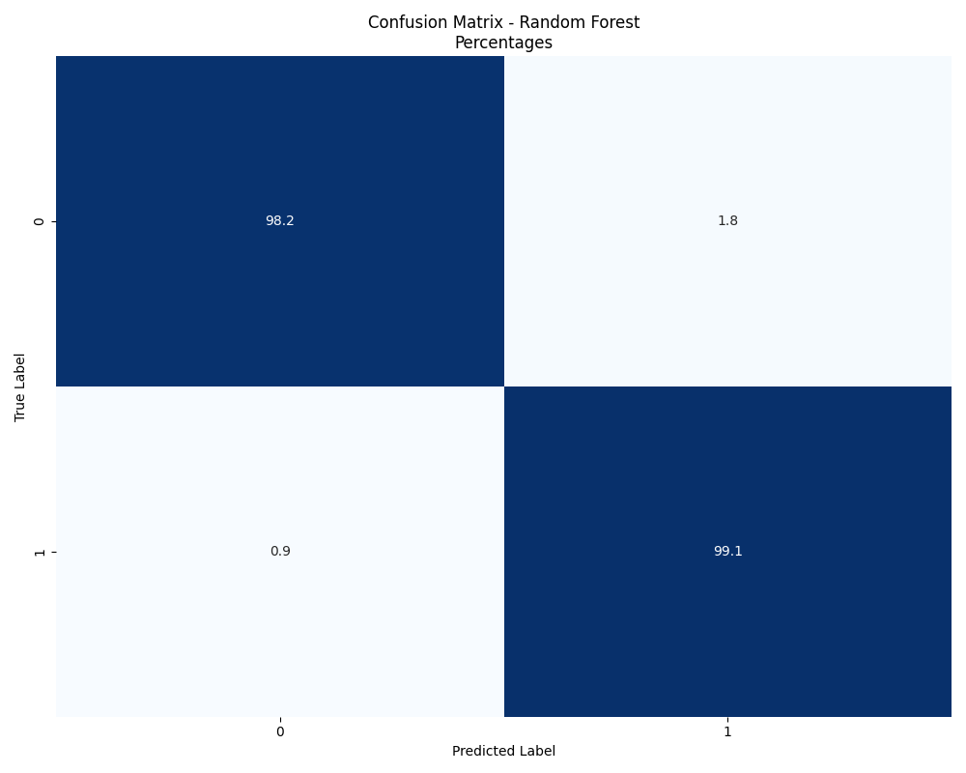
Figure 2. Confusion Matrix – Random Forest %

Additionally, the confusion matrix represented in Figure 2. confirms yet again the robustness of the model by visually presenting that less than 3% of the classifications performed by the model are either false positives or negatives.

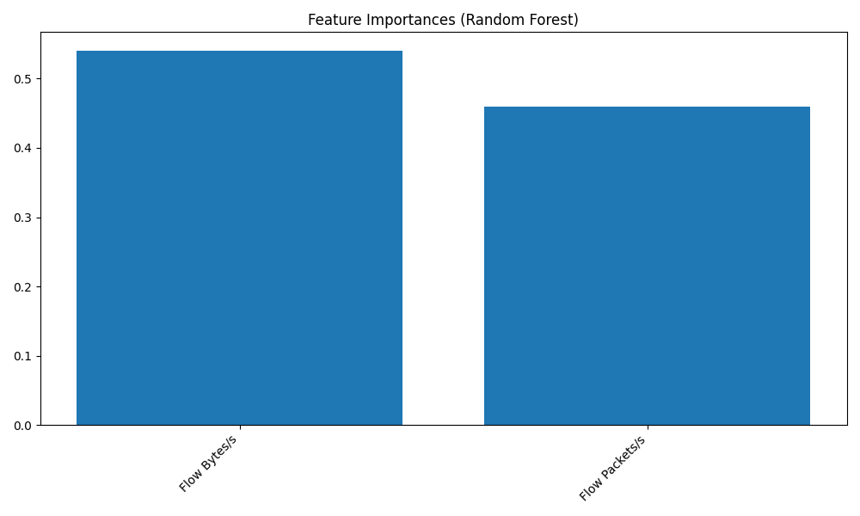
Figure 3. Feature Importances – Random Forest

The Random Forest model's Feature Importance plot allows you to observe the following: the two most crucial features in the dataset for traffic classification are Flow Bytes/s and Flow Packets/s. The volume of bytes transported per second is the most important predictor in determining the target class, as seen by the slightly higher relevance of Bytes/s over Packets/s. Seeing the importance of this features, it can be stated that the model can be associated with the detection of :

- Volumetric Attacks (UDP, ICMP Floods, DNS Amplification Attacks) – where massive amounts of resources are congesting the normal traffic within the network
- Protocol – Based Attacks (TCP SYN Flood)
- Application Layer Attacks (HTTP Flood)

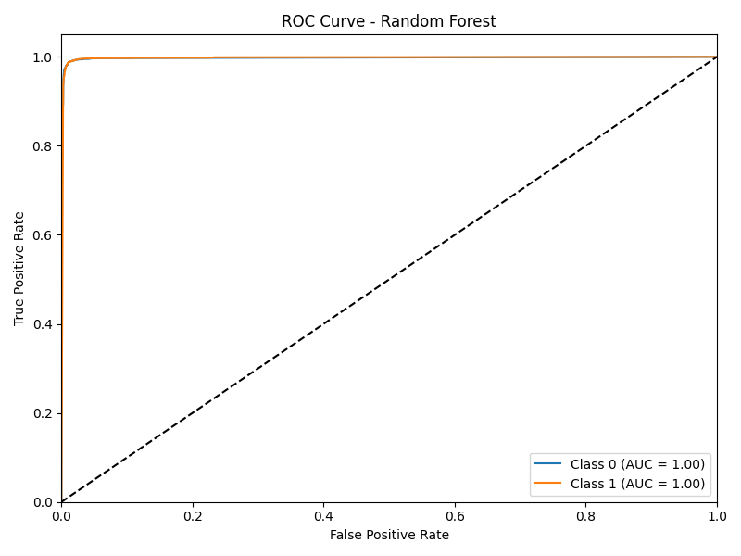
Figure 4. Random Forest - Receiver Operating Characteristic

Figure 4. presents a near perfect ROC curve, meaning almost perfect classification with an Area Under the Curve (AUC) of almost “1”. This suggests that the Random Forest ML model distinguishes between positive (Class 1) and negative (Class 0) instances without error. This confirms yet again the robustness of the Random Forest model.

- XGBoost Results:

Similarly to the results presented in the previous
section for the Random Forest model, the XGBoost provided comparable outputs.

XGBoost Training Results
Metric | Numerical Result
Accuracy | 0.9814472561842479
Precision | 0.9814590771448228
Recall | 0.9814472561842479
F1 Score | 0.9814519931976197
Table 6. XGBoost Training Results

Table 6. summarizes the XGBoost training results, which show consistently strong performance on all evaluation metrics. With a 98.14% accuracy rate, the model demonstrated a great capacity for accurately classifying network traffic, as said before, as in the case of the Random Forest Classifier.

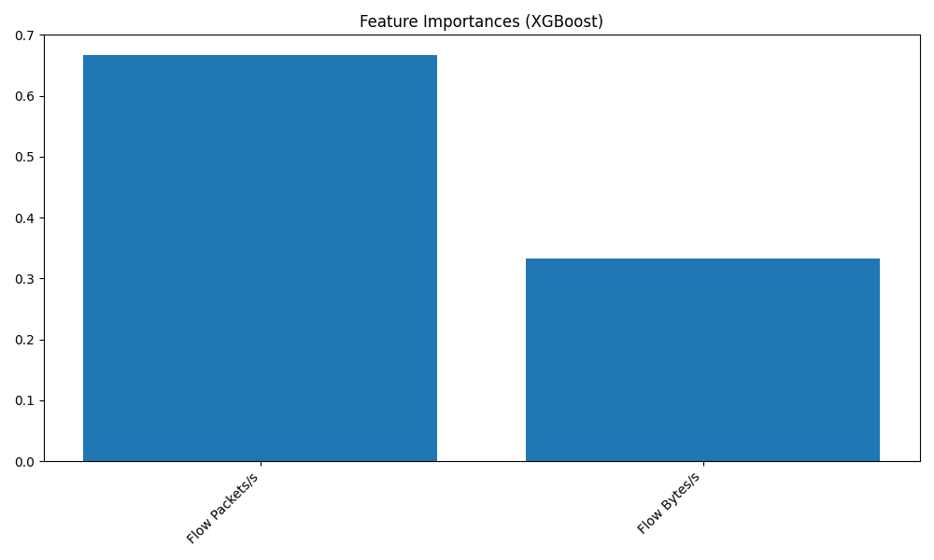

Figure 5. Feature Importances – XGBoost
There are several similarities and differences between the Random Forest model and the XGBoost feature significance plot. Even though both models rank Flow Packets/s and Flow Bytes/s as the most important characteristics for detecting DDoS attacks, XGBoost gives Flow Packets/s a lot more importance than Flow Bytes/s, in comparison to the Random Forest model where a more balanced approach was present, which may help the aforementioned model to be less reliant on only one feature, thus increasing the performance when inaccuracies are met by the model.
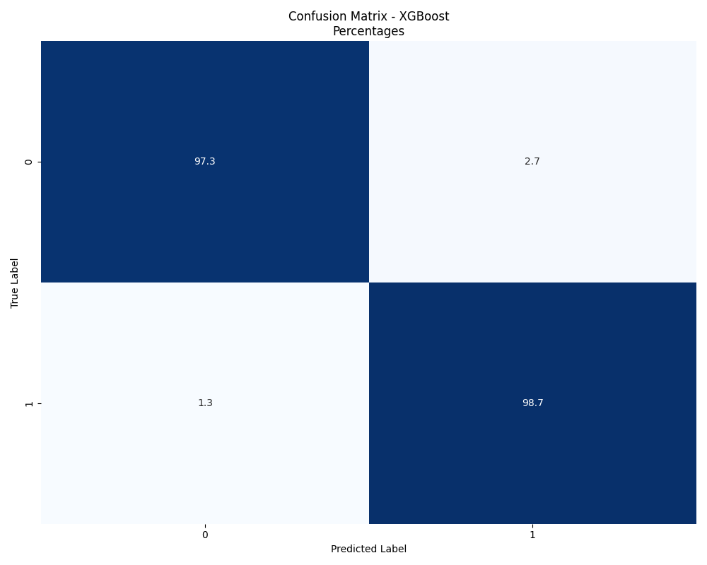
Figure 6. Confusion Matrix - XGBoost

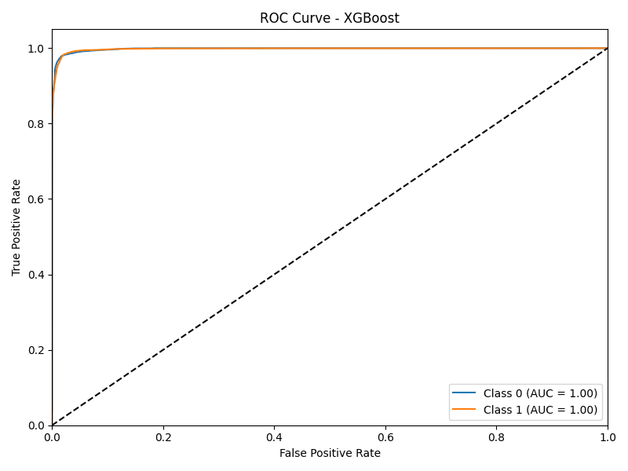
Figure 7. XGBoost - Receiver Operating Characteristic

Again, by analyzing the Confusion Matrix and the ROC of the XGBoost model, it can be stated that the model is dependable, even though the results are minimally worse than those of the RF classifier, which may be the case as a result of the higher dependency of the model to just one of the relevant features.

- LightGBM Results:

LightGBM Training Results
Metric | Numerical Result
Accuracy | 0.9828689223770258
Precision | 0.9828606868087895
Recall | 0.9828689223770258
F1 Score | 0.9828615309409436
Table 7. LightGBM Training Results

Table 7 displays the LightGBM training results, which are both very similar to the Random Forest and XGBoost models.

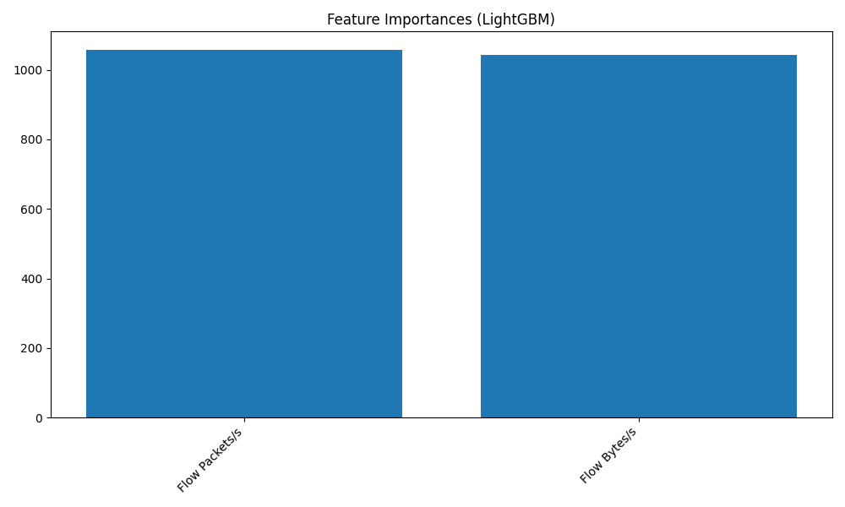

Figure 8. Feature Importances – LightGBM

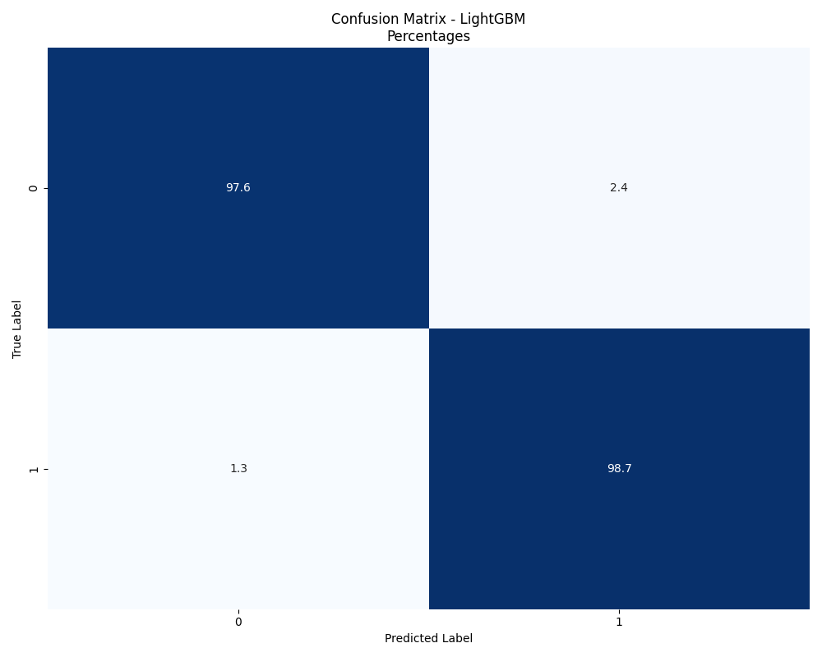

Figure 9. Confusion Matrix – LightGBM

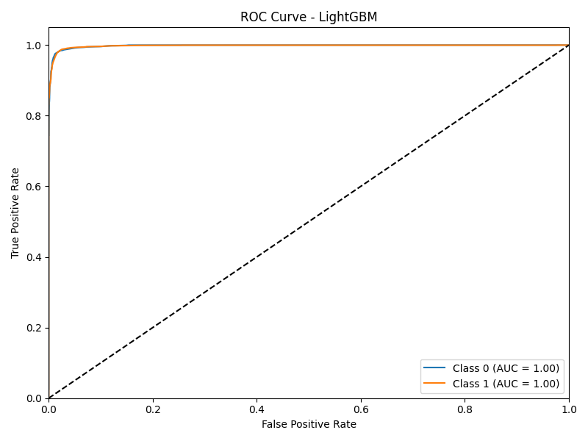

Figure 10. LightGBM - Receiver Operating Characteristic
As in the previously presented cases, the LightGBM model presents great robustness and viability in the detection of DDoS attacks, having a performance similar to the other models which can be interpreted from figures 8, 9 and 10.

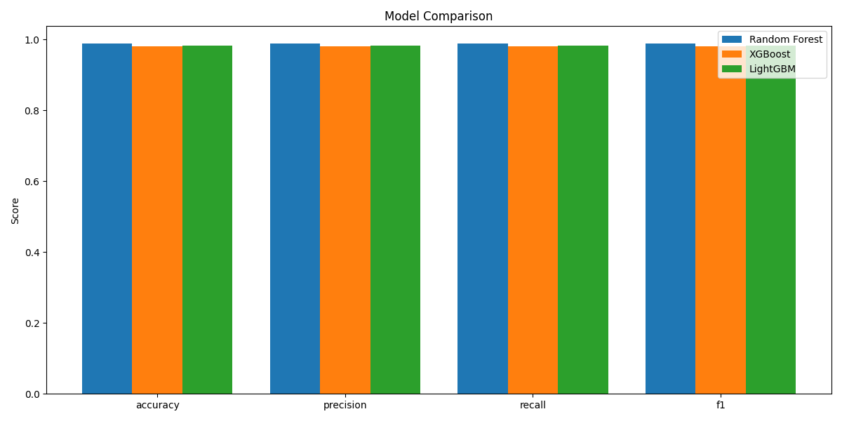

Figure 11. Model Comparison

Figure 11. shows the direct comparison between the Random Forest, XGBoost, and LightGBM models. All provide strong and dependable classification performance, making them equally suitable for DDoS attack detection. Based on the provided metrics any of the models can be used for DDoS detection.

VI. Conclusion

In conclusion, in this study utilizing the CICDDoS2019 dataset, three machine learning models, namely: Random Forest, XGBoost, and LightGBM were assessed for their ability to identify Distributed Denial of Service (DDoS) assaults. With very little performance differences, the testing findings show that all three models obtained good accuracy, precision, recall, and F1 scores. Random Forest demonstrated a balanced reliance on features and great robustness, which can also be said about the two other models. The results demonstrate how machine learning is dependable and strong in detecting malicious traffic patterns at various OSI model layers. Additionally, the models' balanced performance suggests that they are suitable for real-world applications.

Future studies can focus on improving feature engineering techniques and making models more resilient to new types of attacks. Furthermore, by allowing for quick reaction to changing threats, real-time DDoS detection systems can greatly improve the models' practical usefulness.

Adding the categorization of DDoS attack types to the scope would enable customized mitigation techniques and offer better insights into traffic behavior. Furthermore, the process can be automated by incorporating these detection systems into web services through frameworks such as Flask, providing even more practicality to this application.

REFERENCES
[1] Dhruba Kumar Bhattacharyya and Jugal Kumar Kalita, DDoS Attacks. CRC Press, 2016. ISBN: 9781498729659
[2] Radware, “DDoS Handbook – The Ultimate Guide to Everything You Need to Know About DDoS Attacks”, 2024. [Online]. Available: https://www.radware.com/documents/ [Accessed: 24 – Nov - 2024]
[3] T. Subbulakshmi, K. BalaKrishnan, S. M. Shalinie, D. AnandKumar, V. GanapathiSubramanian and K. Kannathal, "Detection of DDoS attacks using Enhanced Support Vector Machines with real time generated dataset," 2011 Third International Conference on Advanced Computing, Chennai, India, 2011, pp. 17-22, doi: 10.1109/ICoAC.2011.6165212.
[4] R. S. Tambe, H. Dand and M. D. Salunke, "Role of Machine Learning Ensemble in DDoS Intrusion Detection," 2023 IEEE 5th International Conference on Cybernetics, Cognition and Machine Learning Applications (ICCCMLA), Hamburg, Germany, 2023, pp. 145-149, doi: 10.1109/ICCCMLA58983.2023.10346867.
[5] I. Jemal, O. Cheikhrouhou and M. A. Haddar, "IoT DOS and DDOS Attacks Detection Using an Effective Convolutional Neural Network," 2023 International Conference on Cyberworlds (CW), Sousse, Tunisia, 2023, pp. 373-379, doi: 10.1109/CW58918.2023.00065.
[6] D. S. Rakshe, S. Jha, S. K. Korde and P. R. Bhaladhare, "Survey and Analysis of DDOS Attack Detection by Hybrid Deep Learning Methodologies," 2024 4th International Conference on Innovative Practices in Technology and Management (ICIPTM), Noida, India, 2024, pp. 1-6, doi: 10.1109/ICIPTM59628.2024.10563902.
[7] D. Zinca and V. Dobrota, “DDoS Attack Detection Using Supervised Machine Learning Algorithms Over the CICDDoS2019 Dataset,” Acta Technica Napocensis – Electronics and Telecommunications, vol. 63, no. 1, pp. 6–11, 2023.
[8] IBM, "What is Random Forest?," IBM, [Online]. Available: https://www.ibm.com/topics/random-forest. [Accessed: 24-Nov-2024].
[9] S. Misra, H. Li, and A. S. Ullah, Machine Learning Guide for Oil and Gas Using Python: A Step-by-Step Breakdown with Data, Algorithms, Codes, and Applications, 1st ed. Elsevier, 2021, https://doi.org/10.1016/B978-0-12-821929-4.00004-4
[10] GeeksforGeeks, "LightGBM – Light Gradient Boosting Machine," GeeksforGeeks, [Online]. Available: https://www.geeksforgeeks.org/lightgbm-light-gradient-boosting-machine/. [Accessed: 24-Nov-2024].

