Ex.no:7B | DATA VISUALIZATION USING TABLEAU  (GOOGLE TRENDS DATASET)

Aim:
To perform data analysis, data preparation, and visual exploration on the Google Trends

dataset in Tableau Desktop to analyze search trends, keyword popularity, geographical patterns, time-based trends, and search interest for meaningful insights.

Algorithm:
- Data Ingestion & Connection
- Connect Tableau Desktop to the Google Trends dataset as a text file source.
- Verify field data types such as Keyword, Date, Search Interest, Region, Category, and Related Queries.
- Data Cleansing & Transformation
- Handle missing or null values across important fields such as Search Interest, Keyword, Region, and Date.
- Verify numerical and categorical field types for accurate analysis.
- Exploratory Visual Analysis
- Search Interest Analysis: Compare average search interest between different keywords.
- Trend Analysis: Analyze search interest across dates to identify changes and overall trends.
- Geographical Analysis: Analyze search interest across different regions.
- Keyword Analysis: Analyze relationships between keywords and their search popularity.
- Dashboard Assembly & Formatting
- Combine key worksheets into an interactive Google Trends Analysis dashboard.

Output:
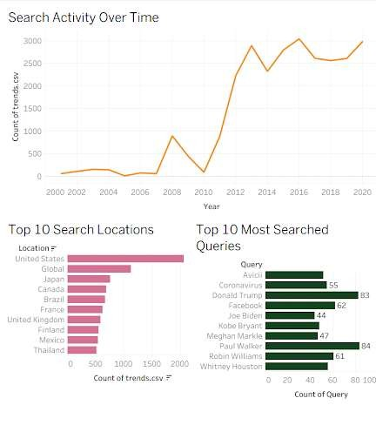
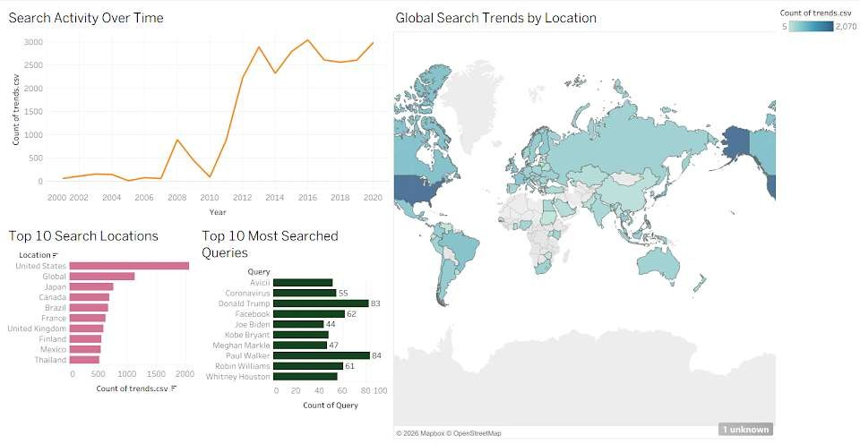

Result:

