**DOCUMENTATION**

**ABSTRACT:**

**Voting is a way to honour those who have helped to secure our rights. The students of the college have the opportunity to help select the co-ordinators volunteering for various services, and the health of the college relies on their participation. The purpose of these elections is to provide a little knowledge about the various techniques in which the elections can be held and to verify the justice level of the existing methods.**

**INTRODUCTION:**

             The online voting system is an online voting technique. In this system students can cast their vote online through the ‘userid’ and the password given to them. There is a database in which all the names of the voters with their complete information are stored. Once the user logs in his/her self to vote there is a confirmation page in order to verify the details of the user. Once the details are confirmed the user is directed to a page where he/she can cast the vote.

            This voting system allows students to assign scores for each of the candidates of the election. The scores of each candidate are stored in the database. Finally the scores of every candidate are summed up and the candidate with the highest score wins the election.

The purpose of using a scoring technique instead of using the usual “voting for a single candidate” for the elections is to make sure that all candidates have an equal chance of consideration by each of the voters. The scores represent the priority of the voter, and the candidate with most number of highest priorities wins the election.

**ANALYSIS**

**ACTORS:**

**Admin:**

ACTR-144

**Description:**

Generate user-id and password for the students.

Update the database.

Refresh user data.

**Use Cases where this actor is a Primary Actor:**

|  |  |
| --- | --- |
| Result Calculation | UC-149 |

**Candidate:**

ACTR-145

**Description:**

Login with the id given.

View result after voting finishes.

**Use Cases where this actor is a Primary Actor:**

|  |  |
| --- | --- |
| Login/Logout | UC-150 |

**Voter:**

ACTR-146

**Description:**

Login with the id given.

Cast vote.

**Use Cases where this actor is a Primary Actor:**

|  |  |
| --- | --- |
| Voting | UC-148 |
| Login/Logout | UC-150 |

**USE CASE DIAGRAM**

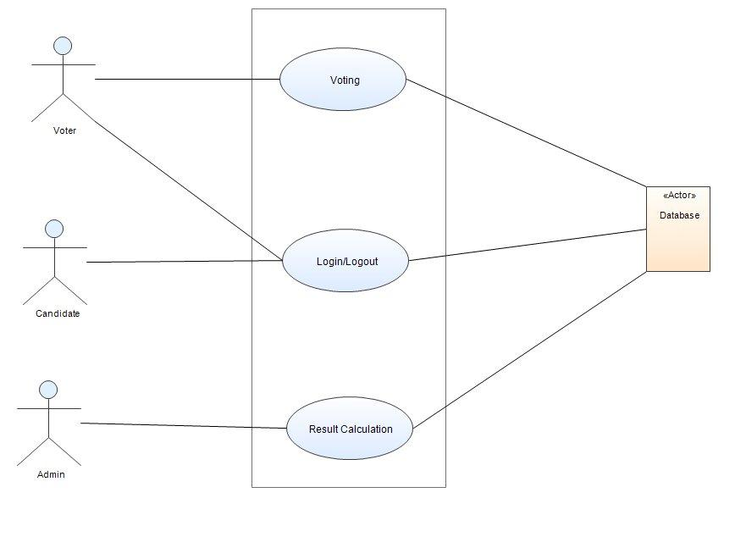

**Actors on the Diagram:**

|  |  |
| --- | --- |
| Admin | ACTR-144 |
| Candidate | ACTR-145 |
| Database | ACTR-153 |
| Voter | ACTR-146 |

**Use Cases on the Diagram:**

|  |  |
| --- | --- |
| Login/Logout | UC-150 |
| Result Calculation | UC-149 |
| Voting | UC-148 |

**USE CASES**

**VOTING**

UC-148

**Description (Goal in context):**

A voter can vote for an entry.

The voter must logout once after the vote has been casted.

**Primary Actors:**

* Database [ACTR-153]
* Voter[ACTR-146]

**Main Flow-of-Events:**

1. Login with the id and password given.

2. Choose a particular candidate to vote.

3. Cast vote.

4. Logout and exit.

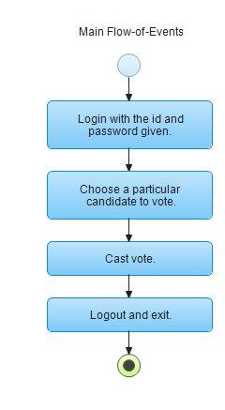

**RESULT CALCULATION.**

UC-149

**Description (Goal in context):**

Based on the vote cast by the voters, the result is calculated.

**Primary Actors:**

* Admin [ACTR-144]
* Database[ACTR-153]

**Main Flow-of-Events:**

1. Cross check the votes that are been casted.

2. Count the number of votes for each candidate.

3. Calculate the total and finalize the result.

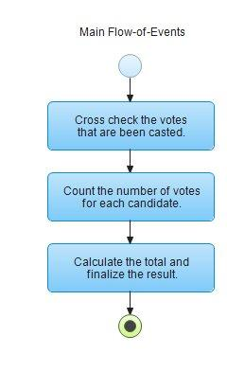

**LOGIN/LOGOUT**

UC-150

**Description (Goal in context):**

It describes how the voter/user logs in or out to the system.

**Primary Actors:**

* Candidate [ACTR-145]
* Voter [ACTR-146]

**Main Flow-of-Events:**

1. The user enters his login id and password.

2. A. If the login and password is valid, a session is opened.

3. i. The security is verified.

4. ii. The specific page of every user is loaded.

5. B. If the login or password is not valid, the login screen is redisplayed with an error message.

6. The user click on the logout button.

7. i. The session is terminated.

8. ii. The login screen is displayed.

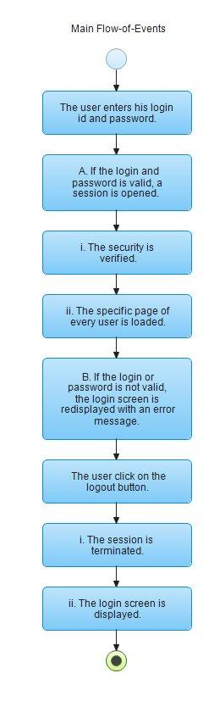

**DESIGN  DIAGRAM**

**ER - DIAGRAM:**

**https://lh4.googleusercontent.com/ewFiSgq3R0EZX9skqx3JQMw-uEDtMFEwfn8_8B1_JvLNB4Qxp8P-5tWdoQiIlJytfAnNbHLf7Ddu6bINGug_I3u_fIQ9EeFNYb9Ur92GSkzgGEFhuPBZMYJV1i1gk04Ftxhq51A5eDEP1OUCPg**

**TABLE DESIGN:**

**VOTER TABLE:**

|  |  |  |
| --- | --- | --- |
| **COLUMN NAME** | **DATA TYPE** | **CONSTRAINT** |
| Vid | Number(10) | Primary key |
| Name | Char[30] | Null |
| Password | Varchar | Null |
| DOB | Number(10) | Null |
| Contact | Number(10) | Null |

**CANDIDATE TABLE:**

|  |  |  |
| --- | --- | --- |
| **COLUMN NAME** | **DATA TYPE** | **CONSTRAINT** |
| Cid | Number(10) | Primary key |
| Name | Char[30] | Null |
| DOB | Number(10) | Null |
| Password | Varchar | Null |

**VOTER DATA:**

|  |  |  |
| --- | --- | --- |
| **COLUMN NAME** | **DATA TYPE** | **CONSTRAINT** |
| Voteid | Number(10) | Primary key |
| Vid | Number(10) | Foreign key |
| Cid | Number(10) | Foreign key |
| Score | Number(2) | Null |

**CONCLUSION:**

 This online voting system will manage voter's information by which voter can login and use his/her voting rights. This system may incorporate additional security features in order to make it reliable, when the scope becomes possible.