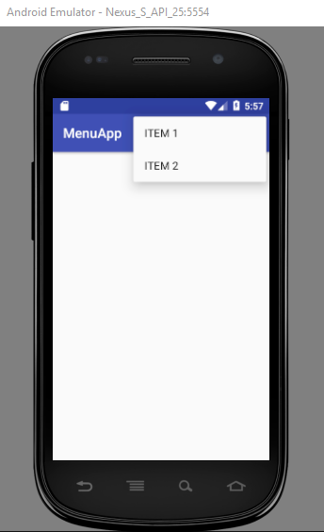

Steps to create the xml file inside res/menu folder
Create a directory under the res folder with below steps;
Right click on the res folder-->New-->Android resource directory.
There you can set Resource type: as "Menu".
Click OK button (refer below screenshot)
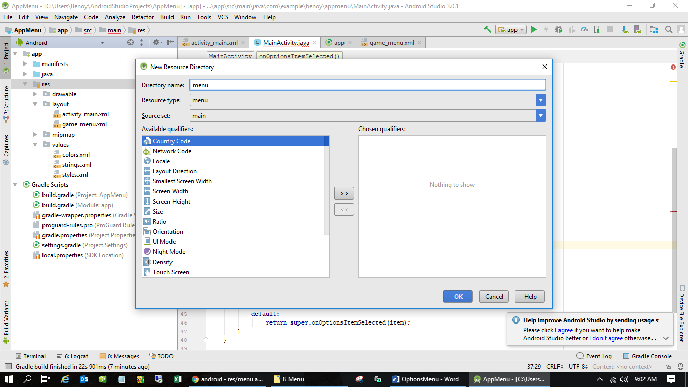

A directory will be created with the name ‘menu’ under res folder. Right click on the menu folder and add “Menu Resource File” with the name “menu_example” as shown below.
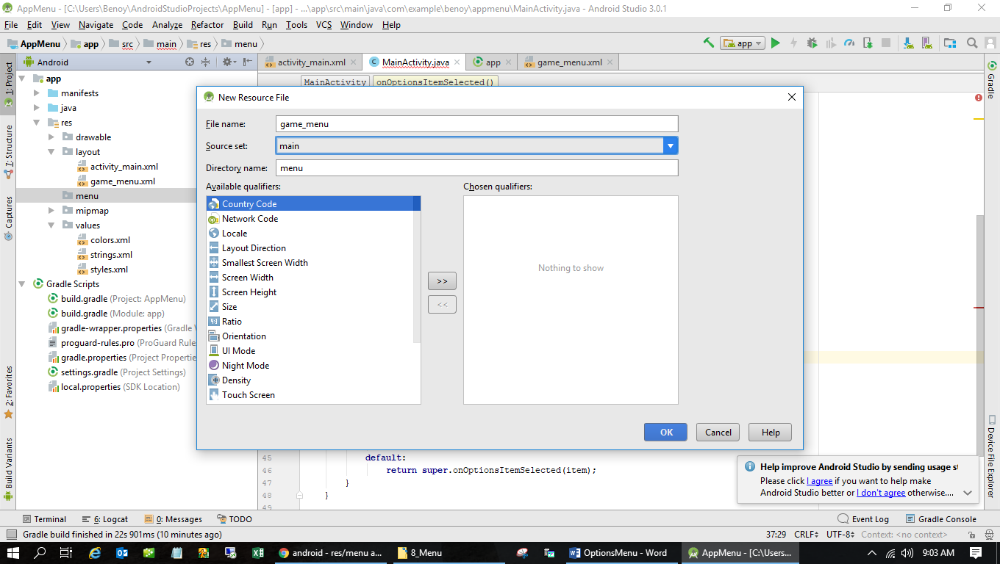

Menu_example.xml

<?xml version="1.0" encoding="utf-8"?>
<menu xmlns:android="http://schemas.android.com/apk/res/android">
<item android:id="@+id/mail"
android:title="Mail"/>
<item android:id="@+id/send"
android:title="Send"/>
</menu>

Main_activity.xml

package com.example.myapplication;
import androidx.annotation.NonNull;
import androidx.appcompat.app.AppCompatActivity;
import androidx.core.app.ActivityCompat;
import android.content.Intent;
import android.os.Bundle;
import android.view.Menu;
import android.view.MenuInflater;
import android.view.MenuItem;
import android.view.View;
import android.widget.Button;
import android.widget.EditText;
import android.widget.Toast;
public class MainActivity extends AppCompatActivity {
// two buttons
Button bCancel, bProceed;
// four text fields
EditText etFirstName, etLastName, etEmail, etPassword;
// one boolean variable to check whether all the text fields
// are filled by the user, properly or not.
boolean isAllFieldsChecked = false;
@Override
protected void onCreate(Bundle savedInstanceState) {
super.onCreate(savedInstanceState);
setContentView(R.layout.activity_main);
// register buttons with their proper IDs.
bProceed = findViewById(R.id.proceedButton);
bCancel = findViewById(R.id.cancelButton);
// register all the EditText fields with their IDs.
etFirstName = findViewById(R.id.firstName);
etLastName = findViewById(R.id.lastName);
etEmail = findViewById(R.id.email);
etPassword = findViewById(R.id.password);
// handle the PROCEED button
bProceed.setOnClickListener(new View.OnClickListener() {
@Override
public void onClick(View v) {
// store the returned value of the dedicated function which checks
// whether the entered data is valid or if any fields are left blank.
isAllFieldsChecked = CheckAllFields();
// the boolean variable turns to be true then
// only the user must be proceed to the activity2
if (isAllFieldsChecked) {
String message=etFirstName.getText().toString();
Intent i = new Intent(MainActivity.this, MainActivity2.class);
i.putExtra("Value1", message);
setResult(2,i);
startActivity(i);
}
}
});
// if user presses the cancel button then close the
// application or the particular activity.
bCancel.setOnClickListener(new View.OnClickListener() {
@Override
public void onClick(View v) {
ActivityCompat.finishAffinity(MainActivity.this);
System.exit(0);
}
});
}
// function which checks all the text fields
// are filled or not by the user.
// when user clicks on the PROCEED button
// this function is triggered.
private boolean CheckAllFields() {
if (etFirstName.length() == 0) {
etFirstName.setError("This field is required");
return false;
}
if (etLastName.length() == 0) {
etLastName.setError("This field is required");
return false;
}
if (etEmail.length() == 0) {
etEmail.setError("Email is required");
return false;
}
if (etPassword.length() == 0) {
etPassword.setError("Password is required");
return false;
} else if (etPassword.length() < 8) {
etPassword.setError("Password must be minimum 8 characters");
return false;
}
// after all validation return true.
return true;
}
@Override
public boolean onCreateOptionsMenu(Menu menu) {
MenuInflater inflater=getMenuInflater();
inflater.inflate(R.menu.menu_example,menu);
return true;
}
@Override
public boolean onOptionsItemSelected(@NonNull MenuItem item) {
switch (item.getItemId()){
case R.id.mail:
Toast.makeText(this,"Mail",Toast.LENGTH_LONG).show();
return true;
case R.id.send:
Toast.makeText(this,"Send",Toast.LENGTH_LONG).show();
return true;
default:
return super.onOptionsItemSelected(item);
}
}
}

