 | Sri Lanka Institute of Information Technology  - 2021-238
Project Topic Assessment – 2021
Topic
Express-way vehicle tracking system image processing.

Abstract (200 Words Max):
Vehicle detection and tracking plays an effective and significant role in traffic rules violation surveillance system where efficient traffic management and safety is the main concern. we discuss and address the issue of detecting traffic rules violation data from video frames. We will develop a unique algorithm for vehicle data recognition and automatic detect traffic rules violation using image processing. Our goal is developing an automatic vehicle detection for traffic rules violations, which can process videos recorded from stationary cameras over roads e.g., CCTV cameras installed from highway. Automatic recognition of vehicle data has been widely used in the vehicle information system and intelligent traffic rules violation system. It has acquired more attention of researchers from the last decade with the advancement of digital imaging technology and computational capacity. We have four areas for Automatic vehicle detection systems are keys to detect road traffic rules violation. They are, Object detection using image processing-Find the vehicle and License plate detection, Traffic Rules Violation Detection System Using Image Processing, Detecting the speed violation using image and video processing, Signal violation and Reverse violation.

Research Area/Group: Select the area by referring to the document uploaded to the Courseweb
Artificial Intelligence and Machine Learning

Supervisor should fill this part

Continuation of Previous Year Project? ☐

Supervisor: I certify here that co-supervisor and myself can guide this students to acquire required knowledge skills and attitudes pertaining to above sub domains of his/her specialization.
Supervisor: Ms. W. Chamari Madushani Silva

If yes, state the Project ID
and year

Co-Supervisor: Ms.Geethanjalie Wimalaratne Signature
Signature

External Supervisor
Name

Team Members:
Student Name | Student ID | Specialization
Leader:  Bojitha Mindula A.M.K | IT18134018 | SE
Member 2:  Ranasinghe M.M.C | IT18097634 | SE
Member 3:  Tennakoon T.M.P.J.A. | IT18148732 | SE
Member 4:  Rushdy Ahamed M.H | IT18185812 | IT

Research Problem:
In Sri Lanka’s express-way there are lot of accidents caused due to the violation of rules by some drivers. But there are no effective methods for detecting those rules violations yet.
We have identified some violations named Parking violation where a vehicle parks in a express-way without a permission or a special reason, Road Lane Violation where a vehicle continuously drives in the wrong lane (second lane), Speed violation where a vehicle exceeding the speed limit of the express-way , Signal violation where a vehicle overtakes another vehicle without giving signals and reverse violation where a vehicle moving in reverse.
Due to above mentioned violations lots of accidents occur in the express-way and those accidents cause lots of severe damages including loss of life.

Solution proposed:
We have discussed and decided to address the above problems using video and image processing. We are going to develop suitable algorithms and detect the vehicles that are violating the rules and detect necessary information of those vehicles.
Currently in highways speed detection is based on RADAR methods and this method is using some devices that are more expensive than the camera. So, in order to reduce the cost that takes to speed detection it is a good solution to use image processing. Therefore, for speed detection we decided to use video and image processing [1].
We take videos recorded from CCTV cameras installed in highways and using those video frames data and image processing concepts we are going to detect the types of vehicles and people separately and vehicles that are violating the above-mentioned violations with their license plate numbers [2].
Vehicle detection and tracking plays a significant role in rules violation surveillance system and safety is the main concern. Therefore, our intension is to develop an automated system that track the vehicles and detect the above-mentioned information effectively and efficiently [3].
References –
[1] Thadagoppula, Pranith & Upadhyaya, Vikas. (2016). Speed detection using image processing. 11-16. 10.1109/IC3INA.2016.7863015. https://www.researchgate.net/publication/314105345_Speed_detection_using_image_processing
[2] Bhaskar, Prem & Yong, Suet. (2014). Image processing based vehicle detection and tracking method. 1-5. 10.1109/ICCOINS.2014.6868357. https://www.researchgate.net/publication/271424684_Image_processing_based_vehicle_detection_and_tracking_method
[3] Şentaş, Ali & Kul, Seda & Sayar, Ahmet. (2019). Real-Time Traffic Rules Infringing Determination Over the Video Stream: Wrong Way and Clearway Violation Detection. 10.1109/IDAP.2019.8875889. https://www.researchgate.net/publication/336002491_Real-Time_Traffic_Rules_Infringing_Determination_Over_the_Video_Stream_Wrong_Way_and_Clearway_Violation_Detection

System Overview Diagram for the solution proposed. Recommended to draw using draw.io. Note: This is not an activity/flow (UML) diagram
- Man components including the data sources, stakeholders, interaction among the stakeholders, etc.
- Interconnection among the components
- Major SW and HW components
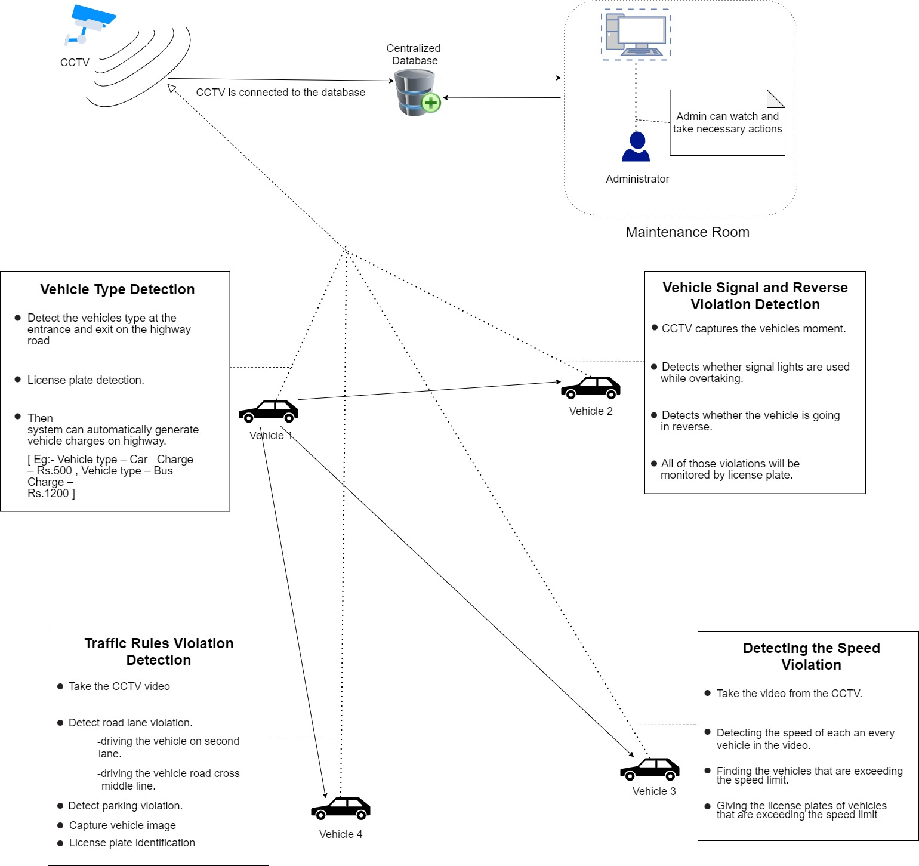

Objectives (1 main objective and 4 sub objectives):
Main Objective:
Our main objective is developing an automatic vehicle detection for highway rules violations, which can process videos recorded from CCTV cameras installed in highways.
Sub Objective 1:
An Automatic vehicle detection system makes use of video data acquired from stationary traffic cameras, performing causal tracking operations over a set of frames obtained from the video to estimate the type of vehicles and vehicle number plate present in a scene. It is just the ability of automatically extract and recognize the vehicle data.
Sub Objective 2:
Parking violation and road lane violation detection system based on video processing. The proposed system captures and processes the images from a video. A camera is used as a detector to take videos to determine the violation. Vehicle can identify number plate number.
Sub Objective 3:
Digital image processing to realize the real-time automatic vehicle speed monitoring using video camera. We take a video of the moving vehicle and by using the video we are going to measure the speed of the vehicle and check whether that the vehicle is moving faster than the speed limit and give the license plate of that vehicle as information.
Sub Objective 4:
Automatic violation detection when vehicle overtaking another vehicle without using a valid signal lights, that will be warned as a signal violation and vehicle reverse violation system using image processing.

Task divided among the members

Member 1
Object detection using image processing.

CCTV cameras recorded a video of a highway road, the system that we are going to develop can detect the vehicles and vehicle number plate. Then system can automatically generate vehicle charge on highway.

Vehicle type detection:

eg: Different vehicle types have different charges from highway.

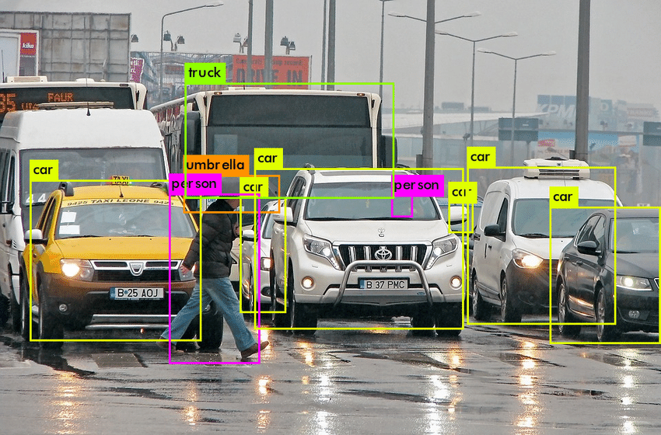

License plate detection:

eg: Highway traffic police can identify the vehicle.

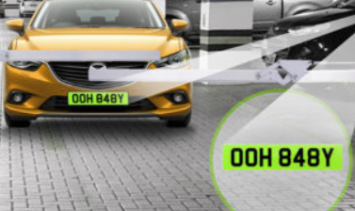

Member 2
Traffic Rules Violation Detection Using Image Processing

Parking rules violation and road lane rules violation detection system based on video processing. The proposed system captures and processes the images from a video. A camera is used as a detector to take videos to determine the violation. Vehicle can identify Number plate number.

- Parking violation: If a vehicle park from highway in road, it is detected as a Parking violation.

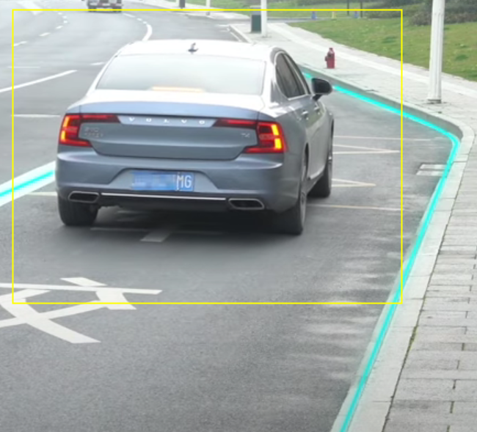

- Road lane violation: If a vehicle crosses a road middle line and driving second lane (not overtake vehicle), it is detected as a Road lane violation.

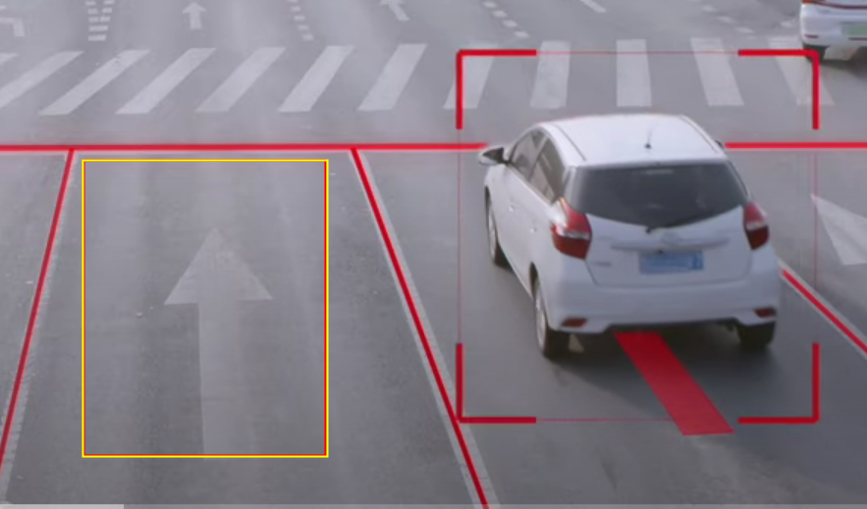

Member 3
Detecting the speed violation using image and video processing
- In here we detect the vehicles that are moving faster than the speed limit. We take a video of the moving vehicle and by using the video we are going to measure the speed of the vehicle and check whether that the vehicle is moving faster than the speed limit.

- When there are more vehicles in the video, we check the speed of each and every vehicle in the video and give the license plates of vehicles that are exceeding the speed limit as information.

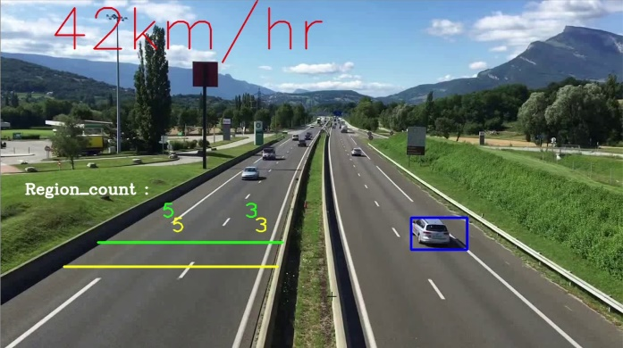

Member 4
Traffic Rules Violation Detection Using Image Processing

- Signal violation: system detects, if a vehicle overtakes another vehicle without using a valid signal lights, it is detected as a signal violation.

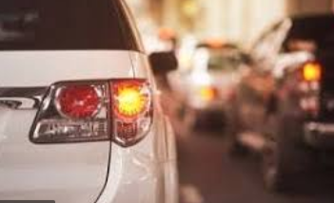

- Reverse violation: If a vehicle drives in the reverse direction of the highway, it is detected as a reverse violation.

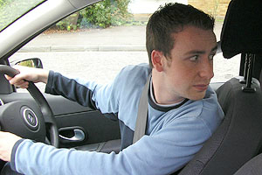

Technologies to be used:
- Machine Learning

- Image processing

- Python

- PyCharm

- Anaconda

Appendix 1

Reply from the Supervisor:

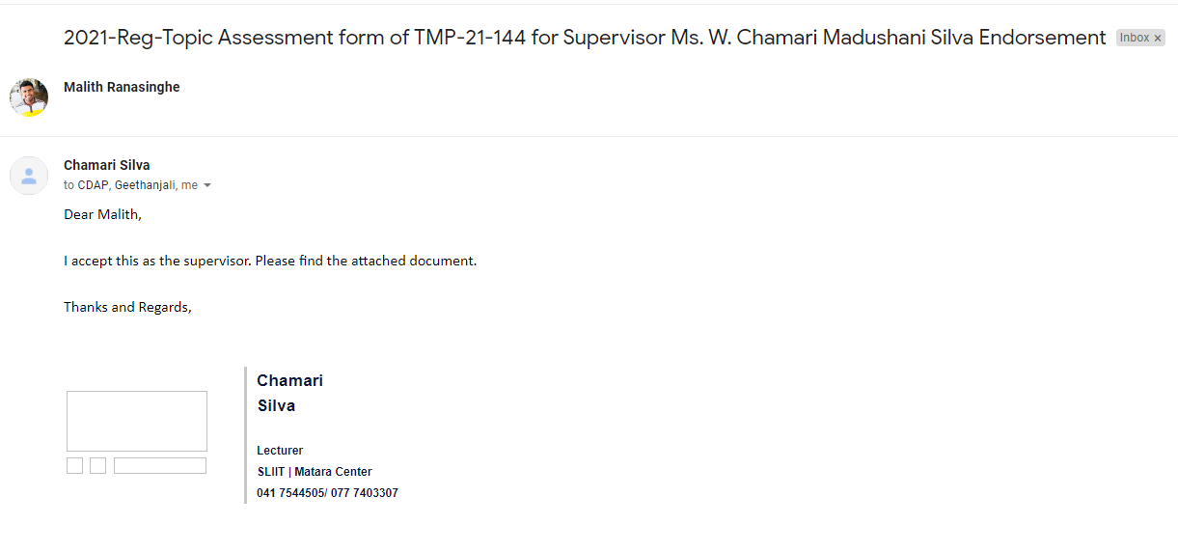

Appendix 2

Reply from the Co-Supervisor:

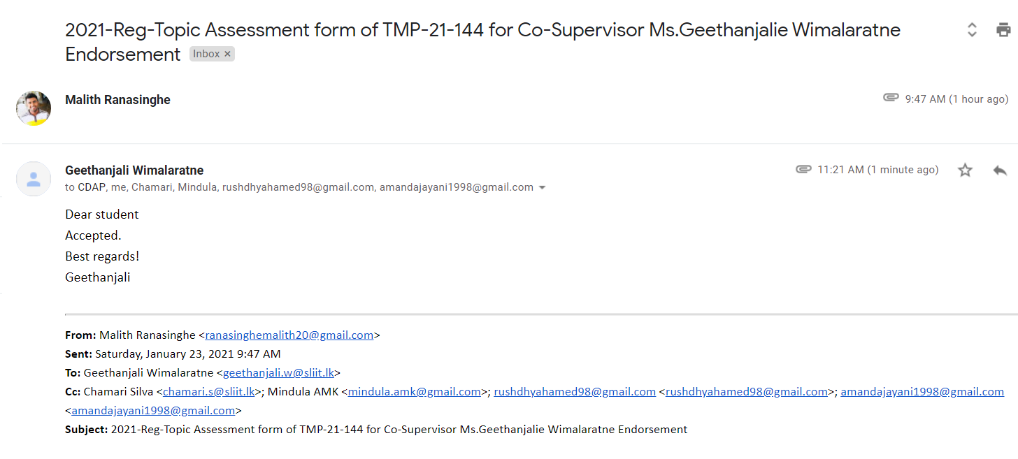

If supervisor States that this year is a continuation of previous work, state the further work the students should do compared to the previous years.
(NOTE: This part has to be filled by the supervisor)

This part will be filled by the Topic Screening Panel members

Acceptable: Mark/select as necessary
Acceptance/  Rejection | Correction State
Acceptance/  Rejection | Minor Correction | Major Corrections
Accepted | ☐ | ☒
Resubmit | ☐ | ☐
Rejected | ☐

Corrections (if necessary)
Please modify the Topic wording “Express-way” instead of “High-way”
Check whether the feasibility how system cover entire road system using CCTV, and how much of the accuracy can be measured for moving vehicles.
Check the data availability, infrastructure availability to proceed with this research.
Discuss this with the supervisor.

Major changes proposed: ____________________________________________________________________________________________________________________________________________________________________________________________________________________________________________________________________________________________________________

Any other Comments: _________________________________________________________________________________________________________________________________________________________________________________________________________________________________
Approved by the review panel:
Member’s Name | Signature
Dr. Dharshana Kasthurirathna | 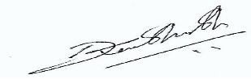
Mr. Udara Samaratunge | 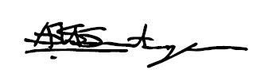

Important:
- According to the comments given by the panel, do the necessary modifications and get the approval by the same panel.
- If the project topic is rejected, find out a new topic and inform the CDAP Group for a new topic pre-assessment.
- A form approved by the panel must be attached to the Project Charter Form.

