|  |  |
| --- | --- |
|  | **Sri Lanka Institute of Information Technology** |



PROJECT REGISTRATION FORM

|  |
| --- |
|  |

(This form should be completed and uploaded to the Cloud space on or before XXXXXXXXX)

The purpose of this form is to allow final year students of the B.Sc. (Hon) degree program to enlist in the final year project group. Enlisting in a project entails specifying the project title and the details of four members in the group, the internal supervisor (compulsory), external supervisor (may be from the industry) and indicating a brief description of the project. The description of the project entered on this form will not be considered as the formal project proposal. It should however indicate the scope of the project and provide the main potential outcome.

|  |  |
| --- | --- |
| PROJECT TITLE  (As per the accepted topic assessment form) | Express-way vehicle tracking system image processing. |

|  |  |
| --- | --- |
| RESEARCH GROUP  **(as per the Topic assessment Form)** | Artificial Intelligence and Machine Learning |

|  |  |  |
| --- | --- | --- |
| PROJECT NUMBER |  | (will be assigned by the lecture in charge) |

PROJECT GROUP MEMBER DETAILS: (Please start with group leader’s details)

|  |  |  |  |  |
| --- | --- | --- | --- | --- |
|  | **STUDENT NAME** | **STUDENT NO.** | **CONTACT NO.** | **EMAIL ADDRESS** |
|  |  |  |  |  |
| 1 | Bojitha Mindula A.M.K | IT18134018 | 0713579450 | IT18134018@my.sliit.lk |
| 2 | Ranasinghe M.M.C | IT18097634 | 0718772549 | IT18097634@my.sliit.lk |
| 3 | Tennakoon T.M.P.J.A. | IT18148732 | 0712374237 | IT18148732@my.sliit.lk |
| 4 | Rushdy Ahamed M.H | IT18185812 | 0777137622 | IT18185812@my.sliit.lk |

**SUPERVISOR, CO_ SUPERVISOR Details**

|  |  |
| --- | --- |
| **SUPERVISOR Name** | **CO-SUPERVISOR Name** |
| **Ms. W. Chamari Madushani Silva** | **Ms.Geethanjalie Wimalaratne** |
| **Signature** | **Signature** |
| **Attach the email as Appendix 1** | **Attach the email as Appendix 2** |
| **22/01/2021** | **23/01/2021** |
| **Date** | **Date** |

**Appendix 1**

**Reply from the Supervisor:**

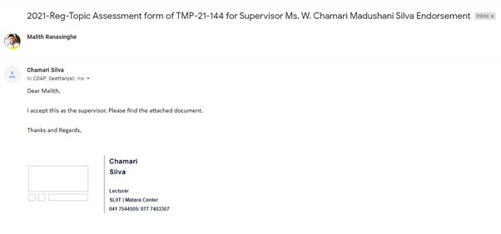

**Appendix 2**

**Reply from the Co-Supervisor:**

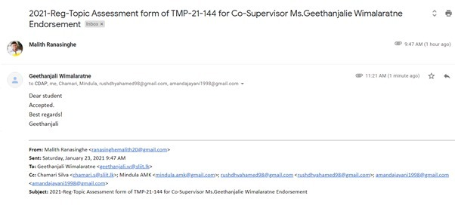

|  |  |  |  |  |  |
| --- | --- | --- | --- | --- | --- |
| EXTERNAL SUPERVISOR Details (if any, may be from the industry) | | | | | |
|  |  |  |  | **Attach the email as Appendix 3** |
| Name | Affiliation | Contact Address | Contact Numbers | Signature/Date |

|  |  |  |
| --- | --- | --- |
| ACCEPTANCE BY CDAP MEMBER (This part will be filled by the RP team) | | |
|  |  |  |
| Name | Signature | Date |

PROJECT DETAILS

|  |
| --- |
| Brief Description of your Research Problem: (extract from the topic assessment form) |
| There are lot of accidents caused in Sri Lanka’s express ways due rule violations. These are some of rule violations we have identified so far.   * Parking violation where a vehicle parks in express way without a permission or a special reason * Road Lane Violation where a vehicle continuously drives in the wrong lane (second lane) * Speed violation where a vehicle exceeding the speed limit of the express way. * Signal violation where a vehicle overtakes another vehicle without giving signals. * Reverse violation where a vehicle moving in reverse.   But there are no effective ways to identify above mentioned rule violations in express ways. |
| Description of the Solution: (extract from the topic assessment form)  We are going to address above problem using video image processing. We are going to develop suitable algorithms and detect the vehicles that are violating the rules and detect necessary information of those vehicles.  We take videos recorded from CCTV cameras installed in express ways and using those video frames data and image processing concepts we are going to detect the types of vehicles and people separately and vehicles that are violating the above-mentioned violations with their license plate numbers. |

|  |
| --- |
| Main expected outcomes of the project: (extract from the topic assessment form) |
| An automatic vehicle detection system for traffic rules violations, which can process videos recorded from stationary cameras over roads e.g., CCTV cameras installed from express way.  This system consists of four main functionalities. They are Object detection using image processing-Find the vehicle and License plate detection, Traffic Rules Violation detection , Detecting the speed violation using image and video processing and Signal violation and Reverse violation. |

WORKLOAD ALLOCATION (**extract from the topic assessment form after correcting the suggestions given by the topic assessment panel.**)

(Please provide a brief description about the workload allocation)

|  |  |
| --- | --- |
| MEMBER 1 | ………………………………………………………………………………………………………………………………………………………… |
| An Automatic vehicle detection system makes use of video data acquired from stationary traffic cameras, performing causal tracking operations over a set of frames obtained from the video to estimate the type of vehicles and vehicle number plate present in a scene. It is just the ability of automatically extract and recognize the vehicle data. | |

|  |  |
| --- | --- |
| MEMBER 2 | ………………………………………………………………………………………………………………………………………………………… |
| Parking violation and road lane violation detection system based on video processing. The proposed system captures and processes the images from a video. A camera is used as a detector to take videos to determine the violation. The vehicle number plate will be identified. | |

|  |  |
| --- | --- |
| MEMBER 3 | ………………………………………………………………………………………………………………………………………………………… |
| Digital image processing to realize the real-time automatic vehicle speed monitoring using video camera. We take a video of the moving vehicle and by using the video we are going to measure the speed of the vehicle and check whether that the vehicle is moving faster than the speed limit and give the license plate of that vehicle as information. | |

|  |  |
| --- | --- |
| MEMBER 4 | ………………………………………………………………………………………………………………………………………………………… |
| Automatic violation detection when vehicle overtaking another vehicle without using a valid signal lights, that will be warned as a signal violation and vehicle reverse violation system using image processing. | |

DECLARATION (Students should add the Digital Signature)

“We declare that the project would involve material prepared by the Group members and that it would not fully or partially incorporate any material prepared by other persons for a fee or free of charge or that it would include material previously submitted by a candidate for a Degree or Diploma in any other University or Institute of Higher Learning and that, to the best of our knowledge and belief, it would not incorporate any material previously published or written by another person in relation to another project except with prior written approval from the supervisor and/or the coordinator of such project and that such unauthorized reproductions will construe offences punishable under the SLIIT Regulations.

We are aware, that if we are found guilty for the above mentioned offences or any project related plagiarism, the SLIIT has right to suspend the project at any time and or to suspend us from the examination and or from the Institution for minimum period of one year”.

|  |  |  |  |
| --- | --- | --- | --- |
|  | **STUDENT NAME** | **STUDENT NO.** | **Signature** |
| 1 | Bojitha Mindula A.M.K | IT18134018 |  |
| 2 | Ranasinghe M.M.C | IT18097634 |  |
| 3 | Tennakoon T.M.P.J.A. | IT18148732 |  |
| 4 | Rushdy Ahamed M.H | IT18185812 |  |