

Executive Summary
Distributed Systems - CSI3344.4
Assignment – 02
Himasha Malith Amarasinghe - 10660238
Lecturer – Mr. Dammike Mendis
Distributed System Project & Written Report
This document outlines the design, setup, and testing of a three-level distributed banking setup built to illustrate key ideas in distributed computing. Core functions like logging in, checking balances, or moving funds were included along with varying cost rules across levels. Dealing with common issues - like ensuring data matches everywhere, handling failures, or connecting from faraway locations - was central to its purpose.
The project was developed in two phases after following recommended iterative methodology. Phase 1 created a two-tier architecture using in-memory storage to test business logic and communications patterns using Pyro5 RPC framework. Phase 2 was the extension of the system into a full three-tier architecture via a dedicated database server (BDB Server) using SQLite for persistent storage, providing complete separation of concerns between presentation (BC Client), business logic (BAS Server) and data persistence (BDB Server) layers.
The system achieves its main technical goals through synchronous request-response communication which supports financial operations that need instant confirmation and a fee calculation system that progresses through six levels. Starting from free transfers under $2,000 to 0.05% fees for transfers above $100,000 (with per-tier caps). The system uses transfer ID verification to handle duplicate requests effectively while providing simple duplicate request management. The system achieves complete observability through its implementation of structured logging and its ability to export data in CSV format.
The system proves its ability to follow ACID transaction rules through SQLite transaction management, and it upholds critical banking operation consistency standards and offers robust error handling with useful client feedback. The testing process confirms that all functional requirements have been met because it checks authentication processes and fee computation for different user levels and it also tests all possible scenarios including when users run out of money and when they try to send money to incorrect addresses and it checks how the system stores data through multiple server shutdowns.
The system design implements academic learning targets through practical distributed systems principles which enable students to understand how to separate system tiers and perform remote procedure calls and handle transactions while learning about distributed system tradeoffs between consistency and availability and partition tolerance.

Table of Contents
1. Introduction 3
2. Application and Technology Background 3
2.1 Banking Systems as Distributed Systems 3
2.2 Technology Stack Selection 4
2.3 Synchronous RPC Implementation 4
3. Application Requirements 4
3.1 Functional Requirements 4
3.2 Transfer Fee Structure 5
3.3 Non-Functional Requirements 5
3.4 Mock Data and Testing Context 6
4. System Design and Architecture 6
4.1 Three-Tier Architecture Overview 6
4.2 Component Communication Patterns 7
4.3 Authentication and Session Management 7
4.4 Transfer Processing Workflow 9
4.5 Database Schema and Persistence 10
4.6 Consistency and Transaction Management 11
4.7 Duplicate Request Handling 11
5. Implementation Procedure 12
5.1 Phase 1: Two-Tier Development 12
5.2 Phase 2: Three-Tier Extension with Database 12
5.3 Development Challenges and Solutions 13
6. User Manual 14
6.1 System Requirements 14
6.2 Installation and Setup 14
6.3 Starting the System 15
6.4 Using the Banking System 16
7. Test Cases and Validation 19
8. Discussion and Critical Analysis 22
8.1 Design Decisions and Justifications 22
8.2 Trade-offs and Limitations 22
8.3 Lessons Learned 22
9. Conclusion 22
10. References 23

List of figures
Figure 1: Fee Structure Table 5
Figure 2: Three-Tier Architecture 6
Figure 3: Transfer Processing Workflow 9
Figure 4: Project Folder Structure 14
Figure 5: Terminal 1 15
Figure 6: Terminal 2 15
Figure 7: Terminal 3 15
Figure 8: Terminal 4 16
Figure 9: Successful login screen showing session token 16
Figure 10: View Balance 17
Figure 11: Successful transfer showing amount, fee, and total deducted 18
Figure 12: Checking transfer status 18
Figure 13: CSV export confirmation message 19
Figure 14: Error message for invalid credentials 20
Figure 15: Invalid recipient 22

Introduction
Modern computing infrastructure depends on distributed systems which provide scalable and reliable networked applications through their fundamental structure. The banking sector faces major challenges when implementing distributed computing because it needs to preserve both data consistency and transactional integrity and system fault tolerance at the same time. The assignment creates a basic distributed banking system which shows essential distributed systems principles through its implementation of remote procedure calls (RPC) and its use of tier separation and transaction management and consistency guarantees.
The banking transfer system enables users to authenticate themselves while they can check their account balances and perform fund transfers between different accounts. The system architecture and design principles of this educational example use mock data to create a simplified version which resembles actual distributed banking systems found in real-world environments. The system solution solves fundamental distributed systems problems which involve handling distant system interactions and handling data between different layers and preventing duplicate requests and ensuring system consistency during system failures.
The implemented system uses Python 3.8+ as the development platform with Pyro5 (Python Remote Objects) for inter-process communication and SQLite for data persistence. The technology stack shows educational simplicity because it uses distributed systems principles which demonstrate enough complexity to show real-world system operation. The following sections present the technical background and system architecture and implementation approach and validation methodology which guided the entire project.

Application and Technology Background

Banking Systems as Distributed Systems
The banking transfer system functions as a distributed system because it includes various client interfaces such as web and mobile and ATM systems and application servers that execute business logic and database servers which store persistent information (Tanenbaum & Van Steen, 2017). The current banking system design separates different functions between its layers to provide both performance improvement and system stability and protection of sensitive information. The client tier performs user interface functions, but the application tier enforces business rules and authentication tasks, and the data tier maintains permanent storage with built-in transactional protection.

Technology Stack Selection
The system depends on Pyro5 (Python Remote Objects) as its RPC framework to establish process-to-process communication. Pyro5 enables users to perform remote method invocation without requiring explicit code because distributed objects can be accessed through Python object interfaces (Pyro5 Documentation, 2024). The system development process becomes more accessible because it conceals network communication complexities which let developers handle remote system boundaries directly. The academic teaching system benefits from Pyro5 because it provides a Pythonic API and minimal boilerplate code which enables students to reach their learning targets while demonstrating RPC principles effectively.

The persistence layer of SQLite operates as a database system which guarantees ACID transactions for banking operations according to the SQLite Consortium (2024). The standard production banking systems use client-server databases which include PostgreSQL and MySQL but SQLite offers embedded deployment and testing capabilities with complete SQL functionality and transaction control. The system architecture maintains SQLite operation within BDB Server boundaries while preserving database tier separation which applies to all database management systems.

Synchronous RPC Implementation
The system operates through synchronous RPC because clients need to wait for server responses before continuing their execution. Financial operations need instant confirmation because customers need to know right away about the success or failure of their $10,000 transfer. Synchronous RPC functions through request-response semantics which provides fundamental error handling capabilities and maintains simple transaction limit management.

Application Requirements

3.1 Functional Requirements
The banking system requires authenticated sessions to enable users to perform their four essential banking operations.
FR1: User Authentication - The system requires users to authenticate through their username and password combination which produces session tokens for future system access. The system needs to preserve authentication state from start to finish of each session while it executes all operations to verify the presence of an active token.
FR2: Balance Query - Authenticated users must be able to access their current account balances through synchronous requests. The balanced information system requires a display which shows all completed transactions along with their respective fees.
FR3: Money Transfer - Users must be able to use a transfer system which lets them send funds between accounts by entering the recipient’s username and transfer amount and an optional message. The system will determine fees through its tiered system while it checks for enough available funds (the transfer amount plus the fee) and blocks all self-transfer operations and checks if the recipient account exists before performing an atomic transfer operation.
FR4: Transfer Status Query - Users must be able to access transfer status by using transfer IDs to obtain all transfer information which includes sender and recipient details and amount data and fee amounts and timestamp and completion status.

3.2 Transfer Fee Structure
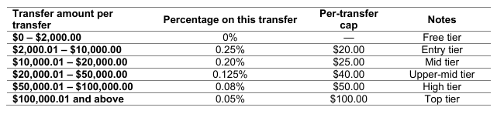
The system implements a progressive fee structure incentivizing smaller transfers while capping fees on larger amounts:
Figure 1: Fee Structure Table
As an example: a $5,000 transfer fee equals $12.50 because it represents 0.25% of the transfer amount. The transfer fee for $150,000 amounts to $75.00 because it represents 0.05% of the transfer amount which falls under $100 cap. All monetary values are round to two decimal places to prevent precision errors.

3.3 Non-Functional Requirements
NFR1: Consistency - The system requires absolute consistency to preserve correct account balance information. The creation of money and its destruction and duplication must never occur. The system requires all transfer operations to perform as single units of work which will either execute both debit and credit operations or none at all.
NFR2: Tier Separation - The system architecture needs to separate all system concerns into three distinct tiers which must operate independently from each other. The BC Client shall not access the database or BDB Server. The BAS Server shall not directly access the database file. Only the BDB Server may import sqlite3 and execute SQL statements.
NFR3: Duplicate Request Handling - The system requires duplicate transfer request identification and processing because network timeouts cause clients to send duplicate requests. The system includes a mechanism which stops duplicate requests from starting new transfer operations.
NFR4: Persistence and Auditability - The system requires all transfer operations to be stored through a recording system which includes sender ID and recipient ID and amount and fee and timestamp and status information. The system needs to enable CSV export functionality, which allows users to export all database tables for audit requirements.
NFR5: Error Handling - The system needs to generate useful error messages which should appear for every system failure that includes authentication problems and insufficient funds and wrong recipient addresses and server connection breakdowns. System failure mode identification represents a fundamental requirement which clients need to fulfill.

3.4 Mock Data and Testing Context
This is an academic teaching system using mock data. Two pre-configured users exist:

Username "alice" (password: pass123, initial balance: $10,000.00)
Username "bob" (password: pass456, initial balance: $5,000.00)
The system does not have any functionality which enables it to connect with operational banking systems or payment processing networks. Production systems require password storage in plain text for educational purposes but this method fails to meet production system security standards. The system design focuses on distributed system architecture and coordination methods instead of delivering security features that are ready for production use.

System Design and Architecture

Three-Tier Architecture Overview
The system uses a three-tier architecture which maintains separate layers for presentation and business logic and data storage functions.
Tier 1: BC Client (Banking Client) - The client tier enables users to access a text-based command-line interface which they use to perform their interactions. It connects exclusively to the BAS Server via Pyro5 RPC, never directly accessing the database or BDB Server. The client contains no business logic; it delegates all operations to the application tier. After login, a session token is issued and used to authenticate subsequent requests.
Tier 2: BAS Server (Bank Application Server) - The application tier contains all business logic which includes authentication and session management and transfer fee calculation through the tiered structure and transfer validation and multi-step operation management. The BAS Server performs all data operations through its connection to the BDB Server instead of using sqlite3 directly or accessing the database file.
Tier 3: BDB Server (Bank Database Server) - operates at Tier 3 as the data tier which functions as the only system that accesses permanent storage. The server contains all necessary functions to import sqlite3 and access the database file through SQL statement execution. The system reveals its data access methods through Pyro5 RPC which keeps all database implementation specifics hidden from other system layers.
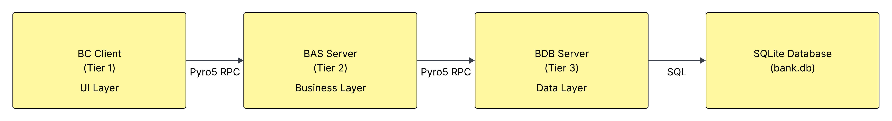
The system design separates its components into distinct tiers which allows developers to scale and test and modify each section independently. The database schema can be modified through changes to method signatures which do not impact the BAS Server's business operations. The system allows users to switch between web-based GUI and command-line interface (CLI) without requiring any modifications to the BAS or BDB Servers. The system follows a fundamental design rule of distributed systems through its modular structure.
Figure 2: Three-Tier Architecture

Component Communication Patterns
All inter-component communication uses synchronous RPC via Pyro5:
BC Client ↔ BAS Server Communication:
- Protocol: Pyro5 RPC over TCP/IP
- Pattern: Synchronous request-response
- Marshalling: Pyro5 automatic serialization of Python objects
- Connection: Client creates Pyro5 proxy to BAS Server via name server lookup
- The system includes five methods which perform the following functions: login(), get_balance(), transfer(), get_transfer_status(), request_csv_export().
BAS Server ↔ BDB Server Communication:
- Protocol: Pyro5 RPC over TCP/IP
- Pattern: Synchronous request-response
- Connection: BAS Server creates Pyro5 proxy to BDB Server via name server lookup
The system uses synchronous communication to achieve immediate operation confirmation which meets the banking industry's need for instant confirmation. During a transfer request, the client blocks synchronously while the BAS Server authenticates the request and coordinates with the BDB Server to execute the transfer atomically before returning a success or failure response. The BDB Server operates as a direct system dependency which causes all data-related operations to stop when it becomes unavailable although the BC Client and BAS Server processes continue to run. But it enables essential benefits for user authentication and error detection and transaction rule management.

Authentication and Session Management
The authentication workflow demonstrates different authorization levels which operate through its multi-level system structure.
The authentication workflow requires the BC Client to transmit credentials to BAS Server which performs authentication by checking these credentials against BDB Server user database information. The BAS Server system produces a UUID4 session token which it stores in memory before sending it to the client for future request authentication.
The BAS Server maintains session tokens in its memory system instead of saving them to the database. The design selection chooses basic design elements because they suit an educational environment. Production systems implement distributed session stores which use Redis as an example to support multiple application servers and preserve session data when the system restarts (Kleppmann, 2017).

Transfer Processing Workflow
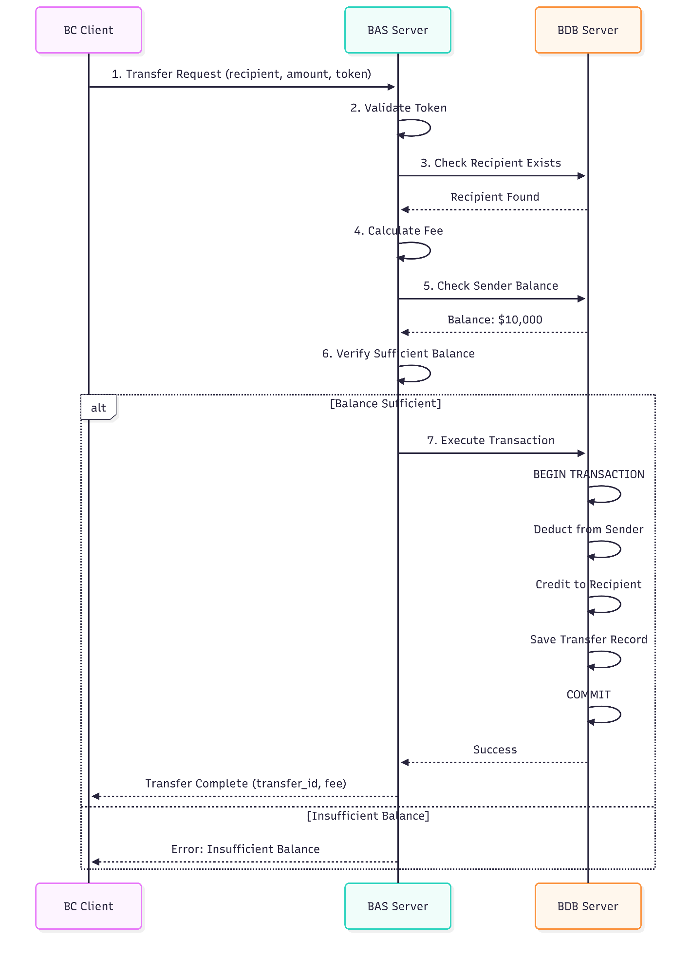
Figure 3: Transfer Processing Workflow

Database Schema and Persistence
The BDB Server manages three tables in the SQLite database:
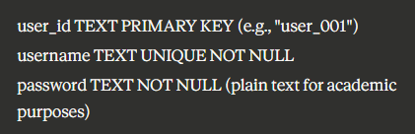
users table:

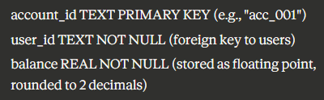
accounts table:

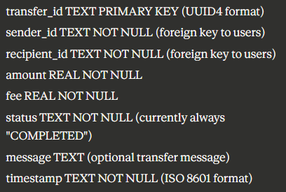
transfers table:

Consistency and Transaction Management
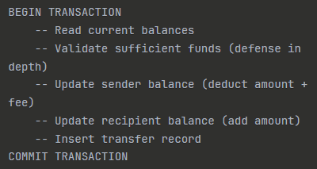
SQLite maintains strong consistency through its database system which supports ACID transactions. The execute_transfer() method in BDB Server performs all database modifications through an explicit transaction.
The system will stop its operation when any step fails because of database constraint violations or when the account balance becomes insufficient. The system will automatically perform a ROLLBACK to maintain atomicity. The default isolation level of SQLite which is SERIALIZABLE prevents multiple transactions from seeing any intermediate stages of database changes. The system uses row-level locking during SELECT operations to stop race conditions which would happen when two transfers try to access the same initial balance value before any update process.
This approach is a tradeoff between availability and consistency. If the BDB Server is no longer available, then no transfers can be processed. In the framework of CAP theorem (Brewer, 2012), such a system focuses on Consistency and Partition tolerance and compromises Availability, which is suitable for financial systems where erroneous balances are unacceptable.

Duplicate Request Handling
The system will attempt to transfer data again when network timeouts occur. The system would perform duplicate transfers when users performed their actions because it lacked duplicate detection functionality. The system contains basic functions which stop duplicate entries from being entered into the system.
- BAS Server generates transfer_id before processing
- BAS Server queries BDB Server: does this transfer_id exist in transfers table?
- If yes, reject as duplicate (prevents double-processing)
- If no, proceed with transfer execution
- The system needs to include the transfer_id field because it performs database insertion of transfer records.
The method operates with a basic design which differs from complex idempotency systems that maintain idempotency keys outside of business data storage (Kleppmann, 2017). The system demonstrates academic concepts effectively through its design which prevents excessive complexity. The production systems would implement client-supplied idempotency keys to perform retry operations following server restarts.

Implementation Procedure

Phase 1: Two-Tier Development
The proposed implementation approach resulted in Phase 1 establishing basic system functionality through a two-tier system which integrated BC Client with BAS Server and stored data in memory. The team checked business rules and communication methods at this point before they added database intricacies to the system.
Phase 1 Scope:
- BC Client with text-based menu interface
- BAS Server with in-memory Python dictionaries for data storage
- Pyro5 RPC communication between client and server
- The system contains all necessary business operations which include user verification and payment amount determination and transaction execution.
- All functional requirements except persistence.
Phase 1 Benefits:
- Rapid development without database schema complexity
- The system allows for basic testing because its memory system maintains a predictable state which remains constant.
- The system requires RPC communication functionality while maintaining proper operation of business logic operations.
- Easy state reset between test runs
The in-memory implementation used Python dictionaries:
- self.users: Dict[str, str] for username → password mappings
- self.accounts: Dict[str, float] for user_id → balance mappings
- self.transfers: List[Dict] for transfer records
- self.sessions: Dict[str, str] for token → user_id mappings
The business logic and fee calculations and RPC communication in Phase 1 operated as their designers had intended. The project followed an iterative approach to identify and resolve logical errors before it implemented database transaction complexity in the system.

Phase 2: Three-Tier Extension with Database
The BDB Server operated as a standalone database server during Phase 2 because it moved from using memory-based storage to SQLite database management system. The system required exact programming changes to maintain its separate tiers which followed their defined principles.
- Created BDB Server (bdb_server.py):
- ONLY file that imports sqlite3
- Manages database connection and cursor operations
- Exposes data access methods via Pyro5 RPC
- Implements transaction management for transfers
- Provides CSV export functionality

- Refactored BAS Server:
- REMOVED all in-memory data dictionaries (users, accounts, transfers)
- KEPT in-memory sessions dictionary (session state, not business data)
- ADDED Pyro5 connection to BDB Server
- MODIFIED all data access to call BDB Server methods instead of local dictionaries
- RETAINED all business logic (fee calculation, validation)

- BC Client (Unchanged):
- No modifications required (benefit of tier separation)
- Still connects to BAS Server with identical method signatures
- Demonstrates architectural benefit: database tier added transparently to clients
Connection Management Strategy:
The BAS Server creates a Pyro5 proxy to the BDB Server during initialization. The Pyro5 threading system has a hidden requirement which states that Pyro5 proxies need to exist and function under the same thread. The solution creates fresh proxies per request thread using a helper method _get_bdb_server() that returns a new proxy instance. The system protects against "calling thread is not the owner" errors which happen when different threads execute their operations at the same time.

Development Challenges and Solutions
Challenge 1: Pyro5 Threading Errors
Problem: occurred when Pyro5 proxy objects were used between different threads because it produced "calling thread is not the owner" exceptions.
Solution: The system needs to create a proxy for every request through the stored URI instead of keeping a proxy object in storage.
Challenge 2: SQLite Connection Management
Problem: SQLite connections cannot be shared across threads
Solution: Create new connection for each database operation, close in finally block
Challenge 3: Tier Separation Enforcement
Problem: The BAS Server prevents developers from obtaining database authorization which they need to perform their refactoring work.
Solution: Code review to verify NO sqlite3 import in BAS Server, all SQL in BDB Server only
Challenge 4: Transaction Atomicity
Problem: The multi-step transfer process needed all its steps to run at once because it did not have any feature which would let the process stop.
Solution: Explicit BEGIN TRANSACTION, perform all operations, COMMIT or ROLLBACK in exception handler

User Manual

6.1 System Requirements
Software Requirements:
- Python 3.8 or higher
- Pyro5 library (install via pip install Pyro5)
- The system requires Windows or Linux or macOS operating system which supports Python execution.
Hardware Requirements:
- Minimal: Any modern computer capable of running Python
- Storage: <100 MB for system and database files
- Network: Localhost loopback interface (no external network required)

6.2 Installation and Setup
Step 01: Install Python Dependencies
Open a terminal or command prompt pip install Pyro5
Verify installation python -c "import Pyro5; print('Pyro5 installed successfully')"
Step 2: Extract Project Files
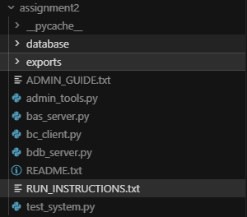
Correct project Folder structure:
Figure 4: Project Folder Structure
The main files are:
- bc_client.py
- bas_server.py
- bdb_server.py
- /database/ folder (created automatically)
- /exports/ folder (created automatically)

6.3 Starting the System
To run the system, it requires Four terminal windows opened.
Terminal 1 – Run Pyro5 Name Server: python -m Pyro5.nameserver
Expected Output:
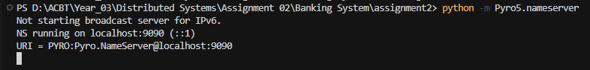
Figure 5: Terminal 1
Terminal 2 - Start BDB Server - Navigate to project directory, then: python bdb_server.py
Expected Output:
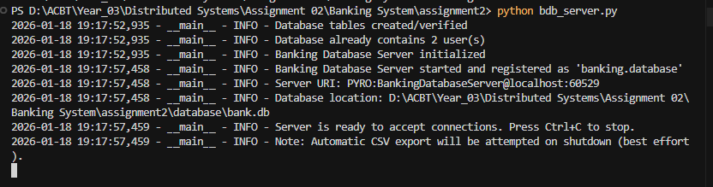
Figure 6: Terminal 2
Terminal 3 - Start BAS Server in project directory: python bas_server.py
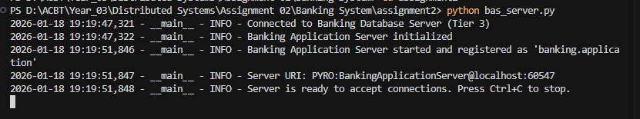
Expected Output:
Figure 7: Terminal 3

Terminal 4 – Start BC Client in project directory: python bc_client.py
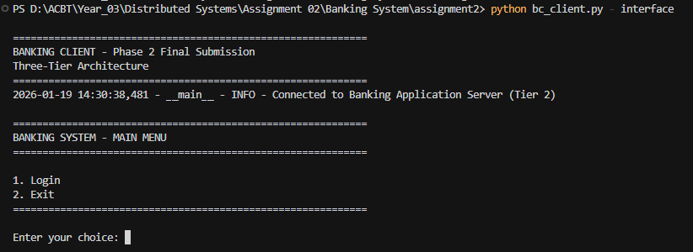
Expected Output:
Figure 8: Terminal 4

6.4 Using the Banking System
Login process:
- In the main menu choose option 1 to login.
- Enter default user credentials:
  - user 1 : Username = alice | Password: pass123
  - user 2 : Username = bob| password pass456
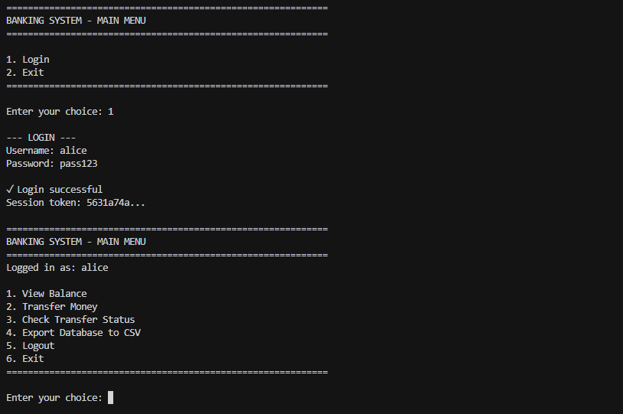
Figure 9: Successful login screen showing session token
Checking Balance:
- Choose option “1” to check the current balance
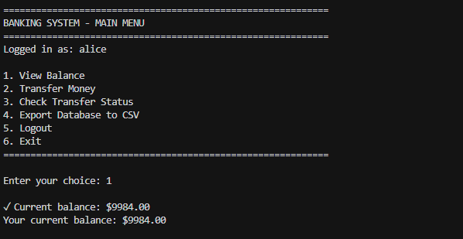
Transferring Money:
Figure 10: View Balance
- Choose option "2” to Transfer Money
- Enter Recipient username
- Enter amount
- Enter optional message
- System will display the transaction confirmation and the transaction ID with fee details
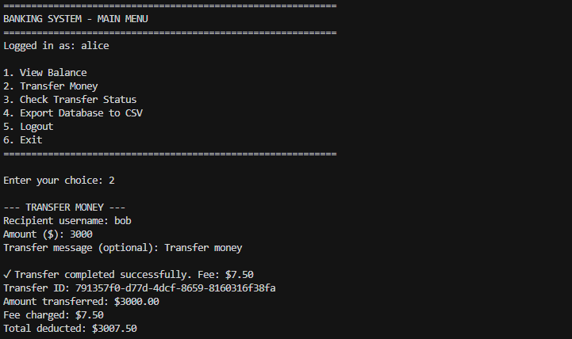
Figure 11: Successful transfer showing amount, fee, and total deducted
Checking Transfer Status:
- Choose option “3” to check transfer status
- Enter transfer ID
- System displays transfer details
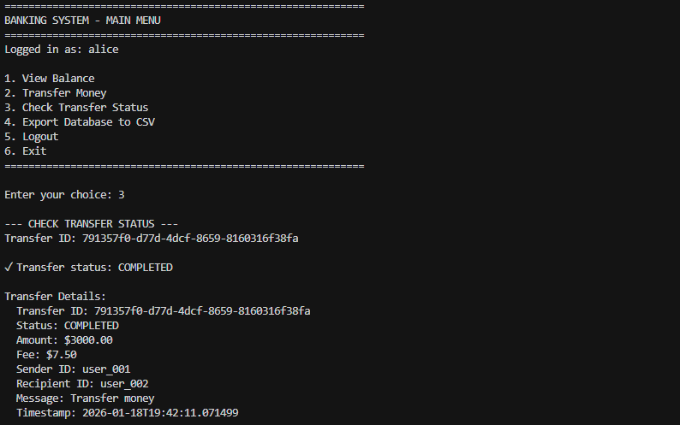
Figure 12: Checking transfer status
Exporting Database to CSV:
- Choose option “4” to Export database to CSV file
- Type “yes”
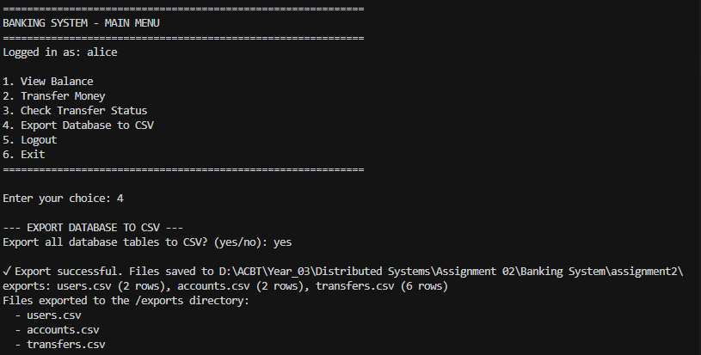
- System exports users.csv, accounts.csv, transfers.csv to /exports folder

Figure 13: CSV export confirmation message
Logging Out:
- Choose option “5” to logout
- The Session token deleted, returns to main menu

Test Cases and Validation
Test Case 1: Authentication - Valid Credentials
- Input : Username: alice, Password: pass123
- Expected Output: Login success message, session token returned. Verification passed
Test Case 2: Authentication - Invalid Credentials
- Input : Username: alice, Password: pass123
- Expected Output: Login failed message "Invalid username or password", no token. Verification failed
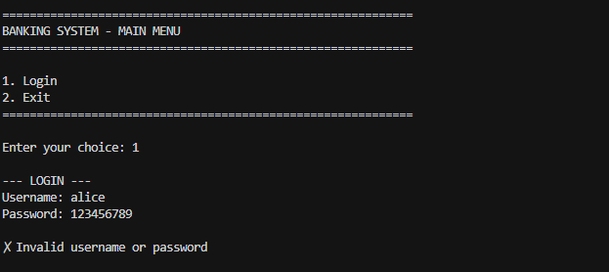
Figure 14: Error message for invalid credentials
Test Case 3: Balance Query
- Input : Select "View Balance" menu option
- Expected Output: Display balance: (e.g., $5000)

Test Case 4: Transfer - Free Tier
Preconditions: User A balance : $5,000, User B balance : $2,000
- Input: User A Transfers $1500
- Expected Output:
    - Fee: $0
    - User A balance : $3,500
    - User B balance : $3,500
Test Case 5 : Transfer Entry Tier
- Input: recipient name, amount ($6000)
- Expected Output: Transferred money to “alice” with $15.00 fee which is 0.25%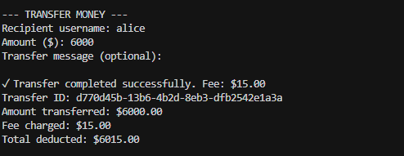
Test Case 6 : Transfer Top Tier
Preconditions: User E balance : $200,000, User F balance : $50,000
- Input: User E Transfers $150,000
- Expected Output:
    - Fee: $100
    - User E balance : $49,900
    - User F balance : $ $200,000
Test Case 7 : Insufficient Balance
Preconditions: User balance : $4,000
- Input: User G Transfers $5,000
- Expected Output:
    - Fee: 0
    - User G balance : $4,000 (unchanged)
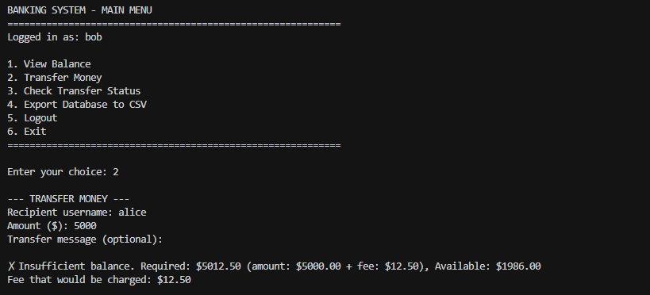

Test Case 8 : Invalid Recipient when transferring
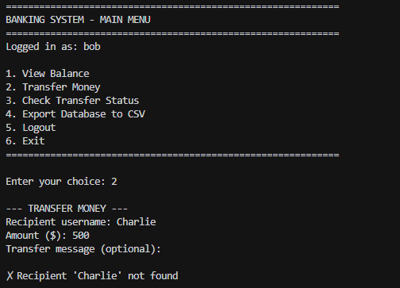
- Input: Recipient: Charlie, Amount
- Expected Output: Transfer rejected with "Recipient 'charlie' not found" error,No money deducted from sender.

Figure 15: Invalid recipient
Test Case 9 : Transfer to Self
- Preconditions: user logged into bob’s account
- Input: enter recipient as ‘bob’
- Expected output: error message “Cannot transfer money to youtself”
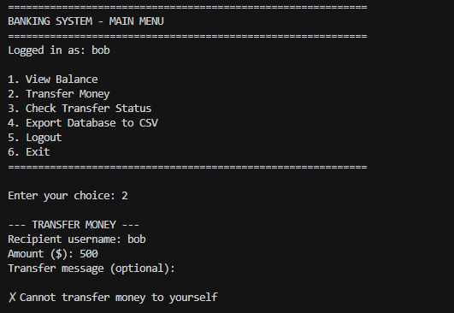

Discussion and Critical Analysis

8.1 Design Decisions and Justifications
The system depends on synchronous RPC communication which enables immediate transaction verification because banking operations need users to get fast success or failure responses (e.g. when funds are insufficient). The system fault tolerance methods Nygard (2018) presented for asynchronous patterns introduce time delays which oppose the requirement for immediate system verification.
Pyro5 was selected over gRPC for its Pythonic API and minimal setup. The method invocation of Pyro5 operates without need for protocol-buffer definitions or code generation which makes it suitable for academic environments because it enables students to study RPC fundamentals without dealing with performance optimization challenges.
The system prevents duplicate transfers through a transfer_id verification process which occurs before any processing takes place. The system demonstrates idempotency through its lightweight design which teaches students about this concept while avoiding production-level framework complexity according to Kleppmann (2017).

8.2 Trade-offs and Limitations
The system prioritizes consistency over availability (CP in CAP theorem), accepting that database unavailability prevents all transfers (Brewer, 2012). The method serves financial systems because any wrong entry in the balance would result in unacceptable errors.
The system faces three main restrictions which include:
(1) The system lacks a stress testing mechanism to handle multiple transactions at once
(2) The system loses all session data from memory when it restarts
(3) The system only accepts plain text passwords for educational use.

8.3 Lessons Learned
The Phase 1→Phase 2 iterative method succeeded because it enabled business logic testing before developers started working on complex database functionality. The Pyro5 threading constraint revealed that remote proxies differ from local objects, requiring fresh proxy creation per request (Waldo et al.,1997). The testing process revealed that error messages should display both exact dollar amounts and complete system failure cause information.

Conclusion
The system achieved its goals by creating a three-tier distributed banking system which performed remote procedure calls and demonstrated tier separation and transaction management and consistency guarantee functionality. The system functioned as designed because it allowed users to verify their identity and performed account balance checks and processed payments with integrated fee management and transfer status monitoring while keeping all system elements completely independent.
The development process of Phase 1 to Phase 2 used an iterative approach to test business rules before adding database complexity to the system. The system achieves technical success through its implementation of synchronous RPC which delivers instant confirmation and its six-tier progressive fee system which ranges from 0% to 0.05% and its ability to handle duplicate requests and its detailed audit system which uses structured logging and CSV export for data retrieval.
The testing process verified all requirements through manual human assessment and automated system verification which proved the correct operation of authentication sequences and fee calculation and error handling and data storage precision. Financial operations need absolute accuracy in their processes so the system gives priority to maintaining consistency instead of availability.
The academic version of the architecture presents distributed systems principles through its simplified design. The system maintains its ability to update its database structure and add new user interfaces and perform background payment processing through its current business operations. The project enables me to gain practical knowledge about distributed system communication behavior and distributed system consistency needs and separate system architecture design.

References
Birrell, A. D., & Nelson, B. J. (1984). Implementing remote procedure calls. ACM Transactions on Computer Systems, 2(1), 39–59. https://doi.org/10.1145/2080.357392
Brewer, E. A. (2012). CAP twelve years later: How the “rules” have changed. Computer, 45(2), 23–29. https://doi.org/10.1109/MC.2012.37
Google. (n.d.). gRPC: A high-performance, open source universal RPC framework. Retrieved April 12, 2024, from https://grpc.io/
Kleppmann, M. (2017). Designing data-intensive applications: The big ideas behind reliable, scalable, and maintainable systems. O’Reilly Media.
Nygard, M. T. (2018). Release it! Design and deploy production-ready software (2nd ed.). Pragmatic Bookshelf.
Pyro5. (n.d.). Pyro5: Python remote objects. Retrieved April 12, 2024, from https://pyro5.readthedocs.io/
Richardson, C. (2018). Microservices patterns: With examples in Java. Manning Publications.
SQLite Consortium. (n.d.). SQLite documentation. Retrieved April 12, 2024, from https://www.sqlite.org/docs.html
Tanenbaum, A. S., & Van Steen, M. (2017). Distributed systems: Principles and paradigms (3rd ed.). Pearson Education.
Waldo, J., Wyant, G., Wollrath, A., & Kendall, S. (1997). A note on distributed computing. In J. Vitek & C. Tschudin (Eds.), Mobile object systems: Towards the programmable Internet (pp. 49–64). Springer. https://doi.org/10.1007/BFb0054206
AI Tool Declaration: This project was written with the help of Claude (Anthropic) on January 19, 2026, to receive guidance with research, assistance in structuring and verification of the reference formatting

