

# Sri Lanka Institute of Information Technology Faculty of Computing Department of Information Technology

# Personal Development Plan (PDP)

IT2100 – Employability Skills Development

**Student Name:** Heshan P.M.Y.D

**Student ID:** IT23545762

**Degree:** BSc (Hons) in Information Technology

**Year:** 2

**Semester:** 2

## Self-Assessment

Self-Assessment I started my self-assessment by reflecting on my academic journey, projects, and personal qualities. To structure this process, I used a SWOT analysis and a skills audit. This allowed me to clearly identify areas where I am confident and capable, as well as those where I need to improve.

**Strengths**: I have strong technical skills in Java, MERN stack development, and Kotlin. Through projects like Police360 .I developed hands-on coding and debugging skills. I am also creative in UI/UX design, with experience in tools like Figma and Canva. I adapt quickly to new technologies and enjoy problem-solving, particularly in team environments where I can collaborate and share ideas.

**Weaknesses**: Despite my technical strengths, I lack industry exposure. I have not yet completed an internship, which limits my practical understanding of workplace dynamics. Time management is another weakness, especially when multiple coursework deadlines overlap. I also face anxiety during public speaking, which affects my confidence when presenting. In group projects, I sometimes avoid leadership roles, preferring to contribute individually rather than guide a team.

**Opportunities**: My university offers workshops, career fairs, and certifications like AWS Academy and Scrum, which I can use to grow professionally. The IT sector in Sri Lanka and worldwide is expanding, creating opportunities in areas like software engineering, cloud computing, and data analysis. Engaging with LinkedIn and GitHub also provides networking opportunities and a platform to showcase my skills.

**Threats**: The IT field evolves rapidly, and failing to keep up with new technologies could hold me back. Competition is strong among peers who already have internships or professional certifications. This motivates me to work harder to stand out.

## 2. Goal Setting

Based on my self-assessment, I set clear goals using the SMART framework (Specific, Measurable, Achievable, Relevant, Time-bound). These goals address my weaknesses while building on my strengths. I divided them into short-term, medium-term, and long-term categories.

## 3. Action Planning

To achieve these goals, I created a structured action plan with clear steps, resources, and timelines.

**Public Speaking**: I will join the university debate club in February 2025 and volunteer for presentations. I will practice regularly by watching TED Talks and recording myself to evaluate progress. Feedback from lecturers and peers will help me improve.

**AWS Certification**: I will enroll in AWS Academy by August 2025, dedicate at least 5 hours weekly to practice, and sit for the exam by December 2025.

**Internship:** I will update my CV and LinkedIn by January 2026, apply to at least 15 internships, and attend career fairs. Networking with alumni will also provide mentorship opportunities.

**Leadership**: I will take leadership roles in projects such as Police360, delegate tasks effectively, and participate in extracurricular activities like event organizing to build confidence.

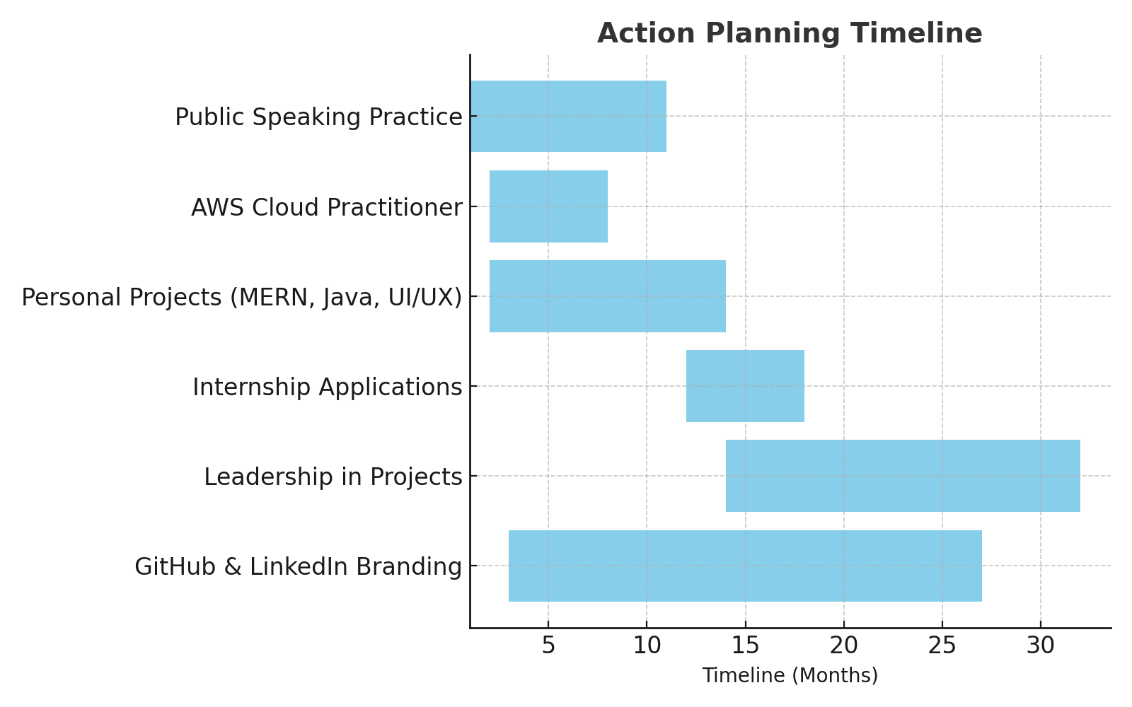**Professional Branding**: I will maintain my GitHub by uploading work monthly, publish two LinkedIn blogs annually, and grow my network to 500+ connections.

## 4. Monitoring & Evaluation Strategy

To stay on track, I will adopt a structured monitoring and evaluation strategy. I will review progress monthly using Notion dashboards and Trello boards, where each goal will be tracked with milestones. I will keep reflective journals each semester to assess what strategies worked and what needs adjustment. Feedback from lecturers and peers will be collected after each presentation or leadership task. If a goal falls behind by more than two months, I will adjust timelines and methods to stay realistic. Success will be measured not only by certifications or projects but also by improvements in communication and leadership.

## 5. Personal Insight & Motivation

My motivation comes from a passion to solve real-world problems through IT. Working on projects like Police360 showed me how technology can improve public services, while FurniHouse gave me space to experiment with design and user experience. These experiences strengthened my belief that IT can create meaningful change in society. The fast pace of the industry excites me because it challenges me to keep learning. I see weaknesses like public speaking anxiety as opportunities to push myself beyond my comfort zone. My ultimate vision is to become not only a skilled developer but also a leader who contributes to Sri Lanka’s digital growth.

## 6. Presentation & Communication

## I have created this Personal Development Plan to be clear and organized for easy reading. Each section transitions from self-assessment to goal setting, action planning, monitoring, and motivation. I have used simple language and made sure it is clear and error-free to demonstrate good communication skills.

## To improve clarity, I used bullet points for listing goals, strengths, and skills. Longer sections are in paragraphs to provide detailed explanations. I also plan to include visuals like a SWOT table, SMART goals, and a Gantt chart to present my plans more effectively.

## Overall, this PDP is designed to fulfill the assignment requirements while showcasing my ability to present ideas in a structured and professional manner. This skill is important for my future career in the IT industry.

## 7. Use of Tools & Evidence

To strengthen this Personal Development Plan, I have included tools and supporting evidence that show my current progress and future goals. I updated my LinkedIn profile to highlight my academic background, technical skills, and projects like Police360 and FurniHouse. This profile serves as a digital portfolio. It helps me connect with industry professionals, stay informed about opportunities, and track my growth over time.

I also prepared an updated CV that highlights my technical skills, teamwork experience, and important project contributions. This CV will keep evolving as I gain more experience through internships and industry placements. Additionally, I enrolled in learning platforms like AWS Academy and Coursera, where I am working toward certifications, including AWS Cloud Practitioner. I will use certificates of completion and progress reports as proof of my development.

I maintain a GitHub repository where I upload my coding work and project outputs. This repository serves as a clear record of my technical growth, showcasing my consistency in applying practical skills. You can find evidence of collaborative development, especially from my work on Police360 and FurniHouse, in this repository.

Finally, I plan to add a skills audit chart and visual documentation of project outcomes. These will provide solid proof of my skills. By combining these tools and evidence, I can support the goals set in this PDP and show my commitment to closing employability gaps through careful planning and action.