**Open Source Development**

**CONTENT MANAGEMENT SOFTWARE**

**(Wordpress.com)**

Submitted to -

Madhushree Basavarajaiah

Submitted by -

Khushbu Maliwal

(14BCE050)

**Introduction**

Content Management System is that application that supports creation and modification of digital content. Wordpress is free and open source CMS and is considered to be the most used website management and blogging in use today. I have created a wordpress blog which is based on Digital Marketing.

**Wordpress Functionalities**

* **Stats**

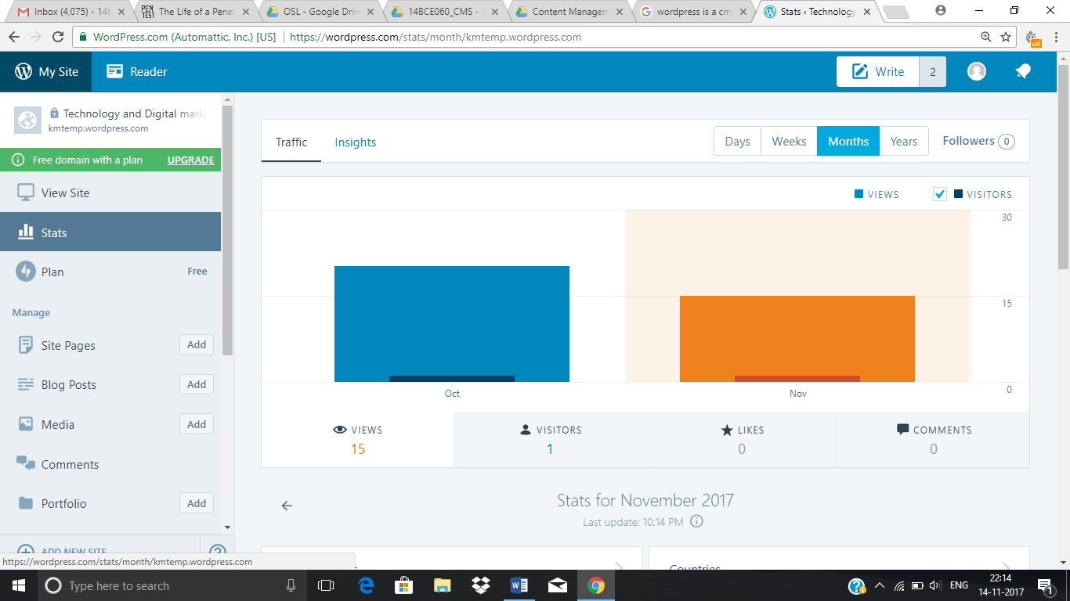

* **Site Pages**

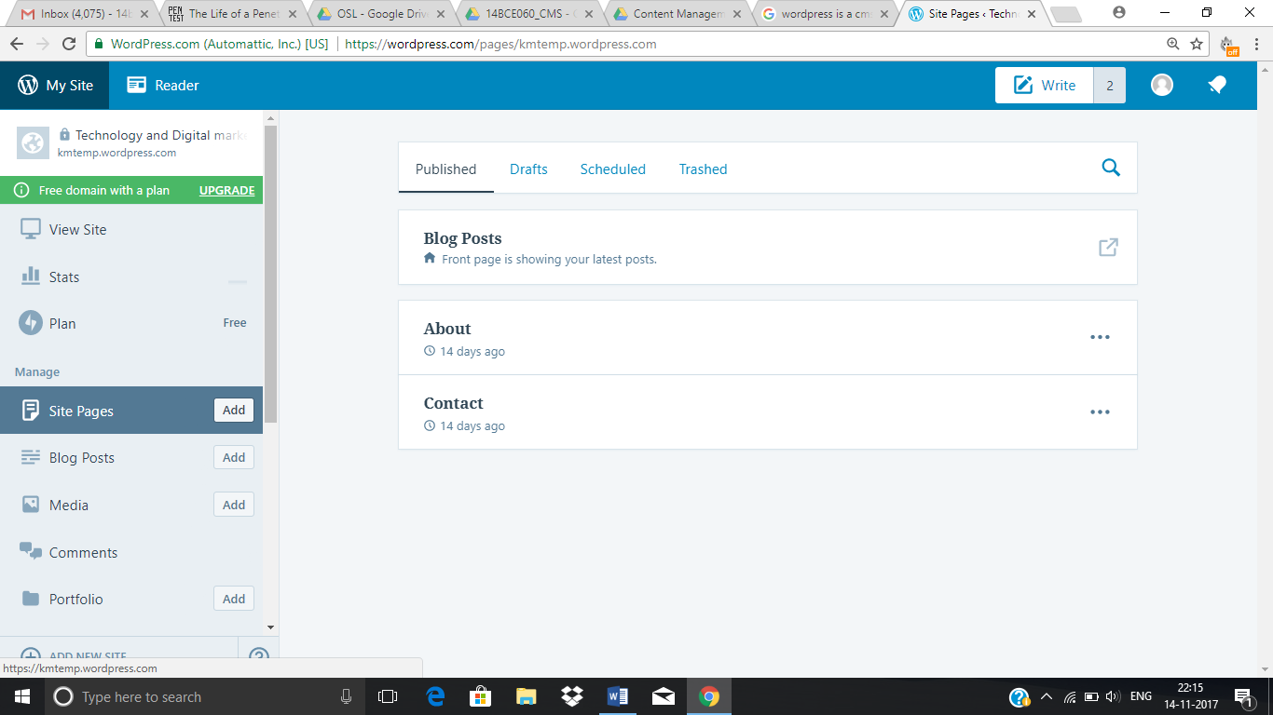

* **Blog Posts**

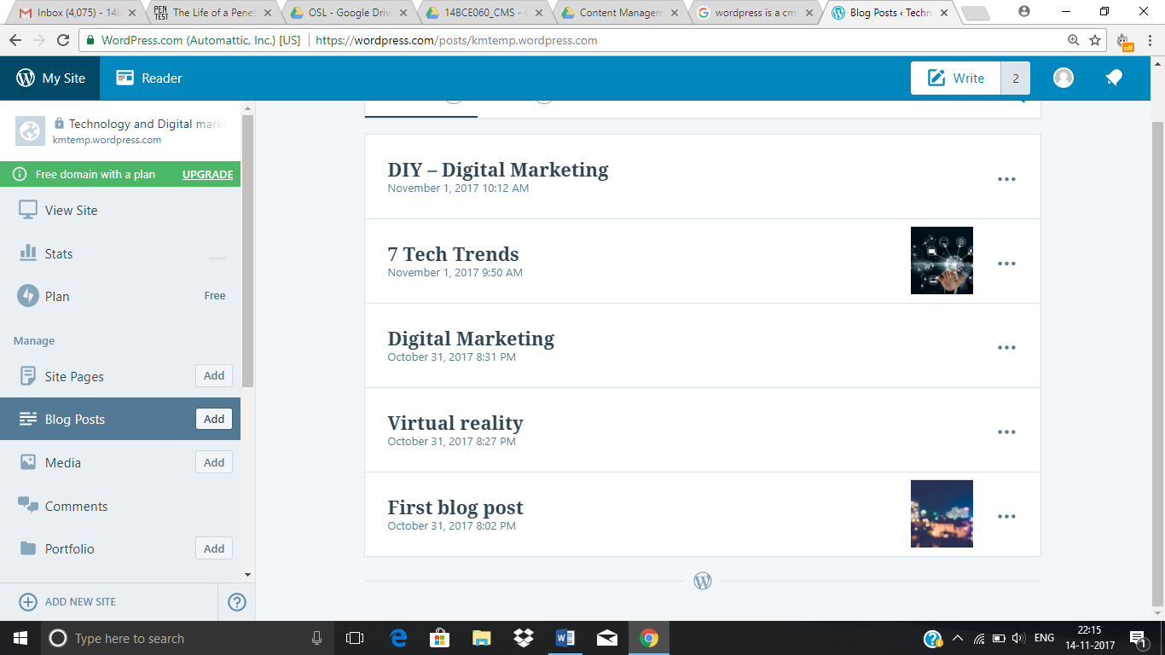

* **Theme Customization**

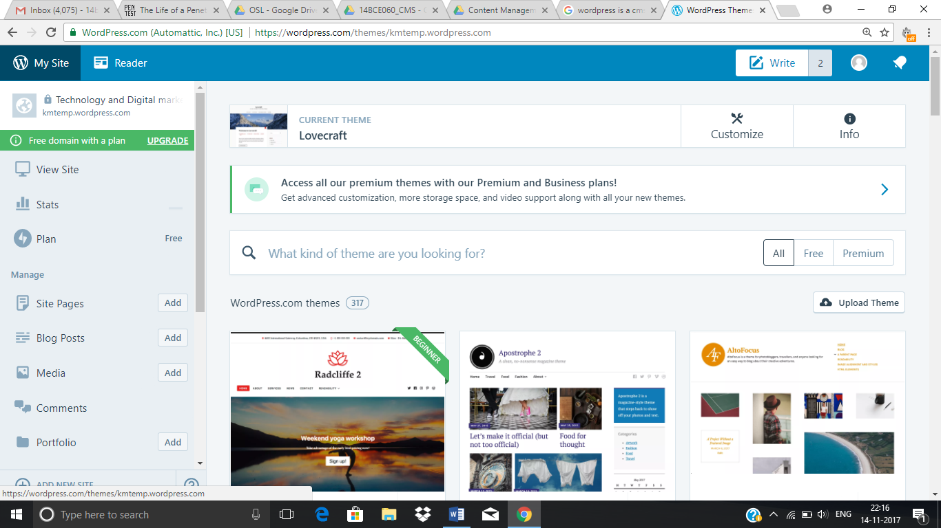

**BLOG POSTS**

* **Home Page**



* **About Page**

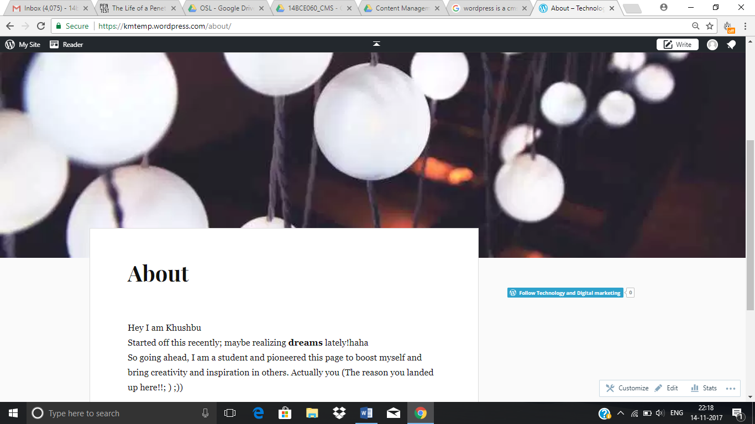

* **Blog Posts**

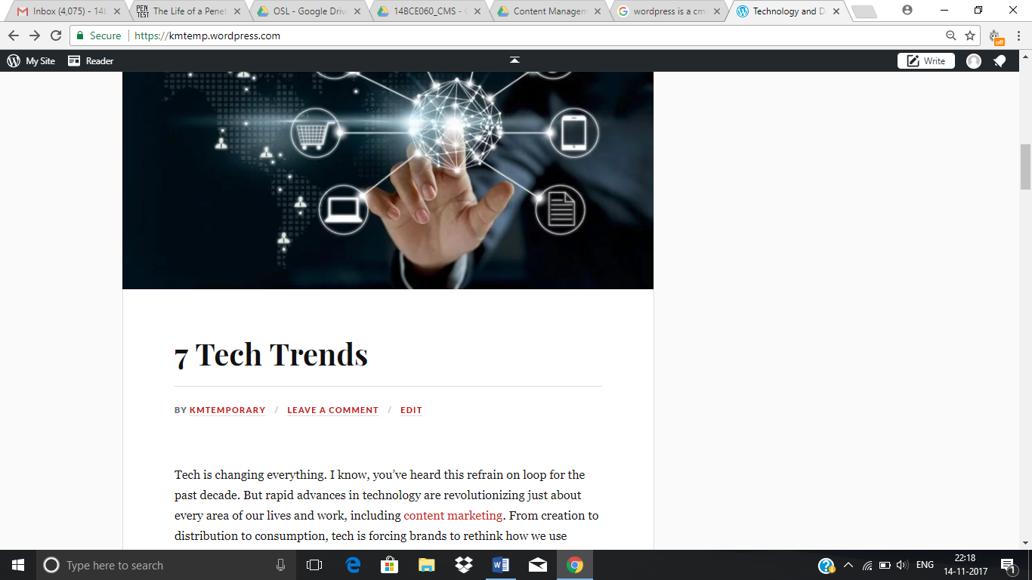

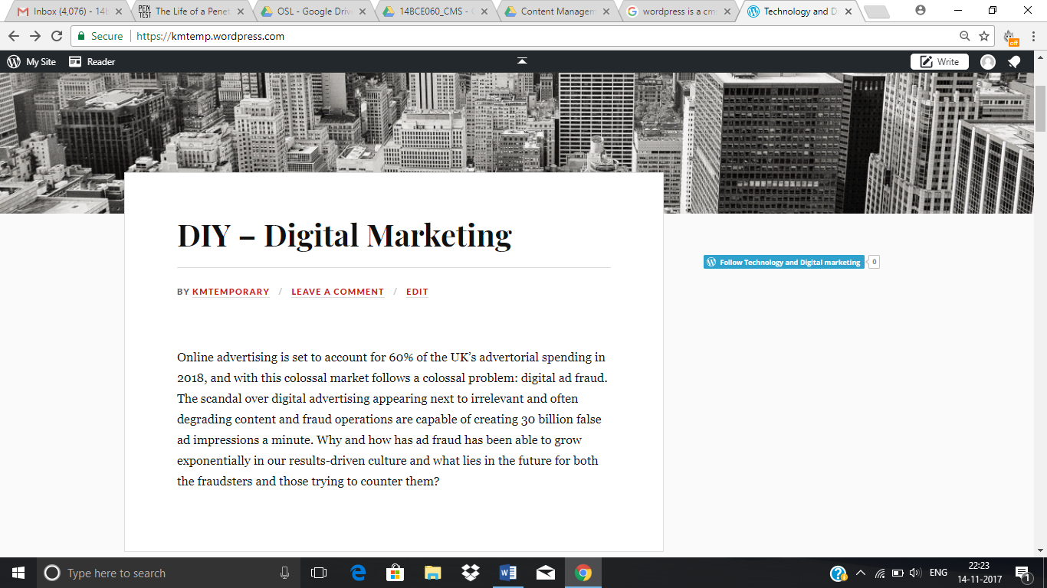

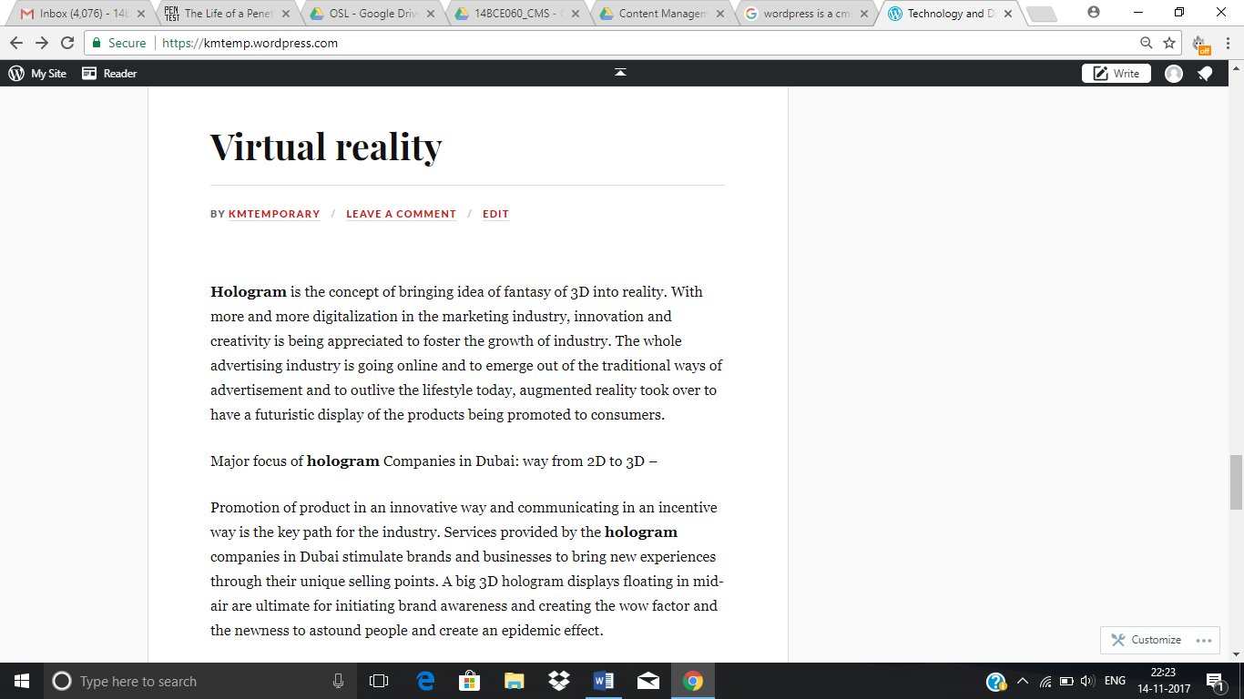

**Conclusion**

We learned content management system using Wordpress as a platform. It is the mostly widely used platform for website development and blogging. And provides us with a wide variety of features to manipulate with.