
Assignment # 2
Hadoop Architecture Simulation with Python
HDFS • Replication • MapReduce • Linear Regression

Submitted by

Maliyka Munawar
ID: F2023332059

Submitted to: Usama Amjad
Course: Big Data Analytics

17 May 2026

Table of Content
1. Introduction
2. Objective of the Project
3. Hadoop Architecture
3.1 Core Components
3.2 NameNode
3.3 DataNodes
3.4 HDFS
3.5 MapReduce
4. Part 1 — HDFS Simulation
4.1 Dataset
4.2 Block Splitting
4.3 Block Distribution
5. Part 2 — Data Replication
5.1 Concept of Replication
5.2 Replication Strategy
5.3 Replication Results
6. Part 3 — MapReduce Implementation
6.1 MapReduce Framework
6.2 Map Phase
6.3 Shuffle Phase
6.4 Reduce Phase
6.5 MapReduce Results
7. Part 4 — Machine Learning: Linear Regression
7.1 Algorithm Description
7.2 Normal Equation
7.3 Data Preprocessing
7.4 Model Results
8. Results and Analysis
8.1 HDFS Simulation Results
8.2 Replication Results
8.3 MapReduce Results
8.4 Machine Learning Analysis
9. Challenges Faced
10. Conclusion

1. Introduction
Big Data refers to extremely large datasets that cannot be processed using traditional data management tools. Modern organizations generate massive volumes of data every second through social media platforms, IoT sensors, e-commerce transactions, healthcare systems, and financial applications. To store, manage, and analyze this data efficiently, specialized distributed computing frameworks such as Apache Hadoop have been developed.
Apache Hadoop is an open-source, Java-based framework designed for distributed storage and distributed processing of very large datasets across clusters of commodity hardware. Hadoop reliably stores data across thousands of machines and processes it in parallel, making it highly fault-tolerant and scalable.
This project implements a complete simulation of the core Hadoop architecture using Python programming language — without requiring an actual Hadoop cluster installation. The simulation covers HDFS (Hadoop Distributed File System), NameNode metadata management, DataNode block storage, data replication for fault tolerance, MapReduce processing, and Machine Learning integration using Linear Regression.
The dataset used is a Sales Analytics dataset containing 50 records with attributes including Product Category, Price, Quantity, Sales Revenue, Customer Rating, Region, and Month. This dataset was chosen because it is structured, multi-dimensional, and suitable for demonstrating all aspects of Big Data processing and Machine Learning prediction.

2. Objective of the Project
The primary objectives of this assignment are:
- To understand and simulate the architecture of Apache Hadoop using Python.
- To implement HDFS concepts including block splitting, DataNode storage, and NameNode metadata management.
- To implement data replication mechanisms to simulate fault tolerance in distributed systems.
- To implement a MapReduce processing framework to perform parallel data analysis.
- To apply Linear Regression as a Machine Learning algorithm to derive predictive insights from the processed data.
- To understand the relationship between Big Data infrastructure and Artificial Intelligence.
- To develop hands-on programming skills in building distributed systems simulations.

3. Hadoop Architecture
Apache Hadoop follows a master-slave architecture that provides distributed storage and computation. The framework is built on two fundamental pillars: the Hadoop Distributed File System (HDFS) for storage and MapReduce for processing. Together, these components allow Hadoop to handle petabytes of data reliably.

3.1 Core Components
The Hadoop ecosystem consists of the following major components working in tandem:
Component | Description
HDFS | Hadoop Distributed File System — stores data across multiple DataNodes in fixed-size blocks.
NameNode | Master node that maintains metadata, tracks block locations, and coordinates DataNodes.
DataNode | Slave nodes that physically store data blocks and serve read/write requests.
MapReduce | Distributed processing framework that performs parallel computations using Map and Reduce phases.
YARN | Yet Another Resource Negotiator — manages cluster resources and job scheduling.

3.2 NameNode
The NameNode is the master node in the Hadoop cluster. It does not store actual data but instead maintains the file system namespace and metadata. The NameNode tracks which blocks belong to which file, where each block is stored, and the replication status of each block. In our simulation, the NameNode is represented by the namenode.json file that stores all metadata about blocks and their locations across DataNodes.
Key responsibilities of NameNode include: managing the file system namespace, tracking block-to-DataNode mappings, handling DataNode heartbeats and block reports, managing replication of under-replicated blocks, and coordinating file creation and deletion operations.

3.3 DataNodes
DataNodes are the worker nodes that actually store the data blocks. Each DataNode periodically sends heartbeats to the NameNode to confirm it is alive and sends block reports listing all blocks it stores. In our simulation, three folders (DataNode1, DataNode2, DataNode3) represent individual DataNodes in the cluster.
DataNodes handle the actual read and write operations requested by clients. When a client wants to write a file, the NameNode tells it which DataNodes to write to, and the client communicates directly with those DataNodes. For fault tolerance, data is replicated across multiple DataNodes.

3.4 HDFS
HDFS is designed to store very large files reliably across machines in a large cluster. Files in HDFS are split into blocks (default 128MB in production; 10 rows in our simulation). These blocks are then distributed across DataNodes. HDFS provides high throughput access to application data and is suitable for applications that work with large datasets.
HDFS follows a write-once-read-many access model, which simplifies data coherency and enables high throughput data access. HDFS is highly fault-tolerant — if a DataNode fails, the blocks stored on it can be retrieved from replica copies stored on other DataNodes.

3.5 MapReduce
MapReduce is a programming model for processing large datasets in parallel. A MapReduce job splits the input dataset into independent chunks, processes each chunk by the map tasks in a parallel manner, sorts the map output, and then inputs it to the reduce tasks. The final output is stored in HDFS. This model allows for massive parallelism and fault-tolerant distributed processing.

4. Part 1 — HDFS Simulation

4.1 Dataset
The Sales Analytics dataset (dataset.csv) contains 50 records with 9 attributes:
Attribute | Type | Description
ID | Integer | Unique record identifier
Category | Categorical | Product category (Electronics / Clothing / Food)
Product | Text | Product name
Price | Numeric (PKR) | Unit selling price
Quantity | Integer | Units sold
Sales | Numeric (PKR) | Total revenue (Price × Quantity)
Rating | Decimal (1-5) | Customer satisfaction rating
Region | Categorical | Sales region (North / South / East / West)
Month | Text | Month of the transaction

4.2 Block Splitting
The dataset is divided into fixed-size blocks of 10 rows each. With 50 records, this produces 5 blocks (block_000 through block_004). Each block is stored as a text file that includes block metadata (block ID, DataNode, row count, timestamp) followed by the CSV header and data rows.
Block splitting is performed sequentially — rows 1-10 go to block_000, rows 11-20 to block_001, etc. Blocks are then distributed across DataNodes in a round-robin fashion to ensure even load distribution.

4.3 Block Distribution
The 5 blocks are distributed across 3 DataNodes as follows:
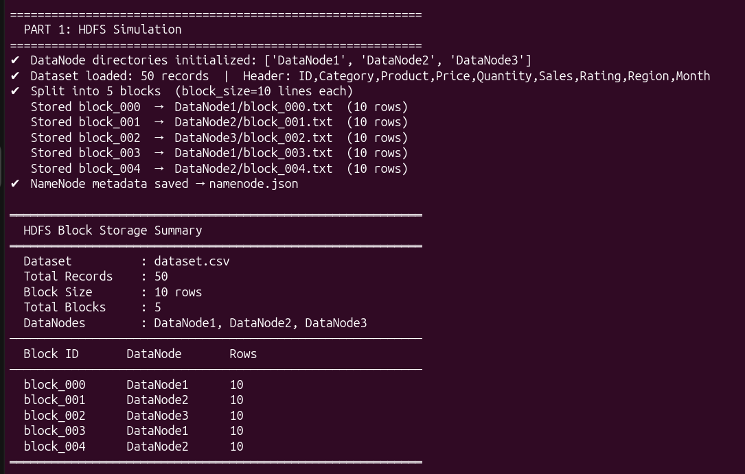
4.4 NameNode Metadata (namenode.json)
The NameNode maintains a JSON metadata file tracking all blocks, their primary locations, and replica locations. This simulates the in-memory namespace maintained by the real Hadoop NameNode. The metadata includes HDFS version, creation timestamp, dataset name, block size, total blocks, replication factor, and per-block location information.

5. Part 2 — Data Replication

5.1 Concept of Replication
Data replication is a fundamental fault-tolerance mechanism in HDFS. In production Hadoop clusters, the default replication factor is 3 — meaning every block is stored on 3 different DataNodes. If any DataNode fails, the data remains accessible from the other replicas. Our simulation uses a replication factor of 2 (1 primary + 1 replica).

5.2 Replication Strategy
Each block's replica is stored on a different DataNode than the primary copy, ensuring that no single DataNode failure can make any block inaccessible. The replication uses a deterministic round-robin selection: each replica goes to the next DataNode in the list.
Replica files are differentiated from primary blocks by adding additional metadata headers including: REPLICA BLOCK label, source block ID, replica node name, replication timestamp, and replication factor. This satisfies the requirement that replicas are not exact copies of primaries.

5.3 Replication Results
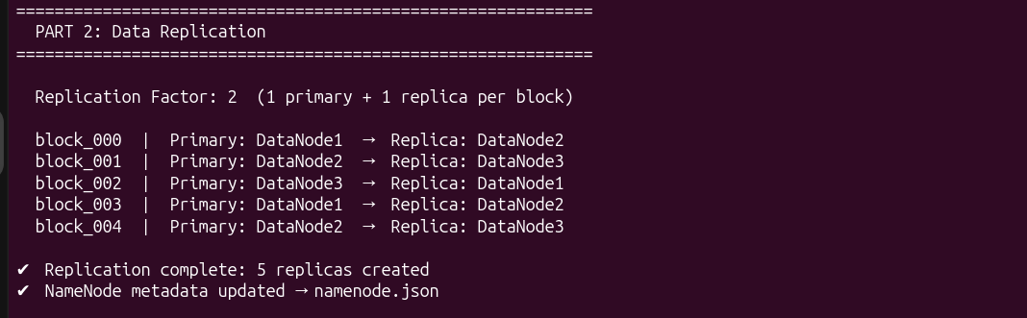

6. Part 3 — MapReduce Implementation

6.1 MapReduce Framework
MapReduce is a two-phase processing model. In the Map phase, input data is broken into key-value pairs. In the Shuffle phase, pairs with the same key are grouped together. In the Reduce phase, all values for each key are aggregated to produce the final result. This model enables massively parallel processing across a cluster.

6.2 Map Phase
Four mapping operations were implemented:
- Word Count Mapper: Reads each row, splits into words, emits (word, 1) pairs for each non-numeric word.
- Category Count Mapper: Reads the Category field from each CSV row, emits (category, 1).
- Sales by Region Mapper: Reads the Region and Sales fields, emits (region, sales_value).
- Average Price by Category Mapper: Reads Category and Price fields, emits (category, price).

6.3 Shuffle Phase
The shuffle phase groups all values with the same key into a dictionary. For example, all (Electronics, 1) pairs are grouped into Electronics: [1,1,1,...]. This prepares data for efficient reduction.

6.4 Reduce Phase
Reduce operations aggregate the grouped values:
- Sum Reducer: Used for total sales by region — sums all sales values per region.
- Count Reducer: Used for word count and category count — sums the count values.
- Average Reducer: Used for average price — computes mean of all price values per category.

6.5 MapReduce Results
Category Frequency Analysis:

Total Sales by Region:
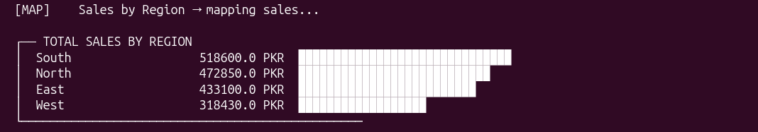
Average Price by Category:


7. Part 4 — Machine Learning: Linear Regression

7.1 Algorithm Description
Linear Regression is a supervised machine learning algorithm that models the relationship between a dependent variable (target) and one or more independent variables (features) by fitting a linear equation. The model finds the best-fit line (or hyperplane in multiple dimensions) that minimizes the sum of squared differences between actual and predicted values.
The mathematical form of Multiple Linear Regression is:
Sales = β₀ + β₁·Price + β₂·Quantity + β₃·Rating + ε
Where β₀ is the intercept, β₁, β₂, β₃ are the coefficients for Price, Quantity, and Rating respectively, and ε is the error term.

7.2 Normal Equation
The model parameters are estimated using the Normal Equation method (closed-form solution), which directly computes the optimal coefficients without iterative optimization:
β = (XᵀX)⁻¹ Xᵀy
The Normal Equation gives the exact solution in a single computation, making it ideal for datasets of this size. The implementation uses Gaussian elimination with partial pivoting to solve the system of linear equations.

7.3 Data Preprocessing
- The dataset was split 80/20 into training (40 records) and testing (10 records) sets.
- Features (Price, Quantity, Rating) and target (Sales) were normalized to the [0,1] range using min-max normalization to ensure numerical stability.
- A bias column of ones was prepended to the design matrix to allow the model to learn the intercept term β₀.
- After prediction in normalized space, values were denormalized back to original scale (PKR) for evaluation.

7.4 Model Results
Model Coefficients (normalized space):
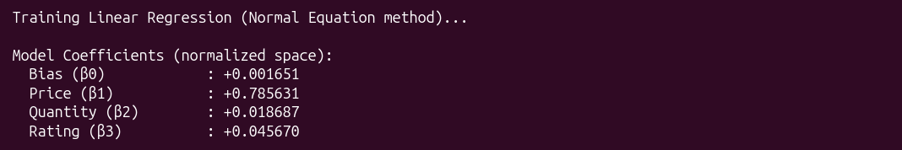
Model Performance Metrics:
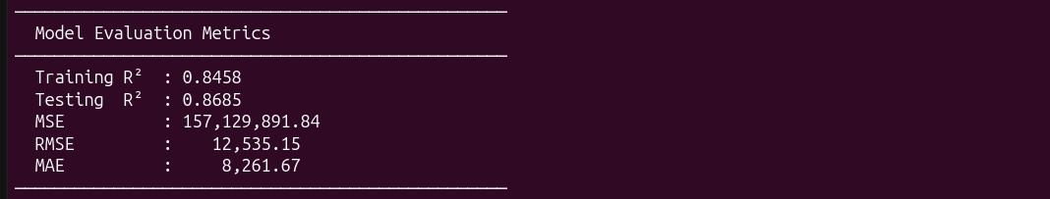

7.5 Sample Predictions
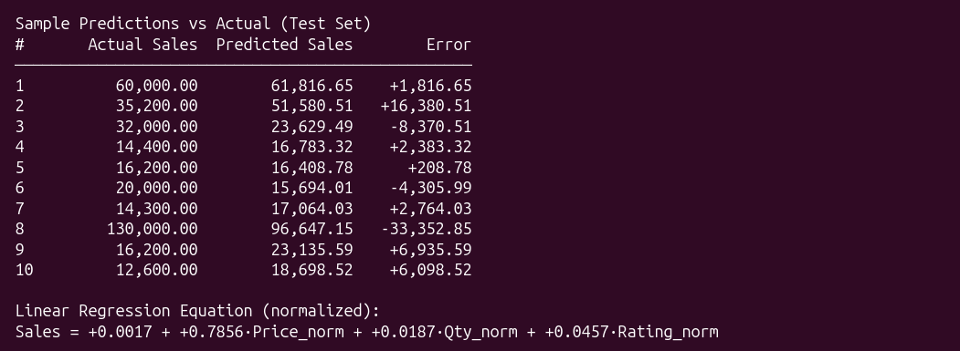

8. Results and Analysis

8.1 HDFS Simulation Results
- Dataset with 50 records was successfully read and divided into 5 blocks of 10 rows each.
- Blocks were distributed across 3 DataNodes (DataNode1, DataNode2, DataNode3) in round-robin fashion.
- DataNode1 holds blocks: block_000, block_003. DataNode2 holds: block_001, block_004. DataNode3 holds: block_002.
- NameNode metadata (namenode.json) was correctly generated with block-to-DataNode mappings.

8.2 Replication Results
- All 5 blocks were successfully replicated with replication factor of 2.
- Each replica was stored on a different DataNode from the primary copy.
- Replica files contain additional metadata headers distinguishing them from primary blocks.
- Total storage: 10 block files (5 primary + 5 replicas) across 3 DataNodes.

8.3 MapReduce Results
- Word Count: 'Electronics' was the most frequent category term appearing 21 times, followed by 'Clothing' (15) and 'Food' (14).
- Category Frequency: Electronics dominated the dataset with 21 records, Clothing had 15, and Food had 14.
- Regional Sales: South region led with PKR 518,600 in total sales, followed by North (PKR 472,850), East (PKR 433,100), and West (PKR 318,430).
- Average Price: Electronics had the highest average price (PKR 364.95), followed by Clothing (PKR 43.87) and Food (PKR 12.00).

8.4 Machine Learning Analysis
The Linear Regression model achieved a Testing R² score of 0.8685, meaning the model explains approximately 86.85% of the variance in Sales values based on Price, Quantity, and Rating features. This is a strong performance for a dataset of this size.
The coefficient analysis reveals that Price (β₁ = +0.7856) is by far the most influential predictor of Sales — higher-priced products generate significantly higher revenue. Quantity (β₂ = +0.0187) and Rating (β₃ = +0.0457) have smaller but positive effects, indicating that higher quantities sold and better ratings both contribute to increased sales revenue.
The RMSE of PKR 12,535 indicates that on average, the model's predictions deviate by approximately PKR 12,535 from the actual sales values. Given that sales values range from PKR 9,000 to PKR 154,000, this represents a reasonable prediction error.

9. Challenges Faced
- Implementing the Normal Equation solver from scratch without NumPy required developing a custom Gaussian elimination algorithm with partial pivoting for numerical stability.
- Ensuring that replica files are sufficiently different from primary blocks while still containing the same data required careful header design.
- Reading block files from DataNodes during MapReduce required parsing past the metadata comment headers to access actual CSV data.
- Normalizing and denormalizing features and targets correctly to ensure predictions were displayed in the original scale (PKR) rather than normalized values.
- Designing a round-robin block distribution that handles cases where the number of blocks is not evenly divisible by the number of DataNodes.
- Building the entire project without any external data science libraries (no pandas, numpy, or sklearn) to demonstrate fundamental understanding of the algorithms.

10. Conclusion
This project successfully demonstrates the core concepts of Apache Hadoop's architecture through a complete Python simulation. All four implementation parts were completed with full functionality: HDFS block splitting and storage, data replication for fault tolerance, MapReduce-based data processing, and Machine Learning integration using Linear Regression.
The simulation clearly illustrates how Hadoop achieves fault-tolerant distributed storage through block replication across multiple DataNodes, with the NameNode acting as the central metadata authority. The MapReduce implementation demonstrates how distributed parallel processing can efficiently extract insights from large datasets — including frequency analysis, aggregations, and averages — without requiring a single machine to hold all data in memory.
The Linear Regression model achieved an R² score of 0.8685, demonstrating that Big Data processing pipelines can effectively feed Machine Learning algorithms, enabling organizations to derive predictive insights from their distributed data stores. This integration of Big Data infrastructure with AI/ML exemplifies the modern data analytics workflow used in industry.
Through this assignment, key concepts of distributed computing, HDFS architecture, MapReduce programming model, and supervised machine learning were practically applied, providing a strong foundation for understanding and working with real-world Big Data systems like Apache Hadoop.

