STATICS
Tutorial Session 1

Australian University of Kuwait
Civil Engineering Program

Instructions:
• Read each question carefully
• Draw free body diagrams where applicable
• Show all your work and calculations
• Use the blank pages provided for your solutions
• Box your final answers

Question 1

Determine the horizontal and vertical components of reaction on the beam caused by the pin at B and the rocker at A. Neglect the weight of the beam.
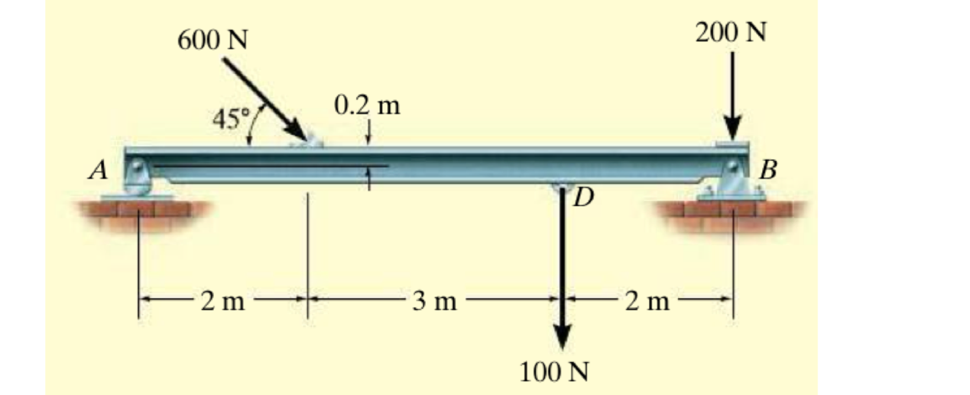

Question 1 - Solution

Question 2

The box wrench is used to tighten the bolt at A. If the wrench does not turn when the load is applied to the handle, determine the torque or moment applied to the bolt and the force of the wrench on the bolt.
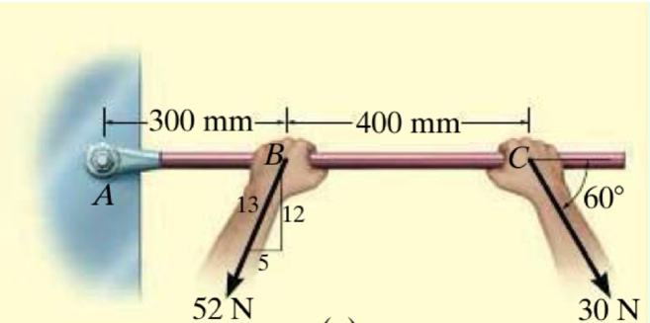

Question 2 - Solution

Question 3

Determine the components of the support reactions at the fixed support A on the cantilevered beam.
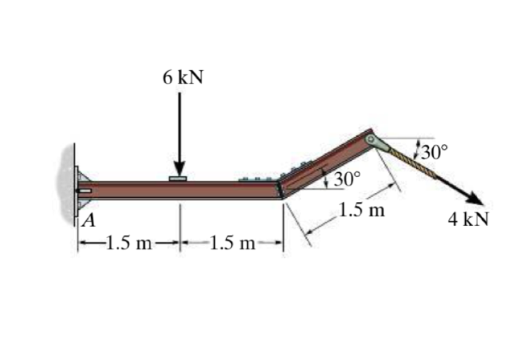

Question 3 - Solution

Question 4

Determine the reactions on the bent rod which is supported by a smooth surface at B and by a collar at A, which is fixed to the rod and is free to slide over the fixed inclined rod.
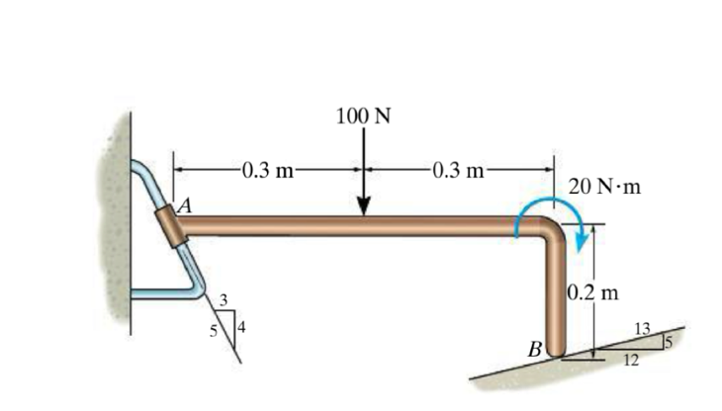

Question 4 - Solution

Question 5

Determine the reactions at the pin A and the tension in cord BC. Set F = 40 kN. Neglect the thickness of the beam.
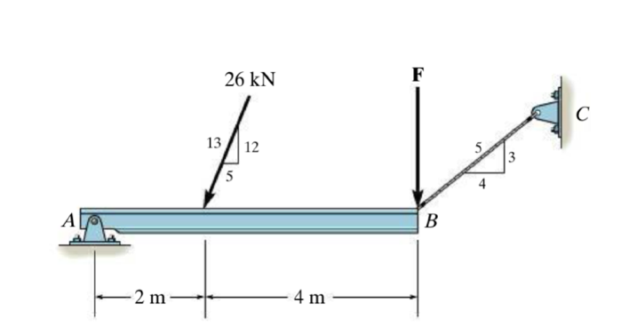

Question 5 - Solution

Question 6
Determine the normal reaction at the roller A and horizontal and vertical components at pin B for equilibrium of the member.
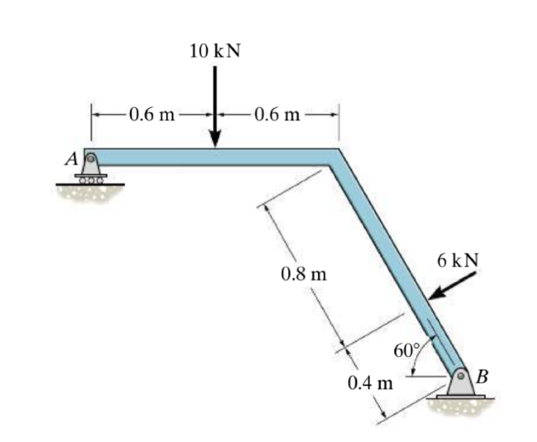

Question 6 - Solution

Question 7
Determine the reactions at point A and B
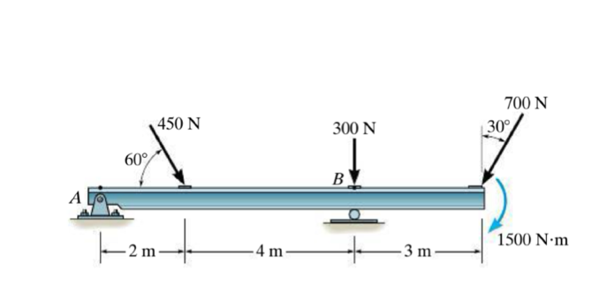

Question 7 - Solution

