

Phase One

Project for PetStarz



October 17, 2023

Authors:

Samantha bogen

Rolan ho

lisa kamdem

Dorian Laycock

Markus Luthi

Contents

Project Selection and Preliminary Analysis 2

About the Organization: 2

Current System Description: 2

Proposed Solution: 3

Use Case Diagram and Use Case Descriptions 4

Use Case Diagram for Foster Database: 4

Use Case Diagram for Digital Form: 5

Use Case Diagram for Waitlist: 6

Class Diagram 8

Appendix 9

Team Constitution 9

Team Curious Comets Members 9

Statement of Team Goals 9

Intellectual Property Statement 9

Team Member Roles 10

Division of Labour 10

Group Expectations 10

Plans for Resolving Conflict 10

Plan if Conflict can not be Resolved 11

Summary 11

# 

# Project Selection and Preliminary Analysis

Project Title: PetStarz Integrated Management System

Project Sponsor: April Shymko, Founder and CEO of "PetStarz"

## About the Organization:

PetStarz is an innovative startup with a laser focus on transforming the pet industry through a groundbreaking Software-as-a-Service (SaaS) online platform. The organization's central mission is to bring about positive, systemic change by offering a comprehensive, digital solution that addresses multiple facets of pet ownership. Specifically, PetStarz has identified four domains that are integral to its operational framework:

1. Ethical Pet Sourcing: The platform seeks to facilitate an informed and responsible choice for potential pet owners by listing pets sourced through ethical means.

2. Supplier Verification: Acting as a bridge between users and a network of verified suppliers—which includes breeders, shelters, and rescue organizations—the platform emphasizes credibility and humane practices.

3. Fraudulent Practice Reporting: Committed to maintaining a high level of integrity within the industry, PetStarz incorporates a mechanism allowing users to report unethical or fraudulent activities. This acts as a self-regulating feature to uphold standards within the platform.

4. Information Dissemination: A cornerstone of the PetStarz platform is its dedicated space for educational content and research. This aims to ensure that pet owners are well-informed and equipped with the knowledge required for responsible pet care.

Designed to be intuitive, user-friendly, and reliable, the platform includes the core values of trust, ethical sourcing, pet welfare, user empowerment, and community support. The ultimate vision is not just to offer a service, but to cultivate a harmonious ecosystem that emphasizes the welfare of pets while empowering users. This aligns with the organization's long-term strategic objectives and offers a scalable solution adaptable to future industry challenges and user needs.

## Current System Description:

As of now, PetStarz is in a foundational stage, operating on a basic digital platform that serves as a preliminary step towards achieving its ambitious and visionary goals. This platform is designed to become a one-stop solution for a local community of pet enthusiasts. However, it's important to note that several crucial elements are still in the planning or conceptual phase, yet concrete implementation. While the platform provides a skeleton structure that aligns with the company's vision of revolutionizing pet ownership and sourcing, it currently falls short in offering the full range of features and functionalities envisioned. The platform lays the groundwork but hasn't yet reached its full potential, which is essential for meeting the diverse and specific needs of pet lovers.

## Proposed Solution:

The "PetStarz Integrated Management System" will include the following features:

1. Unified Pet Listings: In this project, one of the primary features is to build an all-inclusive database covering a variety of pets. This includes canines, felines, and other more exotic animals for adoption or foster. The aim is to provide an advanced and user-friendly search functionality that allows users to sift through listings based on specific criteria like species, breed, age, and location. The addition of a 'Foster Database' extends the scope of the system by listing pets available for temporary care, thus adding an alternative option for users who may not be looking for a long-term commitment but still want to engage with the pet community.

2. Supplier Network: The next step in this project is to develop a Supplier Network feature. This will facilitate a direct link between end-users and a vast, validated network of suppliers, which include breeders, rescue organizations, and shelters. Rigorous validation protocols will be built into the platform to ensure that all suppliers meet the standard of ethical behavior and care for the animals. Additionally, this feature will allow shelters and breeders to create, customize, and manage their own profile pages on the platform, giving users multiple touchpoints to gather information.

3. Fraud Reporting Mechanism with Digital Web Form: A key feature of the project is a Fraud Reporting Mechanism, where a digital web form on the platform allows users to report unethical or suspicious activities. This form simplifies the reporting process by collecting details like the complaint's nature and involved parties. It enhances the platform's commitment to ethical sourcing and integrity. This feature aims to promote transparency and trust within the pet adoption ecosystem, ensuring a safer environment for all users.

4. Research Hub: This part will not only serve as a repository of curated articles and guidelines but also feature a Q&A database. The latter is designed to function as an interactive FAQ platform that supports user queries. Users can post their questions regarding pet laws, ethical supplier selection, or general pet care, which could be addressed by experts in the field like veterinarians. This feature enhances the platform's usability, offering immediate, reliable information for users seeking to make informed decisions related to pet ownership.

5. Community Engagement: It is a significant aspect of this project. Features such as interactive forums and discussion boards are planned. A 'Lost & Found' section will provide a community-driven platform to help locate lost pets. A dedicated 'Events Page' will also be designed to allow stakeholders like shelters and breeders to announce upcoming events, thus facilitating community interactions and knowledge-sharing.

# Use Case Diagram and Use Case Descriptions

### Use Case Diagram for Foster Database:

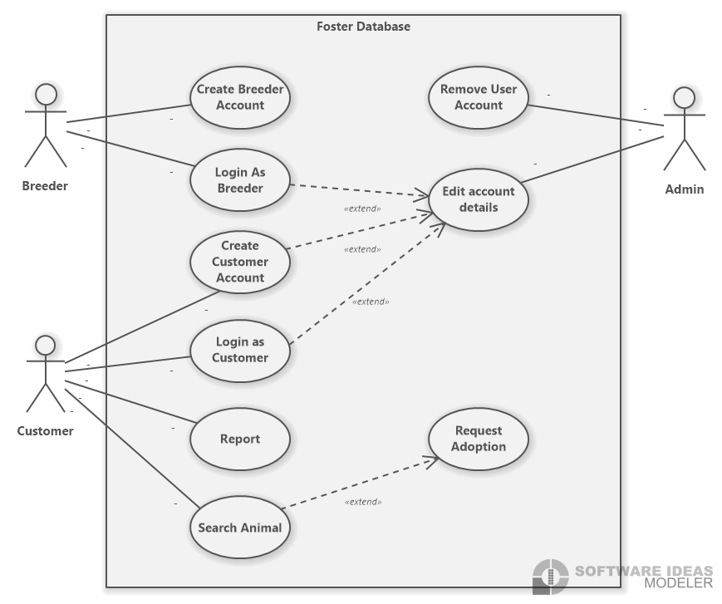

The breeder will create a breeder account with a username and password so they can added as a breeder to the database.

The breeder after creating an account can login as a breeder with the correct username and password, can later on edit their account details if necessary.

The customer will create a customer account with a username and password so they can added as a customer to the database.

The customer after creating an account can login as a customer with the correct username and password, can later on edit their account details if necessary.

The customer can report if they feel like an account is fake or giving out fake information about the information.

The customer can also search animals and look at all the animal that PetStarz have available and if they want to adopt can request to adopt.

The admin can remove a user account if they have been report or a fake account from the database.

The admin can edit account details from all the customers and breeders in the database.

### Use Case Diagram for Digital Form:

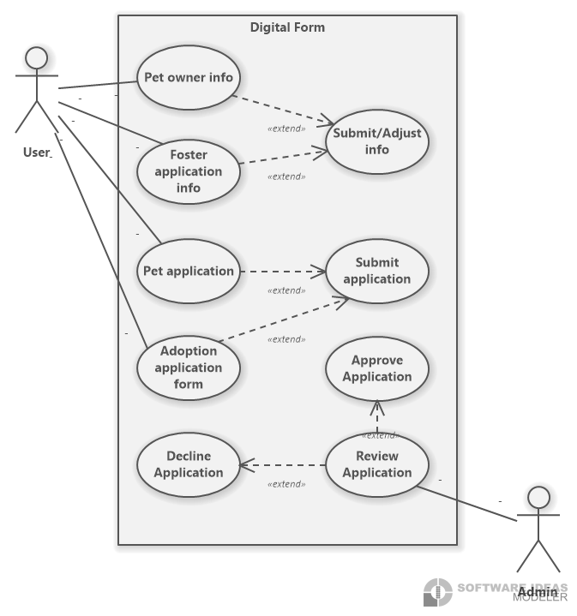

The user will need to enter the required information in the pet owner information form and can then adjust the information and submit the form once they have all the required information, if the user is already a pet owner.

The user will need to enter the required information in the foster application information form and can then adjust the information and submit the form once they have all the required information, if the user wants to become an applicant for fostering.

The user will need to enter the required information in the pet application form and submit the form once they have all the required information, if they want to apply for a pet.

The user will need to enter the required information in the adoption application information form and then adjust the information and submit the form once they have all the required information, if the user wants to become an applicant for adoption.

The admin will review all the application that have been submitted and can either approve to application or decline it.

### Use Case Diagram for Waitlist:

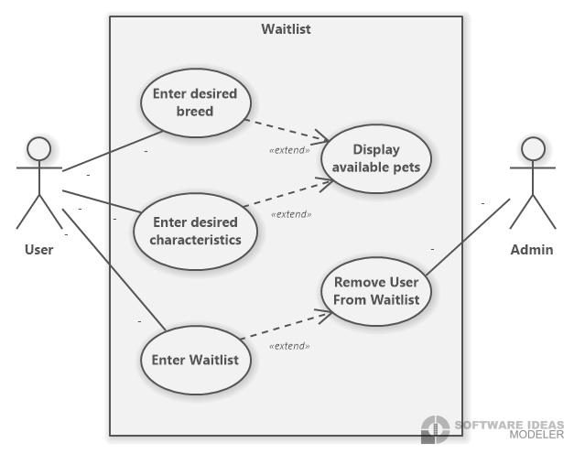

The user can enter the desired breed they are looking for and then the website will display all the available pets once the user clicks enter.

The user can enter the desired characteristics they are looking for and then the website will display all the available pets once the user clicks enter.

The user can enter in the waitlist and later on can remove themselves from the waitlist if necessary.

The admin can remove any user on the waitlist if necessary.

# Class Diagram

# Appendix

## Team Constitution

### Team Curious Comets Members

Samantha Bogen

Has previously attended Capilano University for Studio Art, giving them a keen eye for layout and design. They have worked a variety of fast paced customer service jobs that require attention to detail and being able to problem solve in a fast paced environment. They are great at pattern recognition and critical thinking.

Lisa Kamdem

Previously attended Thompson River University where she learned Java programming. Working as a hostess has taught her the value of patience. Lisa is great at being able to break down ideas and explain them in simple ways that anyone can understand.

Dorian Laycock

Went to Red River College for cabinet making where he learned about CNC programming. Being a cabinet maker taught him the importance of taking care at each step of a project to ensure the result is accurate. He is great at keeping his focus and paying attention to the small details.

Markus Luthi

Has acquired a Red Seal Pipe Fitting ticket through SAIT, where he learned how to follow technical drawings and the importance documentation. Working as a pipe fitter taught him a lot about the importance of safety and how to adapt to a situation on the fly. He learned how to work with and manage a group. Markus understands the importance of leadership and keeping a project on track.

Rolan Ho

Attended Plymouth University for Civil Engineering, where he studied Project and Risk Management. Working as a Civil Engineer, Rolan worked on large scale infrastructure projects in Hong Kong where he had to make sure he was looking at the whole picture. He is good at taking in the entire scope of a project and making sure that everything is being considered.

### Statement of Team Goals

As a group we hope to have clear and open communication to help us to solve any problems that arise as a group. We want to finish each phase of the project on time and keep ourselves on a set schedule so we never fall behind. We want to ensure that all Stakeholders are satisfied with the end result of our project.

### Intellectual Property Statement

Refer to Sait policy AC.2.11

### Team Member Roles

Markus is leading the team

Lisa is making schedules for the team to follow, and keeping us on track for deadline.

Samantha is ensuring that all documents follow APA format.

Dorian is editing and formatting the final document.

Rolan is ensuring the document meets the report guidelines.

### Division of Labour

All tasks will be divided equally between the group and when that can not be accomplished the tasks will be done in a rotation so that no one is consistently doing all the work. The group will have weekly meetings to ensure that everyone feels that the work load is being divided fairly.

### Group Expectations

The group will keep in contact over discord and email and expect responses to be within 24 hours. The group will meet weekly during class times to discuss the project and the progress everyone has made.

### Plans for Resolving Conflict

1. If a team member fails to attend a meeting the group will reach out to understand the circumstances and figure out ways that the situation can be avoided in the future. If there is a second meeting that is not attended that as a strike against them.
2. If a team member fails to meet a deadline, the group will ask the teacher to not give them any marks on the assignment and it will count as a strike against them.
3. If a team member is not meeting the standards of the other members and not contributing the same amount to the projects the group will inform the instructor and ask that they receive a lower mark and it will count as a strike against them.
4. If a team member fails to communicate, the group will reach out to make sure that nothing is wrong and offer any sort of support that they can to ensure that is doesn’t happen again. If it is a continuous pattern without any reason given then the group will bring the matter to the teacher and it will count as a strike against them.
5. If there is different levels of commitment to the project the group will discuss it as a whole and make sure everyone is communicating their expectations properly.
6. If there is a personality conflict between members than someone will mediate between the two until a middle ground has been reached.
7. If someone feels that they are doing more work than everyone else the group will discuss how they can redistribute the workload so it is more even.
8. If a team member is doing less work than the other members than the group will discuss how they can redistribute the workload so it is more even.

### Plan if Conflict can not be Resolved

If a team member reaches three strikes against them, showing a pattern, then the group will ask the instructor to intervene and remove them from the group.

### Summary

The group hopes to collaborate in a fair and equitable way so that all labour is divided equally. We want everyone feels like they have a chance to contribute and be heard. We hope that with our varying views we will be able to come together to build something that meets all of out clients needs and truly impresses them.