Evidence Gathering Document for SQA Level 8 Professional Developer Award.

This document is designed for you to present your screenshots and diagrams relevant to the PDA and to also give a short description of what you are showing to clarify understanding for the assessor.

Please fill in each point with screenshot or diagram and description of what you are showing.

Each point requires details that cover each element of the Assessment Criteria, along with a brief description of the kind of things you should be showing.

Week 2

Unit | Ref | Evidence
I&T | I.T.5 | Demonstrate the use of an array in a program. Take screenshots of:  *An array in a program  *A function that uses the array  *The result of the function running
 |  | Description:

Paste Screenshot here

Description here

Unit | Ref | Evidence
I&T | I.T.6 | Demonstrate the use of a hash in a program. Take screenshots of:  *A hash in a program  *A function that uses the hash  *The result of the function running
 |  | Description:

Paste Screenshot here

Description here

Week 3

Unit | Ref | Evidence
I&T | I.T.3 | Demonstrate searching data in a program. Take screenshots of:  *Function that searches data  *The result of the function running
 |  | Description:

Paste Screenshot here

Description here

Unit | Ref | Evidence
I&T | I.T.4 | Demonstrate sorting data in a program. Take screenshots of:  *Function that sorts data  *The result of the function running
 |  | Description:

Paste Screenshot here

Description here

Week 5 and 6

Unit | Ref | Evidence
A&D | A.D.1 | A Use Case Diagram
 |  | Description:

Paste Screenshot here

Description here

Unit | Ref | Evidence
A&D | A.D.2 | A Class Diagram
 |  | Description:

Paste Screenshot here

Description here

Unit | Ref | Evidence
A&D | A.D.3 | An Object Diagram
 |  | Description:

Paste Screenshot here

Description here

Unit | Ref | Evidence
A&D | A.D.4 | An Activity Diagram
 |  | Description:

Paste Screenshot here

Description here

Unit | Ref | Evidence
A&D | A.D.6 | Produce an Implementations Constraints plan detailing the following factors:  *Hardware and software platforms  *Performance requirements  *Persistent storage and transactions  *Usability  *Budgets  *Time
 |  | Description:

Paste Screenshot here

Description here

Unit | Ref | Evidence
P | P.5 | User Site Map
 |  | Description:

Paste Screenshot here

Description here

Unit | Ref | Evidence
P | P.6 | 2 Wireframe Diagrams
 |  | Description:

Paste Screenshot here

Description here

Unit | Ref | Evidence
P | P.10 | Example of Pseudocode used for a method
 |  | Description:

Paste Screenshot here

Description here

Unit | Ref | Evidence
P | P.13 | Show user input being processed according to design requirements. Take a screenshot of:  * The user inputting something into your program  * The user input being saved or used in some way
 |  | Description:

Paste Screenshot here

Description here

Unit | Ref | Evidence
P | P.14 | Show an interaction with data persistence. Take a screenshot of:  * Data being inputted into your program  * Confirmation of the data being saved
 |  | Description:

Paste Screenshot here

Description here

Unit | Ref | Evidence
P | P.15 | Show the correct output of results and feedback to user. Take a screenshot of:  * The user requesting information or an action to be performed  * The user request being processed correctly and demonstrated in the program
 |  | Description:

Paste Screenshot here

Description here

Unit | Ref | Evidence
P | P.11 | Take a screenshot of one of your projects where you have worked alone and attach the Github link.
 |  | Description:

Paste Screenshot here

Description here

Unit | Ref | Evidence
P | P.12 | Take screenshots or photos of your planning and the different stages of development to show changes.
 |  | Description:

Paste Screenshot here

Description here

Week 7

Unit | Ref | Evidence
P | P.16 | Show an API being used within your program. Take a screenshot of:  * The code that uses or implements the API  * The API being used by the program whilst running
 |  | Description:

Paste Screenshot here

Description here

Unit | Ref | Evidence
P | P.18 | Demonstrate testing in your program. Take screenshots of:  * Example of test code  * The test code failing to pass  * Example of the test code once errors have been corrected  * The test code passing
 |  | Description:

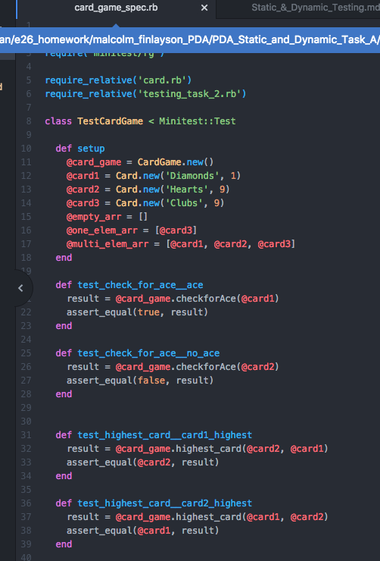

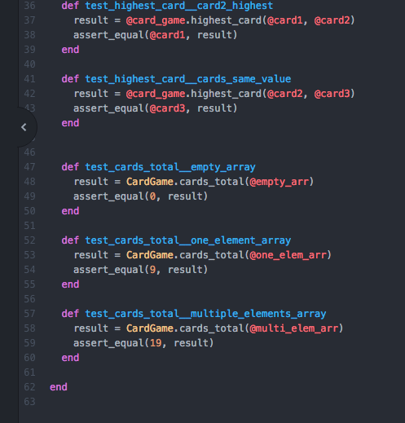

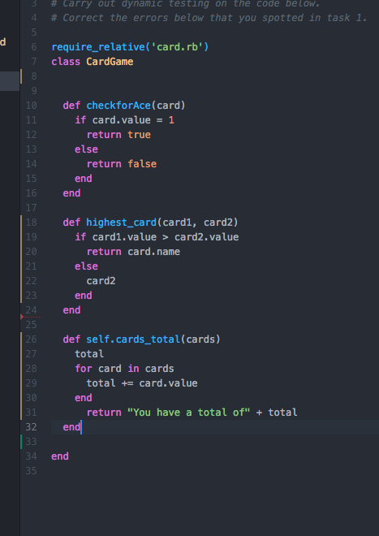

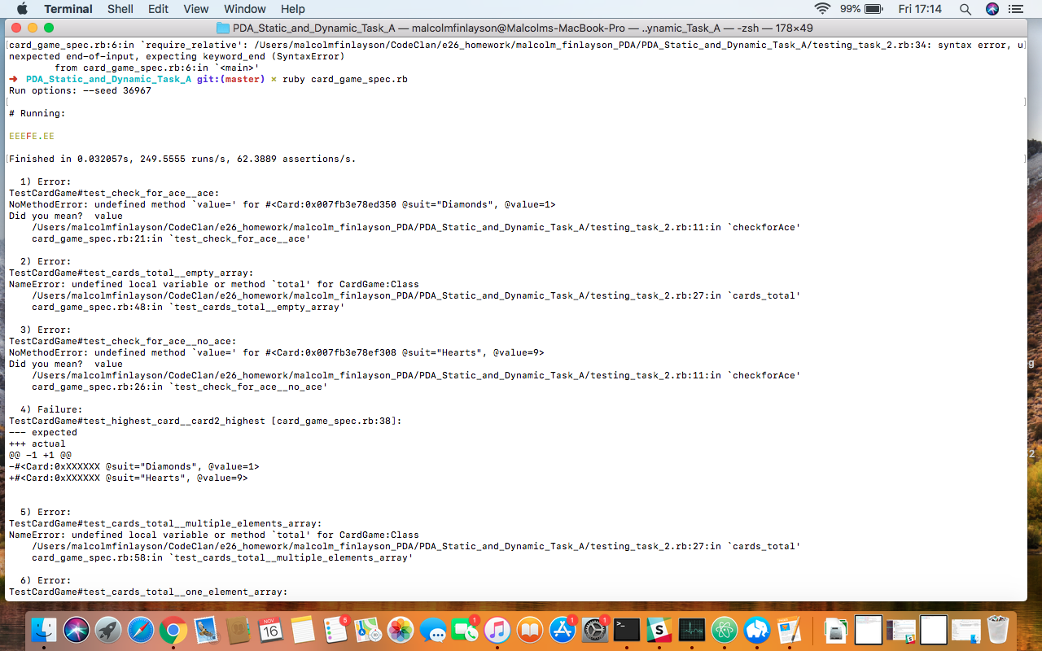

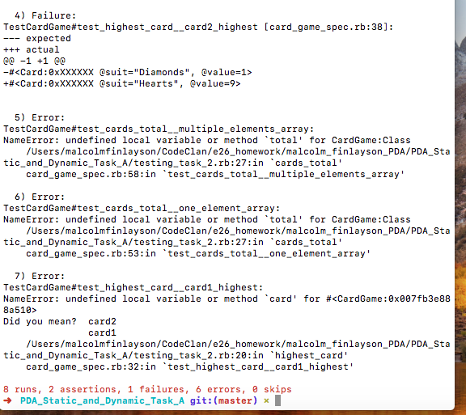

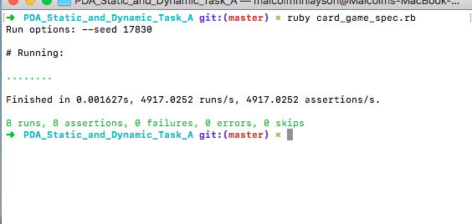

Week 9

Unit | Ref | Evidence
P | P.1 | Take a screenshot of the contributor’s page on Github from your group project to show the team you worked with.
 |  | Description:

Paste Screenshot here

Description here

Unit | Ref | Evidence
P | P.2 | Take a screenshot of the project brief from your group project.
 |  | Description:

Paste Screenshot here

Description here

Unit | Ref | Evidence
P | P.3 | Provide a screenshot of the planning you completed during your group project, e.g. Trello MOSCOW board.
 |  | Description:

Paste Screenshot here

Description here

Unit | Ref | Evidence
P | P.4 | Write an acceptance criteria and test plan.

Paste Screenshot here

Description here

Unit | Ref | Evidence
P | P.7 | Produce two system interaction diagrams (sequence and/or collaboration diagrams).
 |  | Description:

Paste Screenshot here

Description here

Unit | Ref | Evidence
P | P.8 | Produce two object diagrams.
 |  | Description:

Paste Screenshot here

Description here

Unit | Ref | Evidence
P | P.17 | Produce a bug tracking report
 |  | Description:

Paste Screenshot here

Description here

Week 12

Unit | Ref | Evidence
I&T | I.T.7 | The use of Polymorphism in a program and what it is doing.
 |  | Description:

Paste Screenshot here

Description here

Unit | Ref | Evidence
A&D | A.D.5 | An Inheritance Diagram
 |  | Description:

Paste Screenshot here

Description here

Unit | Ref | Evidence
I&T | I.T.1 | The use of Encapsulation in a program and what it is doing.
 |  | Description:

Paste Screenshot here

Description here

Unit | Ref | Evidence
I&T | I.T.2 | Take a screenshot of the use of Inheritance in a program. Take screenshots of:  *A Class  *A Class that inherits from the previous class  *An Object in the inherited class  *A Method that uses the information inherited from another class.
 |  | Description:

Paste Screenshot here

Description here

Unit | Ref | Evidence
P | P.9 | Select two algorithms you have written (NOT the group project). Take a screenshot of each and write a short statement on why you have chosen to use those algorithms.
 |  | Description:

Paste Screenshot here

Description here

